Electronic Engineering
ACDA5002

Scott Thomas
2015683

Assignment report – Design of a prototype bicycle computer

07/05/2021

Abstract
Through this project, an initial proof of principle prototype design for a bicycle computer has been produced. The scope of the project was to design a system capable of basic data logging of relevant parameters; be capable of connecting to a PC via USB for data connectivity; have an internal rechargeable battery and be able to recharge the battery via the USB connection.

Introduction
The system has been designed based on a Microchip PIC device and is capable of displaying speed, distance, cadence, and elapsed time as required.
Additional features that have been added are:
- a real time clock, capable of displaying the date and time with a battery backup so that the date and time will be correct when the device is powered
- A brake light activated when the brake lever is pulled.
Components used:
- Microprocessor PIC16F877 [1]
- 1602 LCD display screen
- 6 buttons used for turning the system on; starting and stopping recording; altering parameters (wheel and crank size); and setting the date and time
- 2 Hall effect sensors (one for distance and one for cadence)
- A relay powered by a transistor to control the switch for the LED brake light array
- LED brake light array
- A boost converter to step up the incoming voltage of 5v to 8v to charge the two lithium-ion batteries connected in series (the boost converter switch is controlled by pin 17 of the PIC16F877, which supplies pulse width modulation through a FET transistor in order to get the correct voltage output
- A voltage regulator to supply a constant 5v to the PIC
- A DS1307 real time clock IC
A block diagram, circuit diagram and flowchart have been produced to give an overview to the system operation and how the system will operate.
The block diagram (Fig 1.), circuit diagram (Fig 2.) and flowchart (Fig 3.) have been included on the next few pages:

Block Diagram (fig. 1)
EEMPROM Storage

Microprocessor PIC16F877
USB connection
LCD display
Hall effect sensor (Distance)
Hall effect sensor (Cadence)
Internal rechargeable battery
On/Off Button (B1)
Start/Stop Recording button (B2)
LED Brake Light
Signal Conditioning
Signal Conditioning
Voltage Rectification
Voltage Regulator
LED Relay
Brake Lever Switch
Real Time Clock
Precision Crystal
Set Date/Time (B5)
Alter Parameters (B4)
Alter parameters (B3)
Set Date/Time (B6)

Circuit Diagram (fig.2)

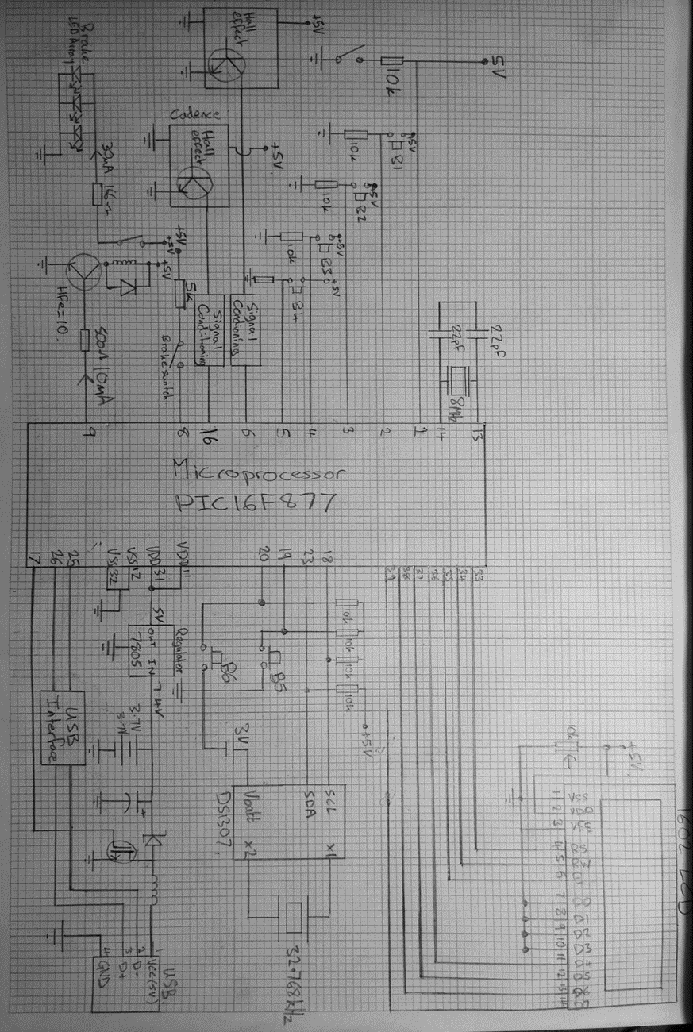

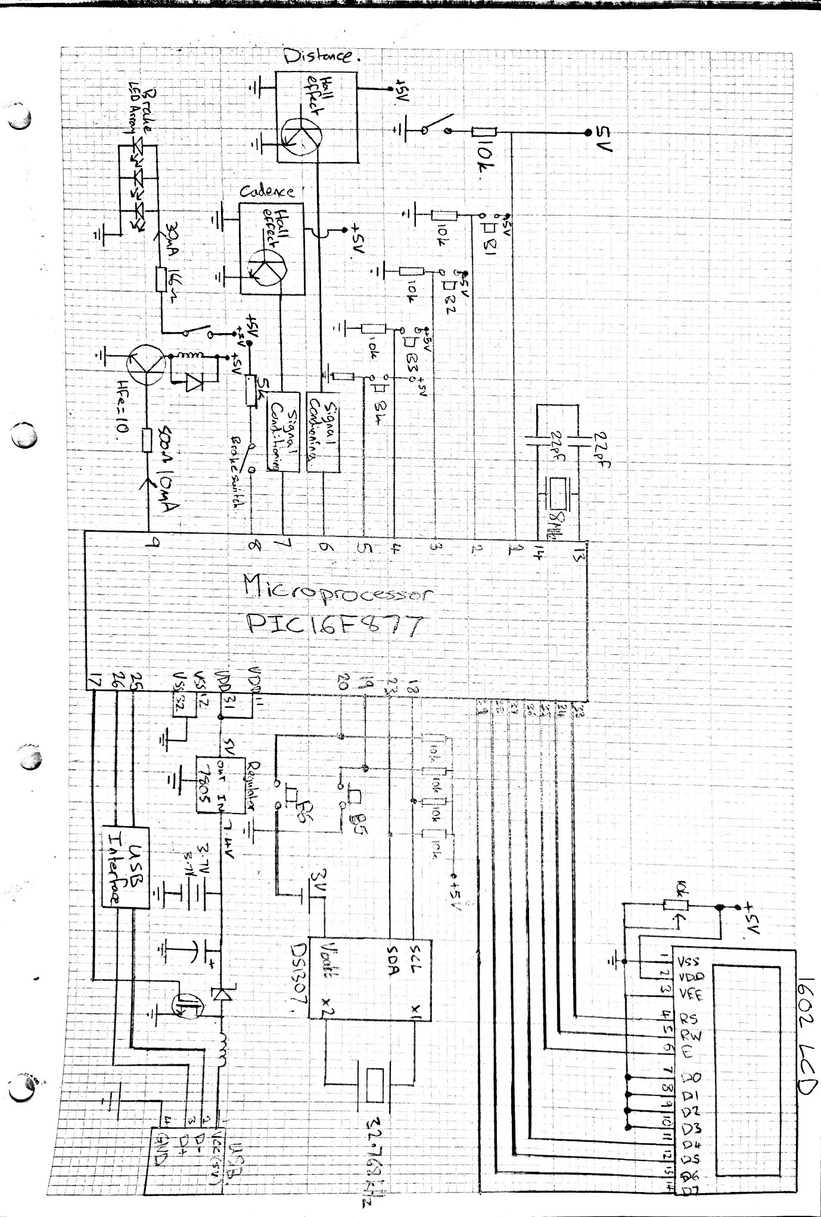

Flowchart (Fig.3)

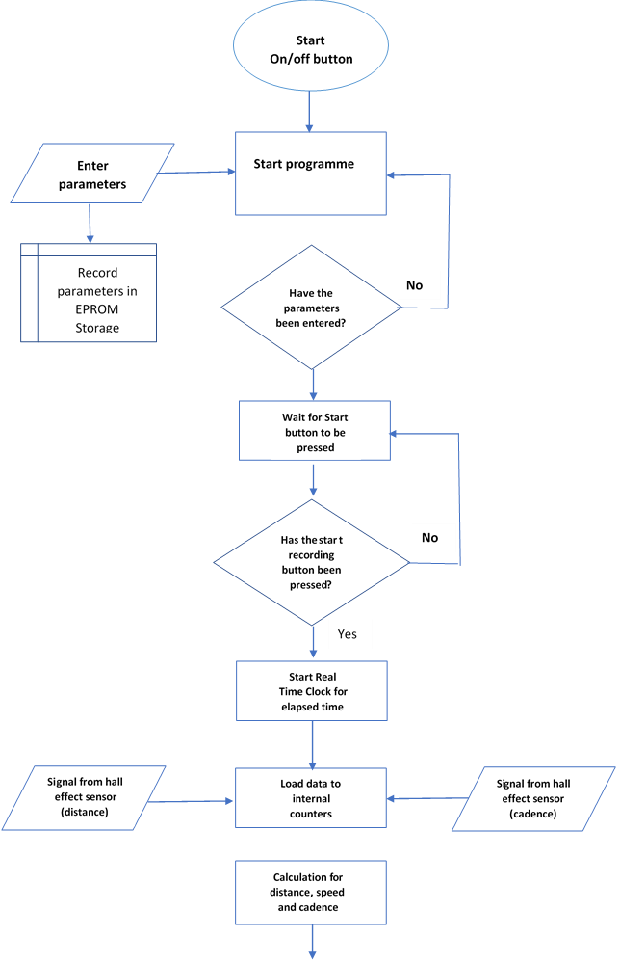


Display data on LCD screen
Has start/stop button been pressed?
No
Stop Recording
Store data of previous ride
Turn microprocessor off/standby mode

Pinout of Microprocessor PIC16F877 [1]

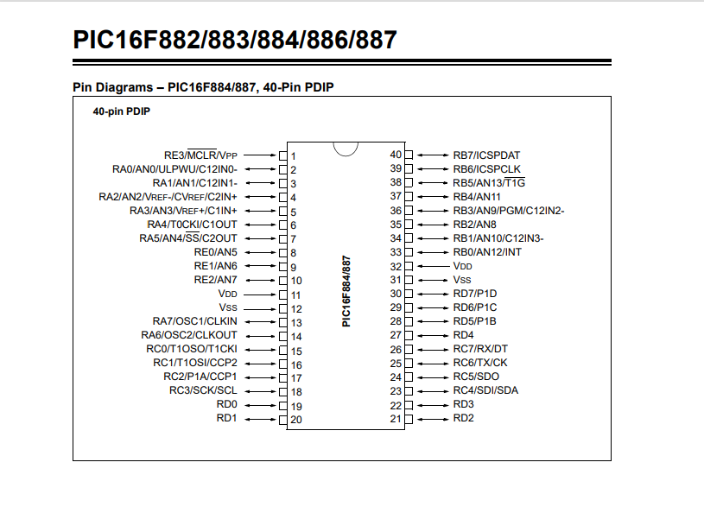

Overview of block diagram (Fig 1.)
The block diagram that has been produced features the Microprocessor PIC16F877.
Inputs:
- USB connection:
  - The USB connection features 4 pins: Pin1- VCC (+5V);Pin2 – D-; Pin3 – d+; Pin4 – GND [6]
  - The voltage line is indicated using red arrows on the block diagram
  - Pin 1 and pin 4 are used to power the Microprocessor PIC16F877 and the pic then powers all equipment in the circuit diagram. They are connected to a voltage converter (boost converter)
  - The voltage converter steps up the voltage to charge the two series 3.7V lithium-ion batteries
  - The batteries are connected to the Microprocessor PIC16F877 via a voltage regulator to give a steady output voltage of 5v which is the voltage required for the Microprocessor PIC16F877
  - Pin 2 and pin 3 are connected to the Microprocessor to allow data communication with an external PC

- Two Hall effect sensors:
  - The hall effect sensors and connected to the Microprocessor PIC16F877 via signal conditioning modules
  - One hall effect sensor is used to record the distance the bicycle has travelled
  - One hall effect sensor is used to record the bicycle cadence

- Push buttons:
  - B1 - On/Off button
  - B2 – Start/Stop recording button
  - B3 – Alter parameters
  - B4 – Alter parameters
  - B5 – Set time/date
  - B6 – Set time/date

- Brake lever switch:
  - A switch located on the brake lever is input to the Microprocessor PIC16F877 which then energises a relay that switches on the brake light array

Outputs:
- LCD display:
  - The LCD screen displays distance, speed, cadence, elapsed time and the current date and time

- LED brake light:
  - The LED brake light is turned on via a relay when the brake light switch is closed

Input/Output:
- EEPROM Storage:
  - The EPROM Storage is used to store the parameters and to store the data recording during the previous ride

- Real Time Clock:
  - The Real Time Clock give the time and date and is set through buttons (B5 & B6) connected to the Microprocessor PIC16F877

Overview of the circuit diagram (Fig.2)
The circuit diagram consists of:
- Microprocessor PIC16F877
- Voltage converter (Boost converter)
- Voltage regulator
- DS1307 real time clock
- Six Buttons:
  - B1 - On/Off button
  - B2 – Start/Stop recording button
  - B3 – Alter parameters
  - B4 – Alter parameters
  - B5 – Set time/date
  - B6 – Set time/date
- 2 hall effect sensors for distance and cadence
- Brake light:
  - Switch on the brake lever
  - Relay output to the brake LED array
- LCD display capable of displaying distance, speed, cadence, elapsed time and the current date and time
- Master reset
Voltage supply:
The voltage to the Microprocessor PIC16F877 is supplied via a USB input. Pin 1 (VCC) is the 5V supply and pin1 (GND) is the ground of the supply. This 5V supply charges two lithium-ion batteries connected in series to give a voltage of 7.4V. The charging of the Lithium-ion batteries is done by stepping up the voltage from 5V to 8V through a boost converter. The batteries are necessary as the system will not be connected to the 5v supply through the USB when in operation. The 7.4V supply from the batteries is then regulated through a 7805 regulator which gives a steady output of 5V when the batteries are charged sufficiently.
Why was a boost converter used and how it works:
A boost converter (a type of switch mode power supply) was required to step up the voltage to produce sufficient potential difference so that the lithium-ion batteries will charge.
Unlike linear regulators, switching converters can produce output voltages higher than their input. During switch conduction (switch via a FET transistor controlled by a Pulse Width Modulated supply from pin 17 of the microcontroller PIC16F877) the inductor current ramps up; when the switch is turned off, the voltage rises rapidly as the inductor attempts to maintain constant current. The diode turns on, and the inductor dumps current into the capacitor. Therefore, the voltage can be much larger than the input voltage. [3]
The boost converter will be controlled by a Pulse Width Modulation supply from pin 17 of the microcontroller PIC16F877 to step the voltage up to 8V to charge the 7.4V battery. The microcontroller PIC16F877, however, runs off a 5V supply and the 7.4V therefore needs to be regulated. This has been achieved using a 7805 [7] voltage regulator to output 5V to the microcontroller PIC16F877.
Data connectivity:
Pin 2 (D-) and Pin 3 (D+) of the USB port are used for data connectivity between the microcontroller PIC16F877 and a PC. These are connected to pins 25 and 26 of the microcontroller PIC16F877 via a USB interface
Hall effect sensors:
The hall effect sensors (one for distance and one for cadence) are connected to pin 6 and pin 16 of the microcontroller PIC16F877. These pins can be allocated as Timer0 and Timer1 and can be used as counters to count how many pulses the hall effect sensors are outputting. The hall effect sensors are active low. This means that the counters will count when the signal output from the hall effect sensors are low. The hall effect sensors will be low when a magnet rotates on the wheel/crank past the hall effect sensors indicating a rotation has been complete. These pulses can then be used to calculate distance travelled, current speed and cadence.
Brake Light
The brake light will be controlled by a switch on the brake lever to indicate to following traffic when the brakes are being applied. The brake lever switch is input to pin 8 of the microcontroller PIC16F877. This will then activate pin 9 to switch a transistor which will then activate a relay to supply the required current to supply the LED brake light array. With this electrical separation is achieved. A protection diode is required across the inductor (relay coil) so that the breakdown voltage does not damage the transistor.
Component value calculations:
- For output 9 of the microcontroller PIC16F877, 10mA must be supplied to the transistor in order for the transistor to be switched on and supply the relay coil with current and switch on the brake LED array:
V=5V I=10mA
R=V/I R=5/0.01 R=500Ω
- LED resistor calculation:
For one of the LEDs to light up, 10mA is required to flow through it. As three LEDs have been used, 30mA is required. Therefore the resistor value must be calculated to allow 30mA to flow:
R=V/I R=5/0.03 R=166Ω

- Transistor gain:
100mA is required to produce sufficient emf in the inductor to switch the relay. As 10mA is flowing into the gate of the transistor, a gain of 10 (hfe=10) is required in the transistor.
LCD Display screen
The LCD display screen (1602 LCD [4]) is connected to PORTB of the microcontroller PIC16F877. The pins used for the output to the LCD display are pin 33 to 39. A 10K potentiometer is used to adjust the brightness of the display screen.
Real Time Clock [5]
A DS1307 real time clock chip has been used to supply the date and time to the microcontroller PIC16F877. A 32.768KHz crystal oscillator is connected to pin X1 and X2 of the chip to provide the timing. The DS1307 chip has a 3v battery connected to pin Vbatt so that when the microcontroller PIC16F877 has no power, the clock will keep time and display the correct date and time on power up. Two buttons have been used to set the date and time. These buttons are:
- B5 – connected to pin 19 of the microcontroller PIC16F877
- B6 – connected to pin 20 of the microcontroller PIC16F877
Master reset
Pin 1 is the master clear pin for this IC (PIC16F877). This pin is active low which means that it should be given a constant voltage of 5 volts. If 0 volts is put on pin 1 then the controller will reset. If the switch is closed then the voltage will go to ground, 0 volts will be on pin 1 and therefore the microcontroller will reset.

Overview of the flowchart (Fig. 3)
- The flowchart begins when the on/off button is pressed (B1)
- The programme is then started and waits for the parameters to be entered
- The parameters are entered using buttons 3 and 4 (B3 and B4) and stored in the EPROM stored of the microcontroller PIC16F877
- When the parameters have been entered the microcontroller PIC16F877 is then waiting for the start button (B2) to be pressed
- Now that the start button has been pressed the real time clock starts to display the elapsed time on the display screen
- The microcontroller PIC16F877 is then loading the pulses received from the two hall effect sensors into internal counters (Timer0 and Timer1)
- A calculation then takes place to calculate the distance, speed and cadence depending on the parameters that have been entered
- The data (Elapsed time, distance, speed, and cadence) is then displayed on the LCD display screen. The calculations will continue, and the display screen will continue to display the current data until the stop recording button is pressed (B2)
- When the stop recording button (B2) is pressed, the microcontroller PIC16F877 will stop recording the data and will store the data collected during the bicycle ride for review and analysis.
- The microcontroller PIC16F877 will then stay in standby mode until the on/off button (B1) is pressed, the system will then shutdown.
Pins of the Microprocessor PIC16F877 used [8]
Pin 1(MCLR) – Master reset switch
PORTA consists of 6 pins (pin2 to pin7). These can all be used as either input or output pins. In this design they are being used as input pins.
Pin 2 – On/off button(B1)
Pin 3 – Start/Stop recording (B2)
Pin 4 – Alter parameters (B3)
Pin 5 – Alter parameters (B4)
Pin 6(T0) – Hall effect sensor (distance) Pin 6 is the input for Timer0 which is being used as a counter.
Pin 16(T1) Hall effect sensor (distance) Pin 16 is the input for Timer1 which is being used as a counter.
PORTE consists of 3 pins which can also be used as either input or output pins.
Pin 8 – Input from the brake lever switch
Pin 9 – Output for the brake light relay
Voltage supply
Pin 11 & 31 (VDD) – These pins are supplied with +5V
Pin 12 & 32 (GND) – These pins are connected to Ground
Clock input
Pin 13(CLKIN) &14(CLKOUT) – These pins are connected to the 8MHz crystal oscillator as shown in the circuit diagram
USB data interface
Pin 25 & 26 - These pins are used to connect to the USB interface for data connectivity with a PC.
Real Time Clock
Pin 18 (SCL) – connected to SCL pin of the DS1307 Real Time Clock chip
Pin 23 (SDA) – connected to SDA pin of the DS1307 Real Time Clock chip
Pin 19 & pin 20 – connected to B5 and B6 to set the date and time.
Pulse Width Modulation
Pin 17(CCP1) – connected to the FET to control the boost converter as shown in the circuit diagram.
LCD display screen
PORTB – Pins 33 to 39.

Internal modules of the Microprocessor PIC16F877 used [9]
Timers:
The Microcontroller PIC16F877 supplies several internal timers. These timers can be used in counter mode and that is the operation that is being used in this system:
Timer0 (Pin6) – Timer0 is being used to count the pulses (low voltage pulses) for the hall effect sensor mounted on the wheel to calculate distance travelled and to calculate current speed.
Timer1 (Pin16) – Timer1 Is being used to count the pulses (low voltage pulses) for the hall effect sensor mounted on the crank to calculate cadence.
EEPROM:
The Microcontroller PIC16F877 has built in electrically erasable read only memory which can be used to store data permanently even if the microcontroller is switch off. Th EEPROM is used in this system to store the previously entered parameters and the data from the last ride for analysis or reference.
Pulse Width Modulation modules:
The Microcontroller PIC16F877 has 2 internal Pulse Width Modulation modules. This system uses Pin 17 (CCP1) to create a PWM supply to control the voltage supplying the battery.

Calculations for the Hall effect sensors (Distance, Speed, Cadence)
Several calculations must be carried out within the microcontroller PIC16F877 to convert the hall effect signals from the wheel rotation and crank rotation to distance, speed and cadence which will be displayed on the LCD display screen.
Distance:
Bicycle wheels are generally 29 inches, and this represents the circumference of the tire. Converting 29 inches to metric = 0.7366 meters. This means that every time the wheel rotates the bicycle will travel 0.7366 meters. Therefore, every pulse received on pin6 (input from distance hall effect sensor and input for Timer0) will add 0.7366 meters to the overall distance travelled and display on the LCD display screen.
Speed:
To calculate the speed, the number of pulses on pin6 in a given time must be counted and then multiplied to give Kilometres Per Hour.
This can be done by counting how many pulses in 10 seconds and multiplying by the circumference. This will then be multiplied by 6 and then by 60 to give speed in meters per hour. This shall then be divided by 1000 to give the speed in Kilometres Per Hour.
Cadence [10]
Cadence is the rate at which a cyclist pedals and is usually calculated in RPM. To give an accurate cadence reading, the pulses from the cadence hall sensor on pin 16 of the Microcontroller PIC16F877 should be counted over 10 seconds and then multiplied by 6 to give the RPM.

Conclusion
During this assignment ‘Design a prototype bicycle computer’, I have learnt a great deal about circuit design; microcontroller selection; use of different components such as hall effect sensors; LED switching; voltage conversion, regulation, and real time clock modules.
I feel that this assignment has allowed me to broaden my knowledge and understanding of electronic design and the processes that need to be completed to get the desired outcome. This system is far more complex than any electronics that I have done previously and I feel that the work that I have completed here will allow me to be more confident when approaching electronic design in the future and possibly lead to me carrying out some independent projects as I have found the overall process enjoyable.

References
[1] - Microprocessor PIC16F877 Datasheet 41291D.book (microchip.com)
[2] - 41291D.book (microchip.com) (Page 8)
[3] The Art of Electronics book (page 647)
[4] I2C-LCD-interface.pdf (opencircuit.shop)
[5] Real time clock using PIC16F877A and DS1307 RTC - CCS C (simple-circuit.com)
[6] USB pinout diagram @ pinouts.ru
[7] The Art of Electronics book (page 602)
[8] PIC16F877A Introduction, pinout, features, Examples, Datasheet (microcontrollerslab.com)
[9] PIC16F877A Introduction, pinout, features, Examples, Datasheet (microcontrollerslab.com)
[10] What is Cycling Cadence? How to Measure It | BikingBro

