Student Name |  |  | Andrei Welkens-Covaci
Student ID |  |  | 1818820
Module Title |  |  | Digital Skills and Research Methods (BMSW4001_LON)
Assignment Title |  |  | Digital Skills and Research Methods
Module Lecturer |  |  | Balendran Kandasamy
Word Count |  |  | 1970 |  |  |  | Date Submitted |  | 07.01.2020


Impact of Virtual Learning Environment (VLE)- Moodle on Students’ learning experience.

Contents
Rationale 4
Objectives 4
Methodology 5
Data collection process 5
Ethical Consideration 6
Primary Data analysis 6
Secondary Data analysis 8
Conclusion 10
References 11
Appendixes 12

Rationale
E-learning method is becoming hugely popular in higher education and it is becoming a necessary instrument for institutions such as universities. Contemporary organisations are facing multiple issues regarding virtual learning as academics in e-learning are facing issues with different learning styles which are designed for different students in order to acquire better learning outcome. According to recent reports, virtual learning method cannot identify and emphasise on individual learning method, which creates problem in higher studies (Islam, et al., 2015). The process of e-learning cannot fulfil individual needs of students, which is creating difficulties among the students of the universities to understand the aim and objective of the classes. A single technological solution is unable to be introduced yet in order to mitigate such challenges in the virtual learning system. Technical challenge is also one of such issues that create problems in virtual classrooms. Issues such as speed, bugs, functional issues and errors create challenges for classroom activities and slow the learning process in different aspects. Funding the high cost of such learning process is also problematic for contemporary organisations which are creating issues for higher education authorities. This research had shed lights on different impacts of virtual learning environment on students through both primary and secondary research process.

Objectives
- To identify the fundamentals of Virtual Learning Environment
- To analyse the impact of VLE on the learning experience of students in the University of Wales Trinity Saint David London
- To identify fruitful strategies to mitigate issues of using VLE

Methodology
Methodology is one of key sections of a research project. It introduces a blueprint for the whole research work. It introduces different approaches and several philosophies, designs and data collection methods are evaluated in this part of the research. The researcher had followed positivism philosophy as it had introduced opportunities to acquire positive data from the natural phenomenon (Padilla-Diaz, 2015). There are other philosophies such as interpretivism and realism, but the philosophies are not acquired by the researcher interpretivism philosophy does not support a structured method for data collection process. On the other hand, the researcher had acquired Deductive approach for the research as it had helped the researcher to test the existing theory rather than making a new theory regarding the influence of virtual learning experience in higher studies (Gog, 2015). Researchers according to their plan about the research are using different designs such as Conclusive and Exploratory designs. The researcher had used Descriptive Design for the research as it had helped the researcher with a proper structure of the data collection process by which both primary and secondary data had been collected by the researcher within the time period (Quinlan, et al., 2019).

Data collection process
Researchers collect mainly two types of data, primary and secondary in order to acquire appropriate conclusion. Primary data is collected from the natural phenomenon and this process acquires both qualitative and quantitative data. Processes such as semi structured interview helps researchers to acquired primary qualitative data and on the other hand, with the help of survey method, the researcher can acquire primary quantitative data (Ness & Patricia, 2015). Apart from primary data, researchers also collect secondary data as it helps to evaluate research papers and online journals to find out authentic information that fulfils the demand of the research project.
In this contemporary research work, the researcher had acquired both primary and secondary data collection method in order to meet the research objective appropriately. The researcher had collected primary quantitative research method as it had helped the researcher to acquire information from the students in order to understand the impact of VLE on the learning experience of the student (Johnston, 2017). In order to conduct survey with students, the researcher had acquired permission from the students and informed them about the survey process and it had helped the researcher to clarify the sole purpose of the research work. 15 students were selected for the data collection process as it had helped the researcher to identify the appropriate information regarding the objective of the work. On the other hand, secondary research is also one of the major parts of this research as the researcher had evaluated 3 journals to include appropriate result for the research.

Ethical Consideration
The researcher had acquired permission from the University in order to conduct the survey appropriately. On the other hand, the researcher had always keenly followed attributes of data protection act and all information of participants was appropriately taken care.

Primary Data analysis
The researcher had used primary quantitative data collection process where 15 students who have access to the VLE were randomly selected. This process had given the researcher a vivid idea regarding the impact of VLE on students appropriately. First two questions of the survey process were the demographic question where important information regarding the age group and gender of students are acquired. It is seen that both male and female students were almost equally participated as number of female students were 8 and rest were male. Therefore, perception regarding VLE had been collected from both genders. On the other hand, students from different age group also had participated in the survey process which also helped the researcher to understand how students from different age group are being influenced by VLE. The third question has huge significance regarding the data collection process as it is seen that students from different streams such as Business, healthcare and I.T had participated in the survey therefore, perception of all these students were acquired by the researcher. Arability of such diversity in the survey process had helped the researcher to acquire perception of different students regarding their learning experience with the VLE.
From the survey, it is seen that only 5 students open the Moodle daily which is a concerning number as it shows that they have very small interest which is why they are reluctant to open the Moodle to acquire study materials. However, all the participants had mentioned that they acquire enough knowledge from the Moodle, they are not always keen to open the Moodle because different factors abate their interest to open it more frequently. Five students open the Moodle once in a week which is essentially low as these students find certain difficulties to acquire knowledge through the Moodle. The next question has clarified the reason behind the issues of accessibility of the Moodle. The question was asked whether the fingerprint feature in mobile device can be used for, the sign in, process to the Moodle would be helpful, as 13 of participants had mentioned that it would be essentially helpful for them to acquire data through this process, as it would increase the accessibility. On the other hand, need of doubt clearance session through which they can ask questions are needed to be effectively introduced in the VLE as it is one of the major drawbacks in such learning process. Daily feedback and doubt clearance sessions are important for students to understand their position in the class.
All students were asked that whether it would be helpful to connect both universities email and personal email and it had acquired mixed answers from participants. According to 6 participants, this process is not that helpful feature as it would have security issues which can introduce to a greater problem for them. It can be clearly seen from the survey that students are happy about the amount of knowledge they can get through the Moodle, but they are not happy about other things about the moodle, which is reflected in the answer of the following question. Students were asked whether they could recommend the Moodle as the bets free learning management system, which was negatively responded by 5 participants which was one third of the whole population of the survey. Their overall experience regarding the Moodle is also needed to be improved as only 3 participants only ranked it 10.

Secondary Data analysis

Use of Virtual learning in Classrooms
Virtual learning methods in classrooms are being widely accepted throughout the world. Contemporary educational organisations are exploring new heights with virtual learning in classrooms and acquiring huge advantages. (Rienties, et al., 2016), had mentioned that after almost a decade of Virtual Learning Environment in Classrooms, it is seen that most of the teachers use only a selected few features or categories of the process in the classroom. It is seen in most of the classrooms that students often struggle with the functionality of the new VLE system as clear instructions and searchable supports, accessibility and appropriate functionality are prime criteria for students in order to improve their study process. VLE systems are continuously improving and educational organisations are acquiring affordable and complex systems in order to provide best supports to classrooms. Such frequent changes in comprehensive learning process is increasing complexities for students as they are finding challenges regarding the accessibility of class notes.
Most of the contemporary VLE systems are providing different online materials to students through audiovisual materials through which students can get a deep delved knowledge by observing step by step supports. It is mentioned in the research report that most of the teachers and students are hugely preferring such process of learning as these learning methods are creating more interests among people regarding the learning process than contemporary normal textbook learning. Along with students, academic staffs are more positive about such learning process because of the usefulness of the VLE system which positively influence their capability and skills to teach.

Different strategies of Virtual Learning Environments
Through the years, virtual learning is evolving through the years because of advancement in technologies in online learning environment. New active learning methods are being introduced by academic organisations by introducing new platforms where students can engage in different learning activities appropriately. Modern educational systems are based on different strategies as both learners and teachers are counting on such strategies to introduce a better academic environment. Certain difficulties are arising in classrooms, which are over dependant on online activities. According to (Chakraborty & Nafukho, 2015), in conventional teaching process, teachers can have face to face conversation with students which introduces certain idea about the learning engagement of the student. In most of the online classes, students find similar approaches regarding instructions which often create problems for them as they have different learning approaches. On the other hand, having timely feedback regarding the progress is a huge expectation of students which often explained mechanically through different online learning processes.
According to the study, a purposeful design for the online study is important for the class work, which can mitigate such issues and more accurate process to provide knowledge through these virtual classrooms can be acquired appropriately. Such purposeful designs are needed to be introduced by identifying the purpose, which these technologies are going to fulfil in the classroom settings. It is the duty of management and teachers of the educational organisations especially universities to understand the actual needs of the system rather that changing the system frequently as this introduces problems for students regarding the accessibility of study materials.

Conclusion
Through the progress of the report, it is seen that in higher education, virtual learning is having huge influence on both teachers and students differently. Main objectives of the research were to find out different aspects of VLE and its influence on students. On the other hand, the researcher had highlighted different challenges of using VLE and strategies to mitigate such issues are appropriately introduced. The researcher had used both primary and secondary research where 2 journals were introduced to evaluate for acquiring secondary data for the research and 15 students from the university were introduced in the survey. From these sources the researcher had acquired important information that accessibility of the VLE is needed to be improved through which a better learning experience can be given to students.

References
Chakraborty, M. & Nafukho, F., 2015. Strategies for Virtual Learning Environments: Focusing on Teaching Presence and Teaching Immediacy.. Internet Learning Journal, 4(1).
Gog, M., 2015. Case study research. International Journal of Sales, Retailing & Marketing, pp. 33-41.
Islam, N., Beer, M. & Slack, F., 2015. E-learning challenges faced by academics in higher education. Jurnal of Education and Trainig Studies, pp. 102-112.
Johnston, P. M., 2017. Qualitative and quantitative methods in libraries. 3 ed. s.l.:World Scientific .
Ness, L. & Patricia, F., 2015. The Qualitative Report. [Online]
Available at: https://www.nsuworks.nova.edu/tqr/vol20/iss9/3/
[Accessed 28 12 2019].
Padilla-Diaz, M., 2015. Phenomenology in educational qualitative research: Philosophy as science or philosophical science.. International Journal of Educational Excellence , pp. 101-110.
Quinlan, C., Babin, B., Carr, J. & Griffin, M., 2019. Business Research Methods. s.l.:South Western Chengage.
Rienties, B. et al., 2016. Why some teachers easily learn to use a new virtual learning environment.. In: Interactive Learning Environments . s.l.:s.n., pp. 539-552.

Appendixes
Appendix 1
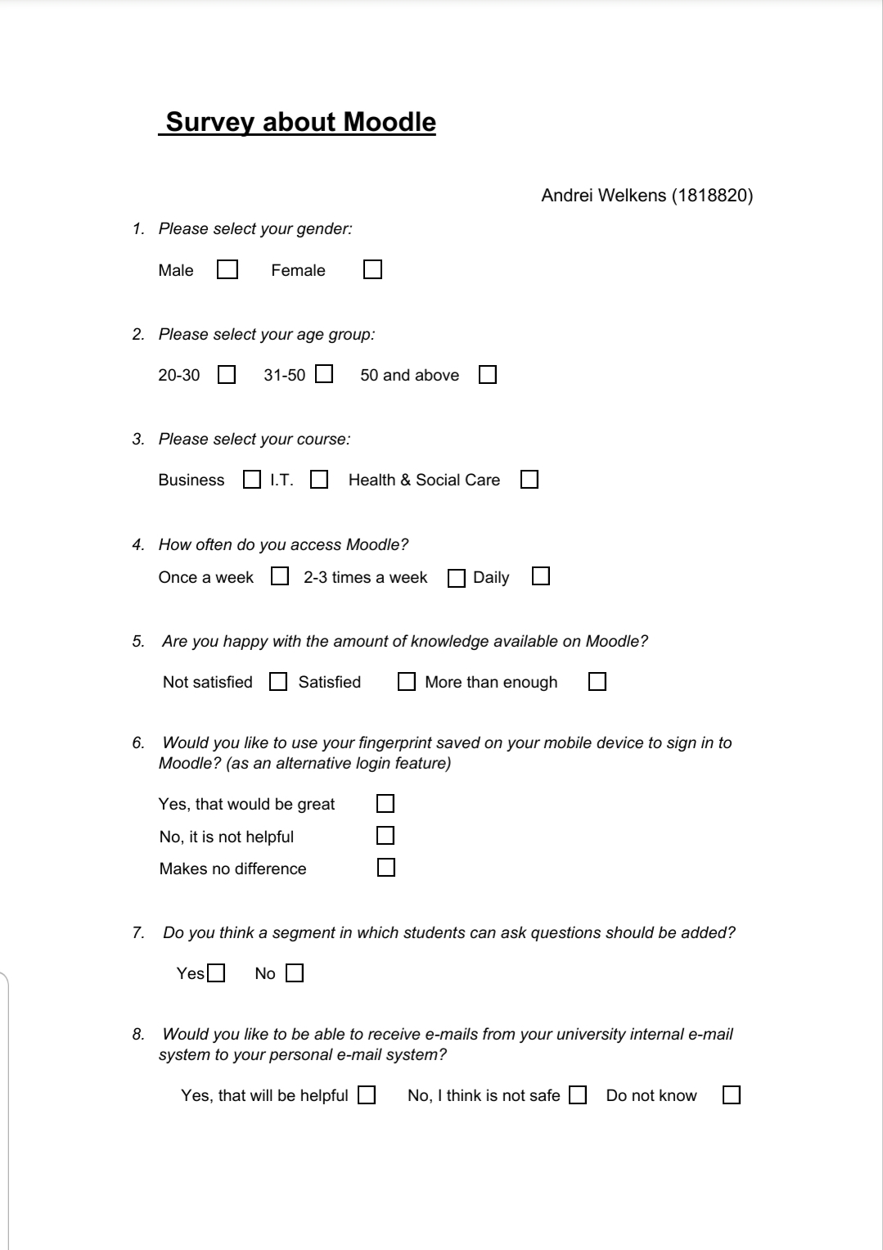

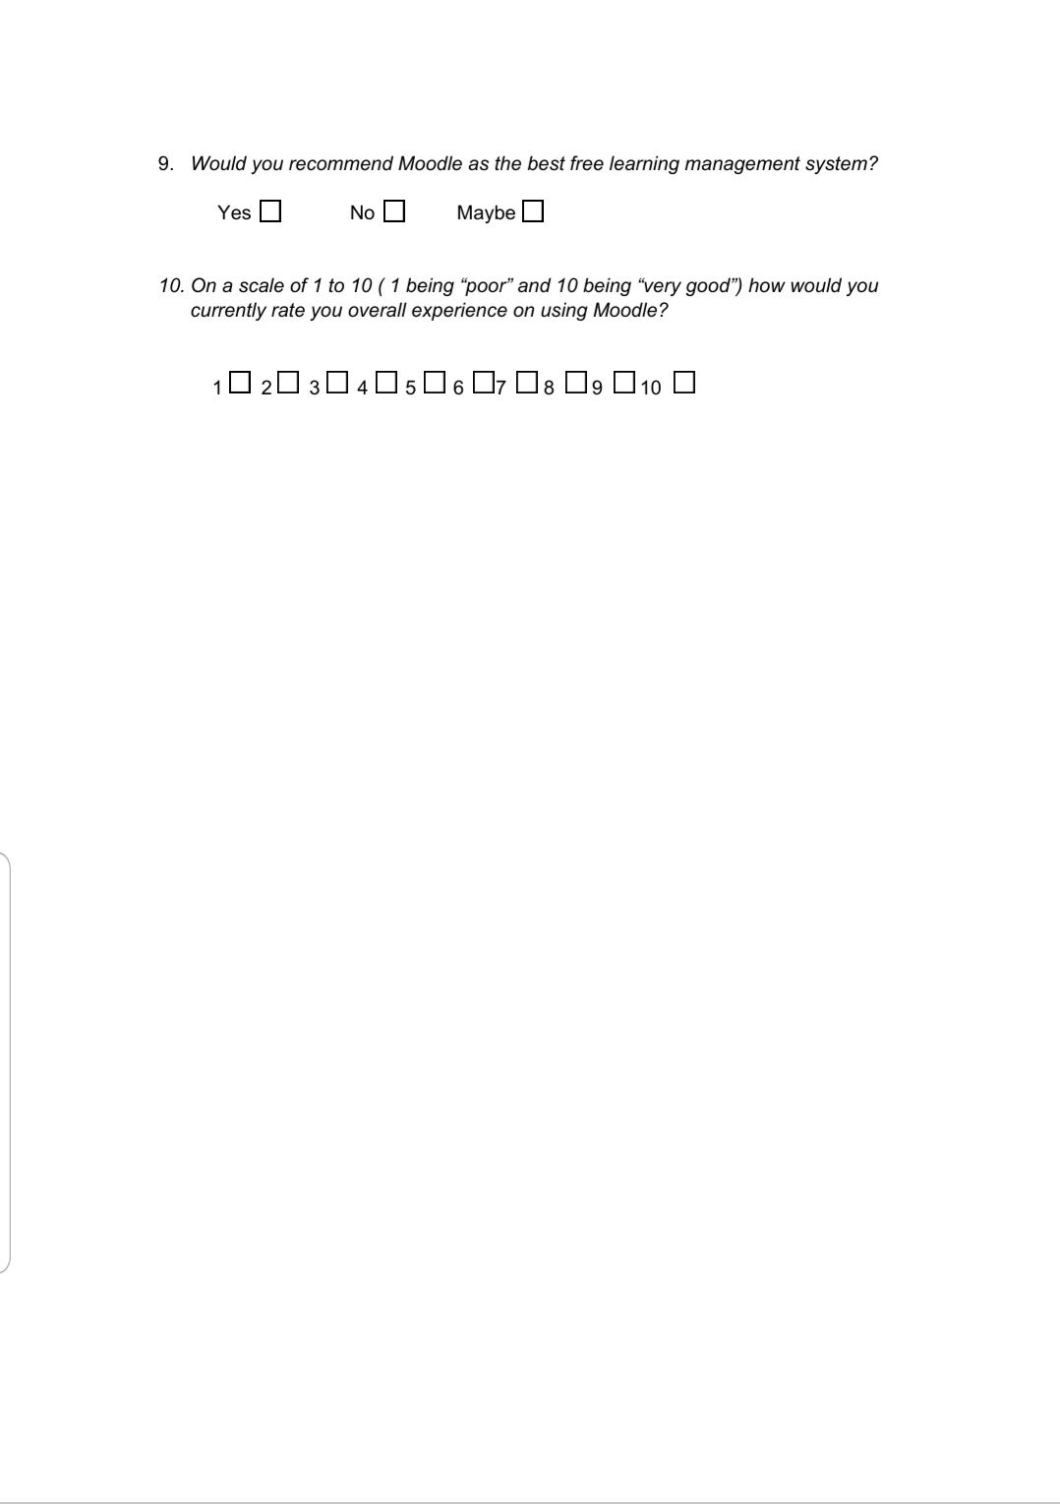

Appendix 2


