
LEVEL 4

SEMESTER 2

MODULE CODE: SHSS4078
Adventure: A Risk worth Taking

aSSESSMENT TYPE: aSSIGNMENT
Assessment/Component: 1 (Part A)
COMPONENT WEIGHTING: 55 %
WORD COUNT: 2000 WORDS
MODULE TUTOR: Denise leonard

Assignment:

With reference to a critical incident case study that we have examined, identify one key contributing hazard. Evaluate your own personal logged experiences in different activities, of risk management in relation to this identified hazard.

You should include a logbook recording every activity session you complete during this module and a synopsis of the critical incident case study as appendices to this submission.

SUBMISSION DETAILS:

Deadline:
Date: 19th April 2019
Time: 3.00pm
Portal: Turnitin

School of Sport, Health & Outdoor Education
Assessment Feedback Sheet

Student No./Name: 1801831/Edward Clive Jones
Module: SHSS4078
Module Code: Adventure: A Risk Worth Taking

Personal Evaluation – to support your academic progress please complete the section below BEFORE submitting your work.
What do you consider to be the best aspects of this work? |  |  | Relating my experience within similar activities to the Lyme bay case study.
Which aspects do you consider could have been improved in this piece of work? |  |  | References.  Better consistency between journals such as always screenshotting the weather.  Making more notes on activity days to help with writing journals.
What have you found most satisfying whilst undertaking this submission? |  |  | Assessing risk management within our activities.
ASSESSMENT CRITERIA | Learning  Outcomes |  | GRADE
ASSESSMENT CRITERIA |  |  | Poor  0 – 25% | Unsatisfactory  26-39% |  | Satisfactory  40 – 49% | Good  50 – 59% | Very Good  60 – 69% | Excellent  70 – 85% |  | Exceptional  86– 100% | %
Complete logbook for each session | All |  |  |  |  |  |  |  |  |  |  | 15%
Provide a synopsis of a critical incident case study | All |  |  |  |  |  |  |  |  |  |  | 15%
Identify a specific significant hazard and the risk it poses to undertaking adventurous outdoor activities | 1,2,3,5 |  |  |  |  |  |  |  |  |  |  | 30%
Discuss a range of appropriate measures that might effectively control the identified hazard and consequent risks. | 1,2,3,5 |  |  |  |  |  |  |  |  |  |  | 30%
Appropriate references used and correctly formatted | All |  |  |  |  |  |  |  |  |  |  | 10%
It is expected that students will present work that is proof read, correctly referenced and adheres to the Assessment Checklist. Therefore a range of 0 – 10 marks will be deducted for non-completion of any of the points on the checklist below.
TUTOR COMMENTS:

Submission date:  via Turnitin |  | Return date:  (at least within 4 weeks) |  |  | Tutor: Denise Leonard |  |  |  |  | Mark:

Assignment Checklist

- Please complete the Personal Evaluation section of the Assessment Feedback sheet, add your name and details, and paste the whole of this assignment document into the front of your assignment

- Submission is a single word file, clearly labelled with your name and module code
- Font style - Times New Roman, size -12 for text and 14 for headings
- Ink colour – black only
- Line spacing – 1.5 line spacing and 2cm- 2.5cm page margins
- Quotations more than three lines to be indented 1 line spacing
- One line space between paragraphs, paragraphs must be left aligned
- Pagination (your assignment should have page numbers)
- All tables and figures are internally referenced and have a title
- Word count checked and written at end of text (before references and any appendix)
- Assignment is within 10% of the word limit (excluding references and any appendices)
- All references in the text are included in the reference list
- Correct referencing following the Harvard style, as described in the Palgrave study skills book ‘Cite them Right’.
- Correct spelling using UK English
- Correct use of punctuation
- Grammar and syntax correct- double check anything that has a green line under it
- I have read my assignment out loud to myself and it makes sense and is easy to read
- Somebody else has read my work and it makes sense to him or her!
- I have checked and I have not plagiarised
Failure to follow these guidelines will cost you marks!
Consequences of inappropriate equipment when undertaking outdoor adventurous activities.
In this essay I will look at the impact equipment and clothing can have on risk management within outdoor adventurous activities. I will be using the 1993 Lyme Bay incident as an example and I will be comparing this to my own experiences in comparable water based actives. By comparing the equipment used by the group at Lyme Bay and the equipment I have been instructed to use or have been given during the activities which I have attended, I will be able to see if inappropriate choices led to certain consequences.

A famous example of an incident where the equipment choice could be considered to be one of the major factors contributing to the disastrous situation, is the 1993 Lyme Bay case study. While not being the only factor that caused the activity to be such as disaster, clothing and equipment choice is important within any outdoor activity. Inappropriate preparation in these areas can cause many different problems to develop based on the environment conditions and how closely the activity follows the instructors original plan. The vital equipment that participants must use on an activity, and the spare equipment that should be brought if plans of conditions change, is a disputed topic. The decision process mostly comes down to the amount of kit the instructor is able to bring while still being able to physically perform. Kit selection will also depend on the instructor’s experience with the activity. Some with more experience who has had more time to refine their primary and spare equipment selection may argue differently with someone’s preparation choices. Furthermore, the equipment the participant is expected to bring and or is suppled will likely to have more of an impact as the instructor can only carry so much spare kit. Participants kit is more of an issue than them just being cold. Making helmets mandatory for an activity where the real risk is extremely minor or rare could increase the perceived risk the participant feels. This is the idea that placing a rope on a traverse will cause someone to think about the chance of falling, whereas if there was no rope the likelihood would be for them to climb without even considering the risk. Overall however proper kit and preparation should allow a group to survive some of the worse conditions that could be expected within an environment. At the very least a decision should be made based on the group kit and experience as to whether they will be able to do the activity on the planed day.

The first water based activity we experienced during this module was at Llandysul paddlers and we spent the whole time on the lake. This was an introduction to water safety and how to use different types of craft. One of the primary pieces of equipment which we wore were spray decks; These were something I had not had experience with before, but I knew what the use of them was. Since I was fairly familiar with using sup’s (stand up paddleboards) and sit on top kayaks, I made use of the spray deck in the sit in river kayaks. After having trouble trying to get the spray deck over the cockpit while on land, and not being able to do it myself, I was filled with doubt as to using it. On a fast flowing river or at sea in wavy conditions it is essential at keeping water out of the craft. However, if you capsize you must either roll back over or pull the toggle and crawl out of the kayak, neither of which I thought safe or enjoyable when under upside-down under water. Possibly the main equipment mistake which lead to the Lyme Bay disaster is the students using sit in kayaks which can’t drain water out the hull and having no spray decks equipped. This meant that when the wind pushed them out into choppy sea the kayaks quickly filled up and without equipment to bail they sank within minutes. I would not want to go into an environment where I may need a spray deck without one or the knowledge of how to use it fully. A group doing an activity such as at Lyme Bay where there is the chance to need spray deck should have left with them on and had the necessary skills to roll or perform capsize drills to empty water from the kayaks. A solution to this would have been to use sit on tops but this can lead to overconfidence and a group may not be able to paddle back to shore in rough conditions. Overall like with the practical activity sessions I have been doing the group kayaking at Lyme Bay should have been taught the basics of using a spray deck and have set off with them on. Furthermore, participants who cannot roll the kayak and must detach the spray deck should have been taught how to empty the kayak while on the water so they can get back in. Knowledge like this should have been taught and would have been essential if the group were to safely travel along the coast in the sea conditions they set of in.

Clothing choice is relevant in every outdoor activity but materials that may be best for certain conditions can be useless in others. Water based activities mean materials such as polyester and especially cotton offer no benefit to warmth once they are wet. A participant may think that wearing a cotton shirt under their wet suit will act as another layer of warmth but its likely to have the opposite effect and draw heat away from them. This is also in the worst place to lose heat from as in a survival situation a person will begin to become hypothermic is they can’t sustain their core body heat. Neoprene used to make wet suits is optimum an suits can be made for different temperatures by covering more extremities and using thicker neoprene. Natural materials like wool will also still offer insulation when they are warm and. In a situation such as Lyme Bay if the participants were using full winter wetsuits with gloves and boots that may have retained body heat if they could keep moving but often when kayaking it is better to wear a thinner wetsuit to aid comfort when paddling and gloves can make it difficult to grip the paddle. During my activity days at Llandysul and in the sea I made choices as to whether to use gloves. The activities on the lake with kayaks and paddleboards did not require much paddling so I used gloves just for the extra warmth as both days were cold and mostly rainy or cloudy. When on the sea the conditions were far better, and I knew we were kayaking a few kilometres, so I just wore the wetsuit. There is not much else you can do for insulation once in the sea other than just wearing a thicker wetsuit which means that its best to stay on a kayak out of the water. Because the Lyme Bay groups kayaks filled up with water they could not use them for flotation and were mostly floating in the water holding onto them which increased the onset of hypothermia.

At Lyme Bay the group did not wear helmets. Other than preventing concussion there are other benefits to wearing one. They make a person who is floating with just their head above the water far more visible. This was a factor that was mentioned in the Lyme Bay reports as it was said that if the group had worn helmets that would have been far more visible. Like most outdoor or safety equipment it is brightly coloured to aid someone in spotting it but at Lyme Bay the only sighting of the group were the floating kayaks which were not near the students. Another benefit of helmets is that the dense foam traps warm air and is noticeably effective at insulating someone’s head. If helmets were worn by the group at Lyme Bay this may have been enough to help some people’s survival chances. When doing any of our water based activities we have brought a helmet. When on the lake they were worn at all times to prevent any chance of concussion and as a way to insulate the head in the cold weather. Due to warmer conditions at sea we were given a choice to wear them, but this was under the conditions that we were not kayaking near any rocks or under cliffs where rocks may fall. Even without wearing the helmets we still had them with us, and they could be used for any of the previously mentioned benefits.

A vital piece of equipment which we wore at all times when doing water activities is a buoyancy aid. We borrow buoyancy aids which are regularly checked to make sure the foam is in good condition and we have the responsibility to check straps and buckles to make sure it will function. The group at Lyme Bay were using life jackets. These work differently as they must be inflated before providing sufficient buoyancy. They also have the benefit once being inflated of pushing the users head out of the water which can prevent drowning in they are unconscious and will provide insulation to the core like with a buoyancy aid. After inspection none of the life jackets at Lyme Bay had been properly inflated which meant they were only providing 6kg of buoyancy. This also means that they would not provide any of the other benefits. Buoyancy aids may have been a better choice for the activity as its easier to swim with one on, assuming the life jacket is inflated, and they will always offer buoyancy. Furthermore, they would have increased the time before becoming hypothermic. Someone who is becoming hypothermic like the students at Lyme Bay may not have been able to blow up the life jacket. Unlike wearing a helmet, I don’t think buoyancy aids increase any perceived risk someone may feel, and I believe they are important for any water based activity.

To conclude on looking at the effect of equipment and clothing choice has on outdoor adventurous activities it can be said that there are essential choices but also personal pieces of equipment. In the Lyme Bay case study, it can be concluded that helmets should have been used as they only bring benefit to the user. The use of life jackets or buoyancy aids should have been better planned by the instructors with the students knowing how to inflate the life jackets. When I am on activity I have time over various sessions to trail various kit and to gauge a better idea of what make be better or more comfortable in certain conditions. Participants who go to activity centres will likely not have any of these luxuries and will be borrowing standard kit with the hopes the instructors know what they are doing. The instructors leading the group at Lyme Bay were inexperienced and made many equipment and planning errors which when added together led to the disaster.
Word count: 1860

Case study synopsis

Lyme Bay 1993

On March 22, 1993 Six teenage girls, two boys and a teacher from Southway Comprehensive left the St Albans Venture Centre at Lyme Regis with two instructors to canoe to Charmouth. The weather was described as fine sailing conditions by the Met office with just a force four wind and a slight swell on the sea. The problems began when one of the under skilled teachers rolled multiple times very early on and was violently sick. Quickly after setting off a strong wind channelled down the valley blew the group out to sea and within 20 minutes, despite the efforts of the other instructor, Karen Gardner, all but one canoe overturned and began to sink, leaving the pupils clinging to the last craft in seas just 9C above freezing. A fishing boat spotted a red kayak bobbing two miles south-east of Lyme Regis and radioed the Portland Coastguard. Seven minutes before the call, the last canoe sank, and the children were left without flotation after their lifejackets became waterlogged. A kayak was spotted by a fishing boat which proceeded to call the coastguard. It’s unclear when the group became disbanded and when the first kayak was abandoned. Four teenage classmates died, four other pupils and a teacher were injured along with two canoe instructors. Following the tragedy, the activity centre manager was jailed, and the law changed to make companies and their employees criminally responsible for causing similar deaths.

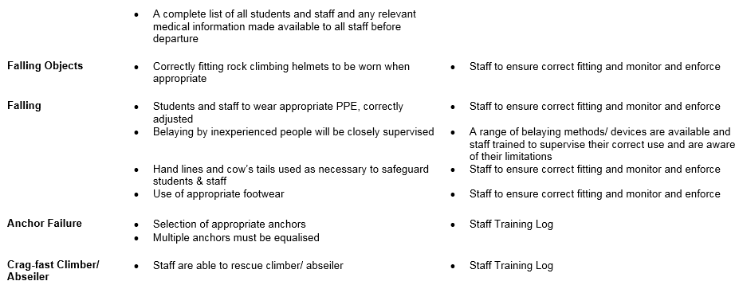
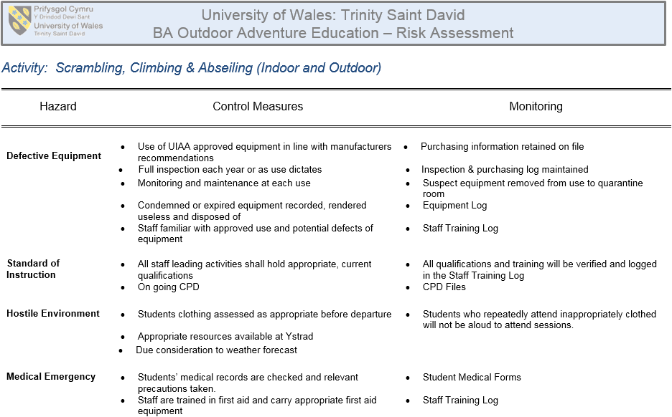
Three Cliffs

Site specific risk assessment
- Tide - Go at a time when the beach is accessible
- Strong wind and rain - Climb appropriate to the conditions
- Rough and steep terrain - Wear correct PPE and footwear
- Falling objects - Wear helmets at all times when near or below the cliff

Weather
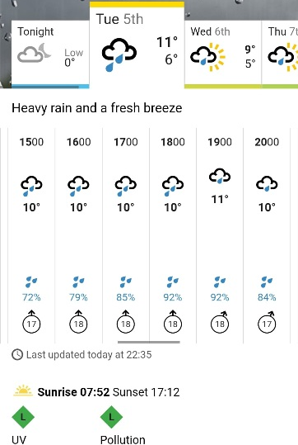
SUNRISE
07:51
SUNSET
17:08

TIME | HEIGHT(M)
00:31 | (LW) 4.7
06:45 | (HW) 11.9
12:51 | (LW) 4.5
19:02 | (HW) 11.8
The tidal information shown is for Mumbles in the Gower Peninsula, Wales. Please note that there is an approximate + 20 minute time addition required to the tide times for Llangennith versus those shown for Mumbles.
This was not the situation on the day. It was colder at what felt like 5°C in the wind and it did not rain until we were exiting the cliffs. This was light and only lasted for about 5 minutes.

Legislation
Sites of Special Scientific Interest (SSSI)
The Gower also has 3 National Nature Reserves (NNR), which are in effect the next line of protection for nationally important environmental areas.

Relevant NGBs
British Mountaineering Council
Mountain Training

Key terms
- UIAA - The International Climbing and Mountaineering Federation or in French the acronym stands for Union Internationale des Associations d'Alpinisme.
- Half Hitch – an overhand knot tied around an object.
- Belay – a device that a climbing rope is passed through which controls the decent of the climber.
- Lock-off - the act of pulling on a hold until your arm is in a bent position, then holding that position using body tension in order to reach the next hold with your free hand.
- ‘Static’ Rigging Rope – a rope that is designed not to stretch when under load.
- Dynamic Single Rope – a rope that has slight elastic properties which allows it to absorb the sudden energy of a fall more slowly.
- Single Pitch Venue – a venue in which all routes can be top roped.
- Grade – a system designed to rank the difficulty of a route. Varies between country and type of activity.
- Jurassic limestone – a rock type formed during the Jurassic period.
- Carboniferous Limestone - a rock type formed during the Carboniferous period.
- Tidal Range – The height difference between high and low tide. Influenced by gravity and rotation of earth. Will vary depending on if it’s a spring or neap tide.
- Rule Of The 12th’s - The Rule of Twelfths is a rule of thumb for estimating the height of the tide at any given time. The rate of flow in a tide increases smoothly to a maximum halfway point between high and low tide, before smoothly decreasing to zero again.
This means that in the first hours of a tidal shift, you may notice that the tide might not rise/fall so much, yet the entire process will accelerate through the mid hours.
- Three Cliffs Bay - a bay on the south coast of the Gower Peninsula.
- Barnacle – marine animal that tend to live in shallow and tidal waters, typically in erosive settings.
- Samphire - Samphire is a succulent that grows in rocky and marshy areas near salt-spraying water sources.

Specific skills
Using a Tubular Belay Device
Rock climbing competency
- Tying in
- Top rope decent

Benefits of session
Focus on site specific risk assessment of climbing in the costal environment at Three Cliffs. Allows the movement of the tide to be studied as well as features of the site to be view and discussed in person such as escape routes.

Kit inspections
If we borrowed a harness we were responsible for checking it over. Instructors would check our own harnesses if we brought them. This also applies to helmets.
Ropes, belays, and all other equipment needed for the day were checked by instructors.
We were expected to bring appropriate clothing and footwear for possible we and near freezing conditions.

Dynamic risk assessment/ additions to SSRA
Tide was far out but was rising towards high tide at 19:02. This allowed plenty of time to do the activities.
Weather was mild which meant it did not greatly increase the risk of climbing.

Reflections
Being exposed on the beach was cold. I was wearing boots, wind resistant trousers, a fleece and coat but I was considering wearing a down jacket too. Overall I wasn’t too cold, but I had no appropriate gloves for the activities, so my hands were very cold.

Near misses/Accidents
The only near miss I recall is near the top of the group climb I nearly knocked a slab down the route which could have hit someone.

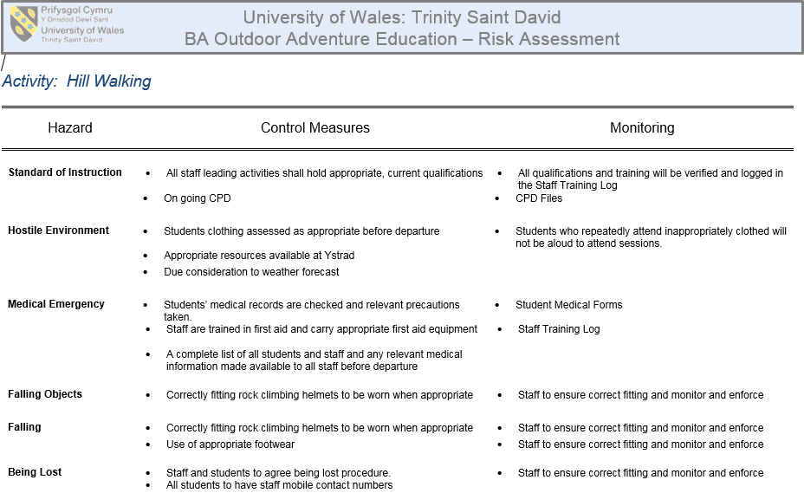
Black Mountain - 12/02/19

Site specific risk assessment
- Thick fog – caution near road and cliff edges.
- Wet slippery ground – stay of smooth quarry stone.

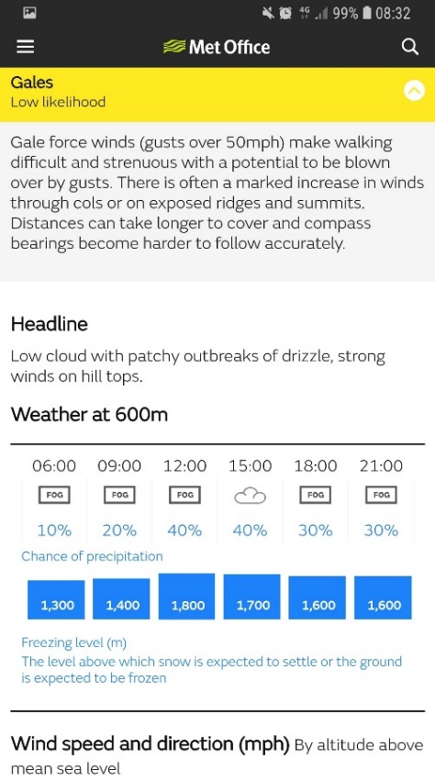
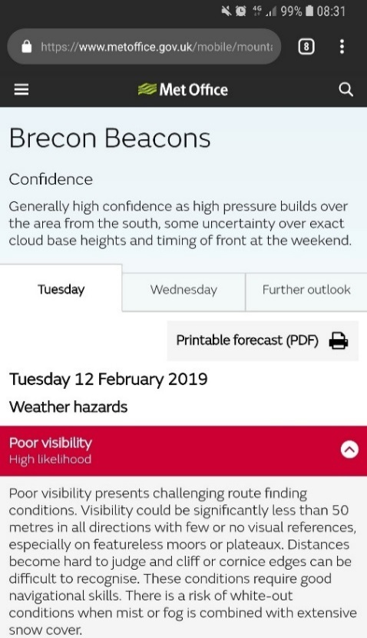
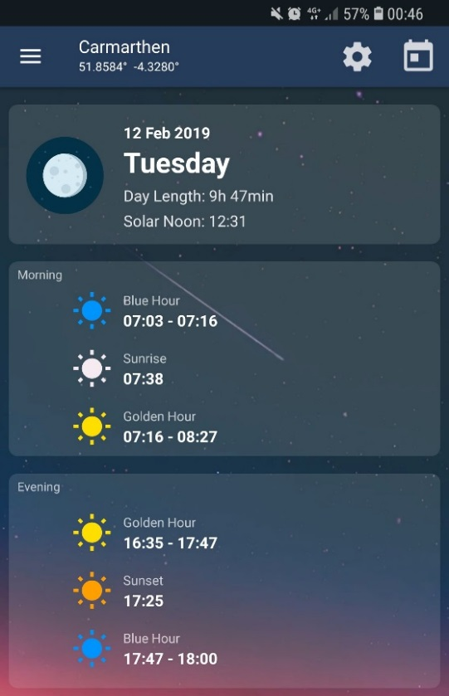
Weather

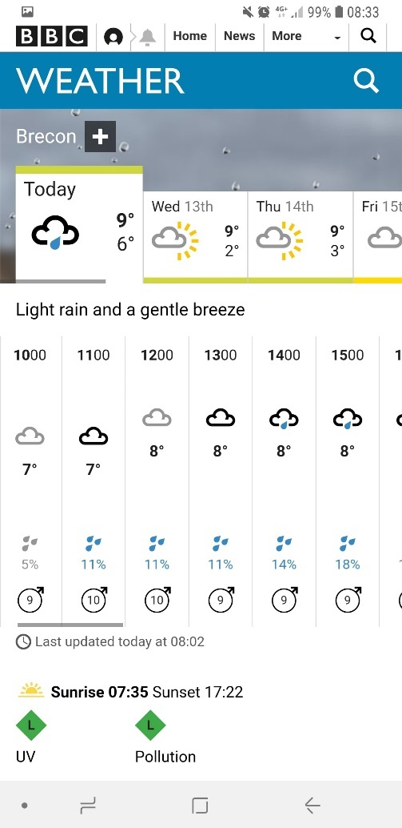
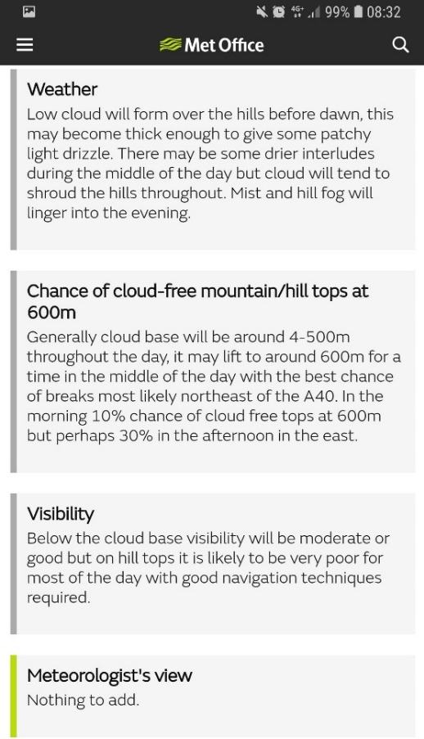
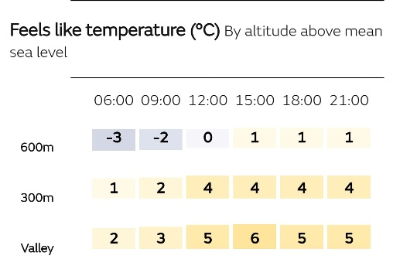
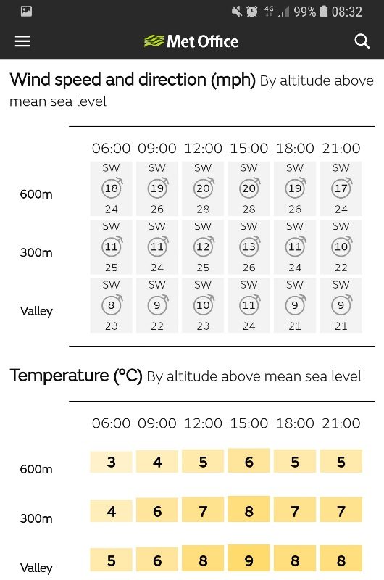

Legislation
European legislation | - EU Habitats Directive (92/43/EEC), transposed into UK law by the Conservation of Habitats & Species Regulations 2010 (as amended)
National legislation | - Wildlife & Countryside Act 1981 (as amended)  - Countryside & Rights of Way Act 2000 (as amended)  - Natural Environment and Rural Communities Act 2006  - The Protection of Badgers Act 1992  - The Hedgerow Regulations 1997
National and local policy and guidance | - Planning Policy Wales (2014) Chapter 5  - Technical Advice Note 5 (2009)  - UK Biodiversity Action Plan  - BBNP Local Biodiversity Action Plan  - Local Development Plan for the Brecon Beacons National Park  - AAPG: Best Practice in Biodiversity and Geological Conservation in Planning and Development

Relevant NGBs
Mountain training awards:
- Mountain leader or Winter ML if there was snowfall.

Key terms
- Cold Front - the leading edge of a cooler mass of air, replacing at ground level a warmer mass of air. Forms when a cold air mass pushes under a warm air mass, forcing the warm air to rise. Thunderheads can form as the moisture in the warm air mass rises, cools, and condenses. As the front moves through, cool, fair weather is likely to follow.
- Temperature Inversion - a temperature inversion is where temperature increases with height. Inversions are most common in winter when mist and fog become trapped in the cooler air low down, but inversions can happen all year round.
- Lowland Leader - qualification for people who wish to lead groups on day walks in lowland countryside and woodland in summer conditions.
- Ordnance survey - the national mapping agency of the United Kingdom.
- Contour Line - a line on a map joining points of equal height above or below sea level.
- Ring Contour – shows a hill
- Trig Point – Triangulation Pillar. Is usually set up by a government with known coordinate and elevation published. Many stations are located on hilltops for the purposes of visibility.
- Naismith’s rule - helps with the planning of a walking or hiking expedition by calculating how long it will take to travel the intended route, including any extra time taken when walking uphill. 15 minutes for every kilometre of horizontal distance, plus 10 minutes for every 100 metres of ascent.
- Grid Lines - vertical lines are called 'eastings', as they increase in value as you travel east on the map. The horizontal lines are called 'northings' as they increase in value as you travel north on the map. In Ordnance Survey maps, each Easting and Northing grid line is given a two-digit code.
- Moel (Welsh) - The first word moel is a common Welsh place-name element meaning 'bare'. The bare hill of?
- Hill Fog - Fog that arises when low cloud covers high ground, but which has not been formed by the uplift and condensation of moist air.
- Freezing Level - The freezing level, or 0 °C (zero-degree) isotherm, represents the altitude in which the temperature is at 0 °C.
- Aspect of slope - In physical geology, aspect is the compass direction that a slope faces.
- Mountain Rescue - The association has a number of regional mountain rescue teams, each of which is an independent charity. The team members are highly trained volunteers who are called out by the police. The primary focus of mountain rescue is to locate and evacuate injured and/or lost persons in upland environments.
- Wind Chill - Wind-chill or windchill (popularly wind chill factor) is the lowering of body temperature due to the passing-flow of lower-temperature air. Wind chill numbers are always lower than the air temperature for values where the formula is valid.

Specific skills
Navigation
Pacing
Group management
Risk assessment

Benefits of session
Practice navigating in cold and fog conditions where visibility is impaired.
Experiencing cold wet conditions during late winter in a mountainous environment above 600m.

Kit inspections
No PPE required only our own kit such as appropriate clothing and footwear as well as other walking essentials and first aid.

Dynamic risk assessment/ additions to SSRA
Weather was similar to as it was forecast.

Reflections
There wasn’t full rain but light sleet and varying cloud movements which made higher altitude visibility poor and navigation had to be all of maps and bearings.
Full waterproofs would have been a better choice than wearing just a coat.
Also bring multiple pairs of better gloves would have made me more comfortable when having to hold the map and compass.
With the kit each member and myself brought with the exception of the instructors its unlikely we would have survived a night on the mountain.

Near misses/Accidents
No near misses or accidents.

Llandysul day 1 - 19/02/19
Hazard | Control Measures | Monitoring
Defective equipment | Use of quality equipment in line with manufacturers recommendations | Purchasing information retained on file
Defective equipment | Full inspection each term | Inspection & purchasing log maintained
Defective equipment | Monitoring and maintenance at each use | Suspect equipment removed from store to quarantine room
Defective equipment | PFDs will be tested annually | Equipment Log
Defective equipment | Condemned or expired equipment recorded, rendered useless and disposed of | Equipment Log
Defective equipment | Staff familiar with approved use and potential defects of equipment | Staff Training Log
Standard of Instruction | All staff leading activities shall hold appropriate, current qualifications | All qualifications and training will be verified and logged in the Staff Training Log
Standard of Instruction | Ongoing CPD | CPD Files
Medical Emergency | Students’ medical records are checked, and relevant precautions taken | Student Medical Forms
Medical Emergency | Staff are trained in first aid and carry appropriate first aid equipment | Staff Training Log
Medical Emergency | A complete list of all students and staff and any relevant medical information made available to all staff before departure
Hostile Environment | Students clothing assessed as appropriate before departure | Students who repeatedly attend inappropriately clothed will not be allowed to attend sessions.
Hostile Environment | Appropriate resources available at Ystrad
Hostile Environment | Due consideration to weather forecast
Wind | Due consideration to weather forecast
Drowning | Staff will identify & manage potential hazards | Staff Training Log
Drowning | PFDs will be worn by all students and staff when appropriate | Staff to and monitor and enforce
Head Injuries | Helmets will be worn by all students and staff when appropriate | Staff to and monitor and enforce
Entrapment | No loose fittings on boats or personal kit | Staff to and monitor and enforce
Foot injuries | Footwear must be worn throughout all sessions | Staff to and monitor and enforce

Site specific risk assessment
- Main road In town - be cautious when crossing the road as it is located between site buildings.
- Debris or sharp rocks in lake or river - wear appropriate footwear.
- Water pollution - monitor the river and avoid areas which are stagnant and foamy.

Weather
Cloudy but dry with no rain. Temperature was cold around 8 degrees.
Evening:
Golden Hour
16:50
Sunset
17:38
Blue Hour
17:59 – 18:12

Legislation
NRW

Relevant NGBs
British Canoeing
Canoe Wales

Key terms
- Kayak - a small, narrow watercraft which is typically propelled by means of a double-bladed paddle. The traditional kayak has a covered deck and one or more cockpits, each seating one paddler. The cockpit is sometimes covered by a spray deck that prevents the entry of water from waves or spray, differentiating the craft from a canoe. The spray deck makes it possible for suitably skilled kayakers to roll the kayak: that is, to capsize and right it without it filling with water or ejecting the paddler.
- Silurian Mudstone – a type of rock formed in the Silurian period.
- Eddy - a circular movement of water causing a small whirlpool. In the case of a river an eddy is a current created behind a rock or other obstruction, such as a house or car, that flows in a circular upstream direction.
- Edge – When a kayak goes sideways fast, water piles up on its leading edge. It makes a cushion of water which can even start to build up on the deck. This cushion may trip you so that you capsize. Edging and leaning are useful for a sea kayaker who likes to play in waves or fast currents. It makes no difference whether it's the kayak that's moving sideways over the water, or the water that's moving sideways under the kayak.
- Breaking in and out – this skill means that you can start to break down rapids, stop and play on features or just catch your breath.
- CLAP – Communication, Line of sight, Avoidance, Position of maximum usefulness.
- Afon Teifi – Afon means river in Welsh. The Teifi has its source in Llyn Teifi. The River Teifi forms the boundary for most of its length between the counties of Ceredigion and Carmarthenshire, and for the final 3 miles of its total length of 73 miles, the boundary between Ceredigion and Pembrokeshire.
- Grade - River grading is a scale which allows canoeists and kayakers to rate the relative difficulty of a stretch of river, or of a specific feature like a white water rapid. Rivers in the UK are graded from one to six. Difficulty increases with the numbers.
- Flow rate - Flow is the total volume of a fluid that flows past a fixed point in a river or stream over time.
- Slalom - navigating a kayak through a course of hanging downstream or upstream gates on river rapids in the fastest time possible.
- Catchment area - the area from which rainfall flows into a river, lake, or reservoir.
- Sewin – is sea trout in Welsh. These are brown trout that are common in the river.
- Salmon - is the common name for several species of fish. Typically, they hatch in fresh water, migrate to the ocean, then return to fresh water to reproduce. However, populations of several species are restricted to fresh water through their lives.
- Japanese Knotweed - Japanese knotweed is a fast-growing and strong clump-forming perennial, with tall, dense annual stems. It usually takes at least three to four seasons to eradicate Japanese knotweed using weed killer. Professional contractors, however, will have access to more powerful weed killer that may reduce this period by half. It is an offence to cause Japanese knotweed to grow in the wild.
- Appropriate Footwear - footwear such as trainers or wetsuit boots for kayaking canoeing.

Specific skills
Paddling technique
Tying onto safety lines
Capsize drills

Benefits of session
Learning about different types of craft.
Learning about tow lines and pushing or pulling techniques.

Kit inspections
We were tasked with bringing kit such as wetsuit boots and gloves, if we wanted, to help us stay warm. Wetsuits, buoyancy aids, spray decks, helmets, and cags were borrowed from the stores and we had to check the equipment. Instructors supplied the tow lines when we needed them for practice as we were on a lake and they were not needed for safety. The kayaks were supplied by Llandysul Paddlers and we checked them over, which was cover in part of the training when looking at different craft, to see if they were usable for the activities.

Dynamic risk assessment/ additions to SSRA
Ground was dry and lake was low due to lack of rain fall. No chance of being washed into river through connecting channels.

Reflections
The weather was cold, so I wore wool socks with trainers and neoprene gloves. I encountered problems with the kayak when setting it up. The seat was too far forward for me to get my knees into the cockpit. This was due to the large soles on my shoes. To remedy this, I had to move the seat as far back as possible, but this was not easy to screw back in. The day consisted of talking about the features of different craft and how to check to see if they are usable as well as any parts which could be a hazard. Next we practiced using spray decks and I couldn’t get it on by myself. After becoming familiar with the sit in kayaks which I had not used before we practiced using different tow lines and pieces of equipment which could be substituted as a tow line.

Near misses/Accidents
No near misses or accidents.

Llandysul day 2 – 12/04/19
Hazard | Control Measures | Monitoring
Defective equipment | Use of quality equipment in line with manufacturers recommendations | Purchasing information retained on file
Defective equipment | Full inspection each term | Inspection & purchasing log maintained
Defective equipment | Monitoring and maintenance at each use | Suspect equipment removed from store to quarantine room
Defective equipment | PFDs will be tested annually | Equipment Log
Defective equipment | Condemned or expired equipment recorded, rendered useless and disposed of | Equipment Log
Defective equipment | Staff familiar with approved use and potential defects of equipment | Staff Training Log
Standard of Instruction | All staff leading activities shall hold appropriate, current qualifications | All qualifications and training will be verified and logged in the Staff Training Log
Standard of Instruction | Ongoing CPD | CPD Files
Medical Emergency | Students’ medical records are checked, and relevant precautions taken | Student Medical Forms
Medical Emergency | Staff are trained in first aid and carry appropriate first aid equipment | Staff Training Log
Medical Emergency | A complete list of all students and staff and any relevant medical information made available to all staff before departure
Hostile Environment | Students clothing assessed as appropriate before departure | Students who repeatedly attend inappropriately clothed will not be allowed to attend sessions.
Hostile Environment | Appropriate resources available at Ystrad
Hostile Environment | Due consideration to weather forecast
Wind | Due consideration to weather forecast
Drowning | Staff will identify & manage potential hazards | Staff Training Log
Drowning | PFDs will be worn by all students and staff when appropriate | Staff to and monitor and enforce
Head Injuries | Helmets will be worn by all students and staff when appropriate | Staff to and monitor and enforce
Entrapment | No loose fittings on boats or personal kit | Staff to and monitor and enforce
Foot injuries | Footwear must be worn throughout all sessions | Staff to and monitor and enforce

Site specific risk assessment
- Main road In town - be cautious when crossing the road as it is located between site buildings.
- Debris or sharp rocks in lake or river - wear appropriate footwear.
- Water pollution - monitor the river and avoid areas which are stagnant and foamy.

Weather

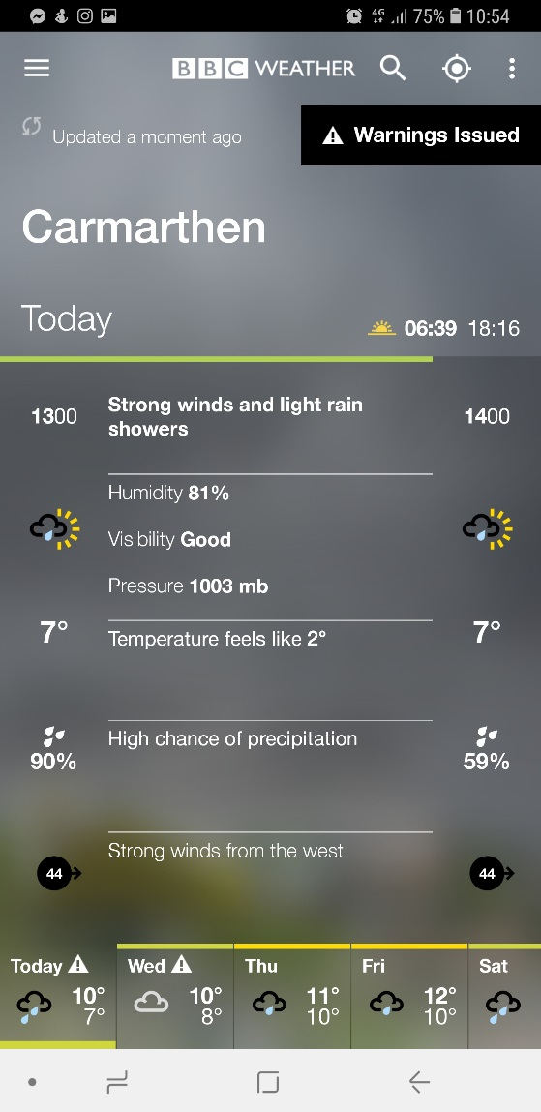
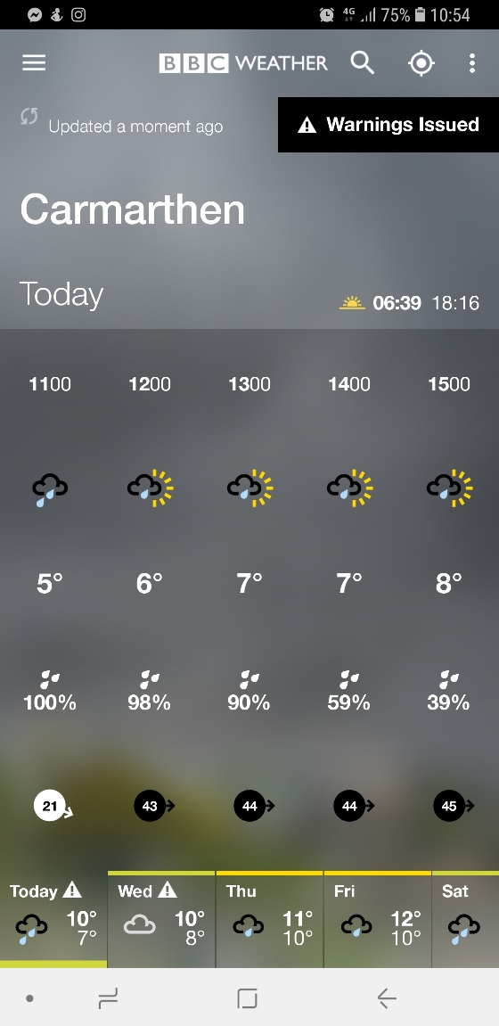
Legislation
NRW

Relevant NGBs
British Canoeing
Canoe Wales

Key terms
- Kayak - a small, narrow watercraft which is typically propelled by means of a double-bladed paddle. The traditional kayak has a covered deck and one or more cockpits, each seating one paddler. The cockpit is sometimes covered by a spray deck that prevents the entry of water from waves or spray, differentiating the craft from a canoe. The spray deck makes it possible for suitably skilled kayakers to roll the kayak: that is, to capsize and right it without it filling with water or ejecting the paddler.
- Silurian Mudstone – a type of rock formed in the Silurian period.
- Eddy - a circular movement of water causing a small whirlpool. In the case of a river an eddy is a current created behind a rock or other obstruction, such as a house or car, that flows in a circular upstream direction.
- Edge – When a kayak goes sideways fast, water piles up on its leading edge. It makes a cushion of water which can even start to build up on the deck. This cushion may trip you so that you capsize. Edging and leaning are useful for a sea kayaker who likes to play in waves or fast currents. It makes no difference whether it's the kayak that's moving sideways over the water, or the water that's moving sideways under the kayak.
- Breaking in and out – this skill means that you can start to break down rapids, stop and play on features or just catch your breath.
- CLAP – Communication, Line of sight, Avoidance, Position of maximum usefulness.
- Afon Teifi – Afon means river in Welsh. The Teifi has its source in Llyn Teifi. The River Teifi forms the boundary for most of its length between the counties of Ceredigion and Carmarthenshire, and for the final 3 miles of its total length of 73 miles, the boundary between Ceredigion and Pembrokeshire.
- Grade - River grading is a scale which allows canoeists and kayakers to rate the relative difficulty of a stretch of river, or of a specific feature like a white water rapid. Rivers in the UK are graded from one to six. Difficulty increases with the numbers.
- Flow rate - Flow is the total volume of a fluid that flows past a fixed point in a river or stream over time.
- Slalom - navigating a kayak through a course of hanging downstream or upstream gates on river rapids in the fastest time possible.
- Catchment area - the area from which rainfall flows into a river, lake, or reservoir.
- Sewin – is sea trout in Welsh. These are brown trout that are common in the river.
- Salmon - is the common name for several species of fish. Typically, they hatch in fresh water, migrate to the ocean, then return to fresh water to reproduce. However, populations of several species are restricted to fresh water through their lives.
- Japanese Knotweed - Japanese knotweed is a fast-growing and strong clump-forming perennial, with tall, dense annual stems. It usually takes at least three to four seasons to eradicate Japanese knotweed using weed killer. Professional contractors, however, will have access to more powerful weed killer that may reduce this period by half. It is an offence to cause Japanese knotweed to grow in the wild.
- Appropriate Footwear - footwear such as trainers or wetsuit boots for kayaking canoeing.

Specific skills
Paddling technique

Benefits of session
Developing a better understanding of controlling a kayak.

Kit inspections
We were tasked with bringing kit such as wetsuit boots and gloves, if we wanted, to help us stay warm. Wetsuits, buoyancy aids, spray decks, helmets, and cags were borrowed from the stores and we had to check the equipment. Instructors supplied the tow lines when we needed them for practice as we were on a lake and they were not needed for safety. The kayaks were supplied by Llandysul Paddlers and we checked them over, which was cover in part of the training when looking at different craft, to see if they were usable for the activities.

Dynamic risk assessment/ additions to SSRA
The previous days and weeks were sunny and dry up until the day before out activity where there was heavy rain fall meaning the river was slightly overflowing and the lake unlike last time was high enough to where you could kayak through the connecting channels to the river.

Reflections
At the start of the day the weather was as forecast, and I began the session in a sit no kayak. There was light rainfall but by 12 this has gone, and the clouds were revealing sun. The first part of the session was spent on the lake practicing paddling techniques and specific movement techniques for the kayak. We surveyed the river and decided that it was too rough to practice anything which would be beneficial, and it could have been too risky as me and many other had never used sit in kayaks on a river before so we would have had to use sit on tops. Because it was cold and rainy I had started of the day with neoprene gloves and I left them on for the rest of the day’s duration. Next we used an inflatable raft and the whole group went down a section of the river which was rough nut more stable in the raft.

Near misses/Accidents
When rafting down the river someone pushed one of the slalom poles out of their way and it swung directly into me. Lucking I was looking down and my helmet took the full force otherwise it would have smashed my face.

New Quay – 26/04/19
Hazard | Control Measures | Monitoring
Defective equipment | Use of quality equipment in line with manufacturers recommendations | Purchasing information retained on file
Defective equipment | Full inspection each term | Inspection & purchasing log maintained
Defective equipment | Monitoring and maintenance at each use | Suspect equipment removed from store to quarantine room
Defective equipment | PFDs will be tested annually | Equipment Log
Defective equipment | Condemned or expired equipment recorded, rendered useless and disposed of | Equipment Log
Defective equipment | Staff familiar with approved use and potential defects of equipment | Staff Training Log
Standard of Instruction | All staff leading activities shall hold appropriate, current qualifications | All qualifications and training will be verified and logged in the Staff Training Log
Standard of Instruction | Ongoing CPD | CPD Files
Medical Emergency | Students’ medical records are checked, and relevant precautions taken | Student Medical Forms
Medical Emergency | Staff are trained in first aid and carry appropriate first aid equipment | Staff Training Log
Medical Emergency | A complete list of all students and staff and any relevant medical information made available to all staff before departure
Hostile Environment | Students clothing assessed as appropriate before departure | Students who repeatedly attend inappropriately clothed will not be allowed to attend sessions.
Hostile Environment | Appropriate resources available at Ystrad
Hostile Environment | Due consideration to weather forecast
Wind | Due consideration to weather forecast
Drowning | Staff will identify & manage potential hazards | Staff Training Log
Drowning | PFDs will be worn by all students and staff when appropriate | Staff to and monitor and enforce
Head Injuries | Helmets will be worn by all students and staff when appropriate | Staff to and monitor and enforce
Entrapment | No loose fittings on boats or personal kit | Staff to and monitor and enforce
Foot injuries | Footwear must be worn throughout all sessions | Staff to and monitor and enforce

Site specific risk assessment
- Sheltered bay – the sea conditions will be more extreme after leaving the shelter of the bay. This means stronger winds, currents, and larger waves.
- Pollution - Fish factory along coast has chemical run off and the area near is best avoided.

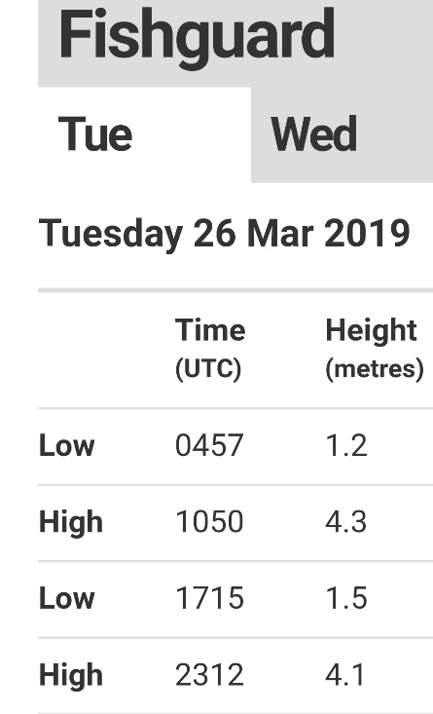
Weather

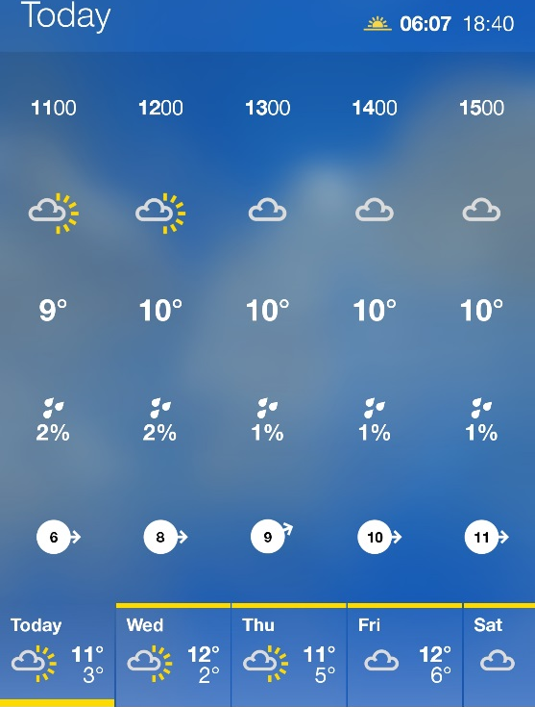
Legislation
Exclusion zones
- National security
Weapons test ranges, offshore oil rigs, nuclear power plants.
- Environmental protection
Nature reserves.
- Ownership
Private beaches, fish farms, oyster beds.

Relevant NGBs
British Canoeing
Canoe Wales

Key terms
- Kayak - a small, narrow watercraft which is typically propelled by means of a double-bladed paddle. The traditional kayak has a covered deck and one or more cockpits, each seating one paddler. The cockpit is sometimes covered by a spray deck that prevents the entry of water from waves or spray, differentiating the craft from a canoe. The spray deck makes it possible for suitably skilled kayakers to roll the kayak: that is, to capsize and right it without it filling with water or ejecting the paddler.
- Silurian Mudstone – a type of rock formed in the Silurian period.
- Eddy - a circular movement of water causing a small whirlpool. In the case of a river an eddy is a current created behind a rock or other obstruction, such as a house or car, that flows in a circular upstream direction.
- Edge – When a kayak goes sideways fast, water piles up on its leading edge. It makes a cushion of water which can even start to build up on the deck. This cushion may trip you so that you capsize. Edging and leaning are useful for a sea kayaker who likes to play in waves or fast currents. It makes no difference whether it's the kayak that's moving sideways over the water, or the water that's moving sideways under the kayak.
- Breaking in and out – this skill means that you can start to break down rapids, stop and play on features or just catch your breath.
- CLAP – Communication, Line of sight, Avoidance, Position of maximum usefulness.
- Afon Teifi – Afon means river in Welsh. The Teifi has its source in Llyn Teifi. The River Teifi forms the boundary for most of its length between the counties of Ceredigion and Carmarthenshire, and for the final 3 miles of its total length of 73 miles, the boundary between Ceredigion and Pembrokeshire.
- Grade - River grading is a scale which allows canoeists and kayakers to rate the relative difficulty of a stretch of river, or of a specific feature like a white water rapid. Rivers in the UK are graded from one to six. Difficulty increases with the numbers.
- Flow rate - Flow is the total volume of a fluid that flows past a fixed point in a river or stream over time.
- Slalom - navigating a kayak through a course of hanging downstream or upstream gates on river rapids in the fastest time possible.
- Catchment area - the area from which rainfall flows into a river, lake, or reservoir.
- Sewin – is sea trout in Welsh. These are brown trout that are common in the river.
- Salmon - is the common name for several species of fish. Typically, they hatch in fresh water, migrate to the ocean, then return to fresh water to reproduce. However, populations of several species are restricted to fresh water through their lives.
- Japanese Knotweed - Japanese knotweed is a fast-growing and strong clump-forming perennial, with tall, dense annual stems. It usually takes at least three to four seasons to eradicate Japanese knotweed using weed killer. Professional contractors, however, will have access to more powerful weed killer that may reduce this period by half. It is an offence to cause Japanese knotweed to grow in the wild.
- Appropriate Footwear - footwear such as trainers or wetsuit boots for kayaking canoeing.

Specific skills
Risk assessment in a coastal environment.

Benefits of session
Developing a better understanding of controlling a kayak.

Kit inspections
We were tasked with bringing kit such as wetsuit boots and gloves, if we wanted, to help us stay warm. Wetsuits, buoyancy aids, helmets, and cags were borrowed from the stores and we had to check the equipment. Two sit on tops were borrowed from our stores but the other we picked up from Llandysul.

Dynamic risk assessment/ additions to SSRA
The wind when we arrived was blowing from the NW but changed through the day and mostly died down reducing the sea to almost flat on the return.
Tide was near high tide but descending.
Varying clouds and bright sunlight so lots of glare of water and chance of sunburn.

Reflections
We kayaked from the beach, west of the harbour at New Quay, a few km to another beach along the coast to the west. The day was hot and due to the consistent paddling I unzipped my wetsuit at the back. I was informed by the instructor to put on my helmet whenever I was near rock or within metres of the cliff where rocks could fall. We kayaked around rock features and through caves on the journey. The wind gradually died down over the course of the day to the point of the sea almost being flat. On the kayak I wasn’t cold at any point, but I did not get in the water other than my feet which quickly warmed in the sun.

Near misses/Accidents
No near misses or accidents.

