Student Name: Ionut-Alexandru Dumitru  Student ID: 2232734  Module Title: Foreign Languages & Cultural awareness  Module Code: BMIH5003  Lecturer: Lisa-Marie Bassler  Date: 09-02-2024 | 
ASSIGNMENT 1: PORTFOLIO
(4 Components)

Component 1: Professional Reflection (500 words +/- 10%)

Weighting: 25%
Cultural differences are very important to learn when it comes to the hotel industry. It is a way to either show great service and make customers feel welcome or it’s a way to offend and lose customers. (Glowacka, 2023) While I was working at a restaurant during dinner time, I observed another server. The restaurant had just welcomed a few guests. They were clearly from India based on the language, accents, and attire they were wearing. The server had gone over and taken their order. On returning with their order, they ignored the cutlery and proceeded to eat with their hands. They were seated in the middle of the restaurant. They had called over the server in a panic asking if there was any meat in one of the dishes at this time the server took the chance to tell the customers about eating with their hands. This hotel was one of the first places I and the co-worker in question had worked. I would say a few things caused these cultural misunderstandings. The primary reason this occurred was a lack of observations. The server did not pick up the obvious signs that the customer was from a different country. Another way this misunderstanding occurred was the inability of the server to have a proper small talk flow to ask specific questions that would result in us understanding the customers and why they were dining. Proper customer care was lacking as well seeing that the server did not ask the relevant questions such as, “Does anyone have any allergies?” or “Is anyone vegetarian?” I believe this all comes down to our lack of training and education. According to (Dubai, 2023) customer service is very important when it comes to the success of the company or organisation. This affects employee retention, customer loyalty, and the ability to adapt. This incident taught me a lot when it came to honing in on my skills. Firstly, I would study the layout of the restaurant. Understanding a variety of cultures would allow me to know where certain customers would be seated especially in this situation. Secondly, the skill I would develop is the ability to have a clean flow of small talk. This small talk would allow me to understand the customer. Small talk is a way to welcome the customer while encouraging a positive experience by building rapport. This would make the customers feel cared for and appreciated which would also boost the positive views of the restaurant. (English, 2023) This skill would allow me to better understand where my customers are from and what type of service I would render. Another skill would be asking the appropriate questions. Asking questions would allow me to understand the diet restrictions, specials that can be introduced, and the way they would be dining so that a meat dish cannot be served for vegetarian customers. This not only protects me as a server but also the hotel's reputation.

References:

Dubai, C., 2023. The Importance of Staff Training and Development in the Hospitality Industry. [Online]
Available at: https://www.linkedin.com/pulse/importance-staff-training-development-hospitality-industry-lmndf/
[Accessed 05 02 2024].
English, L., 2023. Breaking the Silence: How to Navigate Small Talk with Hotel and Restaurant Guests. [Online]
Available at: https://learnlaughspeak.com/breaking-the-silence-how-to-navigate-small-talk-with-hotel-and-restaurant-guests/#:~:text=It%20helps%20build%20rapport%20and,word%2Dof%2Dmouth%20referrals.
[Accessed 05 02 2024].
Glowacka, M., 2023. Intercultural misunderstandings: causes and how to avoid them. [Online]
Available at: https://preply.com/en/blog/b2b-intercultural-misunderstandings/
[Accessed 05 02 2024].

Component 2: Training Plan (500 words +/- 10%)

Weighting: 25%

Identified cultural misunderstanding (in a few words) :
Indian customers were eating with their hands in the middle of the restaurant and they supposed a meat dish was served to them.
Training plan (Why/What//Who/Where/When):
A training plan is important when training employees especially when it comes to preventing cultural misunderstandings. To better show the training plan the five (5) Ws would be used which are why, what, who, where, and whom.
Firstly, we have to understand why we need the training and the importance of said training. Training is important because it helps us as employees to overcome barriers that can occur because of communication. This includes developing knowledge and skills such as verbal communication but most importantly non-verbal communication. For example, hand movements or gestures even facial cues can allow the employee to easily communicate with someone especially if they don’t speak the same language. This can show commitment and training whereby the customers feel understood thus increasing their satisfaction rates while creating a long-term relationship. This will give the hotel a competitive advantage in the market. (Buckley, 2023)
Using the second W we determine what the training plan will contain. The training will be about better serving and understanding customers who have different backgrounds and cultures. It will also show what types of cues to have, the questions that need to be asked, and how to properly respond to the answers given. (Team, 2018) (Team, n.d)
The third W in the plan is using the word who. We determine who will benefit from this training, informing staff who to go to in case of any questions or issues. This training is suited for everyone in the hotel but especially those in the food and beverage departments. In these departments, it is more likely to have a cultural misunderstanding with a customer than those in other departments such as the front office or housekeeping. This training would highlight skills that deal with conversation tactics and ways to go about noticing little aspects of the customer. All staff members should ask customers questions however each question will be tailored based on the said customer. (Team, 2018) (Team, n.d)
The fourth W is the word where. We determine this aspect of the training plan by understanding where the training would take place, the timing of specific questions, and seating arrangements for certain customers. This training will be held in a comfortable room where everyone will be able to focus and give their undivided attention without any interruptions or distractions. It will be an environment devoid of noise and people. Questions should be asked while the customers are walking to their table. This would give the server enough time to know where to seat the customer and the dining experience needed to ensure the customer is satisfied. (Team, 2018) (Team, n.d)
The last W we use is whom. We understand and try to have a list of persons whom the staff can go to in case of clarification, in case of any issues or misunderstandings that an occur. These questions are to help the staff become more knowledgeable. They would be able to know who to go to if and when they need help. (Team, 2018) (Team, n.d)
References:
Buckley, F., 2023. Empowering Your Team: The Benefits of Cross Cultural Training in the Hospitality Industry. [Online]
Available at: https://www.linkedin.com/pulse/cultural-training-hospitality-industry-finbarr-buckley/
[Accessed 24 01 2024].
Team, A. C., 2018. Questions of Every Project. [Online]
Available at: https://business.adobe.com/blog/basics/project-management-101-the-5-ws-and-1-h-that-should-be-asked-of-every-project
[Accessed 24 01 2024].
Team, L., n.d. A culture of learning & empowerment: Our guide to creating an employee training plan. [Online]
Available at: https://www.leapsome.com/blog/employee-training-plan#6-steps-to-outlining-your-employee-training-plan
[Accessed 30 01 2024].

Component 3: Student Self-Reflection (500 words +/- 10%)

Weighting: 25%
The hospitality industry has been growing a lot over time. As globalization and travelling become widely spread there is no corner of the world that humans cannot touch. There are at least one or multiple hotel groups operating in a country. Thus, staff need to be culturally aware especially if they are not from the area. I have been noticing that in this growing time, cultural awareness has either made or broken many people, brands, and labels. To be honest I did not understand why it was important until doing my research for my essays and attending the class. In reference to the Gibbs reflective model, I know that understanding and evaluating my feelings about the topic is essential. I believe that cultural awareness is important because it determines the success of a business, especially in hospitality. (Main, 2023)
Awareness gives a competitive advantage. A customer feels most satisfied when they believe that we the people who serve them understand their needs and wants. For example, let’s assume a family from South Korea has come to England and during a dining experience the server starts speaking small amounts of Korean or greets the family with a bow they would feel the experience is more personalized for them. This will have them satisfied and think that the hotel wants everyone to feel at home. Small gestures like this allow customers to feel welcomed and comfortable and they create a long-lasting relationship with the hotel. Awareness is also the key to seeing similarities in cultures but appreciating the differences. Many people learn much more when they have common ground. They are more open to learning. Thus, awareness is important to allow staff to be intrigued to know more about a specific culture. (Communities, n.d)
My experience in the class has allowed me to understand that even though cultural awareness is different based on the country it all achieves similar goals for the organizations. As someone who plans to go into the hospitality industry, I believe that this experience is important as a student because I get to be a sponge. I soak up all the experience from other classmates and lecturers who have a broader experience within the field. I can better understand and see where their line of thought was for various situations.
However, as time changes cultural awareness will also change and evolve. From my research understanding cultural awareness 50 years ago to now is completely different. It is important to change with the times to ensure that everyone no matter where they go feels respected and appreciated. It is very easy for a hotel to lose its reputation in the year 2024 with social media and growing technology. Thus, as time goes by more training has to be done, and more knowledge has to be taught to the staff of the hotel to ensure customer satisfaction, reduce misunderstandings, or even expand businesses. Knowledge is power and it’s the key for organizations to better adapt to the growing world. (Institute, n.d)

References:
Communities, E., n.d. Why is Cultural Awareness Important?. [Online]
Available at: https://www.evolves.com.au/why-is-cultural-awareness-important/#:~:text=By%20being%20culturally%20aware%2C%20you%20can%20recognise%20and%20appreciate%20other,conflicts%20arising%20from%20cultural%20differences.
[Accessed 24 01 2024].
Institute, T. H. &. T., n.d. The Importance of Cultural Awareness in the Hospitality and Tourism Industry. [Online]
Available at: https://www.thti.edu.tt/blog/the-importance-of-cultural-awareness-in-the-hospitality-and-tourism-industry/#:~:text=Cultural%20sensitivity%20plays%20a%20crucial,and%20expectations%20of%20diverse%20guests.
[Accessed 24 01 2024].
Main, P., 2023. Gibbs' Reflective Cycle. [Online]
Available at: https://www.structural-learning.com/post/gibbs-reflective-cycle
[Accessed 24 01 2024].

Component 4: Training Presentation (6 Slides)

Weighting: 25%
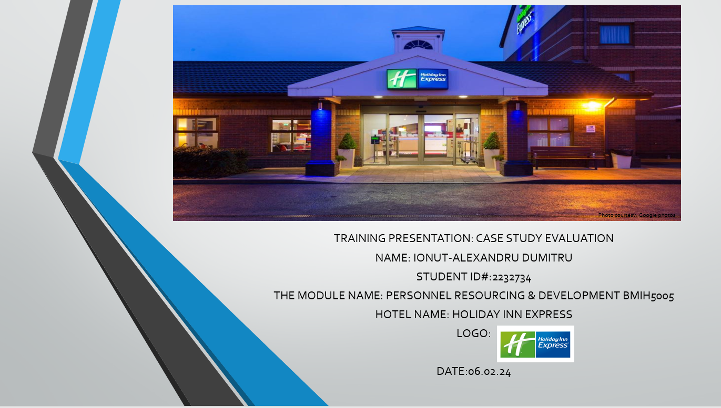
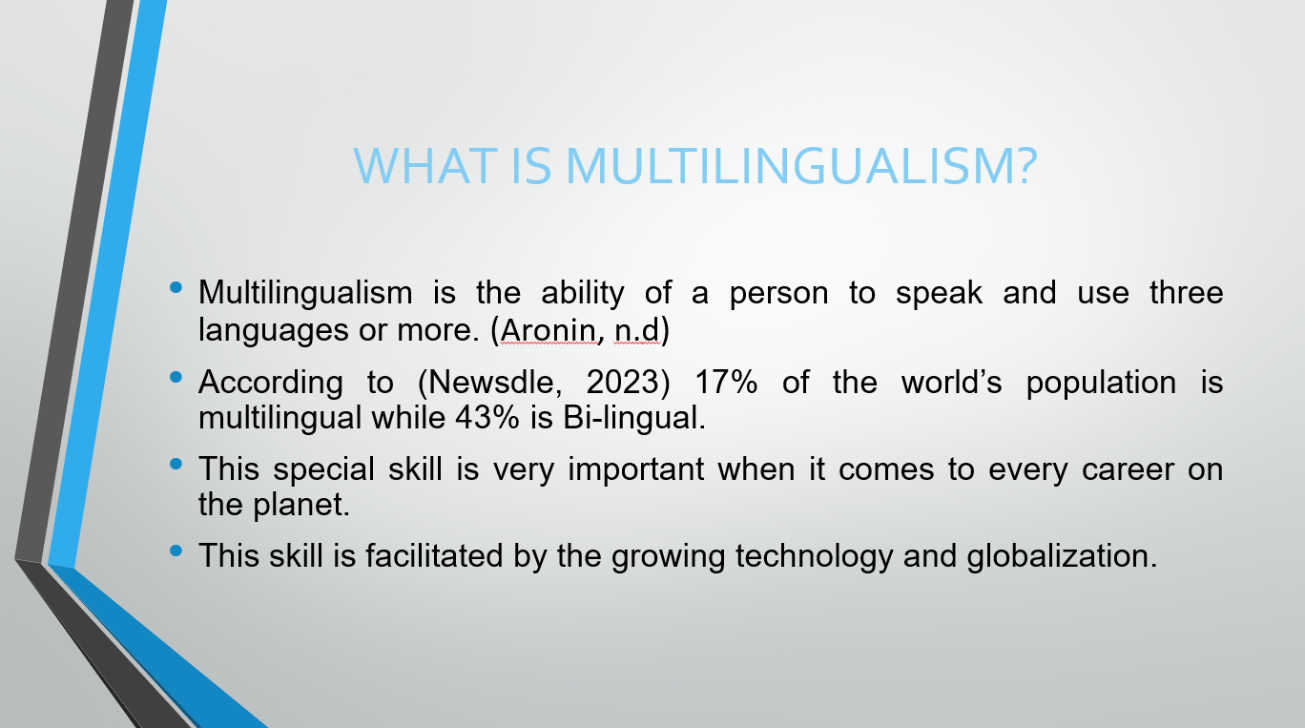
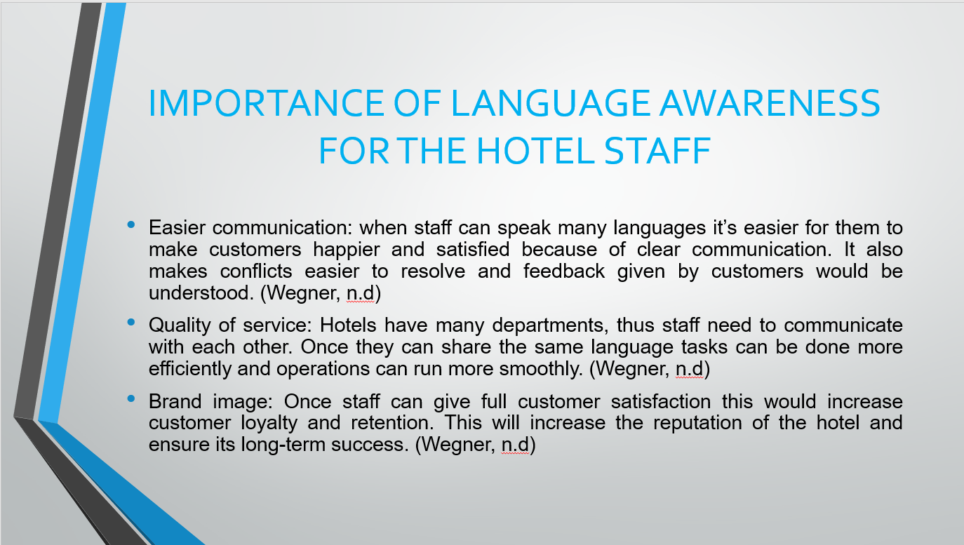

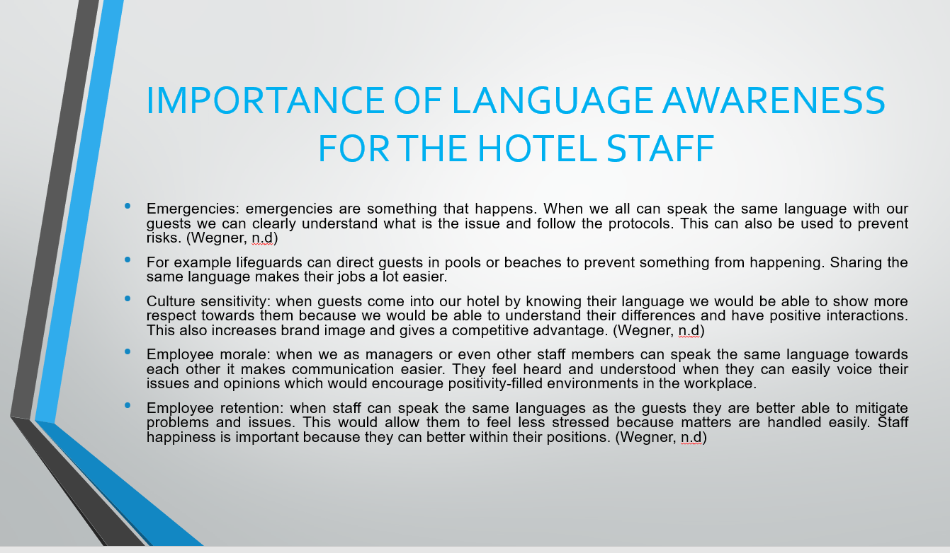

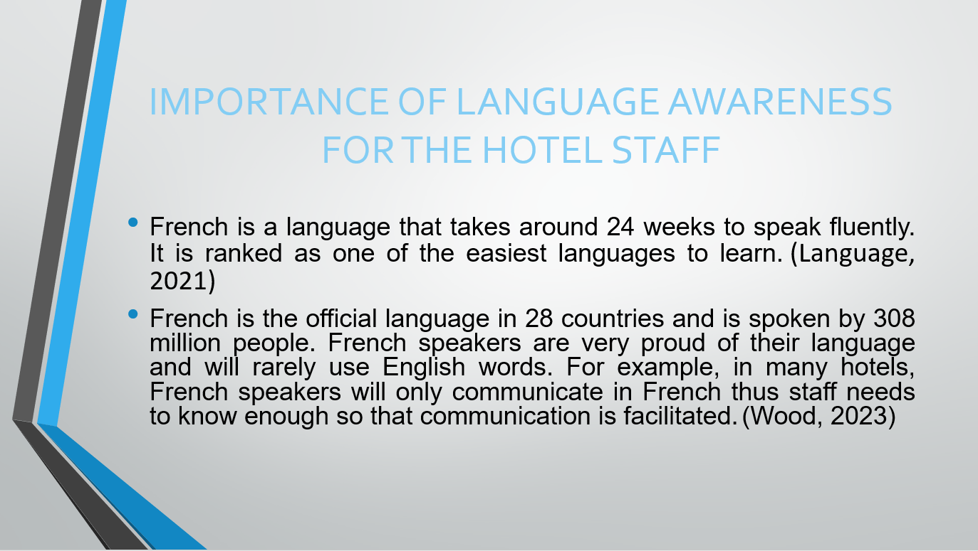

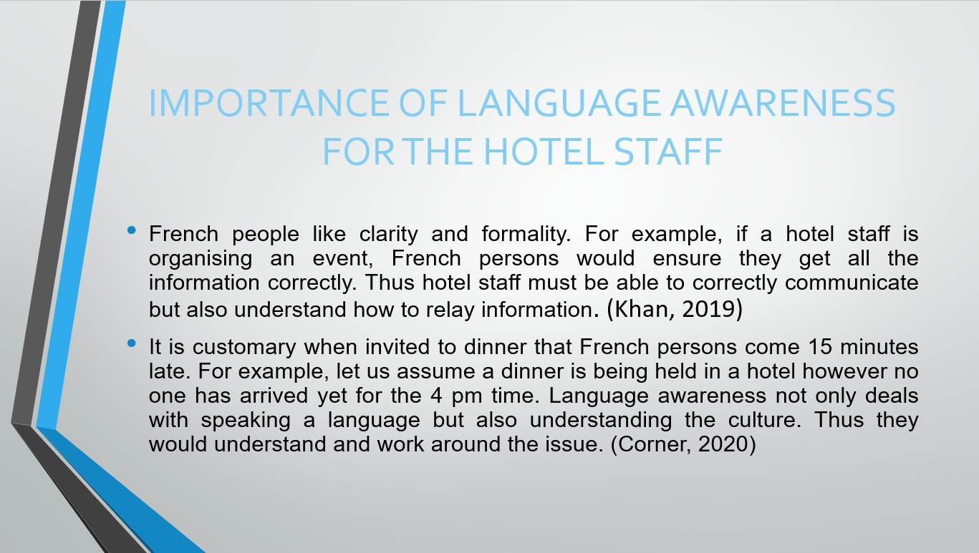
References

Aronin, L., n.d. What is multilingualism?. [Online]
Available at: https://www.larissa-aronin.com/what-is-multilingualism
[Accessed 24 01 2024].
Corner, C., 2020. Cultural don’ts: Arriving on time to a dinner party in France. [Online]
Available at: https://berlitzca.com/cultural-donts-arriving-on-time-to-a-dinner-party-in-france/
[Accessed 24 01 2024].
Khan, Y., 2019. Cross cultural leadership and the hospitality industry: a leadership style towards success in organizational goals in France. [Online]
Available at: https://medcraveonline.com/AHOAJ/cross-cultural-leadership-and-the-hospitality-industry-a-leadership-style-towards-success-in-organizational-goals-in-france.html
[Accessed 24 01 2024].
Language, F., 2021. How long does it take to speak French fluently?. [Online]
Available at: https://www.private-frenchlessons-paris.com/blog/speak-french-fluently#:~:text=If%20you%20are%20an%20English,Afrikaans%20Norwegian%20%E2%80%93%20not%20German).
[Accessed 24 01 2024].
Newsdle, 2023. What Percentage of the World’s Population is Bilingual?. [Online]
Available at: https://www.newsdle.com/blog/world-population-bilingual-percentage#:~:text=43%25%20of%20the%20world's%20population,in%20two%20or%20more%20languages.
[Accessed 24 01 2024].
Wegner, A., n.d. Why Language Learning Is a Must in the Hotel Industry. [Online]
Available at: https://www.babbelforbusiness.com/us/blog/why-babbel-is-a-must-in-the-hotel-amp-hospitality-industry/#:~:text=When%20hotel%20staff%20can%20communicate,higher%20customer%20satisfaction%20and%20loyalty.
[Accessed 24 01 2024].
Wood, E., 2023. How Many People Speak French, And Where Is It Spoken?. [Online]
Available at: https://www.babbel.com/en/magazine/how-many-people-speak-french-and-where-is-french-spoken#:~:text=The%2028%20countries%20are%2C%20in,%2C%20Switzerland%2C%20Togo%20and%20Vanuatu.
[Accessed 24 01 2024].

