Student Journal (Learning Log)
Food and Beverage Operations
BMIH4002
STUDENT NAME: Simona Postu
STUDENT ID: 2128805
TUTOR NAME: Efion Cumberpatch

Contents
Assignment 1 2
Reference: 5

Assignment 1
Restaurant Management and Types of Service

Studying at University of Wales has given me the opportunity to learn and gain expertise in numerous areas on Restaurant Management and Types of Service. It is also including project planning, development, and completion, as well as the extensive amount of effort and detail that goes into each step. This has helped me better envision the duties and responsibilities that may be mine, should I choose to pursue a career in hospitality (Pappas and Michopoulou 2019).

When I think back on my career, one of the most memorable days was my first work. After being properly introduced, I was given a tender to complete, in which I was to provide my thoughts on the project, as well as my suggestions for improving certain elements of it. They welcomed my participation and recommendations and encouraged me to provide as much as I could. This immediately put me at ease and made me feel like I belonged to the group (Lynn 2019).
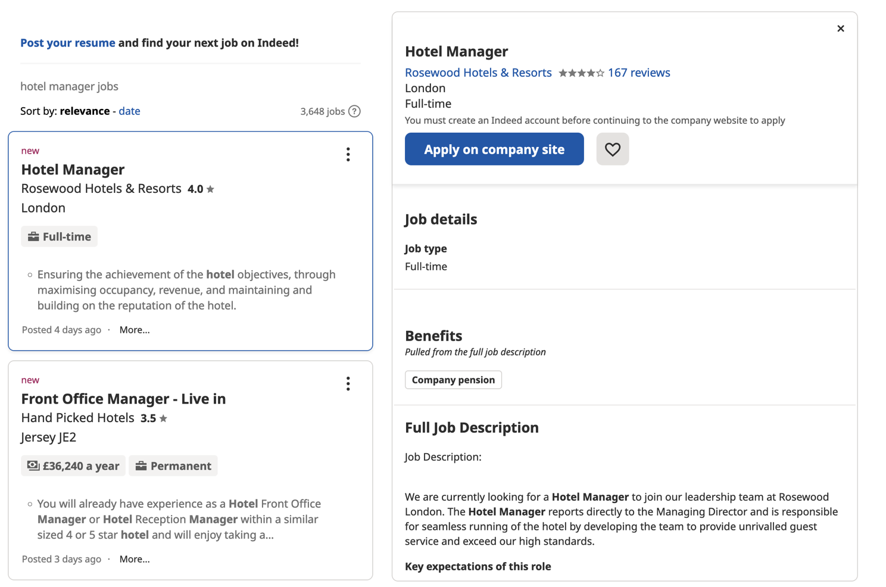
My first week studying was spent completing the work, and I felt completely overwhelmed by the number of materials and the weight of responsibility that had been placed on my shoulders. However, with the guidance of my lecturers, who have decades of experience in the industry between them, I quickly gained confidence and support. I picked up useful hints and learnt new skills by watching and listening to them, including how to talk to and negotiate with other businesses and how to read and understand a wide variety of plans.

Working in hospitality for the first few weeks was a lot of fun for me since it allowed me to put into practise what I had studied about geotechnical, structural, hydrological, and transportation engineering at university. Of course, I understand that this is not always the case and that most workers choose to specialise in a single area, but I am grateful for the chance I had to put my theoretical knowledge to practical use (Filimonau and Brown 2018).

Another important thing I learnt was the need of being flexible and open to change, particularly in the early phases of a project. Another thing I picked up from this experience is the importance of double-checking everything, especially before presenting it to a customer. Each member of hospitality workplace brings unique skills and experience to the table, but they all coordinate their efforts to provide a smooth workflow that allows them to meet tight deadlines and wow the customer. In turn, this contributes to a positive culture at work by helping employees develop as a unit. There were plenty of hectic days when I had to remain late working to get everything done, such as when a customer had an urgent request, or a tender deadline had to be reached. This is quite like my late-night study sessions, and it's interesting to see that it persists even in the professional world (Lombarts 2018).

I now have a better appreciation for the significance of each individual step in any given endeavour. During my study I learned a lot and had a good time working. After weeks as a 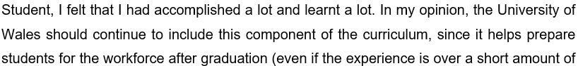time). In my case, I was able to take my internship into a permanent job, so there are obvious benefits. As it turned out, I was able to learn much more than I had anticipated in that period, and my efforts were rewarded with a job offer at the conclusion of the programme (Lee 2017).

Reference:


