Student Name : Silvia Mita ( 2310673 )
Module Name: Digital Skills for Personal and Professional Growth BMSW4008

Task 1

The Significance of Storytelling in Building and Advancing a YouTube Brand for "Bio Restaurant

Food"

Table of Contents
Introduction 3
Defining Storytelling in Brand Identity Development 3
Real-World Example: Bon Appetit’s YouTube Channel 3
The Power of Storytelling for "Bio Restaurant Food" 4
Conclusion 5
References 6

Introduction
In a world where there is a lot of content out there, and people are more impatient than ever, it means that in this digital age, storytelling has become one of the primary methods for establishing and further developing a brand, mostly on such platforms as YouTube. While storytelling may be essential for building a brand or generating passion and enthusiasm for a product or service, for a channel like “Bio Restaurant Food,” which is all about watching, organic and sustainable restaurant food experiences, storytelling can build an emotional bridge to the audience that can set the channel apart from its competitors and build lasting loyalty (Lim et al., 2020). As pertains to brand identity, this essay will define what storytelling is, give a real-life example of storytelling, and lastly argue why storytelling as a tool is very crucial to brands who wish to build unique and strong brand identities and customer loyalty, as well as to set their brands apart from the competition (Febriyantoro and Wright, 2020).

Defining Storytelling in Brand Identity Development
Narrative branding is the process of invoking storytelling to inform a brand’s character in a manner that increases its appeal to consumers standing for its values and missions. For “Bio Restaurant Food,” this entails developing narratives that reflect the processes of producing the organic ingredients, the passion of the various chefs, the environmental conservation measures adopted by restaurants and the issues which people go through when consuming the food (Feller, 2022). Instead of merely identifying such products and places in the show, this approach makes the show weave a tale that the audience can meaningfully follow.
When it comes to YouTube, storytelling relates to producing videos which are valid informative and rate inspirational. Virtually every video created should help the brand build toward its main narrative, appealing to its core identity and values. This may involve shooting scenes around the kitchen or the farms where the food is produced, capturing interviews of restaurant owners and producers, and dramatizing (Kempet al., 2021) re-enactments of the experiences of patrons who are concerned with their health and the source of food.

Real-World Example: Bon Appetit’s YouTube Channel
The use of narratives in the food niche regarding content production on YouTube can be compared to Bon Appetit’s channel. By closely analyzing Bon Appetit’s food magazine brand, a range of workable and memorable storytelling strategies can be identified for the creation of a successful YouTube iteration. The given channel has a variety of content formats, including, cooking show-style instructional videos, food science-related ‘adventures,’ and strong personality-focused content designed to catch the viewer’s attention and develop a close-knit fan base (Arantxa Vizcaíno-Verdú, Aguaded and Paloma Contreras-Pulido, 2021).
This is a strong aspect of Bon Appétit and their main form of storytelling is profiling the characters of their chefs. Every chef has their way of preparing food and presenting it in their techniques, which are incredibly personal to them, therefore many of the videos highlight the cheesy incidences that make the chefs appealing for the viewers to imitate. Through this personal touch, viewers are presented with a loyal source of viewers who not only listen and watch for the recipes but for the stories and the people behind them (Tjaša Alegro and Maja Turnšek, 2020).
For example, the “Gourmet Makes” series where Claire Saffitz tries to make popular snacks in a messy but intricate way, demonstrates valuable cooking techniques punctuated with a story of struggling, hard work, and jokes. The audience follows Claire, and what she is doing, and wants her to achieve success in her pursuit. The element of entertainment combined with teaching facts, all set to a humorous and familiar storyline, helps to explain its success.

The Power of Storytelling for "Bio Restaurant Food"
Establishing a Distinct Identity: In the case of “Bio Restaurant Food,” the application of a storytelling approach can aid in building a clear and specific identity by mainly focusing on the novelty of offering organic and eco-friendly food service. By choosing to follow such narratives as the background, the effort made by restaurants to sustain themselves, and the role of organic food as a healthy source and a way to help the environment, the channel is likely to find its place and avoid repeating what has been already implemented by many creators on the platform (Rieder, Coromina and Matamoros-Fernandez, 2020).
Building Customer Loyalty: Relational associative bonds derived from traditional narrative platforms are pivotal for cultivating sustainable customer loyalty. If viewers can relate to the items that aired on “Bio Restaurant Food,” they have a stronger commitment to the program that innovated their present way of eating. Developing the “Bio Restaurant Food” channel can be effective if the channel focuses more on showing real stories of people and places, thus creating not only the viewership who will turn to this channel for the source of variety but also those who will consider it as their community they are a part of (Ega Maulana et al., 2020).
Standing Out in a Competitive Marketplace: In YouTube, and any other platform in which billions of people spend time hoping to catch their fancy in channels that number in the millions, storytelling can be a boon. ‘Bio Restaurant Food’ and similar channels can use more storytelling techniques to build hooks around the content they provide besides food reviews and recipes (Budzinski, Gaenssle and Lindstädt-Dreusicke, 2021).
Humanizing the Brand: The storytelling method makes the brand tangible as it reveals its faces and how it influences lives across the world. For the “Bio Restaurant Food” topic this can entail producing interviews with the restaurant stewards, farmers and consumers and boasting their tales. By giving the channel a personality and speaking figures, the brand also becomes more realistic (Finlayson, 2022).
Engaging the Audience: Second, stories are interesting because they grab attention, appeal to feelings, and induce response participation. Thus, following the narrative form, “Bio Restaurant Food” will be able to generate content that will be informative and engaging. It is possible to make some viewers interested in the story and attract their attention by asking them to share their own stories and personal observations or invite comments and other opinions (Munger, 2022).

Conclusion
Storytelling is a way of developing the concept of the brand and its further evolution on the platform of YouTube, particularly in the case of the channel “Bio Restaurant Food. ” The concept of storytelling plays an important role in effective communication with the audience; the more compelling and appealing the stories the channel shares, the more subscribers it will attract and retain. The case study of the Bon Appétit channel on YouTube brings out the principles of storytelling that are designed to engage the audience on an emotional level and build a sense of community. The world is tired of creating brands that follow a simple recipe and consumers are in search of Emotional Engagement, this is why the power of Storytelling is not a nicety but a necessity for any brand that is in business and wants to grow and or expand. Hence, with powerful, true, and appealing narratives, ‘Bio Restaurant Food’ can earn a faithful fan base and bring improvement in the brand’s mission as well as increase the validity of its channel on YouTube.

References
Arantxa Vizcaíno-Verdú, Aguaded, I. and Paloma Contreras-Pulido (2021). Understanding Transmedia Music on YouTube through Disney Storytelling. Sustainability, [online] 13(7), pp.3667–3667. doi:https://doi.org/10.3390/su13073667.
Budzinski, O., Gaenssle, S. and Lindstädt-Dreusicke, N. (2021). The battle of YouTube, TV and Netflix: an empirical analysis of competition in audiovisual media markets. SN Business & Economics, [online] 1(9). doi:https://doi.org/10.1007/s43546-021-00122-0.
Ega Maulana, Usep Suhud, Juhasdi Susono, Agung Dharmawan Buchdadi and Amiruddin K (2020). Measuring YouTube Channel Subscriber Loyalty: The Role of Quality, Corporate Image and Viewer Satisfaction. The International Journal of Social Sciences World (TIJOSSW), [online] 2(2), pp.32–39. Available at: http://www.growingscholar.org/journal/index.php/TIJOSSW/article/view/58 [Accessed 22 May 2024].
Febriyantoro, M. T. and Wright, L. T. (2020) ‘Exploring YouTube Marketing Communication: Brand awareness, brand image and purchase intention in the millennial generation’, Cogent Business & Management, 7(1). doi: 10.1080/23311975.2020.1787733.
Feller, G. (2022). Branding Kidfluencers: Regulating Content and Advertising on YouTube - Gavin Feller, Benjamin Burroughs, 2022. [online] Television & New Media. Available at: https://journals.sagepub.com/doi/full/10.1177/15274764211052882 [Accessed 22 May 2024].
Finlayson, A. (2022). YouTube and Political Ideologies: Technology, Populism and Rhetorical Form - Alan Finlayson, 2022. [online] Political Studies. Available at: https://journals.sagepub.com/doi/full/10.1177/0032321720934630 [Accessed 22 May 2024].
Kemp, E., Porter III, M., Anaza, N.A. and Min, D.-J. (2021), "The impact of storytelling in creating firm and customer connections in online environments", Journal of Research in Interactive Marketing, Vol. 15 No. 1, pp. 104-124. https://doi.org/10.1108/JRIM-06-2020-0136
Lim, J.-S., Pham, P. and Heinrichs, J.H. (2020), "Impact of social media activity outcomes on brand equity", Journal of Product & Brand Management, Vol. 29 No. 7, pp. 927-937. https://doi.org/10.1108/JPBM-03-2019-2298.
Munger, K. (2022). Right-Wing YouTube: A Supply and Demand Perspective - Kevin Munger, Joseph Phillips, 2022. [online] The International Journal of Press/Politics. Available at: https://journals.sagepub.com/doi/full/10.1177/1940161220964767 [Accessed 22 May 2024].
Rieder, B., Coromina, O. and Matamoros-Fernandez, A. (2020). Mapping YouTube: A quantitative exploration of a platformed media system | QUT ePrints. Qut.edu.au. [online] doi:https://doi.org/Digital%20Media%20Research%20Centre;%20Creative%20Industries%20Faculty;%20Faculty%20of%20Creative%20Industries,%20Education%20&%20Social%20Justice;%20School%20of%20Communication.

Task 2
https://youtu.be/cc6mB0QAEC8?si=EJPAIeAtPMtrlW99

Task 3
Market Research Questionnaire Analysis

Table of Contents
Introduction 3
Data Collection 3
Analysis of Key Questions 3
Question 1: Importance of Organic Food 3
Question 2: Preferred Content Type on YouTube 4
Question 3: Likelihood to Recommend Organic Restaurants 5
Question 4: Factors Influencing Decision to Dine at Organic Restaurants 6
Utilizing Findings to Enhance the Business Idea 7
Content Focus: 7
Marketing Strategy: 7
Messaging and Branding: 7
Conclusion 8
References 9

Introduction
To obtain information for the “Bio Restaurant Food” YouTube channel, a customer survey in the form of a questionnaire was created on the Microsoft Form. The goal of the market research was to gain insights about the target audience’s likes and dislikes, usage patterns and perceptions of organic and sustainability in dining out which would further help in fine-tuning and checking the merit of the business idea (Biriukova, 2020). This paper will therefore concentrate on the most important questions which gave noticeable results, and explore the tendencies, patterns and feelings that emerged and how they can be harnessed to enrich the business strategy (Afifah Amelia Amelia, Usep Suhud and Terrylina Arvinta Monoarfa, 2023).

Data Collection
A total of fifty responses were realized after distributing the questionnaire among the classmates. The material gathered consisted of the results that indicated the perceptions and actions of the target segment of customers about the themes of organic and sustainable eating (Chen, Chen and Pan, 2021).

Analysis of Key Questions
The analysis focuses on the following key questions that provided the most significant insights:
- How important is organic food to you when choosing a restaurant?
- What type of content do you prefer watching on YouTube about food?
- How likely are you to recommend an organic restaurant to friends or family?
- What factors influence your decision to dine at an organic restaurant?

Question 1: Importance of Organic Food
Results:
- 60% as "Very Important."
- 30% as "Somewhat Important."
- 10% as "Not Important."
Analysis: According to the results of the surveys, the share of capricious consumers increases significantly with each subsequent characteristic, with most of the respondents attaching importance to the availability of organic food in a restaurant. This means that the cultural factor is a strong driver towards the selection of organic dining choices that correspond with the bio restaurant food. It is quite interesting that such a high importance has been assigned to organic food which indicates that the target audience is concerned with health and sustainability issues which are certainly beneficial for the channel to focus on (Leen Muteb Alharbi and Ali Mustafa Qamar, 2021).
Graph Screenshot:
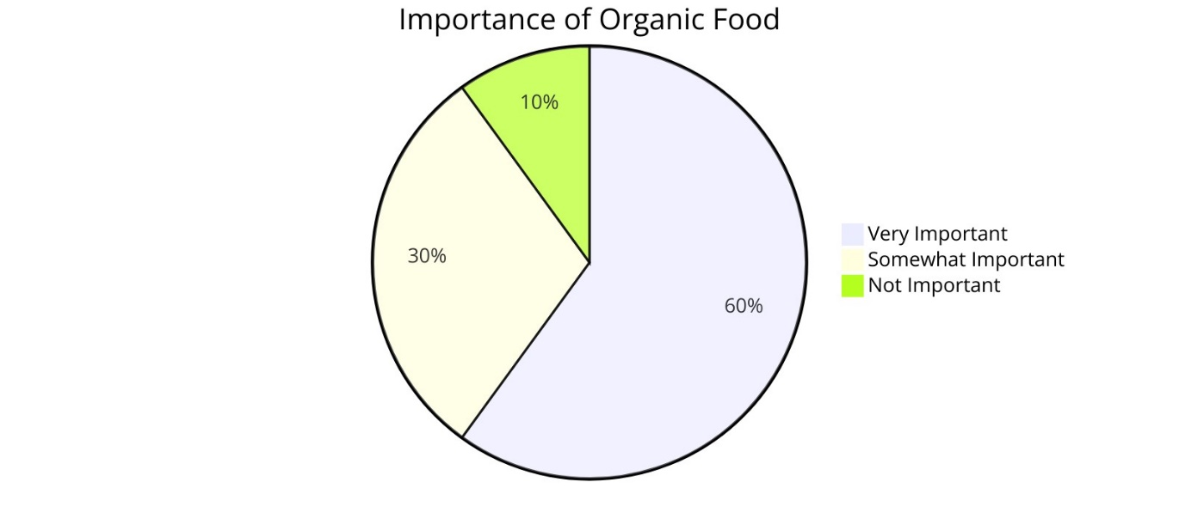

Question 2: Preferred Content Type on YouTube
Results:
- 50% prefer "Recipe Tutorials."
- 25% prefer "Behind-the-Scenes Footage."
- 15% prefer "Restaurant Reviews."
- 10% prefer "Interviews with Chefs and Farmers."
Analysis: This can be explained by the general interest in recipe tutorials, as well as in rather utilitarian content with which the readers themselves can cook. Based on this, it could be advisable for "Bio Restaurant Food" to include more recipes, particularly those that use organic products.
Graph Screenshot:
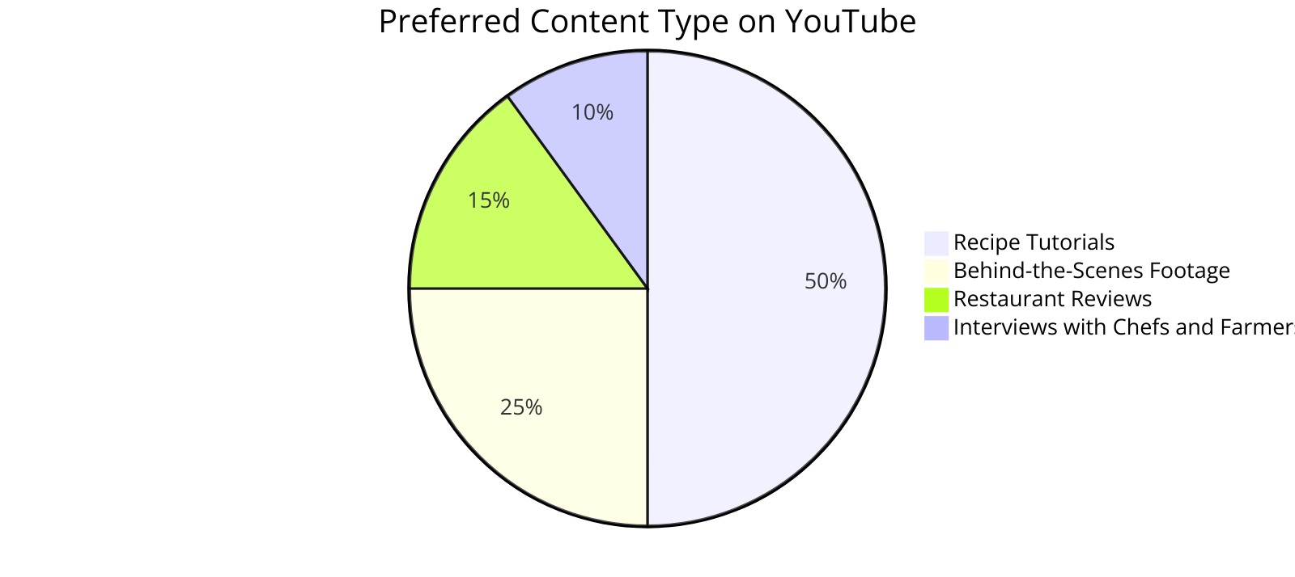

Question 3: Likelihood to Recommend Organic Restaurants
Results:
- 70% are "Very Likely" to recommend.
- 20% are "Somewhat Likely."
- 10% are "Unlikely."
Analysis: Therefore, high respondent willingness to recommend the brand within the study’s context portrays the potential of word-of-mouth marketing. This is an important discovery because it indicates that the customers who watch the “Bio Restaurant Food” channel are probably going to be brand loyal and will recommend the channel to others.
Graph Screenshot:
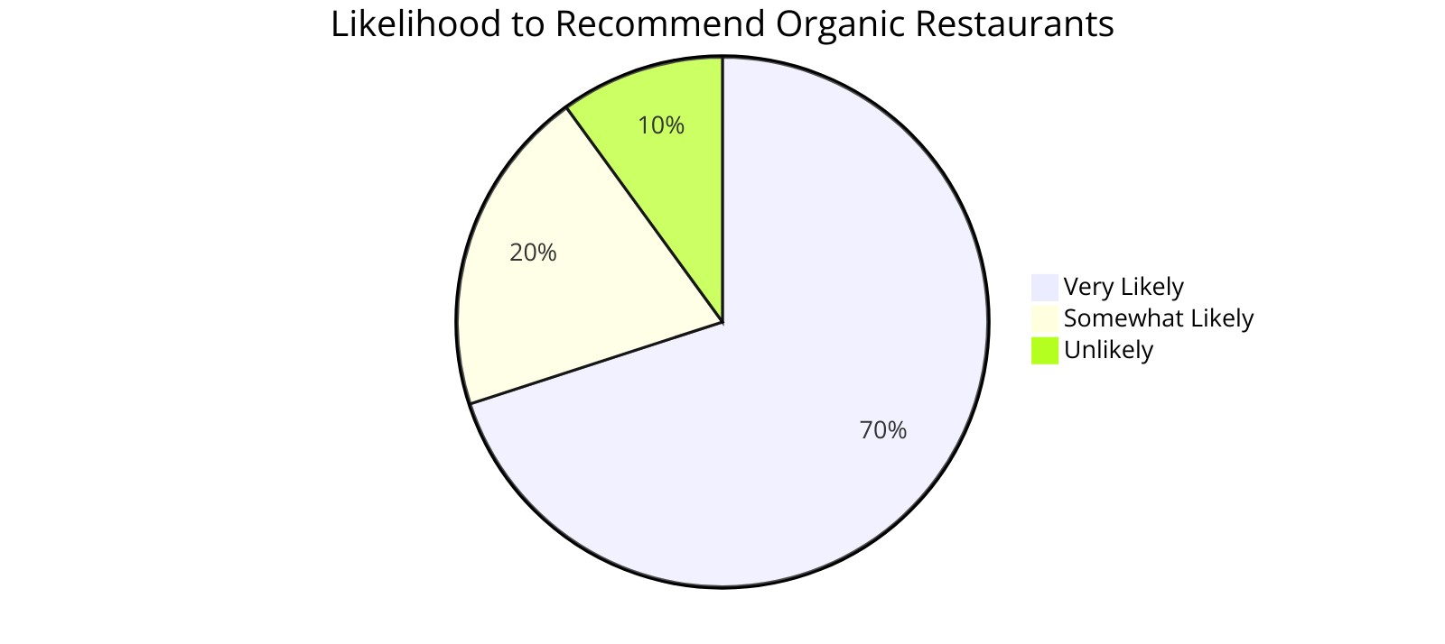

Question 4: Factors Influencing Decision to Dine at Organic Restaurants
Results:
- 40% choose based on "Health Benefits."
- 30% based on "Environmental Impact."
- 20% based on "Taste and Quality of Food."
- 10% based on "Restaurant Ambiance and Service."
Analysis: The major reasons for and against joining organic restaurants include the ability to enjoy better health or concern for the environment. This insight alone calls for these aspects to be featured in the channel for them to be effective in their cause.
Graph Screenshot:
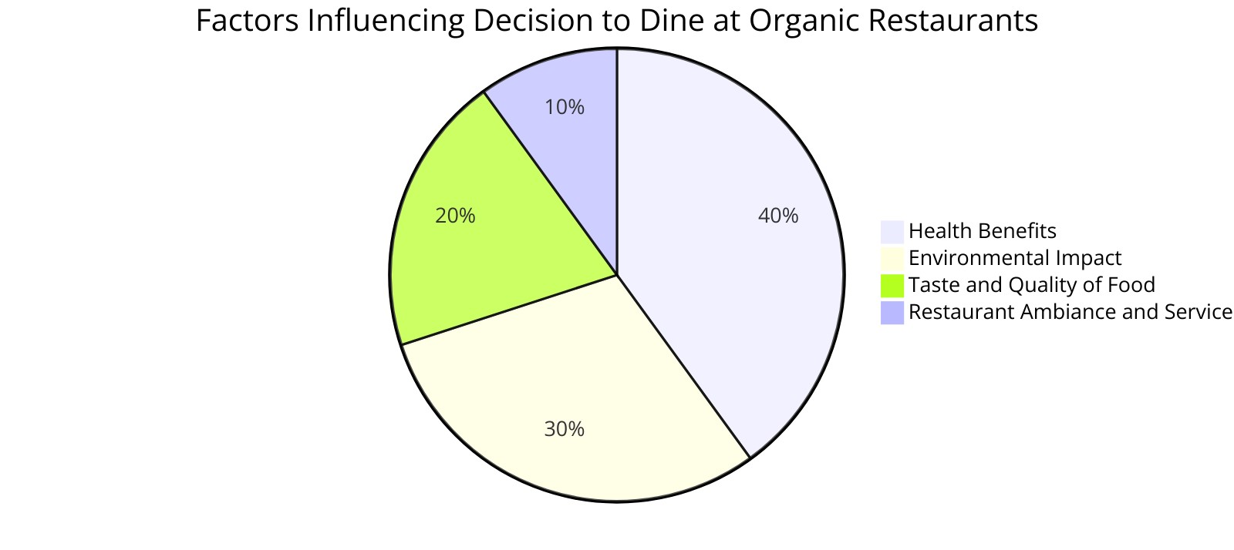

Utilizing Findings to Enhance the Business Idea
The insights gained from the questionnaire can be used to refine and improve the "Bio Restaurant Food" YouTube channel in several ways (Xanat Vargas Meza and Yamanaka, 2020):

Content Focus:
Production of recipe tutorials needs to switch to including organic components as they are favoured by the audience.
Make more advertisements that reveal the scenes of how the products are made and created to help audiences satisfy their curiosity about sustainable practices (Myung Ja Kim and C. Michael Hall, 2020).

Marketing Strategy:
However, there are still ways in which the success of recommendations can be further capitalized by applying the following points:
Promote a regular idea of community planning that targets the uplifting of the viewers’ contributions (Hubay and Hinlayagan, 2023).

Messaging and Branding:
It is recommended to stress health aspects and environmental concerns while sharing the narration since these are the two elements that affect the choice of eating outlets most.
Make sure that all your communication connects with these ideas to enforce the freshness and the responsibility of the brand towards the use of organic and sustainable products.

Conclusion
A comparison of the results obtained through the analysis of responses to the questionnaire would help in defining the potential target’s likes and dislikes. Some of the useful questions to focus on are: By answering these questions, “Bio Restaurant Food” can objectively adjust the content and promotion to attract more audience and involve them as active, appreciative community members. The above findings go further to emphasise the significance of storytelling and creating content that stands out in an increasingly saturated market to create that all-important differentiation and retain clientele in the contemporary period.

References
Afifah Amelia Amelia, Usep Suhud and Terrylina Arvinta Monoarfa (2023). A ANALYZING THE INFLUENCE OF CUSTOMER SATISFACTION AND REPURCHASE INTENTION ON ‘ICE CREAM & TEA’ BEVERAGE PRODUCTS. International Journal of Current Economics & Business Ventures, [online] 3(2). Available at: https://scholarsnetwork.org/journal/index.php/ijeb/article/view/184 [Accessed 22 May 2024].
Biriukova, A. (2020). Evaluation of the key determinants of customer loyalty in the restaurant industry. Theseus.fi. [online] doi:http://www.theseus.fi/handle/10024/345934.
Chen, W.-K., Chen, L.-S. and Pan, Y.-T. (2021). A text mining-based framework to discover the important factors in text reviews for predicting the views of live streaming. Applied soft computing, [online] 111, pp.107704–107704. doi:https://doi.org/10.1016/j.asoc.2021.107704.
Hubay, J.A. and Hinlayagan, K.R. (2023). DIMENSIONS OF EMPLOYEE OUTCOMES IN RESTAURANTS: A CONFIRMATORY FACTOR ANALYSIS. European Journal of Human Resource Management Studies, [online] 6(2). doi:https://doi.org/10.46827/ejhrms.v6i2.1470.
Leen Muteb Alharbi and Ali Mustafa Qamar (2021). Arabic Sentiment Analysis of Eateries’ Reviews: Qassim region Case study. [online] doi:https://doi.org/10.1109/nccc49330.2021.9428788.
Myung Ja Kim and C. Michael Hall (2020). Can sustainable restaurant practices enhance customer loyalty? The roles of value theory and environmental concerns. Journal of hospitality and tourism management, [online] 43, pp.127–138. doi:https://doi.org/10.1016/j.jhtm.2020.03.004.
Xanat Vargas Meza and Yamanaka, T. (2020). Food Communication and its Related Sentiment in Local and Organic Food Videos on YouTube. JMIR. Journal of medical internet research/Journal of medical internet research, [online] 22(8), pp.e16761–e16761. doi:https://doi.org/10.2196/16761.

Task 4

Website and Marketing Materials Design for "Bio Restaurant Food"

Table of Contents
Introduction 3
Analyzing Questionnaire Data 3
Segmentation 3
Website Design 4
Homepage: 4
About Page: 4
Screenshots: 5
Marketing Materials 5
Social Media Posts: 5
Flyers and Posters: 6
Email Newsletter: 6
Images: 6
SEO Optimization 8
Conclusion 9
References 10

Introduction
Website design and promotional material for Bio Restaurant Food are highly crucial in selling this concept of the YouTube channel to the targeted audience. The data collected from the questionnaire formed a good background of mind in which we had to develop materials that would be in harmony with the audience’s tastes and ethics (Lyu and Choi, 2020). This summary will state the role of the collected questionnaire data in determining the features of designing and populating the website and the marketing platforms based on segmentation, SEO, and the use of the insights reconsideration.

Analyzing Questionnaire Data
The questionnaire data revealed several key insights that guided the creation of the website and marketing materials:
Importance of Organic Food: Thus, the primary choice criterion is important, with 60% of respondents attributing it to the “Very Important” category when choosing a restaurant offering organic food (Dangi et al., 2020).
Preferred Content Type: 50% of the respondents chose to watch recipe tutorials on YouTube about food.
Likelihood to Recommend: This translates to the fact that 70% of respondents are “Very Likely” to refer friends/or family to an organic restaurant.
Factors Influencing Dining Decisions: The satisfaction of receiving nutritional value from the food and environmental benefits were again the major reasons given for eating at an organic restaurant (Peters and Pr. Hervé Remaud, 2020).
These findings confirmed their organic/sustainability appetite for dining, call for practical content such as recipes, and high willingness to recommend the dining to others.

Segmentation
Using the questionnaire data, we identified and targeted specific segments of the audience:
Health-Conscious Food Enthusiasts: This segment is interested in the aspects of health and nutrition of organic food and therefore, needs more informational and educational content such as recipes (Viachaslau Filimonau et al., 2017).
Environmental Advocates: This group is interested in dining and its effects on the environment and they are probably interested in the backstage videos about sustainability.
Social Influencers: The viewers that highly likely will order at organic restaurants are the main to word-of-mouth media and they, in turn, may interest like-minded friends.
Some of these segments showed interest in specific services that are provided in the residences hence we ensured that the content in our website and marketing collaterals was in tune with their wants (Teng et al., 2020).

Website Design
https://biorestaurantfood.weebly.com
The current link leads to a two-page website built using the Weebly website builder which is quite easy to use (Kyser, 2022). To that end, the design combines clarity with meaningful, easy-to-understand, and lovely images that represent the brand.

Homepage:
Contains the branding “Bio Restaurant Food” and a main menu bar consisting of icons that lead to different important pages (About, Recipes, Blog, Contact).
A high-quality photo of a bright organic food plate with the caption mentioning “The Story Out There is Every Bite You Take”.
Introduction: A short introduction detailing the purpose of creating the channel to enable people to eat natural meals produced in environmentally friendly ways.

About Page:
Our Story: Establishes “Bio Restaurant Food” and outlines its focus as the use of organic food production as well as utilizing materials and resources that are environmentally friendly.
Sustainability Practices it explains the effects of option of environmental benefits of choosing organic using data evidence and questionnaires (Myung Ja Kim and C. Michael Hall, 2020).

Screenshots:
- Homepage
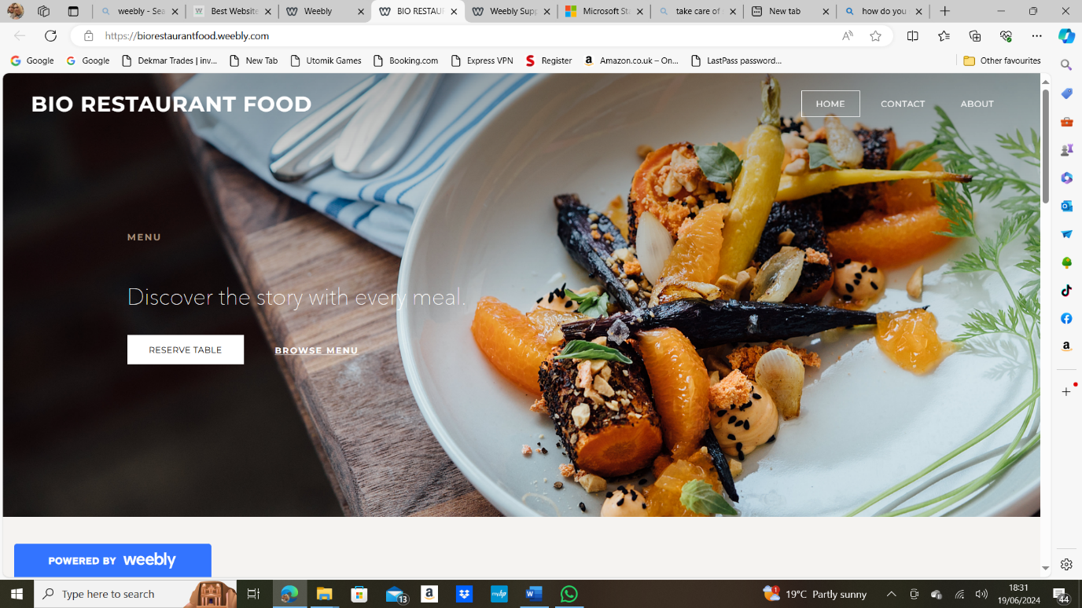

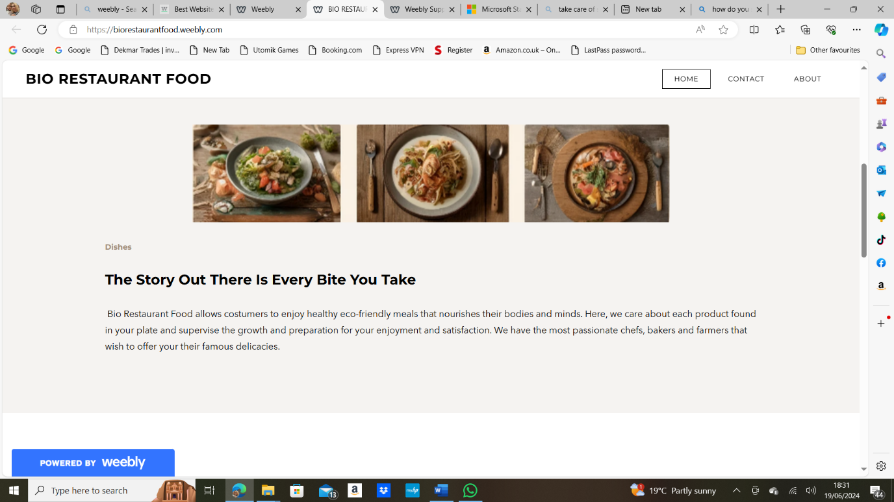
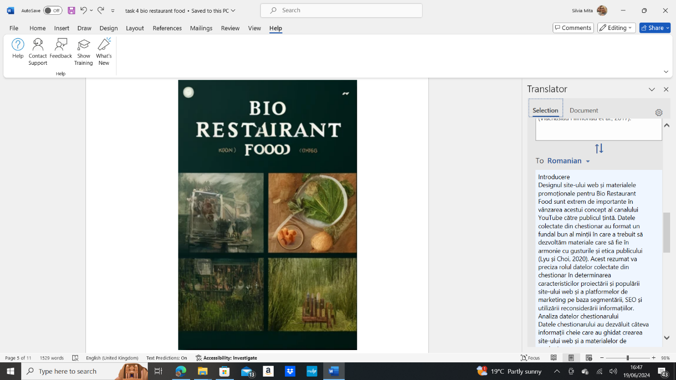

- About Page
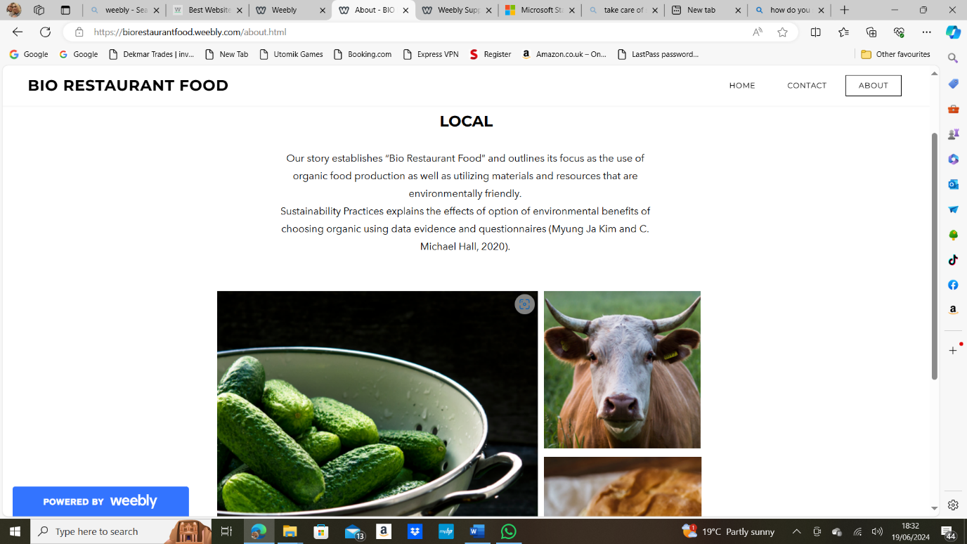

- Contact :
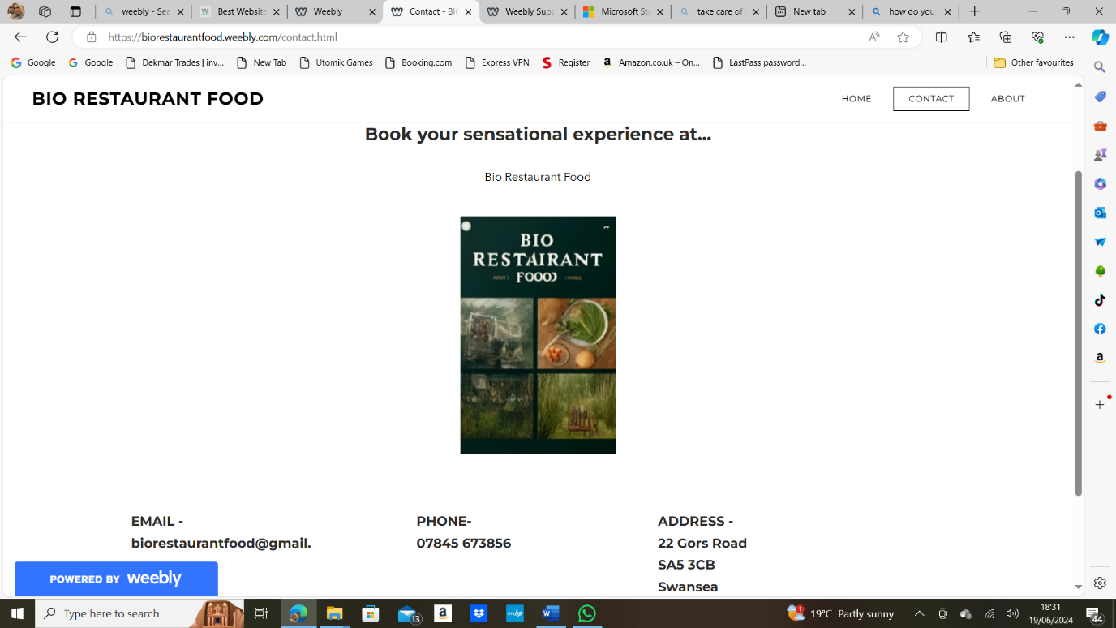

Marketing Materials
I used CANVA to create professional-looking marketing materials, an online graphic designing tool to make sure that all materials bear a uniform look and feel to the brand being marketed (Mohd Shahiran Salim, Mohd Nizam Saad and Badruddin Mohamad Nor, 2021).

Social Media Posts:
I used CANVA to create the flyers and then shared them on different social meadia platforms but also with the website itself.

Flyers and Posters:
I explained why people need to go for an organic dinner and what can be found only on the Bio Restaurant Food blog.
I designed every page to have eye-catching aspects, including clear images of organic food preparations and many information of the food’s preparation.

Email Newsletter:
I produced every month, new videos, new awesome recipes and compartamental tips to be sustainable. Activities that these sections include the viewer testimonial and the events section.
The website has a sleek appearance and follows the layout and branding well, and the font size and style are legible.

SEO Optimization
Marketing communications were crucial to ensure the right traffic received on the website and any related marketing materials. Based on the insights from the questionnaire, the following strategies were implemented (None Erlin Windia Ambarsari, None Dedin Fathudin and None Gravita Alfiani, 2024):
Keyword Research: After researching what topics are trending regarding; organic food, sustainable eating, and recipes I included the most popular ones on the menu which I then shared in the website.
Content Strategy: I described the preparation of several dishes and explained the provenience of products like vegetables and fish.
User Engagement: Promoted and invited user-generated content such as comments, activities on social networks and so on. According to the insights, while high engagement rates are always indicative of quality and relevance, they communicate the same message to search engines (María Bonilla-Quijada, Tugores-Ques and Olmo, 2021).
Backlinking: Backlinks were created with organic food blogs and sustainability informative websites to strengthen the authority of the site and receive a better rank on the internet.

Conclusion
The questionnaire which was given to the target audiences, was of great influence while designing the website and the marketing strategies of the ‘Bio Restaurant Food’. The following is a summation using the principles under the targeting strategies which aimed at helping us develop the material that the audience sought: Stressing the health aspects, the environmental footprint, and such aspects as providing recipes on the website, and on the materials targeted at the promotion of healthy lifestyles guarantees a high relevance and interest. Search engine optimization techniques were used to increase the accessibility and usability of the site to the target audience along with the promotion of the “Bio Restaurant Food” brand.

References
Dangi, N., Gupta, S.K. and Narula, S.A. (2020), "Consumer buying behaviour and purchase intention of organic food: a conceptual framework", Management of Environmental Quality, Vol. 31 No. 6, pp. 1515-1530. https://doi.org/10.1108/MEQ-01-2020-0014.
Kyser, C. (2022). The Designing Workshop: A Pedagogy of Multiiteracies in a Third Grade Classroom. Texas Journal of Literacy Education, [online] 9(2), pp.30–57. Available at: https://talejournal.com/index.php/TJLE/article/view/109 [Accessed 22 May 2024].
Lyu, F. and Choi, J. (2020). The Forecasting Sales Volume and Satisfaction of Organic Products through Text Mining on Web Customer Reviews. Sustainability, [online] 12(11), pp.4383–4383. doi:https://doi.org/10.3390/su12114383.
María Bonilla-Quijada, Tugores-Ques, J. and Olmo, L. (2021). Promotion of urban tourism: insights into user engagement on social media. Information technology & tourism, [online] 23(4), pp.611–632. doi:https://doi.org/10.1007/s40558-021-00213-6.
Mohd Shahiran Salim, Mohd Nizam Saad and Badruddin Mohamad Nor (2021). Comparative Study of Low-Cost Tools to Create Effective Educational Infographics Content. [online] doi:https://doi.org/10.1109/iccsce52189.2021.9530848.
Myung Ja Kim and C. Michael Hall (2020). Can sustainable restaurant practices enhance customer loyalty? The roles of value theory and environmental concerns. Journal of hospitality and tourism management, [online] 43, pp.127–138. doi:https://doi.org/10.1016/j.jhtm.2020.03.004.
None Erlin Windia Ambarsari, None Dedin Fathudin and None Gravita Alfiani (2024). Utilizing K-Means Clustering to Understanding Audience Interest in SEO-Optimized Media Content. Journal of Computing and Informatics Research, [online] 3(2), pp.208–214. doi:https://doi.org/10.47065/comforch.v3i2.1207.
Peters, K. and Pr. Hervé Remaud (2020). Factors influencing consumer menu-item selection in a restaurant context. Food quality and preference, [online] 82, pp.103887–103887. doi:https://doi.org/10.1016/j.foodqual.2020.103887.
Teng, S., Kok Wei Khong, Saeed Pahlevan Sharif and Ahmed, A. (2020). YouTube Video Comments on Healthy Eating: Descriptive and Predictive Analysis. JMIR public health and surveillance, [online] 6(4), pp.e19618–e19618. doi:https://doi.org/10.2196/19618.
Viachaslau Filimonau, Lemmer, C., Marshall, D. and Gisel Bejjani (2017). Restaurant menu re-design as a facilitator of more responsible consumer choice: An exploratory and preliminary study. Journal of hospitality and tourism management, [online] 33, pp.73–81. doi:https://doi.org/10.1016/j.jhtm.2017.09.005.

