

Assessment 2

Student's Name: Natalia Piwowarska
Student ID: 2014062
Course: LCBB5004 Managing People
Lecturer’s Name: Nishi Ramsurrun
Date: 09/05/2022

Table of Contents
Introduction 2
Background of kingfisher plc 3
Concept of employee engagement 3
Key Drivers of employee engagement 4
Evaluation of tools to measure the engagement 5
Employee value proposition 6
Strategies to raise the level of engagement 7
Conclusion 9
References 10

List of Figures
Figure 1: Employee value proposition chart 6

Introduction
For the better management of the employees in the organization, it must be necessary to provide effective environments, tools, and methods. This provides the better development of the organization which gives an effective structure to the business. This study will provide the provides a brief concept of human resource management of kingfisher plc. This study will provide a critical understanding of the business environment that defines the analysed process of the considered organization. The included concept is based on the internal and external factors of the organization that concludes the involvement based on the political, organization, and employees’ issues.
This report has been evaluated by the chief executive of the organization who has to give the review based on the drivers and the concept of employee engagement. Which ha provide the whole knowledge of business structure with the help of diagnostic tools which will be used for the measurement purpose. It will also give the value prospective for the employers and also the conclusion of strategies will help in increasing the level of engagement. The whole study will provide the concept of human resource management.

Background of kingfisher plc
Kingfisher is a kind of home improvement company that provides services internationally to its customer. This company has almost around 1,470 stores around the world with a working team of around 82,000. It concludes approx. eight countries’ involvement which concludes them by the retail banners. That is named as the trade point, koctas, Castorama, B&Q, Screwfix, and so on. For the growth of kingfisher plc, the main contribution is of its employees which have given the effective structure to the company (Kingfisher 2022).
This company is founded in 1982 by Andy Cosslett, and now this was fully controlled by Thierry Garnier as the CEO of this company. The market of this company is extended in the sector if attractive sector which has given 320 million homes for 235 billion euros to its customer. This company has provided an effective structure to the homes which has solved the problems of the customers related to home development (Howard et al. 2019).

Concept of employee engagement
In the conclusion of the measures in the kingfisher plc that helps them to make an effective environment for the workers. The points that are concluded are in this are the implication of work from home that provides an effective environment for the employees of the organization. The included concept of this will increase the dedication and amount of enthusiasm which gives a better feeling to the employees for the work environment (Kingfisher 2022)
The efforts that are made by the employees are in the field of efforts that are contributed to the organization’s goals. It performs as the main key in the communication between the employees and the customers. Kingfisher plc has made a growth with the perfect execution of the human resource engagement plan. In this, it has given job satisfaction in the form of providing flexible working time. After the inclusion of the COVID 19, it has given a safer space to the people that give a safe environment to the employees of the organization.
They are encouraged in the ways of the communication factors of the company which provides a network of work ordering this has made a complex structure. This also offers a rewarding option to the employees that come in the category promotion for excellent work. The affection is made on the internal factors of the organization that concludes the staff, financial situation, and the cultural environment of the organization (Howard et al. 2019).

Key Drivers of employee engagement
The key drivers that are concluded in the success of employee engagement must have to be concluded by the chief executive. The main key points that are concluded in this section are given below that define the drivers of the employee engagement of the company (Sugandini et al. 2018).
- Engagement of the leaders
The proper engagement of the leaders will help kingfisher plc in assigning the task and make a perfect road map for performing the multiple tasks. The leaders can control the workflow the effectiveness of this can be seen in the sales increment (Ariyani and Hidayati 2018).
- Voice of employees
These act as the main drivers for the working concept which can be imposed on the voice and integrity level of the employees. If the employees are faces problems in the working structure, they can do complain to the higher management people.
- Strategic narratives based on the leadership concept
The narrative of strategies gives the model of selecting the leaders in between the employees. The proper line-up management concept has given the sub divination of the higher employees which gives the proper control over the order methods (Goswami and Goswami 2018).
- Integrity of employee
The level of employer integrity provides authentic and strong values to the organization. It defines the level of honesty of the employee which gives the opportunity to scale a positive environment over the organization structure (Goswami and Goswami 2018).
It can also conclude the other factor which gives the opportunity of total involvement of the task for the employee improvement. They are also based on the performance of the company, the management of tasks during the task execution. It must have concluded that teamwork and the collaboration of employees can help to make a trustworthy and safe environment for the employees. The employee should have to also give focus on providing meaningful work to the management that gives the accessibility of sensing the working power of the employees (Ariyani and Hidayati 2018).

Evaluation of tools to measure the engagement
The concept of tools has helped in evaluating employee engagement in the plan in an effective manner. This allows the organization effectively this has deployed the different methods used to collect the information about the engagement plan for kingfisher plc (Sugandini et al. 2018).
- Implication of employee lifecycle
This provides flexibility by the implication of the life cycle in the working tenure of the employees. This process provides the continuous collection of data from the feedback that are has been generated by the employees of the organization. This can be concluded in the development and the performance management phase. This gives the opportunity of reinforcing the proposition based on the value of Kingfisher plc (Trinet 2022).
- Tools related to human resource
Using the method of surveying the employees once per doesn’t provide updated feedback to the employees. To overcome this problem, it is necessary to implement the tools relate to the human resource which gives the ability to get the latest feedback and clarify them at that time only. It also provides the ability to store the data in a single place for the employees (Sugandini et al. 2018).
- Social media
With the involvement of technology, there has been an increase in demand for this methodology in the organization. This will help the organization measure the sentiments by providing s monitored structure based on the glass door reviews and ratings. This can also be performed by the internal establishment of the social media network. This will give the flexibility to the organization to store the collected data in a single place.
- Interviews
The right question helps in making a better strategic plan that helps to acknowledge the key performance of the employees. This gives the opportunity of defining the task in an effective manner that can be beneficial for the kingfisher organization (Sugandini et al. 2018).
- Employee survey
This can be said as the most important tools for measuring the engagement of employees in the organization. That gives the growth opportunity by solving the issues of the employees within the organization. The survey questionnaires belonging to this section are based on feelings and attitude factors. This has helped in understanding the quality of work relationships, job satisfaction, and the passion of employees for the work.

Employee value proposition
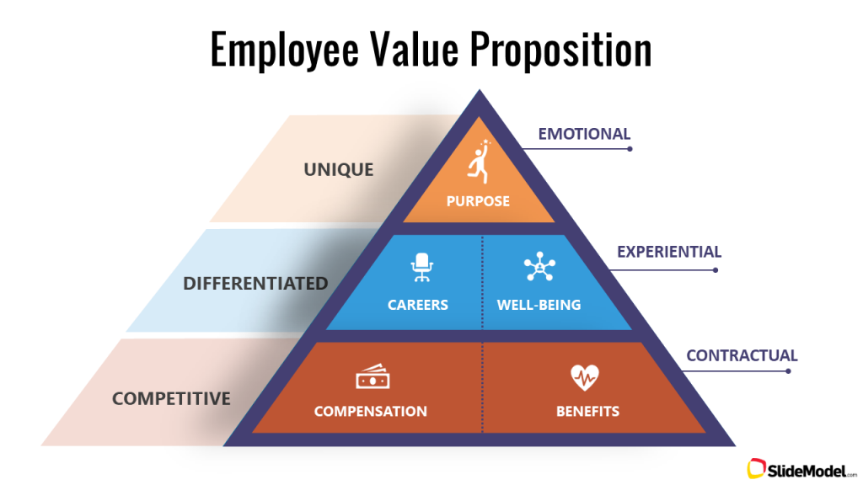
Figure 1: Employee value proposition chart
(Source: Model S. 2021)
This has provided the set of benefits are received by the employees for getting its services in the organization. It can be said to the committee provides the returns based on the employee’s skills. These are based on the skills experience and capabilities of the employees. This has given the essence to kingfisher plc. These are based on the internal and external factors of the organization which provides information about the involvement of the stakeholders. the value proposition for this company is based on the five concepts that are named (Trinet 2022).
- Respect
This can be said to the positive relationship which has been taken by the employee from the organization. It is given in the form of positive relations among the employees and teams (Paadi et al. 2019).
- Stability
This belongs to stability related to the career of the employees that should be enhanced during the organization’s growth. The company has provided different training programs that increase the ability of the employees in an effective manner (Trinet 2022).
- Location
The increased branches of the organization have already given them the opportunity for selecting the relevant location for their work. This depends on the three factors which are known as cultural, technological, and physical.
- Compensation
These are justified according to the salary of the employees or it can be said as the reward which is given to the employees in the form of salary. The company has implicated this method in the form of bonuses based on the evaluation system of the employees (Trinet 2022).
- Work-life balance.
This has concluded in the way of the COVID relief which has been used to impose the work from the concept of the working structure of the organization. It concludes with the payment of salaries based on the compensatory holidays which are given to each and every employee of the organization (Paadi et al. 2019).

Strategies to raise the level of engagement
Strategies will provide an improvised way of working in which it defines the way of working by doing preplanning of the task. This will provide effective ways of executing the task that will help in performing the work on time and with increased productivity (Built in 2022).
- Modularizing the core values and evaluating the mission
- Focusing on the engaging management concepts
- Giving priority to the feedback which is generated by the employees of the organization
- Volunteer opportunities must be coordinated in an effective way
- Making an effective environment for providing better physical and mental health to the employees.
- Rewarding procedure must be implemented within the organization which enhances the work performance of the employee.
- Planning the structure of the company outing which helps in setting the opportunities for the employees.
- Regular survey based on employee engagement.

Conclusion
The study has provided knowledge about the business execution plans which helps them to avoid the issues that can be generated during management. These are based on the internal and external factors of the organization. This has defined the working structure of kingfisher plc which has given the human resource management plan of the organization. The which is provided by the chief executive has defined the concept of employee engagement in the organization. The whole study is based on the internal and external factors of the organization which has helped explain the structure of the organization.
The study has reviewed the concept and drivers for the engagement plan of the organization that provides the learning about the methodology which has been used in the company. This has provided the list of tools that are used in the procedure of measuring the engagement of the employees in the company. At the last, the employee value proposition has been given based on the ideas and analysis which is used in the organization’s research. The implication of strategies, it has helped in the enchantment of the employee engagement plan.

References
Ariyani, N. and Hidayati, S., 2018. Influence of transformational leadership and work engagement on innovative behavior. Etikonomi, 17(2), pp.275-284. https://pdfs.semanticscholar.org/43c3/1103c4ec50e6143389b3f978d527bb8b2dd4.pdf
Built In. 2022. How to Improve Employee Engagement. [online] Available at: <https://builtin.com/employee-engagement/how-to-improve-employee-engagement> [Accessed 29 March 2022].
Goswami, S. and Goswami, B.K., 2018. Exploring the Relationship between Workforce Diversity, Inclusion and Employee Engagement. Drishtikon: A Management Journal, 9(1). https://bit.ly/3iMFtxE
Howard, M., Hopkinson, P. and Miemczyk, J., 2019. The regenerative supply chain: a framework for developing circular economy indicators. International Journal of Production Research, 57(23), pp.7300-7318. https://doi.org/10.1080/00207543.2018.1524166
Kingfisher, 2022. [online] Available at: <https://www.kingfisher.com/en/index.html> [Accessed 29 March 2022].
Model, S., 2022. The Employee Value Proposition (EVP) | Key Components and Examples. [online] SlideModel. Available at: <https://slidemodel.com/employee-value-proposition-quick-guide/> [Accessed 29 March 2022].
Paadi, K., Barkhuizen, N. and Swanepoel, S., 2019. Exploring the building blocks of an employee value proposition for graduate interns. International Journal of Social Sciences and Humanity Studies, 11(1), pp.51-67. https://dergipark.org.tr/en/download/article-file/703582
Shaik, F.F. and Makhecha, U.P., 2019. Drivers of employee engagement in global virtual teams. Australasian Journal of Information Systems, 23. https://journal.acs.org.au/index.php/ajis/article/view/1770/867 (Shaik and Makhecha 2019)
Sugandini, D., Mustafa El Qadri, Z., Kustyadji, G. and Muafi, M., 2018. Employee engagement in entrepreneurship management: SMEs cases. Academy of Entrepreneurship Journal, 24(2), pp.1-8. http://eprints.upnyk.ac.id/17901/1/Employee-engagement-in-entrepreneurship-1528-2686-24-2-145.pdf
Trinet, 2022. [online] Available at: <https://www.trinet.com/insights/think-youre-dealing-with-employee-disengagment-here-are-5-tools-you-can-use-to-evaluate-employee-engagement> [Accessed 29 March 2022].

