LOCATION

Current

The site is in Port Talbot, Wales with location 51°35'42"N Latitude and Longitude 3°47'02"W the existing structure on site is the Bethany Square Car Park of which the address is Bethany square, 87 station road, port talbot SA13 1PQ.

Figure 1
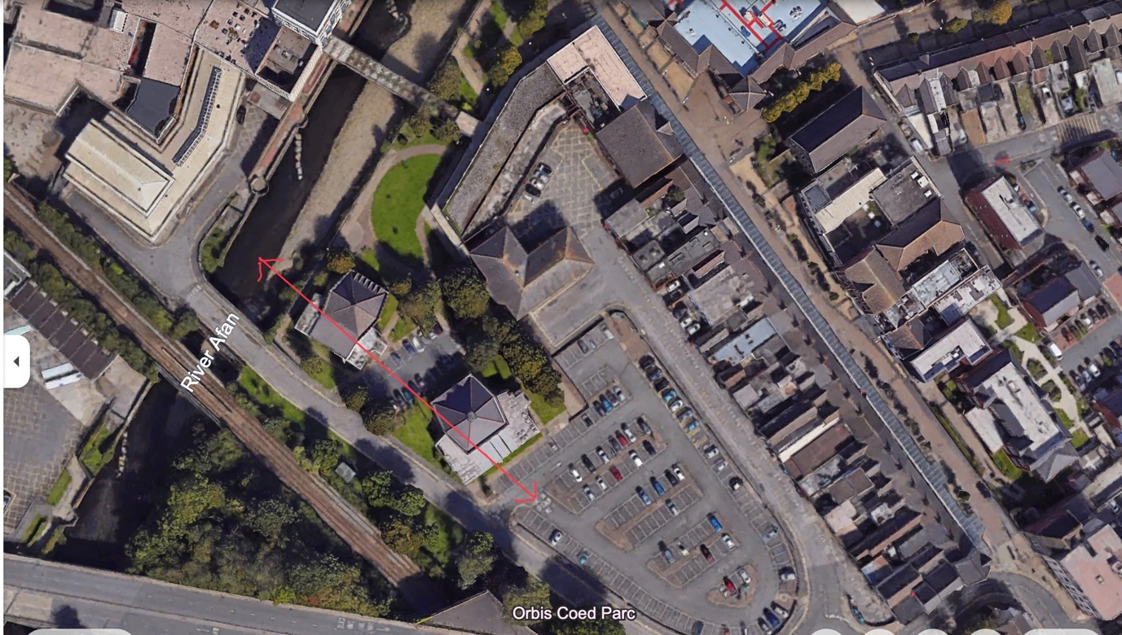
Riverside Baptist Chirch
Carmel Bethany Church
River
SITE

The site is not only located near to one (1) church but two (2), first one being the most important or impactful the Carmel Bethany Presbyterian Church which will remain open during construction. This implies that appropriate precautions and collaborations will need to be taken to ensure the safety of persons, to not impede on person’s access to the church, noise and disruption control, environmental considerations (dust control) etc.

The second church is the Riverside Baptist Church for which vehicle access must remain unblocked by construction to facilitate traffic in and out of this church area as there is no other direct route.

With the site’s existing structure being a carpark, the site is relatively flat and level. It is roughly 115 (m) from the Afan river. This then poses the risk of highly saturated or waterlogged soil which will be examined. The churches in relation to site area is depicted in figure 1.

Figure 2
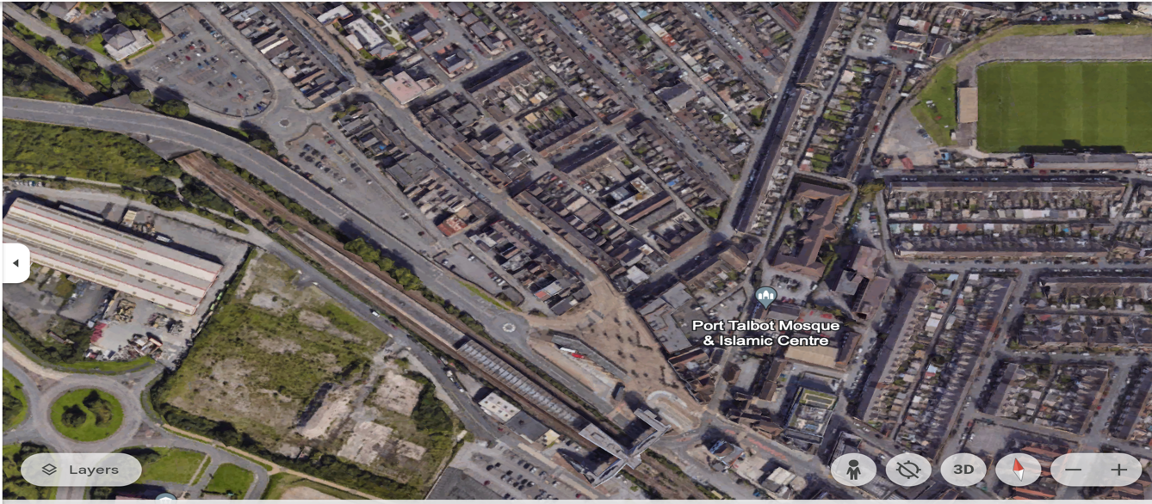
Bus and train station

Site

The M4 motorway is 15 minutes away increasing its accessibility for workers, stakeholders, and visitors.
The site is a seven (7) minute walk from the Port Talbot Parkway rail station and the nearest bus stop making it easily accessible to workers using public transport and persons using the facility upon completion of the project. The site in relation to the location of the bus and train stations are depicted in figure 2.

History
This site has gone through numerous changes over the years in the following years:

Figure 3
Train tracks
SITE

Figure 3 shows a map of the site and surrounding area in the 1870s. At this time train tracks ran directly though the site this railway was called the South Wales Mineral Railway which as its name suggest was used to transport coal and minerals from mines in South Wales valleys.

The train tracks were also accompanied by a small structure called a signal box which is a shelter that housed control equipment used to space and coordinate trains as well as providing signalling staff at the time a form or shelter and vantage point to execute their duties.

Figure 4
Structure 2
Structure 1

In the 1890s the train tracks remained on the site area as well as the erection of another structure on site which seems to be a larger signal box.

The erection of a housing estate or scheme called the Margam Terrace of which included the construction of or numerous houses near the site. This shows that the site area has gone though many changes and alterations over the years.

Up until the 1930s this remained the same train tracks were still in place and the two structures were still present.
Figure 5
New Structure

In 1930 there was a slight change instead for there being two small structures on site, they were removed, and a larger structure was built nearby. Apart from this movement the area remained relatively the same.

Figure 6

In the 1960s the train tracks were removed and the structure on site was demolished with the removal of train. Railways can introduce contaminants such as oil, grease, and heavy metals into the soil from train engines, spills, or maintenance activities. After track removal, there may be concerns about soil contamination and the need for remediation measures to address any pollution caused.
FIGURE 7

In 1969 the area was air marked to be the home of redevelopment of the Port Talbot Centre. It started with the carrying out of bore holes and soil testing to determine if the soil was stable enough to construct on. The area passed and the structures seen today are depicting on the historic map in figure 7 (carpark, churches).

The site area has changed drastically over time and the necessary investigations have been made and will me expanded on in later sections of this document.

