The relevance of ethics within marketing for contemporary business.
Introduction
Every day we are marketed to, whether it be when we are scrolling social media or during our favourite television drama, but are these marketing concepts ethical? This paper will examine the ethical considerations behind the marketing campaigns we see every day. Using relevant academic theories and industry examples it will discuss and analyse the ethical values behind the marketing decisions for contemporary business.
What is Marketing?
Philip Kolter defines marketing as “getting the right goods and services to the right people at the right places at the right time at the right price with the right communications and promotion” (Kotler, 1996).
Marketing is an action for business to promote and sell its products and or services. It is a process of exploring, creating, and delivering value to meet the needs of the target audience. Marketing campaigns happen through businesses completing market research and analysis to understand their customer’s interest. It applies to all aspects of the company’s business including product development, distribution, sales, and advertising.
Marketing has been a tool used by business since the industrial revolution, and since then there have been many different types of marketing era’s that have changed and improved a company’s way of marketing with the help of new technologies. In the 1960’s McCarthy proposed the marketing mix concept that suggested the four Ps of marketing, product, price, place, and promotion. Using these four variables’ marketers can create a marketing strategy that can work long term.
In order for a business to market and advertise to consumers in the UK they must follow a set of advertising codes of practise set out by the British government. There are two different codes of practice broadcast and non-broadcast media however they both follow the same basic set of regulations, to be legal, decent, truthful, honest, and socially responsible.
How businesses market do consumers?
They way businesses can market to consumers has changed dramatically over the last hundred years. In the 1920’s many businesses relied on word of mouth as a way to advertise, a customer would purchase and item and recommend to a friend or family member. In the 1940’s the first television advertisement for the Bulova Watch Company was launched in America during a Baseball game. It was ten seconds long and cost around $10 to create. Now companies pay millions of dollars to have their advertisements aired during high profile television events.
Print advertising is slowly becoming a smaller part of any marketing campaign due to its effect on the environment. Companies are looking at becoming ‘greener’ and therefore see making leaflets, direct mailers and even billboards as a step to far. With the advancements in technology and the creation of the internet, businesses big and small are using social media platforms to market their product. Social media is a way to reach the target audience and a daily basis, a simple post on Instagram can reach hundreds of thousands of people and for an extremely low cost compared to a televised marketing campaign.
Ethical issues in advertising.
Ethical marketing is a process where a company markets their product or services not only focusing on the benefits for the customers but also how they can be socially responsible. There are many different ways a marketing campaign for a contemporary business can been seen to be ethical or unethical.
Competitive issues between companies can often lead to unethical advertisements. Coca Cola and Pepsi are a perfect example of how rivalry between companies can be used to create marketing campaign. Competition between two similar brands in natural, they both want to be on top. Since Coke and Pepsi began, they have been “at war” with each other, with everyone who drinks a soft drink having an opinion, ‘Are you Coke or Pepsi?’. They’re advertising campaigns aren’t always competitive. In 2014 Coca Cola created an excellent example of diversity marketing with their ‘America the beautiful’ campaign. The advertisement had ‘America is beautiful’ being sung in several different languages and had people of all different races and religion, but all united by their identity, American. Following the advertisement being shown during the Superbowl, it became the number one trending topic on social media, and a successful diversity advert.

Figure 1 – Coca-Cola Ad, America is beautiful (National Journal, 2014)
Stereotypical marketing has been at the forefront of many advertising campaigns for the last hundred years. Marketers place people into groups based on their gender, race, ethnicity, age and so on. For years women and men have been marketed to different because of their gender, Moss believes that one reason for this is that men look at a product’ usefulness, technical specifications, they focus on the top priorities unlike women who need all the information and will not make a decision to buy a product until that need is met (GLORIA MOSS). For this reason, companies may use the differences in the research to market their products to potential or continued customers.
Sustainable ethical marketing
Marketing has come a long way since the mass-produced era of the early 1920s where products were produced in mass with businesses believing in the slogan if we make it, they will buy it. Today consumers spend more carefully than previous generations. The Nielsen global corporate sustainability report in 2015, found that “66% of consumers say they are willing to pay more for sustainable brands” (2015 Nielsen Global Sustainability Report, 2015).
In 1987 The World commission on Environment and Development defined sustainability as “meeting the needs of the present without compromising the ability of future generations to meet their own needs” (World Commission on Environment and Development, 1987).
Outdoor and adventure wear brand Patagonia is one company that is at the forefront of sustainability. The companies mission statement “build the best products, cause no unnecessary harm, use business to inspire and implement solutions to the environmental crisis” (Patagonia, 2022), shows that at the core of the brand has strong ethical beliefs with regard to sustainability and the climate crisis.
They’re 2011 Black Friday ad campaing in The New York Times, ‘Don’t buy this jacket’, was a superb example of ethical advertising. Even though it was a risky approach for Patagonia to run a marketing campaign that tells the consumer not to buy their product, the message behind the campaign was to tackle the issue of consumerism head on. The brand understand that buying less is one major step to reduce the eco footprint of its customers. EU marketing director for Patagonia, Jonathan Petty once said that it would be hypocritical for the company to work for environmental change without encouraging customers to think before they buy.
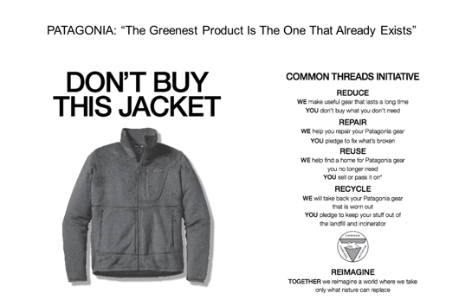

Figure 2 -Patagonia Ad Campaign (CB Insights, 2021)
The business model that they use is different to many clothing manufacturers. They reject fast fashion and opt for high quality long lasting items to help change consumer behaviour. Patagonia attracts customers who identify as both fashionable and concerned about the environment. The heart of the company is to make a pledge between themselves and the consumer to use clothing more sustainably, consume less and to focus on the four R’s reduce, repair, resale and recycle. Patagonia offer their customers a lifetime guarantee on all of their clothing and equipment, and considering the environment their products are used in, is exceptional. They ensure that their customers are satisfied and impressed with their products and in turn become a lifelong customer.
Deceptive marketing campaigns
There have been many advertising campaigns that have been released which have caused controversy. Marketing campaigns that aim to promote a product or service to the consumers that doesn’t provide them with all or purposely hides information is considered to be unethical, as consumers could be left with a product that they don’t need or want.
German car manufacture Volkswagen is one of the top names in the business, 2014 saw them beat previous records and produce a profit of €12.7 billion (Volkswagen, 2014). Since 2009 the company had embarked on a worldwide campaign to promote clean diesel vehicles. Many of their advertisements focused on debunking the myths surrounding clean diesel making it an appealing alternative to existing diesel VW owners and new customers.
In 2014 and 2015 saw possibly one of their most effective and memorable advertisement series, “Old Wives Tales”. The series of advertisements followed three older ladies discussing the myths surrounding the new clean diesel models manufactured by Volkswagen. In one episode saw them tackle the issue that diesel is dirty. After two of the ladies claimed that diesel is dirty the third lady, (the owner of the new Volkswagen) takes off her white scarf and places it close to the vehicles exhaust to prove its cleanliness. The advert ends with the slogan, like really clean diesel, which echoed the statements made at the time that the highly refined diesel fuel used in the vehicles improved combustion efficiency and reduced harmful emissions, a claim that would see them sell approximately 11 million vehicles worldwide.
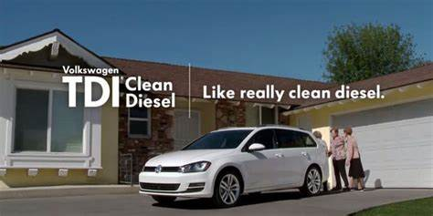
Figure 3 -Volkswagen Ad (Driving, 2015)

However, in 2015 a group of researchers at West Virginia University uncovered one of the biggest frauds in automotive history. Arvind Thiruvengadam, a research assistant professor, and his team tested Volkswagen’s clean diesel cars and found discrepancies in the expected emissions level and passed their finding over to the Environmental Protection Agency (EPA) in the United States of America. After many investigations conducted by the California Air Resources Board (CARB) and the EPA, Volkswagen insisted that the discrepancies where due to a technical issue, they never admitted to any cheating until they were told that their 2016 clean diesel vehicles would not be approved for sale in the U.S. Following this the company finally admitted that they had fitted the vehicles with illegal emission defeat devices designed to mask the emissions during vehicle tests such as MOT’s.
The scandal was a marketing and ethical nightmare for the company, a brand that had built their reputation on reliability. All of their clean diesel marketing ads were removed from social media platforms and mainstream media. Volkswagen where officially charged in the U.S and many other countries worldwide for deceiving consumers with the ‘Clean Diesel’ campaign.
In an article written by Eric Lane, Volkswagen, and the high-tech greenwashing (2016), he claims that Volkswagen are guilty of greenwashing but not in the way we have come to expect. The new trend of high-tech greenwashing within the automotive industry is nothing new, it has been happening for years with regards to misleading information on miles per gallon advertised on vehicles. However, he claimed that using technology to deceive consumers is “more insidious and disturbing than typical greenwashing cases because the entire deception is cloaked in technology” (Lane, 2016). Consumers believed that they were being a more economically friendly vehicle when in reality they’re purchase was up to forty times more harmful to the environment than they were led to believe.
Since the scandal dubbed by the media as ‘Diesel-Gate’ has broken it has cost the company £26billion worldwide in fines, compensation, civil settlements and buy back schemes. A scandal of this size many would have thought that would be the end of Volkswagen. However, in 2021 Volkswagen is still trading and making record profits with the company being worth an approximately £440billion. The company have had to work hard to regain the trust of their customers.
Advertising to children and young people
The Advertising Standards Authority (ASA) have set out separate codes for broadcast and non-broadcast advertisements, but all adverts are expected to be “legal, honest and truthful” (Advertising Standards Agency , 2022). These codes contain strict rules to protect children and young people from misleading, harmful, or offensive material. These rules are in place to protect children they are inexperienced and can become easy prey for big companies. Saturday morning television is full of advertisements aimed at children and many parents will know that all of these ads can create a conflict between the child and parent.
Stereotypical marketing is very common in advertisements involving children. The Gap came under fire in 2016 when a marketing email a sent out to subscribed customers, caused anger and disappointment due to the stereotypes in the ad. Many people took to social media platforms to comment and complain about the ‘damaging’ gender biases of boys being grouped as ‘the little scholar’ and girls ‘the social butterfly’. Those who complained asked the company to acknowledge that for many years gender biases have been holding back girls and women in the classroom and that advertisements like this try to reinforce that boys are clever a girls are a social.
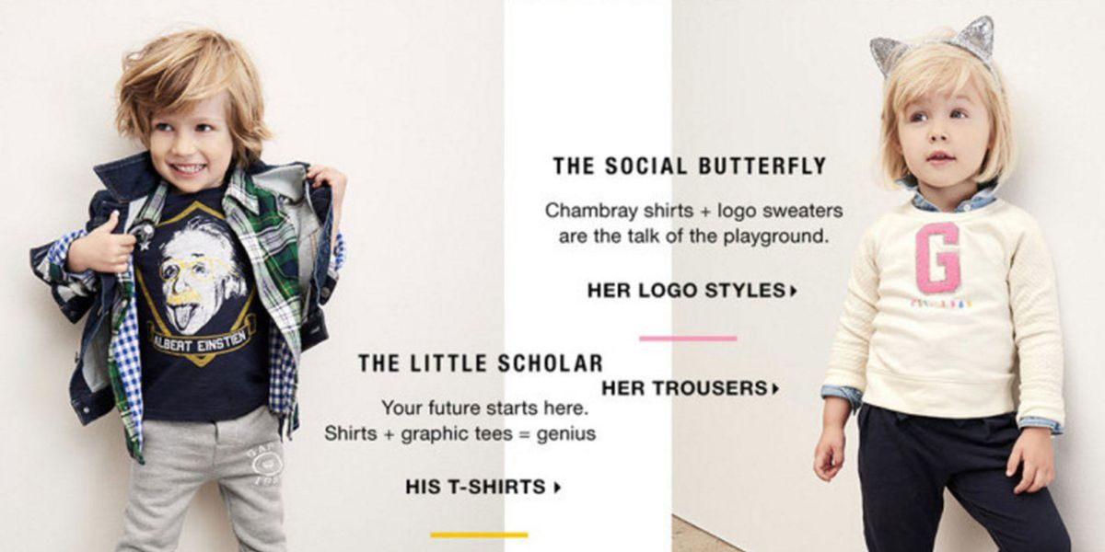
Figure 4 - The Gap (Tongo, 2016)
In response to the criticism The Gap called that their intensions where to celebrate all children and they did not mean to offend anyone with their new campaign. There are many groups and charities, such as The Children’s Society that use social media platforms with their own marketing campaigns that aim to provide people with the knowledge of these stereotypical adverts and how we as consumers can get together to stop the ‘big businesses’ from continuing participate in these types of campaigns.
Conclusion
Marketing has evolved and is ever changing. From the rules and regulations that are needed to be followed to the way we see, read, and hear marketing campaigns. Consumers are more aware now than ever of the climate challenges our world is facing and are expecting businesses to be more ethical and sustainable towards our planet. In the future, things will continue to change, and businesses need to be ready for this. By keeping on top of any changes in regulations and social aspects.

