  CAE & Stress analysis  M5x02064 | Peter Temple (1809106) B Eng. Mechanical and Manufacturing

Table of Contents
Table of Contents 2
Introduction 3
FEA & Motion analysis 4
Motion Analysis of a Gear Chain assembly 5
Conclusion 9
https://uowtsd-my.sharepoint.com/:f:/g/personal/1809106_student_uwtsd_ac_uk/Eu4HXLSvtltOn1VIJbzalkgBSMKNxB5vgTuCtzUQlkkCcQ?e=iv08j1 9
Reference list 10
Bibliography 11
Appendix 1 – 6 DEGREES OF FREDOM & REDUNDANT MATES 11

Introduction
In recent years big improvements in CAD has led to a big change in how prototyping is carried out. Old methods required physical prototypes to be produced to allow testing to be carried out on them, this was a high cost and time consuming process.
CAD is now the engineers choice for prototype development as the tool available to them such as FEA and Motion simulation allow them to design and test prototypes accurately in relatively small times scales and at a massively reduced cost. These tools allow for better designed and tested products.

FEA & Motion analysis
The FEA Method is a numerical technique, which divides complex structures to small elements, meaning the stress and strain distribution of each element can be calculated instead of each complex structure (Lambros S. Athanasiou, 2017).
The Finite Element Analysis (FEA) is the simulation of any given component or assembly using a numerical technique called Finite Element Method (FEM). Engineers can use it to reduce the amount of physical prototypes that have to be produced while also being able to optimize components in their design phase and hence developing better products, in less time and saving on cost of prototype production and testing (www.simscale.com, 2020).
FEA Based simulations are used to serve different purposes to aid design. Two basic design activities design analysis and design synthesis. In design analysis, all the design variables and system design are given and FEA model is to find/record responses to external loads which is commonly referred to as “What if simulation”. In design synthesis design variables are given as changeable ranges rather than values and are applied to evaluate responses of a system. Design Studies are simulation based design synthesis and the same model is executed repeatedly under different conditions to find the best outcomes and design goals (Zhuming, Bi, 2018).
Motion analysis can be used for accurately simulating and analyzing effects of motion which include motors, forces, springs, dampers and friction on an assembly. Motion analysis uses computationally strong solvers and accounts for material properties as well as mass and inertia in its calculations. You can also use this to plot simulation results (Mojarad. Saeed,2018).
The motion simulation simply evaluates how the product will perform through its operational cycle and it allows engineers to visualise the product moving as it would in the real world. This allows the engineers to correctly Spec Motor size for example and also ensures the product is to a good standard to ensure performance, quality and safety (solidsolutions.co.uk,2020).
Both FEA and motion simulation have their limitations. FEA cannot analyze mechanisms as mechanism components move as rigid body which is something FEA cannot process. This means that the mechanism moves without experiencing deformation. Motion analysis assumes mechanical components are rigid so deformations and stresses cannot be considered. FEA studies deformable, stationary components but cannot do anything with rigid body motion (Kurowski. Paul , 2018).

Figure 1- Comparison table
CAN ANALYZE | FEA | MOTION
Structures | Yes | No
Mechanisms | No | Yes
Deformations and stresses | Yes | No
Vibration | Yes | No
Models with rigid body motions | No* | Yes
Models with meshes | Yes | No
Models prepared in CAD | Yes | Yes
(Kurowski. Paul, 2018)

Motion Analysis of a Gear Chain assembly

Using the Solid works software 2018-2019 version, a gear chain assembly was created. The basic principle of this was an input shaft with 1st and 2nd gears on it and also a moving gear assembly to enable gear changes. There was also an output shaft with two gears on, which depending on which gear was engaged on the input shaft would drive the output shaft at a different speed. To enable this performance to be tested a Motion analysis study was carried out.
When running a motion study, to be able to aquire accurate results the programme requires accurate mating relationships. During the assembly process it is easy to over constrain it and in doing resistricting its six degrees of freedom and also creating mate reduncies.
Six degrees of freedom is a specific parameter count for the number of degrees of freedom an object has in three-dimensional space. It means that there are six parameters or ways that the body can move. (techopedia.com,2019).
Redundancies then happen when multiple mates remove the same DOF on a part (see Appendix 1). To check how many redundancies that were present in the Gear assembly after an initial motion analysis was run, next to the mates in brackets states this. Initially there were 36 redundant mates present in my assembly and for the motion study to run properly and calculate accurate results this needed to be reduced.
One good way of reducing redundancies is to remove mates that are not important to the assembly by creating Rigid Groups. This capability can be used, for instance, where a set of parts are in the Motion study that do not move with respect to each other. If they are included in the Motion, all the mates that they are associated with will be solved and included in the redundancy calculations. However, if they are added to a 'Rigid Group' then the mates between them are ignored (Fulcher. Andy, 2020).
Also to reduce the number of redundant mates the use of hinge mates can be used. This type of mate limits the movement between two components to one degree of freedom and has the same effect as having a concentric and a coincident mate together. The main advantages of using a hinge mate is that you use only one mate instead of two, and when using motion studies it greatly reduces the amount of redundant mates as the results are associated with the hinge mate and not a concentric and coincident mate (help.solidworks.com,2018).
Another way to reduce mates further is by using bushings. Solid works gives you an option to replace redundant mates with bushings. This is not recommended as this can induce faults and add bushings to mates that in real life would not be able to be bushed. Using a bush is like using a flexible mate but you must set the stiffness to gain more accurate results. This form of mate redundancy should only be used when the other methods discussed fail as bushings can also increase motion simulation timings.
When running the motion simulation the input shaft was required to turn, the middle gear changer unit was required to move from side to side to engage 1st or 2nd gears. This input shaft was then expected to drive the output shaft in either 1st or 2nd gear. The motion study was carried out over a 10 second period a motor was used on the input shaft where the motor coupling would normally be sitting, this then would spin the input shaft and the gear change unit at a constant speed of 100rpm but at this point 1st and 2nd gears on the input haft would not be driving so hence the output shaft would also be stationary. To enable the output shaft to turn solid body contacts were used between 1st and 2nd input/output gears and also between the input 1st/2nd gears and the gear change unit. This would allow drive to be transmitted from the turning gear change unit to the 1st/2nd gears on the input shaft through the drive tangs on each gear. Once the input gear is now driving the solid body contact between the input/out gears now allows the output shaft to turn due to the gear mesh created by the solid body contact. For this to happen the gear shift unit must move linearly between the first and second input gears(to change gear), a linear motor was applied to do this. The linear motor was set up to move a distance instead of a constant speed it was also set up to only be active(drive the gear chain unit) at a specific time band in the motion study. This the allowed the 1st gear to drive for a period of time, gear change and then into second gear. Multiple linear motors could be used for continuous gear changes between 1st/2nd gear, but for this to happen they must be turned on/off individually at set times as you could not have more than one linear motor running on the same component at the same time.
Once the redundant mates where reduced to an acceptable level (under 10) and conditions for the motion study were in place (drives and contacts) as Motion study was undertaken of the Gear chain, including a gear change. I reduced the redundant mates in the motion study by using rigid groups and there for only having the moving parts considered study, hinge mates instead of concentric and coincident mates and also by adding bushings where required. Once the motion simulation was carried out a plot was created to show the angular velocity of the output shaft where the output sprocket would be.
Figure 2 – Plot from the Motion Analysis. (25 fps)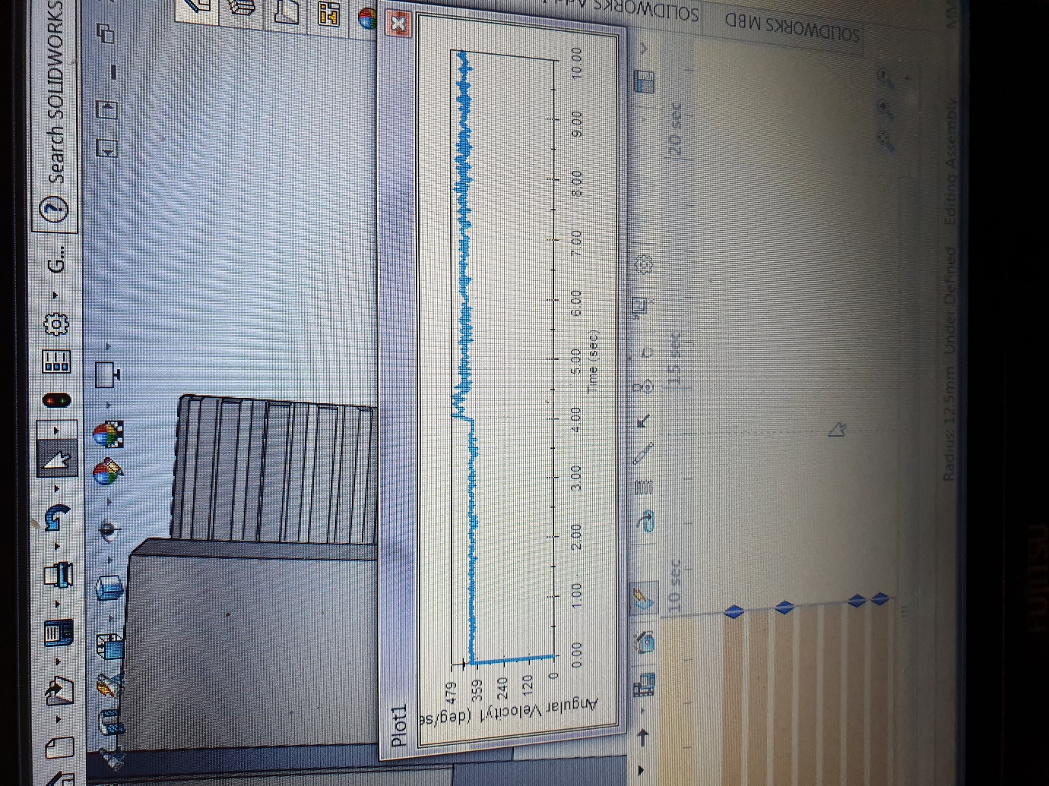
From the plot above you can see where 1st gear has been engaged then at 4 seconds the gear change has happened and now 2nd gear has been engaged. And now the angular velocity of the output shaft has increased slightly.
When looking at the plot, I found the plot line lumpy. To obtain better results I increase the frame rate from 25 to 100 frames per second. This then should plot more data points allowing the graph to potentially smooth out.

Figure 3 – Plot at 100 frames per second
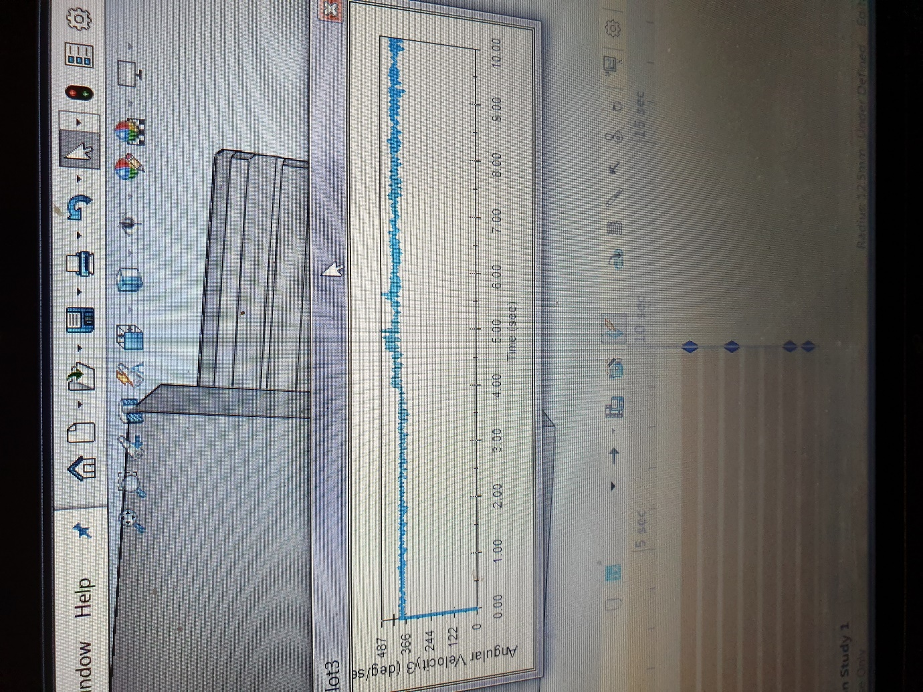
A slight improvement can be seen by increasing the frame rate as the graph plot line appears to be smoother especially around the gear change area of 4 seconds.
A gear box housing was also modelled to contain the gear assembly. When modelling around assemblies the use of solid works equations can be beneficial if used correctly. Using Solid works equation capabilities it possible to define your sketch, model geometry and establish relationships/constraints through equations. This is useful in engineering as many systems rely on ratios and dynamic relationships (Keane. Phillip,2019).
The gearbox was designed as a sealed unit so that oil used to lubricate the gears will not escape and also other contaminants outside of the gearbox cannot getting to the bearings or into the lubrication. Also end cap spacers were fitted on the Non drive side bearings to ensure no float of the shafts and they sit in the correct position. With a slight space for thermal expansion. The size of the gearbox was designed so that it does not take up excessive room. The solid works files can be accessed on the link below.

Conclusion
FEA and Motion simulation can be used to analyse different scenarios. FEA is good for analysing structures and how they deform under given conditions set up by the user and implemented by the Computer programme but it cannot carry out analysis on mechanisms as they are treated as a rigid body with no deformations. The Motion simulation is used for carrying out simulations on mechanisms. Motion simulation was used on the 1st and 2nd gear assembly to record the change in angular velocity between the two gears. To enable the motion simulation to run and obtain accurate results, the amount of redundant mates had to be reduced down using various methods such as rigid body groups, hinge mates and bushings the is all based on the 6 degrees of freedom theory.
With out the CAD motion analysis this would have to be carried out by a physical prototype which would be time consuming and costly.

https://uowtsd-my.sharepoint.com/:f:/g/personal/1809106_student_uwtsd_ac_uk/Eu4HXLSvtltOn1VIJbzalkgBSMKNxB5vgTuCtzUQlkkCcQ?e=iv08j1

Reference list
help.solidworks.com (2018), Hing Mates [online] available at
http://help.solidworks.com/2018/english/solidworks/motionstudies/t_hinge_mates.htm
Keane, Phillip. (2019),Global variables and equations in driven designs [online] available at
https://www.engineersrule.com/global-variables-and-equation-driven-design/
Kurowski, Paul. (2018), A closer look at motion analysis [online] available at
https://www.machinedesign.com/archive/article/21816774/a-closer-look-at-motion-analysis
Lambros, S. Athanasiou. (2017), Atherosclerotic Plaque Characterization Methods Based on Coronary Imaging [online] available at
https://www.sciencedirect.com/topics/engineering/finite-element-analysis
Saeed, Mojarad. (2018), Motion Simulation in SOLIDWORKS [online] available at
https://www.javelin-tech.com/blog/2018/02/solidworks-motion-simulation/
www.simscale.com 2020, what-is-fea-finite-element-analysis [online] available at
https://www.simscale.com/docs/simwiki/fea-finite-element-analysis/what-is-fea-finite-element-analysis/
www.solidsolutions.co.uk (2020), Motion Simulation [online] available at
https://www.solidsolutions.co.uk/solidworks/simulation/features/motion.aspx 2020
www.techopedia.com (2019), Six Degrees of freedom [online] available at
https://www.techopedia.com/definition/12702/six-degrees-of-freedom-6dof
Zhuming, Bi. (2018), Finite Element Analysis Applications [online] available at
https://www.sciencedirect.com/topics/engineering/finite-element-analysis

Bibliography
blogs.solidworks.com (2019), Glodal variables and Equations [ online] available at
https://blogs.solidworks.com/tech/2014/12/solidworks-quick-tip-global-variables-and-equations.html

cadbooster.com (2019), how to use equations in solid works [online] available at
https://cadbooster.com/how-to-use-equations-in-solidworks-basics-advanced/

Appendix 1 – 6 DEGREES OF FREDOM & REDUNDANT MATES
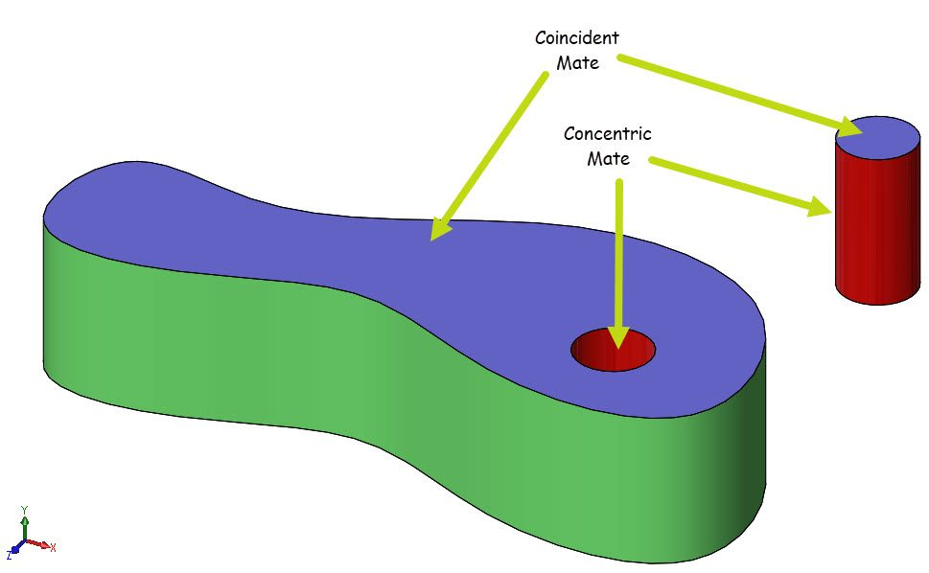

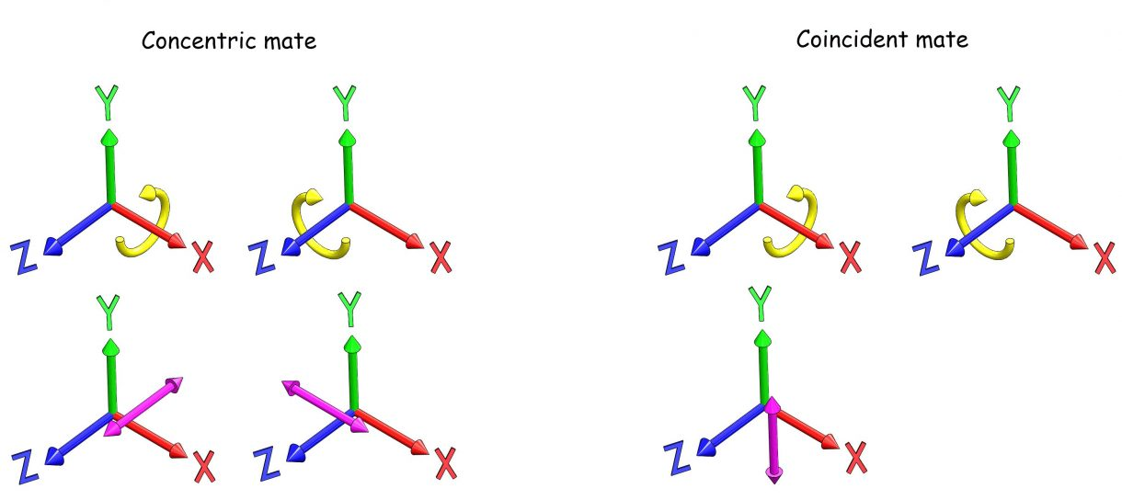
(Saeed Mojarad,2018)
The concentric mate removes 4 degrees of freedom and the Coincident mate removes 3. 7 degrees of freedom are removed from a possible 6. This leads to over constraining the system and redundant constraints are created. The problem with this is that solid works will remove once of the redundant constraints but it might not remove the right one (Saeed Mojarad,2018).

