1. E-PORTFOLIO ACCESS DETAILS

E-Portfolio Platform: Google Sites
Direct Link to Homepage: [Paste Link Here]
Screenshot of Homepage:

2. TASK 1 – IEEE REFERENCING & ESSENTIAL SKILLS
Topic: Essential Skills for Computing Study & Employment

The modern computing and digital workplace demand a balance of technical knowledge and transferable skills to succeed. Key competencies include digital literacy, critical thinking, clear communication, time management, problem-solving, and information literacy. For students on the CertHE Computing course, these skills are essential not only for producing high-quality academic work but also for adapting to the fast-changing technology sector.

Developing strong research and referencing skills ensures academic integrity and helps avoid plagiarism — a fundamental requirement in higher education [4]. In employment, employers consistently prioritise adaptability, teamwork, and the ability to learn new tools and systems quickly. Digital literacy also supports safe and responsible use of technology, protecting data and following professional standards [3].

Task 2
TASK 2 – COLLABORATIVE TEAMWORK & ACADEMIC POSTER

2a Teamwork Mind Map

Central Theme: Effective Teamwork

- Communication: Clear dialogue, active listening, regular updates
​
- Roles & Goals: Clear responsibilities, shared objectives, agreed deadlines
​
- Tools: MS Teams, Zoom, Google Workspace, Mind Meister
​
- Problem Solving: Resolve conflict early, respect different views
​
- Environment: Trust, respect, inclusion, shared accountability

Team Details:​
- Process: We used Mind Meister to build the map, MS Teams for meetings, and OneDrive for sharing resources. We met twice online to agree content and finalise the work.

Figure 2: Effective Teamwork Mind Map

TASK 3 – AUTOMATIC REFERENCING TOOL

3a Topic Summary: Virtual Collaboration

Virtual collaboration refers to working together across distances using digital technologies to communicate, share information, and complete shared tasks In higher education and modern workplaces, it has become a standard way of working, especially in computing and IT fields where projects often involve distributed teams

Common tools used today include Microsoft Teams, Zoom, Google Workspace, Slack, and cloud storage platforms such as OneDrive and Google Drive [3]. These tools support real-time communication, file sharing, co-editing of documents, and task management, removing barriers of location and time zones. The main benefits include greater flexibility, access to a wider range of expertise, reduced travel costs, and the ability to continue working during disruptions

However, virtual collaboration also brings challenges. These include delays in communication, technical issues, difficulties in building trust, and the risk of misinterpretation when messages lack tone and body language. To work effectively virtually, teams need clear guidelines, agreed schedules, regular check-ins, and shared protocols for information security and data management

For students, learning how to collaborate virtually is essential for academic success and future employment. It also highlights the importance of good information management and referencing tools — such as RefWorks — which help organise sources, maintain academic integrity, and save time when writing assignments

Task 4 Review Statement

I have built my e-portfolio using Google Sites, a free cloud-based platform from Google. It was chosen because it is simple to navigate, requires no special software, and allows me to organise content into clear pages and sections. It supports embedding text, images, links, and PDF files, and I can easily set permissions so tutors can view all work without needing an account. This tool demonstrates practical digital literacy and content management skills, which are relevant to both study and future employment.

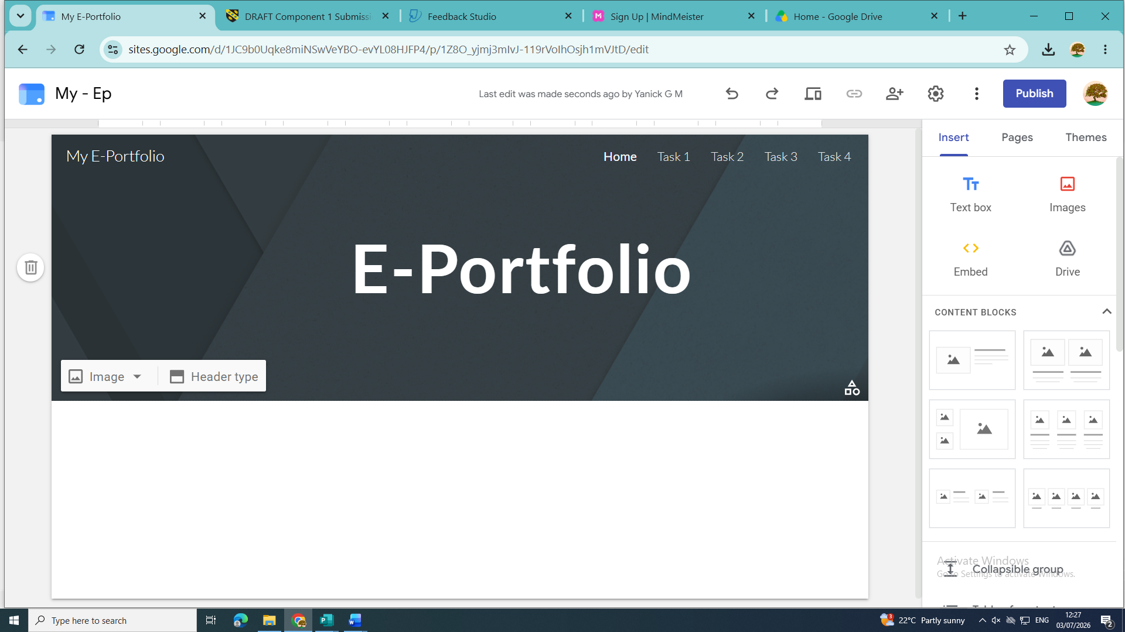

This is screenshot of the main page

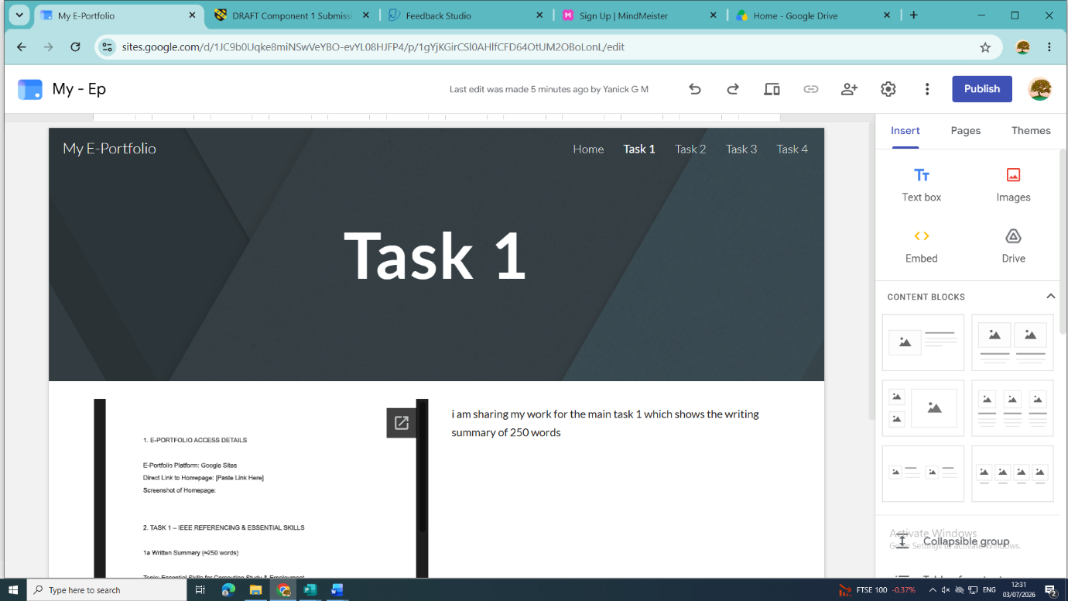

Within this screenshot it shows the first task which is task 1

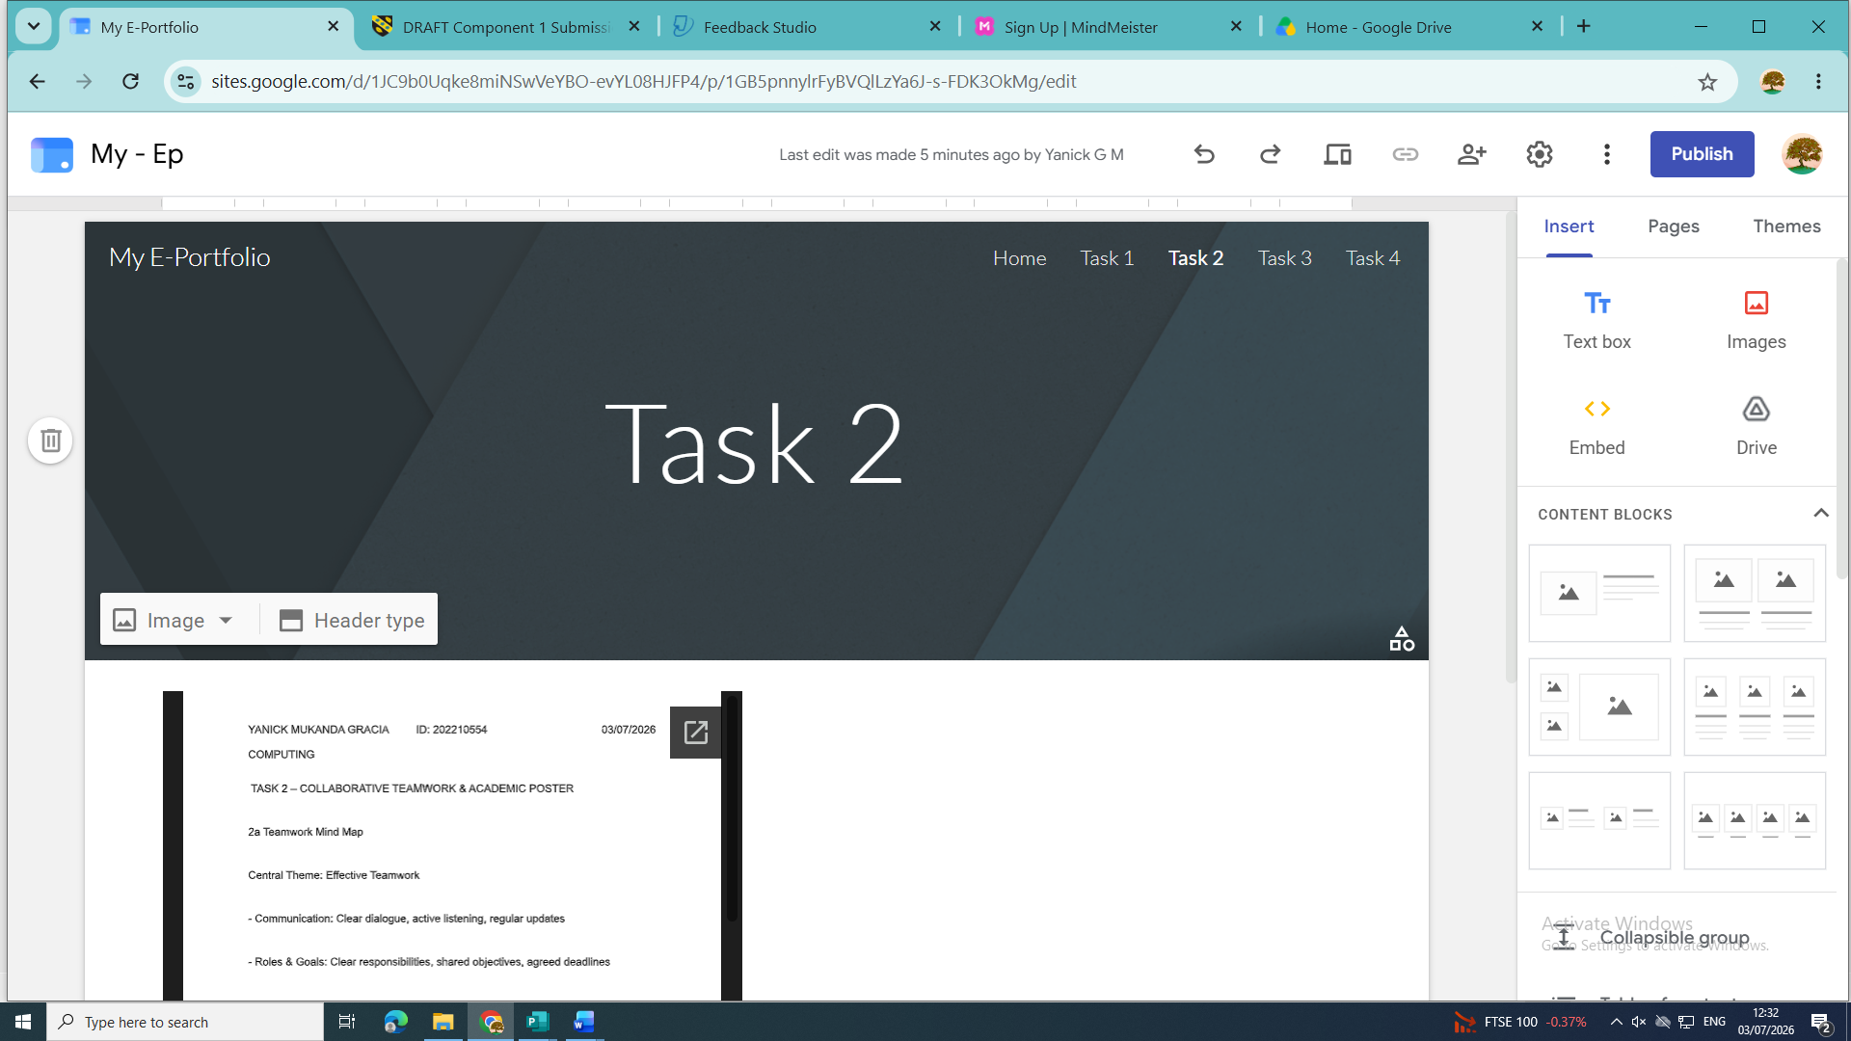

I have also included a new task on another page which is task 2

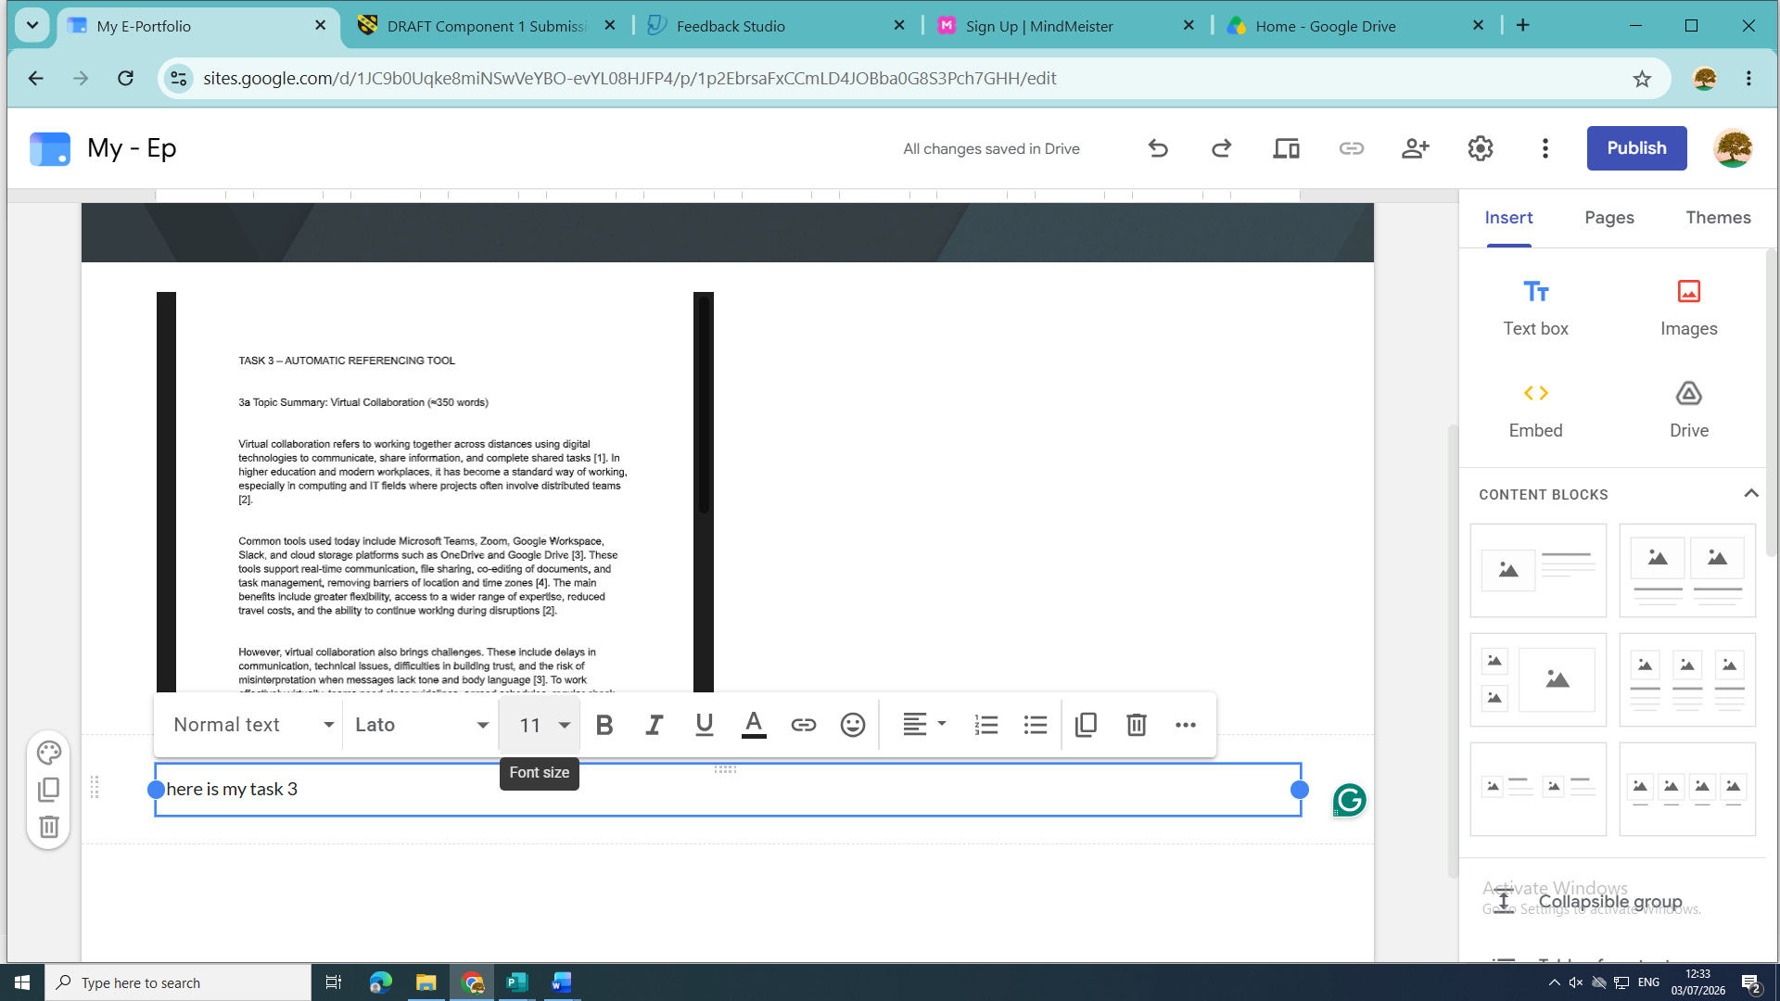

New task 3 page

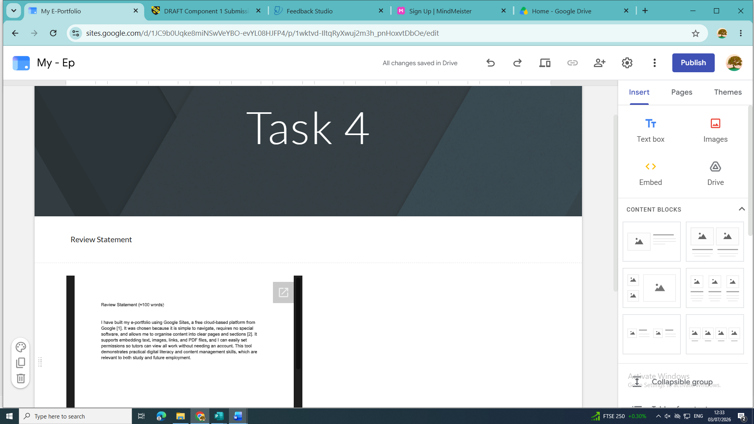

Task 4 the final page review I have tested all the page, and I have concluded that all pages meet my expectations and with my acknowledgement all pages are functional please find attached link of the page

https://sites.google.com/d/1JC9b0Uqke8miNSwVeYBO-evYL08HJFP4/p/1Z8O_yjmj3mIvJ-119rVoIhOsjh1mVJtD/edit

