Professional Career Development
Student name: Sayed Miah
Student number: 1707658
Lecturer: Mary March

Introduction
My name is Sayed Miah. I am 46 years old. I am married and I have 2 children; one is 18 and one is 10. I started work when I was 17 years old in a family business which was an Indian restaurant. I had worked there for over 20 years in which in which I was a waiter. During those times as a waiter I had learnt many skills due to the dynamic business environment. However we sold the business which we had this established business for 36 years. On the other hand, we had another small restaurant which we ran for 10 years after selling our restaurant. However, this location was not ideal to run a fully established business therefore we had to sell this one as well. Currently I am working part time in my close friend’s restaurant.
I chose to study now because I have time in my hands and to gain more valuable knowledge about how various workplaces function. Also, by me studying this will motivate my children to push further on in education. University of Wales Trinity Saint David of London, I chose this university because it was recommended by a friend who’s attending there at this moment and I found this university very interesting through its website and its positive reviews. This was ideal for me because this course would help me in the future to start my own restaurant.
Due to this course I have gained more guidance for my future professional career development. I have learnt about SWOT analysis in which I can now identify my personal strengths, weaknesses, opportunities and threats. Therefore, I can identify and improve problems in my future restaurant.
What employers want?
According to Cottrell (2013), the employers want an easy pathway when they are employing others to go work for their business. The employers want to employ others who have the most skill and who has the most amount of training due to this would save them money because less costs will go to training them. Also, the employee should be capable of doing jobs within the business with the least amount of help due to this would show that they are competent in the work. The employee should also be knowledgeable about the company they are working in because they will be able to incorporate effective and relevant ideas towards the business to make it a success. The employer should consider the employees previous experience so they will have a better understanding of how to cope within that certain type of business.
There are specific skills which the employee should exhibit if wanting a role at the business. Soft skills are difficult to measure but is a fundamental part within the working environment. Verbal communication is one type of soft skill which involves communicating through speaking, this skill is essential in the working environment due to a business runs through effective communication and if you do not have good verbal communication then there would be a high chance of misunderstanding. Another skill which would be key when finding an employee would be good problem solving skills. Nearly all business have their problems and this would need the employees to find a solution in which by having this key skill they will be able find a solution and improve the business without jeopardising the business. Also, by having efficient team working skills this would allow a good rapport between staff members due to they are able to work together properly without any arguments. This leads on to having positive skills about sharing knowledge to one another. By having this skill you will be able to improve the business because you will other various ideas in which you can make multiple ideas which would benefit the business all because of sharing knowledge. This also builds trust. By having good listening skills this would allow ideas to be properly processed, improved and then can be applied to the business. As well as this, it prevents misunderstandings between staff members. An employee who has a skill which can influence others is very important because it will improve the other employees around them making them more knowledgeable and more understanding of the business. This also would motivate them to work better and harder at work, making the business better.

As a businessman there are certain qualities that the staff members should have if wanting to enter the business industry. Firstly, they should be hard working due to without without this high work rate then the business will not succeed as much. All businesses consist of many workers who will have to communicate and work together therefore you will need to have good team working skills. By having this your workers will work in sync which would allow them to solve problems efficiently together. This leads to having good communication skills; this is crucial due to it prevents misunderstanding and arguments which is important for a business to succeed. Another quality which employees should have is relevant experience. So they will know how the business industry functions in and out of the place in which they could verbally and visually give valuable information that they got from previous jobs which would improve your own business. Being punctual to work is very important due to this shows how serious the staff member is to work in this business.
The employee should be honest about aspect of the business. Therefore, this could improve the business because by being honest they could state problems of specific ideas in which then we could work and improve on. Also, by having good auditory skills the employee can listen and apply the ideas towards the business other than not listening clearly can applying inappropriate aspects to the business. The employee should also integrate towards the other staff members so there would be a good understanding towards one another and also it would make them feel more comfortable. The workers should be safe not reckless due to this would harm other workers and customers around them therefore the employee should be cautious and safe.
The idea that I can start my own business after completing this course motivates me to carry on. Also, the idea that if I do well in this course it would make my family and especially my kids proud of me in which this would motivate them to accomplish their dream like I am doing now with this course. I am mentally strong and determined to do my best in this course because the end goal of having a business is my life achievement.

Self-evaluation
The Kolb cycle was published by David Kolb in 1984 which consists of a four-stage cycle of learning and four separate learning styles. Most of this cycle is focused with the learner’s mental processes.
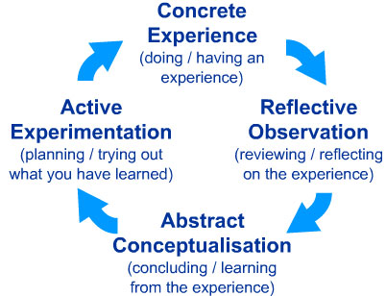
McLeod, S. A. (2017). Kolb - learning styles. Retrieved from www.simplypsychology.org/learning-kolb.html

Individual can learn on different way through experience, reflection, planning and doing it (Maund et al, 2017)
SWOT analysis
According to (Morgan, 2017), SWOT analysis is used to check how equipped you are for the upcoming task. This analysis shows you the main problem of the issue.
S- Strength (positives about yourself)
W- Weakness (flaws about yourself)
O- Opportunities (possible positive things to happen)
T- Threat (Anything that might disrupt your goals)

Personal SWOT analysis on putting up a restaurant

Review of world of employment

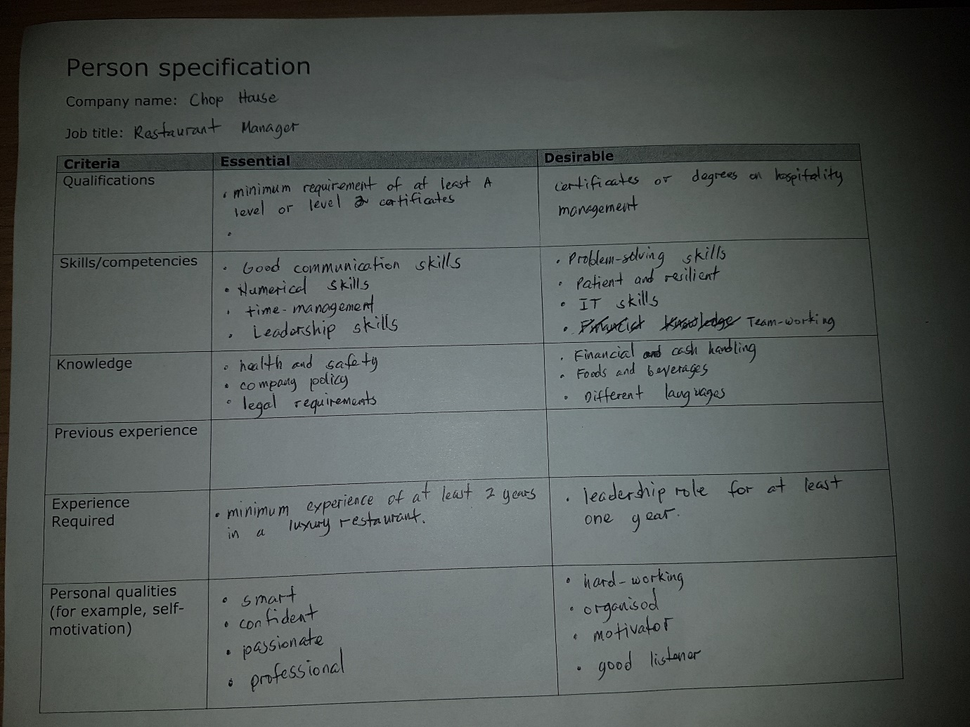
From appendix A, it is important that the candidate has the necessary requirement to apply for a job. If I am going to be an entrepreneur of a restaurant, I should have at least a good training in management skills. On the other side of qualification, it is desirable to have degrees on business management. In my case, I am studying level 4 certificate of higher education in the work place. And understanding on opening and also running restaurants.

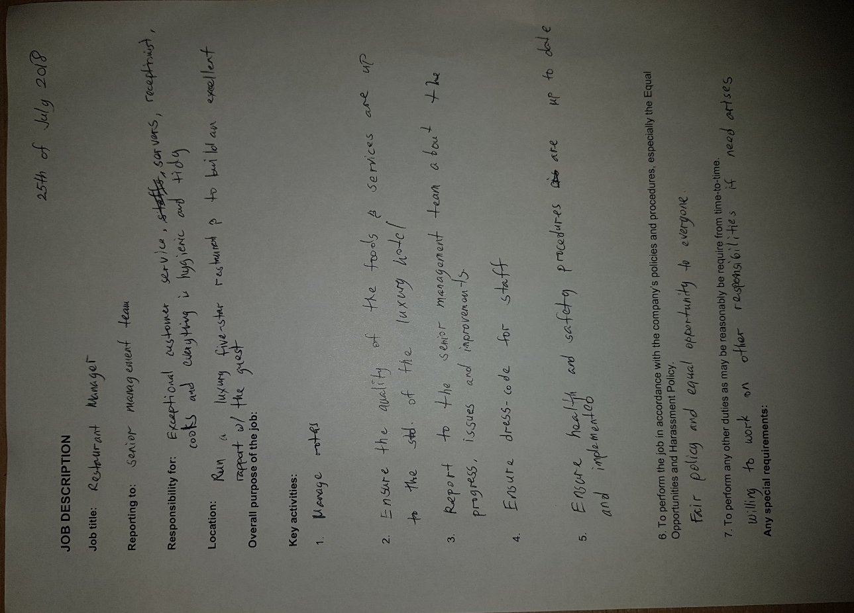

On running a restaurant business in the future, I need to identify my responsibilities, good purpose and key activities. By analysing appendix B, an application for a best manager needs to identify roles and activities including skills, I have more in depth knowledge on having a successful restaurant business due to the skills that I need are identified.

Personal development planning
I have clear goals and aspirations of what I am going to get after this course which will be my own business. This is because I now know many skills and traits of how to sustain and manage a business appropriately due to this course. I have good time management skills in which I can use time appropriately in a business environment. Within the business industry every staff member should be there on time and I am the type of person who believes punctuality is key to a business therefore I always arrive on time. This shows my dedication towards the business I am working at. There are many elements in a business which needs to be handled such as supplies in which those stages have to be sorted within a manageable time period. This I can easily handle through identifying which task is more difficult in which I will give the staff more time to sort out. Therefore, this shows my efficient time management skills I can apply to any business I work in.
To be successful in a business you have to be motivated (Cortrell, 2010). However, I lack in motivation which this could bring my employers and business down with it. But for me to motivate myself I would think of the positive long term goals which could be achieved if I carried on with a positive mind-set during my time in the business. These long term goals would be motivating my kids to strive in education and have a bright future and also a sense of achievement within myself due to all the hard work would have paid off.
I have very good inter-personal skills which is fundamental within a business. I had worked in multiple business since a young age and these experiences have made my communication skills impeccable. By me having these good skills this would reduce the likelihood of misunderstanding between staff members therefore this would make my instructions clear so work would be functioning efficiently.
When a problem occurs I can work calmly and efficiently around this problem. Therefore my problem solving ability is quite good due to I now know the various problem that can arise within a business in which I will know the solution to solve this problem so that it won’t happen again. Problems are vital to a business due to it shows the flaws about the business in which I can identify and solve thus making my business more successful.
I am quite creative in my thinking in which I can think of ideas to improve my business which no other competing business would not have thought of. Therefore, my creative thinking would gave the business an edge in which this would the business successful. However, I am the type of person who does not take many risk which would somehow improve the business. This is because there will be a high chance for something to go completely wrong in which this would jeopardize the business. But this risk could dramatically help the business therefore I should take risk at times due to this risk could be the one which would make the business a huge success.
I am the type of person who can easily build rapport with other staff members. By me building this strong relationship this would also bring trust between on another which this is key for a business to function properly. Also I can work in teams well due to I have good listening skills and can develop others team members ideas. I can even take constructive criticisms due to this would improve my suggestions. By me being able to work in teams appropriately this would help me a lot when going into a business due to within all business team work is fundamental for the business to function.
I can deal with difficult staff members due to I have strong presence in the working environment and I show my authority towards the person in which they will listen to the instructions I give. This would lead to my good leadership skills I have towards people. People listen to my ideas and they all show respect to me. Even those are key attributes of being a leader, there other others which most people don’t show: showing respect to staff members and loyalty towards the business.
Many businesses change dramatically as in themes due to different societal demands. However, a negative aspect about me is that I am the type of person who doesn’t change dramatically even if society is changing. This would make my business very unsuccessful. For the business to be successful I have to allow changes to my business according to societal demands and changes.
All business have competing rivals which want to do better than the other. I have a high level of competiveness in which this will elevate the business to be better than the other business in which this competiveness I have will make the business a success. This is a positive trait about me due to being competitive this will motivate me to improve the business and therefore it will be a success.

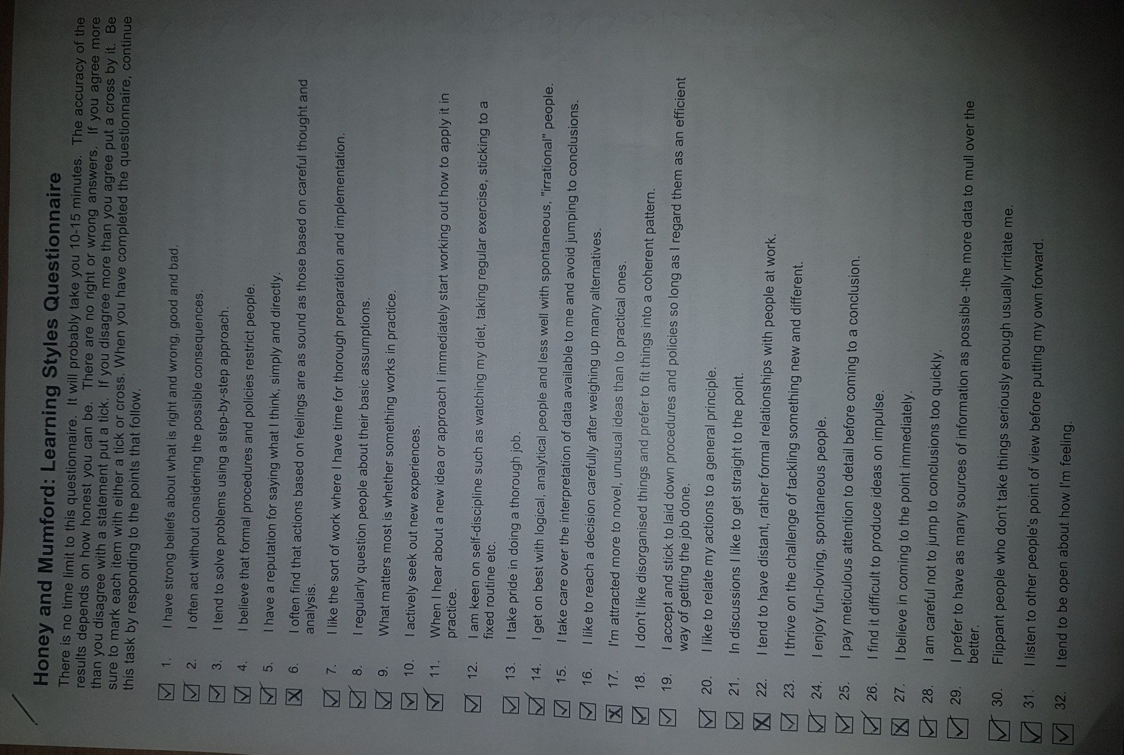

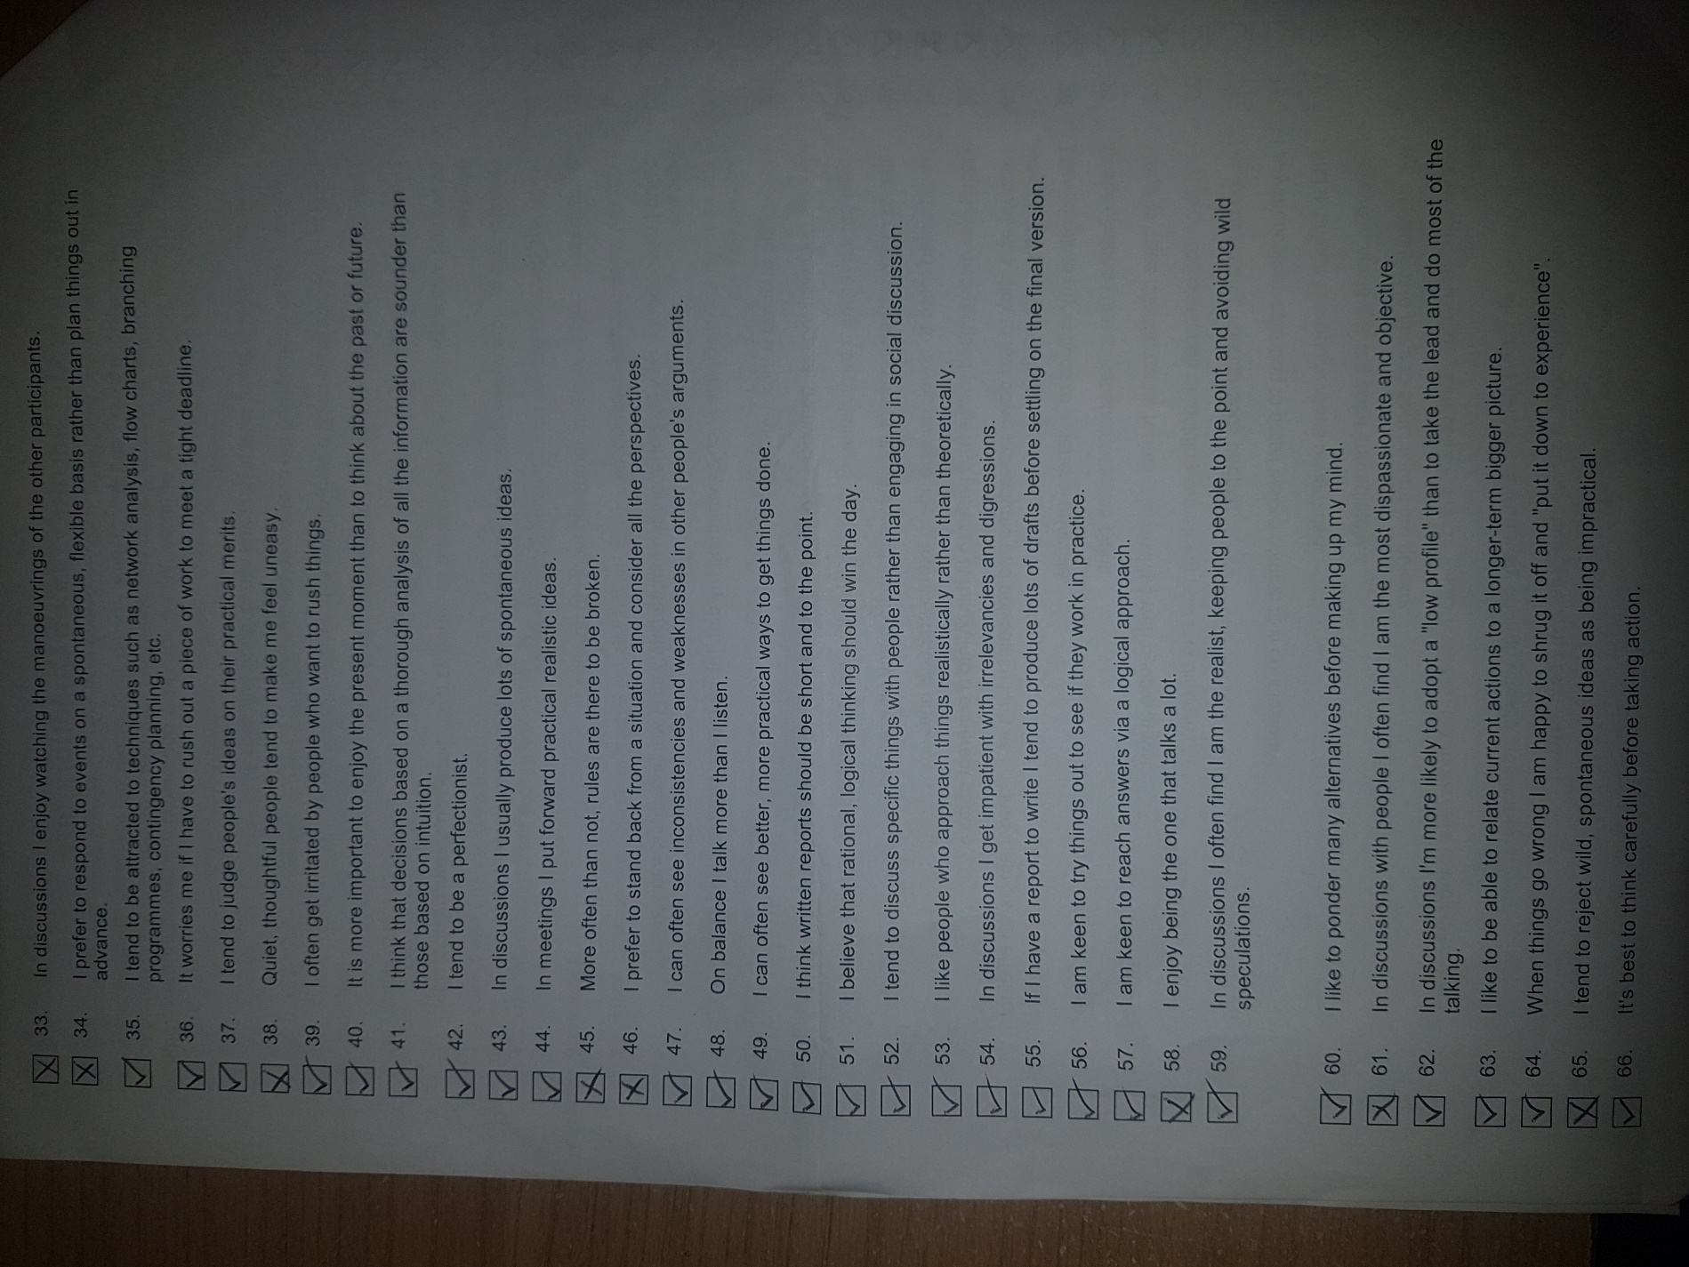

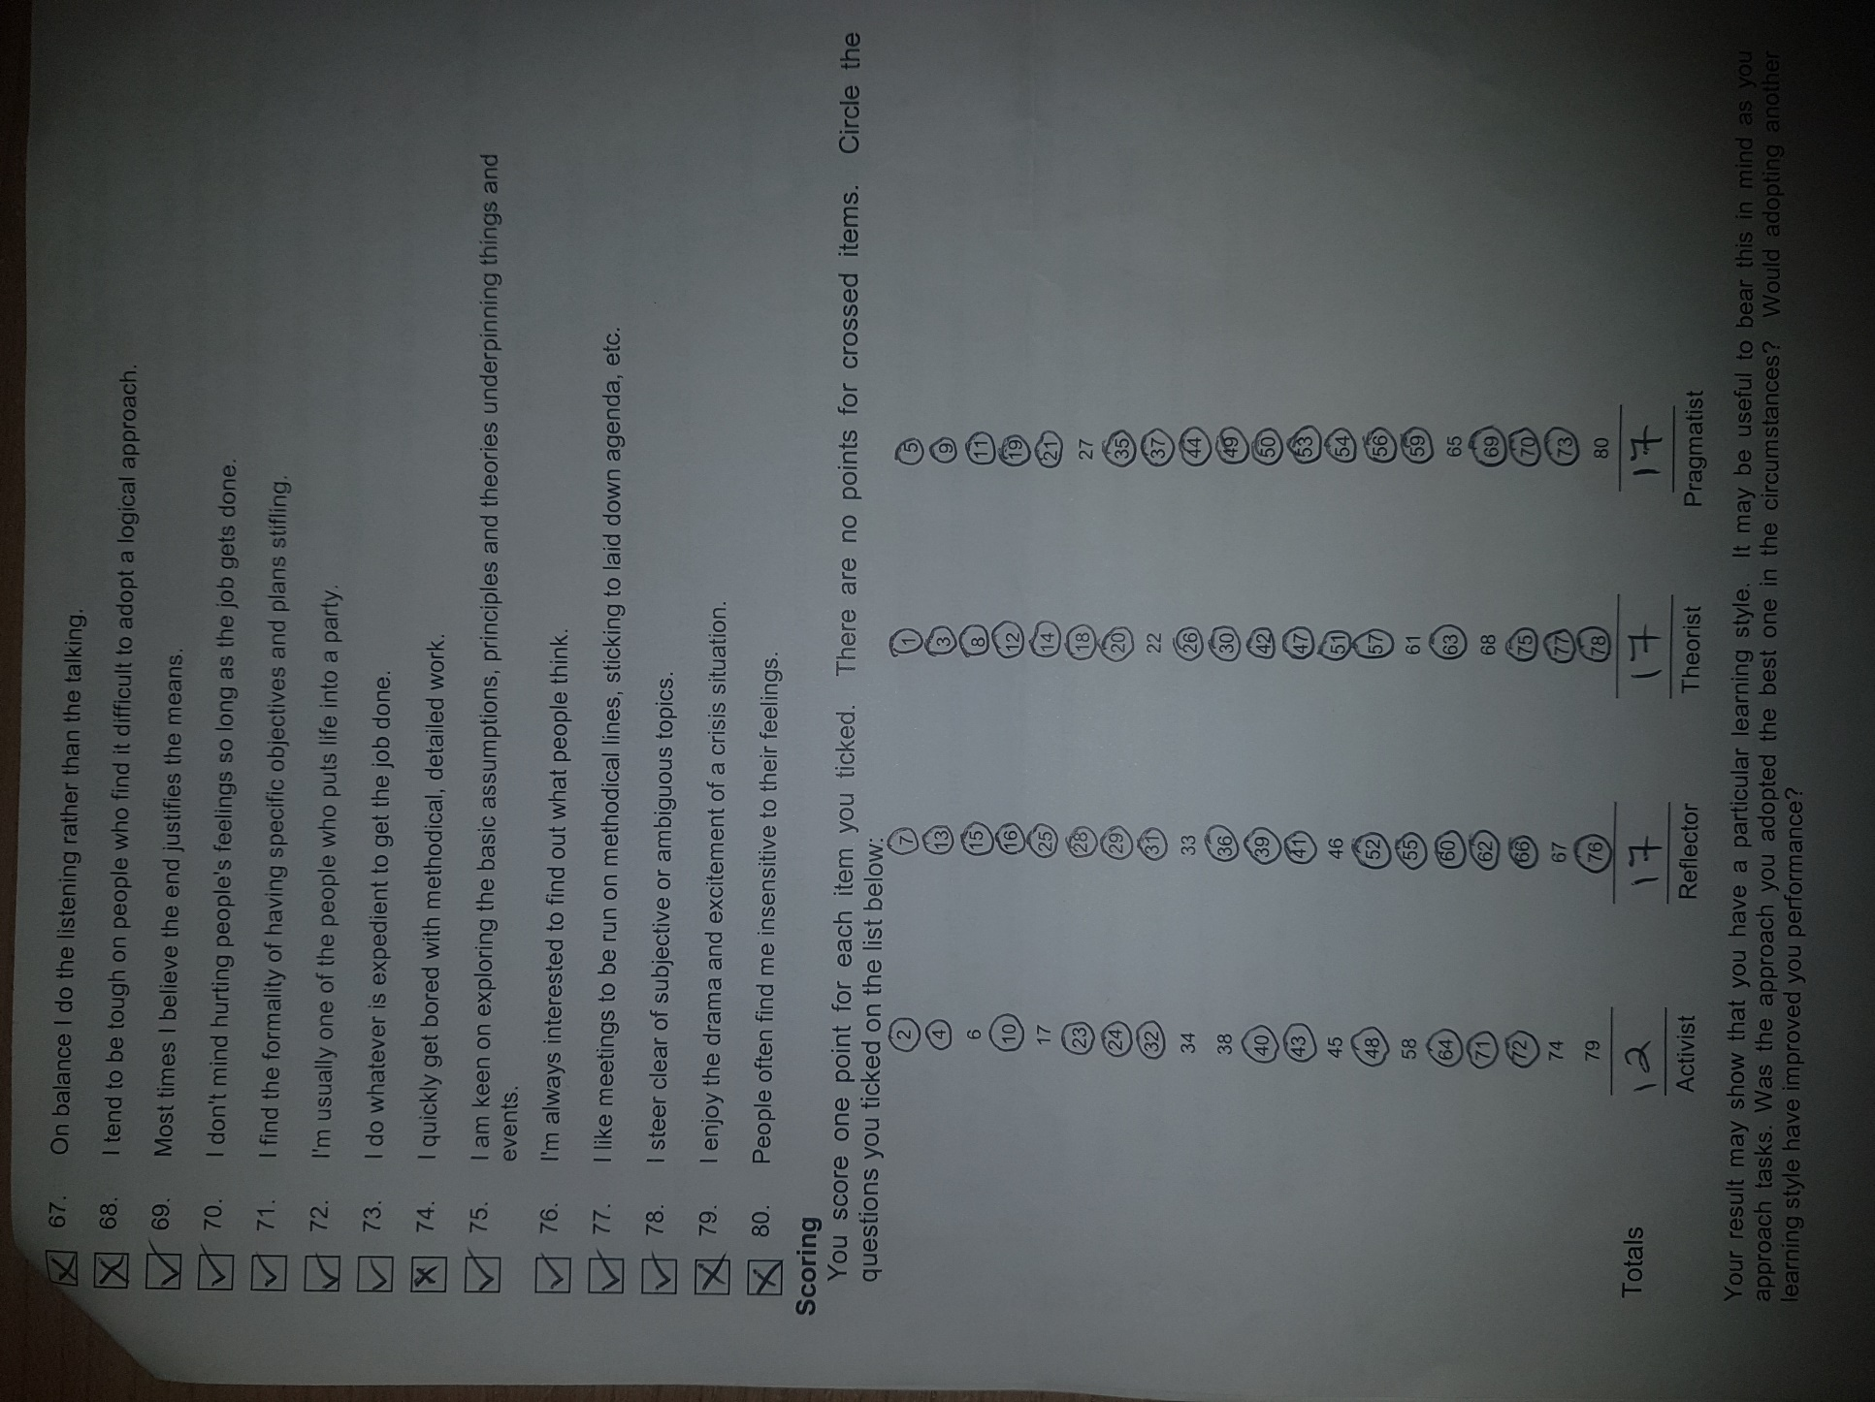

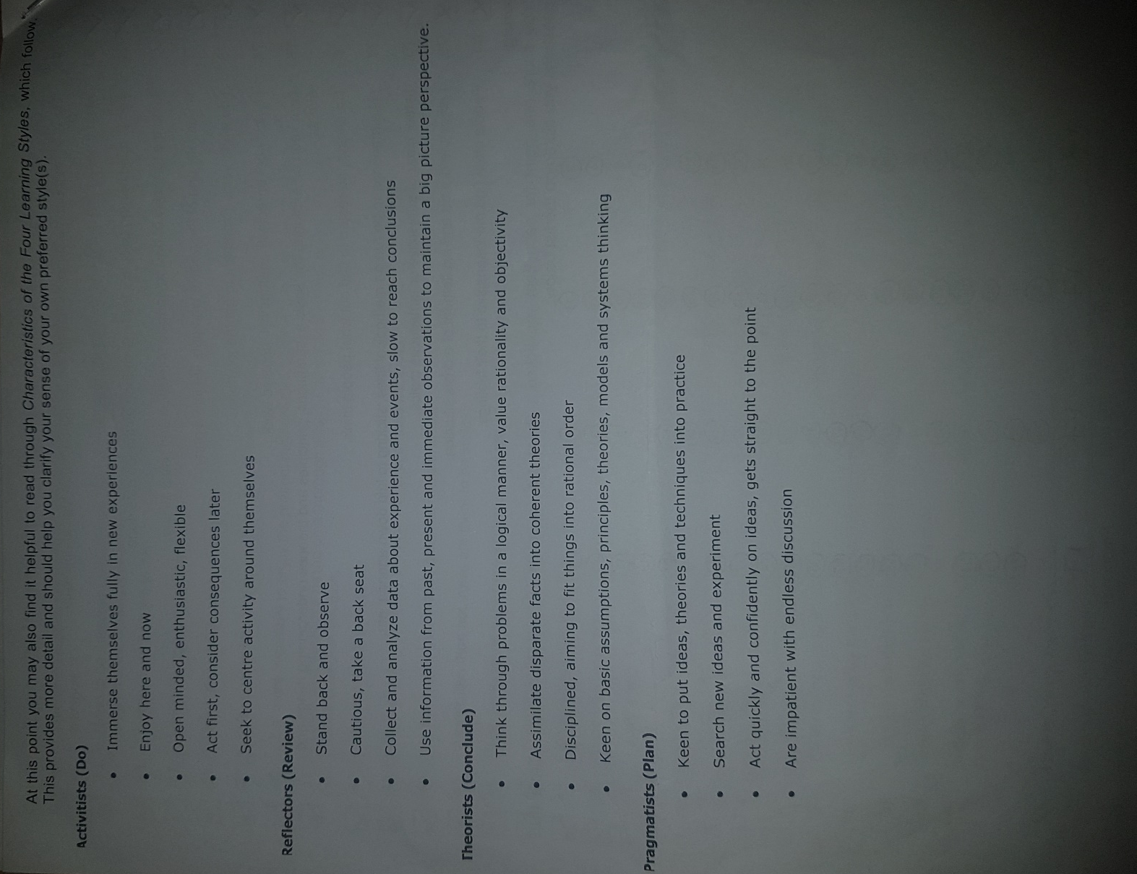

The Honey and Mumford learning styles (1992) made four categories which all people fell in: activist, reflector, theorist and pragmatist learning styles (Wilkinson and Lumley, 2014).
Even though the Honey and Munford questionnaire showed that I was a reflector (17), theorist (17) and a pragmatist (17), in my opinion I think that I am more of a pragmatist. This is because I am the type of person who likes to suggest my ideas to the team and am keen on putting those ideas into good practice. Putting it into practice would show the ideas props and cons clearly in which we can use early intervention to improve those ideas and theories. Finding new and unique ideas which no one has thought about is another trait of mine which I like to do because by findings those inventive ideas I can experiment with them. Whenever there is a group discussion I am the person who would get straight to the problem if there was a situation due to this would save time and increase though about resolutions to problem. This leads me to go on with the fact that I do not like long group talks because it can go of topic and it is time consuming in which we could be doing other essential needs for the business. Finally, I am always confident whenever I suggest an idea due to I had the mental capability to figure out that idea.

Career ambitions and aspirations
Firstly, I am hoping to pass level 4 certificate of higher education in the work place, in which this would allow me to continue level 5 and 6 thus this will let me understand more about the work place and how businesses run. Therefore, this would open many opportunities for me in the business industry. However, my main ambition is to open my own restaurant and run my own self built business within the restaurant industry. Therefore through all the knowledge I hopefully would have gained from the work place course I can make it a success and therefore I can aim to make it a chain restaurant around the whole of London. Another aspiration of mine would be the make my own restaurant which is totally different than any other restaurant around are area due to most restaurants these days are very similar. By having a unique restaurant this also would achieve on of my other aspirations of having many people from diverse backgrounds in my restaurant. Even though having a successful restaurant is my main ambition another important one is for my staff members to build trust with one another. By having a good team it would lead to further success of the team and the restaurant itself.

Development plan
What do I want/need to learn? | What will I do to achieve this? | What resources or support will I need? | What will my success criteria be? | Target dates for review and completion
I need to enhance and improve my management skills. This is because I find it difficult to handle staff members and handle other aspects within the restaurant environment. | To improve my management skills I need to attend all of my university classes due to it will provide me valuable information about how to manage elements within the business. Therefore I will also need to listen much more thoroughly so I will get all vital information from the lesson. | I need to learn valuable management skills from my friend who owns a restaurant. Therefore, I will get relevant and first hand information about how to improve my management skills due to he has all those traits because he owns his own restaurant. | It will be to pass all my subjects at level 4 in which I will then have all the knowledge and understanding about different types of skills used in the work place/restaurant. | For me to accomplish this I need to do achieve it this year. This is because this skill is fundamental when owning and working in a restaurant because others need to listen to you and you will have to sort out aspects such as supplies which is essential for a restaurant.
I need to gain entrepreneurial skills for me to start a business of my own. This is because being an entrepreneur you are risk taking and innovative which a business thrives on. | For me to increase my entrepreneur skills I need to develop my communication skills in a way that people understand my ideas so that it can be reproduced in a practical way such as building a brand new restaurant. | I need to read relevant books about other entrepreneurs who succeeded so I will get motivation and get some key advice which would develop that certain type of skill. Also, I can get advice from an entrepreneur in which I can get valuable information. | I will be a profitable restaurant business so there will be an increase in profits due to the major success of the restaurant. | It will be accomplished in 2 years’ time.
I also need to learn/improve my delegation skills. Within all restaurants you will have to handle business and financial situations in which your delegation skills will come in to practice. | To overcome this you will have to understand yourself and other people. This is because when delegating you will have to understand what other person is suggesting to you and what you are going to negotiate thus the reason for me to understand myself and others. | A businessman could train me to show how to delegate with others due to they are used to delegating business deals. | My success criteria would be to open another branch. | It will take 5 years to be completed.
Finally, I need to learn how to manage finances properly. The financial management within a business is key for the business to sustain itself due to it’s the money that is creating the improvements and developments. | I will need gain more knowledge about the financial side of all businesses. | I will need to get a good financial adviser so they will teach me the way aspects within a business. | My success criteria will be to be financially stable. | This is will be completed in 10 years’ time.

Personal development plan
According to Cortrell (2010), the Personal Development Plan (PDP) gives you a more in-depth understanding about how well the business is running. Within the PDP you are more in control of the actions been held in place.
The benefits of the PDP to academic performance would be firstly you gain more ideas and knowledge of how to improve the performance of the business. Also, this plan allows your self-management skills to be enhanced. The PDP is much less aggravating in which causes less stress as well as bringing happiness. Also, this plan allows you to put in new information to the situation and to your surroundings you are in.
The benefits of the PDP to professional life would be firstly it allows you to self-improve. Also, it lest you understand life better as well as yourself in a way of reflection such as the type of work you want. This plan also offers creativity and allows you to have a greater knowledge of how to problem solve which is vital within a business.
The benefits of the PDP to personal life would be firstly it allows you to understand yourself better so you can deal with inner conflicts therefore making you more settled. Also, it guides towards the right pathway in way that you would reach tour goals and ambitions. Finally, this plan allows you to enhance your reflection skills and improves your real-life application skills in which you will be able to tackle real life situations.

Conclusion

By being aware of what employers are looking for a job applicant, it gives me an idea on skills that I need for hiring prospective employees for my future restaurant. On personal SWOT analysis, it gives me a better understanding on what I need to improve and how to avoid the negative impact of various threats. The world of employment allows to have a better perspective on rights and obligations of employer and employees as well. My PDP serves as my roadmap for my professional career development as a restaurant entrepreneur.

References
Cortrell, S. (2010). Skills for Success (2nd ed.). Hampshire: MacMillan Publishers Ltd.
Cottrell, S. (2013). Study Skills Handbook (4th ed.). New York: Palgrave Macmillan Ltd.
Maund, A. S. (2017). Certificate in Higher Education: Skills for the Workplace Student Yearbook. London: SAGE Publiucations Ltd.
Morgan, P. (2017). The Business Student's Guide to Study and Employability. London: SAGE Publicationm Ltd.
Wilkinson, J., and Lumley, M. (2014). Developing Employability for Business. Oxford: Oxford University Press.

