REPORT

PRIMARK- New Promotional Strategies

Module: Marketing Management
Module code: LCMB7001
Lecturer: Tushara Balendran
Student Name: Deena Palanchoke (2221001)

Company Background
Primark is a leading international retailer with over 17.5 million sq ft of selling space across more than 410 stores in 15 countries. (Retail, 2022). Primark is a subsidiary of Associated British Foods (ABF). It owns and operates a chain of retail clothing stores across Europe and the USA. (Business, 2020). The company’s first store, named ‘Penneys’ was established by Arthur Ryan in June 1969, in Dublin, Ireland. The company subsequently expanded outside of Ireland and into Great Britain, opening a store in Derby in 1974. Today, UK is the Primark’s largest market with 191 stores. The name ‘Primark’ was then invented as it could not use the name ‘Penneys’ outside Ireland, as it was registered by J.C. Penney. With 38% increment in its revenue, in 2022, Primark shows its revenue of approximately 7.7 billion British Pounds with 1.1 billion GBP network in UK. (Primark, 2022 Statista).Primark aims to provide affordable choices for everyone, from great quality everyday essentials to stand-out style across women’s, men’s and kids’, as well as beauty. Primark’s mission is to make more sustainable fashion affordable for everyone. (About Us, 2013). Primark care strategy sets out nine commitments which are divided into three pillars which will help to become a more sustainable and circular business. (Our Commitments | Primark Cares (UK), 2023)
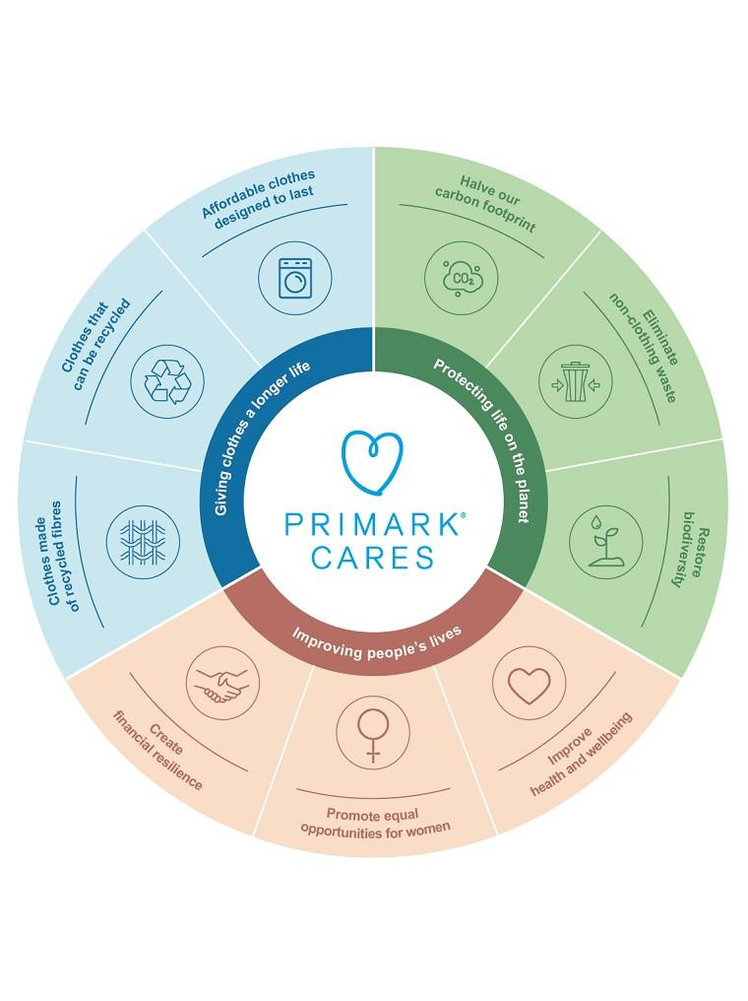
(Our Commitments | Primark Cares (UK), 2023)
Primark is an international fashion retailer employing more than 72,000 colleagues across 15 countries in Europe and the US.
Communication in Marketing Process
According to Richard J. Varey, ‘Marketing Communication is like a coin- it has two sides: ‘
- The offer (expression): To be effective in marketing communication, it's not enough to just provide information about your business and products to your target customers. Without understanding your audience's interests and preferences, it can be risky to make assumptions about what will appeal to them. To overcome this, it's important to first focus on understanding your customers before attempting to convey your message to them.
- The inquiry (impression): Before promoting the desirability of products and striving to satisfy consumers, a crucial aspect of marketing communication is to understand the interests and values of the target audience. This involves learning from them and relating their interests to those of the people within the business. Therefore, it is essential to prioritize this step in the marketing communication process to effectively connect with customers and promote satisfaction. (Varey, 2002)
Marketing communication can be describe as, ‘all the promotional elements of the marketing mix which involve the communications between an organization and its target audiences on all matters that affect marketing performance. (Pickton, & Broderick, A, 2004). The challenges of marketing communications are to communicate the right message, in the right way, to the right people, in the right place, at the right time. There are several channels of marketing communication to reach the target market. Some of the effective marketing communication channels are Traditional marketing, social media marketing, email marketing, direct mail, website, paid advertising, podcasting, public relations, event marketing. Primark is applying combination of different communication channels to reach its target audiences.
Shannon & Weaver Model of Communication
The Shannon-Weaver model was first proposed in the 1948 article ‘A Mathematical Theory of Communication’ in the Bell System Technical Journal by Claude Shannon and Warren Weaver. The goal of this model was “The fundamental problem of communication is that of reproducing a message sent from one point, either exactly or approximately, to another point. The system must be designed to operate for each possible selection, not just the one which will actually be chosen since this is unknown at the time of design.” (Shannon, C. 1948). The model’s explains how messages can be mixed up and misinterpreted in the process between sending and receiving the message. The Shannon and Weaver Model of Communication is a mathematical theory of communication that argues that human communication can be broken down into 7 key concepts: sender, encoder, channel, noise, decoder, receiver, and feedback.

(Shannon and Weaver Model of Communication, 2011)
Shannon and Weaver’s communication model is a widely used framework for understanding the communication process. Some examples of how fashion retailer Primark applies this model are:
Company’s marketing team displayed new digital billboards about Primark’s new products and communicated with target audience. Here, the new billboards are the source of information. The digital technology is the transmitter and the digital billboards itself is the channel of communication for transmitting a message from the sender to the receiver. People see a Primark billboard advertisement and decode the message by interpreting the visual and written message. The billboard message about the new product and its design is the reception and Targeted audience (destination) receives the message. Noise like traffic, technical issues and weather condition can interfere with the transmission of a message. Finally, increase in sales of the same product can be the feedback from the targeted audience.
The Shannon and Weaver model of communication is the ‘mother of all models’ of human communication. It is considered to be highly effective communication model that explained the whole communication process from information source to information receiver. Its’ clear framework and emphasis on technical aspects of communication have made it a useful tool for analyzing and understanding communication in a variety of contexts.
While the Shannon and Weaver model of communication has been widely used in communication theory and practice, there are several limitations to this model. This model primarily focuses on the transmission of information from the sender to the receiver and does not account for the social and cultural contexts in which communication takes place. Another limitation of this model is, it is linear and one way communication model which assumes communication is a one-way process from sender to receiver. Thus, it lacks the complexity of truly cyclical models such as the Osgood-Schramm model. (Chris Drew (PhD, 2023).
Integrated Marketing Communications
Integrated Marketing Communications is a concept under which a company integrates and co-ordinates its many communication channels to deliver a clear and consistent message about the organisation and its products. (Pickton, & Broderick, A. ,2004). Kotler (2003) defines integrated marketing communications as, ‘a way of looking at the whole marketing process from the viewpoint of the customer.’ An organisation’s unified, coordinated effort to promote a brand concept through the use of multiple communications tools that ‘speak with a single voice.’ (Shimp,2000) (Pickton, & Broderick, A. ,2004).
The Stages in an Integrated Marketing Communication Campaign:
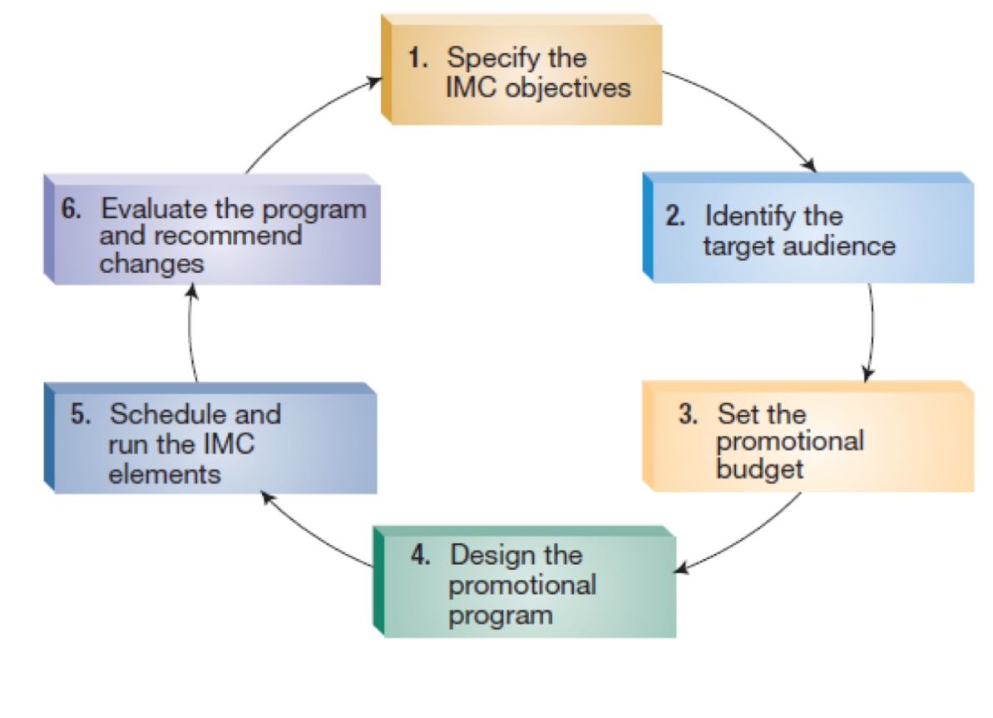
(describe the steps in the marketing communication process. Describe..., 2023)
The principal benefit derived from the integration of marketing communication is synergy. By bringing together the various facets of marketing communications in a mutually supportive and enhancing way then the resulting ‘whole’ is more than the simple sum of its parts. But where integration is not applied, there are potential dangers of marketing communication dysfunction in which the activities and effort become counter-productive. (Pickton, & Broderick, A. ,2004)

Online and offline new promotional strategy to raise the brand awareness.
Promotional strategy is a method used by companies to advertise, promote & sell their goods. A company chooses its promotional strategy based on factors like product type, marketing budget, target audience etc. It is a critical activity to increase product awareness and thereby increase sales.
Online: Augmented reality is ‘a technique that combines a live view in real-time with virtual computer-generated images, generating a real-time augmented experience of reality’ (Kleef, Noltes, and Spoel, 2010, p.1). ‘This indicates that the real, physical environment is supplemented by computer-generated sounds, videos, graphics or location data (Taqvi,2013)’. (Shabani and Hassan, 2017).
Introducing AR technology to create a virtual try-on experience for its Primark customers allow customers to try on different clothes virtually and see how they would look on them without having to physically try them on. This could encourage customers to purchase more items as they would be able to see how they look without the hassle of changing in and out of clothes.
Primark creating interactive games using AR technology would encourage customers to engage with their brand. This could be done by creating scavenger hunts or other challenges that involve finding different items within the store. This would create a fun and engaging challenging experience for customers and increase brand loyalty.
Primark can expand its reach and attract new customer through online shopping. Online shopping makes Primark’s products more accessible to customer who may not have a store nearby or who prefer the convenience of shopping from home, or who does not prefer to be on a long queue for their payment on tills. Primark can add exclusive deals like discount, free shipping and special promotions for online orders. These exclusive deals can help drive traffic to the Primark website and encourage customer to make a purchase.
Offline
Introducing Primark Fashion Show with celebrities
A large target audience will get influence with Primark fashion show where celebrities showcase new collections, design and trends of Primark. This will bring customer, celebrities, influencers, and other member of fashion community together. Hosting Primark fashion show will increase brand awareness and attract new customers who may not have previously been familiar with the brand. It will also generates social media buzz about the execution and visual appealing which will help Primark to reach a wider audience and increase its social media following. Similarly, fashion show also helps customer to create a memorable shopping experience for customers. This can help customers remember the brand and encourage them to make a purchase. Also it helps to build a community around the brand, and showcase their creativity and innovation in the fashion industry.
Primark Loyalty card
Who does not likes offers, discounts and rewards? Primark loyalty card allows customer to earn points on their purchase that will be redeemed for discounts, free items, or other rewards which will increase customer loyalty and repeat purchase. Primark also uses loyalty card to collect date on customer’s shopping habits and preferences, which will be later used to personalize promotions and marketing messages. For example, if a customer frequently purchases seasonal or festive items, Primark could send them targeted promotions for similar items in every season and new festivals.
Brand Equity
Brand equity is the value brought to a product with the aid of a brand name. Current and capacity blessings furnished via a brand compared to the other competitive manufacturers might be measured with the aid of Brand equity. A brand’s happy purchaser equals extra bucks inside the enterprise’s wallet. Brand advantages and its value derived via a product brand is taken into consideration by means of a customers while shopping and ingesting the product
Brand equity is the value added to a product by a brand name. Current and potential benefits provided by a brand as compared to the other competitive brands could be measured by Brand equity. A brand’s happy customer equals more dollars in the company’s pockets. Brand advantages and its value derived by a product brand is considered by a customers while purchasing and consuming the product. (Verma and Kumar, 2022). For making the brand more effective and capable of generating more value for customers, firms have to consider the needs and requirements of customers (Saqib, &Shah,2021).
In the future, companies will fight a battle for brand dominance. Investors will recognize the brand as the most important asset of companies. This is a critical concept. This is a vision of how to develop, manage, strengthen and define the business. It will be more important to own markets than to own resources. And the only way to own the market is to have a dominant brand. The concept of radical transparency in business gives the companies the opportunity to win the battle for success differently from the competitors, which would ensure the company’s sustainable growth and profitability, arousing from the well-shaped relationships with the stakeholders who provide value for the company. The company’s brand would be a synonym for those connections. (‘Defining the Concept of Brand Equity With Radical Transparency’, 2023)

Keller’s Brand Equity Model
Keller’s Brand Equity Model (also known as the Customer- Based Brand Equity (CBBE) Model) was first developed by marketing professor, Kelvin Land Keller, in his widely-used textbook, “Strategic Brand Management.” (MindTools | Home, 2023) The CBBE model presumes that brand equity is built through four steps, and that every step is dependent on the successful realisation of the previous one. The steps should ensure that the brand is first identified (identity), and then understood (meaning), that it provokes a customer's reaction (response) and finally builds the relationship with the customer (relationships). (Sinčić Ćorić and Jelić, 2015)
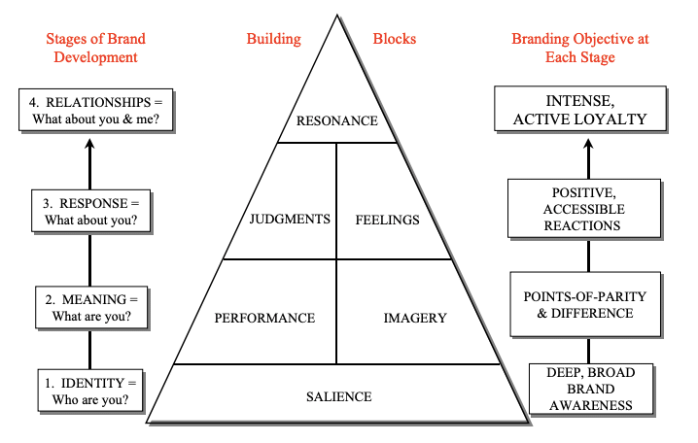
(Figure 1 . Customer-Based Brand Equity model pyramid (Keller, 2009), 2019)
In order to achieve the final goal - a harmonious relationship between customer and the brand, Keller's model consists of six brand building blocks - salience, performance, imagery, judgements, feelings and resonance. Let’s see how the Primark’s “Jumper” product builds its brand in its every step:
Salience: Salience refers to make sure that the brand stand out, and that customers recognize it and are aware of it.
Primark’s Jumper is available in wide range of variety in styles, designs, colour, fabrics and sizes at affordable price. It has high salience as it is a popular and recognizable product sold in Primark stores worldwide, contributing brand’s overall presence in the market.
Imagery: Imagery refers to how well the brand meets the customers’ needs on a social and psychological level. (MindTools | Home, 2023)
Primark’s brand imagery is enhanced by its commitment to several environmental programs and social causes; and its “reduce, reuse, recycle” values, which make customer, feel good about purchasing Primark’s Jumper.
Performance: Performance defines how well the product meets the customers’ need by product’s characteristics and features; product reliability, durability and serviceability; service effectiveness, efficiency, and empathy; style and design; and price. (Hawker, 2019)
Primark’s “Jumper” performance demonstrates its affordability, reliability and durability. People know that their products are well designed and stylish, and that they won’t let them down.
Feelings: Feelings is the emotional response how a brand makes customers feel about themselves in the sense of warmth, fun, excitement, security, social approval, and self-respect.
Customers have positive feelings towards the Primark’s Jumper. They feel it stylish, comfortable, and affordable, which has contributed to a positive emotional connection with the brand. Additionally, the brand’s focusing on affordability helps customers feel good about their purchase decisions and share their feeling with a word of mouth.
Judgements: Judgements refers to the customer’s evaluations and opinions about the product or brand. They judge the product based on quality, credibility, consideration and superiority.
Customers judge Primark’s Jumper as a high-quality, sustainable and affordable. Offering new tending Jumper with availability in range of styles and designs has built a positive reputation.
Resonance: Brand resonance is how a customer identifies themselves with the brand. It is the final block of the brand equity pyramid which sits at the top and is most difficult and most desirable level to reach. It can be achieved when customers feel a deep, psychological bond with the brand through behaviour loyalty, attitudinal attachment, sense of community and active engagement.
Customer now has lasting relationship with the Primark’s Jumper; they not only do the repeat purchase, but have also become the brand’s advocate.
The advantages and disadvantages of Keller’s Brand Equity Model
Advantages | Disadvantages
Keller's model provides a comprehensive framework for analyzing brand equity. It considers both the tangible and intangible aspects of a brand, including brand awareness, brand loyalty, brand associations, and perceived quality. | The model may not be applicable to all types of brands or industries. For example, it may not be as useful for companies that primarily sell commodity products or for brands in industries with low customer involvement.
Keller's model is customer-focused, meaning it emphasizes the importance of understanding and meeting customer needs and expectations. By building strong relationships with customers, brands can create loyal customers who are willing to pay a premium price for their products. | Keller's Brand Equity Model focuses primarily on consumer-facing brands and may not be as relevant for B2B brands or brands in other industries.
Keller's Brand Equity Model provides a measurable approach to brand building, which allows businesses to track the progress of their brand equity efforts over time. | The model does not take into account external factors, such as changes in the market or competitive landscape, which can have a significant impact on brand equity.

Customer Journey
A customer journey is the set of interactions that a customer has with a brand in buying a service or product. It considers the complete interaction roadmap- from brand discovery to purchasing and beyond. (Peterson, 2018). The customer Journey refers to the multiple stages through which your customers goes through when interacting with your business. (Moment, 2021). The goal of understanding the customer journey is to identify opportunities for businesses to improve the customer experience and increase customer loyalty.
Stages of Customer Journey
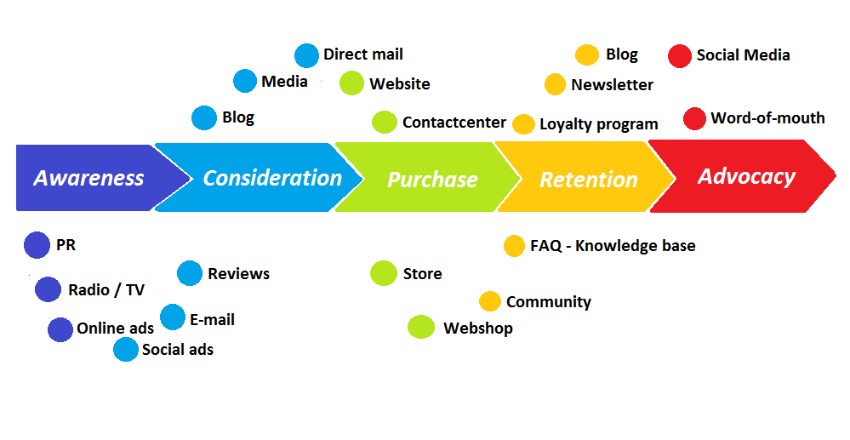
(Christof Sauke, 2021)
The stages of customer journey include:
Awareness: Awareness is the primary degree in which the purchaser turns into aware about the emblem or product via diverse channels such as advertising, social media, or phrase of mouth. During this degree, patron search for solutions and come across more than one brands and merchandise.
Consideration: In the next stage, the customer starts to research and evaluate the brand or product, looking for information such as features, benefits, pricing, and reviews. During this stage, customer begins to look for alternatives to past purchase and company should be able to make a good impression.
Purchases: Once potential customers are satisfied with researching and comparing the product, in the third stage customer makes a purchase decision and completes the transaction. It’s at this stage of the customer journey when customer reviews are crucial.
Retention: In the fourth stage, the customer becomes loyal customer, potentially making repeat purchases and recommending the brand to others.
Advocacy: This is the stage of the customer journey where the customer becomes an active advocate for a company’s brand, actively promoting it to others through social media, reviews, and word-of-mouth.

Customer touchpoint
A customer touchpoint is any time a consumer interacts with your brand, whether that’s through an employee, a website, an advertisement, or an app. Each customer touchpoint is an opportunity for a brand to woo a customer with a great customer experience. The concept of touchpoint is highly intuitive and explicit, and hence useful, since it considers that customers have experiences every time they ‘touch’ any part of the product, service, brand, or organization across multiple channels and media (Pantano and Viassone 2015). (Understanding customer touchpoints—and why they matter, 2022).
Pre-Purchase
The pre-purchase touchpoints are often described as producing unknown results. They are defined as all the moments of contact a potential customer has with a business before they interact with the business themselves. Primark has many pre-purchase touchpoints that customer uses to purchase the products like, social media adverts, social media posts, websites, word of mouth, reviews, sponsorship, public relation etc. In this stage, the customer visits the Primark’s websites to get a sense of the products available, view the latest collections and go through the review of the products. They search the nearest location of the store, its opening time and directions so that it will be easier to plan their visit. Similarly, customer also go through the Primark’s social media such as Instagram, Facebook, Twitter etc. and search for the price, design and varieties of the product. During these interactions, it’s critical to instill trust in the minds of prospects by demonstrating beyond a reasonable doubt that a company’s product or service offerings are better than those of the competition. (George, 2023)
Purchase
The purchase touch points are all the interactions the customer has with the business whilst they are purchasing the advertised service (Customer Touchpoints | Definitions, strategies, & expert interviews, 2023). Customer interacts with these touchpoints while deciding the specific product or service they plan to purchase. Primark makes it easy for customers to shop in a way that suits their preferences and needs. Primark purchase touchpoints that customer user in their purchase are physical store, sales team, customer service, fitting rooms, promotional activities like sales and discount, click and collect online service, point-of-sale system etc. In this stage, customer visits their local Primark store and browses for the product or goes to Primark’s website for click and collect. They will have a one-to-one conversation with a sales representative if they have any questions about the product. They will try the product and confirm that they had made the right decision. Ensuring that the experience customers have at this point is vital a good way to increase the likelihood that this customer will become a customer for life. (Customer Touchpoints | Definitions, strategies, & expert interviews, 2023)
Post-Purchase
Post-purchase refers to the stage in the consumer decision-making process after a purchase has been made. It includes the actions and experiences of the customer after they have bought a product or service. Primark is influencing post purchase behaviour by applying various strategies such as excellent customer service through mails and phone calls, returns and exchanges policy, online surveys and in-store feedback forms. A positive post-purchase experience can lead to customer loyalty, repeat purchases, and positive word-of-mouth recommendations. Here, Primark’s dedicated customer service team resolves customer complaints or issues promptly and efficiently. Primark offers a generous returns and exchange policy, allowing customers to return or exchange items within 28 days of purchase. This helps customer feel more confident in their purchases and can lead to repeat business. Understanding post-purchase behaviour is the first step towards converting first buyer into an advocate or loyal customer. “Keeping customer happy for 100 days meant they would become loyal customers for the next FIVE YEARS” (Enisa, 2021).
Customer Journey Map
The interactions that occur between the customer and the brand/company from pre-purchase to post-purchase are known as the customer journey (Lemon and Verhoef 2016) (Mariola Palazon et al., 2022). Customer Journey Mapping (CJM) is an increasingly popular strategic management tool praised by both academics and practitioners for its usefulness in understanding an organisation’s customer experience. CJM lists all possible organizational touchpoints customers may encounter during the service exchange process. By clearly understanding customer touchpoints, senior management can work with cross-functional team members to employ tactics that foster service innovation. The goal of these tactics is to enhance customer service provider interactions by improving the customer experience associated with each touchpoint. (Rosenbaum, Mauricio Losada Otalora and Germán Contreras Ramírez, 2017)

Customer Persona
Background:  - Singer/Performer  - Completed her MBA  - Works in Classxpresentation  - Entertains people with live concerts in different countries. | Sanju Moktan  | Personal Life:  - Lives with mother and two doggies  - Always active in social media  - Visited many countries while on tour
Demographics:  - Female  - Age 25  - Marriage status: single  - Birth country: Nepal  - Annual Income: £35,000  - Lives in Hounslow, London |  | Shopping Habits:  - Frequent buyer  - Prefers in-store shopping  - Selects affordable, comfortable and durable cloths  - Likes offers and discounts
Hobbies and interest:  - Trying new fashions  - Hanging out with friends  - Dancing, travelling and yoga  - Playing new musical instruments |  | Goals:  - Buy a comfy summer jumper  - To look fabulous in upcoming event  - To support sustainable and ethical fashion brand.

Diagram of customer journey map at Primark of a customer buying Primark’s “Jumper”
Customer Journey Map | Awareness | Consideration | Purchase | Retention | Advocacy
Social Media Post |  | 2  Online search for summer jumper in Instagram |  | 11  10  Leave a positive review of the Jumper online
Store |  |  | 5  Purchase the black summer Jumper  Visit the nearest Primark store | 8  Repurchase of the other products from Primark
Website |  | 3  Browse through the website for reviews and rating
Email | 1 |  |  | 9
Word of mouth | New customer influenced by friend about a new Jumper in Primark |  |  | Received compliments from friends and family | Express positive views on Brand
Window displays and in-store signage |  | 4 | Impressed by the same dress in Mannequin  6
Web Forums |  | Comparing the price of Jumper with other retailers | 7
Customer service |  |  | Got more knowledge about the quality, variety and size of the Jumper

Strengths of Primark Customer Journey Map
Word of mouth: The most effective touchpoint for Primark Jumper because it is where the journey of customer for purchasing of Jumper started. Word of mouth became effective because of its affordability and quality.
Store: Store has been strength for Primark Jumper because it is where customer feels the product physically and made the buying decision.
Website: Primark website has been equally effective touchpoint where customer goes through the reviews and rating, and gets more influenced towards the product.
Customer Service: Primark’s excellent customer service has proved to be a very effective touchpoint for the company. Here, customer gets more face to face knowledge about the product.
Window display and in-store signage: Window display and in-store signage has also equally impressed the customer which has made the purchase easy.

Weaknesses of Primark’s Customer Journey Map
Email: Primark’s email as a touchpoint is not working well for the company. Customers are ignoring the emails send by the company about the product.
Web Forum: Web forum touchpoint is also considered not effective for the company because it creates confusion in the mind of the customer. Different people have different opinion about the product.

The Total Engagement Model
The Total Engagement Model was developed by first author Christopher Roberts and is described more fully in Roberts and Alpert (2010). Essentially, the model poses the following question: How often are an organisation’s intent, or what they think (i.e. value proposition), who they are (i.e. culture), what they say (i.e. brand advertising) and what they do (i.e. value delivered and customer experience) in perfect harmony, from a customer perspective? It is integral to establish a strategic and collaborative link between engaged employees and engaged customers to achieve long term growth (Roberts and Alpert, 2010).
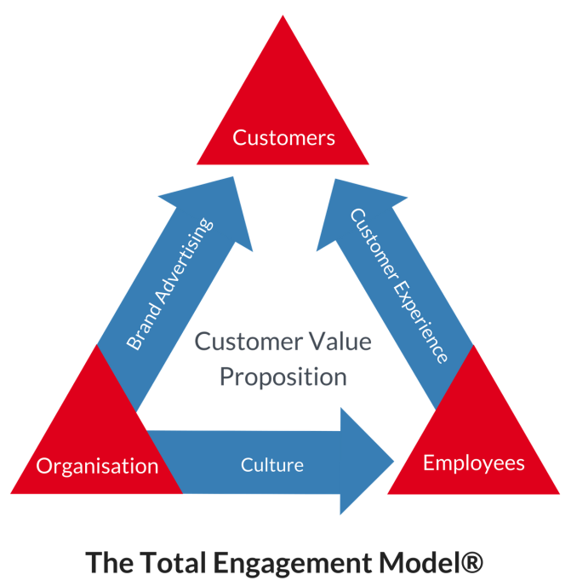
The centre of this model is the Customer Value Proposition. It is the value Primark offer to its customer (Roberts, Christopher, Frank Alpert and Carissa Roberts, 2016). Customer chooses Primark for its affordability and fashionable clothing.
The next stage is brand advertising. Brand is not only the name or logo, it is sum total of who you are and what you stand for. Brand advertising is how Primark communicate the brand to customer (Roberts, Christopher, Frank Alpert and Carissa Roberts, 2016). Primark aligns its brand identity with the values of its target customers, who are looking for affordable and fashionable clothing that allows them to express their individuality. The company has also made a commitment to sustainability, by introducing eco-friendly products and initiatives to reduce waste.
The next stage is culture, which refers to ‘the way we do things around here,’ and represents the internal aspects of the organisation, such as its goal, values and internal behaviours. A strong brand culture can help to create a sense of belonging among Primark employees and customers alike, and can help to differentiate the brand from its competitors.
Finally, the last stage is customer experience, which is a combination of physical and emotional elements, which customer experience when they interact with the brand and the organisation Roberts, Christopher, Frank Alpert and Carissa Roberts, 2016). A positive customer experience can help to build customer loyalty and advocacy, while a negative experience can have the opposite effect. As per Primark’s daily customer response data, Primark’s overall daily positive customer satisfaction responds always exceed 50%.
Overall, The Total Engagement Model recognizes that a brand’s success is dependent on its ability to engage with its stakeholders across multiple dimensions. This model addresses total company interaction with customers, and identifies the strategic drivers of customer engagement. A great customer value proposition combined with delivering a great customer experience is the major drivers of industry leading customer brand loyalty.
Recommendation
The importance of implementing new touchpoints for Primark lies in the ability to enhance the overall customer experience and increase customer engagement, which can ultimately drive sales and customer loyalty. By adopting new touchpoints, Primark can provide customers with new and exciting ways to interact with the brand, both online and offline.
Primark can reach younger audiences by utilizing social media platforms such as TikTok or Clubhouse and engage with them in a more interactive and personalized way. This can help build brand awareness and increase customer loyalty among younger generations who are often more likely to shop with brands that align with their values and interests. Similarly, incorporating virtual try-ons or personalized product recommendations on its website or mobile app can provide customers with a more convenient and personalized shopping experience. This can help reduce purchase hesitation and increase customer satisfaction, leading to higher sales and customer retention. Introducing in-store technology such as interactive displays or loyalty programs can also enhance the customer experience and build customer loyalty. For example, interactive displays can help customers visualize how products would look on them, while loyalty programs can incentivize customers to continue shopping with Primark and increase customer retention. Similarly, with the rise of e-commerce, more and more customers are opting to shop online for convenience and flexibility. Therefore, Primark can invest in its online sales channels to ensure that customers can shop with ease and convenience from anywhere. By offering online sales, Primark can expand its customer reach beyond physical store locations, allowing customers to shop from anywhere at any time. This can help attract new customers who may not have access to physical stores or may prefer to shop online. In addition, offering online sales can also help reduce purchase hesitation and make the shopping process more convenient for customers. With the ability to browse and purchase products online, customers can avoid the hassle of long lines or crowds in stores, and can shop from the comfort of their own homes. Finally, online sales can also provide Primark with valuable customer data, which can be used to improve the overall shopping experience and customer engagement. By analyzing customer data, Primark can gain insights into customer preferences, purchase behaviour, and trends, allowing them to offer personalized product recommendations, promotions, and improve their overall customer experience.
Conclusion
In today's highly competitive marketing environment, establishing brand awareness is essential for businesses of all sizes. By creating a strong brand identity, companies can gain a competitive edge, increase their reputation, and build trust with their customers. Primark, for example, recognizes the importance of building brand awareness and has developed innovative strategies for managing customer journeys across various communication channels. In this study, we critically analyze Primark's approach to raising brand awareness and improving the customer experience through both offline and online promotional strategies. We also provide recommendations for new customer touchpoints that Primark could implement to enhance their brand's competitive advantage in the modern marketing landscape. Ultimately, by prioritizing brand awareness, companies like Primark can thrive in highly competitive markets and stay ahead of the curve.

References:
About Us (2013) Primark Corporate. Available at: https://corporate.primark.com/en-gb/a/about-us/who-we-are (Accessed: 22 April 2023).
‌‘Defining the Concept of Brand Equity With Radical Transparency’ (2023) Building Brand Equity and Consumer Trust Through Radical Transparency Practices, pp. 1–17. Available at: https://doi.org/10.4018/978-1-5225-2417-5.ch001.
Verma, R. and Kumar, M. (2022) ‘Brand Extension in FMCG Sector Through Social Media Enabled CRM and Investigating Its Impact on Brand Equity’, Building a Brand Image Through Electronic Customer Relationship Management, pp. 201–236. Available at: https://doi.org/10.4018/978-1-6684-5386-5.ch009.
‌Shabani, N. and Hassan, A. (2017) ‘Augmented Reality for Tourism Service Promotion in Iran as an Emerging Market’, Advances in Marketing, Customer Relationship Management, and E-Services, pp. 116–129. Available at: https://doi.org/10.4018/978-1-5225-2206-5.ch005.
‌Chris Drew (PhD (2023) Shannon Weaver Model of Communication - 7 Key Concepts, Helpful Professor. Available at: https://helpfulprofessor.com/shannon-weaver-model/ (Accessed: 11 April 2023).
Christof Sauke (2021) Customer Journey Mapping: 5 Action Steps – perspective: international, perspective: international. Available at: https://www.perspective-int.com/en/customer-journey-mapping/ (Accessed: 15 April 2023).
‌‌ Customer Touchpoints | Definitions, strategies, & expert interviews (2023) Sentisum.com. Available at: https://www.sentisum.com/library/customer-touchpoints#:~:text=%E2%80%8DA%20touchpoint%20is%20any%20interaction,anytime%20you%20encounter%20a%20company. (Accessed: 21 April 2023).
‌describe the steps in the marketing communication process. Describe... (2023) Coursehero.com. Available at: https://www.coursehero.com/tutors-problems/Marketing/25690923-describe-the-steps-in-the-marketing-communication-process-Describe-ea/ (Accessed: 11 April 2023).
‌Enisa (2021) Post-purchase behavior: The key to repeat purchases, Loop Returns. Available at: https://www.loopreturns.com/blog/post-purchase-behavior/#:~:text=Post%2Dpurchase%20behavior%20definition,we%20can%20ignore%20thoughts%20%26%20feelings. (Accessed: 22 April 2023).
‌Figure 1 . Customer-Based Brand Equity model pyramid (Keller, 2009) (2019) ResearchGate. ResearchGate. Available at: https://www.researchgate.net/figure/Customer-Based-Brand-Equity-model-pyramid-Keller-2009_fig1_341840657 (Accessed: 15 April 2023).
‌ George, R. (2023) Tapping into Brand Touchpoints, MarketingProfs. MarketingProfs. Available at: https://www.marketingprofs.com/3/george2.asp (Accessed: 20 April 2023).
‌Hawker, K. (2019) Keller’s Brand Equity Model — What It Is & How to Use It, Medium. Medium. Available at: https://medium.com/@keatonhawker/kellers-brand-equity-model-what-it-is-how-to-use-it-84e42d562299 (Accessed: 15 April 2023).
‌ Peterson, K. (2018) Effective Customer Journey Guide with Examples + Free Templates, QuestionPro. Available at: https://www.questionpro.com/blog/customer-journey-map/ (Accessed: 15 April 2023).
‌Pickton, & Broderick, A. (2004). Integrated marketing communications (2nd ed.). Prentice Hall Fiancial Times.
Pickton, & Broderick, A. (2004). Integrated marketing communications (2nd ed.). Prentice Hall Fiancial Times.
Varey. (2002). Marketing communication : principles and practice. Routledge. https://doi.org/10.4324/9780203466919
Retail (2022) ABF Corporate. Available at: https://www.abf.co.uk/our-businesses/retail (Accessed: 9 April 2023).
Roberts, C.J. and Alpert, F. (2010) ‘Total customer engagement: designing and aligning key strategic elements to achieve growth’, Journal of Product & Brand Management, 19(3), pp. 198–209. Available at: https://doi.org/10.1108/10610421011046175.
‌Roberts, Christopher, Frank Alpert and Carissa Roberts (2016), “Strategic Drivers of Customer Engagement: Practical Applications” chapter in the book Contemporary Issues in Customer Engagement, edited by Professor Roderick Brodie, Dr Linda Hollebeek, and Dr Jodie Conduit. (pp. 171-192). New York: Routledge.Rosenbaum, M.S., Mauricio Losada Otalora and Germán Contreras Ramírez (2017) ‘How to create a realistic customer journey map’, Business Horizons, 60(1), pp. 143–150. Available at: https://doi.org/10.1016/j.bushor.2016.09.010.
Business (2020) Primark (part of Associated British Foods) - Business & Human Rights Resource Centre, Business & Human Rights Resource Centre. Available at: https://www.business-humanrights.org/en/companies/primark-part-of-associated-british-foods/#:~:text=Primark%20is%20a%20subsidiary%20of,across%20Europe%20and%20the%20USA. (Accessed: 9 April 2023).
‌About Us (2013) Primark Corporate. Available at: https://corporate.primark.com/en-gb/a/about-us/who-we-are (Accessed: 9 April 2023).
‌
Mariola Palazon et al. (2022) The customer journey: a proposal of indicators to evaluate integration and customer orientation, ResearchGate. Taylor & Francis Group. Available at: https://www.researchgate.net/publication/359650677_The_customer_journey_a_proposal_of_indicators_to_evaluate_integration_and_customer_orientation (Accessed: 20 April 2023).
‌MindTools | Home (2023) Mindtools.com. Available at: https://www.mindtools.com/ajnlcxe/kellers-brand-equity-model (Accessed: 15 April 2023).
Moment (2021) ‘What is the Customer Journey? | Definition and How to create one’, YouTube. Available at: https://www.youtube.com/watch?v=7Xa3lwxg16Q (Accessed: 15 April 2023).
‌Our Commitments | Primark Cares (UK) (2023) Primark Corporate. Available at: https://corporate.primark.com/en-gb/a/primark-cares/our-approach/our-commitments (Accessed: 9 April 2023).
‌Topic: Primark (2022) Statista. Statista. Available at: https://www.statista.com/topics/4684/primark/#topicOverview (Accessed: 9 April 2023).
‌‘Shannon, C. (1948). A Mathematical Theory of Communication. The Bell System Technical Journal, 27(1)
Shannon and Weaver Model of Communication (2011) Communication Theory. Available at: https://www.communicationtheory.org/shannon-and-weaver-model-of-communication/ (Accessed: 11 April 2023).
Sinčić Ćorić, D. and Jelić, D. (2015) ‘Applicability of Keller’s brand equity model in the B2B chemical market’, Economic Research-Ekonomska Istraživanja, 28(1), pp. 1006–1017. Available at: https://doi.org/10.1080/1331677x.2015.1100841.
‌Understanding customer touchpoints—and why they matter (2022) Zendesk UK. Available at: https://www.zendesk.co.uk/blog/customer-touchpoints/#:~:text=view%20your%20company.-,A%20customer%20touchpoint%20is%20any%20time%20a%20consumer%20interacts%20with,1%20with%20that%20retail%20business. (Accessed: 20 April 2023).
‌

‌

