4/30/2026
Network and Cyber Security Essentials

Module Name: Network and Cyber Security Essentials
Module Code: ACCA4024

Student Name: Danuzia Aparecida Soares
Student ID: 2435233
Group: 3

Lecturer’s Name: Kwame Assa-Agei.

University of wales trinity saint david
LONDON CAMPUS

Table of Contents
Cybersecurity Policy Development for HealthPlus Analytics 1
Abstract 1
Introduction 2
Identification of Modern Threats 3
Modern Security Policies 4
Technical Mitigation Measures 6
Proactive Monitoring and Incident Response 7
Continuous Training and Awareness 9
Conclusion 10
References 11
Appendix A: Screenshot of the Board of Directors PowerPoint presentation 12

Cybersecurity Policy Development for HealthPlus Analytics

Abstract

This report presents a data security and governance framework for HealthPlus Analytics (HPA), a healthcare technology company that handles sensitive patient information across the UK. Recently, the organisation has experienced serious cybersecurity incidents, including unauthorised access to cloud-stored data and a ransomware attack. These events highlight significant risks related to data protection, legal compliance, and potential damage to the company’s reputation.
The main aim of this report is to analyse these security challenges and propose practical solutions to improve the organisation’s overall security. It focuses on key principles such as confidentiality, integrity, and availability of data, which are especially important in healthcare environments. It also considers modern challenges, including remote working, the use of personal devices (BYOD), and reliance on cloud-based systems, all of which can increase vulnerabilities if not properly managed.
The report also looks at different ways to protect systems, for example using encryption, adding extra login security like multi-factor authentication, and making sure network settings are properly secured. It also highlights the importance of employee awareness, regular training, and clear security policies. Compliance with UK GDPR and NHS Digital Security Standards is also considered a key part of the proposed framework.
In general, the report aims to provide realistic recommendations to help HPA strengthen its security, reduce risks, and promote a strong culture of cybersecurity.

Introduction

Cybersecurity has become a serious issue for modern organisations, especially those that depend a lot on digital systems and data storage. As technologies like cloud computing, mobile devices, and remote working continue to grow, businesses are more exposed to risks such as ransomware, phishing, and data breaches. This is particularly important in healthcare, where large amounts of sensitive patient data are handled every day and must always be kept secure.

HealthPlus Analytics (HPA) is a data-focused healthcare technology company that manages and stores confidential patient information for hospitals and clinics across the UK. Because this type of data is highly sensitive, the organisation needs to follow strict regulations, including UK GDPR and NHS Digital Security Standards. However, recent security incidents, such as unauthorised access to cloud data and ransomware attacks, show that there may still be gaps in the current security measures. In addition, the use of personal devices and remote access can further increase these risks if not properly controlled.

Additionally, the use of personal devices and remote access has further increased the organisation’s exposure to risk.

This report aims to develop a comprehensive data security and governance framework to improve HPA’s security posture. It focuses on the key principles of confidentiality, integrity, and availability, while also promoting stronger security practices and awareness across the organisation [1].

Identification of Modern Threats

Modern cyber threats refer to advanced and evolving forms of cyberattacks that exploit system vulnerabilities, human behaviour, and emerging technologies. According to NIST, a cyber threat is any event that can negatively impact an organisation through unauthorised access, data loss, or system disruption [2].

The table below shows that most internal threats in HPA are mainly linked to human factors, such as employee behaviour, low awareness, and weak access control. These issues can seriously affect how sensitive healthcare data is protected, stored, and accessed.

Threat | Type of Threat | Description | Impact on Organisation
Phishing by employees | Unintentional Insider Threat | Employees may click on fake emails and reveal login details | Loss of confidentiality and possible system access
Weak passwords | Human Error / Negligence | Staff use simple or reused passwords | Risk of unauthorised access (confidentiality)
Data sharing mistakes | Human Error | Sending patient data to wrong person or insecure channels | Breach of confidentiality and GDPR violation
Malicious employee actions | Malicious Insider Threat | Staff intentionally steal or leak sensitive data | Loss of confidentiality and integrity
Excessive access rights | Privilege Misuse | Employees access data beyond their role | Risk to confidentiality and integrity
Use of personal devices (BYOD) | BYOD Threat | Unsecured personal devices accessing company systems | Malware risk, data leakage (all CIA)
Lack of training | Organisational Weakness | Employees unaware of security risks | Increases likelihood of all threats (CIA impact)

The table above highlights that external threats to HPA are primarily driven by cybercriminal
activities targeting sensitive healthcare data and system availability. These threats can result in serious consequences, including operational disruption, financial loss, and regulatory penalties, particularly under UK GDPR requirements.
Threat | Type of Threat | Description | Impact on Organisation
Ransomware attack | Malware / Financial Attack | Attackers encrypt company data and demand payment | Loss of availability and integrity
Phishing campaigns | Social Engineering | Fake emails sent to employees to steal credentials | Loss of confidentiality
Cloud data breach | Cloud Security Threat | Unauthorised access to cloud-stored patient data | Loss of confidentiality and GDPR violation
Advanced Persistent Threats (APTs) | Targeted Attack | Long-term, hidden attacks aiming to steal sensitive data | Loss of confidentiality and integrity
Malware (virus/spyware) | Malicious Software | Software designed to damage systems or steal data | Affects all CIA components
DDoS attack | Network Attack | Overloads systems, making services unavailable | Loss of availability
Credential theft | Identity-based Attack | Hackers steal login credentials to access systems | Loss of confidentiality

Both internal and external threats demonstrate that HPA must adopt a layered security approach that combines technical controls, strong policies, and employee awareness to effectively protect its systems and data.

Modern Security Policies

Security policies play a critical role in protecting HealthPlus Analytics (HPA), particularly following the recent cybersecurity incidents experienced by the organisation. Well-defined policies provide clear guidelines on how systems, data, and users should be managed to reduce security risks and ensure compliance with regulations such as the UK GDPR and NHS Digital Security Standards.

One important policy that should be implemented is an Access Control Policy, based on the principle of least privilege. This means that employees are given access only to the systems and information they actually need for their job. By limiting unnecessary access, the organisation can reduce the chances of unauthorised use or misuse of sensitive patient data [3].

In addition, a Zero Trust policy framework should be implemented, where no user or device is automatically trusted, even within the internal network. Every access request must be verified, which helps strengthen identity and access management and minimise potential security breaches.

Zero Trust Architecture Model:
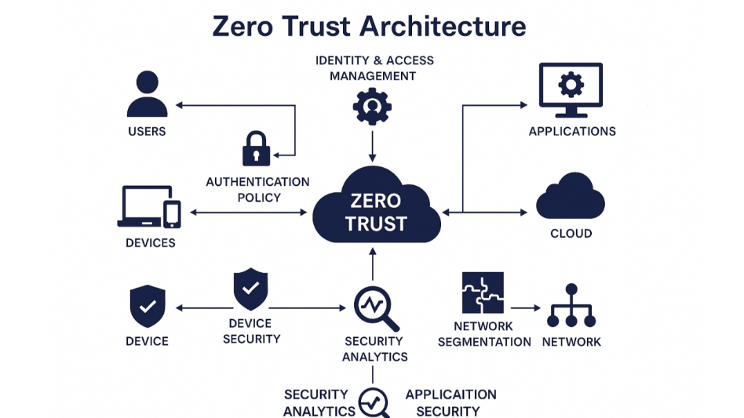

As shown in this image, the Zero Trust model ensures that all users and devices must be continuously verified before accessing systems.

A Data Protection Policy is also essential to ensure that all patient data is handled securely, including rules for data storage, encryption, and secure transmission. This policy supports compliance with UK GDPR requirements and helps prevent data breaches [4].

Furthermore, a BYOD (Bring Your Own Device) Policy should be introduced to manage the risks associated with employees using personal devices. This policy should define security requirements such as device encryption, secure access, and regular updates, helping to reduce vulnerabilities linked to personal device usage.

Finally, an Incident Response Policy should be established to make sure the organisation can deal with security incidents in a fast and organised way. This includes clear procedures for identifying, reporting, and managing cyber threats, which is essential for minimising damage and recovery time.

Technical Mitigation Measures

Technical mitigation measures are very important for reducing cybersecurity risks in organisations like HealthPlus Analytics (HPA), especially after the recent incidents the company has experienced. These measures focus on using technology to protect systems, data, and networks from different types of cyber threats.

One of the main measures is data encryption, both when the data is stored and when it is being transferred. This means that even if someone gains unauthorised access, the information cannot be easily understood or misused.

In addition, multi-factor authentication (MFA) should be used to improve access control and reduce the risk of compromised accounts, especially in cases like phishing or stolen credentials.

Another important area is network security, which involves using tools like firewalls, intrusion detection and prevention systems (IDS/IPS), and properly configured networks. These measures help track network activity and stop suspicious behaviour before it turns into a serious problem. In addition, organisations should use endpoint detection and response (EDR) solutions to detect threats and take action quickly, including malware and ransomware, in real time [5].

Since HPA depends on cloud-based systems, it is also important to have strong cloud security in place. This includes managing access properly and continuously monitoring cloud environments. Keeping systems updated and applying patches regularly is also essential, as attackers often take advantage of known weaknesses in outdated software when updates are delayed or not applied correctly [6].

Furthermore, keeping regular backups of data and having a disaster recovery plan in place is important to make sure systems and information can be restored after an incident, especially in cases like ransomware attacks. Finally, Security Information and Event Management (SIEM) systems can be used to track system activity, detect unusual behaviour, and support faster incident response.

Together, these technical measures provide different layers of protection, making it harder for attackers to take advantage of system weaknesses.

Proactive Monitoring and Incident Response

Proactive monitoring and incident response are important for protecting HealthPlus Analytics (HPA), especially because of the sensitive nature of patient data and the recent security incidents faced by the organisation. Continuous monitoring helps identify unusual activity early, allowing faster action before problems become more serious.

One key solution is the use of Security Information and Event Management (SIEM) systems, which analyse network activity and system logs in real time. These tools can detect unusual behaviour, such as unauthorised access attempts or abnormal data transfers, helping the security team take action quickly [7].

Alongside monitoring, HPA should follow a clear incident response process. This includes identifying the threat, containing it to prevent further impact, removing the cause, and restoring affected systems using secure backups. Having a structured process ensures that incidents are handled efficiently and with minimal disruption.

It is also important to review incidents after they occur, as this helps identify weaknesses and improve future security measures. In addition, employees should know how to report suspicious activity, since early detection can significantly reduce the impact of an attack.

By combining continuous monitoring with a structured response approach, HPA can improve its ability to manage cybersecurity risks and protect its systems more effectively.

Monitoring and Incident Response Process at HPA flowchart:

Continuous Training and Awareness

To ensure compliance with the new security policies, HealthPlus Analytics (HPA) should implement a structured and continuous training programme for all employees. Since many cybersecurity incidents are caused by human error, it is important that staff understand both the risks and their responsibilities when handling sensitive patient data.

The training should start with an onboarding session for new employees, introducing key policies such as data protection, access control, and acceptable use of systems. This ensures that all staff begin with a clear understanding of security expectations.
In addition, HPA should provide regular training sessions, updated to reflect current threats such as phishing, ransomware, and social engineering attacks. These sessions should focus on practical skills, including how to recognise suspicious emails, create strong passwords, and securely access company systems, especially when using personal devices.

To reinforce learning, the organisation can use phishing simulations and short awareness exercises. These allow employees to apply their knowledge in realistic scenarios and help identify areas where further training may be needed.

Clear communication is also essential. Staff should know how to report security incidents quickly and understand that reporting mistakes is encouraged, not punished. This helps improve early detection and response.

By maintaining continuous training and awareness, HPA can improve compliance with its security policies and reduce the risk of human-related security breaches.

Conclusion

HealthPlus Analytics (HPA) has already experienced serious security incidents, highlighting the need for stronger controls and a more structured approach to security management.
This report identified key internal and external threats and proposed a combination of security policies and technical mitigation measures to reduce these risks. By applying these recommendations, HPA can strengthen its overall security, improve compliance with UK GDPR and NHS Digital Security Standards, and reduce the risk of future cyber incidents.
By implementing these recommendations, HPA can strengthen its security posture, improve compliance with UK GDPR and NHS Digital Security Standards, and reduce the likelihood of future cyberattacks. In addition, promoting a culture of security awareness across the organisation will support long-term protection and resilience in an increasingly complex digital environment.

References

[1] W. Stallings, Effective Cybersecurity: A Guide to Using Best Practices and Standards. Boston, MA, USA: Addison-Wesley Professional, 2018.
[2] C. S. Johnson, M. L. Badger, D. A. Waltermire, J. Snyder, and C. Skorupka, Guide to Cyber Threat Information Sharing, NIST Special Publication 800-150, Oct. 2016. doi: 10.6028/NIST.SP.800-150.
[3] J. Andress, The Basics of Information Security: Understanding the Fundamentals of InfoSec in Theory and Practice, 2nd ed. Amsterdam, Netherlands: Elsevier/Syngress, 2014.
[4] W. Stallings and L. Brown, Computer Security: Principles and Practice, 4th ed. New York, NY, USA: Pearson, 2018.
[5] E. Bertino and N. Islam, “Botnets and Internet of Things Security,” Computer, vol. 50, no. 2, pp. 76–79, 2017. doi: 10.1109/MC.2017.62.
[6] P. Mell, K. Scarfone, and S. Romanosky, “A Complete Guide to the Common Vulnerability Scoring System Version 2.0,” NIST, 2007.
[7] M. Behl and K. Behl, “Cybersecurity and cyberwar: What everyone needs to know,” Oxford University Press, 2017.

Appendix A: Screenshot of the Board of Directors PowerPoint presentation



