Activity 1

Qualification: CIPD Diploma in Applied Human Resources

Module Name: 5CBIC – Understanding the Business Context of HR

Word Count: 2196

Student Name: Katy Barron

Student Number: 1811083

CIPD Membership Number: 5339341X

By signing below, I confirm that the work/evidence presented is my own, unaided work. I understand the regulations pertaining to candidate malpractice and the action that may be taken as a result.

Signed: K.L.Barron
Date: 28/01/2019

Coleg Ceredigion is a third sector bilingual college; established in July 1973 and is the only Further Education college within the county of Ceredigion. The college has two campuses based in Aberystwyth and Cardigan with a choice of courses including, Catering, Construction, Childcare and Health Studies, Performing Arts and ICT. Coleg Ceredigion currently employs 183 staff with around 300 full time students and part time students on each campus. The college merged with UWTSD in 2014 and became a part of the University’s group.
On the 1st June 2017, Coleg Ceredigion and Coleg Sir Gar merged to form one college over two counties with 7 campuses covering West and South Wales.
Coleg Sir Gar is also a third sector Further Education college in the county of Carmarthen, created in 1985; becoming a corporate institution in 1993. In 2013, it also became a company within the UWTSD Group as a segment of a regional Dual Sector University. Coleg Sir Gar employs around 800 staff with around 9,000 learners; 3,000 are full time and 6,000 are part time students with approximately 900 higher education learners. The college has five campuses covering Carmarthenshire; Y Graig Campus in Llanelli, Ammanford, Gelli Aur, Jobswell and Pibwrlwyd.
Coleg Ceredigion’s mission is ‘Fulfilling Potential – Changing Lives’ with its values covering Respect, Responsibility and Results. However, following the merge with Coleg Sir Gar, the joint vision now is “To inspire employable, capable and resilient learners who achieve prosperity”.
Ceredigion County Council is a public sector authority and the governing body for the county of Ceredigion since 1996. The council currently employees around 3,500 full time equivalent staff and carries out the services of a Welsh County Unitary Authority to a population of around 75,400, located in West Mid Wales. The staff employed by the council are divided between 2 sites; Aberystwyth and Aberaeron with two depots; North and South from where services are delivered. Ceredigion County Council’s vision is “delivering value for money sustainable bilingual public services that support a strong economy and healthy environment while promoting well-being in our people and our communities”.
Although both organisations provide services, they’re categorised into different sectors. Coleg Ceredigion is in the third sector and therefor is ‘not-for-profit’ or government controlled. Whereas Ceredigion County Council is in the public sector meaning that the organisation is owned and operated by the local government.
Organisations belong to one of three economic sectors; the Private, Public or Third sector with occasional organisations crossing the boundaries e.g. private-public partnerships.
The private sector contains businesses owned by private individuals, other organisations or by high quantity of individual/institutional shareholders. Majority of private sector businesses aim to make profit and have one of three apparent forms; sole traders, partnerships and companies. Publicly Limited Companies (PLC) employ HR specialists to run people management at work with a big HR division/department. However, smaller private companies, partnerships and sole trading business don’t have huge HR functions; only employing a HR specialist or two to perform basic HR tasks. Smaller firms prefer to deal with staff informally (Edwards and Ram, 2010).
The organisations under the public sector would be, central government departments, local and regional government organisations and public service providers just like Ceredigion County Council. These are occasionally wholly funded by taxpayers, subjected to certain public accountability and managed by elected officials. Public sector organisations usually have large HR functions with HR directors as leading influential members of executive boards; insisting that good practice is followed. HR divisions complete various tasks, with specialists and generalists employed to work together. HR practice within public sectors are condemned for having an overly bureaucratic approach; requiring a more business-focused and strategic approach. HRM in public sector organisations differentiate from private sectors through observing significant principles of management practice; treating people fairly and respectably. This can be achieved by following specific written policies (Bach 2010, p563).
The third sector includes organisations who are neither public or private, such as charities and chartered bodies; universities and professional bodies such as Coleg Ceredigion. These organisations are not-for-profit and aren’t subject to government control or company law. HR usually has a peripheral duty, carrying out basic administrative work. HR practice therefore doesn’t have the opportunities to enable HR managers to add compelling strategic value. James (2011) states that cutback of resources is obligating third sector organisations to lower HRM standards.
The culture of HR within organisations impacts the HR function. The culture is based on approaches such as transactional and transformational. Ingram (2018) states that a transactional leaderships’ responsibility is assuring normal operations and motivating the workforce with reward management. However, a transformational leader does more than mundane work and devises strategy to move their department/organisation forward.
The hierarchical bureaucracy structure of a local authority such as Ceredigion County Council demonstrates the use of both transformational and transactional leadership. The higher up on the hierarchy structure, the more transformational leadership is used. However, the lower down the structure, the more administrative and transactional leadership is shown.
This culture is mirrored in Coleg Ceredigion. The business support and lecturing staff perform transactional production whereas the managers who are ranked higher up the hierarchical bureaucracy use a transformational leadership approach; constructing significant decisions.
The typical HR objectives of a public sector organisation like Ceredigion County Council would be associated with enhancing the service that they provide to the public and increase the efficiency to save public money. HR professionals usually have concerns on how they plan to design and deliver work due to government restrictions and assumptions surrounding best practice. The HR function is often structured in a similar way to large private sector organisations (Wilkinson and Taylor, 2016).
In the third sector, the size of the function rests on the size of the organisation. HR will aim to recruit employees with a definite advantage, making them feel appreciated and motivated within the company (Wilkinson and Taylor, 2016). As there’s usually a limited budget within this sector, HR often accentuate terms and conditions to attract and keep individuals feeling valued.
Organisational structures and management roles impact the HR function. Bureaucracy was formulised by sociologist Max Weber in 1890’s. Weber (1964) states three paramount principles of bureaucratic organisations; specialisation, hierarchy and impersonal rationality.
Specialisation is when tasks are divided, with employees recruited for their specific skills to complete special roles. HR provide technical and physical support for foundation activities (Fayol, 1916-1949).
Hierarchy suggests power and authority; this resulted in the formation of hierarchical structure. This allows only those high up in the organisational hierarchy the responsibility to assign to those lower down the hierarchy.
Impersonal rationality made dishonesty and discrimination impossible; with the rules forming today’s anti-discrimination legislation – to be suitably judged on your own excellence and not for your sex, gender, skin colour, religion, sexual orientation, nationality and disability.
The strengths of bureaucracy are that it provides a predictable and secure career path and the rules give various protection. However, complexity of the rules could lead to staff feeling helpless and confused and the precise definition of tasks could generate an alienated workforce. Overall there are strong bureaucratic elements in almost all organisational forms today.
Divisionalisation (or M-Form) is a development of the bureaucratic organisation; as organisations grow, the difficulty to manage from the central increases. This results in some decision-making being decentralised. Divisionalised organisations create separate products, markets or geographical divisions whom are responsible for operational decisions. Each division is seen as a mini-bureaucracy, with strategic decisions being sent to headquarters (Boxall and Purcell, 2008). Divisionalisation was essentially created by Alfred Sloan in the 1920’s. The divisional structure is popular within multinational corporations (Hales, 2001).
The matrix organisation model was created during the 1960’s. The organisations are involved in projects with limited durations. Each project requires work from functional specialists from functional departments. Line managers decide who controls departments.
Unfortunately, with the matrix model individuals are answerable to at least two managers which can lead to a feeling of insecurity and the structure is threatening to functional managers. However, the model improves organisational communication; improving the speed and effectiveness of decision making. REFERENCE
The network organisation (N-Form) is an informal version of the matrix organisation. Aiming to build up networks and connections between departments in the organisation for faster dispersion of ideas. REFERENCE
The ways to do this include, Unilever. This is used to create relationships between managers and divisions (Boxall and Purcell 2008, p264). Another way is using network managers with various roles e.g. co-ordinators of information transfer (Child 2005, p255).
The success of N-form organisations is culture (Whittington and Mayer, 2000). Bettis (1991) states that with the development of N-form, the M-form has become dated; the structure’s key resource is knowledge. According to Purcell (2005) the M-form structured followed strategy. However, the N-form is strategy.
Virtual organisation is another structure and replaces physical assets with computer networks. There are six characteristics of virtual organisations identified by Warner and Witzel (2003, ch1); inadequate physical structure, mobile work, dependence on communications technology, hybrid forms, ‘boundaryless’ inclusive and flexible and responsive.
Strategic alliances are co-operative relationships between firms. Contracter and Lorange (1998) recognise six objectives; reduces risk, technology exchange, countering competition, overcomes government trade, achievement of frugality of scale, vertical quasi-integration advantage.
Chandler (1962) argues that organisational HR structure should reflect and support the business strategy.
Organisational design improves organisation performance; ensuring sustainability by addressing the organisations structure. Organisational development aims for high performance through the involvement of people and behaviours of an organisation (Roberts, 2016).
Organisation design considers the organisational structure, systems, processes and culture; ensuring these elements fit together efficiently to maximise the organisations performance and reach its goals.
According to the CIPD (2015), organisation development must take a systematic approach for constant organisation performance through its people. Organisation development focuses on performance, development, capabilities and skills as well as the working environment’s culture.
The CIPD (2008) studied and identified changes in the structure of HR within large public and private sectors; revealing organisations were adopting variations of Ulrich’s (1997) three-legged model as HR structure rather than centralised HR departments. This resulted in HR functions becoming specialised and divided.
Within organisations, those with managerial authority will determine and implement organisational strategies; delivering them through suitable HR practices. To be strategic players, HR specialists must understand internal political structures and how they influence policies and strategies. HR specialists need to build alliances and expose the added value of HR contribution (Farnham, 2010). Ulrich (1997) states that HR is crucial for the development of specialists; working with managers to determine and implement strategies and promoting vertical integration of HR.
Business context varies across private, public and third sector organisations, ending with variations of HR approaches. A focus has been on how strategy is devised by organisations; with three alternative approaches (Taylor and Wilkinson, 2016).
Firstly, there is rational/classical which is where ‘strategy-making’ is allocated to senior managers, to guarantee evaluations on internal and external environmental factors using analysis tools e.g. SWOT and PESTLE.
Secondly is emergent/incrementalism which was introduced by James Quinn (1980). His discovery was that rational strategy developed at senior levels determined the strategic direction of the organisation.
Finally, the third approach is symbolic/radical approach. This indicates that organisations often progress with the business of competing and developing tactics as they work; experimenting with ideas and choosing those that work.
To align HR and business strategies, managers use contingency thinking and models. Contingency thinking in HRM has been judged by the ‘best practice school’ who claim that whichever strategy an organisation follows, HR will need to follow the same basic practices to ensure success (Pfeffer 1994, Huselid 1995, Purcell et al 2003).
There are many contingency models such as Boston Consulting Model (Purcell 1989), this suggests HR practices should depend on the organisation’s relative market. Another model by Miles and Snow (1978) aims to identify the relevant HR practices for different competitive strategy.
The most influential model is Michael Porter’s (1985) who focuses on alternative ways that organisations achieve competitive advantage and identified three strategies; cost leadership, differentiation and focus. Cost leadership is the value for money, differentiation is the quality enhancement/innovation and the focus approach involve the use of either cost leadership or differentiation in a market segment.
All the above contingency models advise organisation’s HR function to think strategically whilst adding value.
Another approach is resourced-based thinking. This approach is described as the ‘inside-out’ thinking as oppose to ‘outside-in’ thinking that distinguishes contingency theories. The analysis is done by auditing existing resources regarding competitive strengths. Barney (1991) suggests that the aim is understanding which resources are valuable, rare, inimitable and non-sustainable. The priority of this approach is to protect, heighten and reinforce these strengths.
Vertical and horizontal integration are crucial in developing and implementing HR strategy and is root of HRM and HR strategy (Wilkinson 2008, p28).
Vertical integration is the connection between HR and business strategies with external political, economic, social and legal forces to help form them. Horizontal integration is the ‘fit’ between internal HR strategies and policies. These contain, organisational design, organisation development, employee engagement and resource and talent planning. Marchington and Wilkinson (2008) consider both vertical and horizontal integration need to be enhanced to increase the HR contribution.

Bibliography
Bach, S. (2010) HRM in the public sector. In: Wilkinson, A., Bacon, N. and Snell, S. (eds). The Sage handbook of human resource management. London: Sage. Pp51-77.
Barney, J. (1991) Firm resources and sustained competitive advantage. Journal of Management. Vol 17, No 1. Pp99-120.
Bettis, R. (1991) Strategic management and the strait-jacket: and editorial essay. Organization Science. Vol 2, No3.
Boxall, P and Purcell, J. (2008) Strategy and Human Resource Management. 2nd edition. Basingstoke: Palgrave-Macmillan.
Chandler, A.E. (1962) Strategy and Structure: chapters in the history of the American enterprise. Cambridge, MA: MIT Press.
Child, J. (2005) Organization: contemporary principles and practice. Oxford: Blackwell.
CIPD (2008) The Changing HR Function. London: CIPD
CIPD (2013) Megatrends: the trends shaping work and working lives. London: Chartered Institute of Personnel Development.
Contractor. F, and Lorange, P. (1998) Why should firms cooperate? The strategy and economics basis for cooperative ventures. In: F. Contractor and P. Lorange (eds) Cooperative strategies in international business. Ned York: Lexington Books.
Edwards, P. and Ram, M. (2010) HRM in small firms: respecting and regulating informality. In: Wilkinson, A., Bacon, N. and Snell, S. (eds). The Sage handbook of human resource management. London: Sage. Pp524-40.
Farnham, D. (2010) Human Resource Management in Context: Strategy, insights and solutions. London: Chartered Institute of Personnel Development.
Fayol, H. (1916/1949) General and industrial management. London: Pitman.
Hales, C. (2001) Managing through organization. 2nd edition. London: Business press/ Thomson Learning.
Huselid, M. (1995) The impact of human resource practice on turnover, productivity and corporate financial performance. Academy of Management Journal. Vol 38, No3. Pp635-72.
Ingram, D. (2018) Available at: https://smallbusiness.chron.com/transformational-leadership-vs-transactional-leadership-definition-13834.html [Accessed on: 20 January 2019]
James, P. (2011) Voluntary sector outsourcing; a reflection on employment related rationales, developments and outcomes. International Journal of Public Sector Management. Vol 24, No 7. Pp684-93.
Marchington, M. and Wilkinson, A. (2008) Human resource management at work: people management and development. 4th ed. London: Chartered Institute of Personnel Development.
Miles, R. E. and Snow, C. C. (1978) Organization strategy, structure and process. New York: McGraw-Hill.
Open University. Available at: https://www.open.edu/openlearn/ocw/mod/oucontent/view.php?id=21012&section=1.1 [Accessed on: 11 January 2019]
Pfeffer, J. (1994) Competitive advantage through people. Boston, MA: Harvard University Press.
Porter, M. E. (1985) Competitive advantage. New York: Free Press.
Purcell, J. (1989) The impact of corporate strategy on human resource management. In: Storey, J. (ed.) New perspectives on human resource management. London: Routeledge. Pp67-91.
Purcell, J. (2005) Business strategies and human resource management: uneasy bedfellows or strategic partners? University of Bath Working Papers 2006:16. Available at: http://www.bath.ac.uk/management/research/pdf/2005-16.pdf [Accessed on: 22 January 2019]
Purcell, J., Kinnie, N., Hutchinson, S., Rayton, B. and Swart, J. (2003) Understanding the people and performance link: unlocking the black box. London: Chartered Institute of Personnel and Development.
Quinn, B. (1980) Strategies for change: logical incrementalism. Homewood, IL: Irwin.
Roberts, C. (2016) ‘Organisation Design and Organisation Development’ in Taylor, S. and Woodhams, C. Human Resources Management: People and Organisations. London: Chartered Institute of Personnel Development. Pp165.
Taylor, S. and Wilkinson, K. (2016) ‘Business Issues and the Contexts of Human Resources’ in Taylor, S. and Woodhams, C. Studying Human Resource Management. London: Chartered Institute of Personnel Development. Pp58.
Ulrich, D. (1997) Human Resource Champions: the next agenda for adding value and delivering results. Boston, MA: Harvard Business School Press.
Warner, M. and Witzel, M. (2003) Managing in virtual organizations. London: Routledge.
Weber, M. (1964) The theory of economic and social organization. New York: Free Press.
Whittington, R. and Mayer, M. (2000) The European corporation: strategy, structure and social science. Oxford: Oxford University Press.
Wilkinson, K. and Taylor, S. (2016) ‘Managing and co-ordinating the HR Function’ in Taylor, S. and Woodhams, C. Studying Human Resource Management. London: Chartered Institute of Personnel Development. Pp28.

Activity 2

Qualification: CIPD Diploma in Applied Human Resources

Module Name: 5CBIC – Understanding the Business Context of HR

Word Count: 514

Student Name: Katy Barron

Student Number: 1811083

CIPD Membership Number: 5339341X

By signing below, I confirm that the work/evidence presented is my own, unaided work. I understand the regulations pertaining to candidate malpractice and the action that may be taken as a result.

Signed: K.L.Barron
Date: 28/01/2019

Having considered other environmental and analysis tools such as Porter’s five Forces Framework, I decided that SWOT and PESTLE were best. See Appendix 1.1 and 1.2.
The CIPD (2015) describe a SWOT analysis as a planning tool, used to discover strengths, weaknesses, opportunities and threats concerned with a project or business; discovering the internal and external factor that either support or oppose the objectives.
The internal strengths of CC are that it’s a large third sector organisation and the only Further Education college in the county. CC merged with UWTSD in 2014 and becoming part of the University’s group, and with CSG in 2017. The College offers a vast number of courses over 7 campus with around 1000 employees. HR are responsible for the needs and wellbeing of the staff.
The internal weakness of CC is the geographical location of all 7 campuses. The campuses cover Mid-West Wales and South Wales; with majority in Carmarthenshire. This makes internal communication difficult and lacks opportunity for staff on opposite campuses to get to know one and other. Following the recent merger, all policies and procedures haven’t been harmonised; leading to confusion and complaints from staff which can be difficult for HR.
The opportunity for CC would be offering online courses. HR would need to recruit and/or train staff on delivering video workshops. Another opportunity would be benchmarking to competitors; seeing what benefits they offer their employees. This would require HR to carry out the research and present new ideas.
The threat to CC would be the development of AI; HR may need to deal with redundancies. Another threat would be losing staff/students to competitors. This impacts HR as it could mean recruiting, conducting exit interviews and brainstorming ideas on retention. Brexit is another threat to the College; impacting HR processes such as DBS and could reduce international students/staff and ESF funding cuts.
According to the CIPD (2018), a PESTLE analysis is a flexible review of an organisation’s environmental influences; used in various scenarios resulting in strategic decision-making.
Political changes like change of policies affects HR as there is a need for implementing/amending new and current policies.
Economic factors such as budget reduction influences the services available. This impacts HR as it may affect recruitment and training costs, and employee benefits such as lunch time yoga sessions.
Social changes such as ageing population impacts HR on managing different generations within the workforce. Employees of various ages with have different commitments and training needs to become IT literate. Another change would be the increase use of social media. Misuse of social media could lead to HR dealing with disciplinaries/dismissions.
Technology changes like change from paper to technology would mean HR adapting the way that they store files/documents.
Legal factors like employment law would impact HR; continuously implementing changes and updating policies in the organisation.
Environmental factors such as lowering carbon emissions would impact HR as the need to encourage the use of video conferencing to reduce travel would be greater. CC/CSG cover 7 campuses; resulting in travel claims and communication difficulties that HR would need to deal with
Bibliography
The CIPD (2015) SWOT Analysis Factsheet. Available at: https://www.cipd.co.uk/knowledge/strategy/organisational-development/swot-analysis-factsheet#8008 [Accessed on: 19 January 2019]
The CIPD (2018) PESTLE Analysis Factsheet. Available at: https://www.cipd.co.uk/knowledge/strategy/organisational-development/pestle-analysis-factsheet [Accessed on: 22 January 2019]

Appendix 1.1
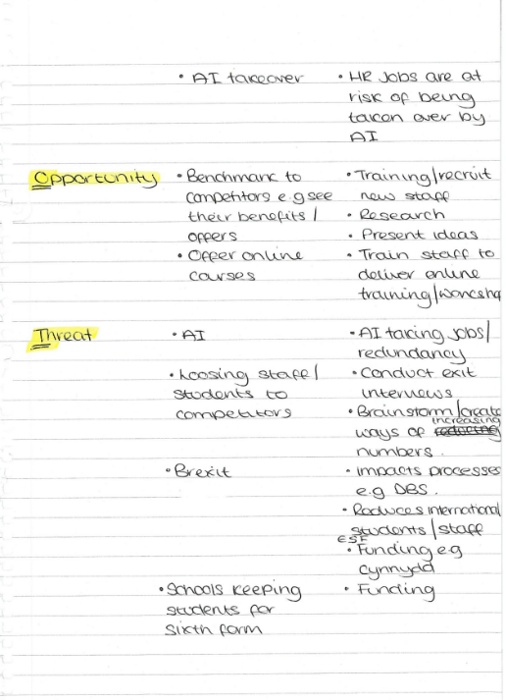
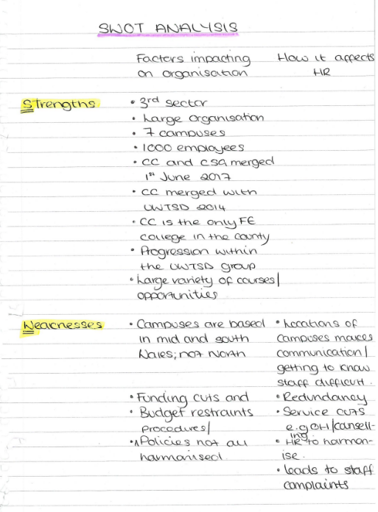

Appendix 1.2


