End User Computing Assignment 2

Introduction

End user information systems provide users a way to more accurately display data by showing evidence of data deprivation in locations. In relation to these maps, code can contain enhanced map creation tools that become of ease to use for end user developers that might include combining datasets from a variety of different working documents to efficiently locate data. The following assignment tasks explain how an appropriate information systems tool could be used for locating easily health related problems in contrast to using Excel. Also this assignment demonstrates the differences between a GIS information created in Mapinfo in comparison to a GIS system made in Excel.

2.0 Using GIS for development

2.1 What is GIS

GIS stands for geographic information systems, these in effect work by solving complex problems found around the world, analyzing data and to openly communicate problems across the world. GIS has been known to be around for awhile as early as 1854 that allows users to help obtain and manage data for attaining the organization’s goals for resolving real life problems. The history of GIS systems were discussed by John Snow back in 1854 as he stated that, [1] “He used points on London residential map to plot outbreak of Cholera.” http://grindgis.com/what-is-gis/what-is-gis-definition. 01/11/2017 Accessed 28/03/2018 15:38pm. With GIS systems, there have been known to be advantages as well as disadvantages for instance, it has been proven useful to detect house information nearest public buildings such as schools and hospitals in specific areas to simplify data. Also, GIS can check congested traffic routes and alternative transport modes to take for improved planning for users and the systems can be used to make the population healthier by focusing data correlations so professionals can determine action to take if solving health, financial or education problems to name a few.

2.2 Development of GIS

GIS usually are renowned for containing some specific geographic information or location in order for users accessing data to see a display that identifies some map of interest. However, data used for collecting mostly becomes user dependent meaning that the more accurate data is, the easier an end user can find information being searched for across the mid, upper, super and output areas and to find data correlations especially with data deprivation. GIS can be used in several ways with software for instance Oracle, Microsoft Excel, Global Mapper andw Mapinfo, but the software being used in this scenario is Mapinfo with a combination of Excel and example townsend index maps to help combine the data in a more representative way.The data and views collected for this assignment were a complete townsend index version, health related data from assignment 1 in relation to substance misuse which was alcohol, schools data that has a relationship to the males and females that have qualifications gained from the disability table, ward data defining increases in rich population containing more disabilities and therefore needing to be provided more unpaid care and discussing the consideration that should be taken to tackle the health related problems focusing on the Swansea area.

3.0 Using Mapinfo to collect data

Mapinfo is a fourth generation technology used for enhancing geographical location issues by combining numerous software technologies such as Microsoft Excel and Access to create a flexible map for detecting data trends and to lookup deprivation data. The Synergos-tech site suggests that, the benefit of using Mapinfo is to improve “data visualization, and advanced geographical analysis” by having the ability to format data in a variety of ways in the output areas contained. http://www.synergos-tech.com/exmp_mip.htm [2] cited 04/05/2018 12:15pm. The following methods is how data has been imported from Excel and the NHS wales site to discuss these trends.

3.1 importing the data

When gathering data the essentiality for keeping the workspaces and their related tables in the same table is necessary because mapinfo sometimes has issues with calibrating tables and previewing map geographic locations. To make this work, add workspace was selected and from that point you can select tables you wish to import. From that point onwards you can hide or show related tables. The below image shows some of the related tables
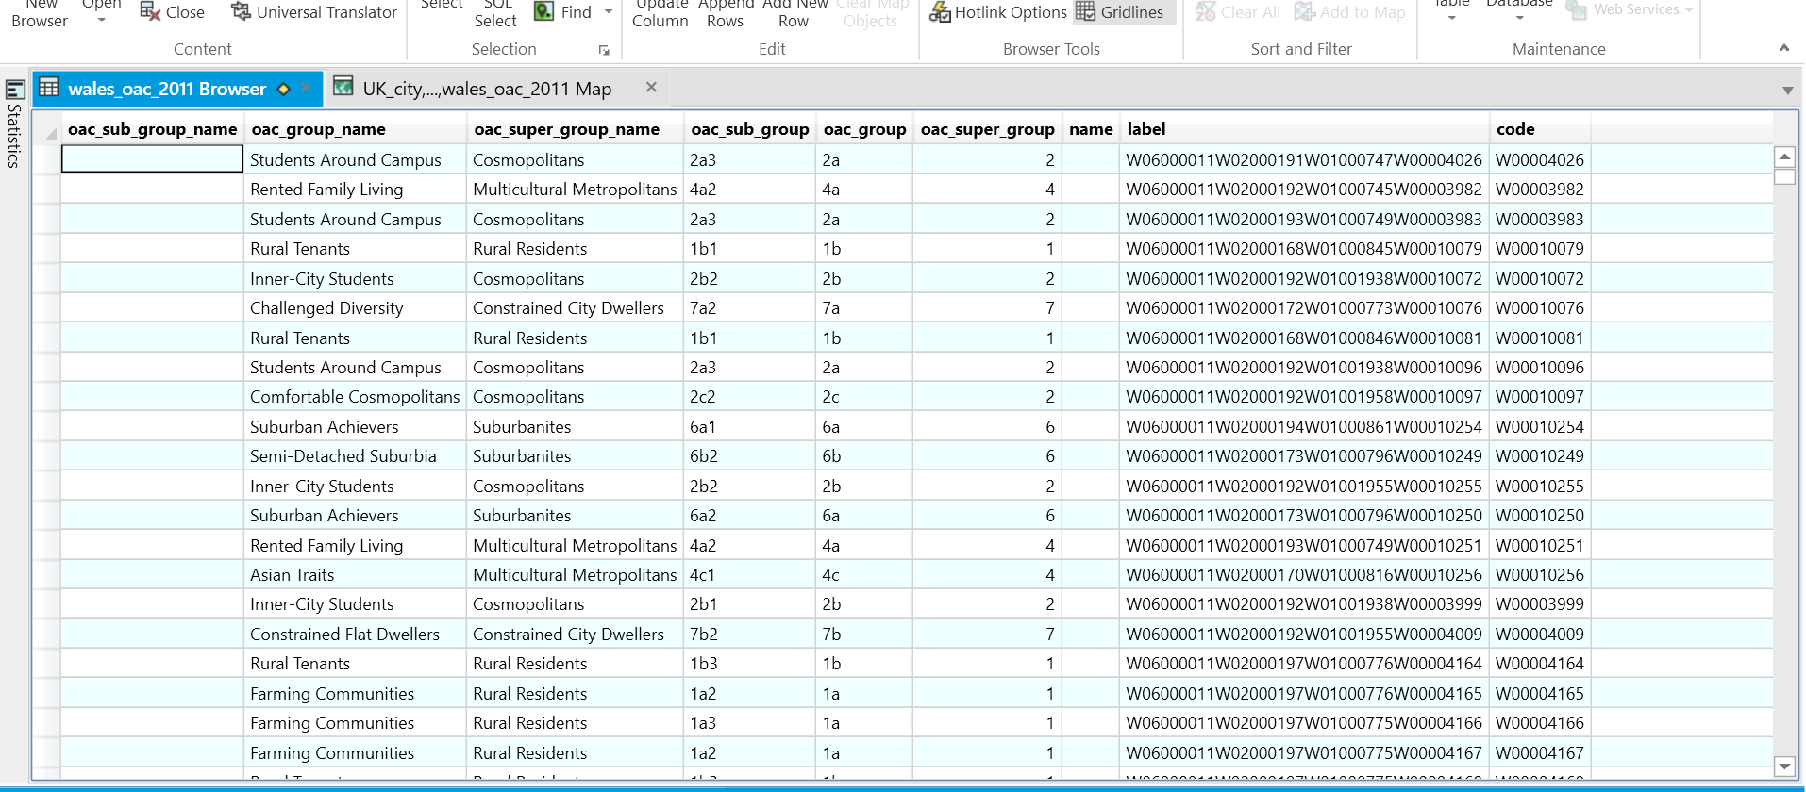
1.0 Data used for GIS

3.2 Health related data

In mapinfo long term health problem or disability data was gathered to show high to low data deprivation. It explains that the more eastern of Swansea people travel to, the higher the population that suffer from a long term disability in crowded areas. Based on the data collected it suggests that the gower has less people suffering from a disability because of there not being as large a population in comparison with areas such as Clydach and Llansamlet. See below image to demonstrate this which uses tables collected from the townsend index and disability table.

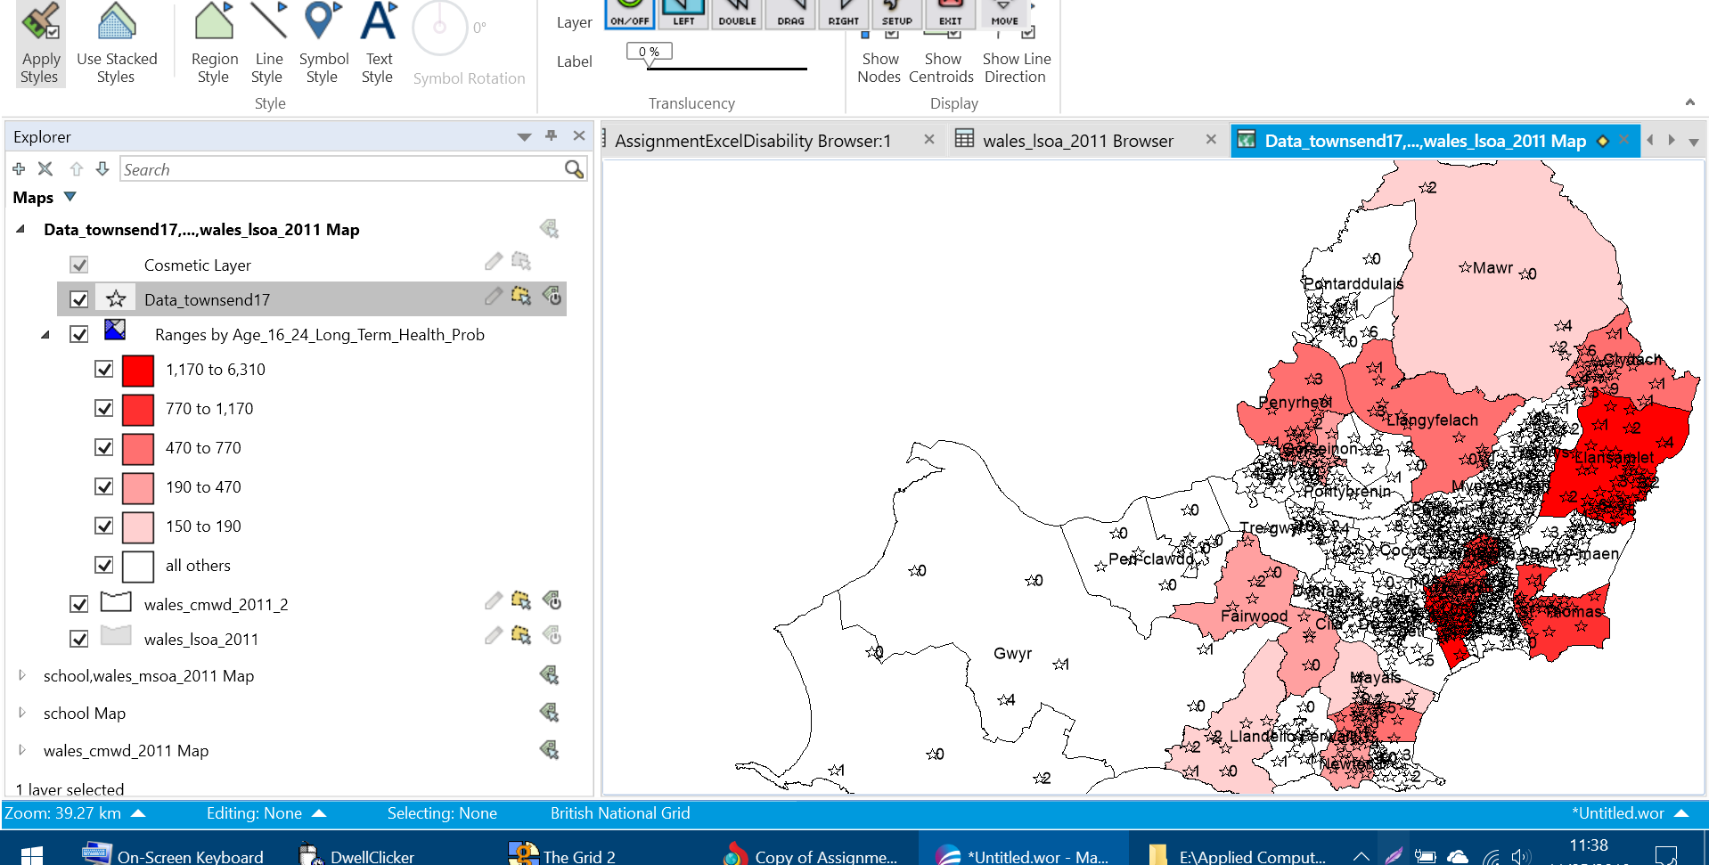
2.0 Ages 16-24 long term health problem or disability

3.3 adding thematic maps using join

Thematic maps can calculate ranges of data deprivation in mapinfo and can be easily customized by modifying the maps used on join. On a successful creation of the join methods the appropriate tables have to be selected to allow the displays to change which for this instance the selected tables were the Assignmentdisability table using rows males and females to check correlations between the gender types that had less qualifications due to long term disabilities. Based on the below images, the data suggests that males have a higher percentage of population without qualifications than females within the age 16 to 24 category (see screen shot 3.0, 3.1)
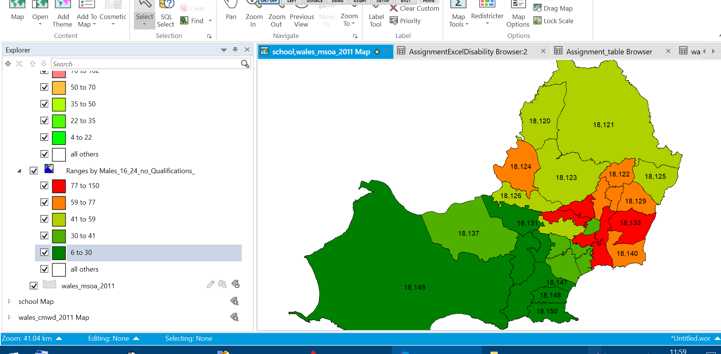
3.1 males 16 to 24 without qualifications

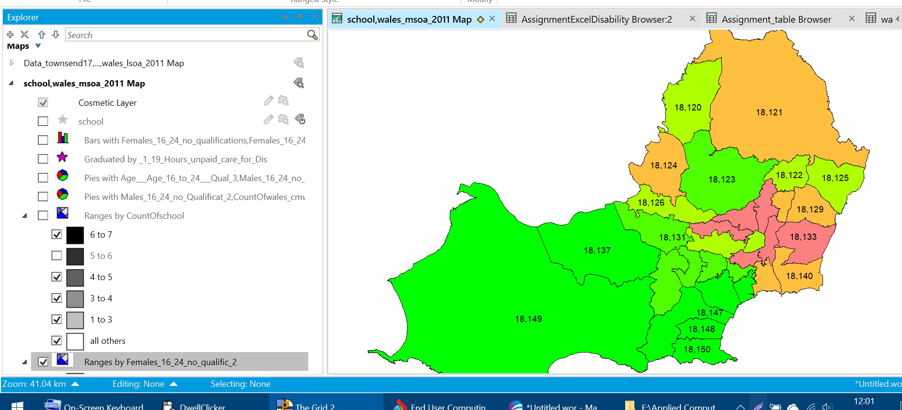
3.2 females 16 to 24 without qualifications

3.4 adding school data to Wales data

The final part of the data involved was school data for checking schools locations in Swansea. This thematic map contains slightly different properties in comparison with the health data because it combines the data of the health map along with the school locations. Properties were also differed by instead of join, count method was used to check the count males and females percentage situated in each school. The data has been collected in this way for checking the overcrowding percentage when schools are between 1 and 7 in each area and it ensures not to much overcrowding is contained in the primary schools. Screen shot 4.0 and 4.1 show a complete map version of school count and the different map layouts that can easily be displayed.

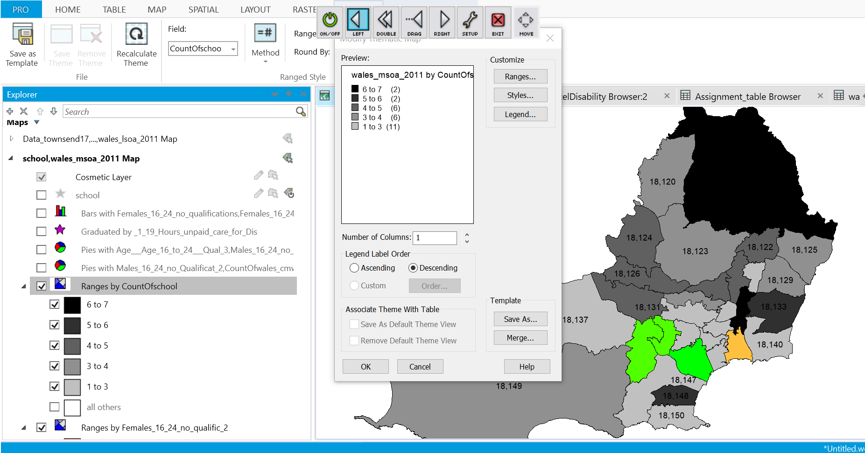
4.0 previews of wales maps with schools data
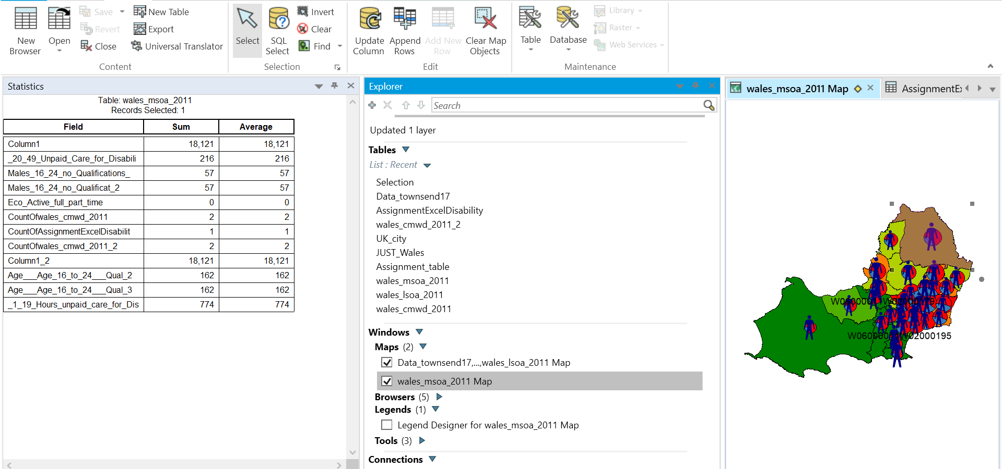
4.1 image of complete map with a preview of overall statistics

