1 Report on 555 Timer Circuit

Author: Joseph Lyons 2030722
Faculty: University of Wales Trinity Saint David
Course: L4 – Fundamentals of Electrical & Electronics Systems (OME HNC Y2) ACDA4011
Date of submission: 17/12/2022

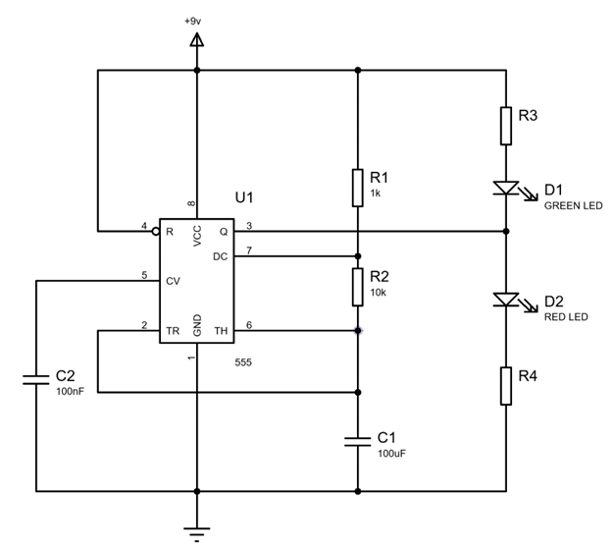

2 Declaration

The work of this report was completed under the supervision of (name supervisors). I declare that this report is the product of my work and is not being submitted for any other degree etc.

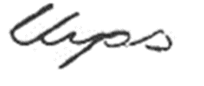

3 Abstract

3.1 The purpose of this activity was to design, simulate and practically create a function 555- timer circuit that turned on & off a Green & Red LED in a repeated sequence.

Using Proteus, a simulated circuit was created that performed the required function. The simulation produced slightly different data from the math used to predict the time on & off. The difference was 0.04s for on & 0.06s for off. The results demonstrate that it takes longer to charge a capacitor than to discharge.

Before building the circuit on a breadboard, a schematic was drawn to represent the physical layout of the components, easily identifying, and preventing any shorting of the circuit, so that once the circuit was complete and supplied with power, it worked as intended.

4 Table of Contents
1 Report on 555 Timer Circuit 1
2 Declaration 2
3 Abstract 2
5 Introduction 3
6 Circuit description and operation 4
6.1 Equipment used (simulation): 4
6.2 Equipment used (practical): 4
6.3 Operation 4
7 Schematic of the circuit drawn and simulated in Proteus 5
7.1 Schematic placement form for the 555-timer circuit 5
7.2 Proteus Simulation (Green LED activation) 5
7.3 Proteus Simulation (Red LED Activation) 6
7.6 Output Voltage & Voltage across the capacitor C1 versus time 7
7.7 Output Voltage & Voltage across the capacitor C1 versus time (in detail) 7
8 Design Calculations 7
8.1 Resistance 8
8.2 Predicted $Timeon \& Timeoff$ 8
8.3 Recorded $Timeon \& Timeoff$ 8
8.4 Period 8
8.5 Frequency 8
9 Tables of timing measurements taken from Proteus simulations 9
9.1 Graph taken from Proteus Simulation 9
9.2 Graph of capacitor (C1) voltage and output voltage against time for the simulated circuit 9
9.3 Graph Time on / Time Off 10
9.4 Table of Measurements from Time On / Time Off Graph 11
10. Details of the 555-Timer Circuit built on Bread Board 12
10.1 Sequence of Building 12
10.2 Breadboard Circuit (Green Activation) 12
10.3 Breadboard Circuit (Red Activation) 13
10.4 Read out of Power Supply 13
11 Conclusion 13
11.1 Simulation on Proteus (7.2/7.3) 13
11.2 Circuit Schematic (7.1) 13
11.3 Actual Circuit (10.2/10.3) 14
References 14

5 Introduction

5.1 This experiment aimed to plan and build a 555-timer circuit, where a Red & Green Led activated alternatively. Proteus was used to create a functioning circuit that was successfully simulated, followed by planning the layout of the circuit on paper for when the components were laid on the circuit breadboard.

5.2 The 555- timer integrated circuit was invented by Hans Camenzind of Signetics in 1971 [1] and has revolutionised the way monostable, bistable & astable oscillator circuits are created to this day.
The design of the 555 IC uses 8 pins each with the following function:

1: Ground
2: Trigger
3: Out Put
4: Reset
5: Control
6: Threshold
7: Discharge
8: Positive Supply

5.3 Picture of the 555 IC
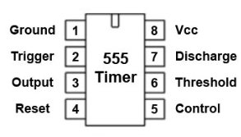 [2]

6 Circuit description and operation

6.1 Equipment used (simulation):

Proteus
Resistors: R1 1KΩ, R2 10KΩ, R3 390Ω, R4 390Ω
Green LED D1
Red LED D2
Capacitors: $C1 0.1μF, C2 100nF$
555 Timer Integrated Circuit (IC) Chip U1
Wire
+9 V Power Source
Earth

6.2 Equipment used (practical):

Breadboard
Resistors: R1 1KΩ, R2 10KΩ, *R3 470Ω, *R4 470Ω
Green LED D1
Red LED D2
Capacitors: $C1 0.1μF,C2 100nF$
555 Timer Integrated Circuit (IC) Chip U1
Wire
+9 V Power Source
Earth

*Note: 470Ω resistors were the closest available within the lab for use, to go in place of the required 390Ω resistors.

6.3 Operation

The function of as 555 Timer within this circuit was to provide an intermittent flashing of a Red & Green LED.

When potential difference (PD) is applied C1 charges through resistors R1 and R2.
As the C1 is charging, the output is high. When the PD across C1 reaches 2/3 of the supply voltage C1 discharges through resistor R2 and the output goes low.
When the PD across C1 drops below 1/3 of the supply voltage C1 resumes charging, the output goes high again and the cycle repeats [2]. The output is turning on and off in repeated sequence the Green & Red LED.

7 Schematic of the circuit drawn and simulated in Proteus

7.1 Schematic placement form for the 555-timer circuit

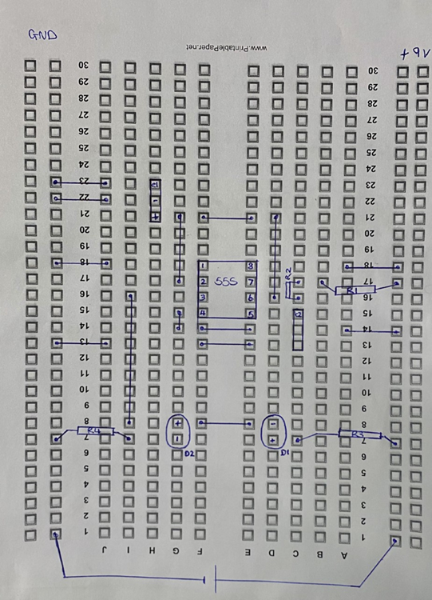

7.2 Proteus Simulation (Green LED activation)

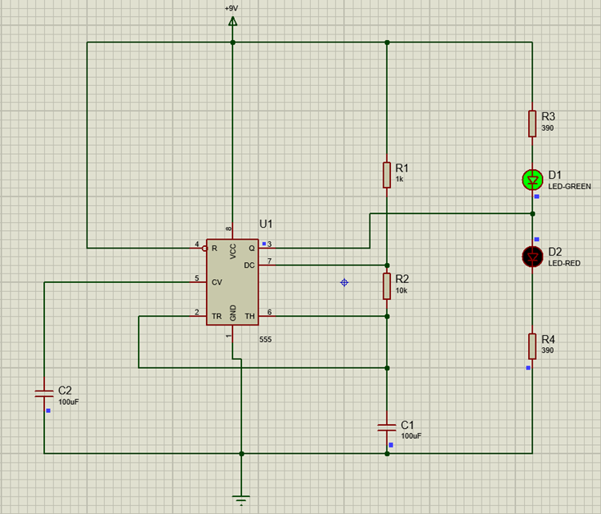

7.3 Proteus Simulation (Red LED Activation)

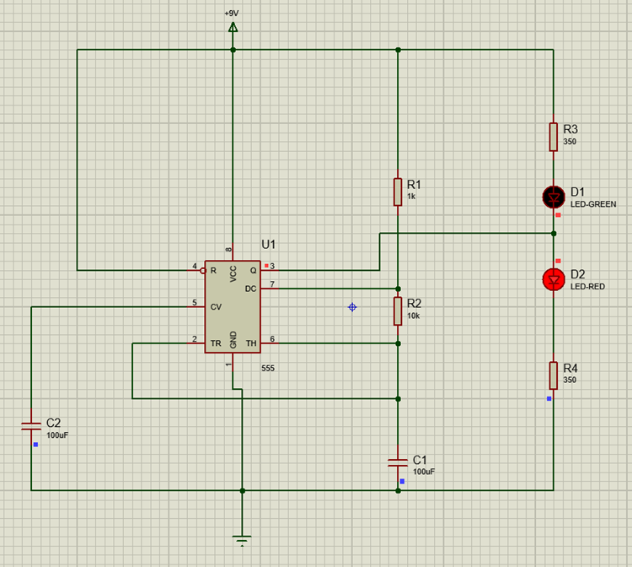

7.6 Output Voltage & Voltage across the capacitor C1 versus time

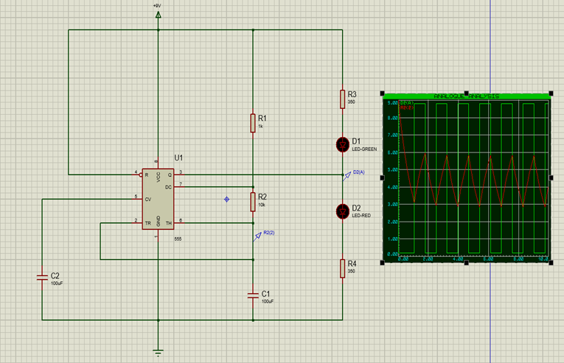

7.7 Output Voltage & Voltage across the capacitor C1 versus time (in detail)

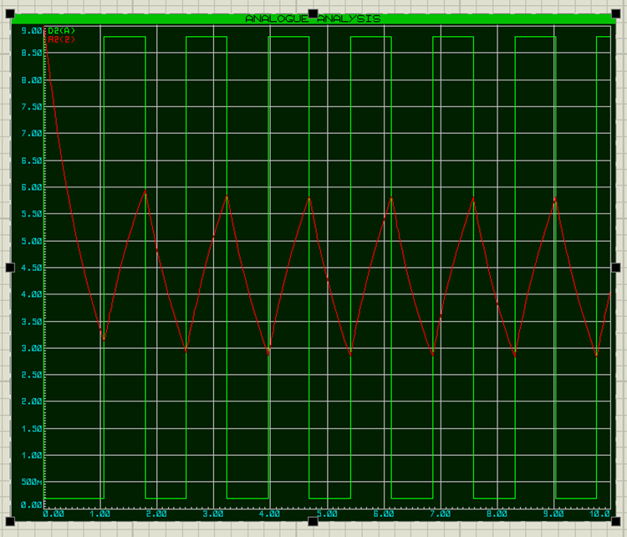

8 Design Calculations

8.1 Resistance
$$R=\frac{V}{I}$$
$$R= \frac{+9V-2.2V(LED)}{20mA}$$

$$R_{3+4}=340Ω$$

*Note: Nearest resistor to 340Ω is 390Ω. The nearest available resistor within the lab where this circuit was built was 470Ω.
*Note: Full drive current was set at 10mA (x2).

8.2 Predicted ${Time}_{on} \& {Time}_{off}$

$$T_{on}=Ln2*\left(1k+10K\right)*100μF=0.76246s$$

$$T_{off}=Ln2*\left(10K\right)*100μF=0.69315s$$

8.3 Recorded ${Time}_{on} \& {Time}_{off}$

Taking a sample between 1.5-4.5 seconds there was a complete cycle of off/on.

$$T_{on}=3.22-2.50=0.72 s (2.d.p)$$

$$T_{off}=2.50-1.80=0.7s (2.d.p)$$

The recorded times are different from what was predicted:

$${Predcited}_{on}-{Recorded}_{on}$$

$$0.76246-0.72=0.04246s$$

$${Predicted}_{off}-{Recorded}_{off}$$

$$0.69315-0.7=-0.0685s$$

8.4 Period

$$Time_{ on}+ Time_{ off}$$
$$0.72s + 0.7s=1.42s$$

.

8.5 Frequency

$$\frac{1}{Period}$$

$$\frac{1}{T_{on}+T_{off}}$$

$$\frac{1}{0.72+0.7}=0.7Hz$$

9 Tables of timing measurements taken from Proteus simulations

9.1 Graph took from Proteus Simulation

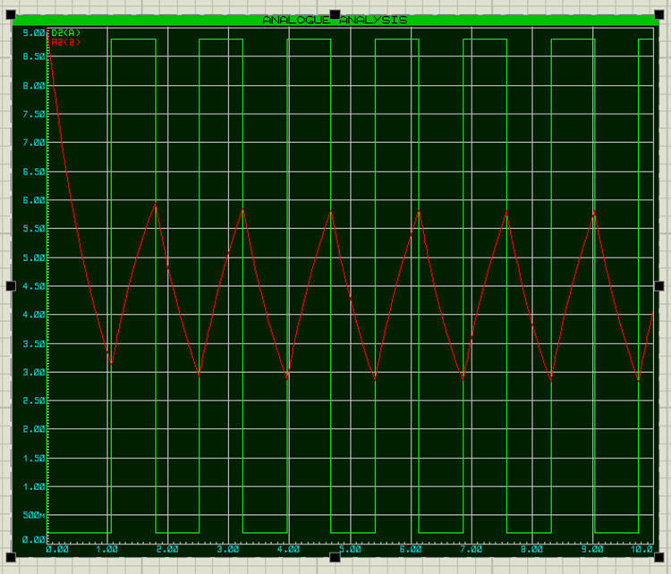

9.2 Graph of capacitor (C1) voltage and output voltage against time for the simulated circuit

Note: Charge across the capacitor is equal to Zero and acts like an “open” circuit, which implied the maximum voltage was dropped across the capacitor, therefore started at the “top.”

9.3 Graph Time on / Time Off

The Peaks represent the time the Light Emitting Diode(s) (LED) were on where the troughs show when the LEDs were off.

9.4 Table of Measurements from Time On / Time Off Graph

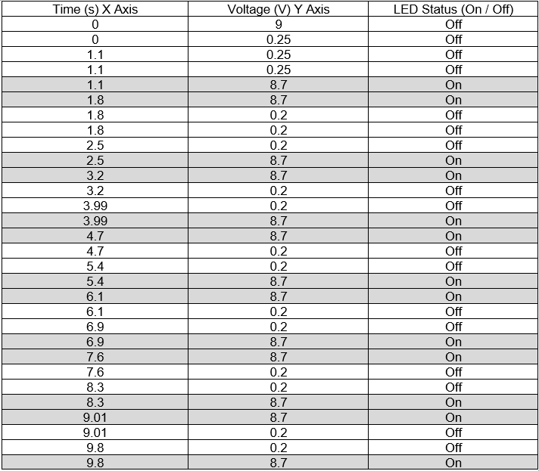

10. Details of the 555-Timer Circuit built on Bread Board

10.1 Sequence of Building

The first component that was laid on the breadboard was the 555-timer chip. Once the chip was situated correctly the remaining components were laid, following the schematic in 7.1.

Secondly the Capacitors C1 & C2 were laid.

Thirdly Each of the four Resistors was placed followed by the Green & Red LED.

Finally, the wires were shortened & stripped then fitted as required by the drawn specification.

The product was a functioning 555 timer circuit that activated a Green and Red LED in a periodic sequence.

10.2 Breadboard Circuit (Green Activation)

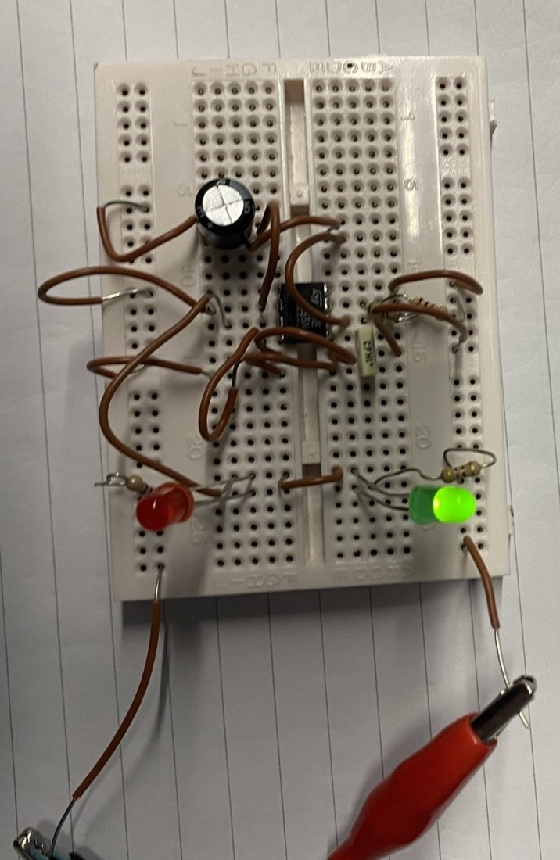

10.3 Breadboard Circuit (Red Activation)

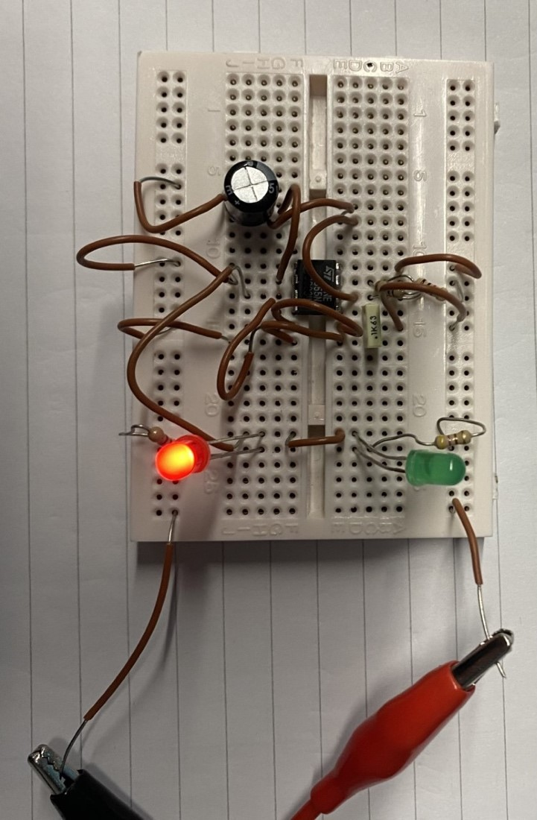

10.4 Read out of Power Supply

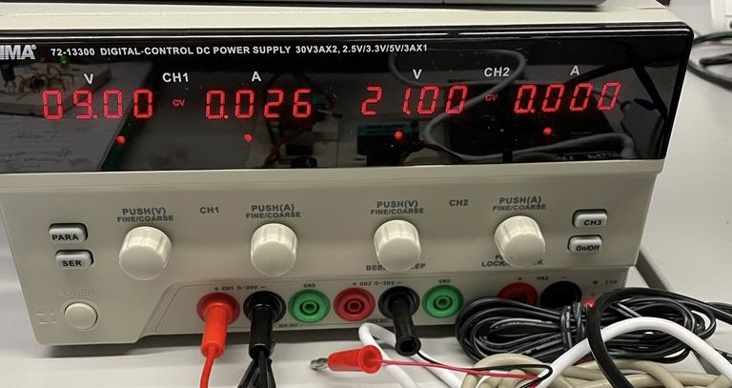

11 Conclusion

11.1 Simulation on Proteus (7.2/7.3)
The program used to build and simulate the circuit was effective and proficient for the task. From this readings were taken from C2 & R1 that presented voltage across time as well as time on/off.

11.2 Circuit Schematic (7.1)

The hand-drawn schematic of the circuit was vital for physically building the circuit. At this stage, it was far easier to identify where the circuit would be shorted, impacting the intended result.
Once drawn, an exercise was carried out flowing along the circuit. Once content, the circuit was built in actuality.

11.3 Actual Circuit (10.2/10.3)

Building the circuit proved far more difficult than the simulation or drawing. Due to the size of the breadboard & required components, there was great difficulty in placing the wires connecting each to its required place. Time constraints contributed to the lack of presentation, yet the circuit created did perform as designed.

References

[1] | G. Lambert, "Circuit Basics," [Online]. Available: https://www.circuitbasics.com/what-is-a-555-timer/. [Accessed 15 Dec 2022].
[2] | P. Kane, "How to Configure a 555 Timer IC," [Online]. Available: https://www.jameco.com/Jameco/workshop/TechTip/555-timer-tutorial.html#:~:text=The%20555%20timer%20was%20introduced%20over. [Accessed 15 Dec 2022].

