Student Self Evaluation Form

This section repeats in brief the common assessment criteria detailed on previous pages. The extent to which these are demonstrated by you determines your mark. Using these criteria, tick the box that best indicates the level of achievement you feel you have achieved with regard to each of them.

Common Assessment Criteria Applied | Level of Achievement
Common Assessment Criteria Applied | REFER |  | 3rd | 2:2 | 2:1 | 1st | 1st
 | OUTRIGHT FAIL | UNSATISFACTORY | SATISFACTORY | GOOD | VERY GOOD | EXCELLENT | EXCEPTIONAL
1. Subject Knowledge and Understanding (which includes using research-informed literature and knowledge and understanding of the subject) | 0-29% | 30-39% | 40-49% | 50-59% | 60-69% | 70-79% | 80-100%
2. Intellectual Skills (Analysis) | 0-29% | 30-39% | 40-49% | 50-59% | 60-69% | 70-79% | 80-100%
3. Pedagogic and Professional Applications  (Practical Application and Deployment) | 0-29% | 30-39% | 40-49% | 50-59% | 60-69% | 70-79% | 80-100%
4. Key Transferable Skills | 0-29% | 30-39% | 40-49% | 50-59% | 60-69% | 70-79% | 80-100%
PLEASE COMMENT ON AREAS IN WHICH YOU FEEL THAT YOU HAVE PERFORMED WELL | PLEASE COMMENT ON AREAS you feel that you need TO DEVELOP
I believe that I was able to reflect on my own pedagogies well and make suggestions on how to improve my own professional applications in the future. I also believe I have shown a good subject knowledge and understanding in using this particular framework. | Areas I need to develop the most in is key transferable skills. Specifically the structure of the assignment so that it flows and improve the written language that I have used to be more academic.
Student’s Name | Megan Jones | Date | 13/12/2017
Student’s Signature | M.S.Jones

ECAD6004

Critically evaluate your creativity and enterprise dispositions in terms of the Entrecomp frame work and how you might develop these to the next level and demonstrate progression.

As a teacher, it is important to be able to critically evaluate your own performance and how you can improve to benefit the learning of the children. Within this assignment, I will be reflecting on my own creativity and enterprise disposition in relation to the Entrecomp frame work. I will then go on to make suggestions on how and what I can do to achieve the next level.

The Entrecomp framework shows how fifteen different entrepreneurship competences have been broken down into three different areas, these are ‘Ideas and Opportunities’, ‘Resources’ and ‘Into Action’. An example of this can be seen below at figure 1.

Figure 1: Area competence and competences.
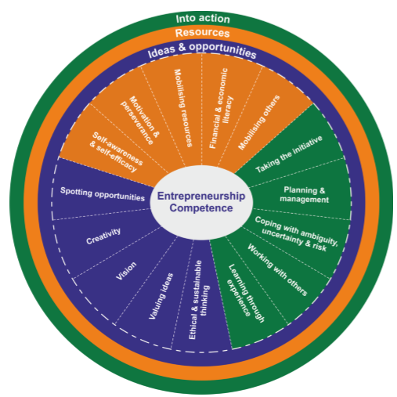

This model can be useful for teacher to make a judgement and reflect on their own practice in order to be an outstanding teacher. The author will focus on reflecting on ones own ability on three competence of the framework. These competences are:
- 1.2 Creativity - Developing creative ideas that are purposeful.
- 2.2 Motivation and perseverance - Having the ability to stay focus and not to give up.
- 3.4 Working with others- Team working and collaborating ideas.
In order to do this, the author will use the Progression Model to determine current level for these competences and different strategies and approaches one can adopt to aim for the next level.

The Entrecomp Progression Model consists of four main levels which are Foundation, Intermediate, Advanced and Expert and these levels can be used as a guide for development. Having this as a reference is useful for a teacher as it can provide the next steps in order to improve on their enterprise disposition, similar to the Literacy and Numeracy framework (LNF) for the children. The Progression model can be seen below at figure 2.

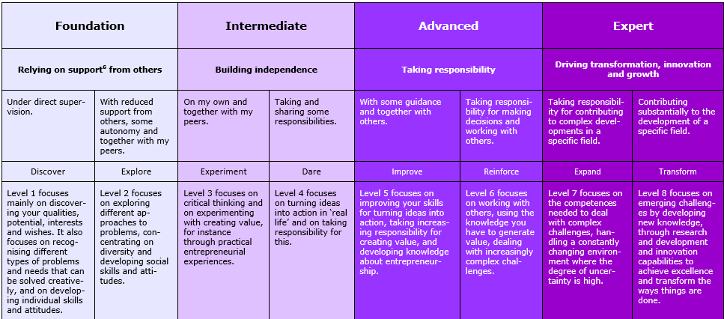
Figure 2.

Some may argue that the Entrecomp framework is not always a good criteria and reflection to measure creativity. Another criteria that might be useful for a teacher that can be used along side the Entrecomp framework is the attributes of the effective and passionate teacher (Day, 2007). This model can be seen below.

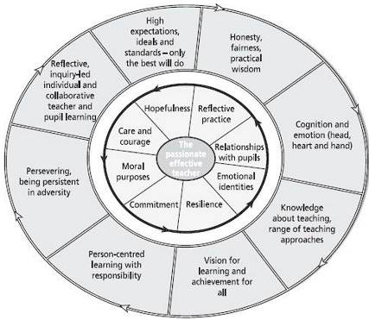
Figure 3.

Day (2007) suggest that there are many demands a teacher may face but teachers who show personal and professional commitment and are at their best intellectually and emotionally will become successful. In contrast to the Entrecomp framework, rather than showing progression this model shows attributes of being a passionate and effective teachers. However, I believe this model is very useful for teachers to use as a guide to see what attributes they may lack in and then use the Entrecomp along side to see what progress they need to make to achieve those attributes.

A teacher’s personality can have a big influence on the classroom. John Dewey (1910) highlights that a child can not separate the influence of a teachers personality being fused with that of a certain subject. Furthermore, there have been a lot of researchers that have found there to be a relationship between dispositions and pupil’s achievements. One of these research is Habits of Mind. Habits of Mind are sixteen problem solving and life skills that are necessary to function in today's society and promote other key skills such as creativity, perseverance and finally insightfullness in the hope of gaining a positive outcome. Similarly, dispositions of character and habits of highly effective teachers share common elements with Habits of Mind. The main element that they share is the importance of teacher’s open-mindedness. MacDonald and Shirley (2009) also agrees and describes open-mindedness to be the most important ‘synergy’.

Creativity
Creativity is hard to defined and means different things to different people. However, according to Csikszentmihaly, creatively is a central source of meaning in our lives, this also emphasises how important it is for creativity to have a main focus within the curriculum.

Creativity links with enterprise education as it is the process in which children develop a capacity to be able to create their own ideas and to then build upon them. Enterprise should start to be delivered to children at a young age and continue to be delivered throughout the education system. This will help ensure that the children are prepared for work in their future lives. Donaldson (2015) states within the Successful Future report that one of his four core purposes that the curriculum will develop in children and young people is enterprising. Therefore, Donaldson is also emphasising the importance of enterprising on children. There is much more freedom within this curriculum for creativity to be absorbed in teaching (Desailly, 2015).

Being able to think in a creative way you are more likely to accomplish goals in our now complex and interconnected world (Pink, 2005). This is also supported by Root-Bernstein (2003) who suggested that those that improve their professional practice are the ones who actively draws on interests to aid creative thinking. Being a creative teacher involves many elements. These elements include being able to generate new ideas, reflecting upon them and evaluating different teaching approaches that work best. All of these elements will result in an environment that will support the creativity within the children.

In regards to the Entrecomp framework, I believe I am currently at an Intermediate level 5 where I refine and test idea to create value for others. An example of how I made this refection can be found at appendix one. This ARC I had written based on one of my lessons where I concluded that there was a lack of creativity in this lesson. I believe that this is the area I can improve in the most because currently, I feel that I am out of my comfort zone due to the lack of control of the creative thinking. However, to be an outstanding teacher I know this is a barrier I must overcome as more and more research and evidence has proven how much creativity benefits a child but for this to happen the teacher must be able to aid them in the right direction. Sir Ken Robinson has presented many educational talks proposes his own strong opinions about creativity in schools. One of these opinions are that schools are so focused on rigid routines that it automatically takes away the creativity within the child. He also suggest that children need the opportunity to explore their abilities and interests. Not allowing children to do this means not allowing them to reach their full potential. In addition to this, Edward De Bono (1985) devised the term lateral thinking. Lateral thinking is in line with promoting creativity as it encourages you to look at things in a different way so that you reinterpret what you see in an original way.

I believe a way I can make progression in the ability to teach in a creative way is by using a cross curricular approach. I would start by teaching a subject I feel more comfortable with and then start to incorporate creativity slowly. For example, I could start by teaching a Key Stage 2 class to be able to write a narrative but add elements of music. The children could create a theme tune for a film trailer to go with their narrative, using my own and the children’s interests to aid the creative thinking. Furthermore, I know I must be careful not to allow the link between the different subjects and creativity to become tokentistic (Barnes, 2015). It needs to have a link to the real world for it to be effective. In addition, to be able to achieve the next level as a teacher I would need to creative an environment where both myself and the children can feel comfortable. I as the teacher need to become the facilitator in order to foster the children’s creativity.

Another way I can ensure I enable creativity in my classroom is implementing ‘The Leonardo Effect’ into my teaching. The Leonardo Effect is a skill based curriculum which will engage the diverse range of aptitudes within children which can be turned into creative, stimulating and remember able learning experiences. Part of the philosophy, children will have the opportunity to be be a part of the planning process. This ensures the learning is child centred so that the children feel valued and have ownership. This relates to a heutagogical approach to teaching and learning and defined as the study of self-determined learning (Hase and Kenyon, 2000). This approach focus’ on the aim of developing a learners capacity and capability resulting in them being high autonomous and self-determined. Children will develop in autonomy and maturity as the approach can be seen as a progression from pedagogy to andragogy to heutagogy. When adopting this approach, the teacher must become a facilitator which allows the children to be guided to discover but at the same time, still aware of what is expected and needed to be achieved.

Motivation and perseverance
Motivation and perseverance can be seen as a force that can guide, initiate and maintain behaviour. Motivation and perseverance can also be seen as self-efficacy. Albert Bandura (1986) introduced this concept and describes it as people being able to deal with a particular task effectively and the ability to reach children’s outcomes and promote learning and engagement. According to the expectancy-value theory, the outcomes of motivation can include performance, commitment and finally persistence (Richardson and Watt, 2006).To be able to motivate and inspire children to learn is essential for a teacher, however, it is just as important to have a motivated teacher for their own well being, job satisfaction and for the children to truly benefit. I believe that I have a high level of motivation as I enjoy teaching and I know this is the career I want to pursue in. Brookhart and Freeman (1992) suggest that altruistic, service-oriented goals and other intrinsic motivations are the main reasons why people choose teaching as a career. This is also supported by the FIT model. The FIT is a teaching framework designed to ensure high-quality teaching and allow teachers to show continuous growth. The FIT model states that social utility values and prior teaching and learning experiences are also motivators for teachers. Therefore, both emphasise that the main motivator for a teacher is the joy of the job itself and wanting to make a difference.

I believe that there is always room to improve my own motivation. Relating to the Entrecomp progression framework I believe I am at an Intermediate Level 6 as I will put effort into following what I am passionate about and create value for others. However, in order to develop and achieve the next level I must consider my own needs in order to be further motivated. Abraham Maslow (1943) suggests in his theory of human motivation that the lowest levels of the pyramid which are made up of basic physiological needs of a human, such as food, water and shelter, need to be met to then progress higher up the pyramid to self-satisfaction. This theory highlights the importance of the teachers environment and well being on their motivation. Similarly, Frederick Herzberg (1959) found that hygiene needs or maintenance factors, such as security, salary and work conditions are seen as a launch pad in order to motivate. Furthermore, David Pink (2010) devised three elements that are true motivation. These are autonomy, mastery and purpose. Autonomy is having the desire to direct our lives including time, technique, team and task. Mastery is having the ambition to get better and creating environments that fosters progress and lastly, purpose sets contexts for autonomy and master as it aspires something that is bigger than ourselves. In future practice, I will consider all these theories when teaching because if I am not positively motivated I can not inspire my children to be.

Working with others
Glaze (2014) indicates that within any profession teamwork is needed to improve performance. This is relevant for teaching as the ultimate goal for all teachers is to make sure every child reaches their full potential. It is important that teachers do not become isolated as this can have a negative impact on the teaching and learning. There are lots of demands on a teacher previously stated by Day (2007) therefore, it is important that teachers rely on each other for support. For example, some teachers may have better subject knowledge on certain subjects and can share ideas, some may have more experience and can give advice and it is always a good way to relive day to day worries. Not only because teachers work closely with other staff members such as teaching assistants, headteacher etc, but the teamwork they will need to achieve with the children and children’s parents. The Welsh Government (2014) proposes how much parental engagement has a influence on a child’s attainment, therefore, emphasising the importance of having a positive parent teacher relationship. Having a good communication and effective teamwork between teachers, children and parents is vital to ensure that the children are receiving the best support that they need and that you gain a good relationship.

Maintaining a professional relationship is important in any workplace. An example of when I did this well in my most recent PTE can be seen at appendix two. This is an ARC I wrote after a lesson where I worked with a supply teacher who was taking the role of a TA in my lesson. From this lesson alone, I knew I am able to work well with other colleges because I was giving my TA clear instructions of what I expected from her during this lesson, we were able to communicate effectively during and after the lesson and together we were able to decide on the next steps for the children in order to see progression. Therefore, looking at the Entrecomp framework I would give myself a Intermediate level 5. In order to achieve the next level, in my next PTE I will have more interaction with parents to further develop my team working skills. I could achieve this by sending letters home to introduce myself and by having an open door policy where I will have the opportunity to get to know the parents as well as the children.

Conclusion
In conclusion, even though there are more relevant models to teaching specifically, the Entrecomp framework can be useful for teachers to use as a progression model. This is because they can see what they need to do to achieve the next step as a teacher and personally, I am aware of many other competences I can make improvements in along side with creativity, motivation and perseverance and working with others.
Furthermore, I believe that developing ones own creativity and enterprise disposition is key to ensure progression in the ability to teach effectively and to inspire children to want to learn.

Reference List
ASCD. (2014). Using the FIT Teaching Framework for Successful Teacher Evaluations. Available at: http://www.ascd.org/ASCD/pdf/siteASCD/publications/fit-teaching-whitepaper.pdf [accessed on 12/12/17].

Baclgalupo, M., Kampylis, P., Punie, Y.,Van den Brande, G. (2016). EntreComp: The Entrepreneurship Competence Framework. Luxembourg: Publication Office of the European Union.

Bandura, A. (1986). Social Foundations of Thought and Action: A Social Cognitive Theory. Englewood Cliffs, NJ: Prentice-Hall.

Barnes, J. (2015). Cross-curricular learning 3-14. London. United Kingdom: SAGE Publications.

Blaschke, L.M. (2012). Heutagogy and Lifelong Learning: A Review of Heutagogical Practice and Self-Determined Learning. Available at: https://files.eric.ed.gov/fulltext/EJ979639.pdf [accessed on 7/12/17].

Cherry, K. (2017). 6 Key Ideas Behind Theories of Motivation. Available at: https://www.verywell.com/theories-of-motivation-2795720 [accessed on 12/12/17].

Costa, A.L., and Kallick. B. (2000). Habits of Mind. Available at: http://www.chsvt.org/wdp/Habits_of_Mind.pdf [accessed on 9/12/17].

DCELLS. (2008). “Art and Design in the National Curriculum for Wales” , Cardiff: Welsh Assembly Government.

DeBono, E. (1985). Six Thinking Hats: An Essential Approach to Business Management, New York: Little, Brown and Company.

Desailly, J. (2015). Creativity in the Primary Classroom. SAGE.

Dewey, J. (1910). How we Think. Lexington, MA: D.C. Heath.

Donaldson,G. (2015). Successful Futures Independent Review of Curriculum and Assessment Arrangements in Wales.

Glaze, S. (2014). For Effective Schools, Teamwork is not Optional. Available at: https://www.edutopia.org/blog/effective-schools-teamwork-not-optional-sean-glaze [accessed on 11/12/17].

Grigg, R. (2014) Becoming an outstanding primary school teacher. Second edition. London, United Kingdom: Routledge.

Hase, S., and Kenyon, C. (2000). From Andragogy to Heutagogy. Available at: http://ultibase.rmit.edu.au/Articles/decoo/hase2.htm [accessed on 11/12/17].

Hickey, I. and Robson, D. (2013). The Leonardo Effect: Motivating Children to Achieve Through Interdisciplinary Learning. United Kingdom: Routledge.

Karabenick, S.A., and Conley, A. (2011). Teacher Motivation for Professional Development. Available at: http://mspmap.org/wp-content/uploads/2012/01/Teacher-PDM.pdf [accessed on 3/12/17].

McQuerrey, L. (2017). Why is Team Working Important in the Classroom? Available at: http://work.chron.com/teamwork-important-classroom-18281.html [accessed on 12/12/17].

Richardson, P., Karabenick, S., and Watt, H. (2014). Teacher Motivation: Theory and Practice. Routledge.

Sheperd, J. (2009). Fertile minds need feeding. Available at: https://www.theguardian.com/education/2009/feb/10/teaching-sats [accessed on 13/12/17].

Thomson, I. (2015). Maslow, Herzberg and Pink’s Theories in the Workplace. Available at: https://blog.sodexoengage.com/maslow-herzberg-and-pinks-theories-in-the-workplace [accessed on 11/12/17].

Welsh Government. (2014). Rewriting the future: raising ambition and attainment in Welsh Schools. Available at: http://gov.wales/topics/educationandskills/schoolshome/deprivation/rewriting-the-future-schools/?lang=en [accessed on 15/11/2017].

Young, L. (2014). Enterprise for all: The relevance of Enterprise in Education. Available at: https://www.gov.uk/government/uploads/system/uploads/attachment_data/file/338749/EnterpriseforAll-lowres-200614.pdf [accessed on 1/12/17].

Appendix one.

Model Casgliadau Adfyfyriol â Chymorth (ARC) (Model ‘Myfyrio a Newid’)

Assisted Reflective Conclusions (ARC) Model
Dyddiad/Date: 9/11/2016
Digwyddiad critigol (Ffocws)/Critical incident (focus): World War 2 - literacy
Profiad/ Experience

Teimladau/  Feelings  “What are your feelings regarding the experience?” | I enjoyed teaching this lesson because the children were fully engaged because this topic is new to them and I also find this theme interesting.
Cofio a Deall/  Remember and Understand  “Can you list the aspects of the learning experience that went well?”  “What were the elements of the learning experience that were disappointing?” | - Children were motivated to learn  - Children had a good idea on what a newspaper report looked like.  - Lack of originality as all the children wrote their newspaper article from the same perspective.
Gwerthuso a dadansoddi/  Evaluate and analyse  “What will you keep the same to ensure effective teaching and learning in the future?”  “What was the cause of the most important disappointing element?” | - I will do the same activity they did before to remind them the features of a newspaper article.  - I give them too much guidance on what to right about rather than just fostering the children’s ideas.
Casgliadau a chamau gweithredu/  Conclusions and actions  “What are your possible solutions to the disappointing issues identified?”  “What will you do next?” | - Next time I will give the children more opportunity before hand to be creative so that their work would be more original.  - Rather than just hand write the newspaper article, introduce a digital competency element by using technology
Y profiad newydd / Transformed experience

Appendix two.

Model Casgliadau Adfyfyriol â Chymorth (ARC) (Model ‘Myfyrio a Newid’)

Assisted Reflective Conclusions (ARC) Model
Dyddiad/Date: 11/2/17
Digwyddiad critigol (Ffocws)/Critical incident (focus): Place Value - group activity
Profiad/ Experience

Teimladau/  Feelings  “What are your feelings regarding the experience?” | - I was pleased with how well this group worked and used numicon to help them.  - They all participated well and asked relevant questions.  - I feel like I worked well with the new TA as she understood and the task and could give me good feedback about the children in her group.
Cofio a Deall/  Remember and Understand  “Can you list the aspects of the learning experience that went well?”  “What were the elements of the learning experience that were disappointing?” | - Questioning - Children asked each other questions and were able to answer my questions when I proposed certain problems to them e.g does 13 have the same value as 31?  - Use of resources - numicon aided learning.  - Some children over powered others and had to be reminded to give everyone a chance
Gwerthuso a dadansoddi/  Evaluate and analyse  “What will you keep the same to ensure effective teaching and learning in the future?”  “What was the cause of the most important disappointing element?” | - I will continue to use the TA cards I have made every lesson - good communication tool between teacher and TA.  - Use the same resources.  - I planned the activity as a paired so the lesson did not flow as easily because they had to share resources.
Casgliadau a chamau gweithredu/  Conclusions and actions  “What are your possible solutions to the disappointing issues identified?”  “What will you do next?” | - I would change this activity to an individual task so they can work at their own speed.  - Next I would challenge this group by looking at Hundreds.
Y profiad newydd / Transformed experience

