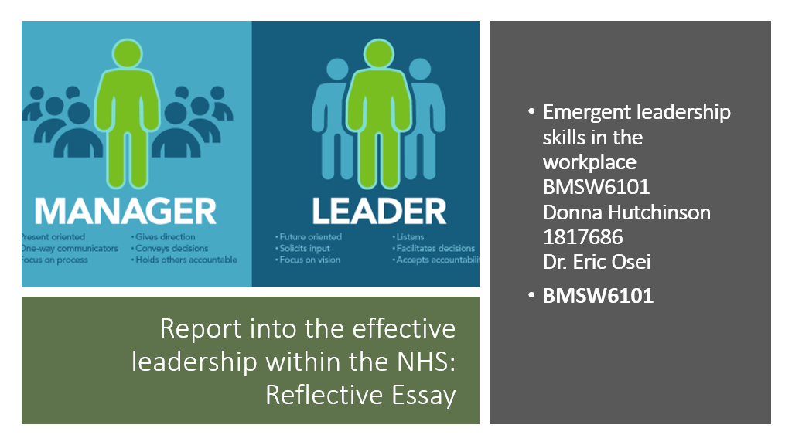

Page 1 Cover page

Page 2 Contents

Page 3 Introduction

Page 3 Difference between Leadership and Management

Page 4 Effective Leadership Styles

Page 5 Effective Leadership Skills

Page 6 Leadership style in Covid- 19 era and other emergencies

Page 9 conclusion

Page 10 References

Page 11 Appendices
Figure 1 Management &leadership (Page 11)
Figure 2 Management and Leadership (Page 12)
Figure 3 Leadership Styles (Page 13)

Page 14 Self reflection
Page 15 References

Introduction

This report explores what challenges management have had to endure overcome and adapt to within the management and leadership sectors of the N.H.S. All that management have had to encumber through-out different stages of its development, from experiencing strikes within the N.H.S establishment, through to shortages of staff, and a global pandemic crisis in 2020. A further in depth examination into what Management and Leadership entails what are the desired requirements for management within the N.H.S. as well as a further breakdown and explanation of what Effective Leadership Styles are, a further understanding of the different types of Leadership Skills available and what skills and styles should be by those in management or a supervisor position have they utilised within the NHS, a closer look into what outline the differences between the two Management and Leadership styles. Finally, a discussion about Ethical leadership, and the position it holds within the NHS.

Difference between Leadership and Management
People commonly confuse leadership and management, although management and leadership are often used interchangeably, while the styles may at times overlap. So what is the difference between the two?
- managers set out to achieve organizational goals ensuring tasks are met and functions completed –
- Through implementing processes such as budgeting,
- organizational structuring,
- Staffing.
- Whereas leadership is more centred on a vision to help guide change.
- leaders are more intent on thinking ahead
- Motivating People
- Are more inclined to capitalizing on opportunities
Where as those who hold the position of leadership do not need to hold the title of manager as leadership abilities can be highlighted in many roles.

Management
Management is more than one aspect, and management within the N.H.S remains the same, provide the best service, maximise system efficiency, modify its resources to gain the most output ( add more value to a patients experience), and save on finance. Management can be defined as the process of achieving goals while making the best use of those available resources.
As it stands incremental innovation maybe what is best when considering any difficulties for management within the NHS, as a drastic overhaul could present more problems then solutions
“long-term vision for the NHS. Not a drastic overhaul, but sustained and progressive evolution towards a health system that is designed and funded to meet the changing physical and mental health needs of an ageing population with increasing multimorbidity's”
( The Lancet aug 2021.)

has its own added stressors including the red tape that entangles you with government ana ll the rules regulation that cant be crossed, yet still be expected to exceed the excpectation s without the securing several positions/operations at once. Whether this is the administration of a business, a non-profit organisation, or a government body. The process
Key aspects of management:
- Technical Aspect - When referring to the technical side of management, this encompasses the knowledge and skill required for these operations as well as the techniques used by the managers.
- Human Aspect - The manager's interpersonal skills are part of the human element of management which entails the manager's ability to work with people.
- Conceptual Aspect – This is the conceptual side of management. Being able to recognise the various components that may exist between management, and the relationships between team members and employees.
- Design Aspect - The management design component comes last. This method enables managers to deal with problems as and when they occur.

Those in the field of management are typically accustomed to handling high-stress, complex circumstances, they are accustomed to maintaining an exceptionally high level of responsibility, and they are fundamentally driven to achieve goals while encouraging and supporting their team.

- Phenomenal motivators
- Leadership skills
- Motivational
- Inspirational

“Managers support an organization by executing tasks, functions, and activities that align with the organizational strategy,” (Luden n.d)

Leadership :

All to often people are under the misconception that leadership means being “The Boss”, or in the very least if you are the boss, you are responsible for making all the decisions. In all truth being a leader is more about identifying the key factors in others, encouraging, and allowing those in your team or under your guidance the support and direction to ensure they fulfil their best potential for themselves and the company. It was Frank Parsons who developed the idea of matching careers to a person's individual talents, skills, and personality.
Some of the qualities needed to be exhibited for good to exemplary leadership within the NHS
To maintain good leadership, management need to exhibit or encumber most if not all these tendencies:
- Patience
- Moral strength
- Integrity
- Courage
- Compassion
- Great resilience
- An ability to think ahead
- Be innovative

Effective leaders tend to Exhibit:
- Accountability- Incredibly important (and speaks more about the individual's character ) So what does this entail - Taking full responsibility for one's Team, its performance(s), regardless of the positive or negative outcomes.
- Confidence- Demonstrating confidence is essential as it helps instil motivation and confidence within the team and amongst its members.
- Adaptability- Plans, schedules rules and even goals can change without notice with the N.h.S, a good manager needs to be ready to act with confidence, assertion and positivity to ensure the team feel confident and act accordingly to the changes.
- Creativity- The best leaders rarely follow established paths or replicate the paths of others. They instead embrace new ways of thinking and strategies that others have yet to try.
- Empathy- Executives, managers, Team leaders and even supervisors, must initially work at a higher level of understanding than all other employees.
- Focus- Focus is essential in assisting with ensuring team members stay on target , for completing goals on time, and avoiding potential distractions while achieving major goals.
- Positivity. In a tiresome and gruelling situation/circumstance position having a positive outlook can be the difference between coping with the trials and tribulations of the gruelling tasks set before an individual within the nhs, Is infectious, positive individuals can motivate their team to achieve goals, do their best work, and exceed expectations.
- Risk-taking- Leaders face risks on a regular basis, as well as spotting an opportunity, they should also know when to recognise a challenging problem or dilemma, and when to play it safe.
- Stability- Staying power is desirable, as being responsible for leading notable change can be trying.
- Team-building- All people in control or who hold an element of power, require dedicated teams to complete projects, offer support, advice and insight.

The difference between the two and the similarities :
 | LEADERSHIP |  | MANAGEMENT
 |  | Similarities
1 | Think ahead to Focus on goals | Both entails working with People | Focus on tasks
 | Take risk | Both involve influence | Dictate
 | Encourage of underlings | Both create organizational and functional structures | Maintain the highest expectations of the company
 |  | Both are concerned with goal accomplishment
 |  | Both involve holding influence with others
 |  | Both involve Talking with Individuals Companies Organizations
Management

Effective Leadership Styles

There are several different leadership styles which help identify and incouporate an individual's methods as well how the conduct their behaviours when giving direction, or support. So how do the N.H.S ensure that they are covering the correct requirements, when hiring staff to fulfil positions. It is so important when motivating peers or staff members and especially when it comes to ensuring plans are put into effect, and most importantly to have everything cohesively carried out through to completion.

- Transformational Leadership - Is a style of leadership in which the leader inspires and motivates employees to work together to achieve a common goal. Transformational leaders frequently embody their vision and have such a strong belief in the project at hand, what its is, how or what they say, which helps strengthen their cause so they can then inspire others to do the same.
- Authoritarian or Autocratic Leadership - An authoritarian or autocratic leader imposes policies and procedures, establishes expectations, and defines outcomes. This is individual is essentially the boss, who has complete control over their team and makes all decisions with very little input from the members of their team.
- Democratic leadership - also known as participative leadership, allows everyone on the team to get involved and collaborate to make important decisions. While everyone's ideas are welcome, the leader will have the final say in the decision-making process.
- Transactional leader - To motivate employees, transactional leadership employs a model of rewards and punishments. At the start of a project, clear goals are established, with everyone informed of the reward if those goals are met and the consequences if they are not.
- Laissez-faire leadership -Also known as "delegative leadership," is a hands-off approach that allows team members to make decisions on their own initiative. Employees are valued for their opinions, and decisions are made in a collective manner, which is like participative leadership.
- Bureaucratic leadership - This style of leadership prioritises the needs of the company and relies completely on strict rules and guidelines that all team members must follow. This is quite common in long established industries companies where precedents have established rules.
- Servant Leaders - Servant leadership prioritises the team over the individual. As a result, a servant leader is someone who can set aside personal agendas in order for their team (and the company) to thrive. Servant leaders go out of their way to serve their team and make sure everyone is happy and fulfilled. (the medical staff within the N.H.S such as the nurses)

Effective Leadership Skills
Essentially effective leadership skills are exhibited by the way an individual
- directs, motivates, and manages others.
A person's leadership style also influences how they strategize and implement plans.
- Decisiveness - Effective leaders are those who can make decisions quickly based on the information available to them. Time and experience are required for effective decision-making.
- Integrity - Many people associate integrity with truthfulness or honesty, but in many cases, it also refers to having and adhering to a set of strong values.
- Relationship/Team building - Leadership generally requires the ability to assemble and sustain a cohesive team of individuals working toward a common goal
- Problem solving - Good leaders are capable of resolving problems that arise on the job. Staying calm and identifying a step-by-step solution are requirements that are essential for effective problem solving.
- Dependability – An incredibly important skill, People can trust and rely on you if you are a dependable leader. As a trustworthy individual follows through on plans and ensures to stick to things that have been agreed or promises kept.
- Ability - Capacity is the ability to teach and mentor others. The ability to teach and mentor is one skill that distinguishes leadership from many other competencies.

Leadership Style in COVID-19 era and other emergencies

In the NHS, strong leadership can be found at most if not all levels, and in all roles, and within all teams. This pandemic left in its wake such a devastation. Hundreds of thousands of direct lives have been lost, and millions of people have been affected by the disease, potentially with long-term health consequences. So building and sustaining trust in such uncertain times just goes to highlight the importance especially during the first phase of the response to the COVID-19 pandemic. Were individuals within hospitals felt that they were more empowered to exercise their leadership, regardless of title or rank.

“The most important thing has been giving power to front line teams… In the past, many barriers were in place to making changes, with centralised decision making that stifled innovation. In COVID-19 early stages, national oversight stepped back in response to the emergency, and clinical teams were able to self-govern, innovate and collaborate to implement changes that met the immediate needs of their patients. My main urge would be to remember that NHS staff have moved mountains to reply to covid. Leaders please trust front line staff to do what is needed and empower them to deliver the best for their own patients.”
(Hospital Doctor Midlands 2021)

Ethical leadership within the NHS

Ethical leadership is concerned with fair treatment of followers, setting an ethical example for others, and actively managing morality. This type of leadership is especially desirable in the healthcare sector, where the most vulnerable people are cared for.

“And the country has fallen behind in the coordination of care and in equity. Social care is in a precarious financial state and suffers from a gaping disconnect from the health service and COVID-19 has ruthlessly demonstrated the harms of this disconnect”
(The Lancet 2021)
Within the NHS which has many strengths, the biggest plus by far is the fact that within the U.K they provide free healthcare to all. But with a whopping 67million people in the country and an estimated waiting list of 19million there could be more than strain on the management or leaders of teams within the NHS.
“The provision of care, free to all, is fundamental to life in the UK”.
(The Lancet 2021).

From September 2020 extra support was provided in response to the current environmental conditions, NHS England and NHS Improvement aimed to provide refreshed leadership support. Expert-led seminars on inequalities in health and racial injustice were to be held, as well as effective learning needs to set for senior officials in health and social care.
“long-term vision for the NHS. Not a drastic overhaul, but sustained and progressive evolution towards a health system that is designed and funded to meet the changing physical and mental health needs of an ageing population”
(Thelancet.com, 2020)

Conclusion
Overall, the management and leaders within the NHS have been trying to make up for years of slack, so truly have been given the short stick, but have still tried to ensure they cover as many failing aspects as possible, which in turn have left them with a diabolical backlog, of patients, staff and finances mentioning but a few. The N.H.S can more effectively lead their teams and various sectors to success by recognizing the areas in which change needs to be acted upon, and then putting those actions into practise, fully utilising the guiding principles as well as raise the industry standards by utilising workplace management theories
“The response must be a renewed, long-term vision
for the NHS. Not a drastic overhaul, but sustained and
progressive evolution towards a health system that is
designed and funded to meet the changing physical
and mental health needs”
( The Lancet 2021. )

Typically, leaders apply concepts from different management theories that best suit their employees and more importantly the company culture, but

. “And that’s if the NHS’s capacity is substantially expanded above pre-pandemic levels, at a cost of at least £2 billion per year”

Training is always a requirement as things are forever changing, and new rules and regulations are constantly being imparted onto management and expected to be carried out smoothly.
There has been a transformation in mental health over the last five decades, with the world realising how important mental wellness is, but there is still more that needs to be done to ensure that everyone has access to high-quality care when they need it.

Transformational leadership is still important in today's ever-changing healthcare environment, but it must be founded on ethical behaviour.

References
Doyle, L. (2019). Leadership vs. Management: What’s the Difference? [online] Bachelor’s Degree Completion. Available at: https://www.northeastern.edu/bachelors-completion/news/leadership-vs-management/. [Accessed on 23 Mar. 2022]
www.england.nhs.uk. (n.d.). NHS England» Compassionate and inclusive leadership. [online] Available at: https://www.england.nhs.uk/ournhspeople/online-version/belonging-in-the-nhs/compassionate-and-inclusive-leadership/. [Accessed on 13 Mar.2022]

ifs.org.uk. (n.d.). Homepage -. [online] Available at: https://ifs.org.uk/. [Accessed 23 Feb. 2022]

leadersdirect.com. (n.d.). what-is-management | Management. [online] Available at: https://leadersdirect.com/what-is-management. [Accessed on 24 Feb. 2022]
Jambawo, S., 2018. Transformational leadership and ethical leadership: their significance in the mental healthcare system. British Journal of Nursing, 27(17), (pp.998-1001). [accessed on 12July 2021. )
The Lancet (2021). The NHS: the many challenges for leadership. The Lancet, 398(10300), p.559. [accessed on 23 Feb. 2022]
Project.co. (2021). The 7 Types of Leadership Styles Explained - With Examples. [online] Available at: https://www.project.co/leadership-styles/#:~:text=1%20Transformational%20Leadership.%20Transformational%20leadership%20is%20a%20leadership [Accessed on 19 Mar.2022}

Appendices

Figure 1 Management & leadership
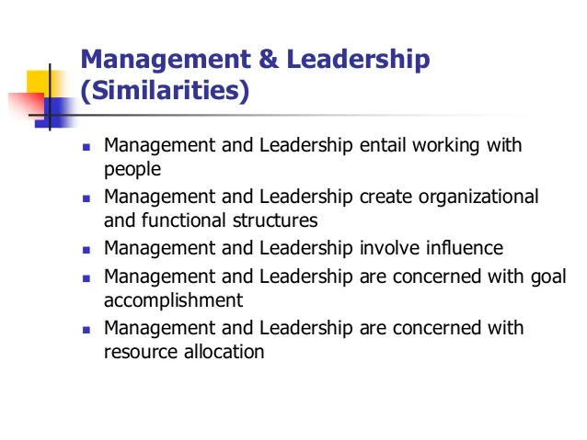

Figure 2) Leadership and Management
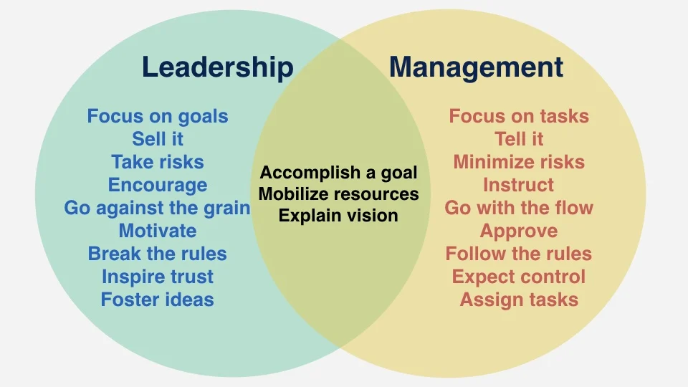

Figure 3 ) Leadership style

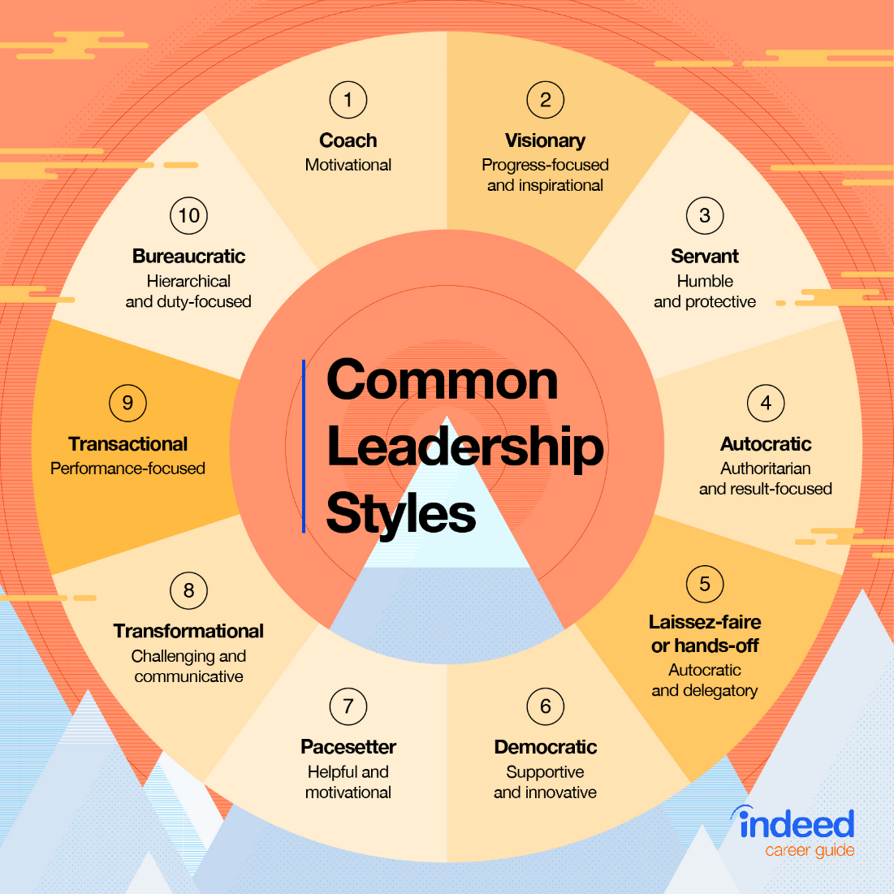

Self-Reflection on my learning experience of Emergent Leadership Skills

This journey through the module of emergent leadership skills has been a real journey of self-discovery for myself. It seems logical that there is more than one way to conduct yourself in business yet understanding that there is more than one way to succinctly manage and lead then I initial fathomed.
Understanding that there are several sufficient and more efficient ways to run a company, it seems logical but understanding how important it is to clearly have a plan, and to be able to execute that plan, or even deliver across the proposal to the team, if one can’t fully clearly express the thoughts and ideas as well as motiving people in and out of companies. Then certain areas need to be re-evaluated within the company, or task duties or ideas need to be closely examined to see where area can evolve, change or be extinguished.
At first initially I believed my style is one that evolves with the situation or circumstances I am presented. If we examine first life at home for example.Within my home life although I am the boss and in control of all elements including the children within it. I still seek to raise well rounded individuals and as such feel it is important that each person believes and understands that I value their input, and that their voice or opinion matters. So although I would say my style of leadership at home is Democratic with a healthy dose of Laissez-faire leadership, as I trust the individuals I live with to carry out task (chores etc) without interference or further direction from myself, there are times that a strong guidance is required or just a complete over ruling is necessary and the Autocratic leadership style raises a stance and comes to the forefront within the home.
Alternatively, when I am engaging with clients my management style changes and I opt for a more Transformational style of leadership peppered with the Laissez-faire and a splash of Democratic leadership, as a counsellor I must work with my clients to help them become the best version of themselves. In doing research into leadership styles, I actually found two leadership styles that we haven't covered as yet in this module, but I found they aligned well with what I do professionally,
Person Centred Leadership - Person-centred leadership is a complex, dynamic, relational, and contextualised practise aimed at assisting associates and leaders in achieving self-actualization, empowerment, and well-being.
There are several components to the person-centred style of leadership that I found apt for counselling, as a counsellor must have a strong sense of positive self-regard or self- esteem not just for themselves but also for the client.
Rogerian leadership style – Or Reflecting Feelings Technique, this type of communication technique is based on the counsellor rewording, paraphrasing, or simply repeating what was said by the client. This style is non-directive, which basically means that I do not direct my clients’ actions.
I have found that this module has helped me elevate not only my leadership techniques with clients and family but has helped strengthen my abilities and capabilities on a day-to-day basis, making me more confident talking and interacting, with people out in the world of business not just the world of people.
I've found that my confidence has grown as a result of everything I’ve learned, showcasing leadership techniques and interpersonal skills that are exhibited everywhere I go. Mingling with friends, working in a school, handling clients even with trips within the university, I make a point of ensuring team exercises happen between the students, forcing people who don’t know each other to bond with people they may have otherwise not even considered a possible connection.
Overall I believe this module has helped me exponentially to believe firmly in my thoughts and actions, set out the plan, do the research and create the steps, put in a contingency plan and most importantly trust in myself .

References:

Cardiff, S., McCormack, B. and McCance, T. (2018). Person-centred leadership: A relational approach to leadership derived through action research. Journal of Clinical Nursing, 27(15-16), pp.3056–3069. [accessed on 29 Mar. 2022]
https://www.facebook.com/thoughtcodotcom (2019). Rogerian Argument: Cooperation, Not Confrontation. [online] ThoughtCo. Available at: https://www.thoughtco.com/rogerian-argument-1691920. [Accessed on 29 Mar. 2022]

