Jessica Cox
1901525
6th January
Observational Writing:
Identify an image and write a semiotic analysis

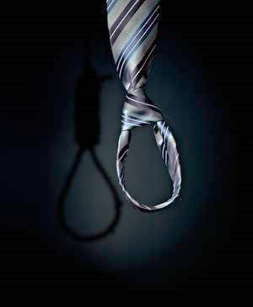

Image 1 “untitled”

Looking at the image by Theormer, on first inspection it seems to be an image of a tie that is highly contrasted with a dark background, which allows the tie to stand out more. I like how the colours are all dark because it gives the image a dark atmospheric.
I like the sheen that is on this tie because the reflection that shows could almost be a reflection of someone’s life. Another thing that I like about this image is how the tie is slightly off centre because that way it draws your eyes to look more onto the noose.
On closer inspection, you can see that the shadow of the tie creates a noose. The noose within the image could represent suicide. If we were to look deeper into the image would it be a reflection on male suicide? As suicide is one of the most common causes of death this image provokes thought surrounding that.

I think that this could be a reflection onto male suicide because a tie is associated men. Could this image be a response to male suicide increasing? According to the Samaritans

“Suicide rates by age and gender. In the UK, the highest suicide rate is among men aged 45-49. In the Republic of Ireland, the highest rate is among men aged 55-65.”¹

On further inspection, this photo could also other connotations and suggestion. I feel that this could be related to school/work as the cause. This is because a tie is normally related to uniform.
The image is not being obvious when looking at the noose suggesting the secrecy of suicide. Typically, this could be missed in passing it is only when looking closer does it reveal its true meaning.

In comparison this image “The Cultural Symbolism of the Noose” is obviously fuelled by different meaning. The noose here is cultural and obvious. It would not be a representation of suicide as it is not secretive.

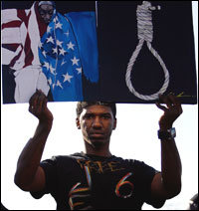
Image 2 “The Cultural Symbolism of the Noose”

Joseph Jordan is the curator of an exhibit of photographs called "Without Sanctuary: Lynching Photography in America." discusses symbolism of the hangman's noose. In this series of images, the message is clear in comparison to the first image where you have to delve deeper into the image for meaning. According to James Allen “the photographer was more than a perceptive spectator at lynching’s. The photographic art played a significant a role in the ritual as torture or souvenir grabbing- a sort of two- dimensional biblical swine, a receptacle for a collective sinful self.”² Allen believes that by photographing the lynching’s this is as bad as the death itself.
I do not necessarily agree with his point of view, without documentary photography we would not have visual representation of these things happening throughout history. According to Capture Magazine “Documentary photography, like its cousin photojournalism, is committed to exposing the truth and sharing it with the world. Truths that many people may never be exposed to are displayed through the lenses of photographers dedicated to sharing stories of planet Earth and the people that inhabit it.”³ Photography to me is about representation both these image aim to do this but in different ways. The first one getting the viewer to think about suicide and how we can support people the other recording hangings throughout history.

Bibliography

Mental health statistics: suicide | Mental Health Foundation
https://www.mentalhealth.org.uk › statistics › mental-health-statistics-suicide
11 Sep 2019 - Suicide remains the most common cause of death for men aged 20-49 in the UK.
https://www.samaritans.org/wales/about-samaritans/research-policy/suicide-facts-and-figures/
- Without Sanctuary, James Allen. Twin Palms publishers. 2010-2018
- The power of documentary photography. By Amanda Copp | 22 November 2016

James Allen (Ed.) - Without Sanctuary: Lynching Photography in America

Illustrations
- Theormer, (untitled)
- Chris Graythen “The Cultural Symbolism of the Noose” 2007

Jessica Cox
1901525
6th January
Manifesto Writing
Lecturer- Julia Lockheart

8 Statements
- Not all photography has hidden meaning
- Photography needs to show skill and technique within the image. It shouldn’t be a simple accident.
- The notion of beauty is no longer relevant in contemporary art practise.
- An Artist can truly represent themselves in an image or series of images.
- Photography is just as superior as any other art form.
- My art practise gives me the ability to artistically communicate my feelings.
- The camera allows me to give the viewer a snapshot of that moment in time.
- Today we live in a throwaway society. Digital Photography could be considered a part of this.

Not all photography has hidden meaning

According to Leslie Mullen “Photography was originally considered a way to objectively represent reality, completely untouched by the photographer’s perspective.” ¹ If we took this into consideration then this would mean photographs were taken to purely represent what was in front of the photographer. Although this doesn’t always have to be the case. Some photographers will manipulate the reality in order to given a deeper meaning to their work. If we look at the work of Cindy Sherman, she manipulates the reality of her self-portrait to reveal deeper meaning.

Figure 1. Cindy Sherman, Untitled Film Still, 1978-2014

If we compare this to the work of Joanna Kustra she focusses on how the image look and it being aesthetically pleasing as opposed to revealing hidden meaning within the image.

There are many similarities between figure 1 and figure 2. Both images are portraits trying to portray some element of a female’s life. A difference between these images are Image one shows a women portraying everyday life and what women was meant to do before whereas image two shows a portrait of a women with no meaning. This goes with the statement that “not all photography has to have a hidden meaning” because when you look at image 1 you can clearly see that it has a hidden meaning but by looking at image two there is no hidden meaning and it’s just a portrait of a women.
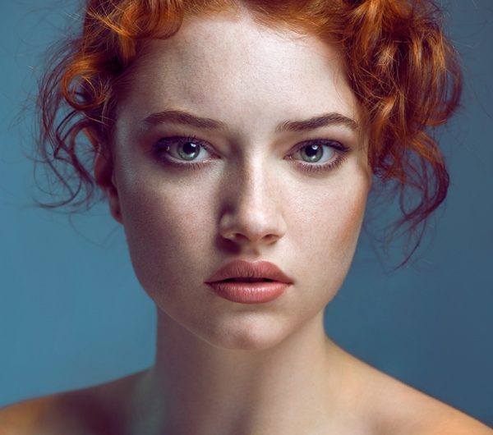
Figure 2 Joanna Kustra,Untitled 2011
The notion of beauty is no longer relevant in contemporary art practise.
If we look at the meaning of beauty it states “it is the quality that gives pleasure to the sight or aesthetic pleasure generally: a particular grace or excellence.”² I do not fully believe that all photographs are a subject of pleasure. Some photographs are made to repel or disgust the viewer some are created to give a political point of view. There are many reasons behand taking a photograph and it is not always related to that of beauty. #
If we look at the views of Plato he states “beauty is the object of love”³. Many forms of Art such as the work from the “Masters” were considered beautiful. If we look at the work of Van Gogh although it could be argued that it had hidden meaning there is no doubt that many of his paintings would be considered beautiful. Today many contemporary art forms are considered controversial. This does not distract from the importance of the contemporary art form however, it doesn’t necessarily have to be beautiful. If we compare the work of Van Goghs Sunflowers and Bankseys artwork it is clear that they are significant in history but for very different reasons. The beauty of the sunflowers and the technique used is incredible and in all purposes of the word, they are beautiful. Whereas Bankseys work is sending a very political message to its viewers.

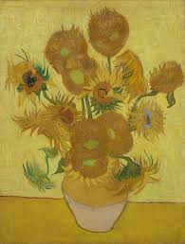
Figure 3. “Sunflowers” Vincent Van Gogh, January 1889
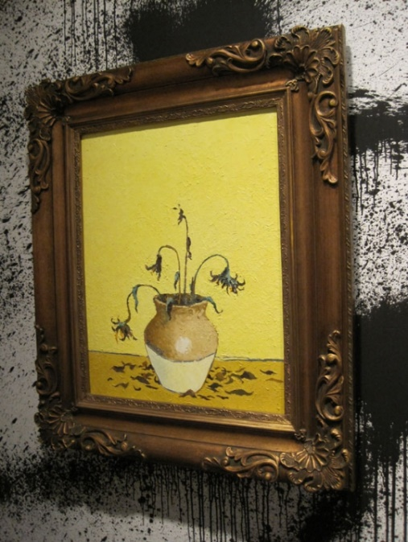

Figure 4 Banksy, Sunflowers From Petrol Station (2005)

Photography needs to show skill and technique within the image. It shouldn’t be a simple accident.
Many photographers learn through experimentation, in today’s society a large percentage of people carry a camera in the form of a mobile phone. Lots of snapshots taken could be considered aesthetically pleasing. Does this make them highly successful photographs? In my opinion no it doesn’t. I think that you have to learn the rules before you can break them. As a photographers it is important that technique has been considered. This could vary from the Rule of Thirds to Lighting.

Bibliography
- RUTH IN PHOTOGRAPHY: PERCEPTION, MYTH AND REALITY IN THE POSTMODERN WORLD, Leslie Mullen, 1998
- Random House ‘Dictionary’ (2006) [WWW] http://www.dictionary.reference.com/search?r+2&q=beauty [accessed 18/12/2019]
- Christopher Janawy ‘Plato’, The Routledge companion to Aesthetics ed. B. Gaut and D.M. Lopes (London: Routledge. 2001) pg.3

Illustrations
Figure 1. Cindy Sherman, Untitled Film Still, 1978-2014
Figure 2 Joanna Kustra,Untitled 2011
Figure 3. “sunflowers” Vincent Van Gogh, January 1889
Figure 4 Banksy, Sunflowers From Petrol Station (2005)

Jessica Cox
1901525
6th January
Reflective Writing
Lecturer- Jon

There are many photographers who have inspired me to become to photographer who I am today. Throughout History photographers have had a massive impact on society, according to the ‘Journal of art in society’,one of the main perceived advantages of photography was that it appeared to give painters a fresh and objective version of reality” ¹ . Within this Journal McCouat gives comparisons of painted portraits to that of a photograph. Looking at the two figures below there are distinct similarities between the images, from their positioning to their clothing. However, Van Gogh has painted the image with bright colours and large brush strokes. This is something that could be interpreted in many different ways.

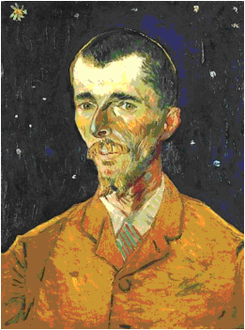
Figure 1. Vincent van Gogh, Portrait of Eugene Boch (1888)
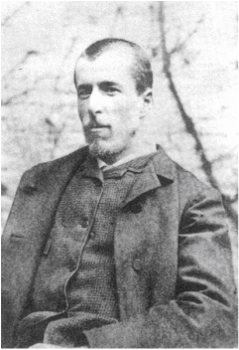
Figure 2. Photographs of Eugene Boch

I don’t necessarily agree that Photography is simply a tool for “Painters” I think it is giving a new generation of creative thinkers a different outlet for exploring their creativity as well as creating a social message. If I compare my image (Fig 3) to that of Marc Clamage (fig 4) there are clear similarities. They are both exploring homelessness and poverty. They are expressed in very different ways. Through the photograph, the viewer can make emotive connection more easily as it gives the girl life. It seems real and makes it more relatable. In my opinion, it is easier to make a connection with the photograph than it is to the painting. With social issues such as homelessness, I think it is vitally important that the message is clear. There is no area for misinterpretation. The painting could easily be misinterpreted to be a different social message such as, mental health or even issues with youth in society.

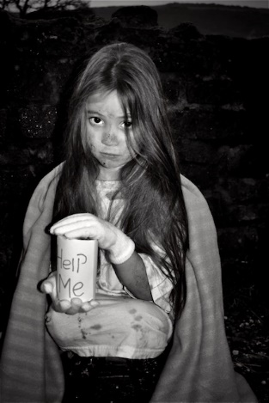
Figure 3. Homeless, Jessica Cox 2019
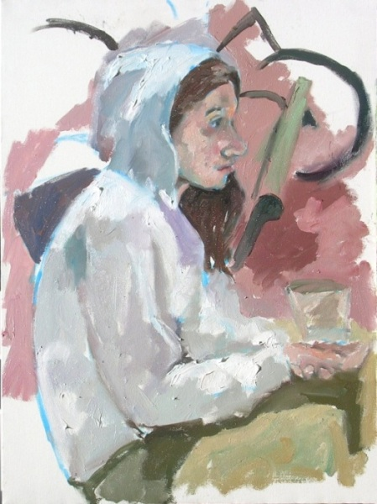

Figure 4 Marc Clamage, Colleen, 2011. (via: http://www.ipaintwhatisee.com/panhandlers.htm)

In todays society we interpret art in a very different way to what we have done throughout art history. According to Stephen Mulhall “influence of expression theory of art which was developed at the beginning of the twentieth century”^{2.} This gives the impression that at the turn of the twentieth century that expression through art has changed. He also goes on to say that “According to expression theory, am artist is someone who gives articulate expression or emotions or feelings in the various artistic media”³. I think it is interesting that Mulhal is exploring the idea that artist is express themselves in a different ways. However, by expressing this as an articulate way of expression then this should be easily read within an image. Something I fell I have clearly communicated within my work, and is also something I would like to explore further.

According to Catherine M.Soussloff she discusses that art is based on assumption. She says “the individual sense perception’ of the artists could be visible to the viewer in the work of art. Expressive claims for the work of art rest on assumption”⁴. I have made the messages clear in my work to avoid misconceptions about the work. This is clear in “Mandy” (Fig. 5), that the woman photographed has had mental health issues; with the colour family portrait in the background it clearly shows that there are two sides to her life. Similarly in the piece titled “Dark times” (fig 6) , using text in my work it allows me to articulate what I want the viewer to get out of my images.

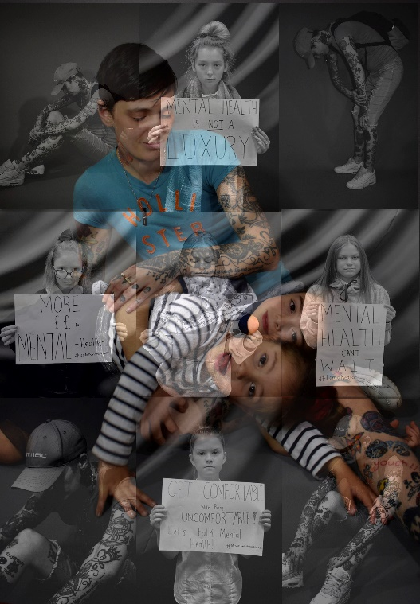

Figure 5. “Mandy” Jessica Cox, 2019

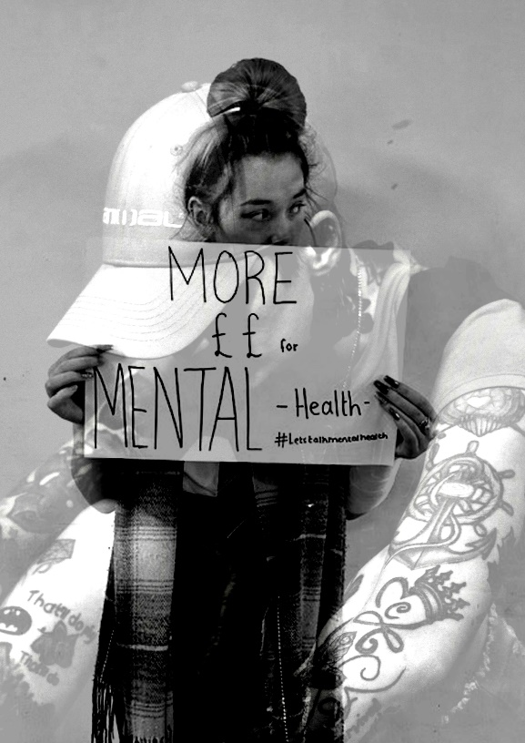

Figure 6. “Dark times” Jessica Cox 2019

Bibliography
- The Journal of Art in society. Phillip McCouat Partt4 “New Approaches to “Reality””
- Stephen Mulhall “Expression”, A companion to Aesthetics, ed David Cooper (Oxford: Blackwell Publishing, 1995) p.144
- Ibid
- Catherine M.Soussloff The Absolute Artist (London:Taschen, 2004) p.44

Illustrations
Figure 1. Vincent van Gogh, Portrait of Eugene Boch (1888)
Figure 2. Photograph of Eugene Boch
Figure 3. Homeless, Jessica Cox 2019
Figure 4. Marc Clamage, Colleen, 2011. (via: http://www.ipaintwhatisee.com/panhandlers.htm)
Figure 5. “Mandy” Jessica Cox, 2019
Figure 6. “Dark times” Jessica Cox 2019

