Indie Game Development
  - Lecture 3a Lab Tutorial Exercise

Dynamically Generating a Scene Layout: Part 3

Objectives
In this exercise, you will continue with the dynamically generated 3D scene from the layout defined in the XML.

Exercise 1: Adding Game Objects to Tiles
- Open your project from the last exercise. Note that you will need to have finished that exercise to proceed with this one.
- Open up the Layout Control Script.

Create Portal Method
- Create a new private method with a return type of void called CreatePortal.
  - The method should accept the following arguments:
    - An argument of type Tile called tile.
    - An argument of type int called toRoomNumber (representing the next room the door leads to)
- This method adds any portals (doorways) in the current room to the tile object passed to the method using the portal prefab created earlier.
- Instantiate a new Portal game object from the Portal prefab and store it in a variable called portalGameObject (see what you did in the CreateTile method).
- Get the Portal script component attached to it so you can set its properties.
- Set the portal’s transform position to the tile’s position.
- Attach (anchor) the portal to the room game object (stored in parentTileAnchor).
- Set the room the doorway leads to using the toRoomNumber argument passed to the method.
// Set the room the portal leads to
- Add the portal to the current room’s list of portals.

Add Floor Tile Object Method
- This method adds a game object (e.g. a portal, enemy, player) to a floor tile.
- Create a new private method with a return type of void called AddFloorTileObjects.
  - The method should accept the following arguments:
    - An argument of type Tile called tile.
    - An argument of type char called mapChar (representing the character string on the map)
    - An argument of type LayoutMapCodes called layoutMapCodeType (what the layout map code represents)
- Use a switch statement to perform different actions based on the layout map code type.
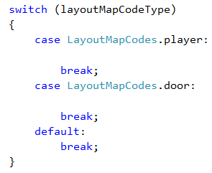
- For the player section, add the following
  - Check if this is the first room (use isFirstRoom variable)
    - Set the player’s transform position to the tile’s position (see what you did above).
    - It is no longer the first room. Set the isFirstRoom variable to false.
  - End If
- For the door section, add the following:
  - Call the CreatePortal method passing in the tile to attach the portal to and the room number it leads to.
  - The map character code for the room number needs to be converted to an integer.

Updating the Add Tile Method
- Locate the AddTile() method and locate the commented out call to AddFloorTileObject and uncomment as shown.
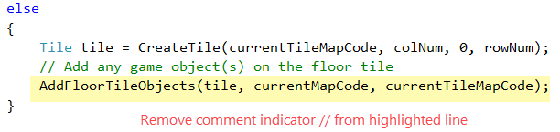
- Save your changes.

Exercise 2: Detecting when the Character Enters the Portal Doorway
- In this exercise, you will detect when the player character enters a portal doorway and trigger a custom event to notify the game that the player has entered a new room and the new room layout needs to be built.
- Create a new subfolder in the scripts folder called Events.

Event Broadcast Messenger Script
- Create a new script file called Messenger.
- Open the file and delete everything from it.
- Go to the following address: http://wiki.unity3d.com/index.php/CSharpMessenger_Extended and locate the code for Messenger.cs
  - Copy all the code (be careful not to copy MessengerUnitTest as you do not need it).
  - Paste the copied code into your Messenger script file.
- Save and close the file.

Game Event Script
- Create another script file called GameEvent in the Events folder you created earlier.
- Open up the file and delete:
  - The import statements (all the using …)
  - The Start() and update() methods.
- Now add an event for when the player character enters a portal (changes room) as highlighted.
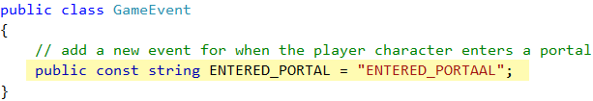

Portal Script
- Return to Unity and tag your Player game object character with the tag “Player”.
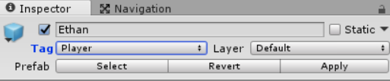
- Open up the Portal script.
- Because the portal is a Trigger collider object, you will use the OnTriggerEnter and OnTriggerExit methods for collision detection (when the player character enters the trigger zone).

On Trigger Enter Method
- Create the OnTriggerEnter Method as shown. The other parameter represents the collider object that entered the trigger zone. Add the following steps to this method.
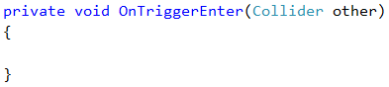
- First check if the player has just entered this room (hovering around the doorway). If yes, exit and return early.
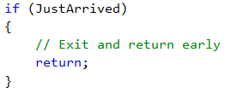
- Next check if it was the player that entered the room, if yes broadcast the entered portal event with the room number the player entered. Recall that tags are case-sensitive.
// Check if it was the player game object that entered the portal
// Player entered portal, broadcast to any method listening the room number the player entered
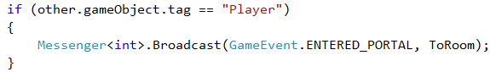

On Trigger Exit Method
- Create the OnTriggerExit Method as shown.
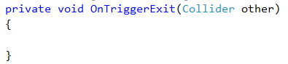
- Check if the game object that is exiting the trigger zone is the Player.
  - If yes, set just arrived to false.
- Save the script.

Exercise 3: Responding to the Entered Portal Event
- Return to the Layout Control script.
- Here you need to let the messenger know that the Layout Control is listening out for the Entered Portal event and how it will respond.

On Room Changed Method
- Create a new private method with a return type of void called OnRoomChanged.
  - The method should accept a single argument of type integer called roomNumber.
- This method will respond when the Entered Portal event occurs and all it needs to do is:
  - Call the BuildRoom() method with the room number passed into it.

Awake Method
- Locate the Awake method.
- Add the following to the Awake method to inform the Messenger that this object will be:
  - Listening for the Entered Portal Event
  - When it occurs, the OnRoomChanged method will handle what should happen.
  - OnRoomChanged will also expect an integer argument parameter.

On Destroy Method
- It is good practice to destroy any event listeners when the game object is destroyed. Unity’s OnDestroy method is executed when a game object is destroyed.
- Create the OnDestroy method and add the code to remove the event listener created in the previous step as shown.
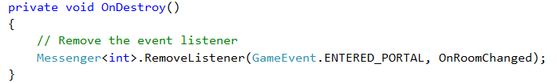
- You can test but you will probably find out that your player character does not get positioned when changing rooms.

Exercise 3: Make the Player Character Enter the Room
- Create a new private method with a return type of void called EnterRoom.
- The method should accept a single argument of type integer called fromRoomNumber
- Loop through all the portals in the current room.
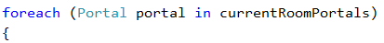
  - Check if this is the first room or the portal’s to room matches the fromRoomNumber argument (the door leads to the room the player is coming from, then it is the right door to position the player).
    - Set the portal’s just arrived property to false
    - Position the player at the portal’s position.
    - Set is first room to false.
  - End If
- End For Loop

The Build Room Method
- You need to make one slight change to the Build Room method.
- Locate this method and insert the following after the call to CreateRoomMapLayout() to make the player character enter the new room through the portal doorway that leads back to the room the player is coming from. Note: RoomNumber still holds the last room number, it gets changed after this line to the new room number.
// Make the player character enter the new room indicating what room the character is coming from, which is still currently stored in RoomNumber.
- Save your changes and test. Can you now walk through all the rooms?

Exercise 4: Adding a Particle Effect to the Portal
Finally!
Note: this exercise is optional and you can skip to the challenge exercise.
Particle systems (orderly mechanisms for creating and controlling large numbers or moving objects) are useful for creating visual effects e.g. fire, smoke or spraying water.
- Go to the Materials folder in your project.
- Create a new material and rename it to FireParticleMaterial or whatever you prefer.
- Apply the fire_sprite as the texture.
- Change the Shader setting to Particles Additive (soft). This will make the particles appear hazy and brighten the scene like a fire.
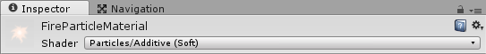
- From the main menu, select GameObject Particle System
- You should see the default spray of white puffballs.
- From the Inspector window, adjust the settings as you wish, for example, I went with the following and No it is not a great effect, you are probably better at this than I am.
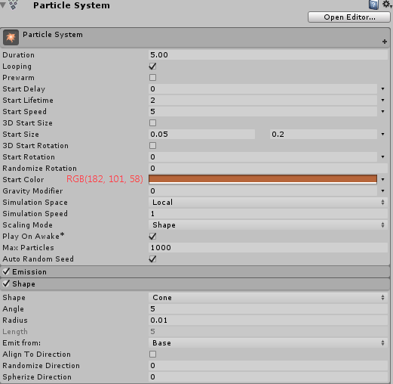
- Under renderer, set the Material to the fire_particle material created earlier and you may want to set a maximum particle size.
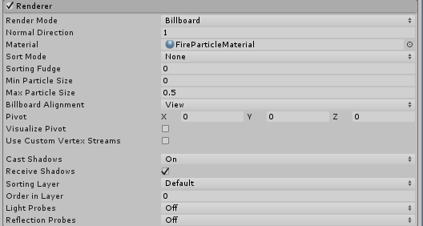
- Next, you need to attach the particle effect to the Portal prefab object.
  - Drag your portal prefab into the scene
  - Drag the Particle System you just created onto the portal game object so it becomes a child object of the portal
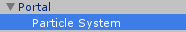
  - Select the Portal game object from the hierarchy window and in the Inspector window, hit the Apply button, to apply the changes made to the Portal Prefab.
  - You should now be able to expand the Portal prefab in the asset window, showing its child game object.
  - Delete the Portal game object from the scene as it will be added dynamically.

Exercise 5: Some Minor Adjustments
A few minor adjustments, just because I am being a bit of a perfectionist. You can skip.
- Open the Layout control script.

Resize Room Method
- Locate the ResizeRoom() method and make the following changes to this method:
// Retrieve the floor object from the scene
// Position it and resize the floor to match current room dimensions
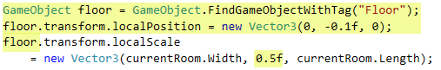

Create Tile Method
- Locate the CreateTile() method and look for the line that sets the y position for the wall and change as shown below (should increment by half floor height)
// Increment y by the half the height of the floor

Exercise 5: Challenge Exercise
- Try adding other game objects to your scene, e.g. an enemy character. You can either:
  - Make your own game object using basic 3D objects.
  - I have made a couple of assets available on Moodle. You will have to import the package into your game.
  - Note: you may need to add colliders to the characters to prevent your player character from walking through them.
- That’s all.

