Title: Student Learning Log
Student name: Romana Afrin
Student number: 2021258
Module: BMIH6004
Lecturer: Christopher Wilkin Rodrigo Fernandes Aguilera
Word count: 1200

Student Learning Log
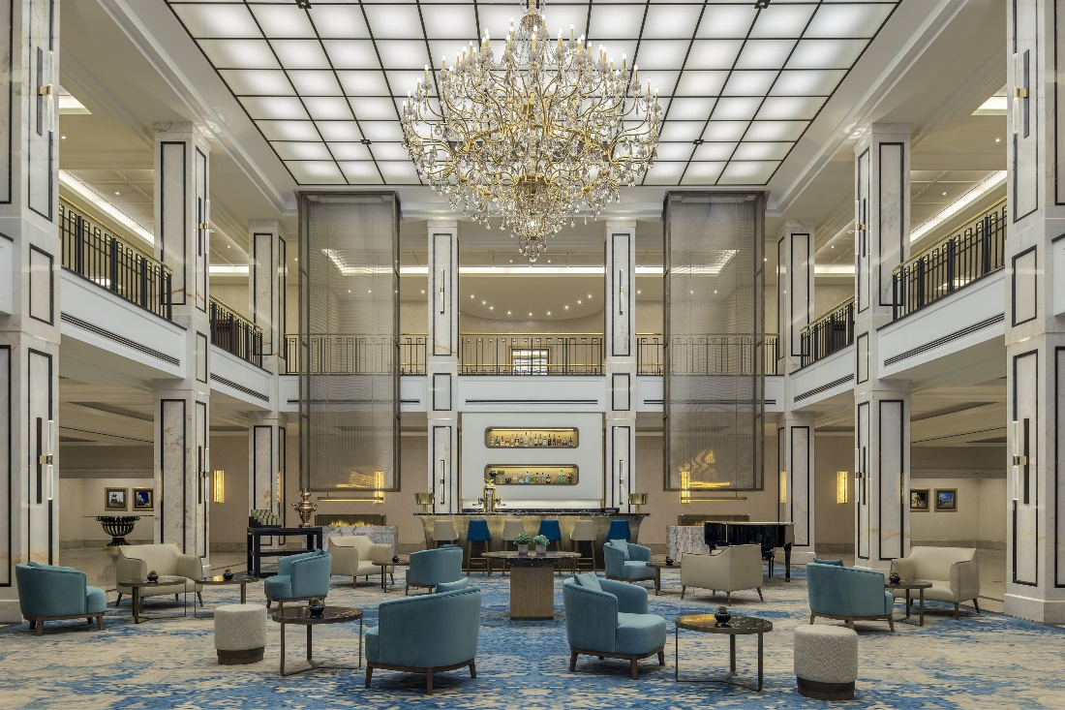
I was assigned a variety of jobs when I first started working with administration. However, because management enabled me to become involved in guest management so late, it is still ongoing. Even though I only started working in administration, I learned a lot. So far, I was able to supervise around and observe, learn ways to promote in social media; help with managing the customers and helping them out by communication skills.
At the start of the week when beginning to work for administration management, I was assigned to supervise and see how the hotel worked. This allowed to not only learn and see how everything was being done but also observing and looking for things a supervisor would need to look for so that everyone. It has also allowed me to see how the supervisors themselves need to manage and observe so that everything goes as planned and for everyone's safety. Overall, it allowed me to be in the supervisors' feet to see how much pressure they have when managing the staff and events alongside. It also allowed me to learn how staff members did certain things and multitasking giving me an insight on how to do it when I begin helping, so that I could help around when it is short staffed.


The next day I was allowed to learn ways to promote certain things in the hotel with the use of social media. This helped me learn ways how to place and use the different kind of background to make the products stand out and make consumers buy and visit the hotel to get the remarkable offers (Guest Touch, 2021). This lead me gaining so much knowledge about how things worked and learn how many views are needed for the products to sell out or not. It also allowed me to understand why Marriott needed to keep posting and be active in social media so that it is still well known and allows to bring in more consumers in the hotel and lead to the hotel being even brighter than it is right now (Dunton, 2019). These skills made it easier for me to understand the main things that need to be known when posting which would help me use this information in the future.
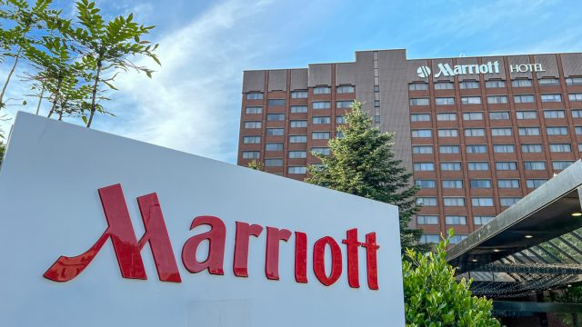
The next few days, the management allowed me to help our customers and take in reviews so that the hotel knows what they need to be improving the hotel to make it better and pleasing to the consumers expectations and trend. It also allows the hotel to stay in touch with what is going on around the world so that the hotel can expand into a much more comfortable atmosphere for its clients. Other than that, it also allowed me to learn so many things for example learniong how to communicate with customers without being uncomfortable or shy. This allowed me to be much more confident around others leading me to improve my communication skills even more. Overall, it was a wonderful experience for me as I got to know the customers well which allowed me to help staff members out when they needed some help improving services.
I did not struggle quite as much as when I worked for the other two managements, however I did quite find it difficult to understand sometimes when the staff members were trying to make me understand how certain things worked. However, I managed to understand after a while and beginning to understand why things were done to make the hotel a better place. It was also quite hard for me to make the right choice of colour backgrounds when I was chosen to try. However, after a few tries I began to see superior results which was also posted on the website due to how splendid my work was after a lot of tries. This also helped me to know how a camera should be held to get the right shadows in the picture and the light that is needed, so that the picture is rightly proportional and pleasing to the consumers eyes.
The management did not run to any problems during my placements. However, there could have been many incidents which could have been avoided in a much easier manner, for instance: Supervisor not being there when a staff member is in need, causing management to struggle greatly; bringing in personnel from diverse fields of employment who know what to do. Because of the substantial number of consumers who poured in, there was a lot of confusion and chaos as supervisor was not there. The best way to solve this problem so that management does not have to worry about being short staffed is to assign more employees and instruct them to stay in when the hotel is overcrowded with customers, making it much easier to manage the number of customers who are present and resulting in fewer customers waiting for their orders for an extended period of time a long time, leaving both the workers (supervisors) in and the clients relieved and satisfied with the service (Mistry, 2022). However other than that, the management was really organised and helpful to customers and staff members themselves so that everyone is pleased with the behaviour there. The management has helped me and made me learn quite a lot of things while I was there which I was really pleased about. They also allowed me to have some time to get used to the new atmosphere, so that I do not run into problems when beginning to work. This has also helped me work in a faster rate due to having a small break at the start of the management.

Overall, I had received a lot of experience and acquired new skills that I can apply in the future, such as: Interpersonal skills that led to me being much more confident and allowing me to ask further inquiries when I was inquisitive about how matters performed around the hotel, in addition to allowing me to talk with consumers and support them in any way, the experience has allowed me to time manage so that I could finish a task immediately to move on to a different task and begin so that minimal time has been wasted and work has been done (multitask), Problem-solving abilities which has allowed me to do tasks when I have been assigned to solve something on the spot, This led me to use this whenever I would need to think rapid and give some thoughts and answers (Hughes, 2018). (Hughes, 2018).It was a lovely experience even though I was struggling the first week, however the struggles helped me become more experienced and understand the necessities that are needed in the hotel when working within the area. it was a wonderful experience for me due to learning so many things in a few days. The management has also helped me a lot to get through and help me out when I am straggling with things. Furthermore, they have been encouraging me a lot so that I could be a much brighter person in the future and help consumers in a hotel or any other places.

Reference:
- Liz, B, H,. (2018). Top 8 Skills for a Successful Career in Hospitality. Available at: https://www.highspeedtraining.co.uk/hub/top-hospitality-skills/ (Accessed on: 19, September 2018).
- Guest Touch,. (2021). How To Improve Online Reputation For Hotels. https://www.guesttouch.com/blog/how-to-improve-online-reputation-for-hotels (Accessed at: 26, July 2021).
- Snehal, M,. (2022). How to Deal with Common Challenges in Hotel Industry?. Available at: https://www.ezeeabsolute.com/blog/how-to-deal-with-challenges-in-hotel-industry/#:~:text=Engaging%20your%20guests%20on%20social,with%20whatever%20tactics%20you%20apply (Accessed on: 6, December 2022).
- Alex, D,. (2019). What does going into administration mean?. Available at: https://companieshouse.blog.gov.uk/2019/02/27/what-does-going-into-administration-mean/ ( Accessed at: 27, February 2019).

