Workshop Skills Logbook
L4 – Workshop Skills ACDA4022
Electrical & Electronic Engineering Degree Apprenticeship
Joshua H – Student Number: 2420839

Introduction
This report will outline the process by which to create a PCB Non-Inverting OpAmp. Designing the schematic, breadboard, and PCB and then creating and proving the PCB works as intended.

Schematic Design
Figure 1 shows the schematic of the amplifier connected to a signal generator and oscilloscope. This schematic was created following instructions given in the lab, in proteus. Changing resistance in R1 and R4 will affect the gain. R3 and R2 are known as potential dividers changing their values will affect the generated wave’s rising and falling edge.
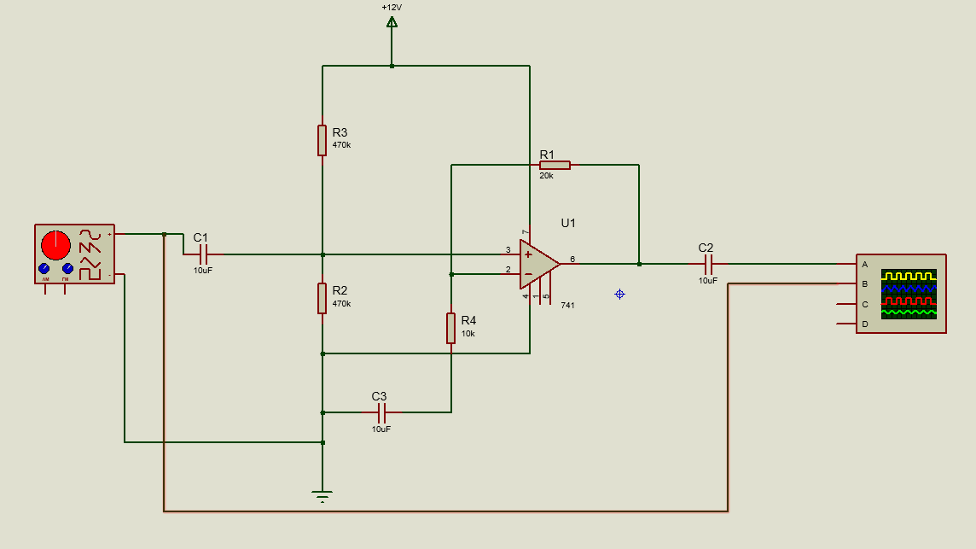

Figure 1: Schematic Design connected to test equipment in proteus

Testing In Proteus
Proteus was used to create the schematic and test the circuit’s function before moving to the breadboard. From proteus, the voltages and gain can be modelled. The gain can be calculated using the readings, taken in proteus, by dividing the voltage out against the voltage in. Results from this show a maximum gain of 3 quickly ramping up from 1 Hz; starting at 20 Hz and ending at 50,000 Hz. The design uses all the same components which will be used later in the real assembly so the simulated results are a good indication of how the actual PCB will function.

Frequency (Hz) | Voltage In (Volts) | Voltage Out (Volts) | Gain  (dB)
1 | 2 | 3.56 | 1.82
2 | 2 | 4.72 | 2.36
5 | 2 | 5.72 | 2.86
10 | 2 | 5.94 | 2.97
20 | 2 | 6 | 3
100 | 2 | 6 | 3
200 | 2 | 6 | 3
500 | 2 | 6 | 3
1,000 | 2 | 6 | 3
2,000 | 2 | 6 | 3
5,000 | 2 | 6 | 3
10,000 | 2 | 6 | 3
20,000 | 2 | 6 | 3
50,000 | 2 | 5.8 | 2.9
100,000 | 2 | 3.26 | 1.63
200,000 | 2 | 1.68 | 0.84
500,000 | 2 | 0.66 | 0.33
Figure 3: A graph to show the amplitude of the output at different frequencies for the simulated amplifier. The gain is in a logarithmic scale using this equation $dB=20log10​(\frac{Vin}{Vout})$
Figure 2: Table of results from testing in proteus, gain was calculated using $dB= \frac{Vout}{Vin}$

Figure 4: A graph to show the gain of the amplifier over different frequencies for the simulated amplifier. The gain is in a logarithmic scale using this equation $dB=20log10​(\frac{Vin}{Vout})$

Breadboard Prototyping
To test the circuit worked as intended before sending it to a manufacturer the components were laid out on a breadboard. The breadboard was planned on paper, copied from the circuit diagram shown in Figure 1, and then placed component by component. Some troubleshooting was required as the comparator had a different pinout than initially thought. Furthermore, the breadboard would have benefited from having different colour wires for the input and output to help with usability, and the wires connecting components to supply and ground, in best practice, should be the same colour and distinct from the rest of the wires in the circuit.
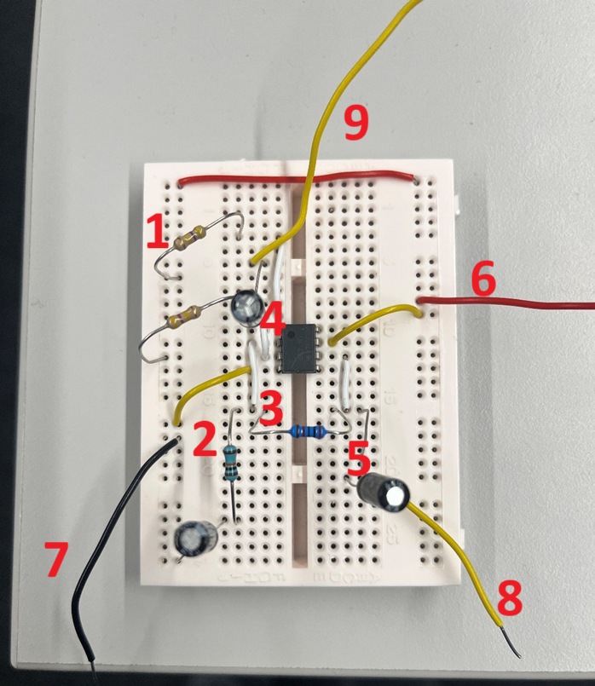

Figure 5: The amplifier circuit placed on the breadboard, annotations below
- The two 470k Ohm resistors
- The 20k Ohm resistor
- The 10k Ohm resistor
- The comparator-
- A capacitor (all capacitors are 10mF)
- Supply
- Ground
- Output
- Input
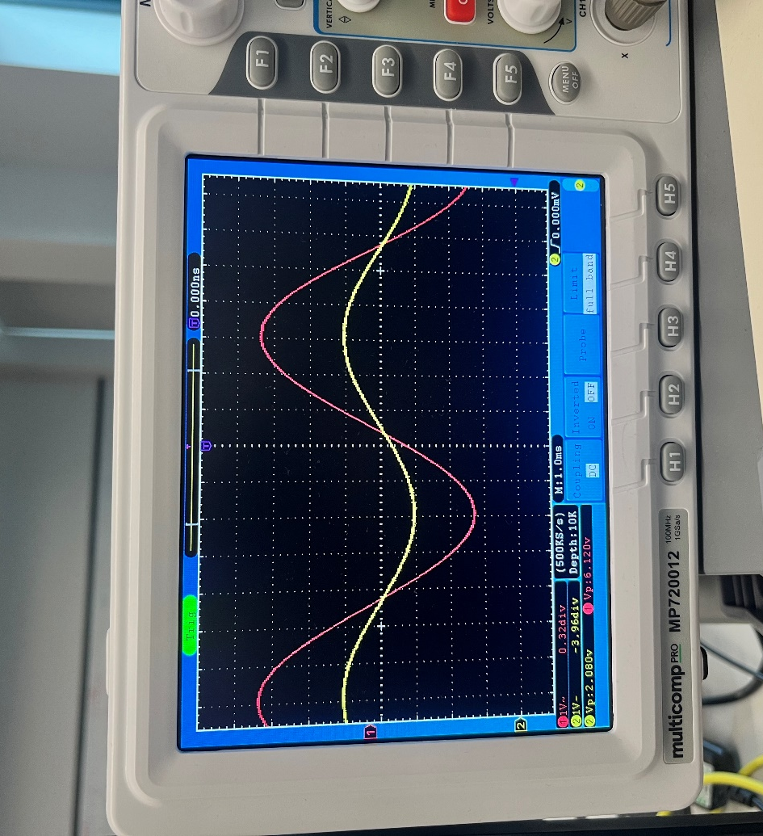
Figure 6: Oscilloscope reading from Figure 5
This is the waveform produced by the breadboard after being attached to a signal generator and an oscilloscope as shown in Figure 6 it is reading as 2.080 Volts as the input and 6.120 Volts as the output. This waveform is the expected result of the board meaning we can move forward with the production of the PCB for the board to be placed on.

Breadboard Testing
The breadboard in Figure 5 was tested by attaching an oscilloscope to the input and output leads, components 8 and 9 respectively, and attaching a signal generator to the input lead. All testing equipment was then grounded in common with the rest of the circuit. The input voltage was set at 2 volts and the frequency was increased from 1Hz to 500,000 Hz.
Frequency (Hz) | Voltage In (Volts) | Voltage Out (Volts) | Gain  (dB)
1 | 2 | 2.56 | 1.33
2 | 2 | 4.36 | 2.18
5 | 2.12 | 5.72 | 2.70
10 | 2.08 | 6.04 | 2.85
20 | 2.04 | 6.08 | 2.98
100 | 2.02 | 6.04 | 2.96
200 | 2.04 | 6.08 | 2.98
500 | 2.04 | 6.08 | 2.98
1,000 | 2.04 | 6.08 | 2.98
2,000 | 2.04 | 6.08 | 2.98
5,000 | 2.04 | 6.08 | 2.98
10,000 | 2.04 | 6.08 | 2.98
20,000 | 2.16 | 6.08 | 2.84
50,000 | 2.16 | 6.08 | 2.84
100,000 | 2.16 | 4.64 | 2.14
200,000 | 2.16 | 2.4 | 1.11
500,000 | 2.16 | 1.2 | 0.55

Figure 8: A graph to show the amplitude of the output at different frequencies for the amplifier on breadboard. The gain is in a logarithmic scale using this equation $dB=20log10​(\frac{Vin}{Vout})$

Figure 7: Table of results from testing on the breadboard, gain was calculated using $dB= \frac{Vout}{Vin}$

Figure 9: A graph to show the gain of the amplifier over different frequencies for the amplifier on breadboard. The gain is in a logarithmic scale using this equation $dB=20log10​(\frac{Vin}{Vout})$
Results
The test results from the breadboard are very similar to what was achieved with Proteus. However clear differences were observed, the proteus simulation and the breadboard results generally differed on voltages at and high bands, this, however, is as expected due to real-world effects such as parasitic impedance and capacitance in the circuit and components which are not considered in proteus simulations.
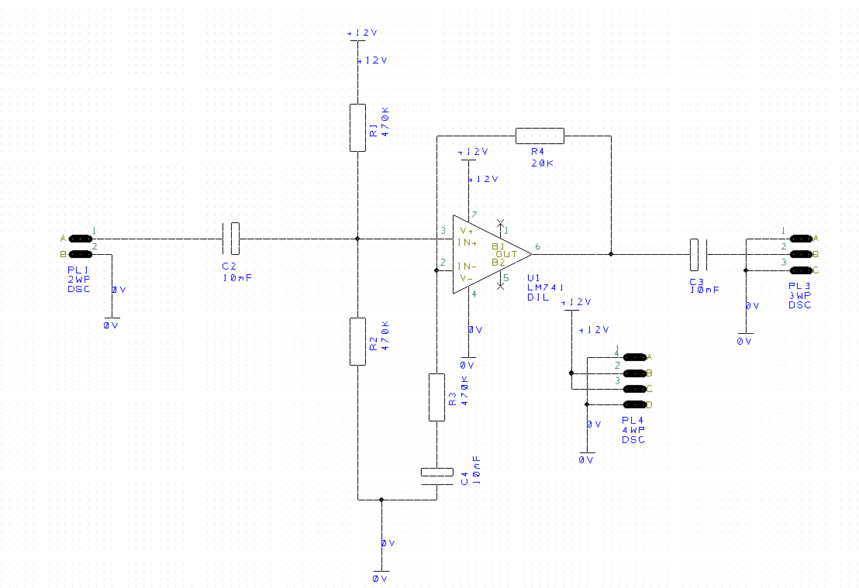
Printed Circuit Board Creation

Figure 10: Circuit as a printed circuit board
The diagram from Proteus was copied into the Easy-PC, then using the software a PCB design was created, during the creation of the PCB a copper fill was used for the ground contacts which led to pin 3 being connected to the ground as shown in Figure 11, unbeknownst to myself when creating the PCB Easy-PC has several checks to find design, integrity and connectivity rules, problems are then highlighted and shown on the PCB in pink. These problems were found after the creation of the board as well as a silkscreen issue in which C3 is inverted. 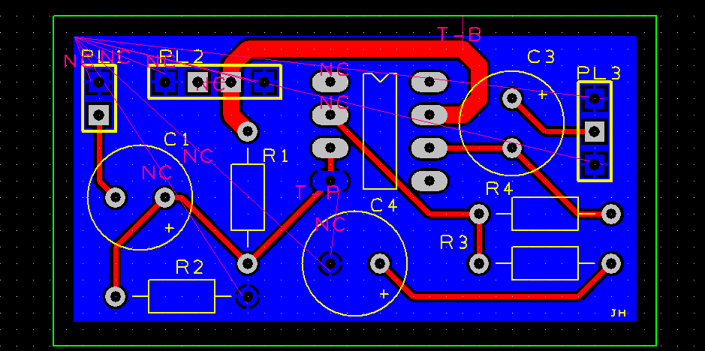
Figure 11: PCB layout with error messaging overlayed

Although the board itself would not work, the steps to create and fault find are documented below.
The tools were set up on a tidy workstation, helping hands and blue tack were used to keep the board stable, and an extractor fan was used to remove fumes from the solder, All component legs were first cleaned pliers were used to abrade any oxidised metal on the components, ensuring good solder connections.
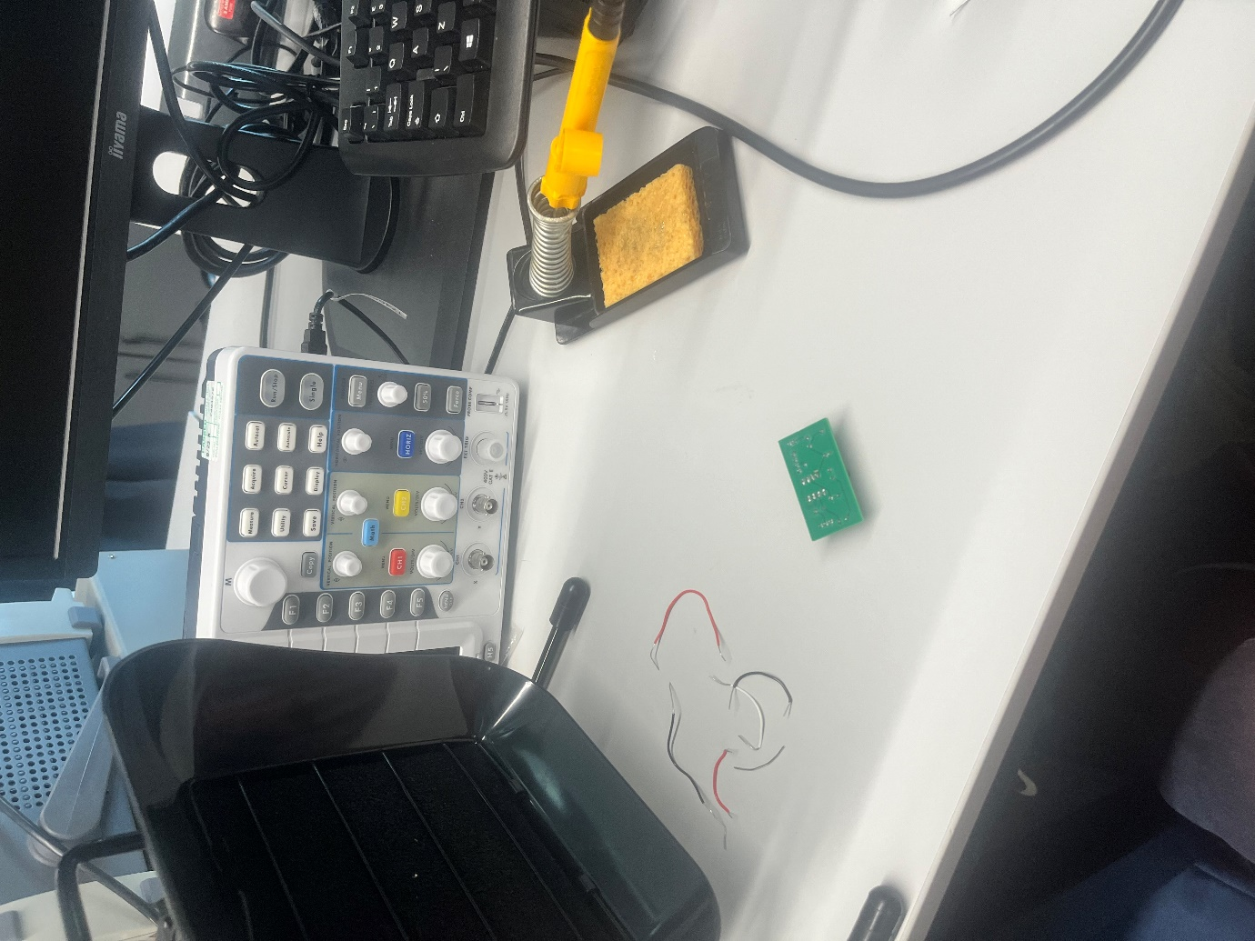
Figure 12 Clean workstation to start soldering on
The comparator was placed in the board and secured with blue tack, this component was placed in first as it was required to be flat to the board, and with no other components on the board, it meant that if any mistakes were made there would not be any chance of damaging another component. The resistors were placed next; they were placed on one side bent in the board to find the correct leg length needed on one side and then the other side was matched evenly. Once placed in the board one leg was splayed to keep the component secure whilst the other was cut down to size, component legs are cut before soldering as there is a possibility to affect the component and/or the joint if the legs are cut to size afterward. Once placed in the board one leg was splayed to keep the component secure whilst the other was cut down to size, component legs are cut before soldering as there is a possibility to affect the component and/or the joint if the legs are cut to size afterwards.
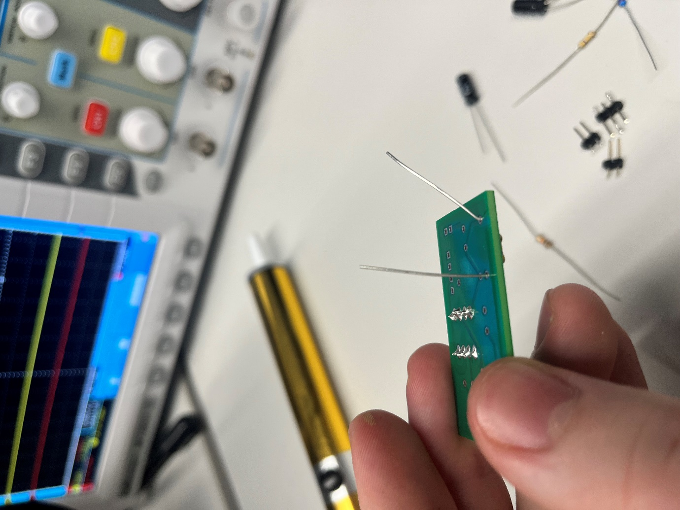
Figure 13 First resistor placed into the board; one leg splayed to keep the component secure

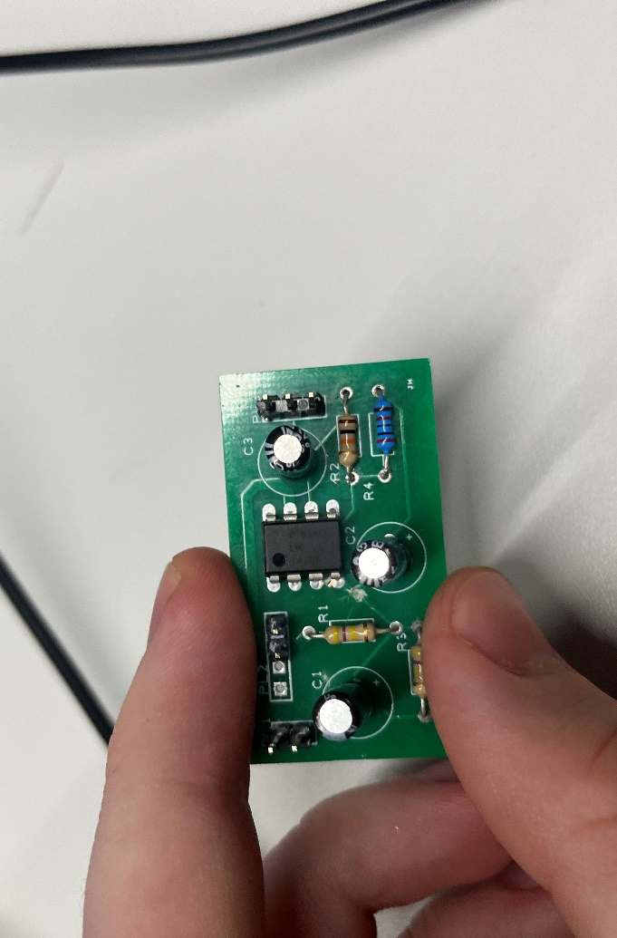
All other components were placed in the same way as described above resulting in the board below.

0

Figure 13 shows the completed board

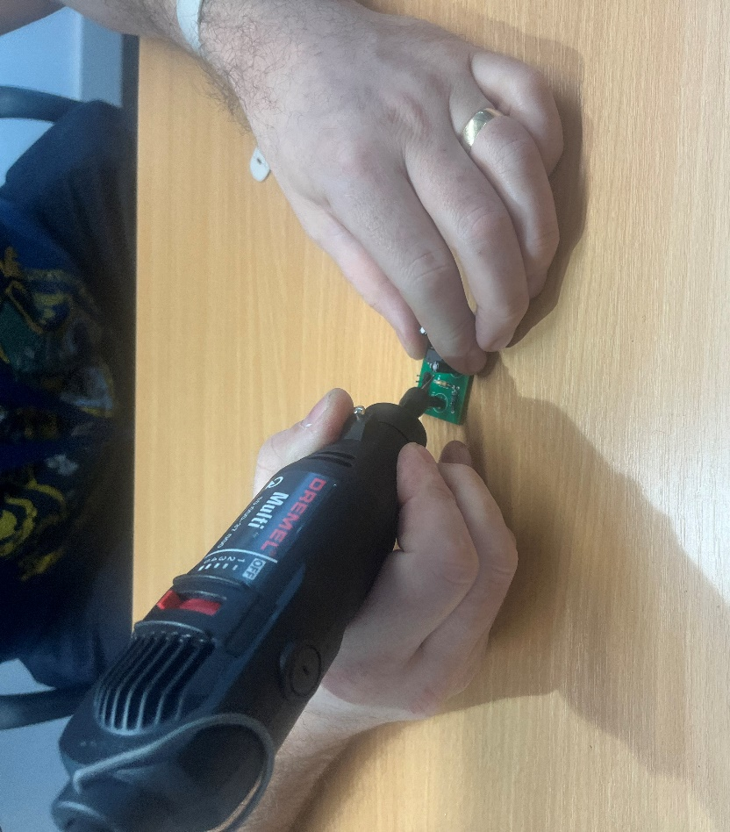
The initial build went very smoothly, with no real problems, and all solder joints were observed to be good. Testing began soon after the visual inspection where the board was then discovered to be broken, and the aforementioned problems with pin 3 and the capacitor were found. A Dremel was then used to bore out the track in between pin 3 and ground. Then a wire was brought across from R1 to pin 3 and soldered in.

Figure 14 shows a Dremel being used to break a track

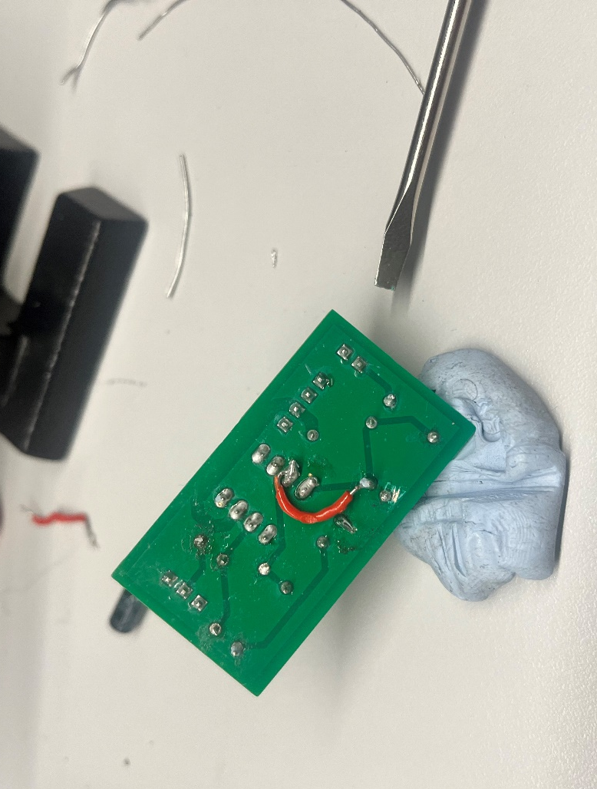
Figure 15 shows the wire across the pins, and the extra solder on for the grounds

The ground connections across the board were also thought to be incorrect, the top layer of the PCB was removed to reveal the copper layer, and solder was then placed in these holes and connected to any components connected to the ground, as shown in figure 15. After the wires, all that needed to change was the capacitor and the final connection was complete. To remove a component from the board a small amount of solder was applied to the iron for better heat conduction and a solder sucker was used to remove the larger amount of solder. Then using helping hands and pliers with the soldering iron placed on the connections the capacitor was removed.

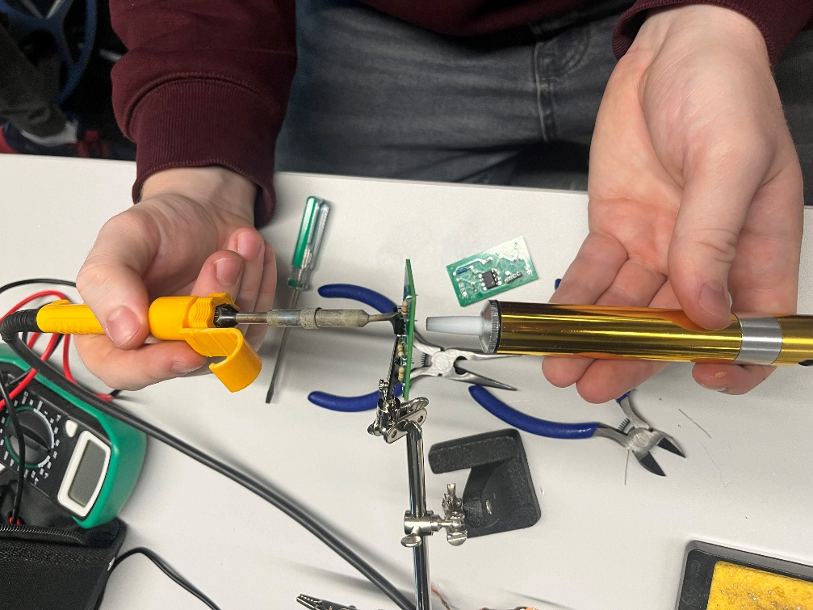

Figure 16 shows the removal of excess solder within the connection vias
After the capacitor was removed the connection vias still contained solder, figure 15 shows the method by which it was removed.

Testing the PCB
The PCB was connected to an oscilloscope and wave generator using header and crocodile clips.
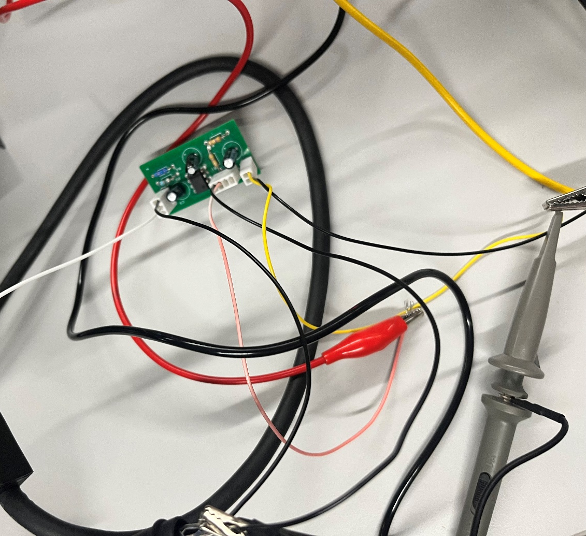

Figure 17 shows the set up fo the capacitor with all changes made
The wave generator was set at 2 volts and resulted in an unexpected output of a 12-volt wave, which means it at this point was generating a gain of 6 as shown in Figure 18.

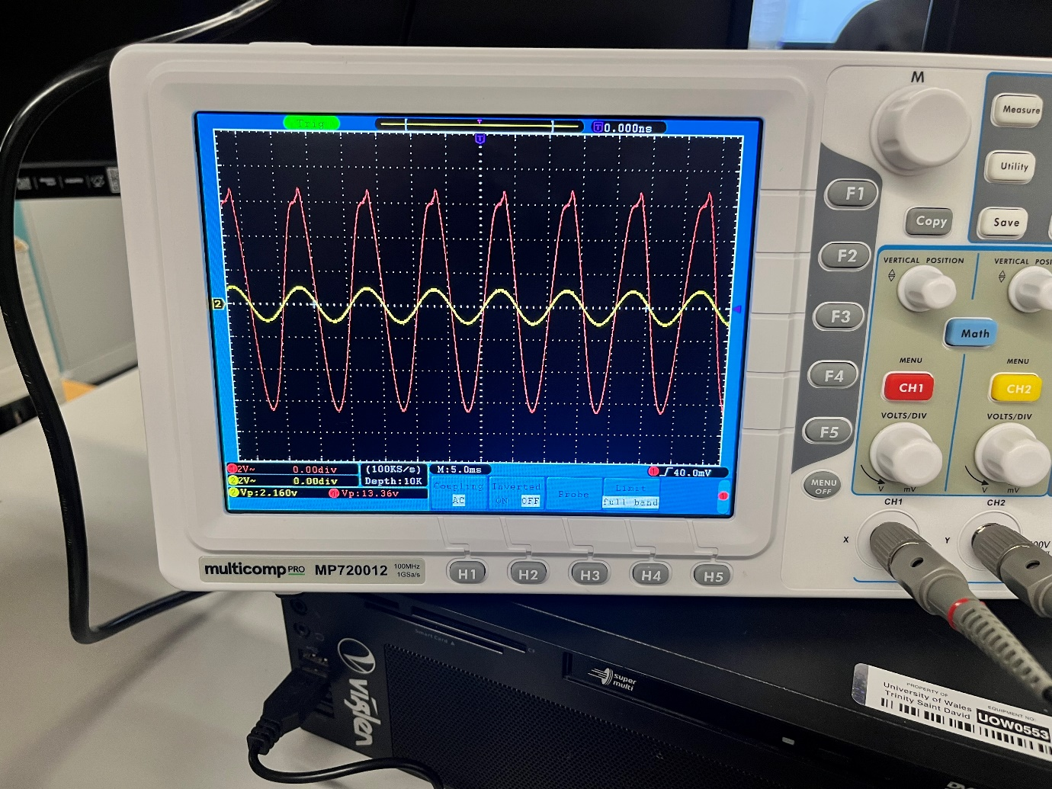
Figure 18 shows the output of the PCB after all corrections were made
This result however was never replicated, testing for the amplifier's operation at different frequencies was set for the day after. Once set up again in the same method as before the amplifier would not generate any useful waveforms. At this point in the industry, a new board with an updated design would be created as more testing would not be cost-effective, further, this board would be unusable for a customer due to the many changes. However, I continued testing to hopefully find the issue within the board.
The board was tested with an oscilloscope to find at which component the input wave changed incorrectly, it was found that after the comparator the output wave was wrong, implying that the feedback loop was incorrectly wired. Furthermore, testing with a multimeter found that the potential divider had incorrect values across it. Reading 10 volts when 6 is expected, implying

that the potential divider wasn’t going to ground. This fault was attempted to be fixed however no amount of changes caused it to be fixed.

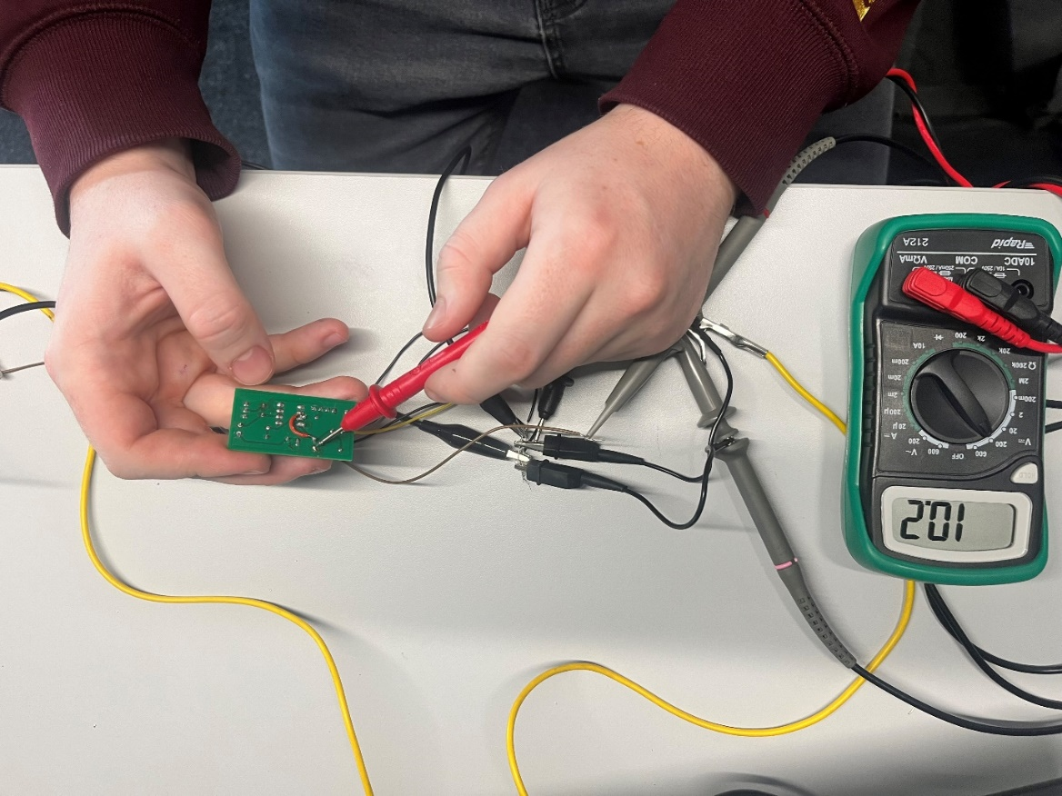

Figure 19 Showing the potential divider values during testing

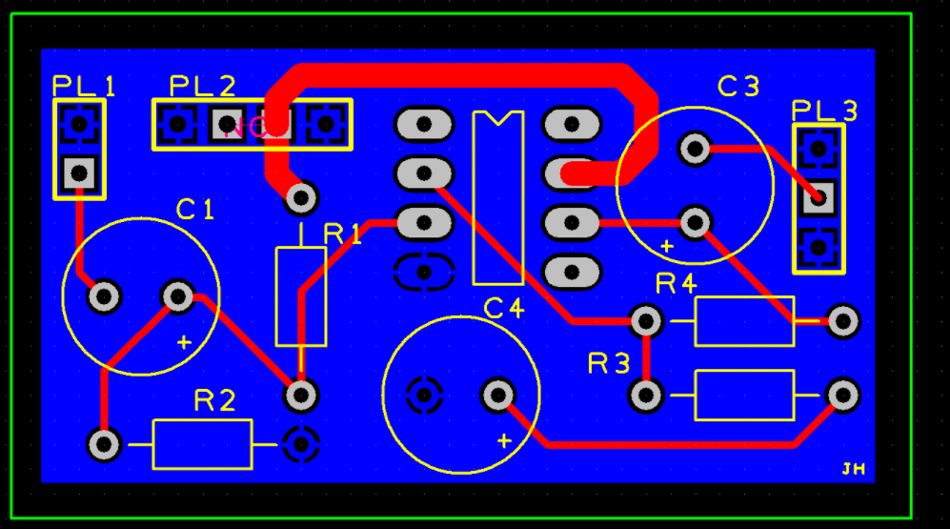
The figure below shows the updated board with an updated capacitor and a correct input path, if more time had been available I would have offered this new design for creation and after checking using the design check rules I believe this version would work.

Figure 20: Revised board

