UNIVERSITY OF WALES TRINITY SAINT DAVID

LONDON

Term 2-Assessment 1

Module: Strategic management Module code: LCMB7003

Lecturer’s name: Steven Sommerville Name: Nertila Halleshi
Student’s number: 1712377

Assignment’s requirements: Report on the Google vs Baidu in China

29th of April 2019
London, UK

Table of content
Executive summary…………………………………………………………………3
Company-Main findings……………………………………………………………4
Google vs Baidu in China…………………………………………………………...7
Google vs Baidu analysis……………………………………………………………8
Google vs Baidu (internal environment, financial analysis)………………………12
Recommendations…………………………………………………………………15
Conclusion…………………………………………………………………………16
Reference’s list…………………………………………………………………….17

Executive summary
Google Inc. and Baidu are two main competitors in the Chinese market by providing online advertising and gaining in this way their revenues. Apart from this, both the companies do compete in the same web services and also pay per click platform, but different from Google Inc. , Baidu is having a great support from the Chinese government which gives more room for the company to operate and giving in this way more access to the business to operate by using that company. Seeing the situation, a detailed external and internal environment report is prepared in order to give a clear view of the real situation of the both companies. Based on the external and internal analysis, there are provided different recommendations in order to give an opportunity for the investors to invest in the company and gain in this way a new and big successful market such as the Chinese one. Moreover, the internal analysis provides the greater impact that Google should gain as it shows a sustainable financial strength compared to the Baidu company which is showing fluctuating financial data.

Company-Main findings
Talking about Google and Baidu in China is too wide because these two companies have such a big impact in China but Google is more used abroad by including different aspects and areas where it has been engaged and also is trying to get involved more even in China by offering different strategies and in a way or another offering more services in order to gain more customers compare to the other companies, but what does strategic management mean? According to the strategic management journal in 2007, the strategic management seemed to have to do with the strategies that are intended, predicted by the general managers considering the other people’s companies and on behalf of their owners and involving the most effective sources in order to realize the performance of the company in the external environment in which it operates. (Anon., 2007) The basic areas where the strategic management field seemed to be focused, based on Lynch, lead to three main “sections” that are (Lynch, 2015): strategic analysis, strategic development and strategy implementation. All these three, take into consideration the analysis that should be done in different perspectives in order to have a clear analysis of the whole company as a unit. On the other hand, when talking about the strategic decisions that a company should have as a primary scope relate to context, content and process, according to Lynch. (Lynch, 2015)
As mentioned, the company dealing with in this report has to do with Google in China and its major competitor Baidu that even though they have different target groups, they seem to be challenging each other in the same country. On 12 September 2000, Google announced the addition of STC (the simplified and traditional Chinese) versions to Google.com and also started to provide search services for Chinese users worldwide (William L Hosch, 2018). On 10 September 2004, Google.com launched simplified Chinese Google News but in 2006 it was renamed as Google Information due to the announcement that was done in 2005 for setting up a research and development center in China.
Also, in that year that was 2006, Google launched its China-based google.cn search page the results of which were censored by the Chinese government (William L Hosch, 2018). Being in this situation, google used its Chinese name GǔGē that means ("harvest song"), but still it was not able to be successful in getting more users until April of that year which Google officially entered in the Chinese market. The way the Chinese government controlled the country was also reflected in the research companies by blocking users to have access in Google's YouTube site and other Google online services that were denied by being used in an illogical way. Due to different reasons, many Google employers were leaving the company, such as Kai-Fu that left on the 4th of September 2009 and at that time Google decreased the share towards the rivals such as Baidu (Mazur, 2018).
Controversially, Baidu is an “older” company as it dated since 1996 with Robin Li who had developed the Rank Dex site-scoring algorithm for search engines results page ranking, the same one used for the Baidu search engine that in 2000 was launched in Beijing of China. A news search engine and picture search engines were launched by Baidu in 2003 but different from Google these were used in identifying and grouping different articles. During these years, the Baidu company seemed to have used the exploring corporate strategy (Johnson, n.d.), the focus of which was on the gaining of a strategic position making the right choices by analyzing the environment, capability, the purpose and the most important the culture of the Chinese country as shown below in figure one.
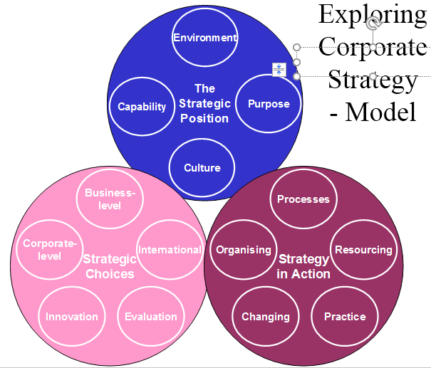
Fig.1 Exploring corporate strategy
However, Google seemed to have used the strategic fit strategy (Johnson, n.d.) by analyzing the business environment due to the fact that China was a new country for it to be in and the capabilities, resources, competences in China were limited by the government for the Google company as it is shown in figure 2.. Nevertheless, Google tried to employ many people by having into account the limit access towards the environment and also the strategies used by the other competitors like Baidu that in that period of time were enough successful and had gained a kind of big amount of customers as it had clear the target group towards which it was operating. Still, both the companies started to go ahead by bringing in different strategies, but the problem consisted on the fact that Google was facing obstacles by the Chinese government, the effect of which even now days is too much “censoring” in different environmental, cultural and political issues.
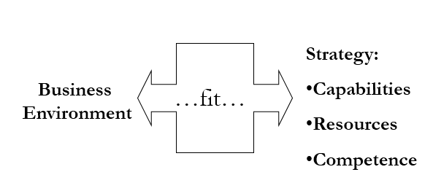
Fig.2 The strategic fit model
Also, considering both the companies and most important the country, Google was in a new country and the “brand name” owned in other countries was not the same in China as there were other competitors like Baidu that compete in different services, providing key contact with the market and had a kind of “adaptation” process with the Chinese government which Google lacked since in its beginnings there. Google in the recent years competed with a limited range of products in China as it thought the market will “grow” to some extent by the “brand name” created in other countries, but in fact Google “forgot to consider” the Chinese government “effect”.
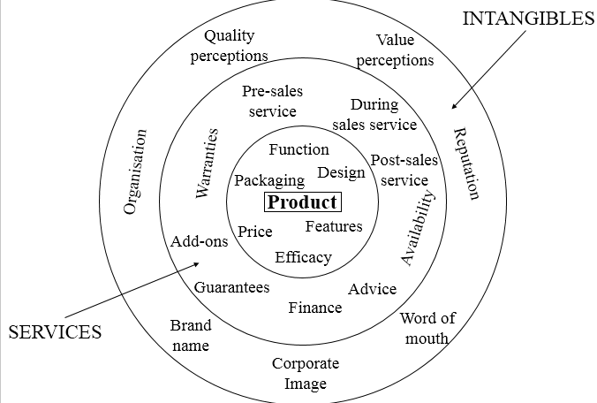
Fig.3
As seen by the figure three, when launching a product, a company should have into (Johnson, n.d.) consideration the services and intangibles that it is going to use in a certain country and seemed that Google didn’t do this properly and faced consequences in the following years as in 2010 Google concentrated its services and search queries from Google.cn to Google.com.hk in Hong Kong, as Hong Kong has gained an independent power especially judicial ones, meaning that the country provides free censorship “services” towards internet services and information different from China that had hack attacking towards Google services and users by making all Google search sites in all languages to be banned there apart from Google Mail and Google maps that seem to be not affected, but resulting in a ban for Google in China.
On the other hand, Baidu in 2010 had a great impact in the Chinese users by growing up but it also experienced Iranian cyber army attacks which made the Baidu’s sites temporarily (Costill, 2014) inaccessible (for some hours) and later on some Chinese hackers attacked the Iranian websites. With the passing of the years, Baidu continued to be used in China while Google was banned by China.

Google vs Baidu in China (position, strategies in the market share)
As Google seem to be maintaining a stronghold in the global internet searching part, Baidu seems to have reached the upper level in China with 74.6% according to BBC news reports for February 2019 while Google has been ranked the 5th for the online search market by having gained only 2.03% share (China, 2019)even though Google and Baidu operate in similar web services, the focus of which differs a lot because for Baidu company the focus is the local Chinese market while for Google is to continue to be expanded globally.
Moreover, Baidu is known to be a specific online search company for the Chinese market but to somehow it has many products and services that are similar to the Google but is directed by the government. Baidu gives the benefit for its users in the Chinese language and cultural services which enables it at the market positioning to be more usable as Chinese language is too complex, a fact this that for Google has been struggling in the business and technological aspects. Baidu’s focus seems to continue its focus in the Chinese market even though that nation has a limited internet usage. It is offering different specific search services (Rieple, 2008) such as a missing search person, senior citizen search and patent search, services these specific for the Chinese legal requirements imposed by the government.
On the other hand, Google efforts in China appear to have been for many years censored by the government (Mazur, 2018), but still Google is continuing to diversify the products in order to expand the business in the markets that are developed and also by doing experiments on high-speed broadband network that is named as Google Fiber. Both the companies, Google and Baidu, seem to be generating revenues from the advertising process (Anon., n.d.) but the Baidu’s advertisements are mostly based in one target group while the Google ones are diversified as being in a global target group.
The efforts to go back in China for the Google company still continue and this time seems to be supported by the Tencent when in January of this year the Google’s parent company Alphabet made a patent agreement and what is more Google did open an office in Shenzhen by adding an investment of $550million in JD.com (William L Hosch, 2018), a commerce firm being also invested by Tencent. Moreover, Google has launched a Wechat Mini Program which means that there is a strong partnership between Tencent and Google as it is a Tencent “platform” called “We chat”. Another collaboration between Tencent and Google was reported to be on the news side (China, 2019), an engine being based on the content recommendation in which Google is too brave and by doing so, Tencent will be able to defeat Bytedance which owns a similar news application known as Jinri Toutiao. However, a lot of efforts or other offering strategies will be a great help for Google to be part of the Chinese target group, by taking into consideration also the “oppression” that the Chinese government offers to Google services.

Google vs Baidu analysis
In order to analyze Google vs Baidu Inc., is important to be focused on its environmental aspect that is external and internal. However, Google seems to have began to offer a Chinese language version of Google.com in 2000 by having used the servers that were located in USA but that site was censored by the Chinese government and by having faced this problem and many debates at the same time, Google decided to offer a modified version by calling it Google.cn and this time by using servers that were located in China (Cuofano, 2019). All the other companies, even Google, that entered in China with their sites should be careful to not “damage” the image and interest of the Chinese government and by trying to bring instability in the Chinese population. In the beginning Google did not provide for the Chinese users e-mail or blogs’ creations as the content of them was censored by the government. However, Google alongside with the other companies faced a lot of criticism and political pressure in the USA as it was seen to be cooperating with the Chinese government and being in this situation Google had to decide to change the policies towards it operated (Lasserre, 2012).
Using the five forces model (Porter, 1980) in order to analyze it externally, the situation of the Google in China “is” as follows. First of all, the five forces model according to Lynch has to do with five categories that are: threat of substitute products and services, rivalry among existing players, threat of new entrants, bargaining power of suppliers and the bargaining power of buyers. Being borrowed by the micro economics field, these five forces seem to “define” the structure of a certain industry that in our case is Google and Baidu.
Firstly, the threat of substitute products and services (Porter, 1980) has to do with the products and services that Google offers in China which are different from the other competitors, but on the other hand if the threat of substitute is high meaning that other companies are trying to be like Google, then Google has to do more investment in research and development in order to have and bring more innovations in the Chinese market. So, Google is experiencing a moderate threat of substitutes or substitution which include many advertising channels such as tv, radio and printed media. Google should take into consideration these as those can lead to low switch costs and give a moderate value towards the high availability of the substitutes. The low switching costs provide an easier access for the customers to switch to other substitutes’ services different from Google’s ones. Also, the moderate value of having a high availability of substitutes offers to the customers higher options to switch from Google services and products.
Secondly, rivalry among existing players (Porter, 1985), which means that Google has too many competitors in a certain area but in different services which means that a partnership with Tencent as mentioned up, will help Google to gain profits in different services based mainly on the market share. Even though Baidu has gained a very successful market share in China due to the language service provided, for Google it will be difficult if it does not in a way try to offer a Chinese language service to the Chinese target group and this will help to defeat Baidu in this aspect as they both operate on the same web service. Moreover, external factors such as large number of firms, high diversity of firms and low switching costs seem to be a very high risk that “promotes” rivalry towards the Google company in China. As Google has many competitors in China that are Yahoo, Bing, Apple, Comcast, the biggest one that is Baidu and others, the diversity in products offered by them is also big (Porter, 1985). Google offers many services but offering different products and services for the customers different from the competitors such as the Google Glass, Google Fiber and Chromecast makes Google a strong force in the business area. On the other hand, with so many products such as mobile phones and services offered to the customers, they experience a very low cost to switch from one company such as Google to another company that might be Baidu, making it in this way difficult for Google to keep the target group unless Google offers time after time new products and services (John Thompson, 2014) to keep the customers satisfied.
Thirdly, threat of new entrants (Porter, 1985) should be taken into consideration by Google if Google wants to gain a big position in the Chinese market share. By taking into account the other recent competitors in China, if still there is a new entrance, then the current competitors will offer less profitable services in order to reduce this new threat, a reason that should be applicable even for Google towards the other competitors and also “applicable services suitable “for the Chinese government. Also, the moderate cost of doing business, providing a high cost of brand development and the easy way to fulfill the regulatory requirements are three factors that Google should pose a considerable notice as many other companies can enter anytime in the market and have a direct competing with Google. Another fact is the fact of trying to be a brand (John Thompson, 2014)in the Chinese market for Google that leads to a very high cost and it will be difficult for other new entrants to enter the market and to try to keep their operations for a long time because for Google this is an advantage as it has one of the most valuable brands in the worlds. Google should not also forget that for other new entrants, it has a disadvantage that are the regulatory requirements which for a new entrant are very easy to comply in order to be in the market share of China, while for Google this has been censored by the government.
Fourth, has to do with the bargaining power of suppliers (Porter, 1985) of Google censorship. If the suppliers demand a strong bargaining power then it will be obvious that the price will be higher to be got from Google Censorship, which is not very profitable for Google in China as it will be a minus more after the fact of having a high availability of suppliers and a large population of suppliers. But if both these factors can be combined (Paul Dobson, 2004), those can minimize the effect of the bargaining power of any single supplier on the Google’s business as it will be easier for Google to move to another supplier even though Google has different suppliers because the company in itself offers a diversity of products such as Google Search, Google Glass, Google Fiber etc.
Fifth, is the bargaining power of buyers (Porter, 1985)which seems to have a weak influence in the business of Google due to these factors: the small size of the buyers that are individual, an increasing and high demand by the buyers and the quality of the information offered by Google in a moderate range. As it is known, individual buyers do not offer a very big portion of revenue for a company, even for Google, which means that they can be considered as a weak force for the company’s revenue aspect even though they have a high demand that increases day by day to have new products from Google and other companies as well. Moreover, the information provided by Google and its quality, advertising aspect still seems to continue to be limited in the analytical data (Paul Dobson, 2004) as this data informs the advertisers on the advertising environment, online one that is complex and dynamic as well. Also, talking about the Chinese country, it will be difficult for Google to provide a quality in the information given as that information until now has been censored by the government, unless Google tries to find a strategy to comply with the fact of not facing anymore a “censorship ideology” by the Chinese government. However, Google is working a lot in providing qualities and many services and products for many other countries, the revenues of which are growing day by day, based on the big demands of the different customers.
Moreover, an analysis on Google based on the PESTEL Model (Chernev, 2012) can give a view of the external factors in the macro-environment that might be used as opportunities or threats for a certain company like Google. By taking into consideration these factors and the competitive advantage, the company may have a help in making new strategies in order to follow those to get bigger opportunities and to minimize the threats faced in different countries where Google is present by boosting the company’s performance and creating thus a “brand” of it. Also, the PESTEL model analysis gives a better understanding of the values of a company such as Google in the perspective of an investor and on the other hand the position of the firm in a remoted business environment. When talking about the PESTEL model, we immediately should recognize the external factors that according to Lynch are (Lynch, 2015): political, economic, sociocultural, technological, ecological and legal one.
Firstly, the political factor (Lynch, 2015) that Google has been facing since the beginning in the Chinese country, has had a strong impact in censoring the information provided and “defeated Google to go back home”. On the other hand, the political factors that have had a significant impact in the macro- environment of Google had to do with the globalization, the opportunity to have a stability in the political climate and the threat posed by the online companies that are sponsored by the Chinese country. Talking about these factors, Google seem to have opportunities on those as the more the globalization process increases, more demand it will have for doing online advertising and if there is a stable climate (Paul Dobson, 2004), the company might operate safely without facing obstacles from the Chinese country but the risk for those companies that are sponsored by the government like the case of Baidu and other large companies, can provide a big threat for Google to operate in the Chinese country.
Secondly, the economic factor for Google that is directly faced with the changes happening in the economic aspect (Lynch, 2015), might give also the way in changing the opportunities in the market share that are available to businesses like Google. So, if there are many markets that offer an economic stability and also if there are different countries that are in a rapid growth, then these are opportunities for Google to use and to expand more the company globally, but in the case of the Chinese country, these two factors are a lot related with the Chinese government oppression that “gives a big contribution” in keeping that economic stability (Paul Dobson, 2004)and also in growing day by day. Google might use these two factors as opportunities and why not to give a clear view of economic growth that might give to the Chinese country, by posing” limits” to the Chinese government.
Thirdly, the socio and socio-cultural factors (Lynch, 2015) has to do with the way how much aware the customers are towards the products and services offered by Google and which is their response towards them, factors these that can bring many barriers to the company due to the fact that there is an increasing statistic towards the usage of the social media and there is an increase in having a diversity of users. As there are other companies that operate in China in the social media aspect such as Facebook, Google faces a threat because Facebook offers a wide range of services in advertising different product services, companies online. Moreover, there is an increase of many different users, giving thus an opportunity to Google to make improvements in order to provide matching with the users’ preferences (Paul Dobson, 2004)and most important by analyzing each individual preference.
Fourth, the technological factors (Lynch, 2015) are also important in the PESTEL model. Google is now known for dealing with the technological aspect and different external technological factors have a strong impact in the company as these factors can make or break a company such as Google. So, a Chinese country that is growing day by day offers also many technological factors such as the fact of having internet access and many different mobile devices. Both of these present an opportunity for Google to grow the internet access in China and provide mobile devices with a high rapid adoption not only in the Chinese market share but also globally. By doing so, Google will have higher revenues in the advertising area as a result of more developing market shares being able to be connected online. By being a company that offers online products, Google can improve this by doing exploitation in the mobile trending aspect and in a way defeat Baidu.
Fifth, are the ecological or environmental factors (Lynch, 2015), that influence a company in making different strategic business directions. When talking about these factors, we should keep in mind that Baidu different from Google got a shock in advertising a cancer therapy which contributed to the death of 20 people and Baidu as a company was gaining revenues by the online advertising that it did to this therapy, even though it was not experimentally proved to be successful and this was a strong impact in the environmental side and it should ”pay” about the consequences of it different from Google that seems to be “clear” by this side. Also, by having a sustainable company such as Google, the interest will be growing by being influenced from the environmentalism spreading globally, opportunities available to be exploit by Google. It should provide a strong impact in improving the ecological/environmental side of the company so that in response it will have a strong impact in the country by the customers due to the rising of the positiveness perception towards the company.
Sixth, the legal factors (Lynch, 2015) which for Google seem to be within a limit and this have an influence in the fact that what can Google do. A country like China, seem to provide limits to Google especially in censoring its information provided by Google to the customers. By taking this into consideration Google should find opportunities in order to improve the online privacy of its users and also to provide some innovative measurements in order to put a limit to those people who violate the rights of the property, the intellectual one. This can help a lot in gaining a position in the Chinese country, as the government will not be able to censor the information provided by Google, but still it might “accept” Google in China with these new terms which for other Chinese companies such as Baidu will be a benefit in increasing their revenues in the market share of China.

Google vs Baidu (internal environment, financial analysis)
When talking about the internal environment, we should have a clear idea that we are going to discuss about the financial and the value side of the company. So, as per 2016 China seemed to have had the largest number of users, that was almost one-quarter of the world’s internet users are based there different (Cuofano, 2019) from Google that almost doesn’t exist in China. Nevertheless, both the companies do have similarities that are: firstly, they get both revenues through paid advertising platforms by owning their own search algorithms and use geo-targeting and keyword analysis tools. Secondly, Baidu offers almost the same services in terms of programs that Google offers like Baidu maps, Baidu Baike that is like Wikipedia etc. Thirdly, you can do the same applications through Baidu SEO like Google in having useful results on the Chinese market articles, but on the other hand there are some differences (CNNIC, 2005) between the two companies that in fact do add value to each of them.
The differences consist on the focus primarily that as mentioned up, for Google is to expanded worldwide while for Baidu is one-country only, China. Also the language (Paul Dobson, 2004), Chinese one for which Baidu is a search Chinese engine, the characters of which are simply offered, while Google has English as its priority and seem to be struggling in order to satisfy the Chinese needs sine it left in 2010.Another difference has to do with the ranking that each of them does to their products. It is true that Google displays the same results worldwide while Baidu tend to rank as first the Chinese sites leading in this was to a high ranking stage for services like Baidu Knows, Baidu Wiki et but this is a problem with the EU laws a fact this that it doesn’t affect China as it works on its country laws. Also the censorship way of controlling the web which for Baidu that has “free censorship” agreement (Cuofano, 2019) I would call it, as the government controls it all and also offers priority to those sites that are hosted in China different from Google that doesn’t censor anything in its webs worldwide and doesn’t have a specific priority for the sites.
What is more, is the fact that Baidu seems to have the tendency to offer a mixed paid site (Costill, 2014) layout different from Google that offers a nice neatly top to down layout meaning that a certain company should pay more to Baidu in order to be layout on the top and due to updates like Panda and Penguin Google has placed more emphasis on the quality content semantic search by defeating Baidu in this aspect because it is not as much advanced as Google is. However, Google pays a great consideration to the signals sent by the social media (Mazur, 2018) by also penalizing those sites that do scrape the content and especially the technological one, but Baidu pays attention only to its own forums that have a focus on travel, lifestyle, etc which is not a good element for a company in detecting a duplicate content for example.

Talking about the financial side, as seen by the fig.4 Google revenues for the 2017 are higher than Baidu accordingly 86.04% for Google and 73.80% for Baidu even though it is in the online advertising side (Cuofano, 2019).
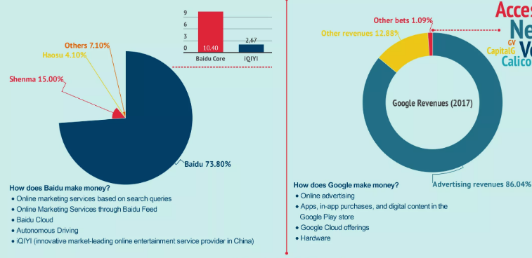
Fig.4 cited by: https://fourweekmba.com/baidu-vs-google/

Also, Baidu seem to offer performance on advertising by using a pay for placement and pay per click platform towards (Cuofano, 2019) which they have to pay for premium placement in order to increase the clicks for the fact that Baidu is the largest controlling market search engine in China and the advertisers have to pay to Baidu in order to have their advertisements displayed with a given keyword which is similar to Google. On the other side, Google uses the AdWords program in order to allow the companies to advertise and put certain keywords on cost per click base, but Google offers and Android operating system that is operating worldwide. Based on this, it is a fact now that Baidu seems to operate in a monopolistic web based search and as a result it has not seen a share price growth different from Google that continues to diversify its source of income and in this way gain a share price value. Recently, Google seem to have done an investment in a partnership agreement (CNNIC, 2005) with JD.com company by backing in this way the e-commerce distribution platform and gaining revenues and also a partnership with the Tencent company in o-investing in startups like Chinese Al startup XtalPi.

Based on the calculations done for both the companies, as shown in the table below, it is noticed that Google financial efforts are higher than Baidu even though it operates in “small” access towards Baidu in China. Also, the investment side done from Google Inc. in China is getting expanded by collaborating with other companies, offering in this way more room in order to be near to the Chinese market with its products even though is doing it not directly in order to “push away” the Chinese government oppression. Due to these investments, the target market is expanded and other investors are going to be interested in order to collaborate with Google Inc. and one reason why its revenues are increasing is because of this fact. Both the companies seem to have a lower fixed asset turnover during these three years which means that despite of the regions where those operate and also products, having a low fixed asset turnover, less effective is the company to utilize the investments in fixed assets in generating certain revenues.
 | Google Inc. | Baidu
Net income 2016-2017 -2018 | 26064-3020-8948 | 16,361-18,288-22,582
Current ratio20167-2017-2018 | 6,29-5,14-3,91 | 2,16-2,07-2,44
Return on capital employed 2016-2017-2018 | 72,287-152,502-177,628 | 61,234-130,372-175,752
Net profit margin 2016-2017-2018 | 21,58-11,42-22,46 | 16,49-21,58-26,96
Fixed asset turnover 2016-2017-2018 | 2,64-2,62-2,29 | 0,41-0,40-0,37
Interest cover 2016-2017-2018 | 254,16-264,97-275,37 | 8,68-9,72-8,25

However, the interest cover for the companies seems to be a turnover, because Google Inc. seems to have increasing interest cover, and the higher is it as a ratio, easier is for the company to pay debt expenses using its earnings. This is a safety margin for the creditors of the company because the investors and the shareholders as well, as it give guarantee for them that the company will be able to pay the bills and other interest expenses. While for Baidu this seem to be getting lower year by year by making it in this way not easily trustable for a certain investor to invest in that company.

Recommendations
Based on the analysis done in the previous pages, some of the suggestions for Google Inc. in order to go back in China and invest again might be: First of all, the fact of creating other alliances with other successful companies like Tencent, JD.com and other ones like Apple China in order to provide Google as a search engine in the mobile, so that the company will not have a kind of direct contact with the Chinese government but doing it step by step, so having less direct where the intention will be benchmarking and learning for mutual benefit and to develop new ideas. A possible alliance might also be with a supplier or distributor, co-operation with the customers’ orientation of Google Inc. through which they can generate revenue and market place by innovating, lower cost offering and leaving the partner to be focused on its main competitor, so gaining competitive advantage through learning.
Secondly, having as a principle the need for local customizing, meaning to offer language, communication and culture issue values and differences on target group tastes. This will help the company gain more target groups and of course other investors.
Thirdly, and also very important, the company should provide different ways in order to do an exploitation of the market, the experience it had before, the financial strengths, good products it offers and why not low their cost or have higher costs if the products is unique (not imitable) by widening the distribution system through professionals and being in this way a technological leader in that particular area.
Fourthly, based on the internal analysis of the company, the interest cover of the company seem to be increasing by offering in this was a credible company in the market so that the chances to have investors collaborating with the company are more increasing compare to the other company that is Baidu that the interest cover of which is getting low year by year.

Conclusion
In this report was given a wide analysis of the situation of Google Inc. in the Chinese market. It was mentioned the historical background of the company, the countries in which it operates and also some of the services it offers. Different from Google Inc., the other competitor that is Baidu offered the same services but in a main focus that was the Chinese group, achieved this through the Chinese, Mandarin language, a very efficient way to gain that target group and also by having the Chinese government as the main supporter.
The analysis on this report was done externally and internally by providing in this way a view of the external issues and factors that influence the company and also from the internal view, it was given a financial analysis of the companies performing in three years of time. There were also given suggestions based on the external and internal analysis of the companies, but the recommendations were mainly focused on the Google Inc. company, the ways how it can go back to China and gain a market share directly or indirectly through alliances with other companies. Moreover, the Google Inc. has recently created some alliances in the Chinese market by trying in this way to invest into the Chinese market and achieve in this way the target market that in 2010 was out. However, new perspectives should be taken into consideration by the company, new trends in order to gain that market share and compete or defeat why not its main competitor that is Baidu.

Reference’s list

Anon., 2007. Nag et al. Strategic Managment Journal, p. p 944.
Anon., n.d. https://www.statista.com/statistics/266206/googles-annual-global-revenue/. [Online].
Chernev, A., 2012. Strategic marketing management. 7th ed. s.l.:Cerebellum Press.
China, M. m., 2019. Baidu market share in China Feb 2019.
CNNIC, 2005. 16th Statistical Survey report on the internet development in China. s.l.:s.n.
Costill, A., 2014. 18Things you should know about Baidu. s.l.:s.n.
Cuofano, G., 2019. Baidu vs Google:The twins of search compared. s.l.:s.n.
John Thompson, J. M. S. F. M., 2014. Strategic management awareness&change. 7th ed. s.l.:Cengage learning EMEA.
Johnson, S., n.d. Exploring Corporate Strategy. 8th ed. s.l.:s.n.
Lasserre, P., 2012. Global strategic management. 3rd ed. s.l.:Palgrave Macmillan.
Lynch, R., 2015. Strategic management. 7th ed. s.l.:Pearson Education.
Lynch, R., 2015. Strategic Management PowerPoint on the Web. 7th ed. s.l.:s.n.
Mazur, L., 2018. Google Inc.-Company profile, information, business description, history, background information on Google Inc. s.l.:s.n.
Paul Dobson, K. S. R., 2004. Strategic management, issues&cases. 2nd ed. s.l.:Blackwell PublishingLtd.
Porter, M., 1980. Competitive strategy: techniques for analysing industries&competitors. s.l.:Free press.
Porter, M., 1985. Competitive advantage: creating and sustaining superior performance. s.l.:Free press.
Rieple, A. H., 2008. Strategic management, theory&application. s.l.:Oxford University Press.
William L Hosch, M. H., 2018. Google Inc. American company. s.l.:s.n.

