

Program: Master of Business Administration

Module Name and Code: Marketing Management (LCMB7024_LON)

Assessment 1: Individual report

Lecturer Name: Laila Maazouz

Student Name: Shrutik Jayeshbhai Sanghani
Student ID: 2532586
Word Count: 2480

Date of Submission: 27 March 2026

Table of Contents

TASK 1 2
1. Critical Analysis of Macro-Marketing Environment: Netflix and Disney+ 2
2. Industry Context 3
3. Macro Analysis 3
3.1. Macro Factor 1: Technological Change 3
3.2. Macro Factor 2: Economic Conditions 4
3.3. Macro Factor 3: Social and Cultural Trends. 5
4. Comparative Impact on Competitive Position 6
4.1. Netflix (Pioneering Organisation) 6
5. Conclusion 7
6. References 8
TASK 2 9
1. Strategic Context 10
2. Strategic Responses and Competitive Advantage 10
2.1. Porter’s Generic Strategies 10
2.2. Ansoff’s Growth Matrix 11
3. Key Strategic Differences and Their Impact 14
3.1. Focus on Monetisation vs Growth 14
3.2. Differentiation vs Hybrid Strategy. 14
4. Conclusion 15
5. References 16

TASK 1

1. Critical Analysis of Macro-Marketing Environment: Netflix and Disney+
The macro marketing environment is an important concept in strategic marketing because external factors shape opportunities and threats that shape competitive positions (Kotler and Keller, 2016). These external forces are highly analysed within the framework of PESTEL, which refers to the analysis of the Political, Economic, Sociocultural, Technological, Environmental, and Legal factors (Gupta, 2013). The current essay is a critical analysis of how Netflix and Disney+ have experienced opportunities and threats due to technological and economic forces in the macro environment and how they have affected the placement of the companies in the market.

2. Industry Context
The international subscription video on demand (SVoD) solution has migrated swiftly away out of conventional television on the on demand digital method. Netflix which started as a DVD rental company in 1997 evolved to be a universal streaming giant with a worldwide subscriber around 260 million by the year 2025 (Statista, 2025). In 2019, Disney Plus, a service, began with the launch of over 130 million subscribers up to the end of 2025 because of good intellectual property (IP) by Disney studios (Statista, 2025). The emergence of the streaming market indicates more macro trends on the phenomenon of digital consumption but puts the pressure on competitors even greater.

3. Macro Analysis

3.1. Macro Factor 1: Technological Change
The most important forces of SVoD strategy are the technological forces, which play an active role in delivering the content and the user experience. Data analytics innovation, artificial intelligence (AI), mobile networking and content distribution platform have transformed competitive dynamics.
Figure 1: Technological Change – Opportunities and Threats
Macro Factor | Netflix | Disney+
Opportunities | - Advanced AI-driven recommendation engine enhances engagement (Gomez-Uribe & Hunt, 2016)  - Ad-supported tiers enable additional revenue streams (McAlone, 2025)  - Mobile broadband expansion supports global accessibility | - Leverages strong IP (Marvel, Star Wars) to attract viewers on mobile devices  - Ad-supported subscription tiers increase reach (McAlone, 2025)  - Investment in app infrastructure enables smooth streaming experience
Threats | - Competitors (TikTok, YouTube, Amazon Prime) using short-form and personalized content (Smith, 2023)  - High cost of maintaining cutting-edge technology and digital infrastructure | - Lag in personalization algorithms compared to Netflix  - Continuous technology investment needed to keep up with competitors, increasing costs

3.2. Macro Factor 2: Economic Conditions
Economic dynamics such as inflation, the level of disposable income and price sensitivity are also having significant effects on subscription based streaming platforms such as Netflix and Disney+.
Figure 2: Economic Conditions – Opportunities and Threats

Opportunities from Technological Change
Macro Factor | Netflix | Disney+
Opportunities | - Tiered pricing plans (ad-supported, standard, premium) capture price-sensitive consumers (Johnson, 2025)  - Expansion in emerging markets with growing middle-class populations (Statista, 2024) | - Tiered pricing and bundled offerings (Disney+ + Hulu or ESPN+) attract new customers (Johnson, 2025)  - Growing presence in emerging economies with affordable mobile internet
Threats | - Subscription fatigue due to multiple competing streaming services (Lee, 2024)  - Inflation and currency fluctuations increase operational costs | - Subscription fatigue and consumer price sensitivity may limit growth (Lee, 2024)  - Rising content production and licensing costs reduce profit margins

3.3. Macro Factor 3: Social and Cultural Trends.
The consumer behavior and platform strategies in the SVoD business are influenced considerably by factors related to social and cultural factors. The shift in lifestyles, growing use of digital media and evolving tastes on content determine the way these platforms, such as Netflix and Disney+, shape their content and interaction. Also, the emergence of mobile-first audiences, the appeal of short-form and content that has to be localized or culturally relevant is influencing the competitive industry. Knowledge of these trends enables platforms to optimize materials, pricing, and advertising approaches to fit the anticipations of the subscribers and draw more attention (Smith, 2023; Statista, 2024).

Macro Factor | Netflix | Disney+
Opportunities | - High demand for diverse and original content supports original programming expansion (Gomez-Uribe & Hunt, 2016)  - Global audience adoption of mobile streaming increases reach in emerging markets (Statista, 2024)  - Growing preference for binge-watching drives engagement | - Strong family-friendly content aligns with parental preferences  - Popular franchises (Disney, Pixar, Marvel) attract multi-generational subscribers  - Expansion in local-language content enhances regional market penetration
Threats | - Cultural sensitivity issues can lead to backlash or reduced engagement (Lee, 2024)  - Rising popularity of free social media video platforms reduces willingness to pay | - Risk of content saturation leading to subscriber fatigue  - Regional content preferences may require significant localization investment to remain competitive

4. Comparative Impact on Competitive Position
Figure 3: Global Subscribers Growth (Netflix vs Disney+)

4.1. Netflix (Pioneering Organisation)
Netflix being the first SVoD service has played the role of being the technology leader and its early pioneer in the international market to create a great competitive edge. It has led to the ability to cut across a wide variety of audiences and maintain a base of loyal subscribers by its proprietary recommendation algorithms, high degrees of personalization, and large content library in different locations (Gomez-Uribe & Hunt, 2016). Moreover, the vast geographical distribution of Netflix that has been achieved with the investments in mobile streaming and cloud infrastructure has allowed the company to reach the new markets, consolidating its grip on the market. Nevertheless, the new digital content forms and competitors, such as Tik Tok and YouTube Shorts and Amazon Prime Video, pose an increasing threat to these due to offering short-based or personalized content and becoming popular among the younger audiences (Smith, 2023). Economic risks are also a major threat: subscription fatigue, inflation, and currency changes may decrease the disposable income or deter consumers to have multiple subscriptions at the same time (Lee, 2024). As a result, Netflix can continue to be successful through its ability to manage the adoption of technology, cost-efficiency, and strategic pricing structure adjustment. Artificial intelligence, ad-based levels, and content consultation are investments that are necessary to stay differentiated in a highly competitive and dynamic market.
4.2. Disney+ (Follower Organisational)
Being a new entrant in the SVoD market, Disney+ enjoys the advantage of having a strong intellectual property portfolio, such as Marvel, Star Wars, and Pixar franchises. These resources provide Disney+ with the opportunity to appeal to a multi-generational audience and implement cross-platform bundling business, i.e. integrating Disney+ with Hulu or ESPN+ in certain markets (Johnson, 2025). Packaged services and branded content develop value by creating better relationship and loyalty to subscribers. However, as a competitor, Disney+ is experiencing technological limitations, among which are the necessity to modernise their recommendation engines, ad-delivery platforms as well as performance of streaming to rival Netflix in its own sense of personalisation (McAlone, 2025). Economic issues also require that the elastic pricing strategies are taken, as the platform would have to remain competitive on both developed and emerging markets where disposable income and price sensitivity is different. Though Disney+ possesses a significant lead in content, it needs to constantly invest in technology, pricing innovation, and user experience to move within the reach of the technological innovator, Netflix platform so that the company could grow sustainably and remain relevant in the market.

5. Conclusion
This analysis has shown that the technological change and economic conditions have been a source of opportunity and threat to Netflix and Disney+ using the PESTEL framework. Technology maximizes personalisation and content delivery and monetization models but maximises competition and cost. There are forces in the economy that influence pricing innovation and market growth but introduce pressures of subscription fatigue and inflation. The technological dominance held by Netflix helps the company to sustain its place in the market, and the ability of Disney + to make use of branded and pricing strategies, as marketing tactics, reinforce the position of the company in the market. The two have to work around these macro forces strategically in order to maintain growth and profitability.

6. References
Gomez‑Uribe, C. A., & Hunt, N. (2016). The Netflix Recommender System: Algorithms, Business Value, and Innovation. ACM Transactions on Management Information Systems, 6(4). https://doi.org/10.1145/2843948
Gupta, S. (2013). Environmental and PEST Analysis: An Approach to External Business Environment. International Journal of Modern Social Sciences, 2(1), 34–43.
Johnson, M. (2025). Streaming Platform Pricing Strategies in a Cost‑Sensitive Economy. Journal of Media Economics, 38(2), 115–130. https://doi.org/10.1080/08997764.2024.987654
Kotler, P., & Keller, K. L. (2016). Marketing Management (15th ed.). Pearson.
Lee, A. (2024). Subscription Fatigue in Digital Media: Consumer Behavior Trends. Journal of Consumer Behaviour, 23(4), 401–415. https://doi.org/10.1002/cb.2098
McAlone, N. (2025). How Netflix’s Ad Tier Is Changing the Streaming Wars. Business Insider.
Smith, J. (2023). Competition from Short‑Form Video Platforms. Telematics and Informatics, 78, 101981. https://doi.org/10.1016/j.tele.2023.101981
Statista (2024). Mobile Broadband Penetration Worldwide.
Statista (2025). Number of SVoD Subscribers Worldwide (Netflix & Disney+).

TASK 2

1. Strategic Context
Market expansion has shifted the video streaming industry to promoting sustainable growth, active customer interaction, and profitability because of the saturation of the market in developed markets and the growing rivalry with existing video streaming companies as well as new short-form content influencers like Tik Tok and YouTube (Business Insider, 2025). Such companies as Netflix and Disney+ need to be responsive to changes in technologies, such as AI-driven personalization, mobile stream infrastructures, and ad-based models, and economic pressures such as subscription fatigue, inflation, and sensitivity to prices (Zielnicki et al., 2025). In this respect, the systematic analysis and application of strategies to generate a competitive advantage, resource distribution, and guarantee the long-term development of the business despite the complexity of the macro environmental factors can be facilitated using generic strategies developed by Porter and the Growth Matrix by Ansoff (Kotler and Keller, 2016). Netflix has been focusing on technological innovation and penetrating the global market, whereas Disney+, being a follower, will apply its brand recognition and IP rights to rapidly build its subscriber base and introduce strategic bundling of its products. Such a strategic context preconditions the assessment of specific responses of each company to opportunities and threats of the external environment, underlining the relations between the macro-environmental pressure and the strategic choices of firms.

2. Strategic Responses and Competitive Advantage

2.1. Porter’s Generic Strategies
Figure 4: Porter’s Generic Strategies
Porter’s Generic Strategy | Netflix | Disney+
Cost Leadership | - Uses scale to offer competitive subscription pricing worldwide  - Introduced ad-supported tiers to attract price-sensitive consumers (McAlone, 2025) | - Limited use; Disney+ focuses on premium pricing rather than cost competition, though lower introductory prices helped initial adoption (Panmore, 2024)
Differentiation | - Heavy investment in original, exclusive content (e.g., Stranger Things, Squid Game)  AI-driven personalized recommendation system enhances user experience (Zielnicki et al., 2025) | - Leverages iconic IP (Marvel, Star Wars, Pixar) for exclusive content  - Bundled offerings with Hulu and ESPN+ enhance perceived value (Forbes, 2025)
Focus / Niche Strategy | - Minimal; Netflix aims for global reach rather than niche markets  - Some region-specific content to penetrate local markets | - Strong focus on family-friendly content and fans of Disney-owned IP  - Targets specific segments through bundles and themed content

2.2. Ansoff’s Growth Matrix
Figure 5: Ansoff’s Growth Matrix for Netflix
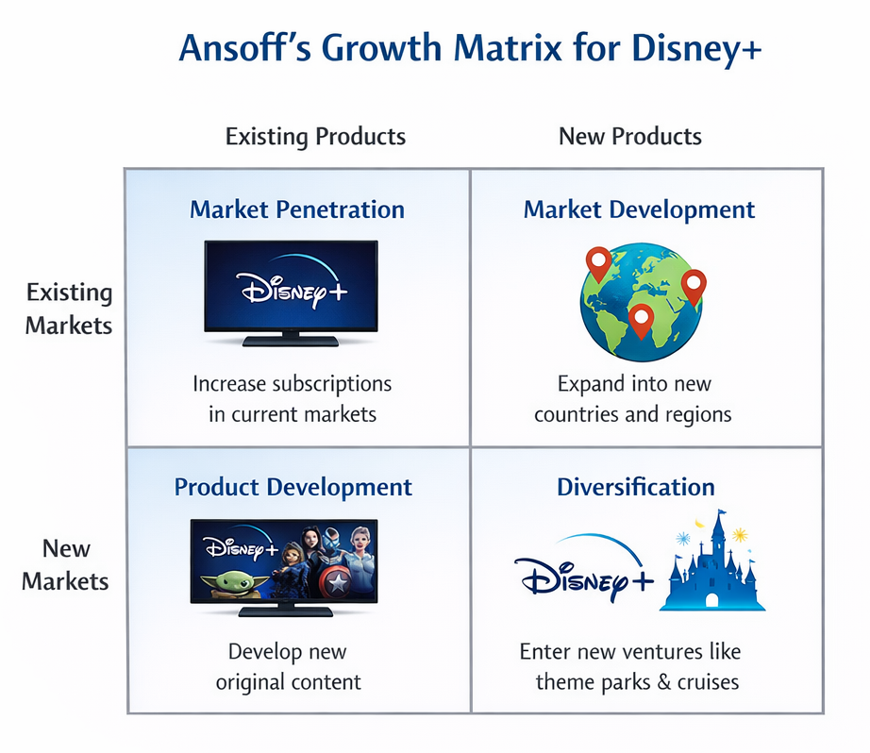
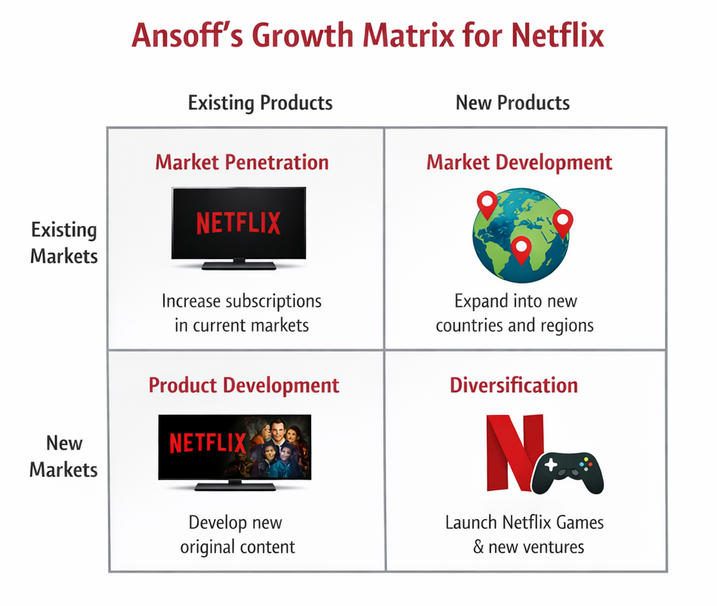
Figure 6: Ansoff’s Growth Matrix for Disney+
Ansoff Growth Matrix is a strategy framework that assists companies in determining the areas of growth by studying the connection that exists between the newly developed products and existing products and using the same approach to explore the connections that exist between the new markets and existing markets (Ansoff, 1957). It breaks down growth plans into four quadrants namely: Market Penetration, Product Development, Market Development and Diversification. Both Netflix and Disney+ use this structure to manoeuvre around a competitive and quickly changing video streaming market.
Applying to Netflix, the Market Penetration strategy entails more active interaction between current subscribers using the powers of its AI-based system of content recommendations, which is used to customize content, cut the churn (Zielnicki et al., 2025). Mature market users who are price-sensitive are also drawn to the introduction of ad-supported subscription levels (McAlone, 2025). Still in the Market Development, Netflix is going global, specifically in the emerging markets of India, Latin America, and Southeast Asia, with local content and streamlined mobile content (Statista, 2024). The Product Development quadrant is associated with development of new products, including interactive content and mobile games, and ad-tier monetization, which improve the value of existing users (Panmore, 2024). Lastly, Diversification is an indication of the activities that Netflix has outside streaming its videos such as mobile games and live streaming sports in selected areas which are new products in new markets (Business Insider, 2025).
Disney+ takes the same strategy but with a different focus on the brand and IP portfolio. Its Market Penetration aims at growing the number of subscribers in current markets with the high quality of Disney, Marvel and Star Wars content. Product Development entails new original series, live sports and original IP releases. As Market Development, Disney+ enters new foreign markets, focusing on the areas, where the family-friendly streaming is on the rise. Diversification Incorporating content with theme parks and cruise experiences with services of Hulu and ESPN+, this allows leveraging weaker entertainment ecosystems we have created (Forbes, 2025).
In order, the Ansoff Matrix demonstrates the involvement of the two platforms to develop in a purposeful way: Netflix focuses on technological solutions and specialization, whereas Disney+ focuses on differentiating brands and providing diverse services as the strategy to maintain market growth and competitiveness.

3. Key Strategic Differences and Their Impact

3.1. Focus on Monetisation vs Growth
Netflix has changed its strategic emphasis to the monetisation rather than just growing its number of subscribers. The advent of ad-supported levels, price selectiveness and variety in content delivery can be seen as a wider industry issue where expansion is no more than an infinite goal (Business Insider, 2025). Netflix has been pursuing monetisation to derive more revenue per user and cover up the increased production cost of the content and infrastructure expenses. Such a course of action enables the company to be financially sustainable and responds to the shifting consumer trends, such as subscription fatigue and increased price sensitivity in major markets. Conversely, Disney+ has remained focused on subscriber growth at the expense of the profitability in the short term. Bundling products, including Disney+ with Hulu or ESPN+, and paid sharing programs introduced in 2025, have both interimently decreased the profitability and allowed Disney Plus to increase its subscriber tips in the shortest possible time. Under the shift of the strategic priorities toward customer acquisition as opposed to instant monetisation, unlike Netflix, which is struggling with stagnant subscriber growth in developed markets, Disney + aims at developing the market and positioning its brands.

3.2. Differentiation vs Hybrid Strategy.
Netflix and Disney+ are pursuing the differentiation as a strong competitive advantage strategy, yet the former one integrates the cost leadership strategy that provides it the opportunity to explore various markets, engage in product development, and diversify. This hybrid model helps it expand globally and enables Netflix to change the prices or the services features depending on the economic conditions in the region. Disney + on the other hand highly depends on premium brand value and bundle experiences in keeping its customers. It focuses on high-quality and franchise-based content and curated packages reinforce a high-end positioning but the lack of flexibility in the price-sensitive markets. Its difference also affects how the companies use Ansoff growth paths since the hybrid business model of Netflix allows it to enter the market, innovate the products, and diversify to make its growth paths more focused, which is why the Disney+ uses bundling and premium content to improve the perceived value and client loyalty which will bring its growth focus.

4. Conclusion
Netflix and Disney+ have reacted strategically to their macro environment, with Netflix using cost driven reach and diversified growth through Ansoff pathways whilst Disney+ using mainly differentiation and expansive product offerings based on its IP strengths. The Porters and Ansoff framework indicate that Netflix multi pronged strategies contribute to the maintenance of competitive advantage, that is, through global presence and innovation, when Disney+ develops its competitive strategies on the foundation of strategic content differentiation and bundling to overcome the competitive pressure and sustain growth.

5. References
Ansoff, H. I. (1957). Strategies for diversification. Harvard Business Review. https://hbr.org/1957/09/strategies-for-diversification
Business Insider. (2025). Netflix’s new growth phase: Navigating ad-tier expansion and profitability. https://www.businessinsider.com/netflix-earnings-preview-wall-street-password-sharing-ad-tier-2025-7
Forbes. (2025). Disney’s bundling strategy drives streaming growth. https://www.forbes.com/sites/greatspeculations/2025/11/18/disneys-200-billion-plot-twist-streaming-the-real-magic/
McAlone, N. (2025). How Netflix’s ad-supported tier is changing the streaming wars. Business Insider. https://www.businessinsider.com/netflix-ad-supported-tier-growth-2025-3
Panmore, A. (2024). Netflix competitive strategy & growth strategies. Panmore Institute. https://panmore.com/netflix-competitive-strategy-growth-strategies-case-study
Panmore, A. (2024). Disney’s generic competitive strategy & growth strategies. Panmore Institute. https://panmore.com/disney-generic-competitive-strategy-intensive-growth-strategies
Zielnicki, K., et al. (2025). The value of personalized recommendations: Evidence from Netflix. arXiv. https://arxiv.org/abs/2511.07280
Kotler, P., & Keller, K. L. (2016). Marketing Management (15th ed.). Pearson.

