Museum, Heritage and Representation (HPHE5008)
How important is the concept of authenticity in the presentation of heritage?
By Anthony McDonald 1701752
5) Based on your visit to St Fagans National Museum of history, consider how the museum promotes public understanding of the archaeological record

St Fagans
After visiting St Fagans I wouldn’t know how to refer to the establishment, it is a combination between a museum and an interactive history lesson. The ‘Museum’ is a unique experience and a great dive into the culture of Wales. St Fagans definitely tries to appreciate its origins and remain ‘authentic’ whilst still trying to exhibit a vast collection. After visiting St Fagans and able to roam around both the interior and exterior I have nothing but fondness for the establishment and thing the organization of the facility exemplifies and makes the most of the unique layout they have decided to pursue. The
The objective of St Fagans was to present the evolution of Wales through different mediums, such as; Architecture, Photos, film, art and even members of staff with stories to tell (McAleavey. 2013)
Plan
- Main Building
- Exterior
- St Fagans Castle
Main Building
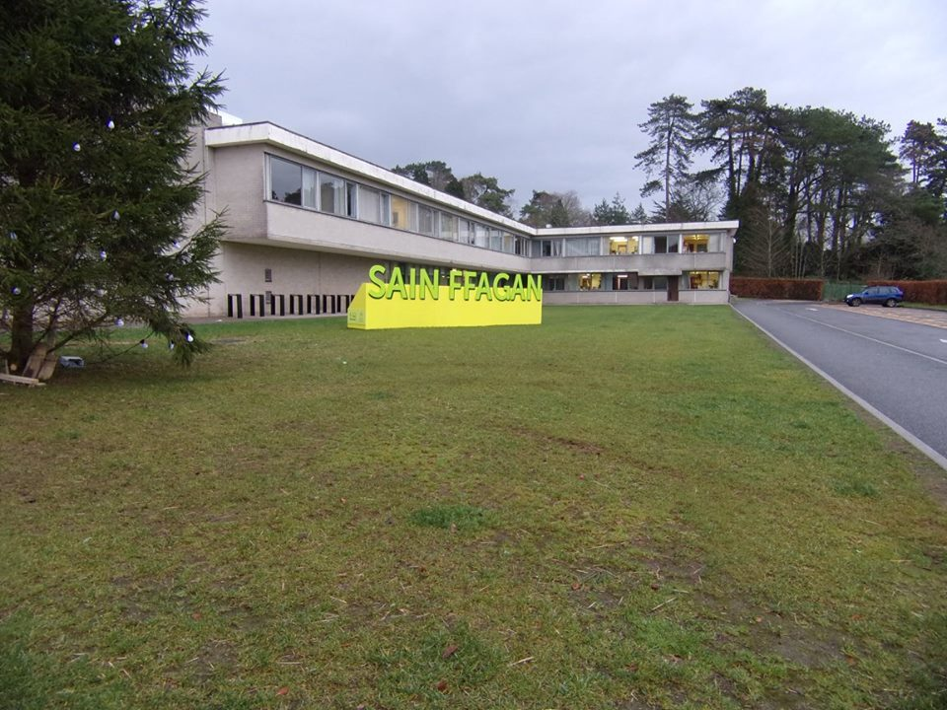
When coming up to the entrance of St Fagans it presents itself as a modern-sleek but somewhat small building to house a museum in. There isn’t much that stands out in terms of representation of what the Museum exhibits and what the intentions of the collection are.
This is a weakness of the establishment, once inside and experiencing the fun and somewhat unique collection they have, it is not fairly shown on the outside with a somewhat generic appeal.

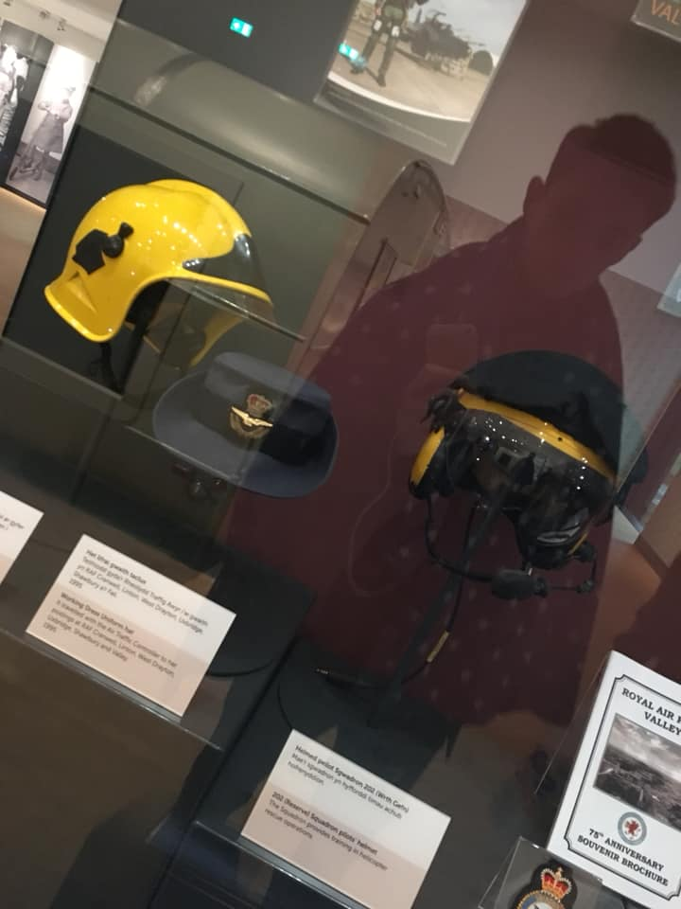
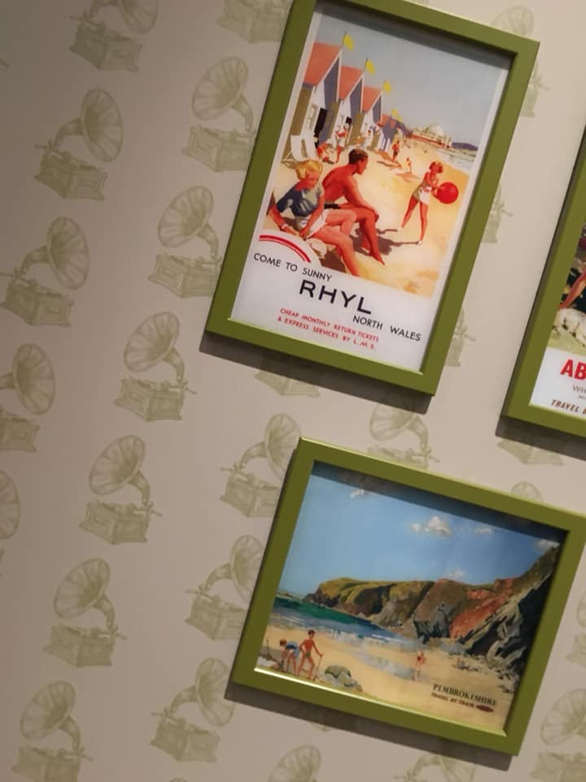
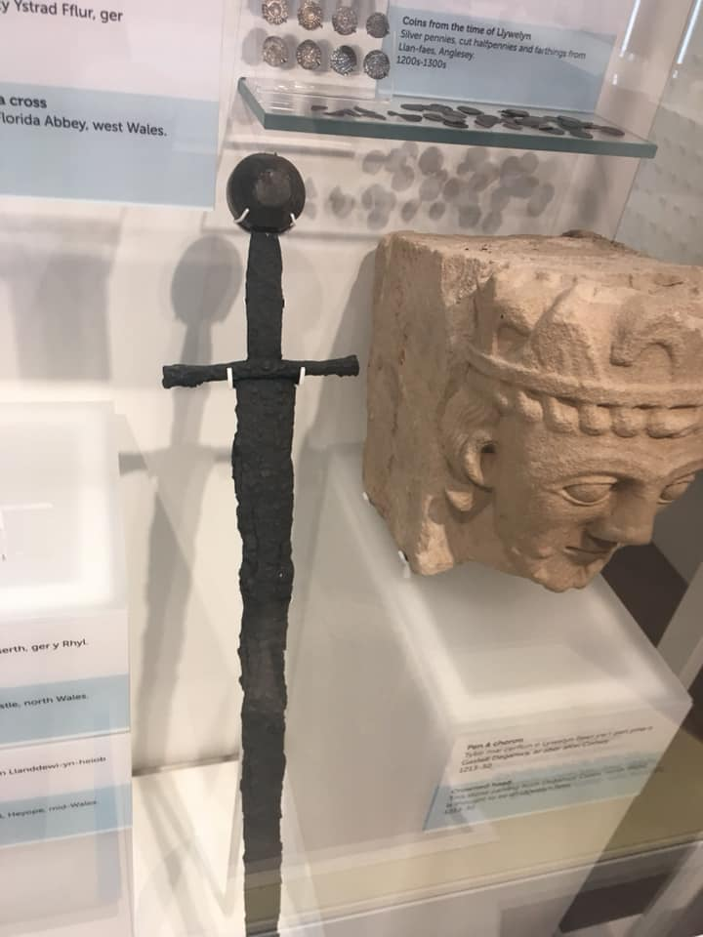
The interior of the building consists of cultural evolution throughout Wales’ history from archaeological remains to tourist posters for holiday locations such as Rhyl. With different themes being represented in different rooms from Welsh history to Welsh Culture, the two do intertwine with one another which would explain why they are kept within proximity to one another inside the main building allowing for the most enjoyable and least jarring experience. This setup inside however feels quite uninspired compared to the main exhibits outside, the rationale is clearly to show pride in Welsh heritage however means the collection they have to show-off only appeals to a more niche market. This is not to be considered a ‘weakness’ as it is an extremely specialist location and should represent the cultural heritage of the surrounding area, the issue however is more the fact of questioning the people it will attract, which ultimately is the sustaining factor of these establishments.
The interior however is not the main draw of St Fagans and is instead a nice addition that allows for a bigger collection covering a large timescale of the evolution of Wales over time, containing objects you perhaps wouldn’t see in other museums like old uniformed service outfits (I.e The Fireman’s Helmet above).
Exterior
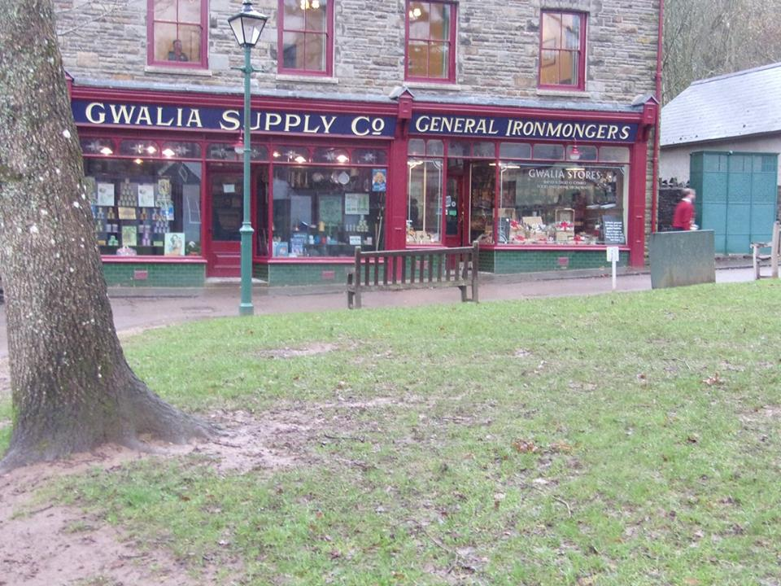
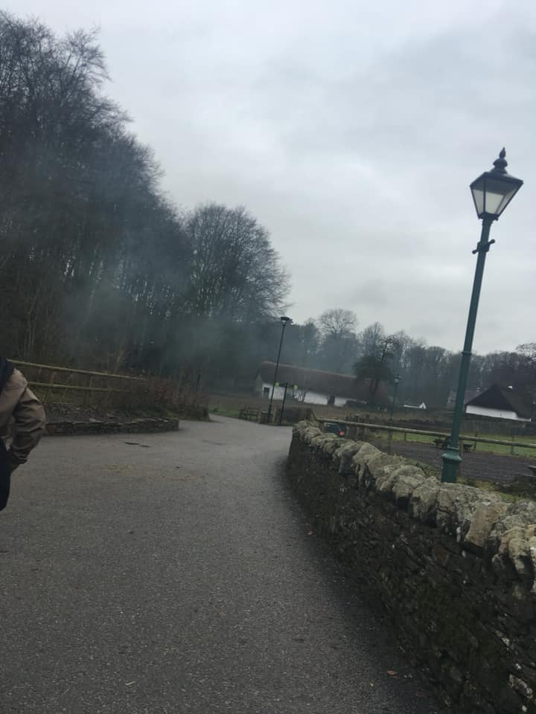
Walking outside from the main hall you are welcomed into an almost village like setting. Following the initial path you are greeted by thatch roof houses all of old design, surrounded by forestry and stone walls, it feels like a different location to the modern administration building you were just in.
The immersion of being in the past is impressive and it is due to the dedication and efforts into making everything feel authentic as possible. The ‘general store’ is a model of a shop from the 1800’s and visitors are able to purchase a different variety of local goods.
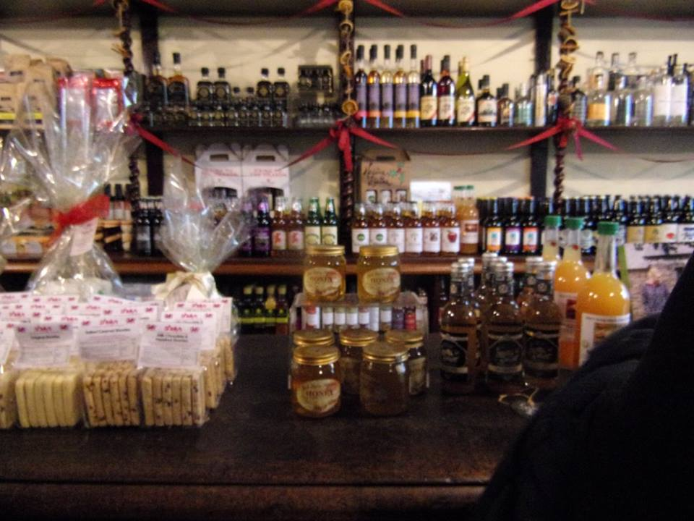
Even the pathway stays true to the St Fagans cause by presenting its buildings and layout in an almost evolutionary way with the earlier styled buildings the first ones you come across seamlessly transitioning to later times and building types, such as more modern houses in comparison to a farmhouse.
The ability to walk through this almost giant time capsule is something worth experiencing due to the sense of scale St Fagans creates and is surely a strength in regards to representing Welsh culture through time and how things evolved.
The extracted buildings located at St Fagans and re-erected consist of farmhouses from the 15th-18th century from surrounding Welsh villages as well as a woolen mill from the 18th century, the buildings being almost picked up and moved somewhere else helps with the feeling of authenticity especially whilst surrounded by other authentic buildings. (Peate. 1965)
The strength of the collection remains from the fact that these buildings aren’t preserved isolated in evolving towns and cities, by recreating a small village creates a bigger sense of walking through history and truly experiencing the past.

When walking through St Fagans it is clear that the collection there represents an amalgamation of all Wales thanks to its location and the contributors to the museum, from employees to stakeholders (McAleavey.2009)
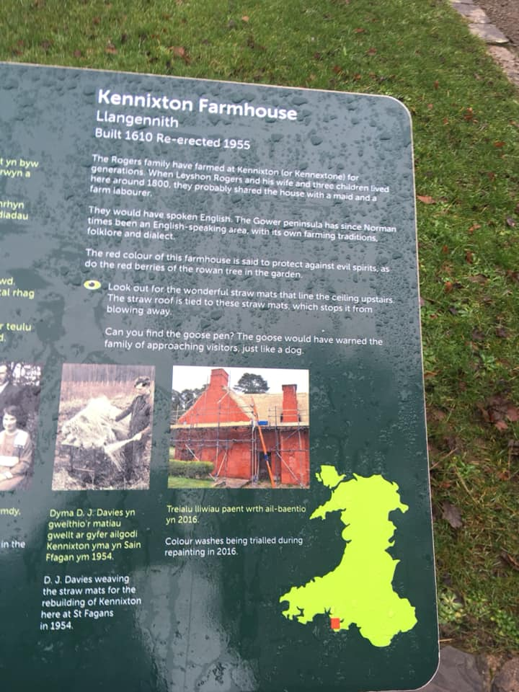
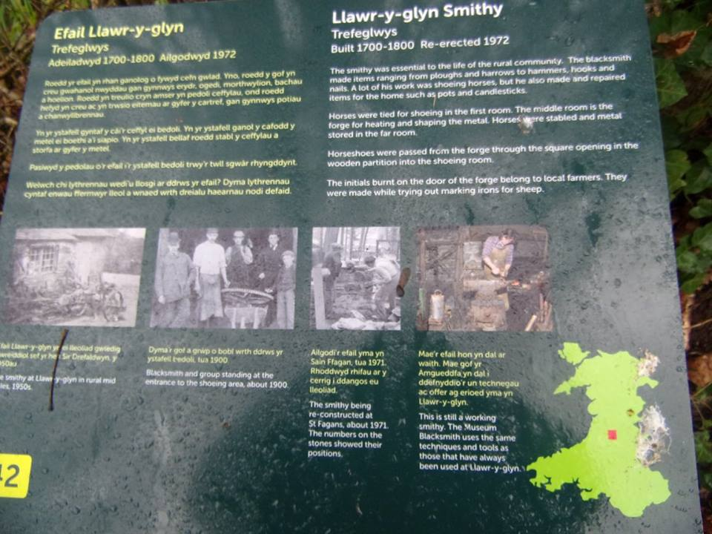
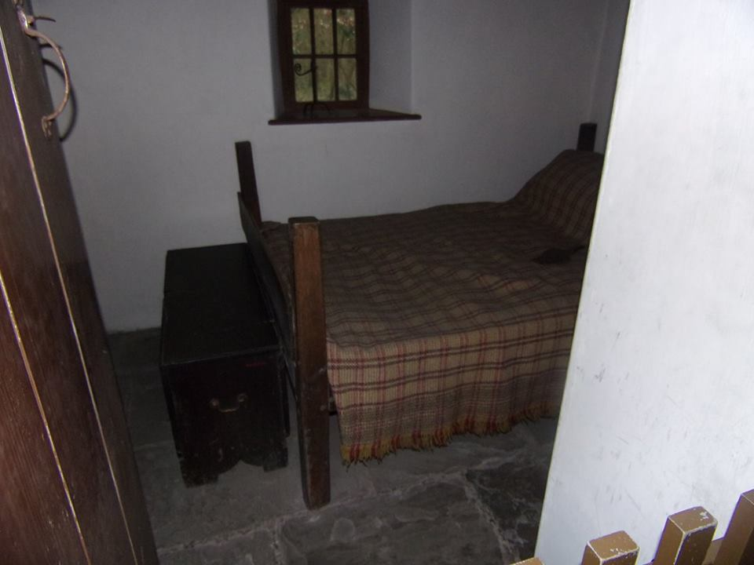
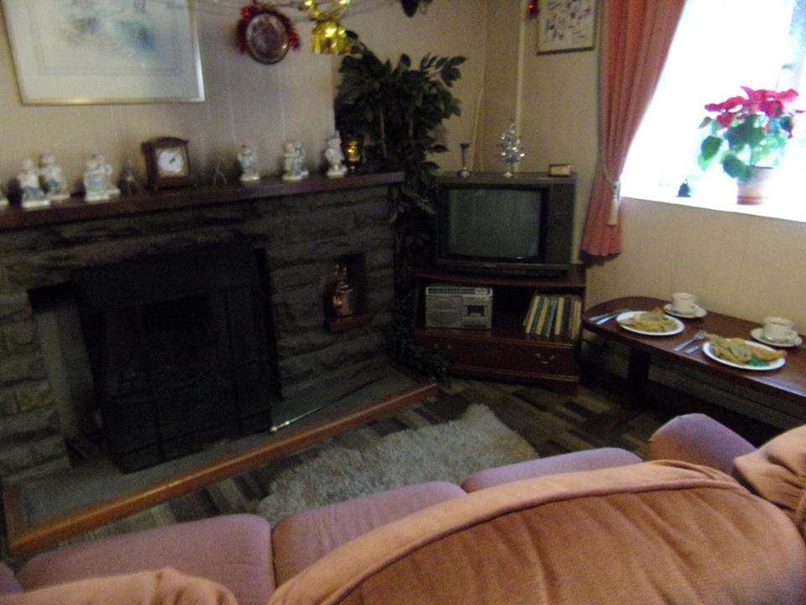

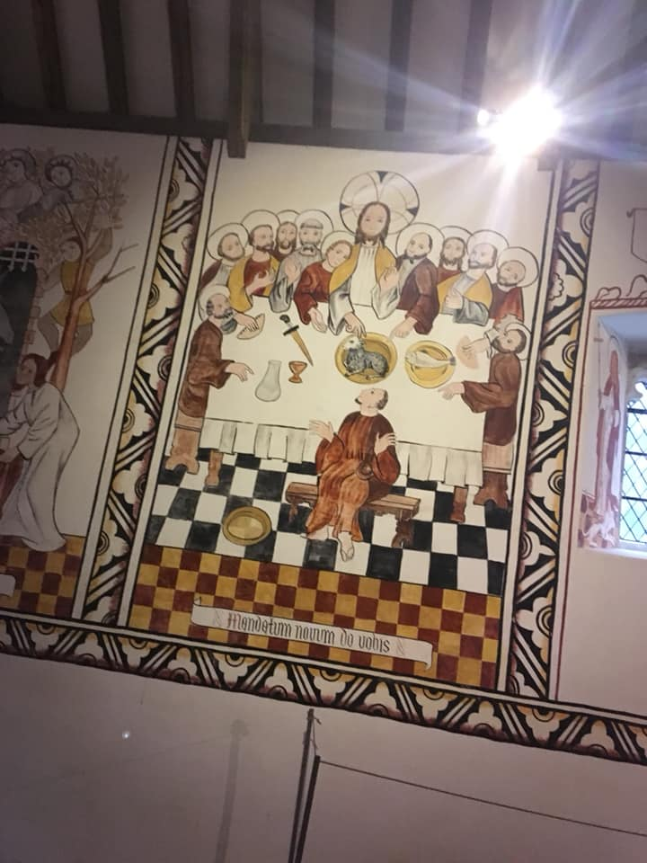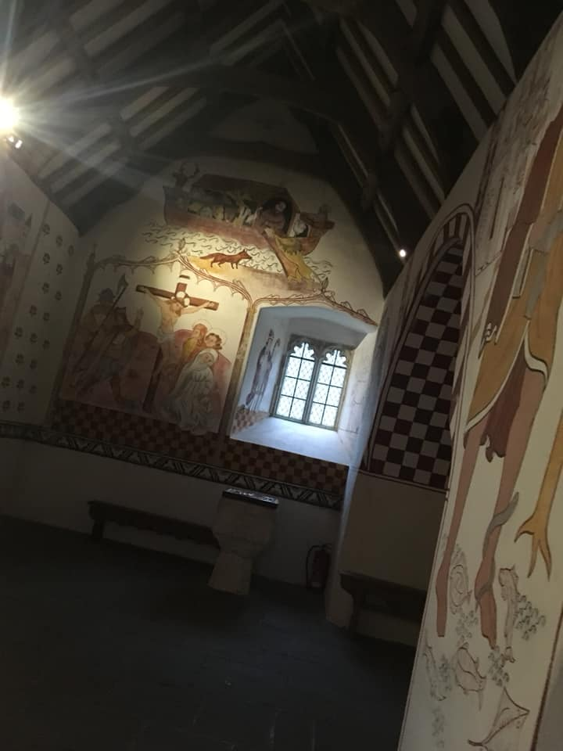St Fagans Castle
Looking over the grounds of the exhibitions is St Fagans castle, which is in fact a mansion built over the remains of a small castle (Peate.1965). The mansion and gardens are maintained and able to be walked amongst by visitors, the mansion is upheld and the lower floors are recreated to portray early 18th century scenarios and settings such as laying out the kitchen and hanging paintings of servants that worked in the house. Although the mansion is overlooking the museum, it itself is one of the most grand exhibits at St Fagans as its separation from the other buildings helps separate the class levels of the buildings erected in the village scenario compared to the mansion.
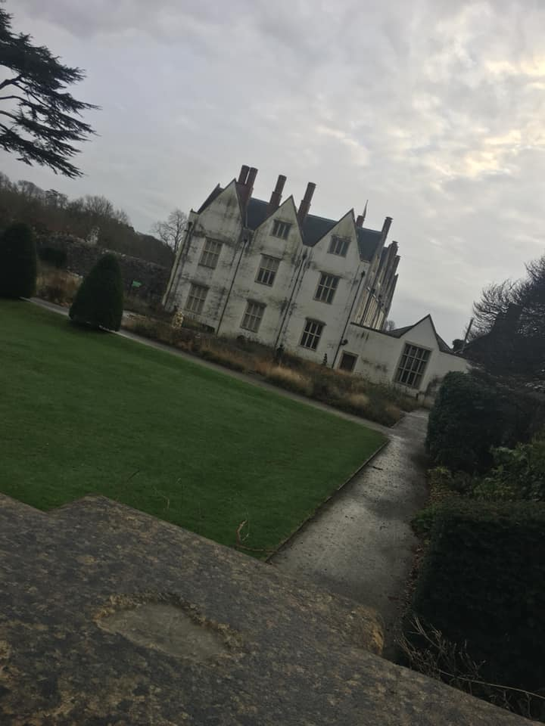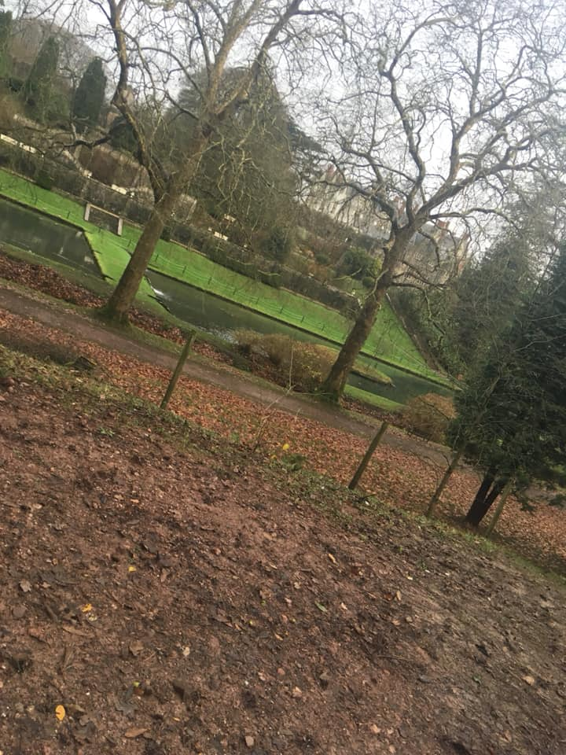

St Fagans was an experience I will not forget and one I have highly recommended to many different people I know varying of ages. The presentation of the main building allows visitors to understand the goal the Museum is trying to achieve and journey it wants to take people on through Welsh history, the scope of objects is wide enough to garner interest from almost anyone and then the walkthrough village with elderly workers relating personal stories to the buildings they are stood in is a nice added touch. Unfortunately those people cannot work there forever but their legacy and stories can be maintained by others, overall the sense of leaving St Fagans is like returning to another age and it achieves exactly what it sets out to do.

Bibliography
McAleavey, M. (2009). Renewal or Betrayal? An Experiment in Reflecting Welsh Identity at St Fagans: National History Museum. Folk Life, 47(1), pp.58-65.
National Museum Wales. (2019). Learning at St Fagans National Museum of History. [online] Available at: https://museum.wales/stfagans/learning/ [Accessed 18 Jul. 2019].
Peate, I. (1965). The Welsh Folk Museum. Journal of the Folklore Institute, 2(3), p.314.

