Impasto

And the effect of technology on this method
Of painting

by Nada Najar

Nada Najar

Student number: 152393

Module Independent project

Tutor: Alex Duncan

Fine Art

Word count: 4933

Submitted in partial fulfilment for the requirement of the degree BA(Honour) university of Wales trinity saint David (10 December 2022)

Contents:

1-List of illustrations: page 4
2-Summary: page 8
3-Introduction: page 9
4-Chapter 1: Impasto:
-its meaning for the artist and the viewer: page 13
-Its development to becoming prominent recently: page 16
5- Chapter 2: the effect of technology on Impasto painting:
- the effect of camera: page 29
-the effect of 3D printing: page 33
6- conclusion: page 42
7- Bibliography: page 44

Auerbach, F. (1960) Head of E.O.W [ oil on wood] Available at: https://www.tate.org.uk/art/artworks/auerbach-head-of-e-o-w-i-t06682
(Accessed 14/12/2022).

Baraniuk, C (2016), (The Next Rembrandt), BBC, Available At: https://www.bbc.co.uk/news/technology-35977315
(Accessed 14/12/2022).

BBC, (2016), Computer paints 'new Rembrandt' after old works analysis. Available at:
https://www.bbc.co.uk/news/technology-35977315
(Accessed14/12/2022)

Cherevan, L., (2014), Video shooting of printed replica by Prixel [video]. Available at: https://www.youtube.com/watch?v=U8k6tsUROyg
(Accessed 14/12/2022)

Degas, E., (1871), Dancing Class, Available At:
https://www.edgar-degas.net/dancing-class.jsp#prettyPhoto
(Accessed 28.11.2022).

Degas, E., (1875), Place De La Concord, Available At:
https://www.everypicture.org/degas-place-de-la-concorde
(Accessed at 28.11.2022)

Dos-Santos et al., (20016), 3D Printed Models applied in medical studies, Available at:
https://www.intechopen.com/chapters/51434
(Accessed 14/12/2022)

Dos-Santos, J., L., (2009), The Fetus Project, Dezeen, Available at:
https://www.dezeen.com/2009/07/16/the-fetus-project-by-jorge-lopes-dos-santos/
(Accessed at 14/12/2022)

Freud, L., (1981), Reflections(self-portrait), Available at:
Lucian Freud reflection self portrait 1981 - Bing images
(Accessed 14/12/2022)

Getty images (2015), (Where's the bulletproof glass? Art-lovers can finally touch the Mona Lisa - a replica at least - at the Prado Museum in the Spanish capital). Available at: https://www.dailymail.co.uk/news/article-2948306/I-feel-art-Gallery-unveils-specially-created-versionsclassic-paintings-blind-people-touching-them.html
(Accessed 14/12/2014).

Hayward, J. (2001) Abstract 31 (oil on canvas on board). Available at:
http://www.abstract-art.com/abstraction/l3_more_artists/ma07x_Hayward_no31.htm
(Accessed 26/11/2022)

Jamie, D. (2017), 2.5 Reproduction of Famous paintings, 3D Natives, Available at: https://www.3dnatives.com/en/top-10-3d-printing-art-141020174/#!
(Accessed14/12/2022).

Kossoff, L. (1962) Portrait of Phillip No.2[Oil on board] Available at: https://www.christies.com/en/lot/lot-1646433
(Accessed 14/12/2014 ).

Monet, C. (1874) Boulevard des Capucines [oil on canvas] Available https://www.wikiart.org/en/claude-monet/boulevard-of-capucines-1874
(Accessed 28/11/2022 ).

Pollock, J. (1950) Number 1 Lavender Mist [ synthetic paint on canvas] Available at:
Jackson Pollock - 'Number 1, 1950 Lavender Mist' Framed Print & Mount, 79 x 99cm, Multi (johnlewis.com)
(Accessed 14/12/2022).

Rembrandt, H, V, R. (1658) self-portrait [Oil on canvas] Available at: https://www.wga.hu/html_m/r/rembrand/27self/
(Accessed14/12/2022).
Renoir, P, A (1869) La Grenouillere [Oil on Canvas] Available at: https://artsandculture.google.com/asset/la-grenouill%C3%A8re-auguste-renoir/HgHrOyFUfcFtLw?hl=en
(Accessed 14/12/2022 )

Rodrigez, I., H., (2015), A blind visitor to Spain's Prado Museum runs his fingers across a 3-D copy of the Mona Lisa, painted by an apprentice to Leonardo da Vinci.Prado Museum, Available at:
Do Touch The Artwork At Prado's Exhibit For The Blind : Parallels : NPRDo Touch The Artwork At Prado's Exhibit For The Blind : Parallels : NPR
(Accessed14/12/2022).

Saville, J. (1992), Propped [ oil on canvas] Available at: https://gagosian.com/artists/jenny-saville/
(Accessed 14 April 2021).

Titian, T., V. (1576) Flaying of Marsyas [Oil on Canvas] Available at: https://www.artble.com/artists/titian/paintings/the_flaying_of_marsyas
(Accessed 14/12/2022).

Titian, T., V. (1510) Man with a Quilted Sleeve [Oil on canvas] Available at: https://colourlex.com/project/titian-portrait-man-quilted-sleeve/
(Accessed 14/12/2022 ).

Turner, J. M.W. (1842) Peace Burial at sea [oil on canvas] Available at: https://www.tate.org.uk/art/artworks/turner-peace-burial-at-sea-n00528
(Accessed 14/12/2022 ).

Van Gogh Museum (n.d) High End Reproduction, Available at:
High End Reproductions - Van Gogh Museum
(Accessed14/12/2022).

Van Gogh, V., (1889) Starry Night [Oil on Canvas] Available at: https://www.vangoghgallery.com/painting/starry-night.html
(Accessed 14/12/2022 ).

(Versus art replica of Van Gogh’s Zinnias, n.d), Available at:
Verus Art Creates Fully Textured 3D Printed Reproductions of Famous Paintings - 3DPrint.com | The Voice of 3D Printing / Additive Manufacturing
(Accessed 14/12/2022).

Summery:
Impasto painting method is not just a technique, but it has unique effects on the artist and the viewer. It has evolved through the history of painting to become prominent in modern times. All tools and mediums involved in producing a piece of art are not separable from the resulting work. These have considerable influence on setting the limitations and the possibilities of creating it at any point of the creation. Thus, advancements in technology had significant effects on painting methods. Artists used the Impasto painting technique in the past. This method became prominent in contemporary paintings because the materials available for modern painters have improved and because of technological advancement, which has a remarkable effect on this method.

Introduction:
The inspiration for this dissertation came from my experience as a radiologist doctor. I used to regularly observe medical images as a way of investigating the human body. Technical advancement in radiology created novel methods of investigation and produced new medical imaging. In the past, there were images of simple x-ray techniques, and afterward, Ultrasound images were invented, followed by computerized tomography (CT scan) and magnetic resonance (MRI). These techniques provide images by visualizing the contrast between the different soft tissues in the body (Roebuck, 2011, p182). Therefore, I gained a lived experience of how technological advancements produce new images for investigations in the field of medicine. In addition, I developed the imagination necessary to transfer these flat medical images into 3Dimentional to match the human body, and a longing for a technology that
can produce 3-dimensional methods of medical investigation rather than flat images. Surprisingly, recently the artist Jorge Lopes dos santos succeeded in blurring the boundaries between art and science. He developed a method for modelling the human body using the Ultrasound technique and 3Dimentional printing with his Foetus 3D project that opened the door for outstanding medical applications. The artist succeeded in replacing flat images of conventional ultrasound with 3Dimentional models of the foetus, and these
models are in use for aiding the discussions about deformed babies with the pregnant parents and for the surgeons' preparation for operations on these foetuses, also to provide models of normal foetuses for the blind expecting parents.
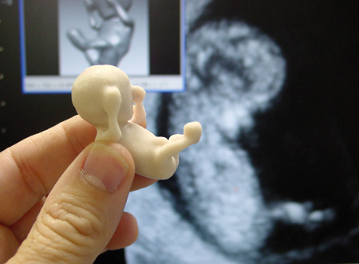

(Dos-Santos,2009)

Eventually, this artist applied the same method for (CT) and (MRI), so the CT scan and MRI images could be converted into 3D models using 3D printing. This technology has many applications in different fields of medicine, such as using these models for medical training and research, also designing implants and devices to improve mobility for people with limited movement abilities and assessing the foetus’s growth and development inside the womb (Warnier, et al, 2014, p 200-203).

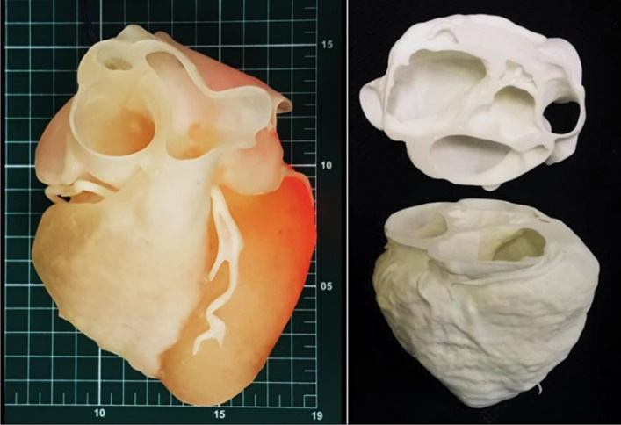

(Dos-Santos et al., 20016)

Likewise, in this dissertation, by considering the impasto painting- which is my practice as a painter- as a human body, I will attempt to investigate the Impasto painting aesthetically this time as opposed to my previous experience in medical investigation. The focus will be on what impasto means for the painter and the viewer and how impasto painting evolved to become prominent way of painting in modern time.
“As far as I am concerned, the paint is the person, I want it to work for me just as flesh does” – Lucien Freud.
(Collins,2001, P182).
The intertwining between art and medicine practices succeeds in removing the boundaries between art and science, which is evident in the above examples
At any time in history, tools have always defined our culture. Our creative endeavour is directly related to the technological advancement in our tools and materials. These tools and materials related had progressed throughout the ages from the stone ages until the present information age. Through the ages, we have experienced a successive evolution of our capacities to create as human beings (Bitonti,2019, page 3). Many technologies are now available to produce the aesthetics, such as photography, digital art, and 3D prints. Thus, the technological role in the aesthetic as a contextual factor for art evaluation justifies our attention. But art critics focus more on contextual criticism rather than the technical and aesthetic qualities of the work of art, contrary to the art viewer, who is more concerned with the experience of beauty.
(Hantula et al, 2009, P323)
Thus, I will also research the effect of technological advancements on the Impasto painting method, starting with the camera and the influence of photographs. Then, the recent 3-D printing technique invention and how it opened the door for great possibilities and the many promises it carries for the future of this practice.

Impasto

Its meaning for the painter and the viewer:
Impasto is an Italian term that means dough. It involves applying thick paint to retain marks made by a paintbrush or knife on the surface of the painting, so it gains a three-dimensional quality to model some forms or mimics the painted subject.
Oil paint has been used traditionally for impasto because of its versatility and thickness. The impasto technique involves taking the oil paint directly from the tube or adding wax to the oil paint as a thickening medium. Nowadays, adding a gelling agent to Heavy body acrylic paint also could be used for impasto. (Stephenson,1989, p141).
A painter can create a contrast between areas of the painting he paints with thick layers of paint, and other areas he leaves with thinner paint, to emphasize some elements of his subject with the use of the Impasto technique (Akib et al., 2016, p 246). Otherwise, the Impasto technique could require covering the whole surface of the canvas with a thick layer of paint that has peaks to create a texture. This visible brush or knife strokes create details that possess a sensual charge because it shows the speed and the strength of applying the paint, revealing the painter’s feelings and emotions, loaded with the artistic personality, soul, and individuality, and carrying the signature of the painter (Lyle Millard, 1987, p 24). Not only that, but many experts think that impasto allow the artist more freedom because it is a more spontaneous process. Thus, the free-sweeping application of the paint is termed gestural.
Impasto is also created by layering excessive amounts of paint to develop a sculptural value to the painting. Paint is a matter that has a modellable body that can reflect an impressive physical presence. Impasto can turn a painting work from a flat surface to a sensual object, which can reflect reality and the raw perception of the eye and mind, with honesty more than an imagined perfectly smooth surface of a two-dimensional painting (Pool, 1991, P19,20). When the Impasto work is prominent, it has the term painterly because the artist produces it through the manipulation of paint.
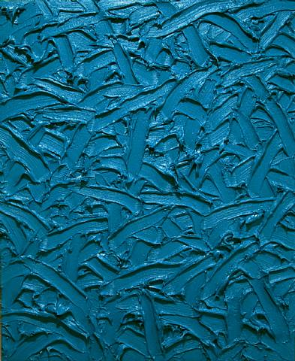
(Hayward, 2001)

In modern times, some painters are exaggerating their experimentation with Impasto. They use enormous amounts of oil paint in their making of paintings to produce very coarse textured and extremely thick works with sculptural values. A disadvantage of that is the need for careful handling of these paintings and the difficulties in cleaning them. Furthermore, specialists are suspicious about risking the traditional rules of painting involved in this technique (Mayer and Sheehan, 1991, p198). Yet, for an artist to be part of modern society and modern art mean to be unconventional and innovative, and contemporary artists did not follow the tradition of painting. So, they did not cease thinking about breaking the old territories and opening the doors for new artistic adventures (Elger et al., 2016, p 9). Besides, contemporary artistic practice is different from the craftmanship of past time painting in that the present painters expected to be more experimental, so they challenged the durability issue in their works. In the “Three Dancers” painting by Picasso, there are few visible cracks because of the thickness of the paint he used. Nevertheless, he was more interested in the vitality and inventiveness of his work rather than the craftsmanship and durability (Collins, 2001, p22,23).

The development of impasto to becoming prominent these days

In the past, some painters used heavy strokes of paint to produce textured paintings very carefully, without challenging the conventional painting methods (Mayer and Sheehan 1991, p197). First, Leonardo da Vinci changed the traditional practice aimed at producing a perfected artificial slickness of the surface of the painting to a uniform soft-focus blurring of the paint. Impasto reflects light more than the conventional flat surface of a painting because it has a sculptural quality. Thus, artists can increase the reflectivity of light when using this technique (Lyle Millard, 1987, p46). The old masters, such as Tiziano Vecellio Titian, used this advantage for painting jewellery or clothes folds (Britannica,2012), this impasto work was evident in his Man with a Quilted Sleeves.
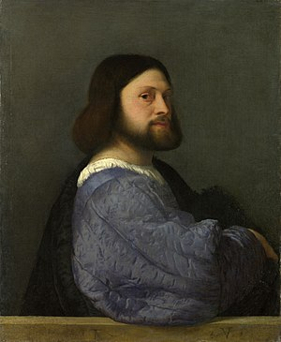
(Titian, 1510)

He also used visible brush strokes because he thought it was a closer representation of reality. At first, he kept a balance between the subject of the painting and the use of the impasto. But this balance shifted toward the paint at the end of his practice. To the extent that the critics thought his "Flaying of Marsyas" was not a finished work, although it was signed (Gopnick, 2003).
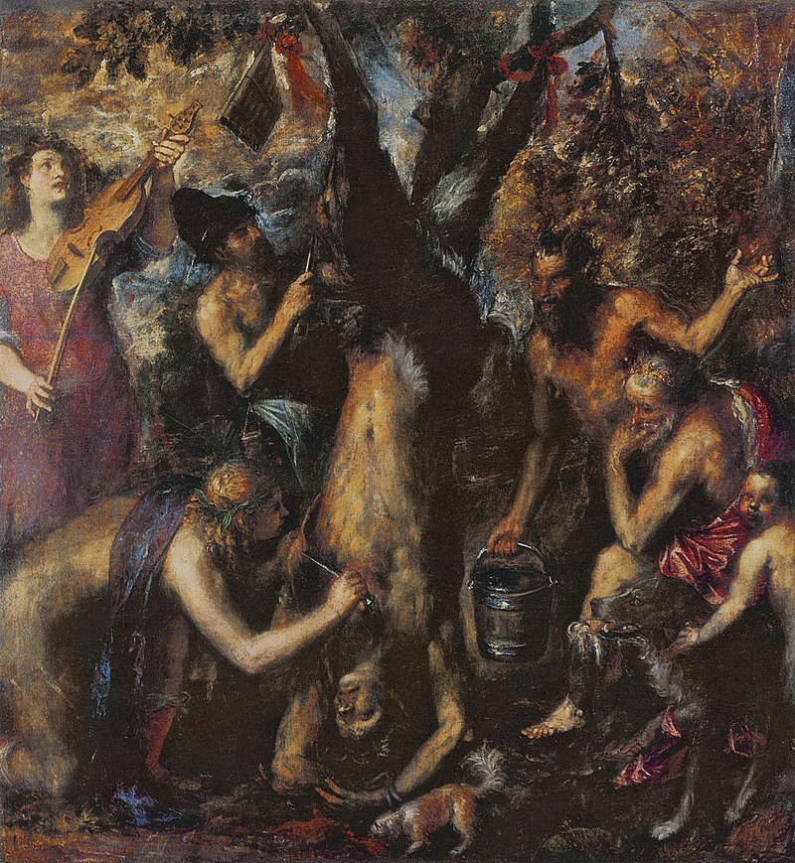
(Titian,1576)

With the Baroque painter Rembrandt, Impasto became more notable. Since the beginning, he succeeded in reflecting emotion using texture and light. He made thick paint strokes to produce portraits with dramatic looks (Galton, 1991, p40). Impasto became more prominent in his later works, inventing a third dimension to his paintings (Gonzalez et al., 2019, p5619-5622). He acknowledged the paint material as a solid matter that he can manipulate into the painting work to turn it into a sculpture and reveal a new statement about the paint that implies the touch as a continuous sense to the sense of vision (Bal, 1994, p365).
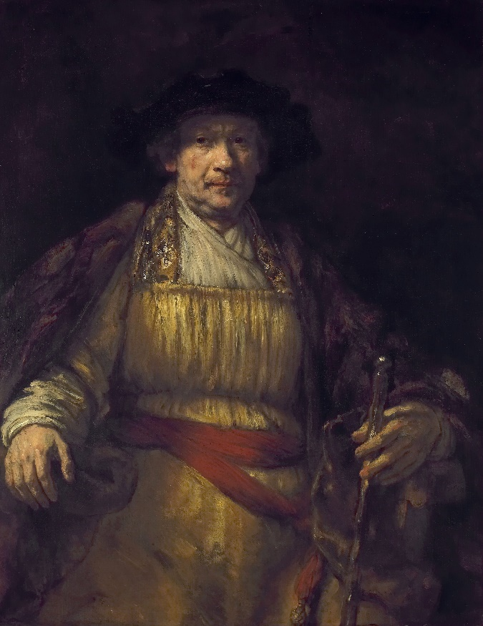
(Rembrandt, 1658

Because the materials available for modern painters improved, and a much broader range of reliable pigments became ready for use (Stephenson,1989, p 17), the impasto technique became increasingly notable. In nineteenth-century landscape painting, the Naturalists and Romantics, such as John Constable, and Joseph Mallord William Turner, made distinctive use of Impasto. Turner’s brush strokes were spontaneous and rough, resembling a gestural abstraction. His subjects have hazy boundaries with the background, and his methods facilitated the innovations developed by the Impressionist movement (Irish Times, 2004).
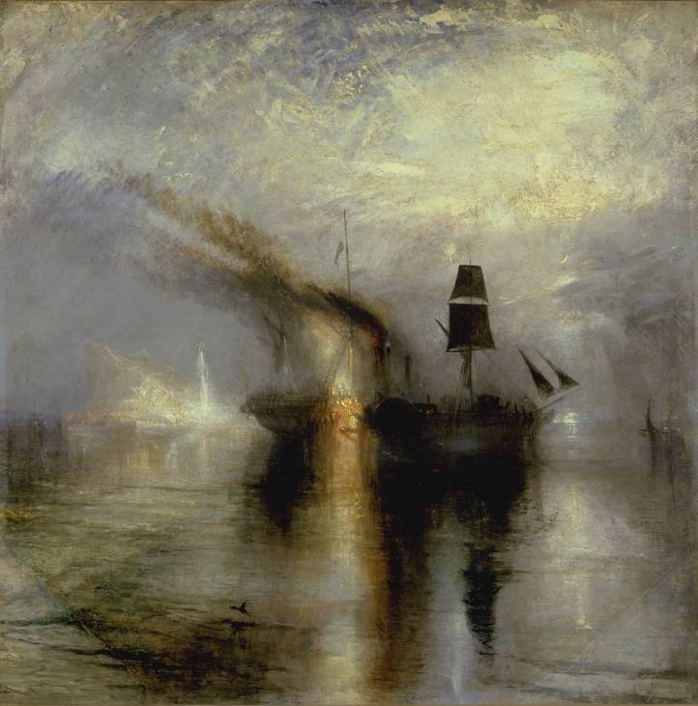
(Turner, 1841)

The Impressionists utilized all the Impasto methods that the painters of the past used. They were revolutionary because they used all these methods together and regularly. They also innovated painting techniques with their immediate and spontaneous use of paint to produce visible and fragmented brushstrokes and create a sense of movement. They covered the entire surfaces of their canvases with impasto textures, building layer upon layer to create a sculptural effect (Wallis, 2002, P34) to emphasize the surface of the painting. Thus, they revolutionized the relationship between the viewer and the work of art (Harrison,1997, p43).
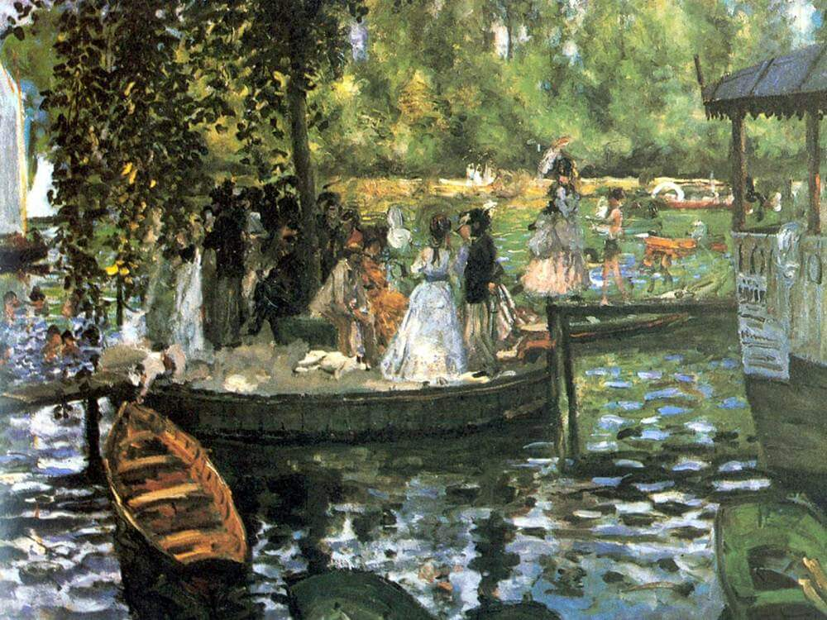
(Renoir, 1869)

Vincent Van Gogh, the Post-impressionist, was pioneering in the use of thick paint. He made exceptional use of the impasto technique. He did not only use it to add a third dimension to his pieces, but also to add a sense of movement and hustle, also to reflect his emotion and his inner turmoil, using spontaneous, thick, and bustling brushwork (Elger et al., 2016, p 54, 56).
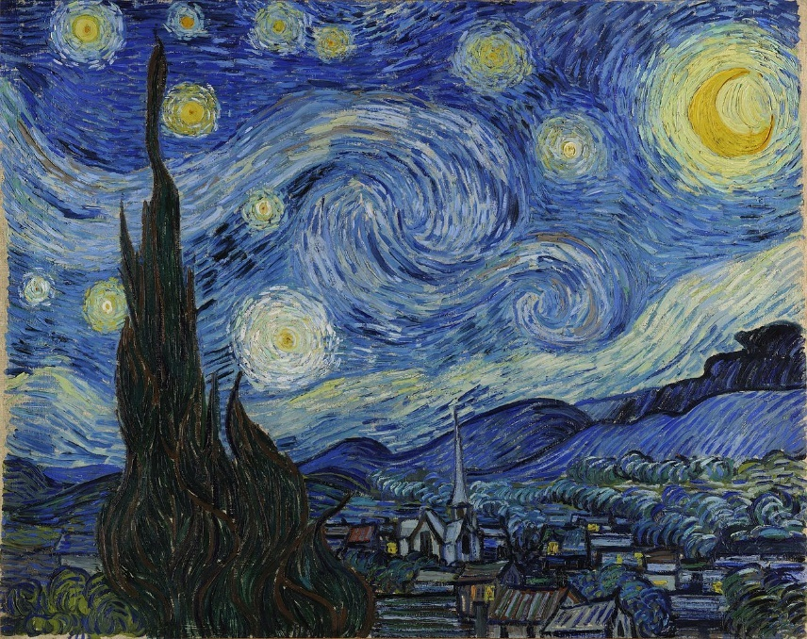
(1889, Van Gogh)

Also, Abstract Expressionist artists used Impasto techniques extensively. They freed their paintings from the controlled movement of the painting brush because they valued spontaneity and put the creative process as the core of their interest. They also appreciated the visible signs in their works and considered them a unique representation of their identities. The artist acts out his inner impulses with the resulting paint marks, which are something of his feelings, ready for the viewer to sense and read (Paul, 2004). Jackson Pollock was a pioneering painter. He revolutionized the process of executing the Impasto technique with his “Action paintings” in a series of works using the drip technique, where he promoted the use of continuous lines of paints, purring paint directly from a can on unstretched canvas laid on the studio floor (Elger et al., 2016, p424). His painting process was named” action painting” because these paintings recorded his energy when dynamically applying impasto. Ever since, the implementation of thick paint was a crucial technique in modern abstract (Collins et al., 2001, p126).
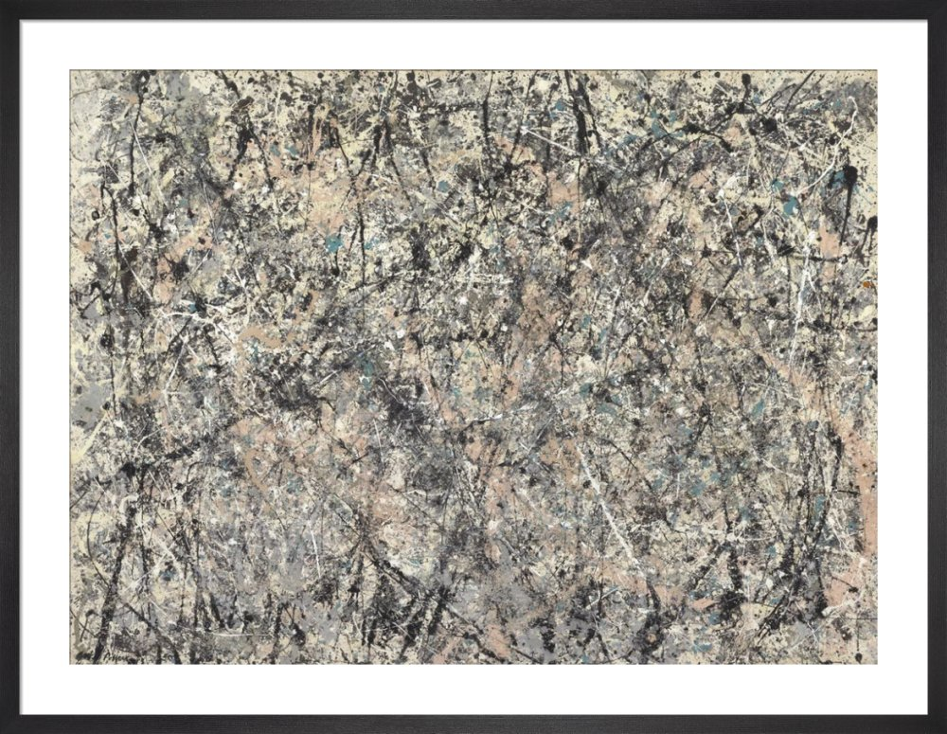

(Pollock, 1950)

Subsequently, the School of London figurative artists often used the Impasto technique to explore novel ways to convey their expressions about themselves and others. Impasto's work of Frank Auerbach was very excessive. He aimed to present a new way of seeing, where the experience of tactility and proximity that the very thick paint can offer is secondary to the experience of seeing or not seeing clearly through the messy brushstrokes (Lampert and Auerbach, 2015, p16-17). He used massive quantities of paint in each of his paintings to the extent that he was to cut short on his spending for his food to afford to spend for his materials (Lampert, 2015, P133). His friend, Leon Kossoff, similarly worked with loads of paint. The surfaces of his paintings were muddy and resembled topographic maps. His work (Head) looked like mummified flesh (Perl, 2000, p79). Both artists took Impasto to the extreme. They produced three-dimensional paintings, which were very heavy to carry (Riggs, 1998). They were famous for their savage inventive manipulation of paint and their highly sensuous and technically ambitious paintings.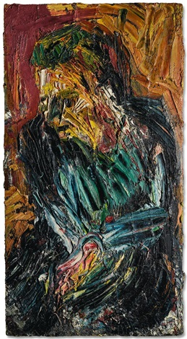
(Kossof,1962)

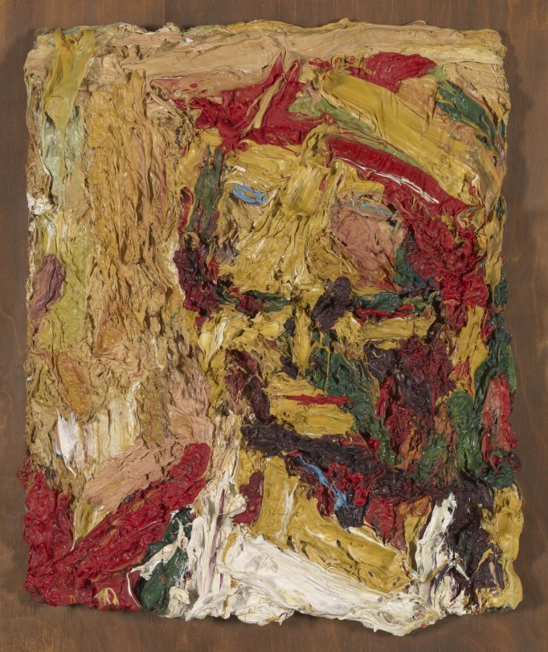
(Auerbach, 1960)

In the Mid 1970s, Lucian Freud became a great admirer of Auerbach’s work and a friend of his. Thus, he discovered the use of thick paint and large brushstrokes, also the modelling quality of the paint medium to mimic reality. He became concerned with the painterly technique to create different textures. Instead of the loose application of paint in Auerbach’s work, Freud was obsessed with reflecting the details with his textured paint (Lampert, 2015, P133). He mastered the novel technical experience to gain an energetic and vigilance depiction of his style and produce more convincing and astonishing work (Collins, 2001, P182). His painterly approach received considerable hostility from critics such as Lawrence Alloway, with others predicting an excellent future reputation for Freud.
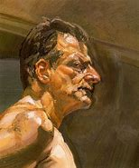
(Freud,1981)

Jenny Savile and other contemporary figurative artists also highlighted the importance of technique and brush strokes, inspired by the practice of the artists from the School of London. Her uncompromisingly large canvases of nude women are very well known for her honest depiction of the human body. She uses impasto to captivate the flesh as a material, reflecting the heavy weight of the female’s body in unflattering reality. She applies thick, broad, and stark brushstrokes to reflect the body marks and the texture of the human skin. She reveals the body imperfections as if the canvas is the human flesh itself, in a sensuous and challenging way of expression (Nead, 1994, pp18-19).
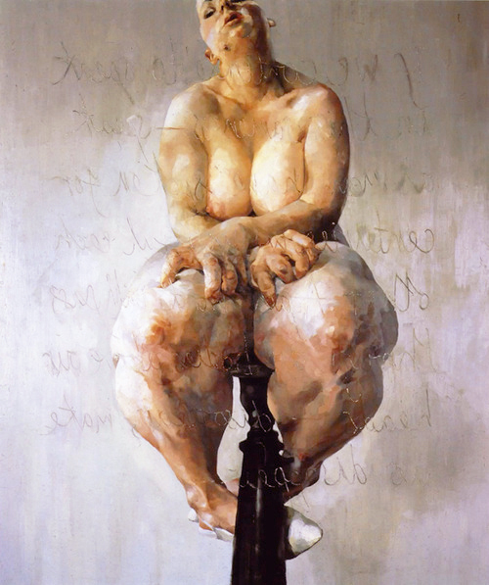
(Saville, 1992)

Impasto became almost compulsory in contemporary art, as the aim is to produce works of art that reflect reality. Using visible brushwork allows the painter to create a textured canvas surface, which is a closer reflection of the world than the conventional paintings, which possess perfectly imaginate smooth surfaces. Also, the texture and marks are highly valued in modern art because they are unique expressions of the artist and reflections of his emotions. Thus, Modern art places paint at the heart of attention. Now more than ever, painters are relying on the Impasto technique. Focussing on the medium and its qualities and making full use of its sensual value is a central idea of modern art termed the “truth to materials” (Tate, n.d).

The effect of technology on Impasto paintings

Every technique or medium involved in producing a piece of art is not separable from the resulting work. These have considerable influence on setting the limitations and the possibilities of creating it at any point of the creation. Thus, advancements in technology had significant effects on painting methods long ago. In the past, painters used mirrors and lenses to assist them in the making of their paintings. They later used the camera obscura as a mechanical tool to cast images of the world on the wall of a dark room. Using this tool by artist Gaspare Vanvitelli (1652-1736) led to new methods of executing a painting, which was then called the genre Italian view painting. This method of execution allowed the artist to express his interest in city life, was used by many artists before the invention of photographs and was a forerunner for the broad application of photography (Roderick, 2003). The use of camera obscura by the Dutch painters in the seventeenth century opened new possibilities and allowed a different manner of work with painting. In the case of Johannes Vermeer, it was an optimal aid to his creativity. He produced extraordinary realistic reflections of the world in his paintings with the help of the precision of the casted images produced by the camera obscura (Jelley,2013, p20,21).
The effect of camera

Besides, the Impressionists’ works were concerned with subjects of daily life, and the invention of photography had a considerable influence on them because they utilized the technique of photography in their paintings.
Artists Jean-Baptist Camille Corot studied Paris Photographers who used to work in The Fountain Bleu (Rubin, 1999, P32). Because a photograph does not include a contour, he produced paintings with hazy effects based on the blurring of the first cameras. Similarly, The Impressionists created the ambiance effect in their works, inspired by the Corot painting method (Pickeral, 2018, P242). Also, the edges of their subjects were blurred and hazy, mimicking the camera snapshot. Monet Boulevard des Capucines is a convenient example because this painting mimics exactly a photograph (Katz and Dars, 2016, P103).
Aaron Sharaf called this haziness of the contour of subjects “the Halation effects” resulting from the movement of these subjects. He also explained in his studies that photography had a remarkable impact on the Impressionists’ paintings (Pool, 1991, p15,16).

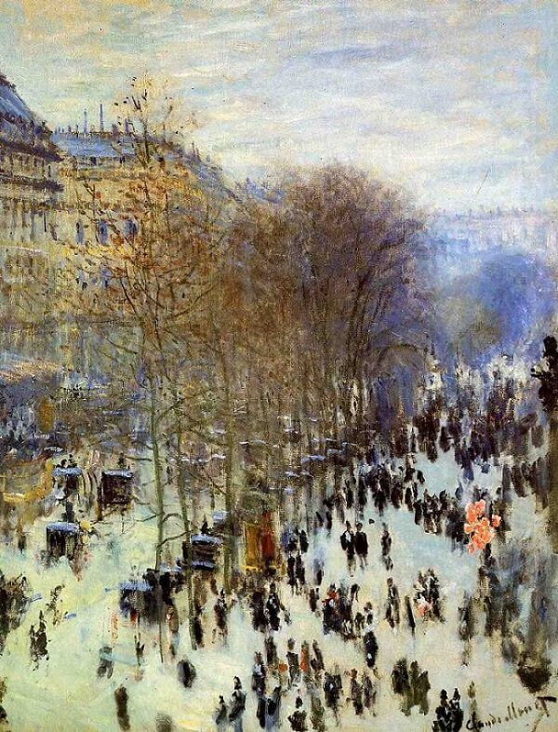
Monet, 1873-1874

Also, they did not make compositional plans for their paintings, just like how a photo captures a spontaneous momentum of time. Photography completely changed the painting pictorial narrative because it captures an image quickly and because of its cheap reproduction method. Degas's work (Place De La Concord) is an example of this messy composition. Edgar Degas outset all other artists of this art movement because he was the one who made the most use of photography in his work, especially his dance paintings.
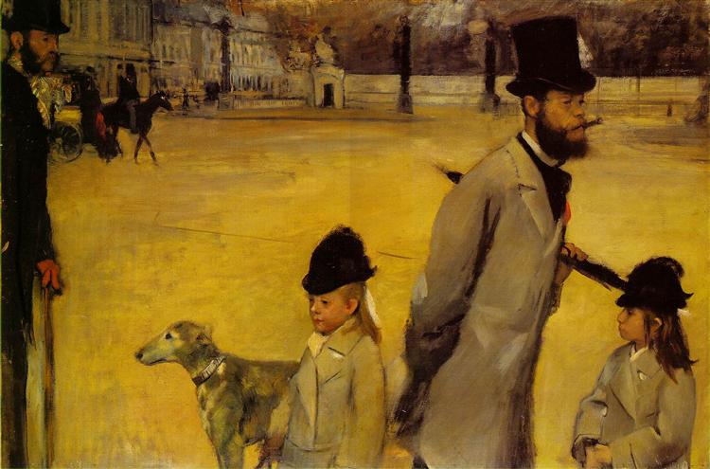
(Degas ,1875)
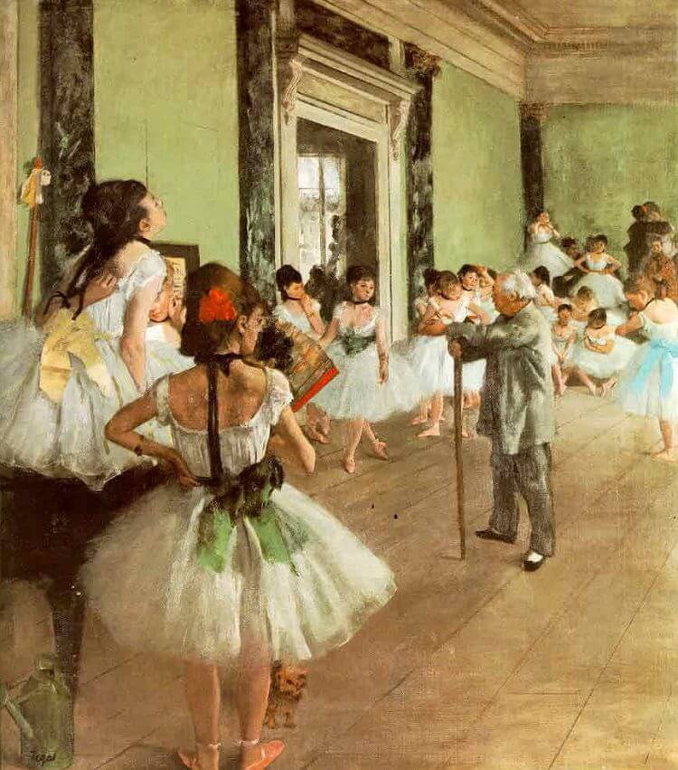
(Degas,1871)
Looking at the history of painting from Manet to Matisse and Cubism, one could note a gradual separation of painting from the representation of reality. Thus, modern art is characterized by the gradual rejection of realism (Harrison, 1997, p43-44). After the invention of sophisticated cameras, several painting movements used impasto to add a third dimension to the paintings. Meanwhile, other art movements moved away from pure representation, which photographs can offer with increased efficacy (such as abstract art, surrealism, and cubism). And other art movements used technology and images in making art (Pop art, digital art, etc.). It is true that photography improved the means of reproduction and opened the door for new creativities. Yet, human emotions are beyond the mechanical representation of reality Produced by the camera. The painter does not produce something that looks like reality but communicates his feelings with the viewer through his painting, where he emphasizes what is important and reflects on that to create great art (McNulty, 1939, p14). Just like how Lucian Freud discussed his thoughts on painting and explained that when a painter creates his work, he eliminates what he thinks is not significant to emphasize his feelings and reflect his deep emotion about the subject that triggers his interest (Feaver, 2002, p26-27).

The effect of 3D printing
Until recently, fine art reproductions were two-dimensional, but the 2D print of a painting does not always live up to the original work. Because it lacks depth and texture if the original was created with thick paint and visible brush strokes as its main characters, like in Rembrandt or Monet’s paintings. In the absence of the texture of the original work, the experience a viewer can get from a replica is not rich. That is also true for artists like Van Gogh, a master of the impasto technique, with the slapping down of thick layers of paint in bustling brush strokes in his Starry Night. The reproduction of such a painting as a conventional 2D print provides a poor experience compared to the original (Scott, 2016). Many great artworks are not just colours and composition. Yet, their texture, visible paint marks, and striking brush strokes make them astonishing.

Yet, the novel technological discovery, the three-dimensional printing methods created more authentic copies of the original artworks. Also, it opened new possibilities for creativity, with its influence on the working methods. 3D printing can mould physical objects directly from a 3D model created on a computer or from scanning an existing object (Hoskins, 2013). This function permits a new way to reproduce an oil painting by accurately remaking the colour and relief of the artist’s brushstrokes and correcting the shortage that 2D printing is missing (Chen,2015, pp260-264).
3-D scanners capture the shape and dimensions of a physical object. They are like the cameras because they can collect data from the surface of an object. Yet, a scanner can also collect information about the distances to the surface of each point of this object, mimicking the geometric shape of a textured painting (3D printing p 178). By utilizing the scanner’s data, a 3D printer uses an additive process to lay down layers of materials and create a three-dimensional object mimicking the exact shape of the original artwork. So, the additive manufacturing process is different from the traditional carving of an object from a block of material to create a sculpture. Additive manufacturing allows us a unique experience with materials because we can build up the object’s micron by micron with an ever-increasing control over the geometry. In addition, 3 D printer allowed us to transfer the software advancement in drawing and visualization into tangible materials. It is inventing new possibilities for engagement with physical matter. We are living in a technological revolution that is transforming our art and culture (Bitonti,2019, page 5).

The new experiments led to the discovery of a fast-enough method of reproduction. At the same time, it can reproduce the same gloss, colours, and topography of the surface of the original painting (Elkhuizen et al., 2019). These prints reflect much more information than conventional prints because they allow a direct connection to the artist by showing his unique brushwork, the texture he creates by his way of manipulating paint, and his interplay of tints. Through that, art lovers can have more engaging experiences, faithful to the artists’ visions and intentions.

Van Gogh Museum of Amsterdam made 3D copies of Van Gogh’s paintings. They have the exact colour, thickness, brushstrokes, and the same size as the original paintings, using a novel system with the help of 3D printing and computer-based deep learning to reproduce authentic copies of historical paintings.
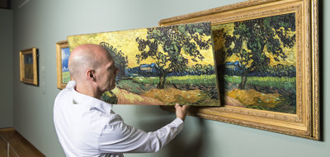
(Van Gogh Museum, n. d)

Furthermore, using 3D printing, also computer data analysis of Rembrandt’s artworks, concerning the colours, depth, and many other details, such as clothing, the experts succeeded in producing a painting in Rembrandt’s style that has the same texture and brushstrokes of his original paintings (Baraniuk, 2016).

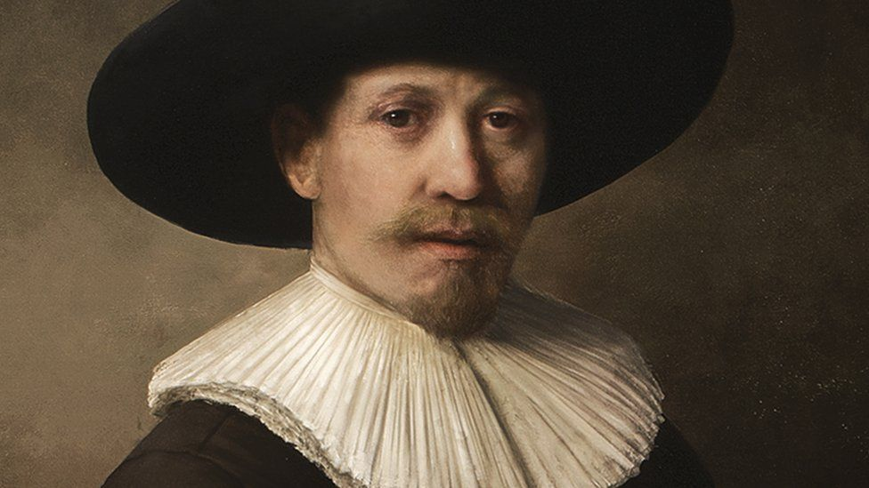
(BBC,2016)

In addition, twelve paintings from the National Gallery of Canada are recently reproduced with the new printing technology. These are textured paintings for several masters such as Van Gogh, Monet, Degas, Gauguin, Cézanne and two Canadian painters Tom Thomson and Frederick Varley.

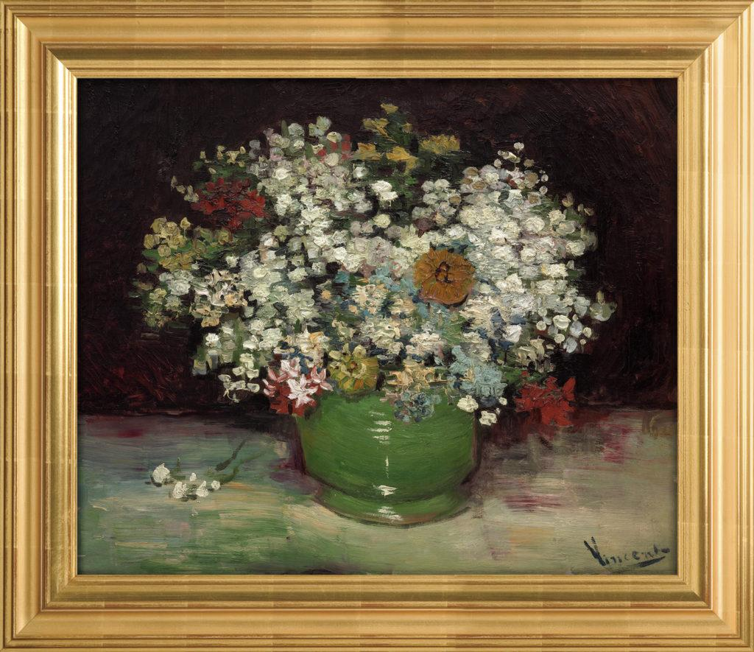
(Versus art replica of Van Gogh’s Zinnias, n.d)

The authentic reproduction of historical paintings produced by the newly developed full-colour 3D printing techniques, and the sophisticated scanners, is highly specialized and precise and can capture information on depth and colour for each millimetre of the painting. The replicas are very accurate to the extent that we can call them clones of the original. It will have remarkable results on art and culture because it allows museums, people, and galleries to purchase these exact copies. Thus, these faithful copies can be taken outside the museums and permit all art enthusiasts worldwide to admire them, making art accessible to wider audience and empowering artists. So, it will assist the development of an art rich culture anywhere in the world. In addition, it will transform the experience of the viewer because when the public can purchase these authentic replicas of their favourite artworks, they will be able to look at them closely and touch their marks, as the originals are too delicate for such intervention by the viewer, and to be exposed to the climate, and need to be carefully stored and handled. Consequently, this technology will help museums to protect and preserve the world cultural assets, because
original art works can be kept safe in specific art storages, and authentic replications can be used to take art to the community (Scott, 2016).
A video A video of High detailed copy of Van Cogh’ s “Stary Night “ is about the faithful replicas that are already made (Cherevan, 2014).

Furthermore, Prado Museum in Madrid is helping to make art more accessible and nurture an art-rich culture for everyone by allowing the blind to enjoy artworks, turning paintings with smooth surfaces into textured tactile 3D replicas using 3D printing technology. So, the blind can sense these paintings by touching and feeling them (Bloom, 2015).
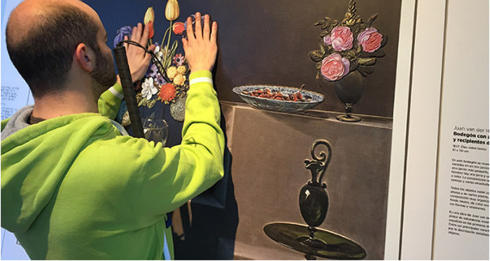
(Rodrigez, 2015)

Commercial galleries are using this technique to reproduce textured paintings of famous artists of the past and make their art available in the market. They are also collaborating with contemporary artists to make their art more accessible with Limited Editions of high-fidelity prints. Shortly, the 3D printing method will become less complicated and not expensive. Artists will reach broader audiences and offer their works at cheap prices, and people can hang them on their walls, authentic textured prints very similar to the original paintings of famous artists, old and new, Galleries like Versus Art (Versus art, n.d), and Arius Gallery (Arius, n.d) are offering the textured replicas to the ma

Also, individual visual artists started to use this novel reproduction technology. Artist Erin Hanson located in San Diego paints landscapes using the impasto technique. She is the first to own these techniques in her studios and produces Limited-Edition 3D prints of her work of art. She is very successful and sale to a broad audience, who are much more satisfied with purchasing her textured prints as they are cheaper than the original works, and at the same time more faithful than the traditional print, as they have the exact colours and texture as the originals (Hanson, 2020).

Combining new technology with traditional tools create outstanding quality art products with high precision and efficiency, simultaneously maintaining the visual quality and tactility of the handmade (Johnson, 2017, p7). The shapes of my landscape paintings are not mouldable, and my ambition is to produce plenty of them and make them available for everyone to enjoy. For the first time in art history, publishing sculpture artworks is possible because of the 3D printing technology, and the more popular a work of art is, the more successful the artist who created it will be (Labaco,2013, p21).
The scientific studies of the late twenty century guided by the complexity theory evoked cultural visual manifestations resulting in the interest in designs of products that mimic nature with its highly complex structures. Yet, this was a difficult task for the conventional methods used at that time. Fortunately, the novel 3D printing technology opened new possibilities, allowing artists to experiment with creating very intricate and complex shapes without the burden of extra cost, which is needed when using traditional manufacturing methods (Warnier, et al., 2014, p122). Many of the experiments with 3D printing are inspired by nature, which involve complex organic structures that sometimes artists allow people to interact with them (Warnier, et al.,2014, p40). Different production methods reflect different ideas and new ways of engagement lead to new forms of art (Johnson, 2017, p8).
The search for aesthetics in 3D printing is still in its early stages. But now, this novel technology will make Impasto paintings much more popular than before.

Conclusion

The above examples are visions that give hints about the creative opportunities of the future. Many of the experiments we are seeing now may appear outdated decades after, but they are remarkable steps in paving the way. With higher numbers of artists engaging with 3D printing, a sophisticated language of the full potential of the technology’s aesthetic powers will eventually develop. There will be more improvements in 3D printing in the future, which will also make use of new materials, and will have further influence on the methods of painting (Warnier, et al., 2014, p41). There are many possibilities of this effect.
Art is an ever-changing idea that uses novel tools and sets new boundaries for revealing human expressions in new artistic forms. With 3D printing, objects are moulded by computer in a layering process, which could free the artist from the labour work and the limitations of the traditional painting methods, and artists are experimenting with the creative possibilities of this novel method (Hoskins, 2013, p6). Yet, artists might produce more sophisticated sculptural paintings challenging the ability of the machine to show the skills and the soul of the handmade. Instead, painters might create smooth surface paintings and rely on the 3D printer to create the impasto effect, or possibly future painters might depend on the 3D machine to produce the physical form of a painting and create a virtual model of this painting on the computer.

Bibliography:

Akib, H. et al, (2016) Artist’s Painting Techniques, London, Dorling Kindersley limited.
Bal, M. (1994) ‘Dead Flesh, or the Smell of Painting’, Visual Culture: Images & Interpretations, pp. 365–383. Available at: https://search-ebscohost-com.ezproxy.uwtsd.ac.uk/login.aspx?direct=true&db=asu&AN=37357904&site=ehost-live
(Accessed: 1 December 2022).

-Arius Gallery, (n,d), available at: https://shop.ariustechnology.com/collections/view-all-textured-art-prints
(Accessed14/12/2022).

Baraniuk, C. (2016) Computer paints new Rembrandt after old works analysis. Available at : https://www.bbc.co.uk/news/technology-35977315

(Accessed; 14/12/2022 ).

Bloom, D. (2015), Feeling artistic: Gallery unveils specially created versions of classic paintings that blind people can 'see' by touching them. Mail online, News,11 February. Available at: https://www.dailymail.co.uk/news/article-2948306/I-feel-art-Gallery-unveils-specially- createdversions-classic-paintings-blind-people-touching-them.html
(Accessed 14/12/2022)

Boyce, N. (2012). Lucian Freud: in the flesh. The Lancet (British Edition), 379(9817), 701–701. https://doi.org/10.1016/S0140-6736(12)60295-5
(Accessed 14/12/2022)

Bitonti, F. (2019) 3D printing design : additive manufacturing and the materials revolution. London, UK ;: Bloomsbury Visual Arts.

CHEN, C. et al, (2015) Method of Reproducing Three-Dimensional Oil Paintings. Applied Mechanics and Materials, 731, pp. 260-264

Collins,J. et all(2001), Techniques of the modern artists, London, Chartwell Books.

Elger, D. et al, (2016), Modern Art, Koln, Taschen.

ELKHUIZEN, W. et al, (2019). Gloss, Color and Topography Scanning for Reproducing a Painting's Appearance using 3D printing. Ithaca: Cornell University Library, arXiv.org. –

-Encyclopedia Britannica., (2012). Impasto. Available at: https://www.britannica.com/art/impasto
(Accessed: 10/12/2022 ).

-Feaver, W., (2002), Lucian Freud, London, Tate Publishing.

-Galton, J., (1991), The Encyclopedia of Oil Painting Techniques, London, Quarto Publishing plc

- Gonzalez, V, et al, (2019). Unraveling the Composition of Rembrandt's Impasto through the Identification of Unusual Plumbonacrite by Multimodal X-ray Diffraction Analysis. Angewandte Chemie (International Ed.), 58(17), 5619–5622. https://doi.org/10.1002/anie.201813105
(Accessed 14/12/2022)

-GOPNIK, B., 2003, Titian & the Touch Of Greatness; In London, a National Gallery Retrospective Spotlights The Sweep of a Master's Brush -- and an Unparalleled Career: [FINAL Edition]. The Washington Post. ISSN 01908286. Apr 13. –

-HAMMOND, M.S., 1986. The Camera Obscura: A Chapter In The Pre-history Of Photography (pinhole Photography, Astronomy, Drawing Machines, Kepler, Perspective), The Ohio State University.

- Hanson, E. (2021) Welcome to The World of 3D Art Reproduction, An Inside Look at the Technical Specifications and Details [blog]. 1 October. Available at: https://www.erinhanson.com/blog?p=technicalspecificationsof3dartreproduction
(Accessed at14/12/2022).

-HANTULA, D.A., SUDDUTH, M.M. and CLABAUGH, A., 2009. TECHNOLOGICAL EFFECTS ON AESTHETIC EVALUATION: VERMEER AND THE CAMERA OBSCURA. The Psychological Record, 59(3), pp. 323-333.

- Harrison, C. (1997) Modernism. London: Tate Gallery.

- Hoskins, S., 2013, 3D Printing for Artists Designers and Makers, London, Bloomsbury Visual Arts.
Ian Sidaway, 2014, The Practical Encyclopedia of Acrylics Oils and Gouache, London, Anness Publishing Ltd.

- Irish Times, 2004, River of Impressionist inspiration., Irish Times,10, Nov 01

-Jelley, J. (2013) ‘From Perception to Paint: the Practical Use of the Camera Obscura in the Time of Vermeer’, Art & Perception, 1(1/2), pp. 19–47. doi:10.1163/22134913-00002006.

- Johnston, L. (2017) Digital handmade: craftsmanship in the new industrial revolution. New edition. London: Thames & Hudson.

, - Katz, R. and Dars, C. (2016) The Impressionists Handbook and the world that inspired them, London, Anness publishing Ltd, London.

- Labaco, R. (2013) Out of hand: materializing the postdigital. London: Black Dog Publishing.

- Lampert, C. and Auerbach, F. (2015) Frank Auerbach. Edited by C. Lampert. London: Tate Publishing.

-Lampert, C., (2015) Frank Auerbach speaking and painting. China, Thames & Hudson.

-Lyle Millard, D., 1987, Impasto, New York, Watson-Guptill Publications.

- Mayer, R. and Sheehan, S. (1991) The artist’s handbook of materials and techniques. 5th ed. / revised and expanded by Steven Sheehan. London: Faber.

-McNulty, H. (1939) ‘“along came the Camera”’, American Artist: Art Instruction, 3(7), pp. 12–14. Available at: https://search-ebscohost-com.ezproxy.uwtsd.ac.uk/login.aspx?direct=true&db=asu&AN=52981675&site=ehost-live (Accessed: 22 November 2022).

- Nead, L. (1994), “Caught in the Act of Staring”, Women’s Art Magazine, (58), pp18-19. Available at: https://searchebscohostcom.ezproxy.uwtsd.ac.uk/login.aspx?direct=true&db=asu&AN=35050677&site=ehost-live
(Accessed: )

. - Paul, S., (2004), Abstract Expressionists, Available at: https://www.metmuseum.org/toah/hd/abex/hd_abex.htm
(Accessed: ).

- Pickeral, T. (2018) Impressionism, London, Flame Tree publishing - Pool, P. (1991) Impressionism, London, Thames and Hudson Ltd

-Pool, P. (1991) Impressionism, London, Thames and Hudson Ltd

- RODERICK, C.M., 2003, Mar 15. Vanvitelli and his 'camera obscura'. International Herald Tribune, 7. ISSN 02948052. - Riggs, T., (1998). Frank Auerbach, Available at: https://www.tate.org.uk/art/artists/frank-auerbach-676 (Accessed 14/12/2022 ).

- Roebuck, K. (2011) 3D printing. USA: [Tebbo].

- Rubin, J, H. (1999) Impressionism, London, Phaidon press Limited

-Scott, C., (2016), Versus Art Creates Fully Textured 3D Printed Reproductions of Famous Paintings,
Verus Art Creates Fully Textured 3D Printed Reproductions of Famous Paintings - 3DPrint.com | The Voice of 3D Printing / Additive Manufacturing (Accessed at 8/12/2022)

-Stephenson, J. (1989) The materials and techniques of painting. London: Thames and Hudson.

-Tate (n.d) Impasto. Available at: https://www.tate.org.uk/art/art-terms/i/impasto
(Accessed: 14/12/2022 ).

- Technology Mimics the Brushstrokes of master’s Oct 23, 2013-last update [Homepage of New York Times Company], [Online]

- ZAMAN, T. et al. (2014). Simultaneous capture of the color and topography of paintings using fringe encoded stereo vision. Heritage Science, 2(1), pp. 1-10. - Wallis, J. (2002) Impressionists, Oxford, Reed educational and Professional publishing Ltd.

-Versus Gallery, (n,d) Available at: https://www.verusart.com/
(Accessed14/12/2022)

-Wallis, J. (2002) Impressionists, Oxford, Reed educational and Professional publishing Ltd.

- Warnier, C. et al. (2014) Printing things: visions and essentials for 3D printing. Edited by C. Warnier et al. Berlin: Gestalten.

-Winnan, C., D. (2012) 3D printing the next technology gold rush, Marston Gate, Amason,co,uk limited.

