

Programme: | MSc Public Health and Social Care in Practice
Module: | Population Health and Digital Health Promotion
Module code: | LCHS7009
Lecturer | Diola Bijlhout` Dr Ping Wu
Assignment Title: | Component 1, 2 Blogs
Student Name | Vignesh Kalsariya
Student ID: | 2525353

Table of Contents
Blog 1- 3
Title: Digital Health Interventions for Irritable Bowel Syndrome: A Critical Assessment of App-Based Brain-Gut Behaviour Therapies. 3
Introduction 3
Overview of IBS and why it is a concern 3
Digital technology used for health promotion 4
Evidence of the effectiveness of the existing digital health technology 5
Critical discussion 6
Recommendation 7
Conclusion 7
References 8
Blog 2- 10
Title: Critically discuss the impact of Bellymind for the digital health intervention of IBS health promotion intervention 10
Introduction 10
Overview of IBS and why it is a concern 10
Describing the digital technology 11
The Use of Bellymind in health promotion of IBS 12
Critical discussion 13
Conclusion 14
References 15

Blog 1-

Title: Digital Health Interventions for Irritable Bowel Syndrome: A Critical Assessment of App-Based Brain-Gut Behaviour Therapies.

Introduction
In this blog, the impact of app-based brain-gut behaviour therapies will be evaluated for health promotion interventions for IBS.

Overview of IBS and why it is a concern
Irritable Bowel Syndrome (IBS) is a digestive disorder and can be characterised by cramping, abdominal pain, and bloating (Nathani, Sodhani and Goosenberg, 2025). It is a long-term concern as it can diminish the quality of life and may lead to depression and anxiety (Staudacher et al., 2023). Here, Stewart (2026), found that IBS has a global prevalence of 11.2%, indicating that it is a common and widespread gastrointestinal condition.
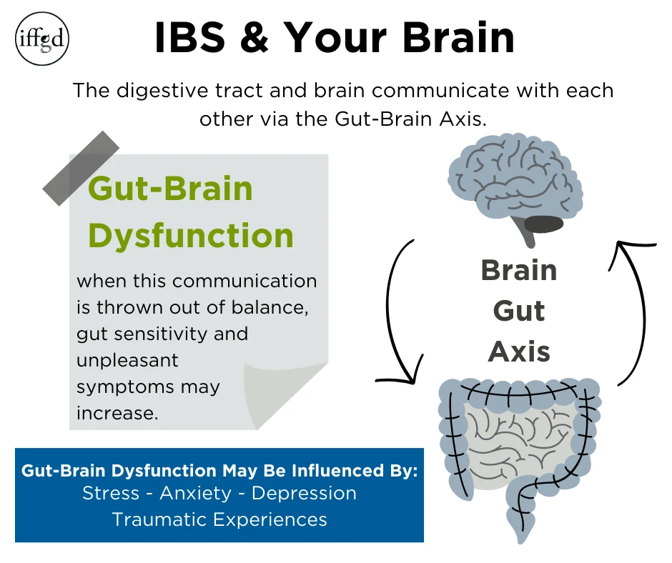
Figure 1: IBS and your brain
(Source: IFFGD, 2026)

Digital technology used for health promotion
The App-based Brain-Gut Behaviour Therapies (BGBT) help to treat Irritable Bowel Syndrome (IBS) by addressing the miscommunication between the central nervous system and the enteric nervous system (Visceral hypersensitivity) (Riehl, 2018). As an example of BGBT, Mahana IBS is used to deliver gut-directed CBT. It guides users in less than 10-minute daily lessons to target stress responses and thoughts which trigger IBS (Brenner et al., 2024). Here, Mahana IBS applies a cybernetic feedback loop through behavioural and cognitive training to monitor, evaluate and adjust physiological stress responses, correcting the maladaptive brain-gut communication (DeYoung and Tiberius, 2023).
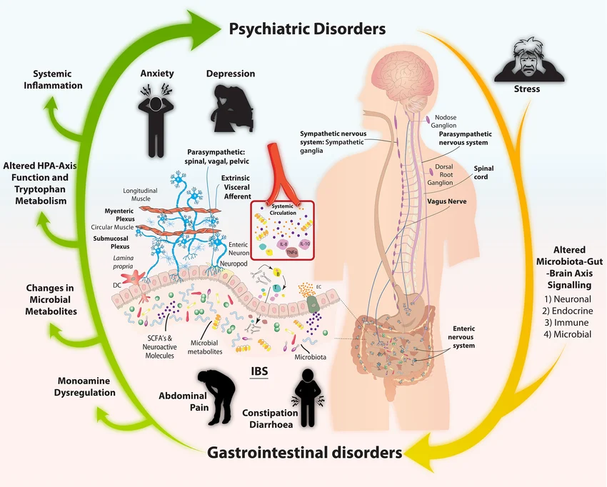
Figure 2: microbiota-gut-brain axis signalling pathways
(Source: Wilmes et al., 2021)

Evidence of the effectiveness of the existing digital health technology
The App-based Brain-Gut Behaviour Therapies (BGBT) are seen to reduce abdominal pain. Here, Peters et al. (2023), reported that using smartphone-delivered GBT helps to drop abdominal pain scores significantly from 60 mm down to 26 mm. Similarly, it is helpful for reducing depression and anxiety, ultimately improving the mental health of the patient (Tao et al., 2023).
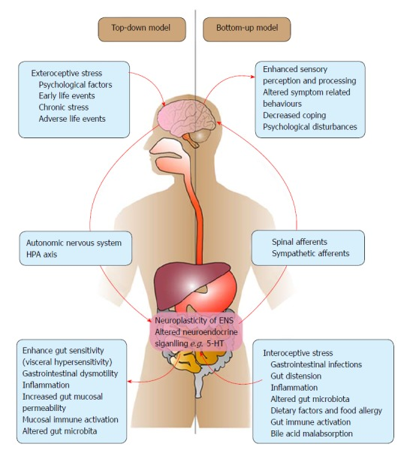
Figure 3: Top-down and bottom-up models of patho-physiology of IBS
(Source: Devanarayana and Rajindrajith, 2018)
However, the effectiveness of these interventions may depend on sustained user engagement, indicating that digital interventions may not produce consistent outcomes for all patients.
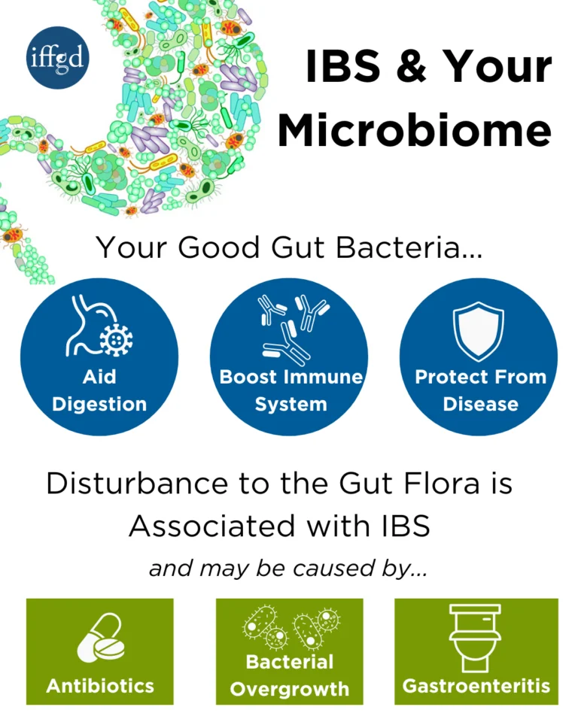
Figure 4: IBS and your Microbiome
(Source: IFFGD, 2026)

Critical discussion
Advantages
Digital BGBT helps to overcome systematic and geographical barriers, which is helpful in connecting patients when doctors are not available in rural areas (Staller, 2025). Additionally, these tools are helpful in encouraging self-management by providing evidence-based skills such as cognitive restructuring and stress regulation (Kinsinger, 2017).
Limitations
Access to BGBT remains limited due to cost and time constraints, which reflects the disadvantages of this intervention (Brenner et al., 2024). However, self-guided apps may not be able to fully address the medical condition, which might highlight the need for human clinical oversight.

Recommendation
This shortfall can be addressed through the help of the stepped care approach, which is helpful for bridging the gap in human clinical oversight (Shah et al., 2026). Here, adopting a wearable biosensor array over the abdomen is helpful in mapping the electrical activity of the gut (visceral hypersensitivity).

Conclusion
Therefore, it can be understood from the above-mentioned evaluation that BGBT plays an essential role in the treatment of IBS patients in this digital era.

References
Brenner, D.M., Ladewski, A.M. and Kinsinger, S.W. (2024) ‘Development and current state of digital therapeutics for irritable bowel syndrome’, Clinical Gastroenterology and Hepatology, 22(2), pp.222-234. Available at: https://doi.org/10.1016/j.cgh.2023.09.013 (Accessed: 18 July 2026).
Devanarayana, N.M. and Rajindrajith, S. (2018) ‘Irritable bowel syndrome in children: Current knowledge, challenges and opportunities’, World journal of gastroenterology, 24(21), p.2211. Available at: https://doi.org/10.3748/wjg.v24.i21.2211 (Accessed: 18 July 2026).
DeYoung, C.G. and Tiberius, V. (2023) Value fulfillment from a cybernetic perspective: A new psychological theory of well-being. Personality and Social Psychology Review, 27(1), pp.3-27. Available at: https://doi.org/10.1177/10888683221083777 (Accessed: 18 July 2026).
IFFGD (2026) IBS and Your Gut. Available at: https://aboutibs.org/what-is-ibs/ibs-and-your-gut/ (Accessed: 18 July 2026).
Kinsinger, S.W. (2017) ‘Cognitive-behavioral therapy for patients with irritable bowel syndrome: current insights’, Psychology research and behavior management, pp.231-237. Available at: https://doi.org/10.2147/PRBM.S120817 (Accessed: 18 July 2026).
Nathani, R.R., Sodhani, S. and Goosenberg, E. (2025) Irritable bowel syndrome. StatPearls [Internet]. Treasure Island (FL): StatPearls Publishing.
Peters, S.L., Gibson, P.R. and Halmos, E.P. (2023) ‘Smartphone app‐delivered gut‐directed hypnotherapy improves symptoms of self‐reported irritable bowel syndrome: a retrospective evaluation’, Neurogastroenterology & Motility, 35(4), p.e14533. Available at: https://doi.org/10.1111/nmo.14533 (Accessed: 18 July 2026).
Riehl, M.E. (2018) ‘The emerging role of brain-gut therapies for irritable bowel syndrome’, Gastroenterology & hepatology, 14(7), p.436. Available at: https://pmc.ncbi.nlm.nih.gov/articles/PMC6111498/ (Accessed: 18 July 2026).
Shah, A., Shahil-Feroz, A., Sheehan, K.A., Wright, S., Nolan, R.P., Strudwick, G., Sockalingam, S. and Seto, E. (2026) Development of Virtual Mental Health Stepped Care Service for a Heart Failure Remote Management Program: Qualitative Descriptive Study. JMIR Formative Research, 10, p.e82139. Available at: https://doi.org/10.2196/82139 (Accessed: 18 July 2026).
Staller, K. (2025) ‘The Promise of Digital Therapeutics for Disorders of Gut-Brain Interaction’, Gastroenterology & Hepatology, 21(5), p.328. Available at: https://pmc.ncbi.nlm.nih.gov/articles/PMC12100526/ (Accessed: 18 July 2026).
Stewart, A. (2026) Global IBS Prevalence Estimated at 11%, With Higher Risk in Women and Younger Adults. Available at: https://pocncoe.com/ibs-c/home/article/global-ibs-prevalence-estimated-at-11-with-higher-risk-in-women-and-younger-adults/?highlight=null (Accessed: 18 July 2026).
Tao, T.J., Lim, T.K., Yeung, E.T.F., Liu, H., Shris, P.B., Ma, L.K.Y., Lee, T.M.C. and Hou, W.K. (2023) ‘Internet-based and mobile-based cognitive behavioral therapy for chronic diseases: a systematic review and meta-analysis’, npj Digital Medicine, 6(1), p.80. Available at: https://doi.org/10.1038/s41746-023-00809-8 (Accessed: 18 July 2026).
Wilmes, L., Collins, J.M., O'Riordan, K.J., O’Mahony, S.M., Cryan, J.F. and Clarke, G. (2021) ‘Of bowels, brain and behavior: A role for the gut microbiota in psychiatric comorbidities in irritable bowel syndrome’, Neurogastroenterology & Motility, 33(3), p.e14095. Available at: https://doi.org/10.1111/nmo.14095?urlappend=%3Futm_source%3Dresearchgate.net%26utm_medium%3Darticle (Accessed: 18 July 2026).

Blog 2-

Title: Critically discuss the impact of Bellymind for the digital health intervention of IBS health promotion intervention

Introduction
In this blog, the impact of Bellymind will be discussed for the digital health promotion intervention of IBS.

Overview of IBS and why it is a concern
Irritable bowel syndrome (IBS) is a complex digestive disease, which can be characterised by its altered bowel habits such as constipation, diarrhoea and recurrent abdominal pain. IBS significantly reduces patients' quality of life due to increased healthcare utilisation, reduced work productivity and treatment costs (Nathani, Sodhani and Goosenberg, 2025). Additionally, in the UK, the prevalence of IBS is estimated to be around 10 to 20 % of the population (Makkawy et al., 2023). It has been a fatal medical concern, as it can lead to mental health issues and reduce the quality of life (Staudacher et al., 2023).
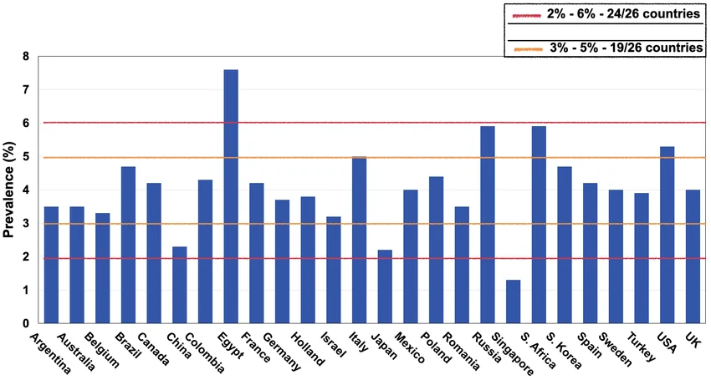
Figure 1: Worldwide prevalence of IBS
(Source: Sperber, 2021)

Describing the digital technology
The betterment of health care could be done through “Bellymind”, which is an adhesive and breathable biosensor array with an AI-driven digital coaching platform. It will be helpful in mapping real-time abdominal electrical activity and correlating it with physiological stress and visceral hypersensitivity to provide immediate personalised neuromodulation (Ramadi et al., 2020).
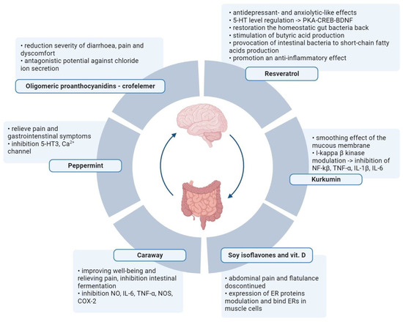
Figure 2: Alternative therapies in IBS by active metabolites of plants
(Source: Dudzińska et al., 2023)
This proposed digital technology aligns with the Biopsychosocial Model by bridging the objective data with the subjective social and psychological states (Kusnanto et al., 2018).
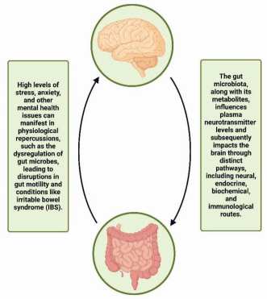
Figure 3: Bidirectional relation of gut-brain-axis
(Source: BHOWMICK et al., 2025)

The Use of Bellymind in health promotion of IBS
The technology named Bellymind will be helpful for providing actionable health promotion by preventing stress-induced gut flare–ups before they happen and improving IBS management (Mustafa, 2025). Similarly, this proposed technology helps to intercept the pain signals in the enteric nervous system, which is helpful for desensitising the gut (Patel and Pasricha, 2020). This is helpful in lowering nerve sensitivity, which causes normal digestion to feel painful in IBS patients. Here, AI-enabled bio-feedback engines powered by machine learning will be helpful for correlating electrical baseline shifts in the gut for predicting pain flares.
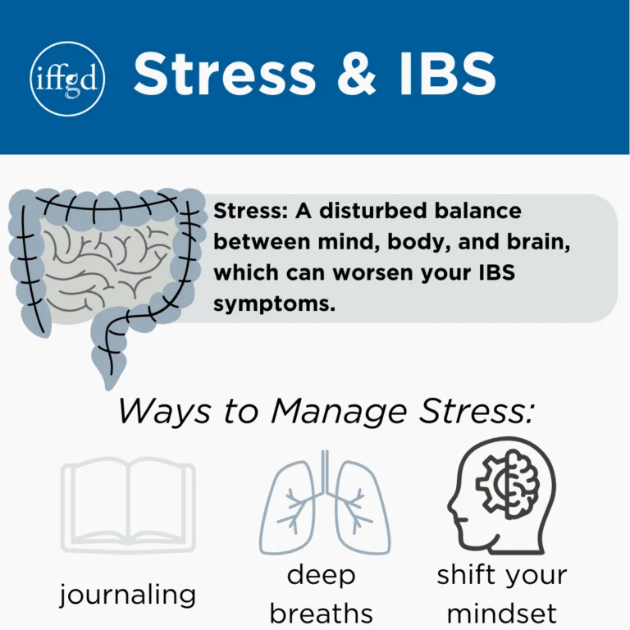
Figure 4: Stress and IBS
(Source: IFFGD, 2026)

Critical discussion
Advantages
- It is helpful in proactive stress intervention through the help of AI detection in minimal time with Inexpensiveness.
- It plays an essential role in personalised digital coaching, where it is helpful for tailoring the intervention to users’ specific needs.
Disadvantages
- Continuous wearing of an adhesive array can cause allergic dermatitis or skin irritation.
- Artificial intelligence is still in exploratory phases, which limits the implementation and calibration accuracy of the technology due to data security issues (Faiyazuddin et al., 2025).

Conclusion
Therefore, it can be summarised from the above-mentioned findings that Bellymind plays an essential role in the intervention of IBS, which is a crucial threat nowadays. The intervention of the disease will be helpful for global patients to recover from the disease in a non-expensive and time-friendly way.

References
BHOWMICK, B., BANERJEE, S., GAYEN, S., SAMANTA, S. and BANERJEE, N. (2025) ‘Irritable Bowel Syndrome: Gut Microbiota Dysbiosis and Psychological Co-morbidities’, Journal of Clinical & Diagnostic Research, 19(1). Available at: https://jcdr.net/articles/PDF/20500/75633_CE%28Ra1%29_F%28Sh%29_QC%28PS_OM%29_PF1%28AG_SS%29_PFA%28IS%29_PB%28AG_IS%29_PN%28IS%29.pdf (Accessed: 18 July 2026).
Dudzińska, E., Grabrucker, A.M., Kwiatkowski, P., Sitarz, R. and Sienkiewicz, M. (2023) ‘The Importance of Visceral Hypersensitivity in Irritable Bowel Syndrome—Plant Metabolites in IBS Treatment’, Pharmaceuticals, 16(10), p.1405. Available at: https://doi.org/10.3390/ph16101405 (Accessed: 18 July 2026).
Faiyazuddin, M., Rahman, S.J.Q., Anand, G., Siddiqui, R.K., Mehta, R., Khatib, M.N., Gaidhane, S., Zahiruddin, Q.S., Hussain, A. and Sah, R. (2025) ‘The impact of artificial intelligence on healthcare: a comprehensive review of advancements in diagnostics, treatment, and operational efficiency’, Health science reports, 8(1), p.e70312. Available at: https://doi.org/10.1002/hsr2.70312 (Accessed: 18 July 2026).
IFFGD (2026) Psychological Factors and IBS: How Stress, Anxiety, and Mental Health Affect IBS. Available at: https://aboutibs.org/what-is-ibs/psychological-factors-and-ibs/ (Accessed: 18 July 2026).
Kusnanto, H., Agustian, D. and Hilmanto, D. (2018) ‘Biopsychosocial model of illnesses in primary care: A hermeneutic literature review’, Journal of family medicine and primary care, 7(3), pp.497-500. Available at: https://doi.org/10.4103/jfmpc.jfmpc_145_17 (Accessed: 18 July 2026).
Makkawy, E.A., Abdulaal, I.E., Kalaji, F.R., Makkawi, M., Alsindi, N. and MAKKAWY, E.A. (2023) ‘Prevalence, risk factors, and management of irritable bowel syndrome in Saudi Arabia: a systematic review’, Cureus, 15(10). Available at: https://doi.org/10.7759/cureus.47440 (Accessed: 18 July 2026).
Mustafa, Y.F. (2025) ‘When the gut speaks: the hidden toll of irritable bowel syndrome on body and mind’, Gastroenterology & Endoscopy, 3(3), pp.135-151. Available at: https://doi.org/10.1016/j.gande.2025.05.002 (Accessed: 18 July 2026).
Nathani, R.R., Sodhani, S. and Goosenberg, E. (2025) Irritable bowel syndrome. StatPearls [Internet]. Treasure Island (FL): StatPearls Publishing.
Patel, Y.A. and Pasricha, P.J. (2020) ‘Enteric neuromodulation for the gut and beyond’, Cold Spring Harbor Perspectives in Medicine, 10(1), p.a034355. Available at: https://doi.org/10.1101/cshperspect.a034355 (Accessed: 18 July 2026).
Ramadi, K.B., Srinivasan, S.S. and Traverso, G. (2020) ‘Electroceuticals in the gastrointestinal tract’, Trends in pharmacological sciences, 41(12), pp.960-976. Available at: https://doi.org/10.1016/j.tips.2020.09.014 (Accessed: 18 July 2026).
Sperber, A.D. (2021) ‘epidemiology of IBS and other bowel disorders of gut–brain interaction (DGBI)’, Alimentary pharmacology & therapeutics, 54, pp.S1-S11. Available at: https://doi.org/10.1111/apt.16582?urlappend=%3Futm_source%3Dresearchgate.net%26utm_medium%3Darticle (Accessed: 18 July 2026).
Staudacher, H.M., Black, C.J., Teasdale, S.B., Mikocka-Walus, A. and Keefer, L. (2023) ‘Irritable bowel syndrome and mental health comorbidity—approach to multidisciplinary management’, Nature Reviews Gastroenterology & Hepatology, 20(9), pp.582-596. Available at: https://doi.org/10.1038/s41575-023-00794-z (Accessed: 18 July 2026).

