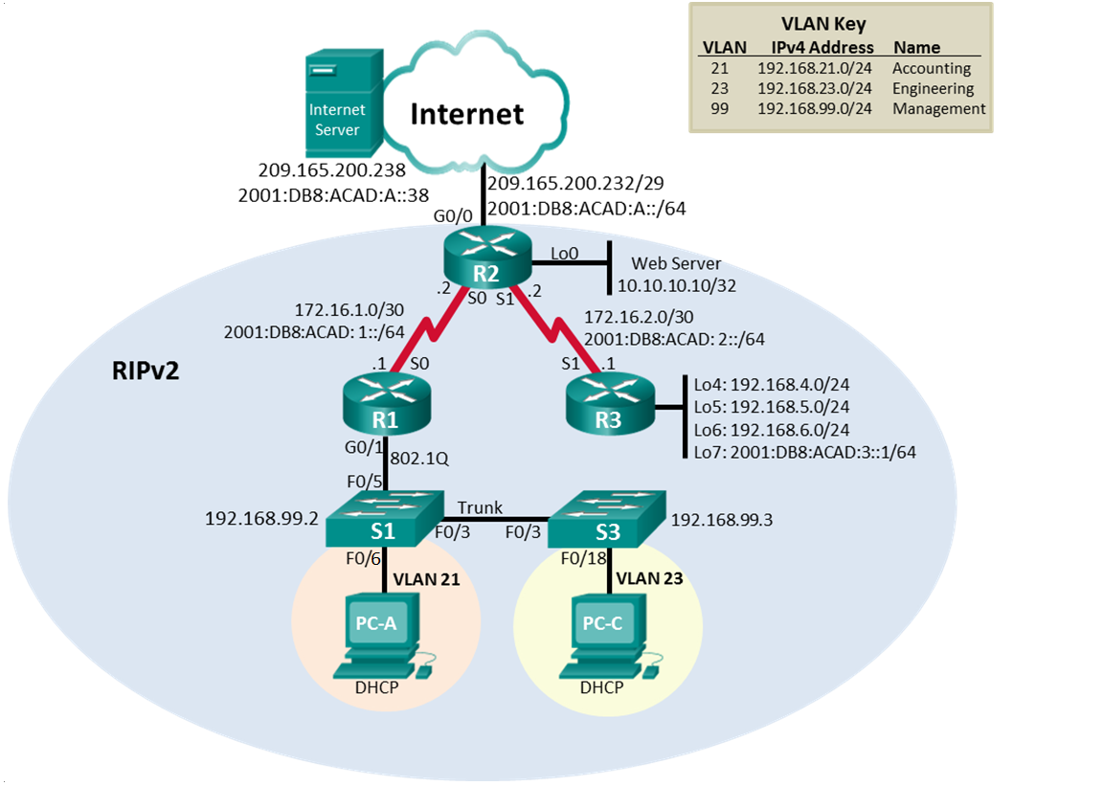

Final Configuration:

R1#sh run
Building configuration...

Current configuration : 1809 bytes
!
version 15.1
no service timestamps log datetime msec
no service timestamps debug datetime msec
no service password-encryption
!
hostname R1
ip dhcp excluded-address 192.168.21.1 192.168.21.20
ip dhcp excluded-address 192.168.23.1 192.168.23.20
!
ip dhcp pool ACCT
network 192.168.21.0 255.255.255.0
default-router 192.168.21.1
dns-server 10.10.10.10
ip dhcp pool ENGNR
network 192.168.23.0 255.255.255.0
default-router 192.168.23.1
dns-server 10.10.10.10
!
!
no ip cef
ipv6 unicast-routing
!
no ipv6 cef
!
!
interface GigabitEthernet0/0
no ip address
duplex auto
speed auto
shutdown
!
interface GigabitEthernet0/1
no ip address
duplex auto
speed auto
!
interface GigabitEthernet0/1.21
description Accounting LAN
encapsulation dot1Q 21
ip address 192.168.21.1 255.255.255.0
!
interface GigabitEthernet0/1.23
description Engineering LAN
encapsulation dot1Q 23
ip address 192.168.23.1 255.255.255.0
!
interface GigabitEthernet0/1.99
description Management LAN
encapsulation dot1Q 99
ip address 192.168.99.1 255.255.255.0
!
interface Serial0/0/0
description Connection to R2
ip address 172.16.1.1 255.255.255.252
ipv6 address 2001:DB8:ACAD:1::1/64
clock rate 128000
!
interface Serial0/0/1
no ip address
clock rate 2000000
shutdown
!
interface Vlan1
no ip address
shutdown
!
router rip
version 2
passive-interface GigabitEthernet0/1.21
passive-interface GigabitEthernet0/1.23
passive-interface GigabitEthernet0/1.99
network 172.16.0.0
network 192.168.21.0
network 192.168.23.0
network 192.168.99.0
no auto-summary
!
ip classless
!
ip flow-export version 9
!
ipv6 route ::/0 Serial0/0/0
!
line con 0
!
line aux 0
!
line vty 0 4
login
!
!
end

R2#sh run
Building configuration...

Current configuration : 1804 bytes
!
version 15.1
no service timestamps log datetime msec
no service timestamps debug datetime msec
no service password-encryption
!
hostname R2
!
username webuser privilege 15 secret 5 $1$mERr$SvWFW3CBz5vTzcBF6nT5u0
!
interface Loopback0
description Simulated Web Server
ip address 10.10.10.10 255.255.255.255
ip nat inside
!
interface GigabitEthernet0/0
description Conneciton to ISP
ip address 209.165.200.225 255.255.255.248
ip nat outside
duplex auto
speed auto
ipv6 address 2001:DB8:ACAD:A::1/64
!
interface GigabitEthernet0/1
no ip address
duplex auto
speed auto
shutdown
!
interface Serial0/0/0
description Connection to R1
ip address 172.16.1.2 255.255.255.252
ipv6 address 2001:DB8:ACAD:1::2/64
!
interface Serial0/0/1
description Conneciton to R3
ip address 172.16.2.2 255.255.255.252
ipv6 address 2001:DB8:ACAD:2::2/64
clock rate 128000
!
interface Vlan1
no ip address
shutdown
!
router rip
version 2
passive-interface Loopback0
network 10.0.0.0
network 172.16.0.0
default-information originate
no auto-summary
!
ip nat pool INTERNET 209.165.200.225 209.165.200.228 netmask 255.255.255.248
ip nat inside source list 1 pool INTERNET
ip nat inside source static 10.10.10.10 209.165.200.229
ip classless
ip route 0.0.0.0 0.0.0.0 GigabitEthernet0/0
!
ip flow-export version 9
!
ipv6 route ::/0 GigabitEthernet0/0
!
ip access-list standard ADMIN-MGT
permit host 172.16.12.1
access-list 1 permit 192.168.21.0 0.0.0.255
access-list 1 permit 192.168.23.0 0.0.0.255
access-list 1 permit 192.168.4.0 0.0.3.255
line con 0
!
line aux 0
!
line vty 0 4
access-class ADMIN-MGT in
login
transport input telnet
end

R3#sh run
Building configuration...

Current configuration : 1296 bytes
!
version 15.1
no service timestamps log datetime msec
no service timestamps debug datetime msec
no service password-encryption
!
hostname R3
!
interface Loopback4
ip address 192.168.4.1 255.255.255.0
!
interface Loopback5
ip address 192.168.5.1 255.255.255.0
!
interface Loopback6
ip address 192.168.6.1 255.255.255.0
!
interface Loopback7
no ip address
ipv6 address 2001:DB8:ACAD:3::1/64
!
interface GigabitEthernet0/0
no ip address
duplex auto
speed auto
shutdown
!
interface GigabitEthernet0/1
no ip address
duplex auto
speed auto
shutdown
!
interface Serial0/0/0
no ip address
clock rate 2000000
shutdown
!
interface Serial0/0/1
description Conneciton to R2
ip address 172.16.2.1 255.255.255.252
ipv6 address 2001:DB8:ACAD:2::2/64
!
interface Vlan1
no ip address
shutdown
!
router rip
version 2
passive-interface Loopback4
passive-interface Loopback5
passive-interface Loopback6
network 172.16.0.0
network 192.168.4.0
network 192.168.5.0
network 192.168.6.0
no auto-summary
!
ip classless
!
ip flow-export version 9
!
ipv6 route ::/0 Serial0/0/1
line con 0
!
line aux 0
!
line vty 0 4
login
end

S1#sh run
Building configuration...

Current configuration : 2003 bytes
!
version 12.2
no service timestamps log datetime msec
no service timestamps debug datetime msec
no service password-encryption
!
hostname S1
!
!
!
!
!
spanning-tree mode pvst
spanning-tree extend system-id
!
interface FastEthernet0/1
switchport mode access
shutdown
!
interface FastEthernet0/2
switchport mode access
shutdown
!
interface FastEthernet0/3
switchport mode trunk
!
interface FastEthernet0/4
switchport mode access
shutdown
!
interface FastEthernet0/5
switchport mode trunk
!
interface FastEthernet0/6
switchport access vlan 21
switchport mode access
!
interface FastEthernet0/7
switchport mode access
shutdown
!
interface FastEthernet0/8
switchport mode access
shutdown
!
interface FastEthernet0/9
switchport mode access
shutdown
!
interface FastEthernet0/10
switchport mode access
shutdown
!
interface FastEthernet0/11
switchport mode access
shutdown
!
interface FastEthernet0/12
switchport mode access
shutdown
!
interface FastEthernet0/13
switchport mode access
shutdown
!
interface FastEthernet0/14
switchport mode access
shutdown
!
interface FastEthernet0/15
switchport mode access
shutdown
!
interface FastEthernet0/16
switchport mode access
shutdown
!
interface FastEthernet0/17
switchport mode access
shutdown
!
interface FastEthernet0/18
switchport mode access
shutdown
!
interface FastEthernet0/19
switchport mode access
shutdown
!
interface FastEthernet0/20
switchport mode access
shutdown
!
interface FastEthernet0/21
switchport mode access
shutdown
!
interface FastEthernet0/22
switchport mode access
shutdown
!
interface FastEthernet0/23
switchport mode access
shutdown
!
interface FastEthernet0/24
switchport mode access
shutdown
!
interface GigabitEthernet0/1
!
interface GigabitEthernet0/2
!
interface Vlan1
no ip address
shutdown
!
interface Vlan99
mac-address 0001.9776.6501
ip address 192.168.99.2 255.255.255.0
!
ip default-gateway 192.168.99.1
!
!
!
!
line con 0
!
line vty 0 4
login
line vty 5 15
login
!
!
!
end

S1#sh vlan

VLAN Name Status Ports
---- -------------------------------- --------- -------------------------------
1 default active Fa0/1, Fa0/2, Fa0/4, Fa0/7
Fa0/8, Fa0/9, Fa0/10, Fa0/11
Fa0/12, Fa0/13, Fa0/14, Fa0/15
Fa0/16, Fa0/17, Fa0/18, Fa0/19
Fa0/20, Fa0/21, Fa0/22, Fa0/23
Fa0/24, Gig0/1, Gig0/2
21 Accounting active Fa0/6
99 Management active
1002 fddi-default act/unsup
1003 token-ring-default act/unsup
1004 fddinet-default act/unsup
1005 trnet-default act/unsup

VLAN Type SAID MTU Parent RingNo BridgeNo Stp BrdgMode Trans1 Trans2
---- ----- ---------- ----- ------ ------ -------- ---- -------- ------ ------
1 enet 100001 1500 - - - - - 0 0
21 enet 100021 1500 - - - - - 0 0
99 enet 100099 1500 - - - - - 0 0
1002 fddi 101002 1500 - - - - - 0 0
1003 tr 101003 1500 - - - - - 0 0
1004 fdnet 101004 1500 - - - ieee - 0 0
1005 trnet 101005 1500 - - - ibm - 0 0

VLAN Type SAID MTU Parent RingNo BridgeNo Stp BrdgMode Trans1 Trans2
---- ----- ---------- ----- ------ ------ -------- ---- -------- ------ ------

Remote SPAN VLANs
------------------------------------------------------------------------------

Primary Secondary Type Ports
------- --------- ----------------- ------------------------------------------
S1#

S3#sh run
Building configuration...

Current configuration : 2076 bytes
!
version 12.2
no service timestamps log datetime msec
no service timestamps debug datetime msec
no service password-encryption
!
hostname S3
!
!
!
!
!
spanning-tree mode pvst
spanning-tree extend system-id
!
interface FastEthernet0/1
switchport mode access
shutdown
!
interface FastEthernet0/2
switchport mode access
shutdown
!
interface FastEthernet0/3
switchport mode trunk
!
interface FastEthernet0/4
switchport mode access
shutdown
!
interface FastEthernet0/5
switchport mode access
shutdown
!
interface FastEthernet0/6
switchport mode access
shutdown
!
interface FastEthernet0/7
switchport mode access
shutdown
!
interface FastEthernet0/8
switchport mode access
shutdown
!
interface FastEthernet0/9
switchport mode access
shutdown
!
interface FastEthernet0/10
switchport mode access
shutdown
!
interface FastEthernet0/11
switchport mode access
shutdown
!
interface FastEthernet0/12
switchport mode access
shutdown
!
interface FastEthernet0/13
switchport mode access
shutdown
!
interface FastEthernet0/14
switchport mode access
shutdown
!
interface FastEthernet0/15
switchport mode access
shutdown
!
interface FastEthernet0/16
switchport mode access
shutdown
!
interface FastEthernet0/17
switchport mode access
shutdown
!
interface FastEthernet0/18
switchport access vlan 23
switchport mode access
!
interface FastEthernet0/19
switchport mode access
shutdown
!
interface FastEthernet0/20
switchport mode access
shutdown
!
interface FastEthernet0/21
switchport mode access
shutdown
!
interface FastEthernet0/22
switchport mode access
shutdown
!
interface FastEthernet0/23
switchport mode access
shutdown
!
interface FastEthernet0/24
switchport mode access
shutdown
!
interface GigabitEthernet0/1
!
interface GigabitEthernet0/2
!
interface Vlan1
no ip address
shutdown
!
interface Vlan23
mac-address 0005.5e76.4d01
no ip address
!
interface Vlan99
mac-address 0005.5e76.4d02
ip address 192.168.99.3 255.255.255.0
!
ip default-gateway 192.168.99.1
!
!
!
!
line con 0
!
line vty 0 4
login
line vty 5 15
login
!
!
!
end

S3#sh vlan

VLAN Name Status Ports
---- -------------------------------- --------- -------------------------------
1 default active Fa0/1, Fa0/2, Fa0/4, Fa0/5
Fa0/6, Fa0/7, Fa0/8, Fa0/9
Fa0/10, Fa0/11, Fa0/12, Fa0/13
Fa0/14, Fa0/15, Fa0/16, Fa0/17
Fa0/19, Fa0/20, Fa0/21, Fa0/22
Fa0/23, Fa0/24, Gig0/1, Gig0/2
23 Enigeering active Fa0/18
99 Management active
1002 fddi-default act/unsup
1003 token-ring-default act/unsup
1004 fddinet-default act/unsup
1005 trnet-default act/unsup

VLAN Type SAID MTU Parent RingNo BridgeNo Stp BrdgMode Trans1 Trans2
---- ----- ---------- ----- ------ ------ -------- ---- -------- ------ ------
1 enet 100001 1500 - - - - - 0 0
23 enet 100023 1500 - - - - - 0 0
99 enet 100099 1500 - - - - - 0 0
1002 fddi 101002 1500 - - - - - 0 0
1003 tr 101003 1500 - - - - - 0 0
1004 fdnet 101004 1500 - - - ieee - 0 0
1005 trnet 101005 1500 - - - ibm - 0 0

VLAN Type SAID MTU Parent RingNo BridgeNo Stp BrdgMode Trans1 Trans2
---- ----- ---------- ----- ------ ------ -------- ---- -------- ------ ------

Remote SPAN VLANs
------------------------------------------------------------------------------

Primary Secondary Type Ports
------- --------- ----------------- ------------------------------------------
S3#
S3#

