Do comics celebrate or subvert the status quo?
1703032
BA Illustration
Word count: 1,344
Scott Smith

In preparation for my eventual dissertation, I will be viewing comic books and their influence on systematic norms through a critical and introspective lens. Regardless of personal opinion, the comic book industry has never been more successful than now, with the rise of the Marvel cinematic universe, and television adaptations, Marvel and DC’s iconic heroes are everywhere, they’ve become unavoidable. Stories can be an escape from reality and the writers much like Charon of Greek mythology, for a small free, transport you across the river and into the fictional world of your choosing. But, have you considered the fact that fictional experiences can shape the audience’s perspective on reality? To further prepare myself, I will be focusing on the phenomenon of fiction shaping reality and culture.

Dramatic portrayals, often fetishized and romanticized, can reinforce rather than challenge stereotypes.

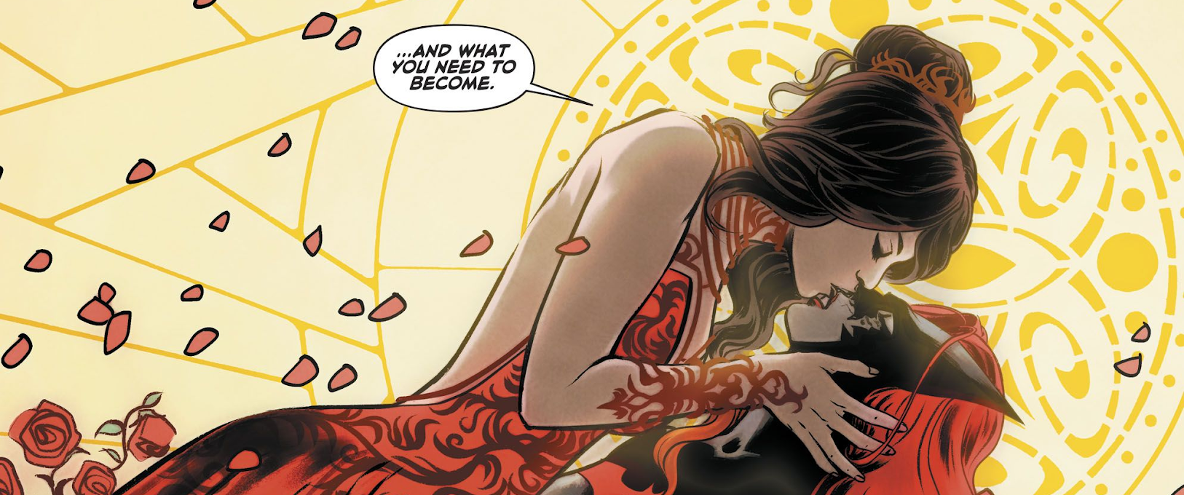Laming, M. and Blanco, F. (2017). Batwoman (2017) Issue #10.
Kate Kane as Batwoman, an openly gay Jewish woman.
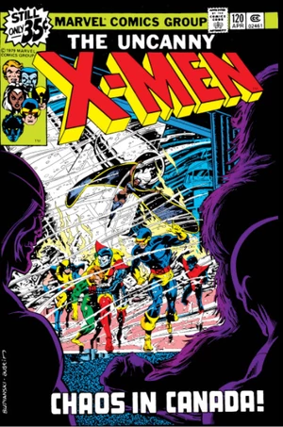
Queer theory was built from the foundation of Queer studies and women’s studies. Queer theory is a collection of writings and academic papers that discuss what it is to be ‘queer,’ and operate as a queer individual in a heteronormative society. Building upon the challenges put forth by feminism that challenges the concept that gender as part of the essential self, Queer theory expands its focus to encompass any sexual activity or identity that falls into normative and deviant categories. Teresa De Lauretis coined the term queer theory for a self-organized conference at the universe of california, Santa Cruz in 1990.

Foregoing the establishment of Queer theory during the 1990s, Marvel studios introduced to the world; a new character, Northstar. Northstar is credited as being the first major gay character, creator John Byrne commented that Northstar was to be gay since his inception in 1979, his identity was gay through and through, he was created with homosexuality as a defining aspect of his character. The decade preceding Northstar’s debut, The stonewalls riots made history. The Stonewall riots; a series of spontaneous, violent demonstrations by ‘queer’ individuals. “In the early hours of June 28, 1969, New York City police raided the Stonewall Inn, a gay club located in Greenwich Village in New York City. […] The Stonewall riots served as a catalyst for the gay rights movement in the United States and around the world.” In retrospect, the creation of Northstar was an inevitable natural progression, even fifty years after the riots, we’re discussing the events, it was a powerful moment in history that changed the world. Comic books are influenced by reality, just as they influence reality, it’s an equal exchange.
Budiansky, B., Austin, T. and Crespi, D. (1979). X-Men Vol 1 #120. [image].

In 1993, fourteen years after Northstar was introduced to the world, Michael Warner defined queer as ‘resistance to regimes of the normal.’ Was John Byrne conscious in his defiance? Was he aware of what creating Northstar symbolised, as the first of his kind? He was defying the heteronormative regime that would persist despite the strides and progression made. Even now, four decades later, we’re dealing with media tropes such as ‘bury your gays’ and ‘dead lesbian syndrome.

“[Television] has yet to recover from the [2015/16 and 16/17] seasons, which included the deaths of an overwhelming number of lesbian and bisexual women characters. These deaths were often in service of another straight, cisgender character's plotline, and sent a toxic message to audiences. This decades-long trend — referred to in popular culture as "Bury Your Gays" — has made countless headlines in the past year, educating both viewers and creators alike on just how ubiquitous this trope has been." — Opening statement to the 2017/18 GLAAD Where We Are on TV Report. If queer theory seeks to understand what it means to operate as a queer individual in society, a society that has defined heterosexuality eurocentric ideals as the norm, are queer and non-white characters cursed to portray the worst of their experiences? Or, can the media, comic books specifically, work to subvert queer struggles and change the world? Or, will the media continue to validate the heteronormative behavior that legitimized the hatred and violence against the queer community?

The phenomena that I plan to research in depth as the foundation of my eventual dissertation includes but, is not limited to; bury your gays, queerbaiting, and the gay/trans panic defense. Alongside characters such as Batwoman, Midnighter, Iceman, Poison Ivy, Miss America, and Valkyrie which will build a library of references and experiences to discuss and analyze.
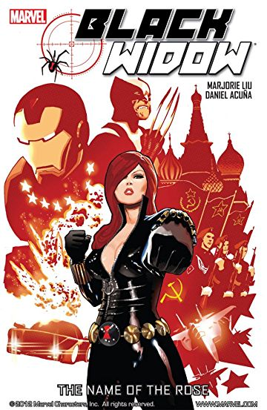
Natasha Romanova, The Black Widow, Marvel's very own observation on tropes and sexist expectations of what a strong female character should be. Callous, heartless and unloving. This expectation is plainly subverted during the narrative of the name of the rose, one of Black Widow’s many stand-alone issues. Imus champion, a b-lister villain to the Avengers in the past, feeling humiliated by his repeated defeats, sought to seek revenge on Natasha Romanova because he considered her “the heart of the Avengers.” (name of the rose #4.) Black Widow, despite how director Joss Whedon might wish to portray her, is not the embodiment of the cold superspy who relies heavily on her sexual prowess to achieve her goals, it’s sexist and removes Natasha from her powerful feminist narrative. Portraying Black Widow as the very tropes she was created to subvert removes her from herself.

First-wave feminism occurred during the 19th and early 20th century, it focused on legal issues, primarily on gaining the right to vote. British women in 1918 gained the right to vote, defining the first wave of feminism, Natasha would make her debut forty-six years later, in Tales of Suspense #52, during the second-wave of feminism. Second-wave feminism’s aim was to increase equality for women by gaining more than just enfranchisement.
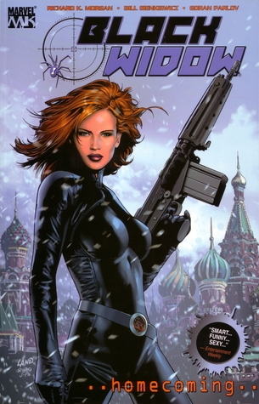
“Dressed to kill’s a strange expression. Heels you can barely walk in, let alone run. Skin exposed all over, regardless of weather. A look that says “take me, I’m yours.” Dressed to be killed, more like. But if you want to reel in a shark, you’ve got to put meat on the hook.” (Natasha Romanova, Homecoming #3.) Homecoming was released in 2004, fifteen years ago, forty years since her debut, this monologue is out of character and works to dismantle the fifty years of continuity. Subconsciously or consciously, Richard K. Morgan has aided in the dismantlement of Natasha Romanova’s narrative as a strong female character, in a single issue, she was reduced to her sexuality.

As quickly as a comic book character can be created to subvert and challenge the status quo, they can be rehashed and reintroduced as a character that celebrates the status quo. You pick up and read Richard K. Morgan’s portrayal of Natasha, never before being exposed to her character before, your initial experience has now shaped the way you see her forever; a character defined by sexist tropes and not as the feminist symbol she had been established to be, for the last fifty years.

In an attempt to further contextualize and understand both Queer theory and Gender studies on a personalized level, I will seek to redefine both Queer theory and Gender studies by exploring both through the lens of an individual in the twenty-first century, as an individual of the snowflake generation. Collins defines the term ‘snowflake generation’ as “the young adults of the 2010s, viewed as being less resilient and more prone to taking offense than previous generations.” Political correctness is the avoidance of expression or action that may exclude, marginalize, or insult groups of socially disadvantaged or discriminated against. Despite being used infrequently until the latter part of the 20th century, political correctness has the hallmarks of a theory that would be coined by a millennial. The term ‘politically correct’ appeared in a U.S supreme court judgment of a political lawsuit.

Do comics celebrate or challenge the status quo? How can comic books confront stereotypes and stigma? Can comics be used to subvert accepted norms?

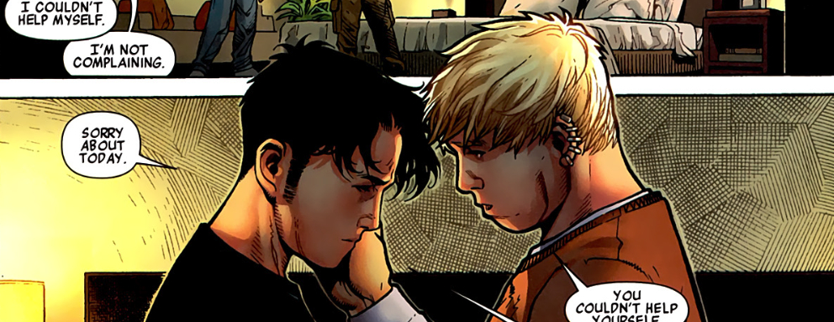Marvel (2010). Avengers: The Children's Crusade (2010) #1. Billy Kaplan and Teddy Altman.

Bibliography :

TED-Ed. (2019). How fiction can change reality - Jessica Wise. [online] Available at: https://ed.ted.com/lessons/jessica-wise-how-fiction-can-change-reality.
HISTORY. (2019). Stonewall Riots. [online] Available at: https://www.history.com/topics/gay-rights/the-stonewall-riots.
NeoGAF. (2019). The Desire for Representation in Games - An Honest, Open Conversation. [online] Available at: https://www.neogaf.com/threads/the-desire-for-representation-in-games-an-honest-open-conversation.1471717/page-2.
The National LGBTBar Association. (2019). Gay/Trans Panic Defense - The National LGBTBar Association. [online] Available at: https://lgbtbar.org/programs/advocacy/gay-trans-panic-defense/.
Laming, M. and Blanco, F. (2017). Batwoman (2017) Issue #10.
Budiansky, B., Austin, T. and Crespi, D. (1979). X-Men Vol 1 #120. [image].
Pilcher, J. and Whelehan, I. (2004). Fifty key concepts in gender studies. London: SAGE Publications.
Fry, P. (2009). 23. Queer Theory and Gender Performativity. [video] Available at: https://www.youtube.com/watch?v=7bkFlJfxyF0.
Marvel (2010). Avengers: The Children's Crusade (2010) #1.
Peters, Brian Mitchell. "Qu(e)erying Comic Book Culture and Representations of Sexuality in Wonder Woman." CLCWeb: Comparative Literature and Culture 5.3 (2003): https://docs.lib.purdue.edu/cgi/viewcontent.cgi?article=1195&context=clcweb.
Singer, M. (2002). "Black Skins" and White Masks: Comic Books and the Secret of Race. [online] jstor. Available at: https://www.jstor.org/stable/2903369?seq=1#page_scan_tab_contents.
Foreman, K. (2018). What is Queer Theory?. [video] Available at: https://www.youtube.com/watch?v=E7p1c2ofLIU.
Gareth Schott (2010) From fan appropriation to industry re-appropriation: the sexual identity of comic superheroes, Journal of Graphic Novels and Comics, 1:1, 17-29, DOI: 10.1080/21504851003798405
P, M. and H. Sewell, E. (2001). Introducing Comics and Ideology. [ebook] Available at:
https://s3.amazonaws.com/academia.edu.documents/3458369/IChapter1.pdf?AWSAccessKeyId=AKIAIWOWYYGZ2Y53UL3A&Expires=1557307683&Signature=syi0s0rBrReLn5cno2Vg8rdMwZw%3D&response-content-disposition=inline%3B%20filename%3DIntroducing_comics_and_ideology.pdf

