Jack Holland (P149473)
Website Development
Project Management Assignment

Contents
1. Risk Management 2
1.1 Risks involving the project 2
1.2 Risk Evaluation Matrix 3
2. Code of Practice 4
2.1 Sustainability Issues 4
2.2 Legal Issues 4
2.3 Ethical Issues 5
3. Quality Assurance 6

1. Risk Management
For the Mumbles Rangers FC database system, the project must be checked for risks. If it is not the project may fail which would result in time and money being wasted.
Risk Management is the process of finding and managing risks in either a project or organisation. The outcomes of the risks are then managed appropriately. There are four main steps to Risk Management, they are: [1]
- Risk Identification
- Risk Analysis
- Risk Planning
- Risk Monitoring
Risk Identification is when the organisation identifies at the risk to a project or organisation, they then analyse the risk. In most cases the organisation or team will prioritise the risks, judging them from non-serious to serious risks. The risks will then be planned against, preventing them from happening and causing a problem for the organisation or project. Then in the future, the risks will be monitored to check they have been prevented and won’t cause an issue.

1.1 Risks involving the project
There were six risks involving the project, they all have been identified and handled accordingly.
1. University
Each member of the project are university students. Two of the group members are on a separate course to the rest of the group, meaning separate members were available at different times of the week. The project was also planned to take place during the December and January months. This is a busy time for the university as the first semester assignments are due.
To solve this risk, the team postponed a meeting so that everyone on the team could complete assignments.
2. Big Team
The project team had five members, this made arranging meeting up a problem. As mentioned previously, the team was also on separate university courses. Making arranging meetings a problem.
To solve this risk, the team looked at each other’s timetables and decided on a day and time that was suitable for all.
3. Football Team
The football team could have folded during the development of the database system, this is because they are a third sector organisation.
There was no solution to this risk as it was out of the project teams control.
4. Access to Information
As Mumbles Rangers are a small club, finding information about the team was challenging. But the team did have a website that provided enough information for the prototype database.
This risk didn’t need solving as the team found more information than originally thought.

5. Illness
The project was planned to take place during the winter months, during the months it is common for people to fall ill with the flu and other illnesses. The team once experienced issues in communication due to team members falling ill.
To solve this risk, the team postponed one meeting until the week after.
6. Weather
Like the illness risk, the weather delayed demonstrating the project to the stakeholders due to severe weather closing in the university.
To solve this risk, the demonstration was delayed until a week later.

1.2 Risk Evaluation Matrix
Probability | Severity of Risk
Probability | Medium  (Risk 1. 2) | High | High
Probability | Low | Medium | High
Probability | Insignificant  (Risk 3, 4) | Low  (Risk 5, 6) | Medium

The Matrix Evaluation chart (adapted from Study.com[2]) shows the severity of each risk identified above.
Risk 1 and 2 are medium risks as not having regular meetings can delay the project and meetings are going to be affected by assignments and other commitments.
Risk 5 and 6 are low risk but likely to happen, this is because of the time of the year the project is taking place.
Risk 4 is insignificant as it is something that is out of the projects team control. It is also extremely unlikely that the Football Club will fold due to its size and popularity.
Risk 3 is very unlikely to happen, so it have been placed under insignificant.

2. Code of Practice

2.1 Sustainability Issues
The Mumbles Rangers FC database project is a sustainable project, the plan is to move the entire administration aspect onto an electronic Microsoft Access database. This will save paper which is better for the environment. The club can also do their paperwork at home from a laptop or computer, rather than at the club office meaning fewer trips to the team office.
In the future, the clubs computing equipment might get too old to run Microsoft Access. Therefore, it will have to be replaced, the old equipment can be recycled at an IT waste collection centre. The new equipment used to replace the older machine will be better for the environment as it will most likely have the “Energy Star” standard included.
The “Energy Star” standard is a government-backed scheme used to reduce greenhouse gases and other pollutants caused by products[3].

2.2 Legal Issues
The project contains legal and ethical issues, there are certain laws the program must abide by. The main three laws are:
- Data Protection Act 1998
- Computer Misuse Act 1990
- General Data Protection Regulation
Data Protection Act 1998 (DPA)
The DPA is an act which is passed by UK Parliament[4] to control how data is handled by companies. The act states that[5]:
- The data collected by a person or company must be used fairly and inside of the law.
- The information should also not be shared without a person’s consent.
- The information held must also be accurate and up to date.
- The data must not be kept for longer than is necessary.
The Mumbles Rangers FC database project abides by the Data Protection Act by keeping data collected inside a secure database that can be protected by a password, the data is also kept internal to the football club and is not shared. The information is kept up to date by the club staff and if a change happens the information will be updated. If a player leaves the club, their data is deleted from the system.
Computer Misuse Act 1990 (CMA)
The CMA is an act passed by UK Parliament[6] to prevent computers being used for malicious purposes. The act states that[7]:
- A person should not access material without permission
- Access computer material without permission with the intent to commit further offences
- Alter computer data without permission
The project does not break any of the rules in the Computer Misuse Act as the football club is legal and lawful with no malicious intended.

General Data Protection Regulation (GDPR)
The GDPR is a law that will come into force on May 25^{th,} 2018[8]. It is a law that gives citizens and residents more control over their personal data[9]. Although the law is not enforced yet, companies are preparing for it by making changes to the way they handle data.

2.3 Ethical Issues
The British Computer Society (BCS) is a professional society who set the standard for most computing professionals, as the university is a member of this society. The project must follow the ethics of the BCS.
By having the same ethical values of the BCS, it allows consumers who are not computing professionals to have trust, security and a peace of mind.
The Mumbles Rangers FC database follows the British Computer Societies code of conduct. Some examples are:
“1. a. have due regard for public health, privacy, security and well-being of others and the environment.”
The Microsoft Access database will be kept safe and secure by using a password, only allowing authorised users at Mumble Rangers FC.
“2. a. only undertake to do work or provide a service that is within your professional competence.”
The database is designed in Microsoft Access, as it is easier to create rather than building one using SQL Server. Microsoft Access was chosen as each member of the team studied the Information Engineering module last year having competence in the subject.
“2. d. ensure that you have the knowledge and understanding of Legislation and that you comply with such Legislation, in carrying out your professional responsibilities.”
By complying with the Data Protection Act and Computer Misuse Act, the project has complied with legal legislation involving the program.

3. Quality Assurance
Quality Assurance is the process of finding out if a product meets the specified requirements. The database project has been tested for Quality Assurance.
It is important that software is tested during its development cycle. If it is not, the software could fail to meet the customers’ requirements. The customer will then reject the software costing the developer time and money. The software could also have glitches or errors which could be exploited if given to the wrong people.

3.1 Quality Assurance for the Project Database
The Mumbles Rangers FC database has been tested for quality assurance, both in its design and security. The two most important sections of the project, if a database is left unsecured potential hackers could steal the data including the sensitive data of player names, addresses and postcodes. If the project was left poorly designed, the non-technical staff at Mumbles Rangers FC would have a hard time using it.
The testing for the Microsoft Access database was done over a period of 1 week. During the testing the suitability of the interfaces was tested, the relationship and integrity were working and checking the validation rules are appropriate.

References
[1] “Risk Management Definition - Financial Times Lexicon.” [Online]. Available: http://lexicon.ft.com/Term?term=risk-management. [Accessed: 16-Apr-2018].
[2] “Risk Assessment Matrix: Definition &amp; Examples | Study.com.” [Online]. Available: https://study.com/academy/lesson/risk-assessment-matrix-definition-examples.html. [Accessed: 16-Apr-2018].
[3] “ENERGY STAR Product Label | ENERGY STAR.” [Online]. Available: https://www.energystar.gov/products/how-product-earns-energy-star-label. [Accessed: 17-Apr-2018].
[4] “Data Protection Act 1998.”
[5] “BBC - GCSE Bitesize: Responsibilities of data controllers: The Eight Principles.” [Online]. Available: http://www.bbc.co.uk/schools/gcsebitesize/ict/legal/0dataprotectionactrev5.shtml. [Accessed: 17-Apr-2018].
[6] “Computer Misuse Act 1990.”
[7] “BBC - GCSE Bitesize: How to prevent computer misuse.” [Online]. Available: http://www.bbc.co.uk/schools/gcsebitesize/ict/legal/1dataandcomputermisuserev2.shtml. [Accessed: 17-Apr-2018].
[8] “What is GDPR? The summary guide to GDPR compliance in the UK | WIRED UK.” [Online]. Available: http://www.wired.co.uk/article/what-is-gdpr-uk-eu-legislation-compliance-summary-fines-2018. [Accessed: 17-Apr-2018].
[9] “What is GDPR for small business: a comprehensive guide.” [Online]. Available: https://www.simplybusiness.co.uk/knowledge/articles/2017/11/what-is-gdpr-for-small-business/. [Accessed: 17-Apr-2018].

Appendix

1. Screenshots of the Demo
Tables
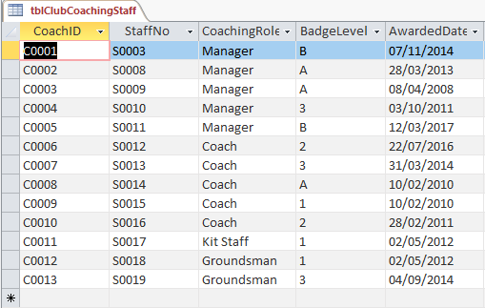
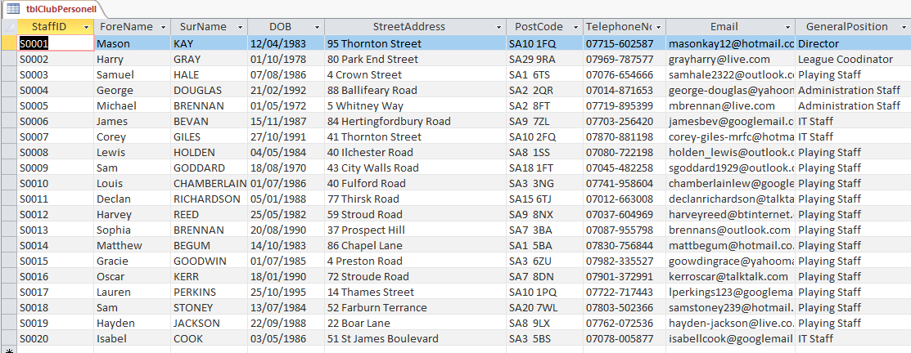
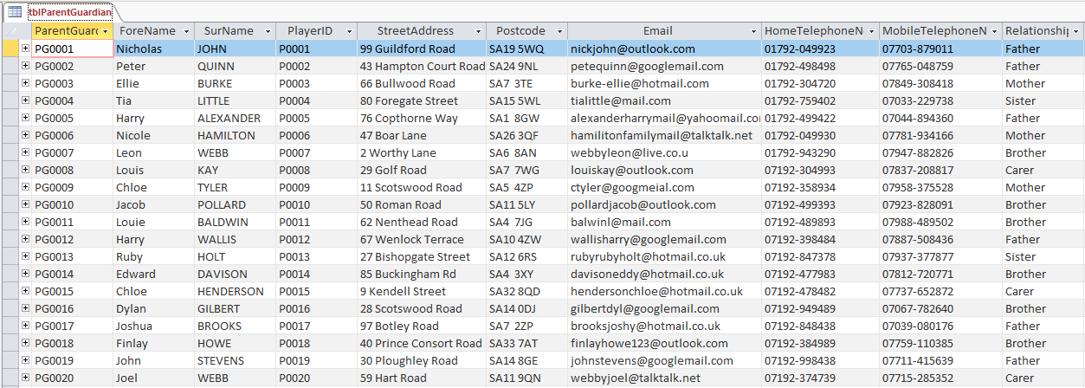
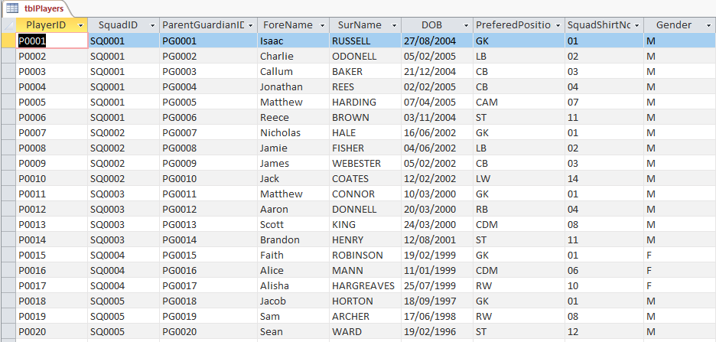
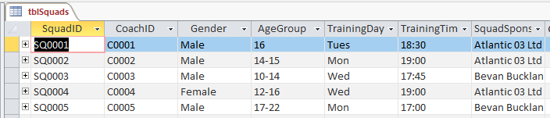
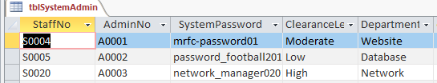

Main Menu Interface
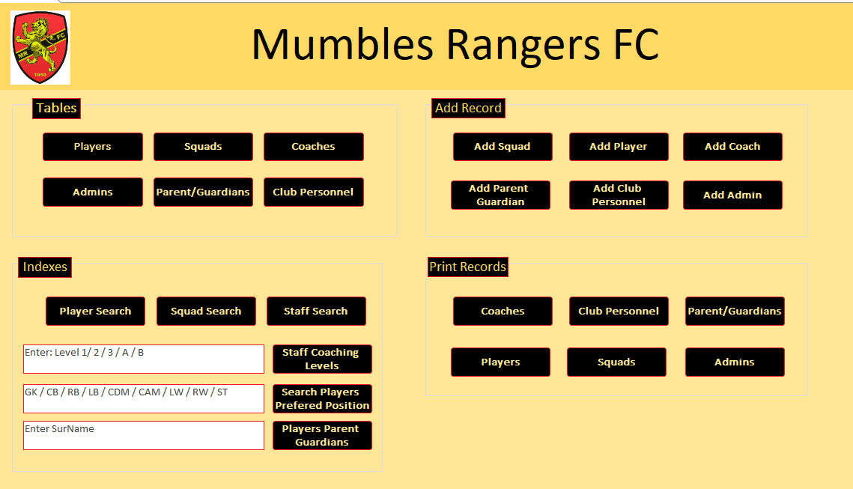
Adding Squad
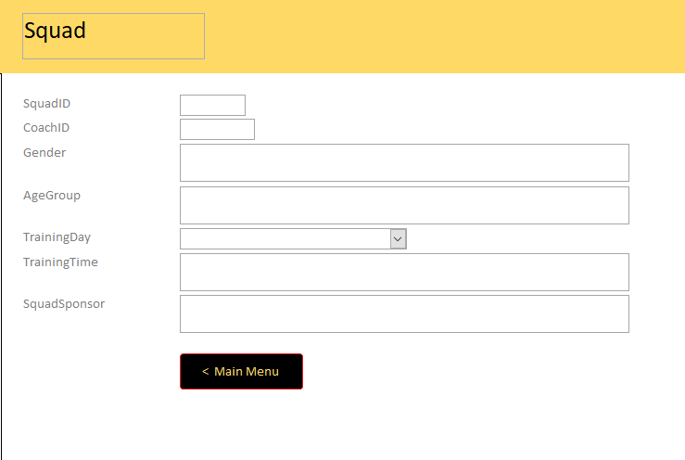

Adding Player
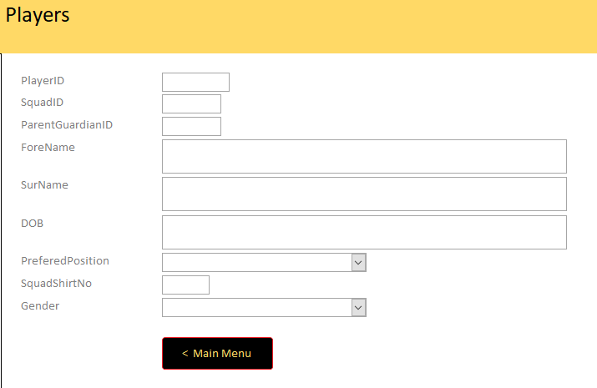
Adding Coach
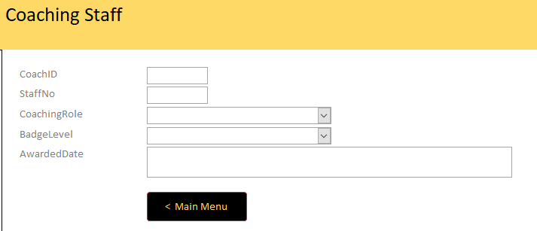

Adding Parent/Guardian
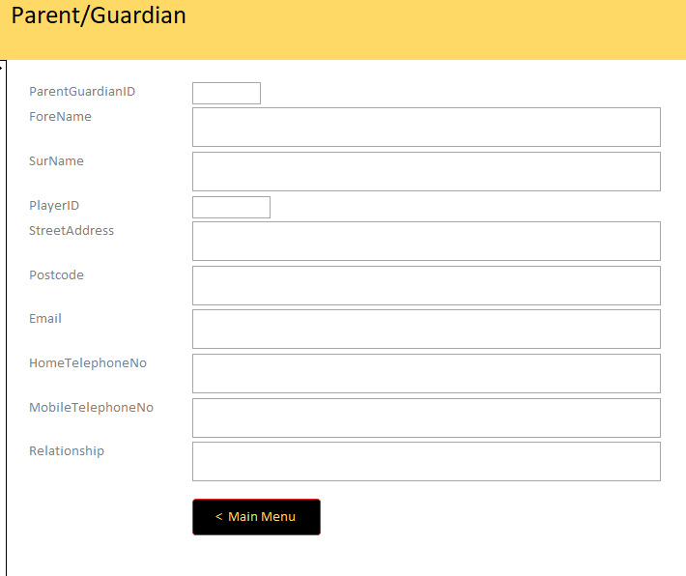
Adding Club Personnel
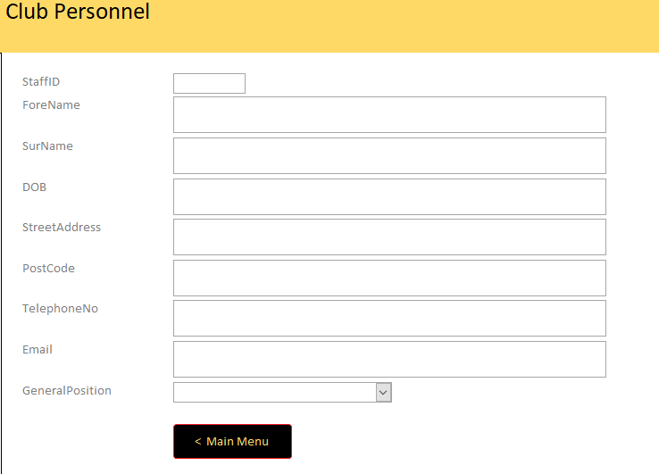

Adding Admins
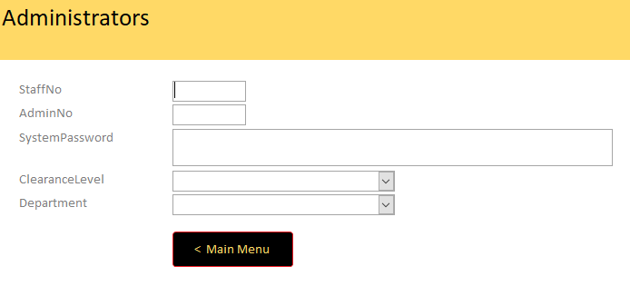

2. Microsoft Project Plan


