1/17/2020
ACDA5005 – Smart & Connected Devices
1809782 – Ben Atkins

Table of contents
- Abstract
- Introduction
- Choices Made for Project
- Improvements & Next Steps
- Conclusion

- Abstract
Throughout this report the author will begin by discussing the decisions made on the implementation of the reporting dashboard detailing the features and technical information. They will then go onto discuss what could have been developed on the implementation and what could not be developed due to lack of knowledge or applicability.

- Introduction
The author was tasked with producing a secure web interface using HTML and PHP as well as having an RDBMS (Relational Database Management System) as a backend, being able to sort through data within the database and having the data display on graphs was a necessity as well as having meaningful information such as aggregated data display to assist the reader in data interpretation.

- Choices made for the project
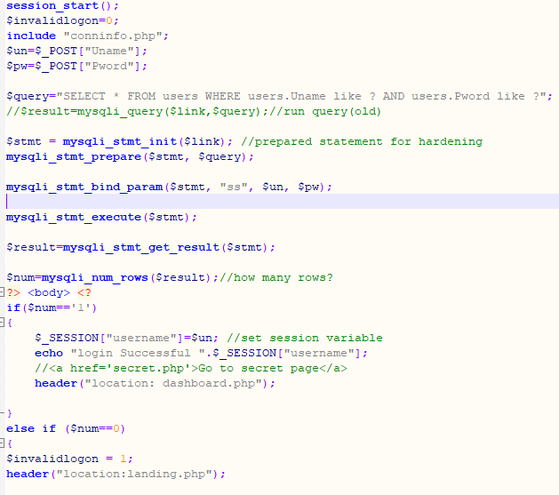
Figure 1 CheckLogin code post-modification

The author first began with the development of the ‘landing’ page, where the user would first arrive and must present logon credentials. This then would link into a sub-page, ‘checklogin’ used to validate the logon credentials. This was provided to the author as part of the project, in order to make it more secure, namely protecting from SQL injection, the author modified the code to run the query through a prepared statement preventing the string being put directly into the query.

Once the development of the initial landing and logon mechanics had been established the author began to work on the dashboard page itself, they provided session validation to access this page, redirecting anyone without a legitimate session back to the landing page using header HTML elements. Following the implementation of the pages structure, title etc. They then began working on the sortable data table seen on the left of the page. This uses the following query within a prepared statement: ‘select Rainfall_in_cm, EntryDate, Sensor from rainfall where Sensor = ? order by ? limit ?;’ the question marks reference the variables being passed in based upon used input into option value attributes located above the table, these option value elements have pre-selected values when the page is initially loaded to prevent the table from being totally empty upon first viewing. The table allows users to filter by sensor or by all sensors, limit the number of rows in the table, and to sort the data by a number of factors including, date, rainfall and sensor.
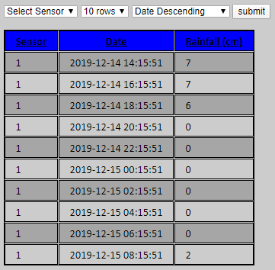
Figure 2 Data Table on Dashboard

Once this was complete the author edited the logout page to include an automatic redirect to streamline user experience further and also edited the provided ‘PullData’ script to allow for additional files should the need arise and additionally added a loop into the code to iterate through the 3 provided data files and return bespoke messages per filename upon successful import to the database to allow the user to identify if there were any errors on which file they occurred.

The author then chose the graph library for the dashboard, they chose to use PHPMyGraph as it is a library they had experience using prior to the project and could navigate the syntax effectively. They began by adding the 3 graphs per sensor to display all of the data that had currently been collected for that sensor using a vertical line graph for each graph, these were stored on a separate .PHP file per graph and added to the main dashboard by using it as a source for an image element. They then chose to add the main graph, this was done in a similar manner to the other graphs with the exception of using a vertical column graph and containing data from all 3 sensors over only the last 24 hours of data, due to the nature of the data provided this had to be hard coded as the latest date on file was January 2019.

The author then finalised the dashboard page with various styling and presentational elements and also added the aggregated data fields seen within the blue boxes, this made use of a few less generic SQL statements such as, MAX, LEFT & AVG to format the data using aggregate functions and trimming.

- Improvements & Next Steps
Whilst the author is happy with the work produced, they would have added a number of additional presentational and functional features to the application to assist with user cognition and usability. These features were left out due to lack of scope for them due to the small amount of data or due to lack of knowledge on how to implement them effectively and securely.

The author would have first added more personalisation and configuration to the graphs on the page, due to some of the configuration statements not working they were unable to edit such things as the graph’s axis, any colouring or adding titles for the axis despite following syntax guides.

Another feature the author would have liked to properly implement was the sorting on the data table, despite passing in the correct ORDER BY syntax into the SQL query from the option value element the data would not be sorted upon outputting to the table, they believe this to be an issue with passing strings into the query using the ‘MYSQLI_stmt_bind_param’ command.

The author would have additionally like to implement a privilege level system using the field specified on the users table to display varying information and control depending on the aforementioned privilege value. This would then be used alongside a settings page allowing all users to edit their password but giving higher privilege users the ability to edit other user’s privileges add new user’s and remove other accounts.

The author would have also added CSS style sheets to each of the pages to aid in reducing the overall volume of code but due to there only being two viewable pages the author felt this to be unnecessary for the scope of the project and opted to use inline CSS in lieu.

- Conclusion
In conclusion, whilst the author is happy with their solution for the monitoring dashboard application they feel that certain additional features would have been of benefit and provided needed functionality to be able to make this a modern live monitoring dashboard that could be used in a corporate or research capacity. Despite this it still functions and accomplishes its assigned tasks displaying the correct data and allowing it to be imported and providing security measures to protect the information.

