

LOCATION: SWANSEA | LLEOLIAD: ABERTAWE
LEVEL 4 | LEFEL 4
EXAMINATION PERIOD | CYFNOD ARHOLIADAU
2023 | 2023
MODULE CODE: ACCB4017
SOFTWARE DEVELOPMENT
(IN-CLASS TEST – time to BE ARRANGED BY MODULE LECTURER)
TIME: 2 HOURS
answer all questions

Equipment or materials required. Please select from the following:
Adnoddau neu ddefnyddiau sydd eu hangen.

Cyfrifiannell/Calculator ☐
Llyfr Agored/Open Book ☒
Arall/Other ☐

Nodwch/Please Note: Students will answer the questions below using the programming language they have studied during the module. The questions/solutions shown below refer to the Python language, but some groups may be studying the module using other programming languages (such as C). Therefore the paper will be adapted to reflect this if required.

Additionally, at some delivery locations, where the test is delivered via electronic means such as Moodle, questions may be drawn from a random pool, but will be in the style and of a similar difficulty level to those listed below.

ANSWER ALL QUESTIONS

1. a) Which variable type would be most suitable to store each of the following values?

p string

-41 int

Gemma string

2.56 float

G5 string

34.62 float

[1 mark each - 6 marks total]

1 b)

What errors are present in the following code for welcoming a user to a program? Line numbers are included for easy reference

1 print(“Welcome to my program")
2
3 print("Please enter your name: ")
4 myName = str(input())
5
6 print("Welcome, " myName)
7
8 print("I shall say hello to you 10 times: ")
9
10 for counter in range(0, 10)
11 print("Hello")

# REVISED CODE (Copy & Paste )
print("Welcome to my program") # Added quotation mark to complete the print statement

print("Please enter your name: ")
myName = str(input()) #Changed the variable to be inputted to be a string instead of an integer

print("Welcome " + myName) # Added + to add my the string variable into the print statement

print("I shall say hello to you 10 times: ")

for counter in range(0, 10): #Semi Colon + Change the Counter from 11 to 10
print("Hello") #Added Indent

[5 marks]

1 c) How many iterations do the following loops have?

for i in range(2, 6, 1): 4 iterations
print("Hello")

for i in range(0, 12, 2): 6 iteration
print("Hello")

[4 marks – 2 marks each]

1. d) What is the value of the integer variable total after the following code is executed?

total = 1
for x in range(0, 9, 1): # There are 8 iterations
total = total + x # For x being 8 and then adding the total vaule being 1 this equals 9
if x == 5:
total = 0
total = total - 1

20 [3 marks]

1 e) Logic

- Given the following values x=5, y=2, z=15 is the statement below true or false?
x<=y 5<=y
false

- Given the following values x=5, y=3, z=12 is the statement below true or false?
x == z/y 5==4
false

[2 marks total]

[20 marks total for Question 1]

2. Calculating the volume of a cone

The volume of a cone is calculated using the formula shown below:
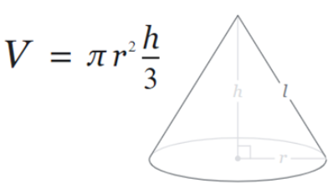

Task:
Write a program to calculate the volume using the above formula.

Allow the user to enter the measurements for r and h. Both r and h should be positive numbers. You can set pi to 3.142

Print the volume on the screen to 2 decimal places
[10 marks total for Question 2]

internal class Program
{
private static void Main(string[] args)
{
double radius = 0;
double height = 0;

bool validRadius = false; // Input validation for radius
while (!validRadius)
{
Console.WriteLine("Enter the radius of the cone:");
string radiusInput = Console.ReadLine();
if (double.TryParse(radiusInput, out radius) && radius > 0)
{
validRadius = true;
}
else
{
Console.WriteLine("Invalid input. Please enter a positive number for the radius."); //Valid input value for radius
}
}

// Input validation for height
bool validHeight = false;
while (!validHeight)
{
Console.WriteLine("Enter the height of the cone:");
string heightInput = Console.ReadLine();
if (double.TryParse(heightInput, out height) && height > 0)
{
validHeight = true;
}
else
{
Console.WriteLine("Invalid input. Please enter a positive number for the height."); //Validation for valid input for height
}
}

double volume = (3.142 * (radius * radius) * height) / 3;
volume = Math.Round(volume, 2); // Volume value to be rounded to 2 decimal places

Console.WriteLine($"The volume of the cone is: {volume}"); //Volume Output
}
}

3. Using lists (Python) or arrays (C etc)

Task:
Declare an empty list in your program to hold some measurements, for example:

rainfall = [ ]

1. Prompt the user to enter five (valid) rainfall measurements (in millimetres) and store them in a list. (eg 3.3, 5.0, 2.6 etc)
2. Print each of the entered values on the screen using a loop.
3. Calculate the total rainfall (ie add all five measurements)
4. Also calculate the average rainfall and print it on the screen

Sample output:
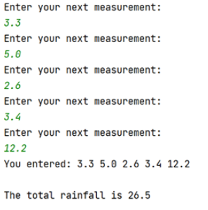
[15 marks total for Question 3]

4. Using Functions

Task:
Write a function called entermeasurement() which will allow the user to enter a measurement for one side of a parcel and then return it to the main program. The function should also check that the measurement entered is greater than 0.

From the main program, call your entermeasurement() function 3 times - once for each of the length, width and height measurements, and print the measurements returned on the screen.

Also, calculate and print the volume of the parcel (length * width * height) on the screen.

Sample output:

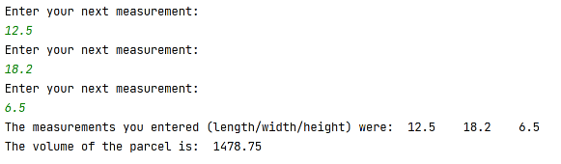
[15 marks total for Question 4]

Diwedd/End

