STUDENT NAME: Federica Giocoli
STUDENT ID : 2121746
MODULE NO: Strategic Management LCMB7003

MBA – Marketing Business and Management

Analysis of Nike’s marketing strategy
Table of Contents

Executive Summary 2
Introduction 2
Section 1 3
Nike’s Company history 3
Exploring strategy 4
Nike’s mission and strategic objectives 5
Success factors of Nike 6
Section 2 7
Critical analysis of external environment 7
Industry analysis 12
Section 3 14
Analysis of Nike’s internal environment 14
SWOT analysis 19
Conclusion 20
Recommendations 21
Reference list 22

Executive Summary
Strategic Management is a continuous procedure that organizations have been utilizing for a long time. Strategies are central to any business as it involves planning, monitoring and assessing several external and internal aspects instrumental in the success of an organization. The strategic process involves formulation, implementation and evaluation of different operations so that goals and objectives can be achieved along with management of the risk factors. Strategic management involves a number of avenues pertaining to the analysis of the external environment, organizational strategy, and organisational direction and controlling strategy. Together, it formulates a holistic approach for the organization. Engaging in the strategic management process involves the participation of top management and planning staff to mould the streams of inputs, processes and outputs for the organization. It is a powerful strategy to excavate the issues and organizational dynamics so that they can be mitigated on time.
In this report, the strategic management of Nike will be discussed elaborately. The report will incorporate various theoretical models and analyze its environment. The array of competitive advantages achieved by the company will also be assessed in this report. Various concepts and techniques will be applied for a successful analysis of the company and suitable recommendations are suggested towards the end. Nonetheless, the report engages in capturing the historical and social development of the company to produce a fundamental framework of the functional aspects of the company.

Introduction
An understanding of the strategic management of an organization would give an idea about current operational processes that help in achieving goals, objectives and competitive advantage for the company. It would assist in the synthesis of external and internal contexts culminating in the impact on the management. The organizational strategy is hereby dictated, depending on the interactions and outcomes of these contexts. The report aims to highlight these interactions through a detailed analysis of Nike.
The report aims to study the growth of Nike in the global market through the analysis of its strategies on the basis of theoretical frameworks. The proliferation of the industry in the athletic domain will be analyzed using tools such as PESTLE analysis, Porter’s Five forces, SWOT analysis, VRIO analysis etc, which would give a bird’s eye view of the entire organization. It would also help in scrutinizing logistics, operational procedures, competitive atmosphere and opportunities available for the company.
The report has been primarily divided into three sections. The first section engages in providing information about company history and locating it in the present scenario. It informs vividly about exploring strategies, mission and objectives of Nike. Setting the premises of the company, the organizational strategic position will be affirmed through introspection of the company. The mission, objectives and success factors will also be discussed in this section. In the second section, the critical analysis of the external environment will be carried out through PESTLE analysis. It would widen the view of the company by situating it with respect to its external environment. The industry analysis will be carried out with the help of Porter’s Five forces to give a dynamic view of the threats and influence embedded within the industry. The last section deals with an analysis of the internal environment through the VRIO framework and SWOT analysis. The report encapsulates all the observations in the end and aims to provide helpful recommendations to bring improvements to the organization.

Section 1

Nike’s Company history
Nike’s history dates back to the year 1964 when it was in its pre-mature stage named Blue Ribbon Sports, founded by Bill Bowerman and his student Phil Knight; headquartered in Beaverton, Oregon. The simple idea of innovating runner’s shoes marked the foundation of Nike. The business acquired its pace in the 1980s and this was the time when it was renamed, Nike (Nike, 2022). Today, Nike is a multinational association involved in the design and development of footwear, equipment and apparel in the global market. The strategic development of Nike entails a series of acquisitions that helped the company to grow. Some of the initial acquisitions were Cole Haan, Bauer Hockey, Hurley International etc. The company was ahead of its time in addressing the issue of the environment in its product design in the 1990s (Standaert, 2022). Unfortunately, the idea could not be nourished with a plan of action, as the company faced a major labour crisis in the mid and late 1990s. The company suffered harsh criticism and was accused of unethical overseas labour practices. Nike took the initiative and implemented several programs focusing on the sustainability of the products and working environment.
Later in the 2000s, it continued with the expansion strategy by acquiring Converse, Starter and Umbro. In 2005, Nike delved deep into the design philosophy of creating greener products and reconsidered its product lifecycle and impact of choices on the supply chain. The ‘Considered Group’ of designers formed the backbone of the company. Along with that, the company analysed the consumer needs and demands and coordinated the production with the factory. By 2008, Nike Inc (Nike, 2022). had reached the pinnacle of success acquiring the position of the leading brand in athletic products. Nike could cater to the needs of the customers by a persistent emphasis on innovation and the development of its products.
Around 2008, the company Nike Inc. became a leading player with a revenue of $18.6 billion, out of which Nike solely accounted for $16 billion while the rest of the share was accounted for by acquired brands. Nike enjoys success because of the popularity of its footwear which represents 61% of the brand revenue, followed by 33% of apparel and 7% of equipment. America was the leading consumer of Nike and the company’s success could be attributed to its brand image (Chen, 2020).
Over the years Nike has paved the way towards the Considered goals of sustainability with each year introducing an innovative design in its Spring collection. It has expanded its ethos to diversity, equity, inclusion, responsible sourcing and protecting the planet. Today, Nike enjoys a brand value of over $30 billion, which makes it the most valuable apparel brand in the entire world (Chen, 2020). The brand has garnered fame because of its ethics in business as well as the connection it builds with consumers. The company aims for 29 enterprise targets along with corporate commitments for the next 50 years such as a Science-Based carbon target, and Net Zero Target.

Exploring strategy
Over the years, Nike Inc. has been developing and implementing strategies to thrive in the industry and overcome various challenges. The technique of strategic management has been remarkably utilized by the company to pave the path to success. The company engages in objective analysis, strategic formulation, implementation, evaluation and control . The company sets a strategic plan to assess the business areas and performance of the company (Standaert, 2022). Strategic management helps in navigating the best direction to get desirable outcomes. It includes an assessment of the competitor’s technique, SWOT analysis and introspection of the company’s policies and procedures. Other processes include SMART goals, Benchmarking and break-even analysis techniques to decide on the number of products to be sold. Strategies further include budgets, audits and financial breakdowns.
Nike has been an experienced player in the industry and it has aimed to bring innovative products to meet consumer demands. The company uses a robust marketing strategy by using famous celebrities as the face of the brand. The company retains traditional and non-traditional methods of distribution and has also incorporated sustainability into its vision. Nike has managed to establish a firm grip over its consumers with the extraordinary experience of the products.
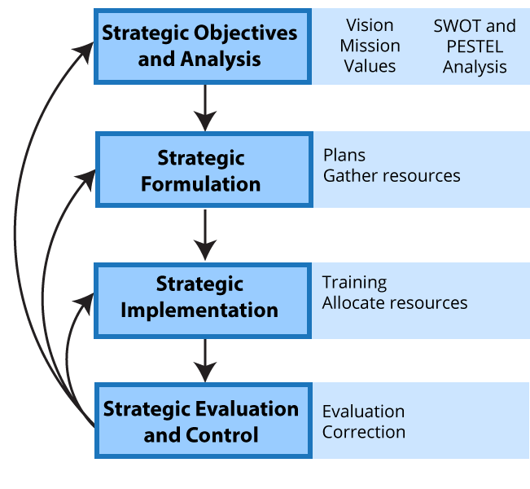
Figure: Strategic plan in Nike
Source: (Standaert, 2022)

Nike’s mission and strategic objectives
The mission of any organization outlines the strategic direction for the business. It is based on the core beliefs of the organization. The corporate mission is quite simple “to bring inspiration and innovation to every athlete in the world”. Based on the mission, one can get a clear picture that the company believes in catering for the athletes. Inspiration and innovation compose the soul of philosophy. Nike extended the mission with “If you have a body, you are an athlete”. The strategic goal could be sensed through this statement that the company aimed to cater for everybody. The company banks on the inspirational stories of the athletes, motivating people to push their limits (Standaert, 2022). The ‘Just Do It’ slogan is simple yet echoes through the masses as a unique and innovative idea of Nike.
The emphasis on action accompanied by a determination to go limitless represents Nike’s organizational strategy as well. The company is determined to reach every customer in the global market and designs to satisfy its customers globally (Standaert, 2022). The objective is aligned with the mission which is not confined within rigid structures. It is vague yet flexible to be aligned with the temporal nature of business environments. The objectives are mostly future-oriented so that Nike Inc. can preserve its place as the leading business organization.

Success factors of Nike
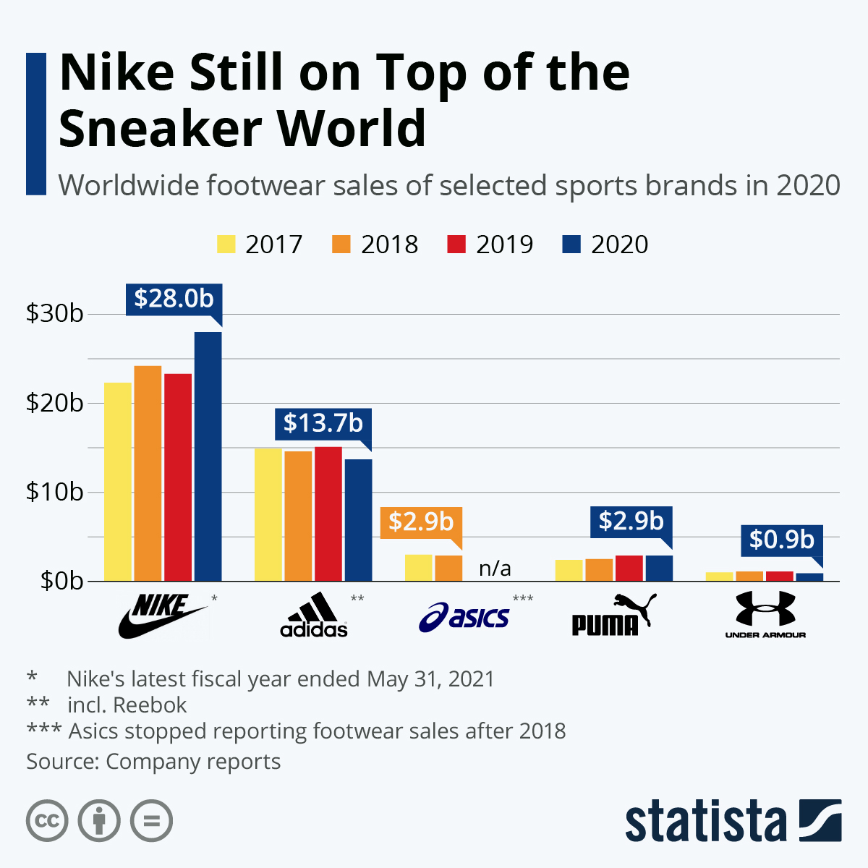
Figure: Worldwide footwear sales in 2020
Source: (Chen, 2020)
Nike Inc. is the leading brand for sneakers in the world. The company has been reigning in the industry for so many years. There are various key success factors that have helped in maintaining the position.
- Marketing strategies: Nike sponsors several sports and athletes teams to increase brand recognition across the world. The simplistic Swoosh logo and ‘Just do it’ tagline have helped the customers to connect with the brand. The company promotes the products through famous celebrity athletes, college teams and professional teams (Chen, 2020).
- Diverse product range: Nike started with shoes but soon expanded the company, introducing a range of products such as equipment and apparel. It focuses on the design, manufacture and distribution of the products solely. Lately, the company has also introduced shorts, jerseys, baselayers etc for various sports.
- Strong research and development team: The company has always depended on its designers who have helped in bringing innovation. The team makes sure to study current market trends, and the demand of the customers and develops the latest technology for the product design (Chen, 2020).
- Production and manufacturing facilities: Nike is the leading supplier of apparel and athletics as well as a producer of the product. It incorporates a vast workforce all around the world and operates overseas manufacturing in China, Taiwan, Indonesia, India etc (Standaert, 2022).

Section 2

Critical analysis of external environment
Nike Inc. has been a productive and prioritised company with an asset of total US $26.2billion and a revenue of US $37.4 billion by the year of 2020 (Alsaffar, 2020). The company has a market share of 28% within the total global market. The company’s performance efficacy can be estimated through a proper PESTEL analysis, highlighting the overall performance benefits, advantage points in functioning, and focusing on the internal employees’ aspect (corporate responsibility) within the working areas of the company.
Political factors –
The company is situated within the country of USA, thus political liberty and entrepreneurial growth have both been implemented within the company. The industry has been enjoying the benefits generally received for the support of national yet international pride. Though the raw materials are being harvested from the regions and manufacturers from China, Vietnam, Indonesia, and Thailand. The supply chain depends on the rubber materials and fabrication of the final products have been performed within the native country. The USA holds a total of 36 factories with a total workers of 5151. Rest of the Nike manufacturing sites are being distributed across the 517 factories within 41 countries. The company holds a major liability towards its American workers. The political agendas had not hampered the employees’ direction of work. Corporate responsibility (CR) head is the CEO of the company, and Mark Peter held the responsibility without any inclination towards political affiliations, during the national games and international games like Olympic. Geo-politics hamper these kinds of scenarios. The company has been detrimental in providing the proper incentives to the employees who have been efficient in working fields. The company maintains and manages proper corporate social responsibility with proper logical and sustainable solutions provided to the employees. Adjusting with the geopolitics and the increase in the tariffs (taxes and import duties) for shoes made in China, American companies have adjusted their supply chain according to the requirement. 10% of the total shoes produced in China, have been imported into the markets of America, and the increased tariff would have cost Nike an additional US $7 billion per year. Shoes manufactured within the factories of China have now been channelized into the Asian markets (like India, Vietnam, and Indonesia).
Economic factors –
The company’s economic success and factors have been dependent on the global economic conditions. Thus, it is expected that the company’s economic performance is going to be hampered by the process of recession, inflation and country’s GDP. The stability of the country’s currency defines the company’s stability in business deals. This has also been translated into the functionality of Nike. During the global recession in 2008, the company lost a hefty amount of 12% from their sales figures. The company had to undergo a complete re-structuring process, with cutting costs, and making a streamlined supply chain. This has been evident that the market stability thus provides for the company’s fluent operation and growth in business. During the time of COVID-19 again the company has suffered a drop in revenue by 38% during the fourth quarter of the day. Despite the decrease in offline and store bought sales, the company has seen an ever growing priority in the online market, where, during the same period of pandemic, the company has observed a growth by 30% in terms of gaining revenues from. During the time of inflation in 2008, the company had understood the importance of mobile technology. Thus, developing the mobile platform for business purposes has become the most prioritised effort, and this method has paid to the company’s valuation figures. Recently, the company has incorporated sustainable metrics within their economic valuations. Their production strategy has been dependent on the procurement of the (raw and resource) materials, making the bill of materials (BOM), and finally evaluating waste calculation to reduce the cost of production. This has aided the development, design, manufacturing and supply chain related issues around a product, and increased the economic controls within the company.
Socio-cultural influences –
Corporate social responsibility for the organisation has been deeply integrated within the company’s policy frameworks. The inclusion of women within the employees and motivating the women athletes through social campaigning have gained attention. The dependency on the social factors and inclusion of societal benefits across the regions have been beneficial (Shtal et al., 2018)). Nike has been emphasising on the innovative approaches within the company to motivate the social and cultural alignments of specific regions. During the 1970s and early 1980s, the sportswear company started ‘sneaker-head culture’, which has been followed effectively by the company. The inclusion of iconic faces from the sports have been effective in this industry. Michael Jordan signed contracts with Nike, during his peak hours of performance. The house-hold motivation based around an iconic model has expressed the enthusiasm within the teenagers and professionally aspirant athletes. The company does provide on time transactions of payment to their stakeholders, partners and vendors. The company has tried to include social changes within their company’s organisational performances. Their incorporation of ‘dream crazy’ advertisement campaign (2018) had tried to boost the unbreakable tenacities within the sportsmen, but the society reacted to it differently, aggravating the priorities of personal choices, and racial debates for incorporation of black culture within the sports sectors. The company has a well-defined customer base within their regions of markets, providing brand-loyalty, and necessary feed forward actions for the business to proliferate (Abushoke and Aisha, 2020). Their strategy to develop a product has been based upon the stages of ‘considered design’, incorporating technical plans, redesigning process, designing steps, highlighting on the existing supply chain issues, changing the human resource management, modifying or re-specifying the job roles within the organisation. The company prioritises corporate social responsibility within the employees, and being sceptical about the raw materials being harvested from China, due to the country’s disturbed labour laws. From the perspectives of their archenemy Adidas, Nike has been incorporating sustainability practices within the labour practices.
Technological factors –
Incorporation of online markets and stores, have helped the company to attain the recognition from the necessary customers. Within the time span of pandemic, their online platform has documented registration of 25 million new users. Their modern approach of sustainability has enlisted the ‘McDonough Braungart Design Chemistry’ (MBDC) within the company practices. The certification process enlists the materials used, chemicals implemented and helps in the management process, and have been much more effective than their traditional ‘Considered design’ approach, where only the designing, manufacturing and estimation of product life cycle were considered only (Bruzzone, Ciobanu, Chummun and Fabbroni, 2022). The raw materials used in this process also have undergone the certification process named ‘material sustainability index’ (MSI), where environmental impacts of the materials used have been studied. Nike have also imparted ‘manufacturing index’ while auditing for their outsourced products, by the parameters of cost, delivery, quality and sustainability. These indexing processes have been strongly implemented within the company’s practices. The design committee within the company have been provided with ‘creators’ common licenses’ and licensing their digital designs have been most effective in the designing department within the company (Meng et al., 2021). The company has been steadily investing into the development of databases and server based business management processes across the planet. After Nike had understood the importance of technological benefits within the business organisations, the company implemented a high quality unified data integration process for product management, design management, and waste footprint calculation. The business management process has been the most sought after criteria for Nike. The tabulation of sustainable attributes have been depicted by – chemicals used in the manufacturing process; energy intensity for development; raw materials converted at every watts of energy consumed; wastes generated; water footprint calculation for the development process, along with carbon emission rate for each pair of shoes produced (Angeles, 2014). The technological integration has been an obvious integration for Nike's performance benefits.
Environmental considerations -
The aspects of sustainability from the environmental perspectives have been considered within the organisation, as to channelize and manufacture the products from the recyclable materials as much as possible. The raw materials that Nike have been using in the manufacturing process have been related rubbers, cotton, wool, plastic materials and other fabricated materials, from the west and central Asia regions. The company has been appreciating the sustainable practices within their manufacturing process, incorporating single used plastics, recycled materials from the fabrics within their designing process. To achieve this potential critical point, downstream distribution channels have been reorganised to meet the performance expectation and match with quality assurance measurements. Air Jordan XX3, VapourFly, VapourMax 2020 have been produced from the complete recycled materials (O'Grady and Gracey, 2020). The company has been using recycled polyester materials for their manufacturing purposes. The weight aspects within these products have been maintained as per the promises. The company has launched ‘BioMoGo’, which has been produced from the biodegradable foam, and with a biodegradable capacity 50 times faster than the normal mid-soles used in the shoes (Alsaffar, 2020). The force from the competitors have been pushing the company into accepting the modes of sustainable measurements, like metrics for generated wastes, water footprint marks of each shoe, and streamlining the production process so that the bill of materials can be controlled. The reduction in the natural usages and making solutions from the reusable opportunities can provide the premium sport wears with the resilience it needed in the near future of environmental insecurity. Nike promised to be completely sustainable by the year of 2025, which has commercially been delayed to 2030.
Legal aspects –
The ‘dream crazy’ advertisement had elicited legal fumes and repercussions upon social structures, depicting the hidden fear of racial abrogation. The process of legal claims within the company requires dealing with the advocates represented from the company. In the late 1980’s the company was sued for not maintaining proper work-place conditions for the employees within the company’s factories. Nike has protected its designers under the legal regulations of the company, and their design iterations have been kept under the legal term of ‘common creators’ permissions’. During the start of the 21st century Nike’s employees have raged a protest against a company’s administration for providing the employees with structured financial and health benefits (Du et al., 2021). The company has represented itself as one of the most aware companies, maintaining logical and rhetorical suggestions under the broader umbrella of corporate social responsibility.

Industry analysis
Nike has been operating in the sectors of the sportswear industry, dealing with designing, developing, promoting and selling sport footwear, clothing and equipment, within the regions of USA, Europe, Middle East, Africa, Greater China, Latin America, Asia-pacific. The markets within these regions are not being dominated by other companies, and performing a Porter’s Five Force analysis might help the identification process of potential threats, competitors, bargaining power of the suppliers and the strengths of the buyers for the company, Nike. The company has few major rivalries but being visionary, and pro-active the threats have not been detrimental for the company’s performance.
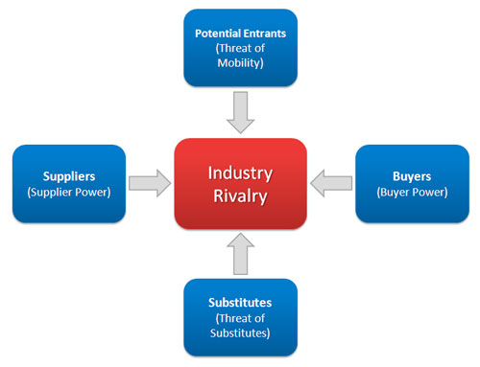
Fig. Porter’s Five forces
Source - Lee et al., 2020
Threats of new entry – Premium and professional sportswear sectors are not being easily dominated by various companies and starting up a new company within this sector has been challenging for the sheer amounts of investments required. The objective purpose of this company has been to serve the professional athletes and maintain the revenue margin as well. Thus, the threats of new entrants are pretty moderate to low within this field (Lee et al., 2020).
Threat of substitutes – The threats of substitutes for this kind of premium and professional products are high, and affects the revenue generation of the parent company. From the Asian countries only the threats of substitutes are high and detrimental. The products are often called ‘rip-off’ products, falling under legal concerns of piracy and authenticity. Obtaining this kind of products may satisfy the customers’ frolic demands but hampers the brand values on an overall level (Alsaffar, 2020).
Power of buyers – The buyers for this kind of products are affluent and belong to the sophisticated level of professionalism. The buyers will be looking for official company store outlets, providing for the premium experiences. Affordability being the main concern, the company did not aim for low grade products, thus the company can maintain the quality with respect to the revenue generation. The power of buyers from this company's specific aspects have been regarded as high.
Power of suppliers – The power of suppliers for this kind of company has been proposed to be high. The suppliers for Nike have cross checked in the criteria of sustainability, quality assurance and other company specific parameters, which if altered can hamper the company’s functionality (Fiorellini Bernardis, 2019).
Power of rivalry – Nike has a plethora of rivalries within their business sector, namely, Adidas, Puma, Reebok, Fila, and COSCO etc. Each of them has their own range of products, targeting for their customers’ needs and simultaneously attempting to expand the market presence. The competitive and rivalry based threats for Nike has been presumed to be high for the sportswear industry.

Section 3

Analysis of Nike’s internal environment
In this section, the internal environment of Nike will be assessed. The analysis will help in exploring internal assets, potentials and vulnerabilities that would help the company to improve upon gaining a competitive advantage. The analysis will be done with the help of VRIO framework and Porter’s Value Chain model.
VRIO analysis of Nike
The four components of the VRIO framework are valuable, rarity, imitability and organisation. The value aspect of VRIO underscores the aspects of the organization that the customer value which helps the organization combat external threats. Rarity refers to the rare factors and resources present in the organization (O'Brien et al., 2019). Imitability refers to the uniqueness of the organization which can be its products, strategies or approach. The organization confirms the stability to support the value, rarity and imitability.
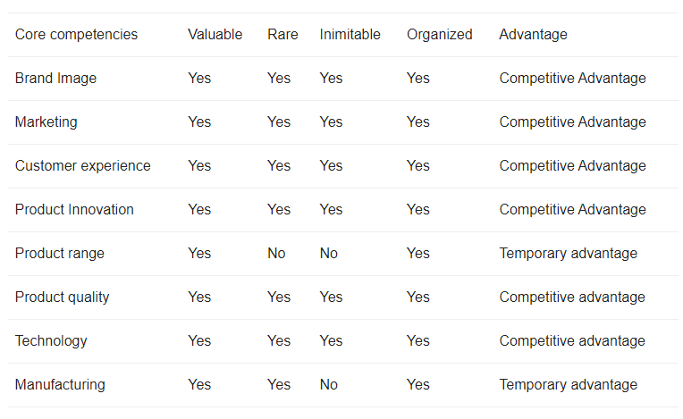
Figure: VRIO analysis of Nike
Source: (O'Brien et al., 2019)
- Value
A multinational company like Nike has ample financial resources to combat any kind of crisis. It keeps the company stable and acts as a valuable asset at the time of mitigation. The greatest strength of Nike is that the customers connect with their idea of innovation and value the products through their experience. The analysis shows that Nike‘s employees are the greatest resource to the firm (Chatzoglou et al., 2018). The knowledgeable design team and trained workforce together help in obtaining productive output. The company adopted the vision of sustainability a long time ago. With sustainability policies, the company has not earned faith in ethical business but also expanded its reach for philanthropic initiatives. It has helped in making the organizational procedures a valuable endeavour that the customers can recognize.
- Rarity
The company ensures rarity through strong financial assets, innovative products and brand image. Nike occupies the leading position in the sports industry and has already made its mark in this niche. Nike embarks upon the sponsorship of the teams and has always aimed to create brand awareness through celebrity athletes. Technology has become a major part of the sports shoe and apparel industry (Osiako, 2022). With a strong financial backup, Nike takes the advantage of the latest technology and invests a considerable amount in its research and development team. The company has successfully ensured high retention which increases the value of the assets in the company. Moreover, the distribution network is also a valuable resource as the global supply chain has helped the company to perform overseas business.
- Imitability
The designers strive to bring innovative products with the latest technology that is patented. Nike ensures that the products and the technology cannot be imitated through patenting. There is no substitute for the product quality that Nike provides to its customers. The product range does not provide any significant advantage to the company as competing companies like Adidas, Puma, and Skechers provide similar products (Chatzoglou et al., 2018). Nike’s greatest strength lies in the invincibility of the shoes. Experience of the product cannot be imitated and thus, the company had been investing a considerable amount in the innovation of the product.
- Organization
Nike has maintained a large base of suppliers and manufacturers. The company has strategized to outsource all of its production to Asian countries. It has helped the company to reap profits as it has helped to form a large supply chain with cheaper investment. The company has a strong distribution channel that has helped in maintaining several operations of the company and avoiding disruption (Osiako, 2022). The rigorous production standards have earned the loyalty of the customers. Overall, Nike has a firm foundation to support all the inbound logistics and continues to enjoy a competitive advantage.
Nike Value Chain analysis
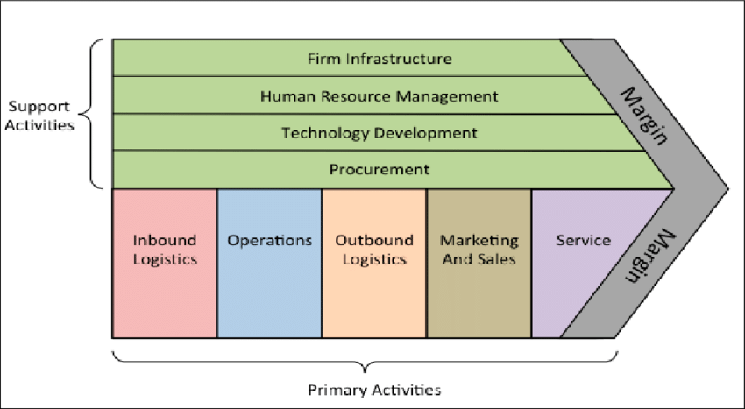
Figure: Porter’s Value Chain Model
Source: (Osiako, 2022)

The value chain analysis of Nike will help in analysing operations related to the delivery of the products. It provides a broad picture of business processes and global business model (Alexandru-Ilie et al., 2020). The primary activities are explained in the following section:
- Inbound logistics
Nike has a robust supply chain that incorporates suppliers, transport, internal delivery, and quality check to deliver quality products. The company operates 567 factories across the globe in 42 countries for manufacturing products (Klaiber and Klopfer, 2021). Sustainability and green business practices are the key components of the company. Nike follows strict policies and procedures concerning the impact of business operations on the environment and society.
- Operations
The company is intensely involved in a number of operations including designing, manufacturing, assembling, packaging and testing. Nike’s value chain exhibits value creation through innovation and gaining a competitive advantage in the market (Alexandru-Ilie et al., 2020). The operations emphasize further bringing productivity, efficiency and value creation.
- Outbound logistics
The outbound logistics engage in the activities after production. The products are sold in various regions across the world through retail stores through distribution centres. Larger revenue is generated through the biggest distribution centre in Tennessee and the logistics centre operating in European logistics located in Belgium.
- Marketing and sales
Nike has successfully built a unique identity over the years through sports sponsorships and promotions through celebrity athletes (Klaiber and Klopfer, 2021). Nike uses efficient marketing activities by connecting through all marketing channels and digital platforms. The key to marketing products is through building a connection with its audience.
- Service
Nike enjoys a broad base of loyal customers and runs programs that make customers a part of Nike’s community. The loyalty of the customers is rewarding as they make the major portion of the revenue generated. The pre-sales and post-sales services aim at keeping the customers engaged through memberships and offers.
The support activities of Nike include
- Infrastructure
The firm infrastructure includes several activities related to quality management, legal matters handling, financing, planning and management. The firm aims to optimise the infrastructure at various levels (Alexandru-Ilie et al., 2020). The activities enable providing efficiency, cutting overhead costs and keeping the work systems in check.
- Human resource management
Nike has numerous outlets and being a multinational company it engages with plats, distribution centres and retail outlets on a regular basis. The fact that Nike has a high employee retention rate speaks for its success in managing human resources. It has more than 70,000 employees globally and ensures a healthy environment by providing ample opportunities for the employees to grow (Osiako, 2022). According to Fortune, Nike is America’s best employer for diversity.
- Technology development
Technology and product quality are the foundation of the company as they go hand in hand. Nike has carved its identity through innovation and has lived up to the expectation of its customers for many years. It invests a considerable amount in the design teams, types of equipment, machinery, manufacturing practices and waste control strategies.
- Procurement
Procurement engages in processes involved in sustaining manufacturing activities. The Global Procurement team of Nike engages in the selection of suppliers with the best quality materials at suitable costs (Klaiber and Klopfer, 2021). The company is also concerned about associating with parties who share the vision of sustainability and environmental safety.

SWOT analysis
Strengths -  - Wide range of products  - Sustainable approaches  - Value based supply chains  - Design priority  - Quality assurance | Weakness -  - The company relies on outsourcing the raw materials, thus quality can be compromised.  - The company’s push to throw the rivals out of business, and claims for legal challenges.
Opportunity -  - Loyal and affluent customer base  - Strong advertising upon ethics and management.  - Strong corporate social responsibility from the company to the employees. | Threats -  - Rivals like Adidas, Puma, Reebok can produce better products for their customers.  - Legal threats from racial inclusion and discriminations.

Conclusion
The company outsources their majority of the products from the manufactures of the China, and functions across the 1152 retail stores. Over the 50 years of its functioning, the company has been a dominant product manufacturer within the athlete foot wear and specialised sportswear sector. The company believes in boosting the confidence of the individual athletes and inspires the belief into the roots. The initiative programmes like ‘P.L.A.Y’, ‘Nike vs. Evil’ were launched, to impart and motivate the aspect of increased participation within the women athletes. The comparison of their sportswear has been compared with the companies like ‘adidas’, ‘Fila’ etc. But the marketing strategies like ‘Just do it’ and ‘There is no finish line’ have been successfully implemented, along with their inclusive nature of sports culture. The recommendation can be obtained from the marketing campaign during the times of 2012 Olympic times. The ambush tactics implemented in the advertisement campaign of Adidas, like not being allowed to use the words like ‘London 2012’, ‘Olympic 2012’, ‘games 2012’, have tested their brand images to the corners of edge. The majority of the Americans knew Olympic 2012 in London was officially being sponsored by Nike. The advertisement campaign and marketing campaign boasted by Nike imparted the logic of ‘greatness’ within each individual athlete, harmonising between the global perspectives and the ultimate goal to achieve ‘prosperity’.

Recommendations
The company successfully bagged athletes within their brand names, and sponsored them to wear their sportswear into the game. The market established by the company was deeply ingrained within human behavior, and proliferated the achievement criteria by boasting the mentality of unbreakable vows within the players and athletes. The aspect of the company’s behavior and prioritizing their customers has been the sole effective portion for their functioning within their markets. The product range has been covered with affordability to the ranges to the premium experiences. The company’s Air Jordan ranges have been the most successful and most ventured products from the company. The use of sustainable approaches and aligning the global rules have been their latest objectives till 2030. Their Air Jordan XX3 has been manufactured from the recycled materials, and considering their objective agendas the company has implemented a waste-score protocol to measure the wastes generated by the process of manufacturing these shoes.

Reference list
About.nike.com. 2022. [online] Available at: <https://about.nike.com/en> [Accessed 30 August 2022].
Standaert, W., 2022. Product digitization at Nike: The future is now. Journal of Information Technology Teaching Cases, 12(1), pp.28-34.
Chen, M., 2020. Financial performance analysis: a case study of Nike (Doctoral dissertation).
O'Brien, D., Parent, M.M., Ferkins, L. and Gowthorp, L., 2019. Strategic management in sport. Routledge.
Chatzoglou, P., Chatzoudes, D., Sarigiannidis, L. and Theriou, G., 2018. The role of firm-specific factors in the strategy-performance relationship: Revisiting the resource-based view of the firm and the VRIO framework. Management Research Review.
Alexandru-Ilie, B., Alexandru, P.D., Iulian, C.C. and Valentin, W.P., 2020. MANAGING ORGANIZATIONS FOR SUSTAINABLE BUSINESS DEVELOPMENT: INTERACTION BETWEEN VRIO FRAMEWORK AND McKINSEY 7S FRAMEWORK.
Klaiber, M. and Klopfer, J., 2021. A Survey of the State of Research on Augmented Reality from a Business Perspective using Porter’s Value Chain. future, 15, p.16.
Osiako, P.O., 2022. PORTER'S VALUE CHAIN-DEDAN KIMATHI UNIVERSITY OF TECHNOLOGY AS A COMPETITIVE UNIVERSITY (DEKUT).
Angeles, R., 2014. Using the technology-organization-environment framework for analyzing Nike's Considered Index green initiative, a decision support system-driven system. J. Mgmt. & Sustainability, 4, p.96.
Abushoke, A. and Aisha, K., 2020. External Requirements and Internal Enablers in the Responsive Supply Chain Management: A Case Study of Nike’s Responsive Supply Chain. Jonkoping International Business School.
Shtal, T.V., Buriak, M.M., AMIRBEKULY, Y., UKUBASSOVA, G.S., KASKIN, T.T. and TOIBOLDINOVA, Z.G., 2018. Methods of analysis of the external environment of business activities. Revista espacios, 39(12).
Meng, S., Wei, B., Xu, G. and Zhang, R., 2021, September. Analysis of Enterprise Operation under the Impact of COVID-19 Epidemic: A Case Study of Nike Inc. In 2021 International Conference on Financial Management and Economic Transition (FMET 2021) (pp. 137-145). Atlantis Press.
O'Grady, T.J. and Gracey, D., 2020. An Evaluation of the Decision by World Athletics on Whether or Not to Ban the Nike Vapor Fly Racing Shoe in 2020. ESLJ, 18, p.1.
Fiorellini Bernardis, A., 2019. Labor issues and workers’ rights within the global supply chain. How to manage the work environment. The Nike case.
Du, M., Guo, Y., Wei, X. and Zhao, J., 2022. Analysis of Business Model of Leading Sportswear Company. 2nd International Conference on World Trade and Economic Development (WTED 2022).
Lee, S., Jung, S. and Ha-Brookshire, J.E., 2020, December. A Framework of Perceived Corporate Social Responsibility Gaps between Internal and External Stakeholders: A Stakeholder Theory Approach. In International Textile and Apparel Association Annual Conference Proceedings (Vol. 77, No. 1). Iowa State University Digital Press.
Alsaffar, H., 2020. Nike’s Marketing Mix and PESTEL analysis in China.
Bruzzone, R., Ciobanu, V., Chummun, M. and Fabbroni, F., 2022. Case study: Branding strategies deployed at the 2012 Games in London. [online] Available at: https://www.businesstoday.in/magazine/lbs-case-study/story/branding-strategies-at-london-olympics-2012-130660-2013-09-14 [Accessed 30 August 2022].

