BA BUSINESS MANAGEMENT
ASSIGNMENT 1
Module: Global business environment
Code:(LCBB4005)
Lecturer: Dr. rexon nting
Name: Navjot Kaur
Student id :2214338

ASSIGNMENT TITLE:
GLOBAL BUSINESS ENVIORNMENT
ASSESSMENT 1
Table of content-
Introduction
A brief introduction of India as a selected country
Theories of business environment
Pestel analysis
Porter five forces model
Opportunities and challenges face by Tesco plc company
Different barriers experience by foreign business in India
Recommendations
Conclusion
References

LIST OF FIGURES

Figure 1: Pestel analysis
Figure 2: Porters five forces model

ASSIGNMENT TITLE:
GLOBAL BUSINESS ENVIORNMENT
Introduction:
International business refers to business operations conducted across international boundaries. International business is the act of purchasing and reselling goods, commodities, and service outside of one’s own nation. Government or a private entity may be in charge of certain trading routes. In which organizations looks for trade prospects outside of its own borders to expand its niche business sector such as manufacturing, mining, construction, and communications etc. Today, entire companies look for growing their business operations. The expansion of company allows locate new customers, which leads to greater income at the same time as concurrently reducing operational charges and saving the organization money. Tesco plc will be highlighted in this report. This company based in UK. the company operates through multi-format stores and online. Tesco offers wide range of food and non-food products including fresh produces, groceries, clothing, home, and entertainment products. In 2012, it was 3rd largest retailer globally in terms of gross sales. This operation has flourished in UK market. This company plans to grow business globally. Throughout the growth, they will need to analyze several elements that must be considered before entering. consequently, the writer will be examined in this report that external elements influencing the company. Additionally gaining a cut- greater income at the same time as concurrently reducing operational charges and saving the organization money. Moreover, gaining a cut-throat edge in this company will be highlighted with opportunities and struggling.

Introduction about India as a chosen country
India is considered as developing country with the area 3,287,263 square kilometers and has population density 382 persons per square kilometers. India has coastline length about 7,516km. The official name of India BHARAT Sanskrit, also known as Republic of India English. India is the seventh largest country in the world, is known for its diverse culture and rich heritage. The official language of the nation are Hindi and English, and has 28 states and 8 union territories. The Indian landmass contains a various type of natural resources. It has recognized as the largest democracy of the world, and as impactful country globally. As one of the fast-growing economies in the world, India offers numerous opportunities to expand business in it. So, setting up a new company in developing country Indian provides numerous benefits. (MAPS OF INDIA,2011).
Business Environment Theories in today era;
As the chosen company is Tesco plc, it is necessary for the Tesco plc to hold in thoughts the inner factors and external factors before the initiation in, India. The accumulation of all external ana internal issues that influence an operation called business environment. Somehow these elements work in favor of business and sometimes have adverse impact on business. (Grimsely,2014)

Pestle analyses; it is a framework that used for analyzing and scanning the external factors while starting a business.



FIGURE 1 :(PESTLE ANALYSE)

The above model of pestle is used to evaluate the factors affecting the businesses;
It is clearly seen in the above figure the factors such as political, economic, social, technological, legal, environmental will be affected the Tesco plc to begin a business in India according to pestle analyses.SO these factors will have taken into consideration by Tesco plc.

1: POLITICAL FACTORS :
As one of the world’s largest democracies, India has a form of federal government. The political environment is heavily impacted by elements such as politicians’ interests, government policies, and multiple political parties by which Indian business environment is subject to multiple political factors. (Edrawsoft, (n.d.). The federal government imposed several taxes such as income tax, service tax and sales tax and it should be essential for Tesco plc to follow these rules. Understanding the laws, procedures, and the stability of the government are crucial considerations for Tesco’s future market. The interesting thing is India has political stability that will be act as opportunity for Tesco to achieve success.

2: ECONOMIC FACTORS:
The factors like economic growth, inflation, employment and unemployment rates and consumer purchasing power, economic conditions, tax system are known as economic factors. These factors are responsible to determine Tesco plc financial performance. The rising GDP of India give opportunities to Tesco plc for business expansion. Since the country economic reform in 1991, especially after the creation of FIBP (Foreign Investment Promotion Board), India’s liberal industrial policies have assured a sizable amount of foreign investment. As a result, the economy has seen boost. So, the business gain various benefits with this growing economy. (Edrawsoft, (n.d.).
3: SOCIAL FACTORS: Social factors include its population growth about; traditions, values, and beliefs of the area, as well as attitude toward labour, among other things. So, aware of the tastes and preferences of the target market will be give benefits for business. As the writer mentioned above India is a diversified nation. (Edrawsoft, (n.d.). Before starting a business in the multicultural country, the firm must become acquainted with traditions, values, and the other facets of local culture. As a result, target market will expand in future Moreover, another factor favoring this business (Tesco plc) is the size of domestic market.

4: TECHNOLOGICAL FACTORS:

Technology factors have a huge role on how products are developed and introduces new approaches to reduce costs, and improve customer service. The India has one of the strongest (Information technology) IT sectors is among the strongest in the world, in terms of cost and customer’s service. One of the strongest IT in the world, with continual technological advancements, is found in India. The IT sector in India is expanding steadily and the availability of 4G and 5G technology will be facilitated the Tesco plc for the innovation of products, supply chain and other services to gain the benefits.

5: LEGAL FACTORS:
Legal factors include consumer rights, copyright, equal opportunity for all, advertising, discrimination law. It will be necessary for the Tesco plc to follow the rules and laws of India before setup business in India. Business finance law, Tax and accounting law, labor laws, Property law, IT law need to be followed by the company.

PORTER’S FIVE FORCES MODEL

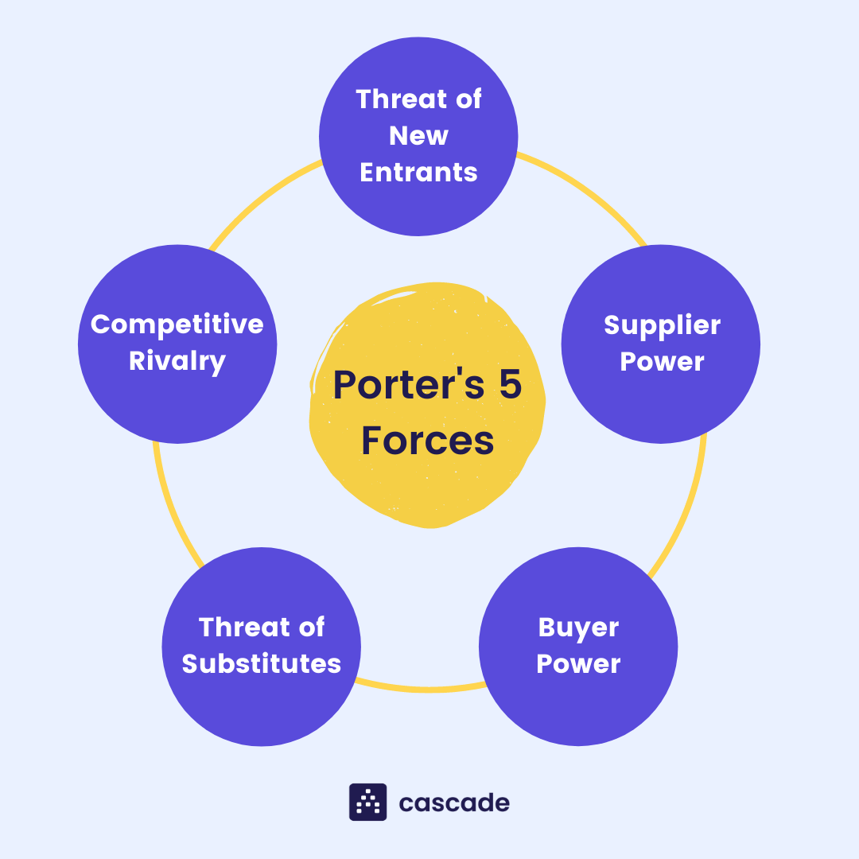
FIGURE 2(PORTER’S FIVE FORCES)
This model is used for analyzing a company competitive environment. As shown in above figure (2), porters five factors include power of buyers, power of suppliers, threat of new entrants, competitive rivalry, threat of substitute products
1.COMPETITIVE RIVARLY;
The price reductions, higher advertising costs, and investments in service, products innovation are a few examples of competitive actions that could limit profitably and trigger competitive responses (Dhilwayo, Witness2022). If there is intense competition it will become challenging for Tesco plc to generate sustained profit.

2.BUYERS BARGAINING POWER;
The buyer negotiating power demonstrates the pressure that customers place on businesses to offer high-quality products at fair prices and first-rate customer service. Therefore, this force directly affects Tesco Plc's capacity to fulfil its corporate objectives. Strong negotiating position lowers profitability and raises industry competition. On the other hand, when consumer power is low, the market becomes less competitive, which improves Tesco Plc's profitability and growth prospects. Indian consumers have less negotiating power, which is advantageous for business.
3.SUPPLIERS BARGAINING POWER;

It represents the pressure that suppliers place on business organizations using a variety of strategies such as decreasing product availability, lowering product quality or rising prices. When bargaining power of suppliers is higher than it can also boost industry competition and will reduce the growth of Tesco plc. However, with limited supplier power Tesco will get more profit and growth potential.

4.THREATS OF NEW ENTRANTS;
IF barriers are low, companies can easily enter the industry. It will create risk for other companies and lowering the profits. Although, Tesco is ninth largest retailer in the world but faces problems such as service quality an inability to understand trends and cultural differences in other counties (essays, UK,2008). If any other company come with these understanding that make easier to entry to start a business it will create threat for Tesco.

5.THREAT OF NEW SUBSITUTE PRODUCTS;
The customers cannot be obtaining the same utility from a substitute product (in terms of quality and performance as they can from Tesco plc as well as the expense of moving to the replacement products is substantial due to higher cost will lower the risk of threat of new substitute products by which Tesco plc will achieve profits.

The opportunities face by tesco plc

The opportunities will face by Tesco plc are given below with explanations;
AFFORDABLE HUMAN CAPITAL; India has a huge amount of experienced people and skilled workers. Also, India is taken into consideration to have one of the maximum subtle and committed workforces globally (Drew Donnelly, PHD) So, it can best opportunity for Tesco plc to open business in India with affordable compensation. As, Tesco plc is manufactured various types of products like food, beverages, clothing, electronics etc. So, these skilled workers and dedicated workforces’ resources can be the first need of Tesco for starting a business in India.
EASY ENTRY REGULATIONS; Global business are now more welcome in India’s market. The India government is working hard to welcome foreign investors with 100% FDI in a variety of industries. (Drew Donnelly 2020). Due to the lowered entry restrictions more international startups are now able to enter enormous benefits. The company (TESCO PLC) can take advantage of the numerous tax breaks and land acquisition conveniences provided by the government; to establish the base to grow the business in India.
TECHNOLOGICAL DEVELOPMENT; India’s technological advancement is accelerating quickly. Numerous Indian sectors have been changed by technologies such as blockchain and artificial intelligence. By taking the advantages of Indian technological transformation, the company can enhance their business easily.
DEVELOPING MARKET; Within 1.37 billion people, the India is the second populous nation. A sizeable number of High-Net-Worth individuals live in this country. Also, the Indian purchasing power has increased due to per capita growth in their population. More customers are asking for high quality products. By which, numerous manufacturing and services sectors in the nation have received fundings from foreign investors which could be better opportunity for Tesco to initiate a business in India.

CHALLENGES FACE BY TESCO PLC
TESCO PLC will face various challenges while doing business in India is mentioned here; challenging for Tesco plc. A system that is adhered to or upheld for business operations is known as corporate governance. The primary method for achieving success in business is referred as business strategies. Because India and UK do not have same corporate governance, the firm must be considered and alter its operations. Also, the culture of UK and India is different. So, it might be challenging to adjust to, therefore research the location thoroughly about culture is need for Tesco plc. Despite progress, India’s infrastructure including railways, airports, seaports PowerGrid and telecommunications infrastructure pose challenges to its growing economy position and ability to deliver public services. Due to massive population growth, increasing urbanization government have need to improve the country infrastructure, which can be big challenge for company. Moreover, the economy prices change regularly, and that frequently forces the corporation to change prices of its products.

BARRIERS WHILE DOING INTERNATIONAL BUSINESS IN INDIA IS MENTIONED HERE; Barrier factors include barrier that make difficult for new rivals to enter market, and high startup costs; as without local understanding, the process needed in launching a business in India can be overwhelming and amount of money is exorbitant which can be afford by few companies. Also, in India companies are expected to pay taxes yearly. For example, the standard rate of corporate tax is 30%, for local companies but more 40%for international companies. However, additional fees that apply to business include central sales tax, dividend tax, property tax and fuel tax. So, it can be another barrier for Tesco plc.

RECOMMENDATIONS FOR APPROPRIATE STRATEGIES
RECOGNISE THE REQUIREMENTS OF THE PEOPLE; For Tesco plc it is crucial to know about the Indian market needs to gain the profits. As, there are many competing industries in India, so Tesco plc must provide something unique that will benefit the Indian people. As a result, the company will achieve success.

FORMING A SIGNIFICIANT CONSUMER BASE; This will be advantageous for business in two ways, the corporations will have the chance to streamline its sales and production processes because the bargaining power of the buyers would be reduced.
A QUALIFIED WORK FORCE; Undoubtedly, India has an advantage of having a highly skilled and reasonable price labors in the world, If the company choose this qualified staff for their business, the company will be able to meet their business performance easily with lower price.
BY INNOVATING NEW PRODUCTS RAPIDLY; India has a diverse market so people have different needs, tastes if the company innovate new product, it will give benefits to the company in various ways; it helps business stand out from competition by utilizing various cutting-edge marketing, production, and sales techniques. Also, innovation will help in market share and revenue and gain competitive advantage.

CONCLUSION
Due to globalization, businesses now have chance to share their goods and services with other nations. Businesses are expanding quickly, as a result of their creativity and effective methods. By which, organisations want to achieve more profit by expanding their business internationally. Although, the companies want expansion but analysing the important factors of business environment is considered as basic needs for companies to start a business either domestic or other nation. The growth of company requires examinations of external factors which can be done by companies by using PESTEL,SWOT, PORTERS FIVE FORCES that is mentioned above by writer of this report. As the company Tesco plc during the extensions, there may be certain difficulties such as cultural difference, tax system, local understanding in the business operations. Although, they can be overcome if the organisations employ the right strategies and preparations. It is necessary for the organisations to satisfy the customers needs and build the growth of businesses. The report author has recommended that companies should have established a sizable consumer base and recognize the requirements of the people and use the appropriate strategies to get success in other countries. If, the company follow the right strategy for doing a business then it can achieve success easily at international level.

REFERENCES
Maps of India. (2011). India-Know all about India including its History, Geography, CULTURE, etc.[online] Available at: https://www.mapsofindia.com/india/ (ACCESSED ON 13 NOVEMBER 2022

Grimsley, S. (2014). What Is Business Environment? -Definition and factors – Video and Lesson Transcript | Study.com,
Available at: https://study.com/academy/lesson/what-is-business-environment-defimition-factors-quiz.html.( Accessed on 13 November 2022)
Edrawsoft. (n.d.). Detailed PESTEL Analysis of India | EdrawMax Online. [online]
( accessed on 13 November 2022)
Available at: https://www.edrawmax.com/article/india-pestel-analysis.html#:~:text=The
https://svg.template.creately.com/jnodwt6r
https://www.cascade.app/hs-fs/hubfs/Blog/porters-5-forces-infographic.png?width=1080&name=porters-5-forces-infographic.png
nhglobalpartners.com. (n.d.). International Business Opportunities In India: Guide for Foreign Investors. [online] Available at: https://nhglobalpartners.com/business-opportunities-india/. (Accessed on 13 November 2022)
.TMF Group (2013). Top 10 challenges of doing business in India. [online] Tmf-group.com.
Available at: https://www.tmf-group.com/en/news-insights/business-culture/top-challenges-india/. Accessed on (14 November 2022)

‌

