📄 ORGANISATIONAL CULTURE REPORT – BRITISH AIRWAYS
Student Name/ID: Dariush Nezamalmolki – 2407310
Module code: LCLM 5005
Title: Organisational Culture Analysis – British Airways
Lecturer: Ibrahim

Overview
British Airways (BA) is one of the UK's largest and most recognised full-service airlines and operates as part of the International Airlines Group (IAG). As a global airline, it works in a highly competitive and heavily regulated industry where organisational culture plays an important role in maintaining safety, operational efficiency, and long-term success. Organisational culture refers to the shared values, beliefs, and behaviours that influence the way people work and interact within an organisation (Mullins and Christy, 2016). At British Airways, culture extends beyond everyday workplace behaviour; it also supports the airline's ability to remain competitive, deliver high-quality customer service, and achieve its strategic objectives.
Over the years, British Airways' organisational culture has developed in response to major changes, including its history as the UK's national flag carrier, its privatisation, international expansion, and increasing competition from low-cost airlines. These developments have helped create a culture centred on professionalism, operational discipline, safety, and customer service. In the aviation industry, these values are particularly important because mistakes can have serious financial, reputational, and safety implications. Schein (2010) explains that organisational culture exists at three levels: artefacts, espoused values, and underlying assumptions. At British Airways, visible features such as staff uniforms, formal communication processes, and strict operating procedures demonstrate the organisation's deeper commitment to consistency, safety, and standardisation.
Despite these shared values, British Airways does not have a single, uniform culture. Instead, different departments have developed their own subcultures based on their specific responsibilities. Flight operations, engineering, cabin crew, and corporate management often have different priorities, communication styles, and approaches to decision-making. For example, operational teams place greater emphasis on safety, regulatory compliance, and following procedures, whereas commercial departments are generally more focused on improving customer experience, increasing efficiency, and achieving financial performance. While these differences can encourage specialised expertise, they can also create communication challenges and conflicting priorities across the organisation.
The airline's culture is also shaped by external factors, including technological developments, changing regulations, environmental concerns, and intense competition within the global aviation market. Advances in digital technology and the continued growth of low-cost airlines have increased the pressure on British Airways to become more innovative while maintaining the high standards expected of a premium airline. Hofstede et al. (2010) argue that organisations with high levels of uncertainty avoidance tend to depend heavily on formal rules and procedures. This characteristic is evident within British Airways, where structured processes help maintain safety and reliability but may also reduce organisational flexibility and slow responses to change.
Overall, British Airways demonstrates a complex organisational culture built around strong leadership, high safety standards, and a premium service reputation. These cultural strengths contribute to operational consistency and reinforce the airline's brand image. However, they can also present challenges, particularly when the organisation needs to adapt quickly, encourage innovation, or empower employees to make decisions. This report critically examines these issues and evaluates how organisational culture influences the structure, decision-making, adaptability, and overall performance of British Airways.

1. Introduction
Organisational culture plays an important role in shaping how organisations operate and achieve their objectives. It influences the way employees communicate, make decisions, respond to challenges, and work towards shared goals. Mullins and Christy (2016) describe organisational culture as "how things are done around here", emphasising that it is reflected in everyday behaviours and working practices. Similarly, Schein (2010) argues that culture goes beyond visible behaviours, as it is also shaped by the underlying values and assumptions that guide employees' actions and influence organisational decision-making.
The importance of organisational culture is particularly evident in the aviation industry. Airlines operate in an environment where safety, regulatory compliance, customer expectations, and operational efficiency must all be balanced. At the same time, they face constant pressure from technological developments, sustainability targets, and growing competition within the global market (IATA, 2023; British Airways, 2024). As organisations such as British Airways employ people from a wide range of cultural and professional backgrounds, creating a shared organisational culture helps promote consistency while supporting collaboration across different parts of the business. Hofstede et al. (2010) suggest that organisations operating internationally must recognise cultural differences while developing common values that unite employees around shared objectives.
This report explores the organisational culture of British Airways (BA), one of the UK's leading full-service airlines. It examines how the airline's culture influences its organisational structure and decision-making, using established theories to support the analysis. The report also considers how British Airways' culture has adapted to external challenges, including technological change, environmental expectations, and increased market competition. Finally, it evaluates whether the organisation's culture strengthens or limits its overall performance and presents practical recommendations for future improvement.

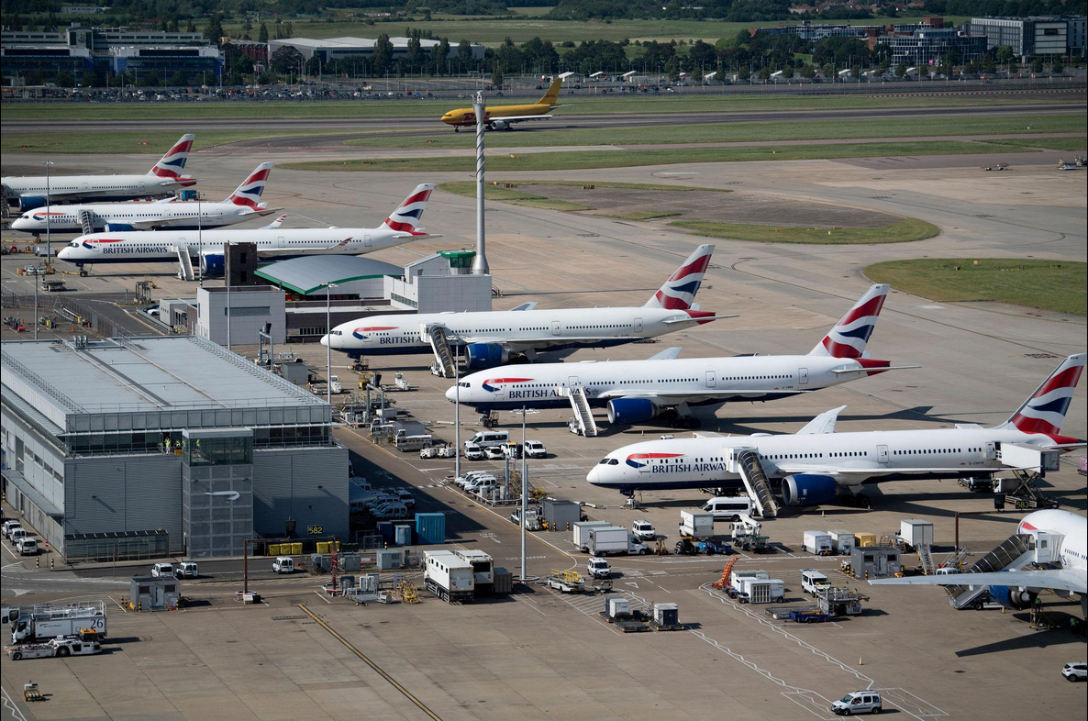

2. Influence of Organisational Culture on Structure and Decision-Making

2.1 Organisational Context of British Airways
British Airways operates in one of the world's most highly regulated industries, where safety and compliance are fundamental to everyday operations. As part of International Airlines Group (IAG), the airline must comply with strict aviation regulations, international safety standards, and operational procedures. These external requirements have shaped an organisational culture that places a strong emphasis on professionalism, accountability, and operational discipline.
Over time, British Airways has developed a culture centred on several core values:
- Safety and risk management
- Professionalism and accountability
- Operational reliability
- Premium customer service
- Compliance with aviation regulations
These values influence both the organisational structure and the way decisions are made throughout the business (British Airways, 2024).

2.2 Impact on Organisational Structure
British Airways follows a functional hierarchical structure, with employees organised into specialist departments, including:
- Flight Operations
- Engineering and Maintenance
- Cabin Services
- Customer Experience
- Ground Operations
- Corporate and Strategic Management
This structure closely reflects Charles Handy's Role Culture, where authority is based on formal positions, clearly defined responsibilities, and established procedures (Handy, 1999). Such a structure is particularly suitable for organisations operating in safety-critical environments because it promotes consistency and reduces operational risk.
Schein (2010) argues that organisational structures develop from shared assumptions rather than being created by chance. At British Airways, one of the strongest underlying assumptions is that safety must always take priority. This belief supports a hierarchical structure because clear reporting lines and supervision help ensure that procedures are followed consistently across the organisation.
However, this approach also has limitations. Communication often passes through several levels of management before action can be taken, which can slow decision-making. Compared with many low-cost airlines that operate with flatter structures, British Airways may find it more difficult to respond quickly to market changes or customer expectations.

2.3 Influence on Decision-Making
British Airways generally adopts a centralised approach to decision-making. Strategic decisions are usually made by senior management, particularly in areas such as:
- Route planning and network expansion
- Fleet investment
- Pricing strategy
- Digital transformation
- Cost reduction initiatives
- Industrial relations
This reflects Hofstede et al.'s (2010) concept of relatively high power distance, where authority is concentrated at senior levels and employees are expected to follow established procedures.
This approach provides several organisational benefits, including:
- Consistent strategic direction
- Strong regulatory compliance
- Improved risk management
- Protection of the British Airways brand
Despite these advantages, there are also some drawbacks. Frontline employees interact directly with customers and often have valuable insights into service quality and operational issues. When their involvement in decision-making is limited, opportunities for innovation may be missed, employee engagement can decline, and the organisation may become less responsive to customer needs.

2.4 Critical Evaluation
British Airways' organisational culture has contributed to its reputation for safety, reliability, and high-quality service. Its hierarchical structure and centralised decision-making help ensure compliance with complex aviation regulations while maintaining operational consistency.
Nevertheless, this culture also creates challenges. The aviation industry is constantly affected by unexpected events such as severe weather, technical failures, industrial disputes, and geopolitical disruptions. In these situations, lengthy approval processes can slow organisational responses. Consequently, British Airways faces an ongoing challenge of balancing two competing priorities:
- Maintaining control, consistency, and safety.
- Increasing flexibility, innovation, and responsiveness.
Finding the right balance between these priorities will be essential if British Airways is to remain competitive while continuing to meet the high safety standards expected within the aviation industry (Schein, 2010; Hofstede et al., 2010).

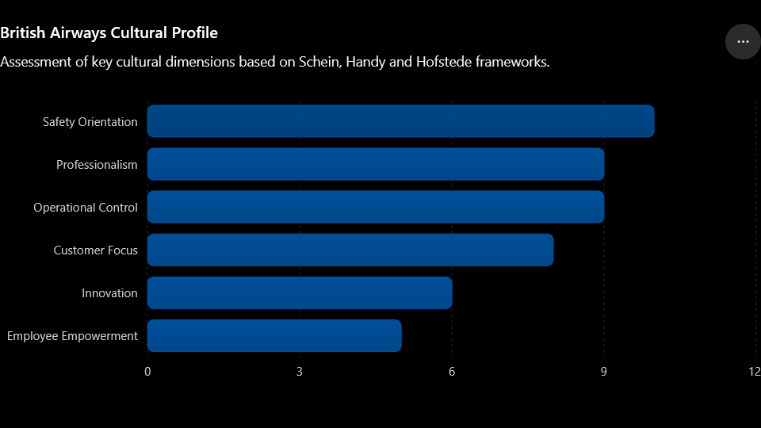
3. Application of Organisational Culture Frameworks

3. Application of Organisational Culture Theories

3.1 Schein's Model of Organisational Culture
Schein's (2010) model helps explain how organisational culture operates at different levels within British Airways.
Artefacts (Visible Culture)
Examples of visible culture at British Airways include:
- Professional uniforms and grooming standards.
- Formal communication procedures.
- Standardised safety protocols.
- A premium brand image and customer service.
These visible features reflect the airline's focus on professionalism, consistency, and operational discipline.
Espoused Values
British Airways promotes several key organisational values, including:
- Safety as the highest priority.
- Customer service excellence.
- Operational reliability.
- Diversity and inclusion.
- Global competitiveness.
These values are communicated through corporate strategy, training programmes, and internal communications.
Underlying Assumptions
At the deepest level, British Airways is guided by assumptions such as:
- Safety is non-negotiable.
- Risks should be controlled through clear procedures.
- Hierarchical authority supports accountability.
- Consistency is preferred over improvisation.
According to Schein (2010), these underlying assumptions have the greatest influence because they shape behaviour and decision-making without being openly questioned.

3.2 Handy's Cultural Typology
Based on Handy's (1999) cultural typology, British Airways is best described as a role culture organisation.
Its main characteristics include:
- Clearly defined job roles.
- Formal rules and procedures.
- Hierarchical reporting lines.
- A high level of specialisation.
This culture is well suited to the aviation industry because it supports regulatory compliance, operational consistency, and safety-critical activities.
However, British Airways also demonstrates some elements of task culture, particularly within:
- Digital transformation projects.
- Sustainability initiatives.
- Innovation programmes.
This suggests that, although role culture remains dominant, the airline is gradually adopting more flexible ways of working in areas that require collaboration and innovation.

3.3 Hofstede's Cultural Dimensions
Hofstede et al. (2010) also provide useful insights into British Airways' organisational culture.
High Uncertainty Avoidance
British Airways relies heavily on:
- Safety procedures.
- Operational manuals.
- Risk management systems.
These practices improve consistency and reduce operational risk but may also limit flexibility.
Moderate to High Power Distance
Strategic decisions are largely made by senior management, while employees are generally expected to follow established procedures and reporting structures.
Moderate Individualism
Employees are accountable for their individual roles, particularly in technical and operational positions. However, teamwork remains essential to ensure safe and effective airline operations.

Safety Orientation ██████████ 10
Professionalism █████████░ 9
Operational Control █████████░ 9
Customer Focus ████████░░ 8
Innovation ██████░░░░ 6
Employee Empowerment █████░░░░░ 5

📄 ORGANISATIONAL CULTURE REPORT – BRITISH AIRWAYS

4. Organisational Culture and Response to the External Environment
Organisational culture plays an important role in how organisations respond to external challenges. British Airways operates in a fast-changing aviation industry influenced by economic uncertainty, technological developments, changing regulations, sustainability expectations, and increasing competition. According to Schein and Schein (2017), culture provides stability by shaping how employees think, behave, and respond to change. At British Airways, a strong culture of safety, professionalism, and operational discipline has helped the airline remain resilient during periods of uncertainty.

4.1 Impact of the COVID-19 Pandemic
The COVID-19 pandemic was one of the biggest disruptions the aviation industry has experienced. Travel restrictions, falling passenger numbers, and operational disruption placed significant financial pressure on British Airways.
The airline responded by:
- Restructuring parts of the business and reducing its workforce.
- Suspending and redesigning routes.
- Expanding digital customer services.
- Introducing enhanced health and safety procedures.
British Airways' existing safety culture made it easier to implement new health regulations because employees were already familiar with working within strict operational procedures. However, the pandemic also highlighted weaknesses in the organisation's hierarchical culture. Centralised decision-making and multiple approval levels slowed some operational responses, demonstrating the challenge of balancing control with flexibility during a crisis.

4.2 Technological Change and Digital Transformation
Digital technology continues to reshape the aviation industry through innovations such as:
- AI-powered customer service.
- Biometric boarding.
- Mobile app integration.
- Predictive aircraft maintenance.
British Airways has adopted many of these technologies while maintaining its focus on operational reliability. However, progress can be slower than in more agile organisations because decisions are often influenced by a cautious, risk-focused culture.
Although innovation teams often work in flexible, project-based environments, much of the organisation still operates within a traditional role culture. As a result, innovation is encouraged but can be limited by established systems and approval processes.

4.3 Sustainability and Environmental Pressures
Environmental sustainability has become an increasingly important issue for airlines due to tighter regulations and growing public concern over carbon emissions.
British Airways has responded by:
- Investing in sustainable aviation fuel (SAF).
- Introducing more fuel-efficient aircraft.
- Expanding carbon offset programmes.
- Supporting long-term net-zero commitments.
These initiatives suggest that the organisation is gradually adopting a stronger long-term strategic focus. Hofstede et al. (2010) argue that organisations with a long-term orientation are better positioned to adapt to future challenges. Nevertheless, sustainability initiatives remain constrained by high costs and the operational complexity of the aviation industry.

4.4 Competitive Market Pressures
British Airways operates in an increasingly competitive market alongside low-cost airlines such as Ryanair and easyJet. These competitors benefit from:
- Flatter organisational structures.
- Lower operating costs.
- Faster decision-making.
Rather than competing on price alone, British Airways focuses on:
- Premium branding.
- High-quality customer service.
- Loyalty programmes.
- A strong global route network.
This reflects a culture built around service quality rather than cost leadership. While this approach strengthens the airline's brand, maintaining this competitive advantage requires continuous improvement and innovation.

5. Organisational Culture: Barrier or Enabler?
Organisational culture can strengthen organisational performance, but it can also create challenges if it does not adapt to changing business conditions.

5.1 Culture as an Enabler
British Airways' culture supports organisational performance in several ways.
Operational reliability
Its strong safety culture promotes:
- Compliance with aviation regulations.
- High operational discipline.
- Minimal tolerance for operational errors.
These characteristics are essential in an industry where safety is the highest priority.
Brand reputation
British Airways' emphasis on professionalism and premium service contributes to:
- A strong global brand.
- Customer confidence.
- Consistent service standards.
Cameron and Quinn (2011) argue that a strong organisational culture improves performance by aligning employee behaviour with strategic objectives.
Employee alignment
Shared organisational values help employees understand expectations relating to:
- Safety procedures.
- Customer service.
- Operational standards.
This improves coordination and reduces uncertainty across the organisation.

5.2 Culture as a Barrier
Despite these strengths, British Airways' culture also presents some challenges.
Bureaucracy and slow decision-making
Its role culture can lead to:
- Multiple approval stages.
- Centralised authority.
- Reduced organisational agility.
As a result, responding quickly to unexpected events can become more difficult.
Limited innovation
The organisation's emphasis on control may reduce:
- Willingness to take risks.
- Experimentation.
- Creative problem-solving.
This can place British Airways at a disadvantage compared with more agile competitors.
Employee engagement
Past industrial relations issues suggest that:
- Some employees may feel excluded from decision-making.
- Communication between management and staff is not always effective.
These issues can affect both morale and productivity.

5.3 Critical Judgement
Overall, British Airways' organisational culture acts more as an enabler than a barrier. Its emphasis on safety, consistency, and operational control is appropriate for a highly regulated industry where mistakes can have serious consequences. However, as the aviation sector continues to evolve, the airline will need to balance these traditional strengths with greater flexibility, innovation, and employee involvement to remain competitive.

6. Impact of Organisational Culture on Performance
Organisational culture has a direct impact on British Airways' performance by influencing safety, service quality, operational efficiency, and its ability to respond to change.

6.1 Positive Performance Impacts
British Airways' culture supports performance through:
Safety
- High compliance with aviation regulations.
- Reduced operational risk.
Customer satisfaction
- Consistent service delivery.
- Strong premium brand reputation.
Operational efficiency
- Standardised procedures.
- Improved coordination across departments.
These strengths help maintain reliable operations and reinforce the airline's market position.

6.2 Negative Performance Impacts
Despite these strengths, there are some limitations.
Reduced agility
- Slower responses to market changes.
- Delayed decision-making during disruptions.
Limited innovation
- Less experimentation.
- Risk-averse culture.
Labour relations
- Communication gaps between management and employees.
- Periodic industrial disputes affecting morale.

6.3 Critical Analysis
Schein (2010) argues that culture improves performance only when it aligns with the external environment. While British Airways' culture supports safety and consistency, it is less effective in responding quickly to change and encouraging innovation.

7. Recommendations for Improvement
British Airways should continue strengthening its culture while becoming more flexible and responsive.

7.1 Increase Employee Empowerment
Give frontline employees greater authority in:
- Customer service decisions.
- Disruption management.
- Day-to-day operational issues.
This would improve responsiveness and employee engagement.

7.2 Strengthen Task Culture
Increase cross-functional teams for:
- Innovation projects.
- Sustainability initiatives.
- Customer experience improvements.
This would encourage collaboration and improve flexibility.

7.3 Support Innovation
Invest further in:
- Agile working practices.
- Innovation programmes.
- Employee idea-sharing platforms.
These initiatives would encourage creativity while reducing reliance on hierarchical decision-making.

7.4 Improve Communication
Introduce:
- Digital collaboration tools.
- Faster communication channels.
- Transparent employee feedback systems.
Better communication would improve coordination and reduce bureaucracy.

7.5 Develop a Learning Culture
Following Senge (2006), British Airways should continue to:
- Develop leadership skills.
- Encourage knowledge sharing.
- Promote continuous learning.
This would improve adaptability and support long-term organisational success. 8. Conclusion
British Airways has developed a strong organisational culture built around safety, professionalism, operational discipline, and high-quality customer service. These values have helped the airline maintain operational reliability, meet strict regulatory requirements, and strengthen its global reputation.
However, the same culture can also limit flexibility. A hierarchical structure and strong emphasis on control may slow decision-making, reduce innovation, and make it harder to respond quickly to changes in the aviation industry.
Overall, British Airways' culture remains a key strength, particularly in supporting safe and consistent operations. However, to remain competitive in a rapidly changing environment, the airline should continue developing a culture that balances control with flexibility and encourages greater innovation while maintaining its core values.

effectiveness in the future.

Safety Orientation ██████████ 10
Professionalism █████████░ 9
Operational Control █████████░ 9
Customer Focus ████████░░ 8
Innovation ██████░░░░ 6
Employee Empowerment █████░░░░░ 5

📚 References (Full List – Harvard Style)
- Cameron, K. and Quinn, R. (2011) Diagnosing and Changing Organizational Culture.
- Handy, C. (1999) Understanding Organisations.
- Hofstede, G. et al. (2010) Cultures and Organizations: Software of the Mind.
- Johnson, G. et al. (2020) Exploring Corporate Strategy.
- Mullins, L. and Christy, G. (2016) Management and Organisational Behaviour.
- Robbins, S. and Judge, T. (2022) Organizational Behaviour.
- Schein, E. (2010) Organizational Culture and Leadership.
- Schein, E. and Schein, P. (2017) Organizational Culture and Leadership.
- Senge, P. (2006) The Fifth Discipline.
- Porter, M. (1985) Competitive Advantage.
- IATA (2023) Industry Report.
- British Airways (2024) Corporate Sustainability and Annual Reports.
Alvesson, M. (2013) Understanding Organizational Culture. 2nd edn. London: Sage.
Armstrong, M. and Taylor, S. (2023) Armstrong's Handbook of Human Resource Management Practice. 16th edn. London: Kogan Page.
Burnes, B. (2020) Managing Change. 8th edn. Harlow: Pearson Education.
CIPD (2023) Organisational Culture and Cultural Change. London: Chartered Institute of Personnel and Development.
Deal, T.E. and Kennedy, A.A. (2000) Corporate Cultures: The Rites and Rituals of Corporate Life. Revised edn. Cambridge, MA: Perseus Books.
Denison, D.R. (1990) Corporate Culture and Organisational Effectiveness. New York: Wiley.
European Union Aviation Safety Agency (EASA) (2023) Annual Safety Review 2023. Cologne: EASA.
Kotter, J.P. and Heskett, J.L. (2011) Corporate Culture and Performance. New York: Free Press.
International Airlines Group (IAG) (2024) Annual Report and Accounts 2024. Madrid and London: IAG.
O'Reilly, C.A., Chatman, J.A. and Caldwell, D.F. (1991) ‘People and organizational culture: A profile comparison approach to assessing person–organization fit’, Academy of Management Journal, 34(3), pp. 487–516.

