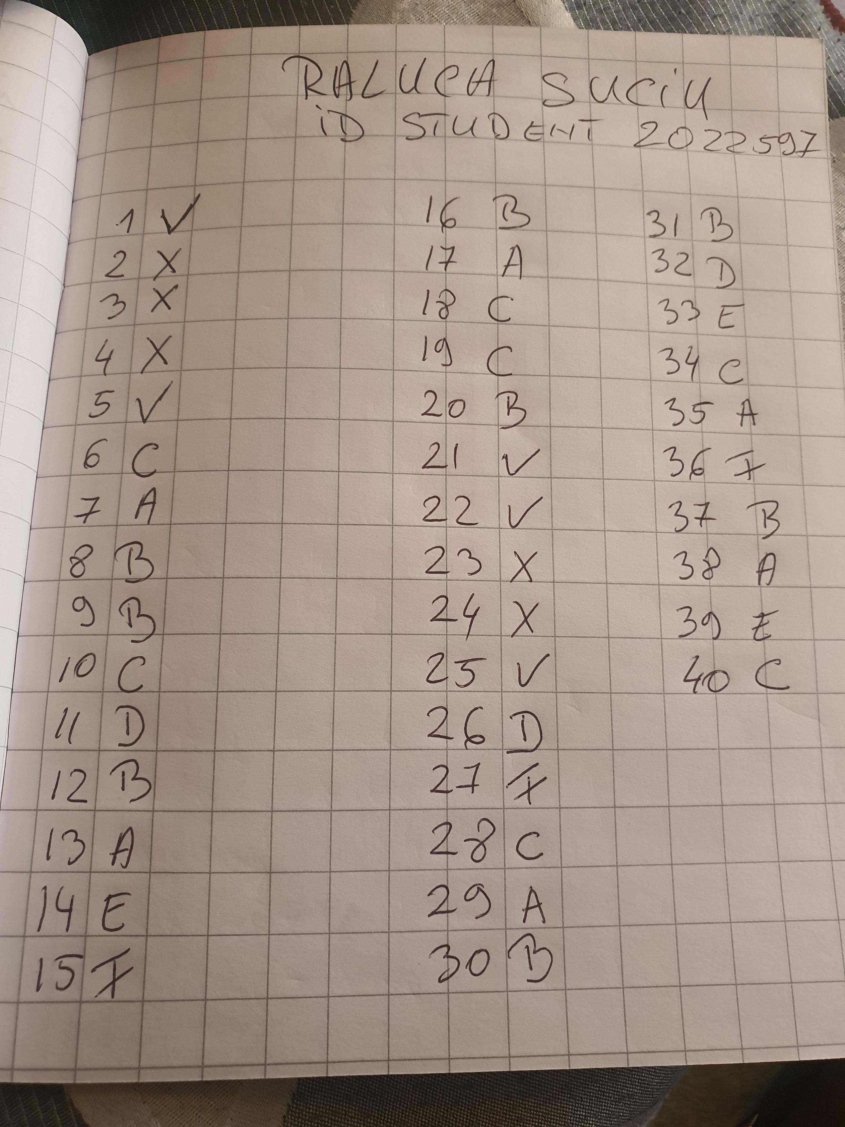
RALUCA SUCIU- 2022597- MANDARIN EXAM

