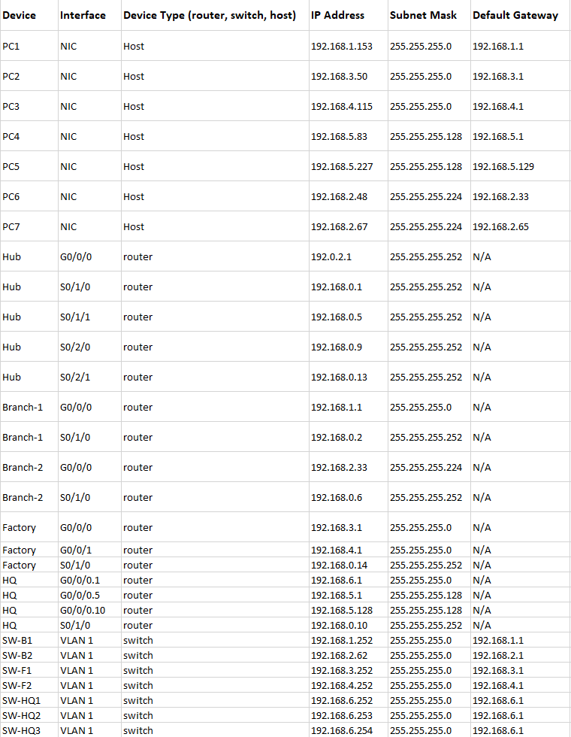

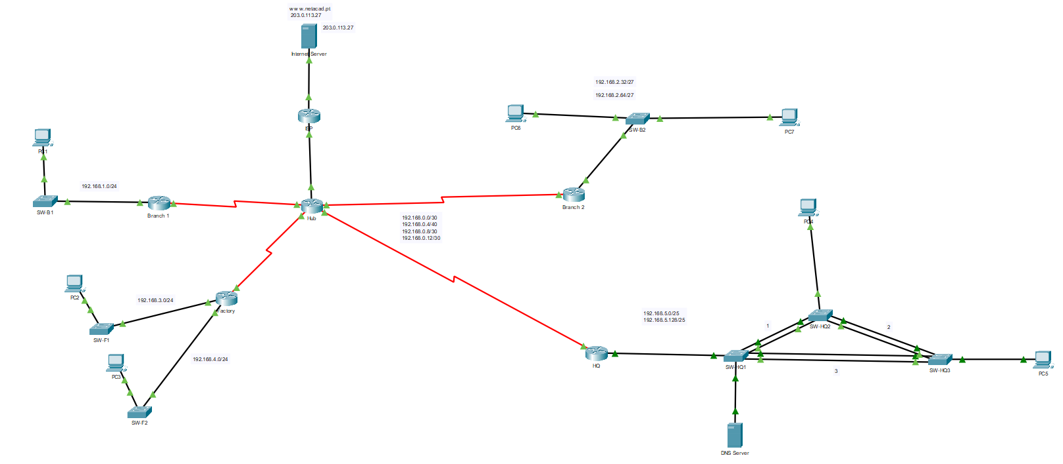

- Passwords of the devices should be changed and should all be different and stronger.
- The switches should not use the default SVI and management VLAN
- The switchports should use different VLAN’s instead of VLAN 1
- Switchports that are not used should be shut down and moved to an unused VLAN.
- Port security should be used
- DTP negotiation being active on trunk ports is a security risk.
- OSPF is active on the LAN interfaces. Passive interfaces reduce unnecessary traffic on the network.
- SSH is not being used on the network.
- 802.1x should be implemented.
- IP source guard should be implemented
- CDP should be turned off or restricted
- DTP is active except on ports connected to PC4 and PC5.
- Legacy STP that is being used on switches should be changed to RSTP
- Trunk links are using Native VLAN 1 which should be changed
- VLAN 99 is only created on SWB2 and its not being used nor does it have a name so it should be removed.

