Identify and Discuss a particular location where the concept of Skyscapes would enhance any existing Heritage Management structures

Dartmoor is an area that would be enhanced by the introduction of Skyscapes to the existing heritage management structures. The ancient stone age remains that dot this landscape would be enhanced by the incorporation of skyscapes into their management. These homes, and in particular the ritual sites, have a much closer relationship to the sky than later medieval and modern sites, and their use would have been intrinsically connected to the sky.
The sky has had an impact, and still has an impact on these sites. Whether it is the movement of the sun, moon, or stars, or the horizon and the shape of the sky overhead, the ritual sites of Dartmoor are open to the sky, and the sky becomes a part of them. It is possible to stand in the centre of a site such as one of the circles at Grey Wethers, and turn around. The horizon is integral at this vantage point. The elevation of the site provides a panoramic view of the area, and the sky becomes a part of the view. It is impossible to ignore.
The sky should be considered when managing an area. It is one thing to maintain the stones, to keep paths clear, and the moorland free of litter, and to recreate, as much as possible, the ground that was present 5000 years ago when the circle where built and used, but this does not give a full picture. The sky played a part, the atmosphere, and the view out into the sky should be taken into consideration. Obviously, it is harder to protect the sky than it is the ground, but that does not mean that projects should not be out into place. At the moment, there is only one skyscapes project with a focus on Dartmoor. This is Dartmoor Skies, which aims to educate about and encourage people into Astrology. Whilst this project works well for general education, and giving people the opportunity to stargaze in an environment in which there is less light pollution than many other areas, it does not have a heritage, or heritage management aspect. However, the charity has previously run talks on what the people who lived around Dartmoor may or may not have seen in the skies (Dartmoor Skies, 2017).
The Dartmoor skyline has changed. In some areas, this is due to the addition of new towns or imposing buildings such as the Powder Mills or Princetown Prison, which are visible against the skyline, and therefore change how we view the horizon interacting with the sky. However, compared to the scale of the moorland landscape as a whole, these are small. Something that has massively affected the visual relationship between the sky and the moor is the introduction of plantations. Several plantations of conifers for timber have been planted across Dartmoor, such as Fernworthy and Bellever Forests. These are visible from miles away, and change what can be seen. They block the lines of sight between monuments, tors, and aspects of the night sky, such as stars or constellations.
There are several ways in which skyscape management could be implemented to help protect the Dartmoor skyscape. These include the dark skies project, an in depth study of the relationship between the Neolithic structures of Dartmoor and the sky, and education on how and why the sky should receive as much attention, and protection as the land. The Dark Sky Discovery project, which aims to develop awareness of the skies (Dark Sky Discovery), does not currently have a specific project on Dartmoor as shown on figure 1. The introduction of this project could help us to understand more about the Dartmoor Skyscape. However, it is possible that due to the presence of Dartmoor Skies, a similar project may not be considered necessary. Study and education would play a part in any Dark Skies project, but separate studies would aid heritage management further. With increased understanding of the relationship between the sky and a ritual site, we can better understand how to protect it, so as to preserve that relationship as much as possible. This has other benefits in that it gives the opportunity to study and learn in more depth about the lives and rituals of the people who lived on Dartmoor thousands of years ago.

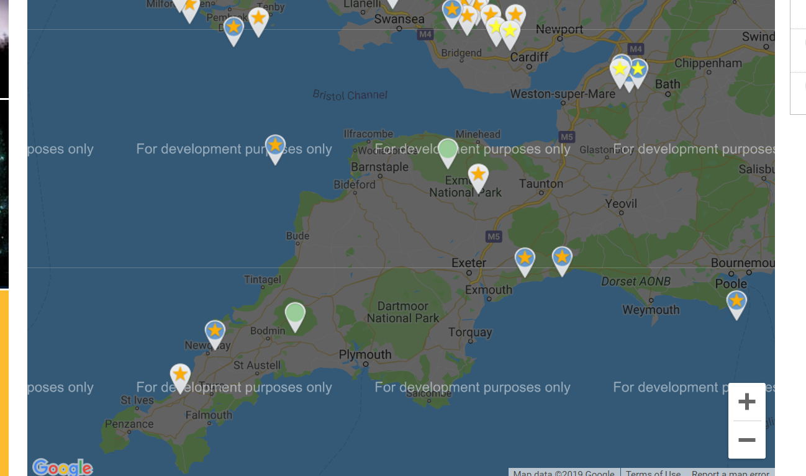
Figure 1: Map showing Dark Sky Discovery Project near Dartmoor (Dark Sky Discovery)

In conclusion, the heritage management of Dartmoor, and in particular the Neolithic Structures that still stand, would benefit from the incorporation of Skyscapes into this management because it would further the mimic the setting in which they where originally built and used. Furthermore, it would provide a more rounded and full learning opportunity, as opposed to viewing the landscape in which they are situate din isolation, and failing to take the Skyscape into consideration. Combining these two would give people a fuller picture of how a ritual site such as Grey Wethers or Scorhill existed in the context of the land and the sky.

Bibliography
Dark Sky Discovery () Dark Sky Discovery Sites [image] Available at: https://www.darkskydiscovery.org.uk/dark-sky-discovery-sites/map.html#sites (Accessed: 15th April 2019)
Dark Sky Discovery () The UK Dark Sky Discovery Project Available at: https://www.darkskydiscovery.org.uk/about_us.html (Accessed: 15th April 2019)
Dartmoor Skies (2017) Past Events – Kent’s Cavern 17/11/2018 Available at: https://dartmoorskies.org/2018/11/17/past-events-kents-cavern-17-11-2018/ (Accessed: 15th April 2019)

