Reflection on Study Skills
ACDA4021 - Study Skills for Electronics
Year 4 - 2024
Gareth E John (2413461)

Contents
1.Presentation Skills 2
1.1 Overview 2
1.2 Screengrabs from PowerPoint Presentation 2
1.3 Where to improve with Presentation Skills 4
Section 2. Personal research on skill sets 5
2.1 Skills for Successful learning in Higher Education 5
2.2 Skills Employers looking for job candidates 6
Section 3. Self-evaluation 7
3.1 Strengths and Weaknesses 8
3.2 Short- and Long-term goals 9
3.3 Action Plan (S.M.A.R.T) 9
Section 4. Application 9
4.1 Looking after data 9
Section 5. Time management and self-organisation 11
Section 6. Conclusion 11
7. Bibliography 11
Section 8. Appendices 12

1.Presentation Skills

1.1 Overview
This report will give a brief overview of what this person is like from youngster to present time. Screengrab 1 shows that he was diagnoses with Loss of hearing and wears Hearing aids in both ears, this didn’t stop Gareth from living his life as he went on to Qualify as a Joinery straight from school, as an Electrician about 8 years ago and play semi-professional in Rugby including represented Wales Deaf as Captain as shown in Screengrab 2. Screengrab 3 show that Gareth as got a family of 3 boys and a beautiful wife.

1.2 Screengrabs from PowerPoint Presentation
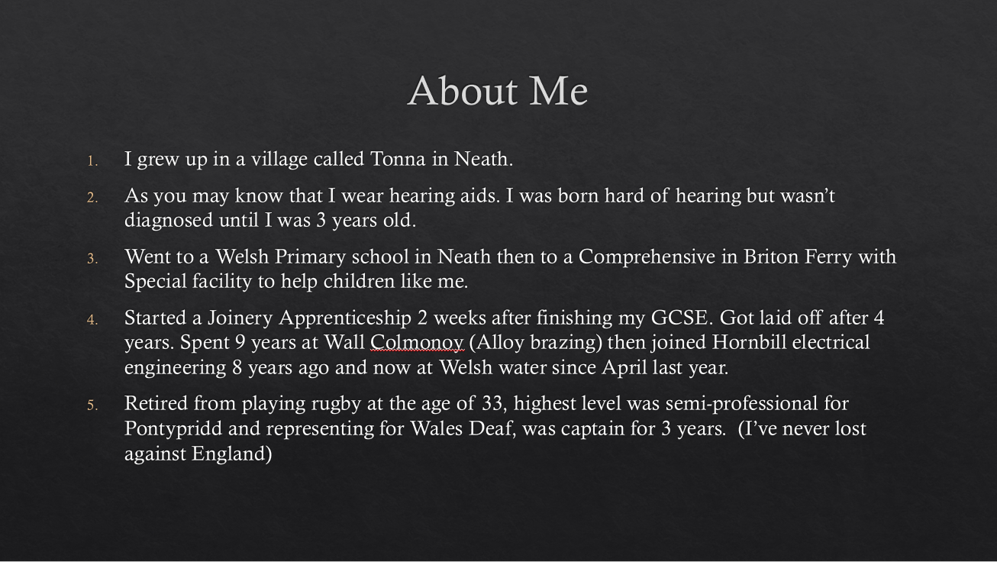
Screengrab 1 – is a summary of the person.


Screengrab 2 – From when Captain and playing for Wales Deaf.

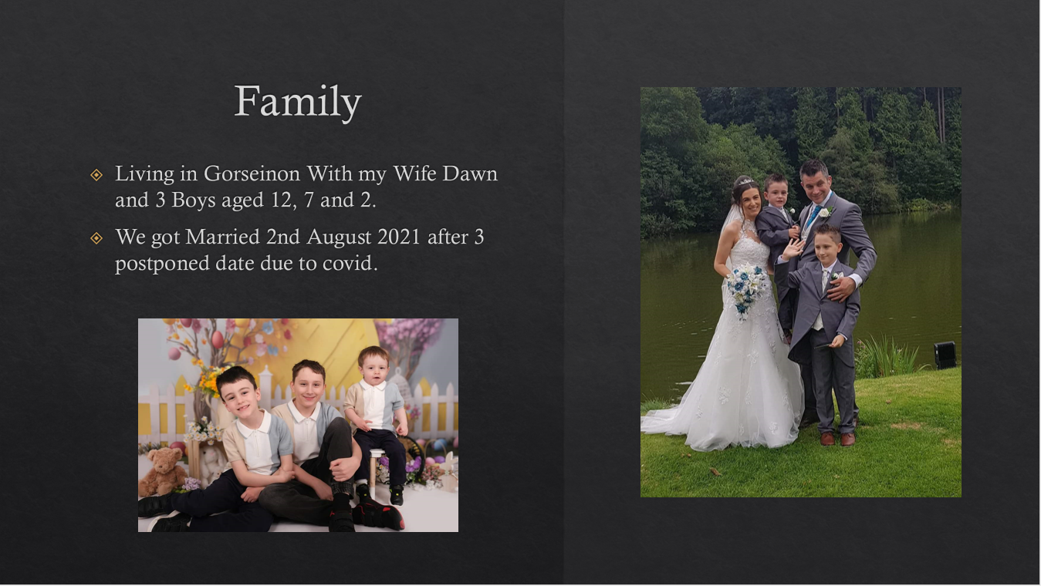
Screengrab 3 – Family.

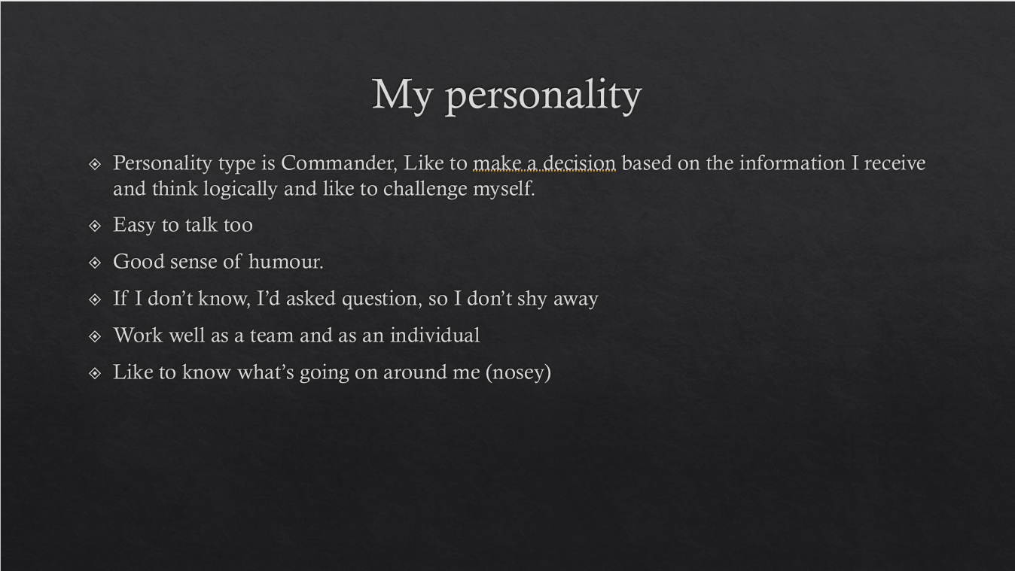
Screengrab 4 -Personality.

1.3 Where to improve with Presentation Skills

Task was to present a PowerPoint presentation about the person life, personal type, what their job role is and where do they see themselves in 5 to 10 years.
After the presentation finished, the feedback was given that the presentation was done in a confidence manner but lack focus on the audience rather than looking at the PowerPoint slide.
Improvement will need that to focus more on the audience and also to relax and not to try and rush through the slide. The text style will need to be clearer to read and the size will need to be a bit bigger. Felt like there should be more image or graphic data on the slides.

Section 2. Personal research on skill sets

2.1 Skills for Successful learning in Higher Education
There are several sets of skills that will help to be successful in Higher Education see following points below and brief description. [1]

Time management
Time management is a skill that will help with learning in higher Education. Setup up alarm clock for your classes in the morning or block out the calendar for your assignments or researching. It essential to manage your time from University and Personal life.
Self-Motivation
Unfortunately, No one will be able to help you with motivation. Is so easy to get distracted from friends and family to do fun things with them, this is where self-motivation or self determination play a vital role in making higher education less stressful.
Communication
It is importance to communicate with the lecturers and engaging with each topic this will help develop more understanding of the topic. Do not be afraid to ask questions, rather than struggle through the subject ask questions for better understanding. Most importantly raises any concerned with mental wellbeing.
Researching
This is a good skill to have with higher education. This will help with the assignment and easy stress finding the information needed.

2.2 Skills Employers looking for job candidates

This is Similar to skills with higher education like Communication and Time management skills but more of soft skills that Employers looking for as this is far harder to train or teach. See following skills below. [2]
Initiative
This is a great skill to have. The ability to think, plan and do the work without being told what to do at every step. This will free up lots of management time.

Teamwork skills
Teamwork is an ability to play your role in a team environment and also to trust the team involve doing their job. This mean lots of communication and speaking up to have your say in each task.

Problem-solving skills
Ability to solve problems or find a solution to a problem is a good skillset to have. This involve researching/investigating the root cause of the problem.

Section 3. Self-evaluation

Below is a self-evaluation test from online, as results shows that this person is an extrovert, can control any emotions, be able to agree or disagree on any topic being discuss.
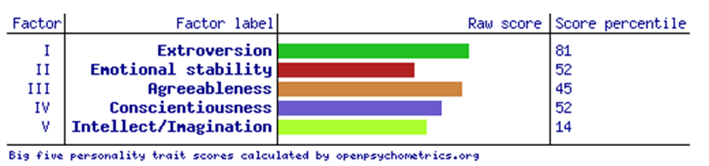
Figure – personality test from Big Five personality trait [3]
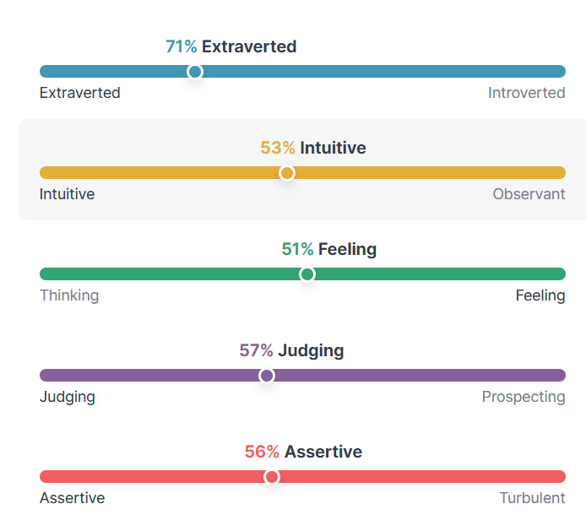
Figure – Personality test from 16 Personality [4]

3.1 Strengths and Weaknesses
The following Strengths and weaknesses from an online test [4]. This show 2 different set of Strengths and weaknesses
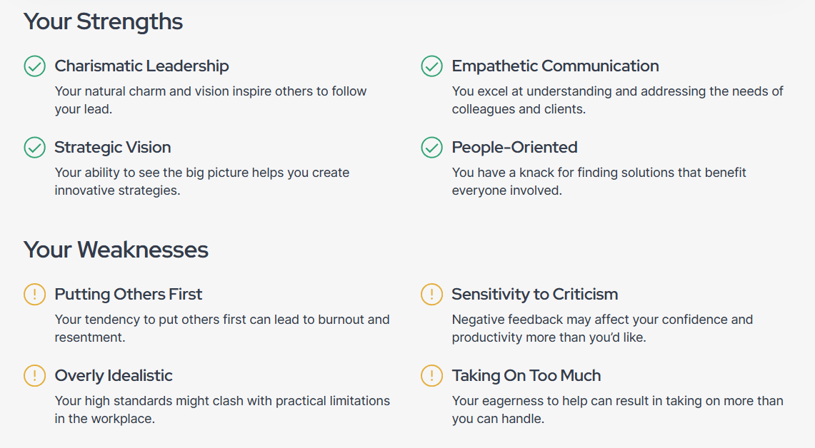
Figure - Strengths and weaknesses on Influential Traits.
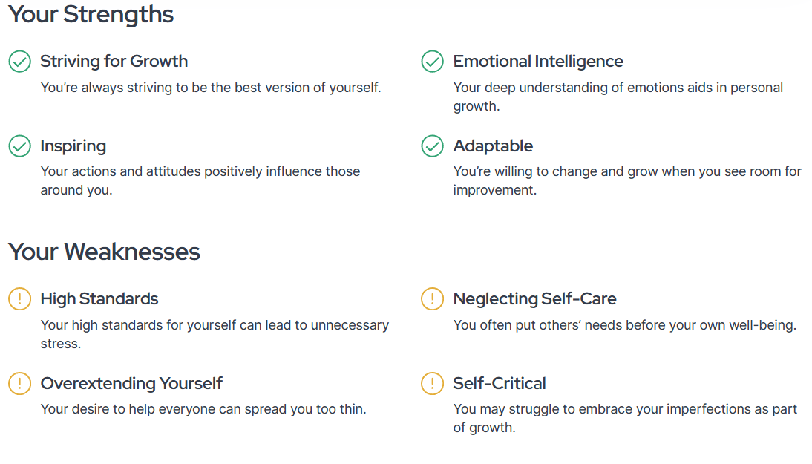
Figure – Strengths and weaknesses on relationships

3.2 Short-term and Long-term goals
Short-term goals within Year 1
On a professional level - to improve knowledge and understand of Electrical and Electronic.
On a personal level - Get healthier and fitter.
Long-Term Goal 3 to 5 Years
Managerial role on a permanent basis
Finish Degree as least a 2:1.
Have an extension built on the house.

3.3 Action Plan (S.M.A.R.T)

Section 4. Application

4.1 Looking after data
There a saying saves in 3s meaning that there are 3 different paths with the same file is stored. [5] Below are the 3 different location that the files are stored. Figure is a USB Type A&C where this is kept on a bunch of keys that is mostly with the owner. The other 2 location are on the personal desktop that connected to the OneDrive and University OneDrive.
All these are setup the same structure as show in figure.
Reason for different locations is for security if the data is loss, corrupts or even ransomware or Malware.
What is Malware and Ransomware?
Malware is a virus that hackers put onto targeted vulnerability people, company or organization. Ransomware is a Malware where the hacker wants come form of rewards from the individual or companies. They target sensitivity information or files on the computer that the hacker knows it is important to the individual. As state on National Cyber Security centre website, it’s shows what the virus can do on the computer affected. [6] The computer itself may become locked, or the data on it might be stolen, deleted or encrypted. Some ransomwares will also try to spread to other machines on the network.
How to Defence the data from Ransomware attack?
As state on cyber security centre website that there is no way to fully protect from these attacks but to defence in depth [6]. Basically, saying do not used same password for all login or account.
- Regularly back-up the data on different locations.
- Keep the device up to date with the latest firmware updates as soon as become available.
- Run anti-virus software regularly.

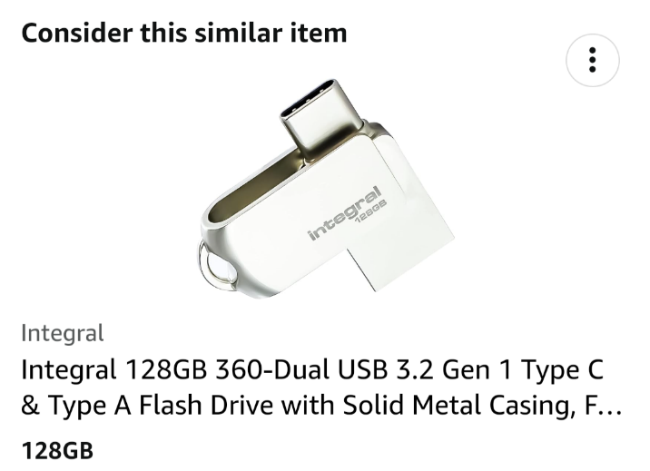

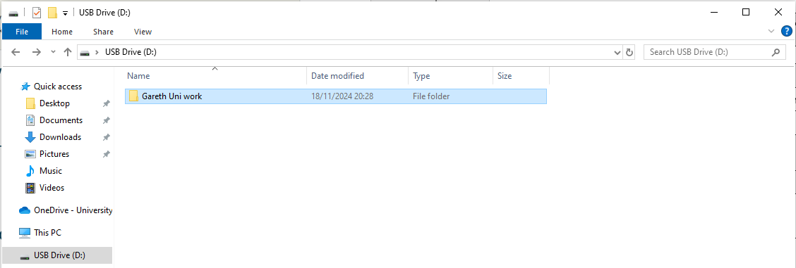

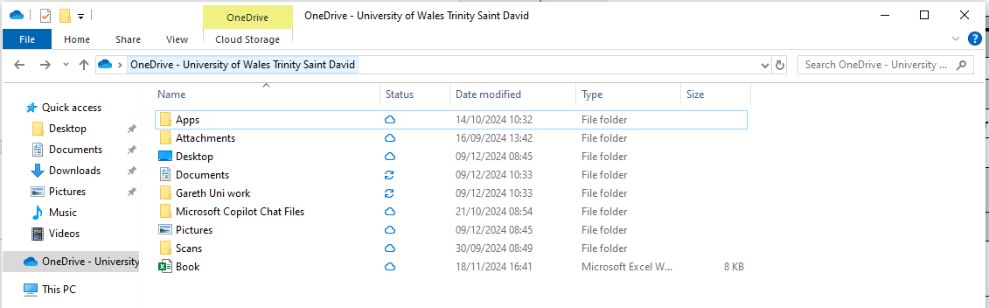
Below is where the same folder structure on the personal laptop.
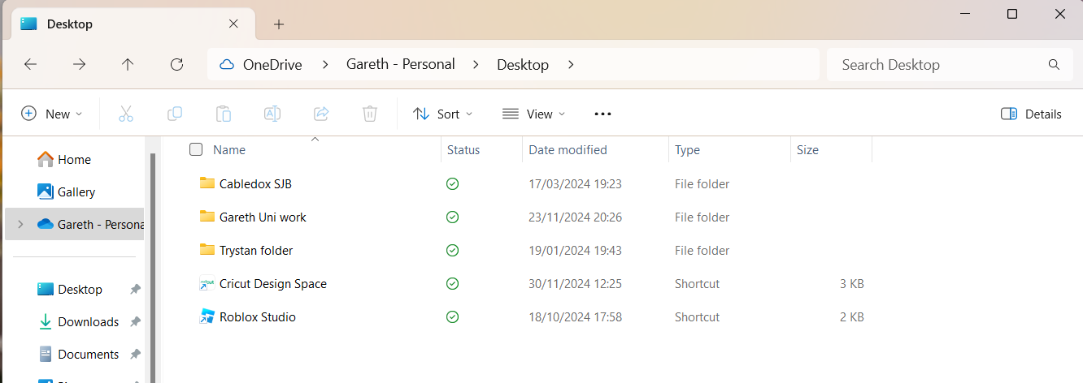
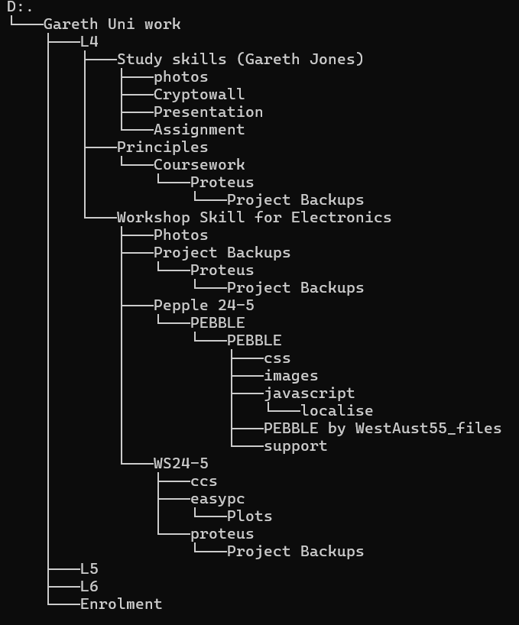
Figure is a copy of the files tree structure from command prompt.

Section 5. Time management and self-organisation

Section 6. Conclusion

Section 7. References

[1] | “Skills you need to succeed at university,” Study Work Grow Pty Ltd, 22 Febuary 2024. [Online]. Available: https://studyworkgrow.com/skills-you-need-to-succeed-at-university/. [Accessed 02 January 2025].
[2] | “8 Sought-After Skills Employers Look For,” Recruit Holdings Co., Ltd, 17 May 2024. [Online]. Available: https://uk.indeed.com/career-advice/career-development/skills-employers-look-for. [Accessed 02 January 2025].
[3] | “Open-Source Psychometrics Project,” [Online]. Available: https://openpsychometrics.org/tests/IPIP-BFFM/. [Accessed 02 January 2025].
[4] | “16personalities,” [Online]. Available: https://www.16personalities.com/enfj-personality. [Accessed 02 January 2025].
[5] | Z. Ammari, “Why you should store your data in 3 separate locations,” 19 October 2015. [Online]. Available: https://tech.co/news/store-data-3-separate-locations-2015-10#:~:text=Files%20are%20less%20likely%20to,prevent%20a%20permanent%20data%20loss.. [Accessed 02 January 2025].
[6] | “https://www.ncsc.gov.uk/,” 09 September 2021. [Online]. Available: https://www.ncsc.gov.uk/guidance/mitigating-malware-and-ransomware-attacks. [Accessed 11 11 2024].

Section 8. Appendices

You are required to produce a correctly formatted report where you will produce written reflection and evidence on the application of the skills covered during
this module. The report should cover all the sections specified.
Remember that an acceptable report format contains as a minimum, a Title Page, Table of Contents, Page Numbers, Numbered Sections and Headings and appropriate diagrams/graphics/tables. The layout should also try to conform where possible to the guidance and sample layout provided during the course of study.

It is essential that you demonstrate background research activities, knowledge gained, and exercises undertaken. The report should refer to sources of information that have contributed and enhanced your knowledge and understanding (e.g. online sources, books, journals, articles). The report must include a list of references / bibliography, following the IEEE Referencing System.

Section 1: Presentation skills
- Provide a brief overview of yourself as per your personal presentation exercise.
- Include 4 screengrabs from your powerpoint presentation
- List the key points that you have learnt when trying to produce and deliver a successful powerpoint presentation
- Describe what aspects you feel you could improve on to enhance your future presentations.

Section 2: Personal research on required skill sets
Perform your own research to identify:
- a) Skills required for successful learning in a Higher Education environment
- b) Generic, transferrable skills employers look for in prospective job candidates.
(make sure you include citations/references in your report to back up your statements)

Section 3: Self evaluation and action planning
- Conduct Self Evaluation exercises to discover your strengths and weaknesses, personality type, suitable career suggestions etc.
(Some links will be provided for you, but you should also perform your own independent research to obtain alternative/additional methods of evaluation such as further on line web based tests).
Show your results. Compare and contrast the findings of these formalised self evaluations to how you perceived yourself before doing the tests. How do the results compare? What have you learned from this exercise? Where do you think you could improve or change?

- List your main short term and long-term goals (include academic, personal, and professional/job related goals)

- From the information you have discovered and documented above, create action plans (that conform to the S.M.A.R.T guidelines) for the Academic and Personal/Professional Skills you need to attain to improve yourself and/or achieve your goals. Do this for at least 4 items.

Section 4: Application
- Looking after your data
- Describe the backup strategy you created that obeys the “in 3 different places” rule discussed in class. Explain how it provides a robust level of data protection for any work you are likely to produce during your time in university, as well as any other important data you would not wish to lose. Refer to your own research on Ransomware and explain how your backup strategy would cope with being hit with this type of malware.

- Time management and self-organisation:
- Describe what steps you take, or intend to take, to enhance your own productivity, improve your organisation and/or reduce your stress levels. Provide evidence such as screengrabs/pictures showing e.g. your electronic calendar/diary.

- Provide screenshots as evidence of your completed e-Portfolio/PDP implementation with a brief written explanation of its content, structure and why you chose that method of organisation (use tools such as the snipping tool as demonstrated in class!).

Section 5: Conclusion & Evaluation:
- Summarize your conclusions / key-findings during the study of the various topic areas in this module, recommending areas of interest for further study and consideration.

Section 6: Referencing
Ensure you include your reference list in IEEE format - at the end of your report but before the appendices.

Section 7: Appendices:
- Include any additional screenshots here as additional evidence of student engagement performed during the course of studying this module. E.g. completed Skills Evaluation questionnaires, Jung/Myers Briggs, introvert/extravert evaluations, Research exercise on viruses/ransomware etc.

