

The relationship between automobile consumption and petroleum and its products consumption from the retail point of view

DBA CANDIDATE:
Jiyu Zhang

Quantitative Research Methods
Module Leader: Dr. Helen Lee

Contents
Abstract 4
Introduction 4
Literature Review 5
Conceptual Framework 11
Statement of Hypotheses 13
Research Methodology 14
Data Analysis 16
Findings 22
Conclusion 24
Limitation 24
Reflective 25
Bibliography 26

Contents of Tables

Table 1 Chi-Square Tests of automobiles amount and petroleum and products 16
Table 2 Group Statistics Independent Samples t test 17
Table 3 Independent Samples Test 17
Table 4 Residuals Statistics 18
Table 5 Descriptive Statistics 19
Table 6 Correlations 19
Table 7 Moudel Summary 20
Table 8 ANOVA 21
Table 9 Coefficients 21

Abstract
This study is mainly based on the data of the retail consumer goods market in China from 2015 to August 2024 released by China Statistics Bureau. The sales volume of petroleum and its products and the sales volume of automobiles, which should be common supplements, were screened out. Through the statistical correlation model, it is verified that there are complementary products or similar relationships between them, and more specific internal relations between them are found out. Consumption can reflect people's demand for goods, but there may be differences between production demand and personal demand. Because the retail consumer market does not include consumer goods needed for mass production, it can explain the preference of individual consumers in China for buying cars at present and can narrow the deviation between the choice of major buyers in the retail market and the data obtained by manufacturers from a macro perspective. It provides a view from the perspective of consumption for the transformation of China automobile industry.

Introduction
Compared with the overall consumption data, the data of social retail consumer goods have a higher correlation with the purchase behaviour of ordinary individual consumers and can also express the consumption will of individual consumers more intuitively. In this study, the automobile and its related industries that have changed greatly in China in the past 10 years were selected from the total retail sales of social consumer goods officially released by China Statistics Bureau for analysis. This paper mainly selects two data: automobile sales and sales of petroleum and its products. The timing is 2015, when the changes are more obvious. The purpose is to study the industrial transformation of new energy vehicles impacting traditional fuel vehicles and prove that fuel vehicles are still the main body of ordinary retail consumption market. To find the correlation between the sales volume of fuel vehicles and the sales volume of petroleum and its products as the main fuel, Chi-square analysis, independent test analysis and regression analysis are carried out by SPSS, and it is found that they are in line with the linear regression model. It is proved that even though new energy vehicles have impacted the whole automobile industry in China market, fuel vehicles still occupy the dominant position in the retail consumption, which is influenced and constrained by the sales of petroleum and its products. It provides support for further research on the pollution of fossil energy, sustainable economic development and sustainable consumption.

Literature Review
Consumption
Consumption is an important item in economics, and together with investment and export, it forms a troika to measure social and economic development (Fine, 1993). Total social consumption plays an important role in the development of statistical economy. Consumption is a way to meet people's material and spiritual needs in life. It is not only an economic activity, but also a cultural phenomenon. Consumption was identified as a research focus by sociologists in the late 20th century. In the economic system, consumption is based on social development, culture and material prosperity, and the act of obtaining goods and services is called consumption (Warde, 2015). This also makes consumption have both social and economic attributes. (Warde, 2022). In economics, consumption is the driving force behind the demand for goods, and consumers are defined as those who are on the receiving end of market exchange. (Granovetter, 1985). In sociology, it can refer to shopping, purchasing or using. The act of shopping or purchasing is still closely related to economics and is also the first thing people think of when it comes to consumption in the usual context.
The consumption value which explains the reason a consumer would like to pay for products or services was developed by (Sheth, 1991). The value is represented by the product category, brand reputation etc (Tanrikulu, 2021). Consumption value can be realized by people's behaviours or purposes of realizing personal value. For example, people need social interaction, value exchange, possession of goods or showing their identity. Therefore, consumption can be divided into different categories. By analysing different types of consumption data over a period, we can roughly conclude that people's preferences for consumer goods have changed during this period. Consumption decisions are easily affected by business cycles and internet trend (Jappelli, 2017).
Consumption can be divided into material cultural consumption and spiritual cultural consumption (Miller, 2020). It is undeniable that spiritual and cultural consumption usually appears on the basis that material consumption is satisfied. At the same time, based on social development and environmental changes, new consumption directions, such as sustainable green consumption, luxury consumption to improve the quality of life and so on. Except for the needs of large-scale production, other social consumption changes can be seen from the retail end of consumer goods (Dangi, et al., 2020).
Social consumption
Social consumption is influenced by culture, social development and family environment (Chan & Goldthorpe, 2024). Social consumption usually represents the cultural beliefs and technological innovations generally accepted by the current society. For example, consumption for the purpose of achieving self-esteem, ensuring life necessities and improving life pleasure and enjoyment (Baumann, 2022).Consumption activities can include a wide variety of goods and services (Boyd & Levy, 1963). Among these goods and services, we may find some commonalities (Solomon, 1983). For example, there are complementary or connected relationships between some commodities. And with the advancement of science and technology, some products themselves will be upgraded. As people's material lives become more fulfilled and enriched, their expectations for products will also increase. People's expectations of the direction of consumer spending will also change to a certain extent.
Consumers are an important part of the social consumption process. They have expectations for the products and services they can get from consumption. These expectations can be categorized into functional, social, emotional and holistic types (Wiedmann, et al., 2009). People consume to meet the above functional needs. Functionality is the most basic type. It means that consumers are willing to pay for the function and practicality of the product or service itself to obtain direct tangible or specific functional attributes (Gomes, 2020). For example, buying food is to obtain the energy and nutrition in the food to maintain life and physical health. Social attributes can also be called social attributes. It usually refers to the association between the positioning of the product and social identity, class, etc., and usually refers to products with higher value or more attention. Cars are products with high social attributes (Shahid, et al., 2022). People are willing to consume for the identity and status represented by the car brand. Emotional attributes are usually highly related to the group emotional connection or personal experience of consumers. A certain product may remind people of specific emotions (Rocklage & Fazio, 2020). For example, the cultural connection of the nation, the meaning of Halloween to Western culture and the meaning of the Spring Festival to Chinese people; or it has special meaning or memory for the consumer personally, the taste of dinner at home, etc. The holistic attribute is to feel complementarity, coherence and consistency from the entire product category (Karatas & Gürhan‐Canli, 2020). For example, in consumption, it usually includes the most necessities of life such as food, clothing, housing and transportation. When these categories meet expectations, the satisfaction of consumption will be appropriately amplified. This is because the overall synergy of such products enables consumers' feelings to be amplified synchronously. Different types of products may form interrelated or complementary combinations in consumption, making consumption have a certain degree of linkage.
The combination of individual consumption forms the total retail sales of social consumer goods, which can reflect the total consumption and changes of individual consumption at the social level (Tanrikulu, 2021). By sorting out and analysing this data according to time, we can see the changes of individual consumers in consumer goods during the statistical time, which is helpful to analyses economic vitality and consumption tendency. This shows that the social attribute of consumption has always existed, and it is of great significance to study social consumption for understanding economic development and people's consumption preferences (Yin & Shi, 2021).
The total retail sales of consumer goods can be used to measure the consumption level of the Chinese people and can also be used as an indicator of the national economy (Liu, et al., 2021). In recent years, with the impact of economic globalization and COVID19, the economic development of countries around the world has stagnated or even declined (Sayyida, et al., 2021). The basic driving force of economic growth is consumption, and even consumption is the goal of investment (Wang, et al., 2016)，It is the driving force behind the development of national productivity. The total retail sales of consumer goods can not only reflect the country's consumption demand, but also reflect the country's national economic level (Liu, et al., 2020). Simply put, an increase in the total retail sales of consumer goods means an increase in social market consumer demand, and vice versa, it means a decrease in market consumer demand.

Consumption concept change
Economic development enables goods and services to meet more diverse needs, especially differentiated needs for some basic needs (Dąbrowska & Gutkowska, 2015). This may lead to a change in people's propensity to consume.
Population changes brought by urbanization, including aging and lifestyle changes, may bring about changes in consumption habits (Apergis, 2016). The reaction in consumption statistics is the change of money spent on different categories of consumer goods. There are some differences between urban and rural consumption behaviors. Urban consumers may pay more attention to products with higher quality and certain brand awareness, while rural consumers generally prefer goods with more balanced price and quality (Song, et al., 2015).
Consumption concept. People's consumption concept will change with social development, economic development, technological innovation and other factors (Wang, et al., 2021). People in rural areas have changed from paying attention to survival consumption to coexistence of survival consumption and enjoyment consumption. From being willing to spend money only on material consumption, it has become the coexistence of material consumption and spiritual and cultural consumption (Boström, 2020). From physical consumption only to physical consumption, physical consumption is as important as online consumption (Cao, 2020). These reflect the change of consumption concept driven by the development of society. Meanwhile, with the development of economics and people’s attention to environmental protection has gradually penetrated the consumption tendency.
The change of consumption tendency in recent years is more obvious to mention green consumption and sustainable consumption (Halder, et al., 2020). Green consumption mainly focuses on the consumption behaviour of implementing the concept of green and low carbon in the whole process of consumption activities, with the aim of promoting the symbiosis between people and the natural environment. Sustainable consumption is derived from the theory of sustainable development in 1980s. Generally, economic growth, ecological balance and social progress are the main goals. Sustainable consumption is to bring economic development into the theory of sustainable development and take moderate consumption as the basis, so that economic development and natural development can be balanced (Tian, 2019). However, the development of urbanization depends on economic growth and scientific and technological progress, industrial structure transformation and institutional changes. Economic growth will bring more employment opportunities and better living conditions and attract rural population to gather in cities. The transformation of industrial structure and institutional changes have made the industrial industry and service industry develop rapidly. However, the lifestyle changes brought about by rapid urbanization will further increase the demand for modern fuels (Li, et al., 2023).

Petroleum and products
Fossil fuels come in many forms, but oil is the most important one (Murshed, et al., 2021). Oil is called the blood of industry. The largest amount of oil is used as a power fuel in various transportation industries, such as cars, trains, airplanes, rockets, etc. At the same time, other products based on oil are also widely used in industrial production and daily life. Since the industrial revolution, oil has occupied an important position in industrial development and economic development. Oil prices are closely related to the global economy. After experiencing several waves of oil price fluctuations, the latest round of world oil and gas has entered a recession cycle. The sharp drop in international oil prices and the resulting low prices, low returns, low investment and low costs have become the new characteristics of the oil and gas industry in the new era (Qian, et al., 2015). Narayan et al. (2019) Through the study of India, it was found that the impact of oil consumption on economic development was not as strong as expected. However, in the process of industrial development, people gradually realized the pollution caused by oil to the environment, such as the large amount of greenhouse gases after combustion, and the particulate matter suspended in the air that harms people's health. The climate crisis has brought pressure on the petrochemical industry to transform green. In the process of reducing carbon emissions, the petrochemical industry has to respond to market demand. (Midttun, et al., 2022). China's oil consumption has increased with its rapid economic growth since 1990. (Leung, 2010). After decades of focusing on economic development, environmental issues have become increasingly prominent, and energy transformation has been gradually promoted as a national policy in China. Reducing air pollution caused by oil refining and consumption has become an inevitable choice for the transformation of China's oil industry (Chen, et al., 2020). In 2017, France and Norway announced plans to gradually stop selling fuel vehicles, followed by the United Kingdom, Germany and other countries that also said they would join the plan. China also has this trend, such as raising national emission standards for gasoline and diesel (Liu, et al., 2020). This is not good news for the oil and automobile industries. But in fact, due to policy and technical restrictions, fossil fuels, especially oil, still account for a large share of the energy structure (Chen, et al., 2023). Therefore, although clean energy such as electricity and wind energy has gradually become a choice in daily life, especially in the transportation industry, the market share of new energy vehicles has increased year by year, but the consumption of petroleum and its products has remained stable at a high level. Research in the automotive industry shows that if fuel prices rise by 10%, the demand for cars in the short distance will decrease by 20% (Hemmati, et al., 2018). This can be shown when the price of one good affect the demand for another good, meaning that the two goods should be used together (Yadav, et al., 2021). Just like cars and petroleum and its products.
Automobile consumption
China is a superpower in automobile manufacturing and consumption in the world (Khanna, 2023). Automobile is one of the important parts of the transportation industry, and the automobile industry is also an important industry of China's national economy. At the same time, the booming automobile industry has also brought about an increase in energy consumption. With the development of China's economy, the automobile industry has got a good development space in China, which has promoted the rapid development of the national economy. Since 2009, China has ranked first in the world in new car sales for 11 consecutive years (Hu, et al., 2021). With the acceleration of urbanization, residents' demand for cars is also increasing. According to the statistics of the Traffic Management Bureau of the Ministry of Public Security, as of June 30, 2024, the number of motor vehicles in China was about 440 million. Among them, the number of automobiles is 340 million, and the number of new energy automobiles is 24.72 million, accounting for 7.18% of the total automobiles (China, 2024). The main energy supply of the automobile industry is still oil and its products, and its energy consumption is also worthy of attention. In 2016, the proportion of energy consumption in China's automobile industry was about three times that in 2006, which was about 10.4%. The consumption of petroleum and its products has exceeded half (Du & Lin, 2019). In 2023, the average fuel consumption of China automobile industry was 3.78 Liters /100 Kilometres (Technology, 2024). The Carbon dioxide (CO₂) emissions from the transportation sector account for a quarter of the total emissions. Especially after the reduction CO₂ emissions was proposed in 2006 for ten years. This result has promoted global efforts to find solutions to reduce the CO₂ emissions in transportation (Yoo, et al., 2021). Among them, countries such as Norway and France put forward plans to phase out fuel vehicles.
China listed developing electric vehicles in the "863 Plan” since 2000. And encouraged the development of energy-saving and environment-friendly electric vehicles and hybrid electric vehicles in 2004 (Du & Ouyang, 2017). In 2008, new energy vehicles began to enter practical applications. In 2011, it entered the industrialization stage. In 2013, China's new energy automobile industry was launched in an all-round way, and before 2016, a trustworthy industry pattern such as technology and brand had not been formed. In 2018, the industry began to adjust and upgrade, and in 2020, new energy vehicles entered the main category of private consumption (Zhao, et al., 2024).
Through the above comparison, it is found that when the oil energy consumption accounts for more than 50%, China has started to reduce the dependence of the automobile industry on oil and its products (Wen, et al., 2021). But at present, petroleum energy is still the main energy provider in the automobile industry, and new energy vehicles have not completely replaced the position of ordinary cars in the hearts of consumers.

Conceptual Framework
The basic idea of this study is based on the concept of complementary products in economics. Complement is usually a large commodity that needs to be consumed with another commodity. The consumption of the two together can meet the needs of consumers. When the demand for a commodity increases, the demand for corresponding complementary products will also increase; When the price of one commodity rises, the demand for the corresponding complementary products will decrease. However, the complementarity between commodities is often asymmetric, and the degree of complementarity between different types of commodities is also different. Before the application of new energy vehicles, in the retail category, the corresponding complementary products of automobiles were mainly petroleum and its products. In recent years, with the application of new energy vehicles and the continuous rise of oil prices, the sales of traditional vehicles will be affected. Therefore, we selected the data of ten years, including the five years before and after new energy vehicles became the consumption choice of individual consumers, to verify the relationship between the consumption of oil and its products and automobile consumption.
In China, there are two main consumer goods: petroleum and its products consumption and automobile consumption. Under the impact of new energy vehicles in recent five years, traditional vehicles seem to have been greatly affected at the retail end. Under this background, this study puts forward two hypotheses. 1. In the past ten years (including the five years before and after new energy vehicles became the consumption choice of individual consumers), whether there is a correlation between social retail consumption, oil and its products consumption and automobile consumption. 2. Whether there are differences and differences between automobile sales and petroleum and its products in China retail consumption market.
To test these two hypotheses, we collected the data of social retail consumer goods for 116 months from January 2015 to August 2024 and screened out the data of automobile sales and consumption of petroleum and its products. Chi-square test in statistical analysis is used to test whether there is significant difference between them and whether they are independent. Use independent t-test to test whether there is any difference between automobile sales and consumption and consumption of petroleum and its products. Use regression analysis to detect the causal relationship between them.
Petroleum and products retail consumption
Automobile amount retail consumption
The total retail sales of consumer goods
Hypophysis 1
Do they have affected relation
Hypophysis 2
Do they have relationship
Finding
Chi-square
Independent
T-test
Regression
Verified Method

Figure 1 Conceptual framework

Statement of Hypotheses
In the total retail sales of consumer goods, we can identify some type of goods that have complementary relationship. Like the Petroleum and products and the automobiles. In most circumstances, the consumption of the Petroleum and products are turned to car, motor and other similar vehicles. In the data set, we can see the evidence that the gap between total retail sales of consumption goods and including retail sales of consumer goods other than automobiles, equals to the item automobiles. But in nearly five years, the new resource automobiles are become more normal in China, it would be affected the traditional automobiles sale. However, the electricity charges for new energy vehicles are usually mixed with the residents' electricity charges. We try to judge whether there is a close relationship between the consumption of oil and its products and the consumption of automobiles at present from the perspective of consumption.
Hypothesis for Chi-square correlation
H0: the petroleum and products consumption would affect the automobile amount consumption
H1: the petroleum and products consumption would not affect the automobile amount consumption
Furthermore, this study wants to identify the difference between petroleum and products and the automobiles. Therefore, this study makes the following hypothesis: （ t test）
H2: The Petroleum and products and the automobiles have no relationships.
H3: The Petroleum and products and the automobiles have strong relationships.

Research Methodology
For resolving the problems, the quantitative research methodology would be appropriate in this research. The description data record lots of numbers, but the limitations of humans lack sensitiveness necessary to get the hidden relationship among the numbers. Using mathematical tools would be help researchers to investigate the potential relationship between data and charts (Champman, 1928). Quantitative approach using Chi-square, T-test to examine the relationship in complementary good in social consumption.
Data source: The data selected in this study comes from the data of the total retail sales of social consumer goods published by the National Bureau of Statistics of China every month from January 2015 to August 2024, totally 116 months.
The total retail sales of consumer goods do not include all consumption, but specifically refers to the amount of physical goods sold directly to individuals and social groups for non-production and non-operation purposes by enterprises (units, self-employed households) through transactions, as well as the amount of income obtained from providing catering services. This means that the total retail sales of consumer goods only count a specific type of consumption, that is, the amount of goods and services sold directly to final consumers, and does not include the value of raw materials, fuels and other consumables used by enterprises or self-employed households for production and operation and fixed asset investment. In addition, the total retail sales of consumer goods do not include residents' expenditure on purchasing commercial housing and farmers' expenditure on purchasing agricultural means of production. Therefore, when we add up the above-limit and unlimited consumption, the data obtained is not equivalent to the total value of all retail sales, because the latter includes a wider range of consumption types and uses.
In addition, the statistics of total retail sales of consumer goods also involve the data collection method and scope. For example, legal entities, industrial activity units and individual business owners in wholesale and retail industries above the quota, accommodation and catering industries report statistical data through the online direct reporting system, while relevant units below the quota obtain data through sampling surveys and then estimate the total. This difference in data collection methods may also lead to differences between the final total retail sales of consumer goods and the total retail value of goods.
In summary, the calculation of total retail sales of consumer goods is based on a specific statistical scope and method, and it does not cover all types of consumption. Therefore, the sum of above-limit and non-limited is not equal to the total retail value of goods.
The main reasons for choosing consumption data are as follows: 1. It is an important indicator to measure economic development. 2. The total retail sales of social consumer goods are published by the National Bureau of Statistics every month, which is relatively reliable. 3. The statistics of the number of cars and petroleum and its products in social consumer goods can better represent the consumption will of ordinary individual consumers, which is more in line with the purpose of this study. e
The selected method: Chi-square, independent test and regression are used to analyze the relationship between the number of cars and oil and its products.
Chi-Square is widely used in classified data statistics (Turhan, 2020). It is mainly used to test the deviation between the actual observation value and the theoretical observation value in statistical samples. This degree of deviation determines the Chi-Square value. The greater the chi-square value, the greater the deviation between the actual observation value and the theoretical observation value. On the contrary, the smaller the chi-square value, the smaller the deviation degree. When Chi-Square value is 0, it means that the two observations are completely equal.
Independent t test uses t distribution theory to infer the probability of differences. T-test is the relationship between two variables, an independent variable X and a dependent variable Y. The independent variables must be category variables and can only be divided into two categories (Gronau, et al., 2020). The significance of independent t test is to compare whether there are significant differences in the mean values of two independent Yang Naben, to determine whether the differences between different groups are statistically significant. In this study, we choose to divide automobile amount consumption into two groups. One group is above average, and the other group is below average. Test whether the gap between automobile sales and consumption of petroleum and its products really exists.
Regression analysis is mainly used to determine the quantitative relationship between two or more variables. Linear regression analysis is used to determine the type of relationship between independent variables and dependent variables. The relationship established between the dependent variable (Y) and the independent variable (X) using the best fitting straight line (Mohajan, 2020). In this study, we regard the consumption of petroleum and its products as independent variable (X) and the consumption of automobiles as dependent variable (Y) and determine the relationship between them through linear regression analysis.

Data Analysis
Chi-square
First, using Chi-square to make sure whether there is a relationship between petroleum and products automobile amount in social consumptions. We categorize the Petroleum and products into five categories, from 1100 to the highest level in these 116 months. And we get the average amount of automobile in the same range, classify as two groups, group 1 s higher than the average amount, group 2 is lower than the average amount. Then we put the data into SPSS, choosing Chi-square to find the relationship between these two complementary goods. Table 1 below shows the result.
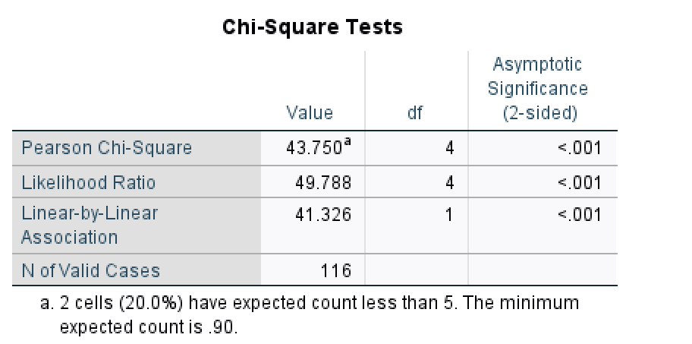
Table 1 Chi-Square Tests of automobiles amount and petroleum and products
In the table 1. we can find square statistic, Pearson Chi-square is 43.75, degrees of freedom(do), corresponding to P<0.001. therefore, we reject the null hypothesis with 99.9% confidence and conclude that there is very strong evidence of an association between automobiles amount groups and petroleum and products.
Independent Samples T test
Independent Samples T test Which is use for detecting whet two independent samples come from a large normal population with that same mean value, that is, detecting the difference of the mean values of the two population. In this study, we make the automobiles amount divided into two groups by the average. Group 1 includes the months which is lower than the total average amount 3511, and group 2 includes the months which is higher than the total average amount.
H2: The Petroleum and products and the automobiles have no relationships.
H3: The Petroleum and products and the automobiles have strong relationships.
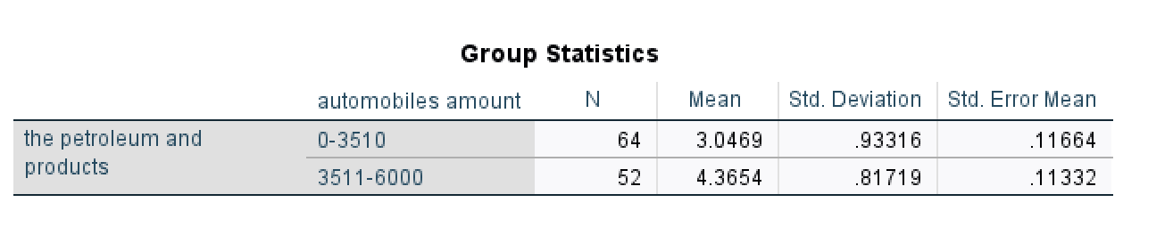
Table 2 Group Statistics Independent Samples T test
In Table 2, we can see that there are 64 below-average data (group 1) and 52 above-average data (group 2). Judging from the Mean of the two groups, the Mean of group 1 is 3.0469, and the Mean of Group 2 is 4.3654, and there is not much difference between the two groups.
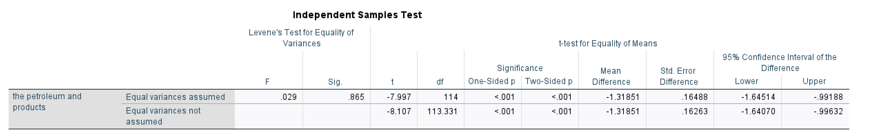
Table 3 Independent Samples Test
In the Independent Samples t test, the Sig. is 0.369 > 0.05. Then, accept the Hypothesis 2: the Petroleum and products and the automobiles have equal variance assumed.
the One-side p<0.05, then we reject the Hypothesis 2: the Petroleum and products and the automobiles are significant difference.
An independent-samples t-test was conducted to compare the categories of petroleum and products for the higher automobiles group (group 1) and the lower automobiles group (group 2). There were significant differences (t (do)=-7.997, p=0.865) in the scores with the mean score for t the higher automobiles group (group 1), (M=-4.3654, SD=0.81719) was higher than the lower automobiles group (group 2) (M=3.0469, SD=0.93316). The magnitude of the differences in the means (mean difference =-1.31851, 95% CI: -1.64to -0.99) was significant. Hence, H3 was supported.
Regression
Regression analysis refers to the determination of the one-inch relationship between two or more variables. An analytical method to estimate or predict the dependent variable by determining the mathematical expression between the dependent variable and the independent variable. In this regression analysis, we predicted the petroleum and products as the independent (X), the automobile amount group as the dependent (Y). Using regression to find out if the petroleum and products influence the automobiles.
In this study, the sales volume of petroleum and its products is the independent variable (X) and the sales volume of automobiles is the dependent variable (Y). Regression analysis implies that y will change when X changes. It means that y changes because x changes.
X axis = petroleum and products (Predictor)
Y axis = automobiles amount (Dependent variable)
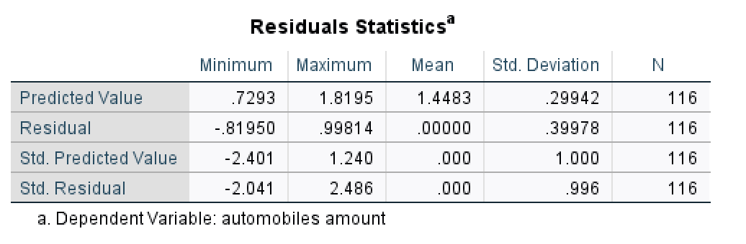
Table 4 Residuals Statistics
In table 4, the minimum Std. Residual is -2.041, the maximum Std. Residual is 2.486. they are in the range of -3.29 to 3.29.
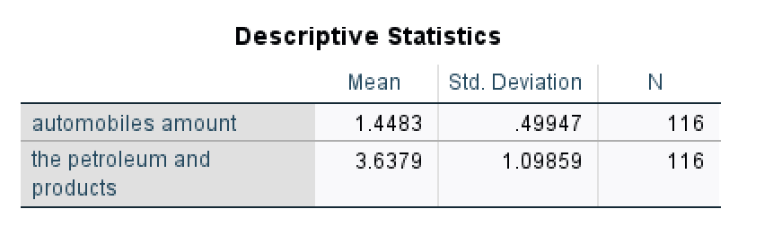
Table 5 Descriptive Statistics
In the part of descriptive statistics, Mean is 1.4483, SD is 0.49947, Mean is 3.6379 and SD is 1.09858 in the classification of petroleum and its products.
Correlation analysis is a statistical analysis method to study the correlation between two or more variables. Correlation analysis can be used to understand the correlation properties between variables. In this study, SPSS was used to verify the correlation between variables. If the absolute value of the correlation coefficient between two variables is closer to 1, then the correlation between the two variables is more significant. Relevant inspection results are shown in Table 6: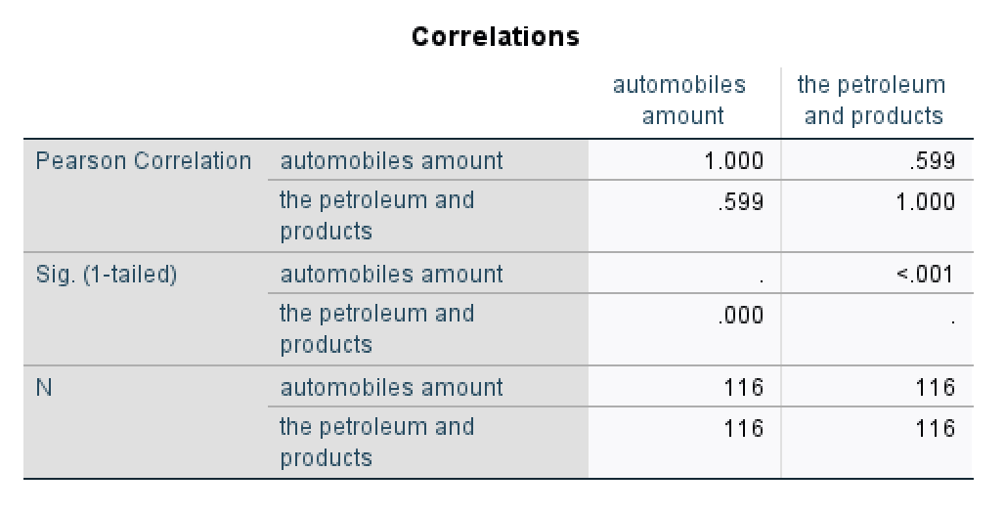
Table 6 Correlations
In Table 6, Pearson Correlation Correlations is used to measure the linear correlation between two continuous variables. Its value range should be between -1 and 1. Where -1 means completely negative correlation, 1 means perfect positive correlation, and 0 means no correlation. In two variables the groups of automobiles(X) and petroleum and products(Y). The Correlation range of these X and Y is 0.599, >0. It means that the groups of automobiles amount (X) positively with petroleum and products(Y). When two variables are correlated, it means that when one variable changes, the other variable may also change accordingly. When the amount of automobiles changes, it will be found that the consumption of petroleum and products will also change.

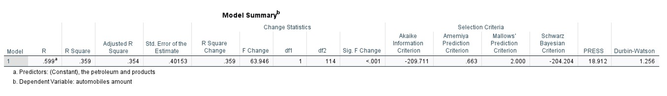
Table 7 Model Summary
R Square represents the fitting degree of the model and reflects the degree of explanation of the independent variable to the dependent variable. The value of R Square should be between 0 and 1, and the closer to 1, the better the fitting degree of the model. In the table, R Square=0.359, indicating that independent variables can explain 35.9% of the reasons for the changes in dependent variables. The closer Std. Error of the Estimate is to 0, the better the fitting degree of the model is. In table8, we can see that Std. Error of the Estimate= 0.40153, which also shows that the fitting degree of the model is better.
Assumption of independent observations require the DW Value should be in 1 to 3. The Durbin-Watson is 1.931, in the range of it. R Square is equal to the proportion of carinae of dependent variable (the automobile amount).
The purpose of variance analysis is to find out the factors that have a significant impact on this thing, the interaction between the factors and the best level of significant factors through data analysis. One-way ANOVA studies whether different levels of a controlled variable have a significant impact on the observed variables. It can help researchers to distinguish whether there are significant differences between groups. We divide the consumption of petroleum and its products into different groups and distinguish the relationship between each group and the quantity consumption of automobiles by variance analysis.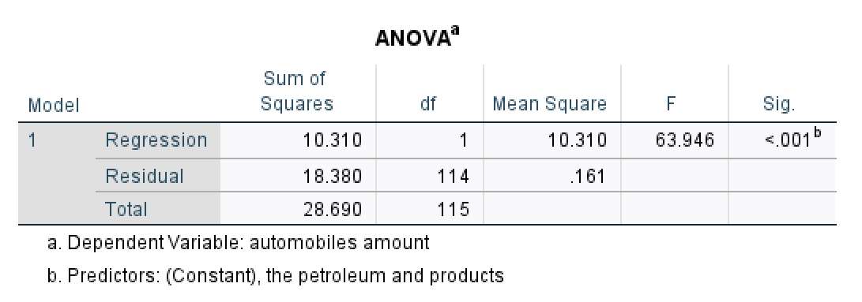
Table 8 ANOVA
From Table 8. We can identify that there was a significant effect of automobile amount on petroleum and products at the p<.05 level for the five conditions [F (1,114) =63.964, p<0.001].
P<.001 means prediction the petroleum and products are better than prediction without the petroleum and products in the model.
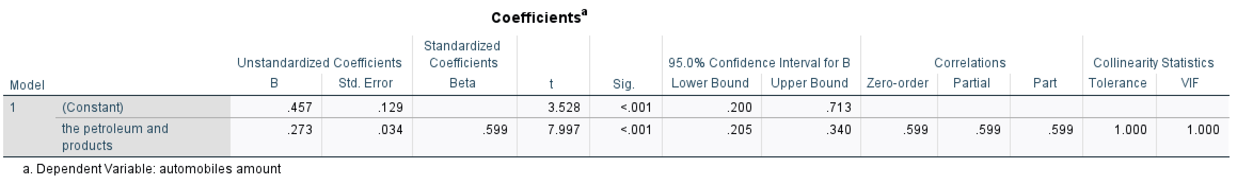
Table 9 Coefficients
In Table 9，.273 positively correlated between automobile amount and the petroleum and products. The β of the petroleum and products >0, the β= 0.273 is meaning category of petroleum and products increase 1 point，automobiles amount increases 0.273. So, we can summarize the regression formula: Predictor of petroleum and products and automobile amount:
Y_{petroleum and products}=0.457+0.273X_{automobile amount}

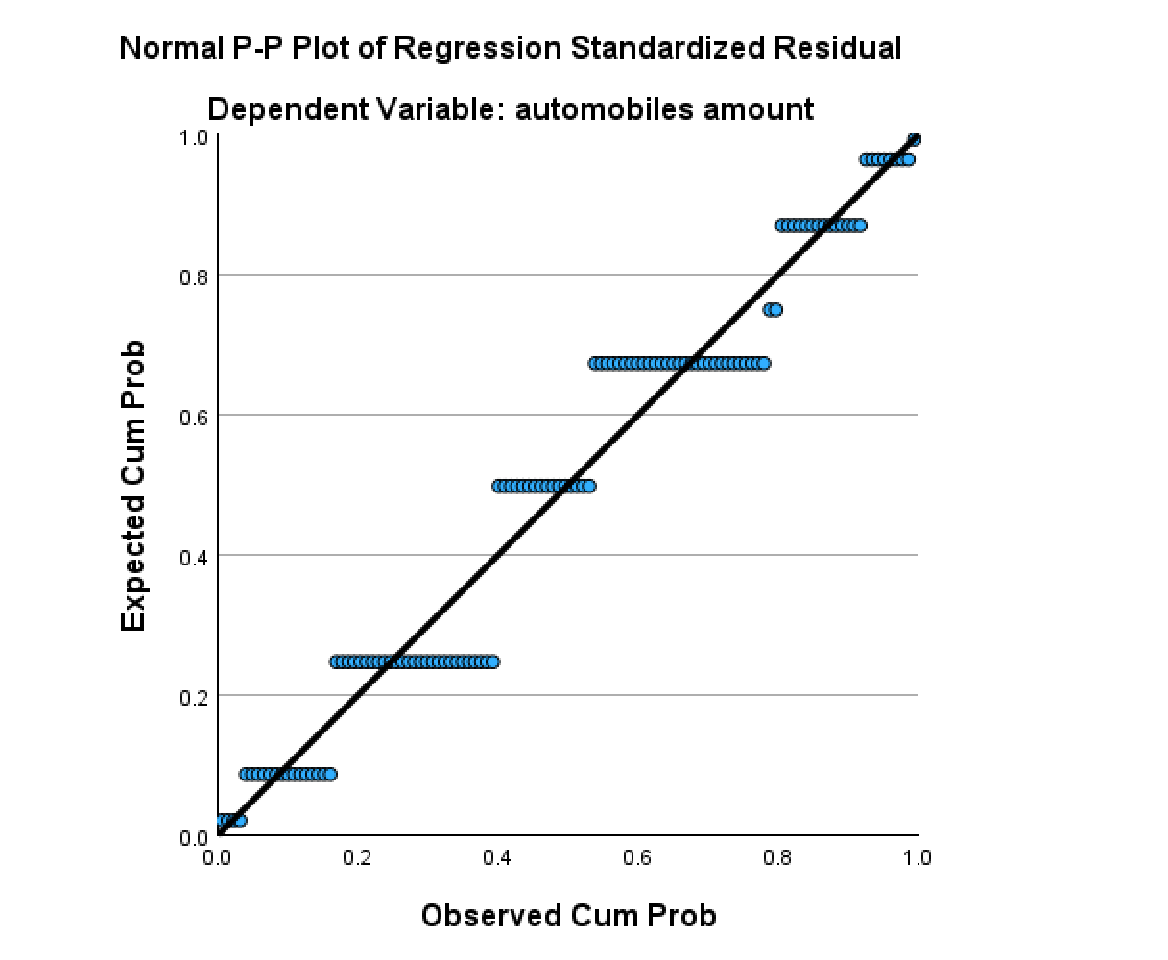
Figure 2 The P-P Plot
The points in the P-P Plot display diagram are basically distributed on a diagonal line from the origin (0,0) to (1,1), which can prove that the sample data basically conforms to the specific theoretical distribution.
From Figure 2 we can find Normality of Residuals ask the PP Plot should be along 45%. The automobiles amount is accepting the requirement. This proves that automobile consumption and consumption of petroleum and its products basically conform to the normal distribution.

Findings
Through Chi-Square analysis, it can be concluded that there is a great deviation between automobile consumption and petroleum and its products, indicating that there is an interactive relationship between them. The sales of petroleum and its products will affect the sales of automobiles. It also proves that the price increase of petroleum and its products will affect the sales of petroleum and its products, and then affect the sales of automobiles.
In Independent Samples t test, we presuppose two hypotheses, one is that the sales of petroleum and its products have nothing to do with the sales of automobiles, and the other is that the sales of petroleum and its products have something to do with the sales of automobiles. In descriptive statistics, we can see that there is little difference between the two groups of automobile sales. group1 has 64 months below the average sales volume and group2 has 52 months above the average sales volume. When testing the p value, we can find that the p value is < 0.05, from which we can get the test result rejecting hypothesis 2 and supporting hypothesis 3. Through Independent Samples t test, we prove that oil and its products are related to automobile sales and prove from the side that traditional cars with oil as the main fuel still occupy a relatively important position in the retail consumption market. If the sales of new energy vehicles dominate, then the relationship between automobile sales and petroleum and its products in Independent Samples t test should accept Hypothesis 2 and reject Hypothesis 3. At the same time, this result also verifies our previous review of the development of automobile industry in China, and the development of automobile industry in China has entered a new stage since 2011. In 2015, it began to be in the period of industry transition. After 2015, new energy vehicles and related industries began to develop in a standardized and large scale. After 2020, due to technological innovation and industry norms, the number of new energy vehicles purchased by individual consumers gradually increased, but the total sales volume of vehicles in social retail did not decrease significantly, which proved that the sales volume of fuel vehicles was decreasing in the same period, which would indirectly affect the sales volume of petroleum and its products. The assumption that the sales of petroleum and its products are related to the sales of automobiles is supported by actual data.
In the regression analysis, we determined that petroleum and its products are independent variables (X) and automobile consumption is dependent variables (Y). During the test, we found that the p value was 0.599, which proved that there was a linear relationship between the two variables. When the sales of petroleum and its products change, the sales of automobiles will also change. When testing the correlation, we get the regression equation of two variables. The coefficient in the equation shows that the sales volume of petroleum and its products will increase by 0.273 for every increase of 1. This value shows that the sales volume of petroleum and its products still has influence on the sales volume of automobiles, but its influence is limited. It indirectly shows that new energy vehicles that do not need oil as the main fuel are gradually increasing in automobile retail sales.
Through the above three test models, it can be proved that there is a linear correlation between the sales of petroleum and its products and the sales of automobiles in the case of social retail. The sales of automobiles will increase with the sales of petroleum and its products. Considering the current car ownership and sales of new energy vehicles in China, we believe that new energy vehicles have not yet occupied the main position of car sales, and fuel vehicles are still the main body of retail consumption. Considering their commodity characteristics, petroleum and its products and automobiles are complementary in the economic sense, and there is an interactive relationship between them.

Conclusion
At the beginning of this study, it is proposed that the internal relationship between the sales of petroleum and its products and the sales of automobiles can be obtained from social retail consumer goods during the decade when the automobile industry has undergone great changes. By collecting and sorting out the 116-month data on the quantity of social consumer goods officially released by China Statistics Bureau, the sales volume of petroleum and its products and the sales volume of automobiles are screened out. After the chi-square test shows that there is a correlation between them, the hypothesis is put forward again. Independent T test is used to verify that there is a strong relationship between oil and its products and automobile sales. To make the relationship between them clearer, we use regression analysis and get a linear regression relationship between them. That is, car sales will be affected by the sales of oil and its products. This is of great help to find the consumption proportion of fuel vehicles among the two commodities that are highly complementary in China's social retail consumer goods in the past 116 months, and indirectly helps to understand that the new energy vehicles that are popular in China at present have not yet occupied the main market in the actual retail consumer goods. At present, in the field of retail consumption, the theme of automobile sales is still traditional fuel vehicles.

Limitation
Because the data used in this study is short, oil and its products are not completely separated. Under the classification of the sales volume of petroleum and its products, there may be some commodities that are not completely matched with the use of automobiles. If this part of the goods can be calculated separately from oil as automobile fuel, there may be different inspection results, which will lead to the deviation of this inspection result. However, due to the limitation of data sources, we can't completely classify it, so we test the relationship between the sales of petroleum and its products as a whole and the sales of petroleum and its products. In addition, because it is a survey on the scope of social retail consumer goods and does not include the statistics of large-scale wholesale manufacturers in society, the conclusion can't show the relationship between the overall sales of automobiles and the sales of petroleum and its products in China. It can only be used to study the performance of social retail consumption market. The observed situation also includes the data of large-scale procurement and mass production, so the research conclusion may be inconsistent with the reality.

Reflective
In this course of quantitative analysis, I am very grateful to the teacher for his theoretical teaching and practical guidance. I learned that the questionnaire should be designed after the research topic and purpose are determined. The steps of collecting, sorting and screening the data after the questionnaire is recovered. Also understand the key and difficult points of establishing a database. Learn to use SPSS to test and analyses data content in class. Select the appropriate model according to different research purposes. It can help researchers quickly distinguish valid data from invalid data, find indicators related to research problems, and make the research process of quantitative analysis more scientific and convincing. Through the study of this course, I understand the main process of quantitative analysis, and my skills of analysing data have been consolidated and improved. I can learn SPSS more deeply, which helps me to process data more quickly and flexibly and find the variables and relationships in the data. And laid a good quantitative analysis foundation for my next empirical research and thesis writing.

Bibliography
Apergis, N. &. L. J., 2016. Population and lifestyle trend changes in China: implications for environmental quality. Applied Economics, 48(54), pp. 5246-5256.
Baumann, S. H. E. a. J. J., 2022. Moral and aesthetic consecration and higher status consumers’ tastes: The ‘good’ food revolution. poetics, online first, March.
Boström, M., 2020. The social life of mass and excess consumption. Environmental Sociology, 6(3), pp. 268-278.
Boyd, H. W. & Levy, S. J., 1963. New Dimensions in Consumer Analysis. Harvard Business Review, Volume 41 (November-December), pp. 129-140.
Cao, J., 2020. Study on the Change of Farmers' Consumption Concept in Northwest China under the Background of Rural Revitalization.. Rural Economy and Technology, pp. (23),130-131.
Champman, R., 1928. The quantitative analysis of environmental factors. Ecology, 9(2), pp. 111-122.
Chan, T. W. & Goldthorpe, J. H., 2024. In A Reader on Audience Development and Cultural Policy. In: The social stratification of cultural consumption: Some policy implications of a research project. s.l.:Routledge, pp. 167-178.
Chen, S. Y., Zhang, Q., Mclellan, B. & Zhang, T. T., 2020. Review on the petroleum market in China: history, challenges and prospects. Petroleum Science, pp. 17, 1779-1794.
Chen, X. et al., 2023. Causality analysis of the impacts of petroleum use, economic growth, and technological innovation on carbon emissions in Bangladesh. Energy, pp. 267, 126565.
China, T. A. B. o. t. M. o. P. S. o. t. P. R. o., 2024. Traffic Administration Bureau of the Ministry of Public Security of the People's Republic of China. [Online]
Available at: https://www.122.gov.cn/
[Accessed 4 10 2024].
Dąbrowska, A. & Gutkowska, K., 2015. Collaborative consumption as a new trend of sustainable consumption. Acta Scientiarum Polonorum. Oeconomia, pp. 14, 39-49.
Dangi, N., Gupta, S. K. & Narula, S. A., 2020. Consumer buying behaviour and purchase intention of organic food: a conceptual framework. Management of Environmental Quality: An International Journal, 31(6), pp. 1515-1530.
Du, J. & Ouyang, D., 2017. Progress of Chinese electric vehicles industrialization in 2015: A review. Applied Energy, pp. 188, 529-546.
Du, Z. & Lin, B., 2019. Changes in automobile energy consumption during urbanization: Evidence from 279 cities in China. Energy Policy, Volume 132, pp. 309-317.
Fine, B. a. L. E., 1993. The World of Consumption. London: Routledge.
Gomes, F. R., 2020. Evaluating a consumption function with precautionary savings and habit formation under a general income process. The Quarterly Review of Economics and Finance, pp. 76, 157-166.
Granovetter, M., 1985. Economic action and social structure: the problem of embeddedness. American Journal of Sociology, , 91(3), p. 91(3): 481–510..
Gronau, Q. F., Ly, A. & Wagenmakers, E. J., 2020. Informed Bayesian t-tests. The American Statistician.
Halder, P., Hansen, E. N., Kangas, J. & Laukkanen, T., 2020. How national culture and ethics matter in consumers’ green consumption values. Journal of cleaner production, Volume 265, p. 121754.
Hemmati, M., Fatemi Ghomi, S. T. & Sajadieh, M. S., 2018. Sci. Iran, pp. 25 (4), 2347e2360.
Hu, S. et al., 2021. CO2 emission and energy consumption from automobile industry in China: decomposition and analyses of driving forces. Processes, 9(5), p. 810.
Jappelli, T. a. P. L., 2017. The economics of consumption: theory and evidence. s.l.:Oxford University Press.
Karatas, M. & Gürhan‐Canli, Z., 2020. When consumers prefer bundles with noncomplementary items to bundles with complementary items: The role of mindset abstraction. Journal of Consumer Psychology, 30(1), pp. 24-39.
Khanna, R., 2023. The New Industrial Age: America Should Once Again Become a Manufacturing Superpower. Foreign Aff, pp. 102, 141.
Leung, G.-K., 2010. China’s energy security: perception and reality. Energy Policy, p. 2011;39:1330–7.
Liu, C., Wu, W. Z., Xie, W. & Zhang, J., 2020. Application of a novel fractional grey prediction model with time power term to predict the electricity consumption of India and China. Chaos, Solitons & Fractals, pp. 141, 110429.
Liu, C., Xie, W., Wu, W. Z. & Zhu, H., 2021. Predicting Chinese total retail sales of consumer goods by employing an extended discrete grey polynomial model. Engineering Applications of Artificial Intelligence, pp. 102, 104261.
Liu, Y. et al., 2020. Life cycle assessment of petroleum refining process: A case study in China. Journal of Cleaner Production, pp. 256, 120422.
Li, Z., Lin, Y. Y., Song, Y. & Li, Z., 2023. Linkages and flow paths of energy consumption: Evidence from China’s sectors. Energy Reports, pp. 9, 4594-4603.
Midttun, A., Khanieva, M., Lia, M. & Wenner, E., 2022. The greening of the European petroleum industry. Energy Policy, pp. 167, 112964.
Miller, D., 2020. Consumption. In The material culture reader. s.l.:Routledge.
Mohajan, H. K., 2020. Quantitative research: A successful investigation in natural and social sciences. Journal of Economic Development, Environment and People, 9(4), pp. 50-79.
Murshed, M., Ali, S. R. & Banerjee, S., 2021. Consumption of liquefied petroleum gas and the EKC hypothesis in South Asia: evidence from cross-sectionally dependent heterogeneous panel data with structural breaks. Energy, Ecology and Environment, pp. 6(4), 353-377.
Narayan, S., Le, T. H., Rath, B. N. & Doytch, N., 2019. Petroleum consumption and economic growth relationship: evidence from the Indian states. Asia-Pacific Sustainable Development Journal, pp. 26(1), 21-65.
Qian, X. K., Jiang, X. F., Dai, J. Q. & Guo, Y. F., 2015. Ten trends of global oil and gas industry development during the 13th Five-Year Plan period. International petroleum economy, 1, pp. 44-50.
Rocklage, M. D. & Fazio, R. H., 2020. The enhancing versus backfiring effects of positive emotion in consumer reviews. Journal of Marketing Research, 57(2), pp. 332-352.
Sayyida, S., Hartini, S., Gunawan, S. & Husin, S. N., 2021. The impact of the COVID-19 pandemic on retail consumer behavior. Aptisi Transactions on Management, pp. 5(1), 79-88.
Shahid, S., Paul, J., Gilal, F. G. & Ansari, S., 2022. The role of sensory marketing and brand experience in building emotional attachment and brand loyalty in luxury retail stores. Psychology & Marketing, 39(7), pp. 1398-1412.
Sheth, J. N. N. B. I. &. G. B. L., 1991. Why we buy what we buy: A theory of consumption values. Journal of Business Research, pp. 22(2), 159–170.
Solomon, M. R., 1983. The Role of Product as Social Stimuli: A Symbolic Interactionism Perspective. Journal of Consumer Research, Volume 10 (December), pp. 319-329.
Song, Y., Li, C. & Pancras, J., 2015. The demonstration effect of consumption across cities in China: evidence from the automobile market. In Emerging Markets and the Future of the BRIC Nations. s.l.:Edward Elgar Publishing.
Tanrikulu, C., 2021. Theory of consumption values in consumer behaviour research: A review and future research agenda. International Journal of Consumer Studies, pp. 45(6), pp.1176-1197.
Tanrikulu, C., 2021. Theory of consumption values in consumer behaviour research: A review and future research agenda. International Journal of Consumer Studies, 45(6), pp. 1176-1197.
Technology, M. o. I. a. I., 2024. China Quality News. [Online]
Available at: https://www.cqn.com.cn/qt/content/2024-07/10/content_9056617.htm
[Accessed 4 10 2024].
Tian, X. Y., 2019. The population trend–from increases to decreases: Exploring the path of moderate growth with green consumption. In: In The Way to a Great Country. 1 ed. s.l.:Routledge, pp. 33-76.
Turhan, N. S., 2020. Karl Pearson's Chi-Square Tests. Educational Research and Reviews, 16(9), pp. 575-580.
Wang, K. H., Umar, M., Akram, R. & Caglar, E., 2021. Is technological innovation making world" Greener"? An evidence from changing growth story of China. Technological Forecasting and Social Change, pp. 165, 120516.
Wang, X., Cai, H. & Florig, H. K., 2016. Energy-saving implications from supply chain improvement: An exploratory study on China's consumer goods retail system.. Energy Policy, pp. 95, 411-420.
Warde, A., 2015. The sociology of consumption: its recent development. Annual Review of Sociology, p. 41: 117–34.
Warde, A., 2022. Society and consumption. Consumption and Society, 1(1), pp. 11-30.
Wen, W., Yang, S., Zhou, P. & Gao, S. Z., 2021. Impacts of COVID-19 on the electric vehicle industry: Evidence from China. Renewable and Sustainable Energy Reviews, pp. 144, 111024.
Wiedmann, K. P., Hennigs, N. & Siebels, A., 2009. Value‐based segmentation of luxury consumption behavior. Psychology & Marketing, pp. 26, 625-651.
Yadav, D., Kumari, R., Kumar, N. & Sarkar, B., 2021. Reduction of waste and carbon emission through the selection of items with cross-price elasticity of demand to form a sustainable supply chain with preservation technology.. Journal of Cleaner Production, pp. 297, 126298.
Yin, J. & Shi, S., 2021. Social interaction and the formation of residents′ low-carbon consumption behaviors: An embeddedness perspective. Resources, Conservation and Recycling, pp. 164, 105116.
Yoo, S., Wakamori, N. & Yoshida, Y., 2021. Preference or technology? Evidence from the automobile industry. Transportation Research Part D: Transport and Environment, Volume 96, p. 102846.
Zhao, Y., Jian, Z. & Du, Y., 2024. How can China's subsidy promote the transition to electric vehicles?. Renewable and Sustainable Energy Reviews, pp. 189, 114010.

