Stress in the UK

Student Number: 2026278
Name: Oana Elena Golici
Module name: Problem Solving and Decision Making
Module code: BMSW 4004
Lecturer: Yohan Mendis

Contents

1. Introduction 3
2. The Scope and Impact of stress 4
3. Environmental Analysis - PESTLE 5
3.1. Political Factors 5
3.2. Economic Factors 5
3.3. Social Factors 5
3.4. Technological Factors 6
3.5. Legal Factors 6
3.6. Environmental Factors 6
4. Causes and effects of stress – Fishbone Analysis 7
5. Decision making 9
5.1. PMI Analysis 9
5.2. The Grid Analysis 11
6. Plan to reduce stress 13
7. Conclusions 14
References 15

Introduction

This report is a framework of stress in the UK, one of the biggest issues at the workplace and in personal life. It is analysis the common factors of stress within people and organizations, identifies the causes and effects by using Fishbone Diagram, and finds viable solutions to be implemented to reduce the stress.
To find solutions will be used PMI table as an efficient tool and to choose the best decision to reduce stress will be implemented Grid Analysis, a very efficient technique.
In the following papers, stress will be defined in numerous ways because it has a different meaning. It can be the response to the attack or any activities or news from outside that can disturb daily living (Seyle, 1936, cited in Stranks, 2005). The term of stress will be detailed by following a few studies in the last decade and some data collected by the Census (Fig1, p.3), which suggested that stress is caused by loss or low income which leads to health and family problems, affect well-being, etc.

The Scope and Impact of stress

To understand what stress is and how it works should have a definition, but stress means different things for people and can have various definitions. Any activities or pressures from outside that are placed upon an individual can create stress. It can have an impact on employment, family, worker health and on performance of organization.
Stress is a long and deep problem in the UK. Students and young people report a prominent level of stress across the country, especially those who are involved in education. Aside from impacting health, well-being, family relationships, etc. can affect academic achievement (Pascoe et. all, 2020). A lot of factors such as low income, redundancies, changes in policy, new rules, long working hours, etc., are streams of stress.
Fundamentally a few changes are produced in the body and involve several changes like emotional, cognitive, physiological, change in behavior. These factors contribute to numerous problems like heart disease, anxiety, depression, incapacity to work, or to adapt to changes (Stranks, 2005).
Fig.1, Source: https://www.ciphr.com/research/workplace-stress-statistics/
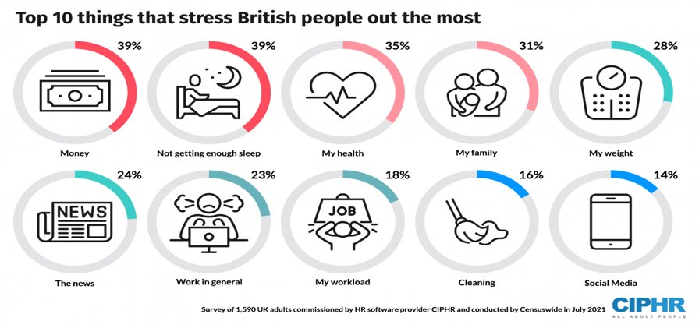

Stress is a complex problem and does not choose from gender or background, also can have a massive impact on family life, employment, well-being, work in general.

Environmental Analysis - PESTLE

The survey conducted in July 2021, by Census, suggested that the main reason for stress is caused by money and lack of sleep (Fig.1, p.4). The low or loss of income can be caused by numerous external factors such as new government policy, COVID-19, future pandemic, new legislation, global monetary crisis, etc. To understand which are the external factors and how they work against the organization and population PESTLE analysis is used.

Political Factors
The political environment affects the organization and population in the short and long term. Any legislation or any new rules cause pressure, and the companies will find difficulties to fix, especially in a brief period. For example, Brexit produces a lot of stress in organizations because it was hard to understand new rules, to deal with and the companies faced a challenging time. Also, people felt insecure and most of them do not have the freedom to move between countries, as well as the rights are affected, and the level of stress caused by those political factors is at a prominent level.

Economic Factors
Related to the survey conducted by Census, money is the main reason for stress. In the last 2 years, the population has had to face the pandemic episode which made a lot of redundancies and impossibility to find a new job, also the impact of the daily living increased in the last years and organizations and individuals had a big problem to implement a good policy to facilitate good standard of living, efficient tools, etc. Even the big economic crisis from 2008 had a massive impact on organizations and people it was “the worst recession since Great Depression” which affected psychological well-being (Lindstrom and Giordano, 2016).

Social Factors
Some aspects of social factors such as education and marriage or career can provoke pressure. The organization should provide support for the employees and protect them as much as possible from external factors which can contribute to stress.

Technological Factors
In the last decade, technology has put a lot of pressure on organizations and people across the country. The innovative technology forced everyone to adopt it and to implement it to cope with new regulations. Also, some people do not have the financial and physical capacity to adopt modern technology which is a big stress factor across the country.

Legal Factors
The new regulations introduced have a massive impact on companies and on members as well. They need to understand and to respect the new rules implemented, but the capacity to affiliate with new regulations from outside can disturb the daily activities of companies and across the population.

Environmental Factors
The range of environmental effects can have different variations and locations, but also can cover everything and everywhere in the country as COVID-19 has done in the last 2 years, or climate change which is a big challenge for organizations to cope with, to comply with new regulations to combat the climate means a lot of money and time-consuming which contribute to produce stress.

Causes and effects of stress – Fishbone Analysis

The external factors produce a lot of problems, effects that affect everything. To indicate the causes and effects of stress the Fishbone Diagram (or Ishikawa Diagram) was used which helps to identify the roots of the problem and point out the major factors related to it. Every category is branching off and demonstrates practical solutions that might not have been considered before to be used to reduce the problem. Based on Fishbone diagrams (see Fig.3) which connects and clarifies the relation between causes and effects a few solutions can be identified as follows:
  - Work from home/flexible hours – working from home is now part of modern life and reduces the conflict family because gives more control to own life (Van der Lippe and Lippényi, 2020). By implementing flexible hours, the individuals can have more flexibility to do organize their own time and achieve other activities, making them more successful.
  - Better living standards – in the last decades, the population has increased three and a half times, which means at the bottom of the social scale is an important level of poverty (Gordon, 2017, p.17). But even the people who are employed cannot support a normal life, to a reasonable standard for themselves and for families.
  - Improving communication - based on the research the lack of communication is one of the things which causes stress because individuals are an impossibility to reach out to each other and stabilize what they missed.
  - Skilled staff - in many organizations the employer does not pay attention to skilled staff and does not invest in their development, like training, courses to improve the skills necessary to carry out the activities. In some areas people with high-demand skills can see the opportunities and create a better life for themselves and their relatives (Taylor-Gobby, 2017).
Fig. 2, Fishbone diagram, Source: Author
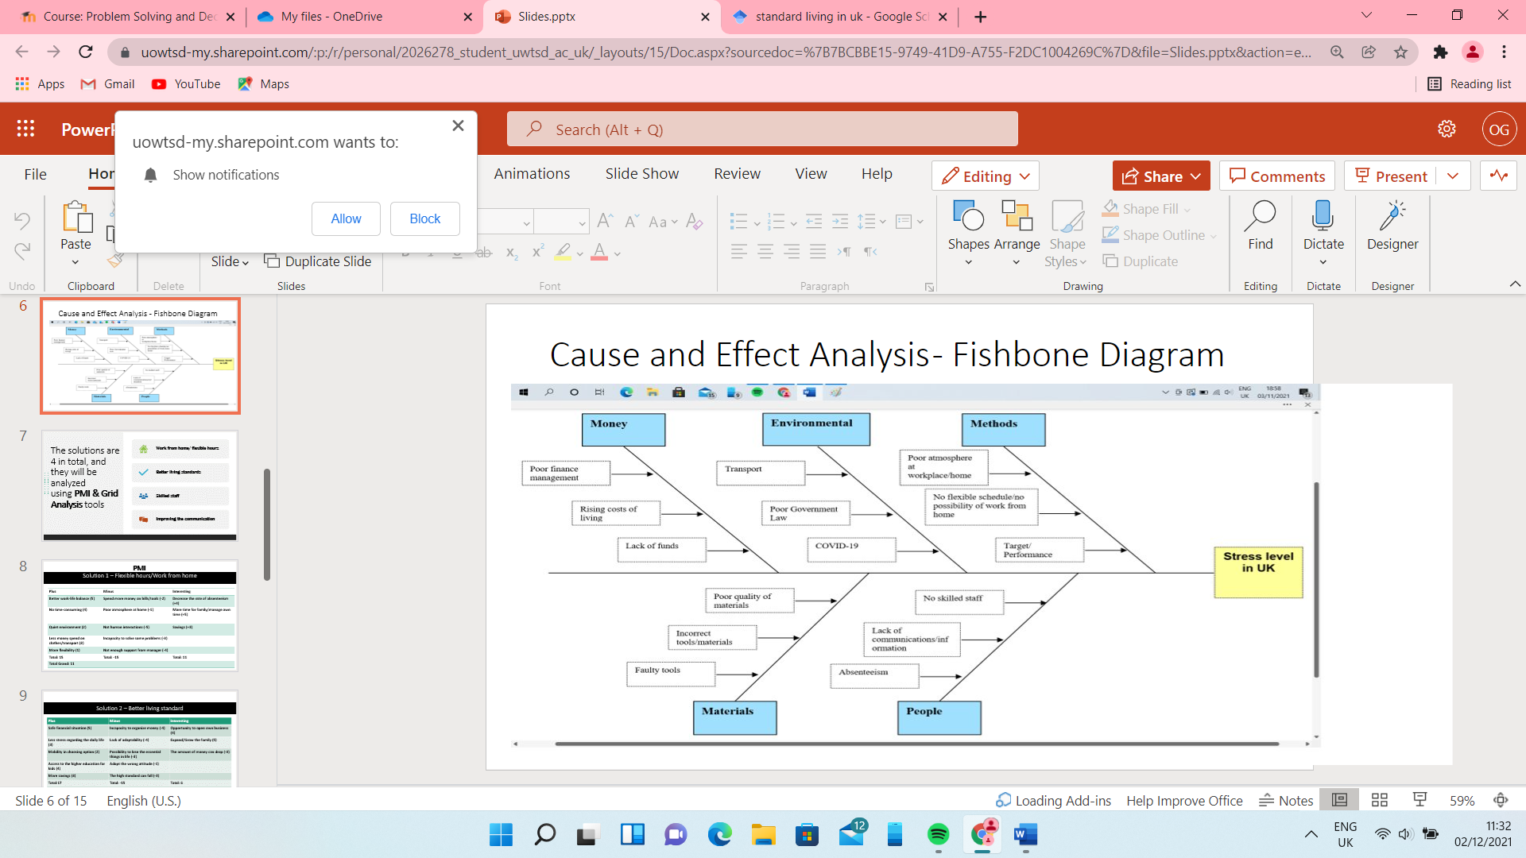
The Fishbone Diagram is the first step to act because is lists it out the root cause of stress. This helps organizations to improve some areas of work to avoid future stress at the workplace and gives people a framework to understand where it is possible to take actions to reduce the pressure in personal or professional life.

Decision making

Ishikawa diagram is a useful tool to find the roots of the problem, but for choosing the best alternative to reduce stress and to make the best decision PMI and Grid analysis are highly effective techniques to be involved in the process of making decisions because the problem has deep roots, and it is a complex problem where many factors need to be considered to reduce pressure and stress across the country.

PMI Analysis
Using the PMI table as a tool, based on Fishbone analysis it was identified an efficient solution that contributed to reducing the pressure was. In the tables, positive factors (pluses), the negative ones (minuses), and the interesting points. To calculate the total and the total grand which gave a framework over the solutions and made it possible to pick up the most effective one a scale was used from 1 to 5, where 5 is the best, it was scored the pluses, minuses, and interesting things.
Solution 1 – Work from home/Flexible hours
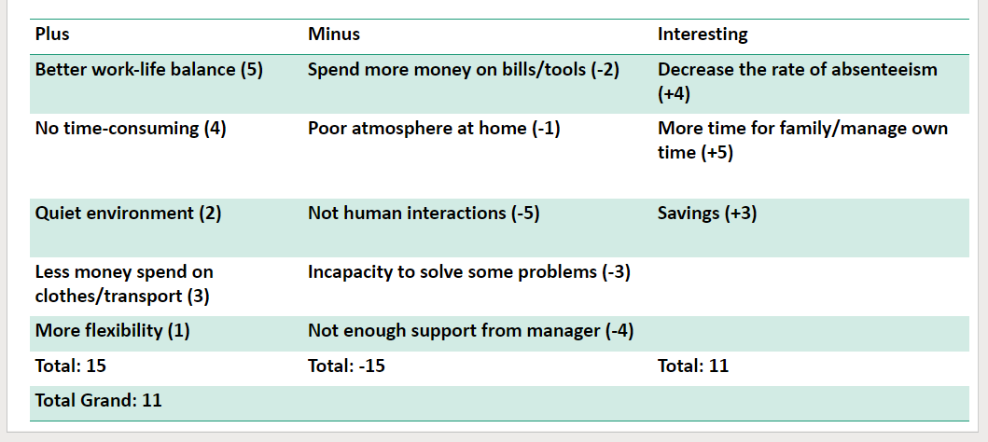
The outcome of this solution is truly relevant because people are more effective from working from home, being happy to have the possibility to choose flexible hours and having more time for family and personal life. Also, it counts the possibility to reduce the rate of absenteeism and to make more savings instead of spending money on transportation or specific clothes.
Solution 2: Better living standards
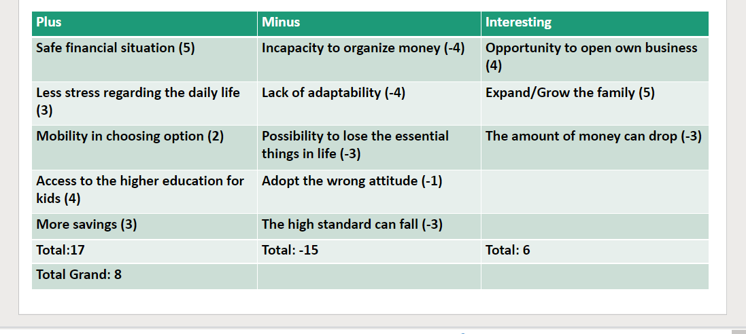
As a result, this solution suggests that a safe financial situation offers more opportunities and choices, mobility in expanding the lifestyle, but on the other side can prove disappointment if the lofty standards go down.
Solution 3: Skilled staff
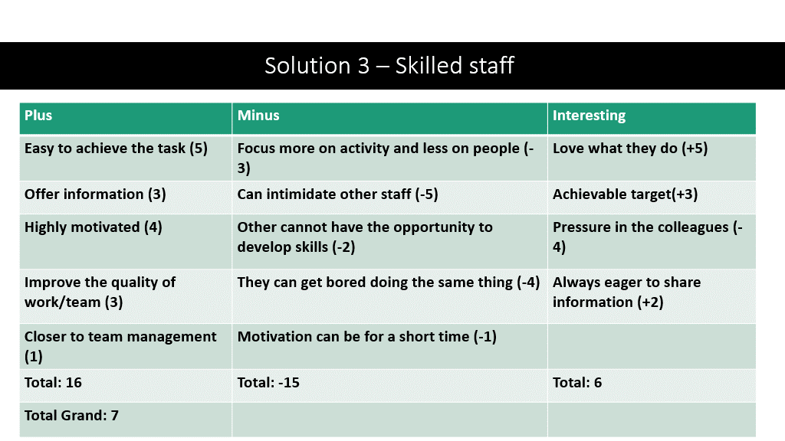
The results show that a skilled staff is more ethic in a company for employer and for the collective as well, they are motivated to achieve everything and to share the information, but also, they can ignore the others and push pressure on colleagues.

Solution 4: Improving communication
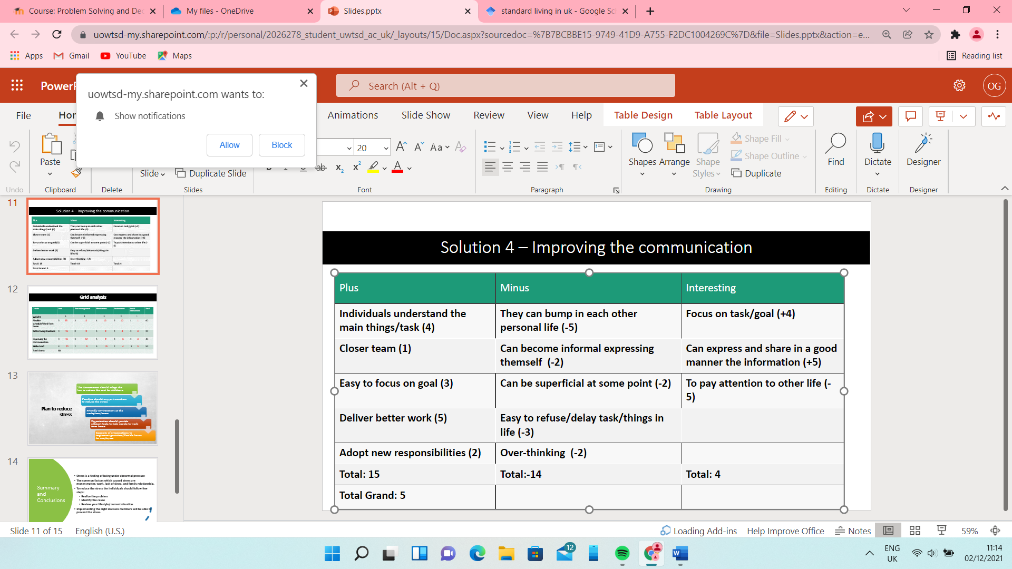
For this solution, the outcome suggests effective communication is the key to achieving the task and delivering the best, but also the job can be delayed, or they can squeeze more personal information about each other.

The Grid Analysis
Regarding the purpose of the study, there are a few solutions and some criteria to consider, and grid tool is a good technique to use for making the best decisions.
In a table are laid out the factors and the options. Each factor is scored on a scale from 0 to 5, where 5 is the most important, and each option (solution) is scored from 1 to 5, where 5 is particularly good. After that to see what the best solution is the value from the factors was multiplied by the value of the option and resulted the maximum score of every solution outlined. A grand total of 60 points belongs to the first solution found it – Work from home /Flexible hours.

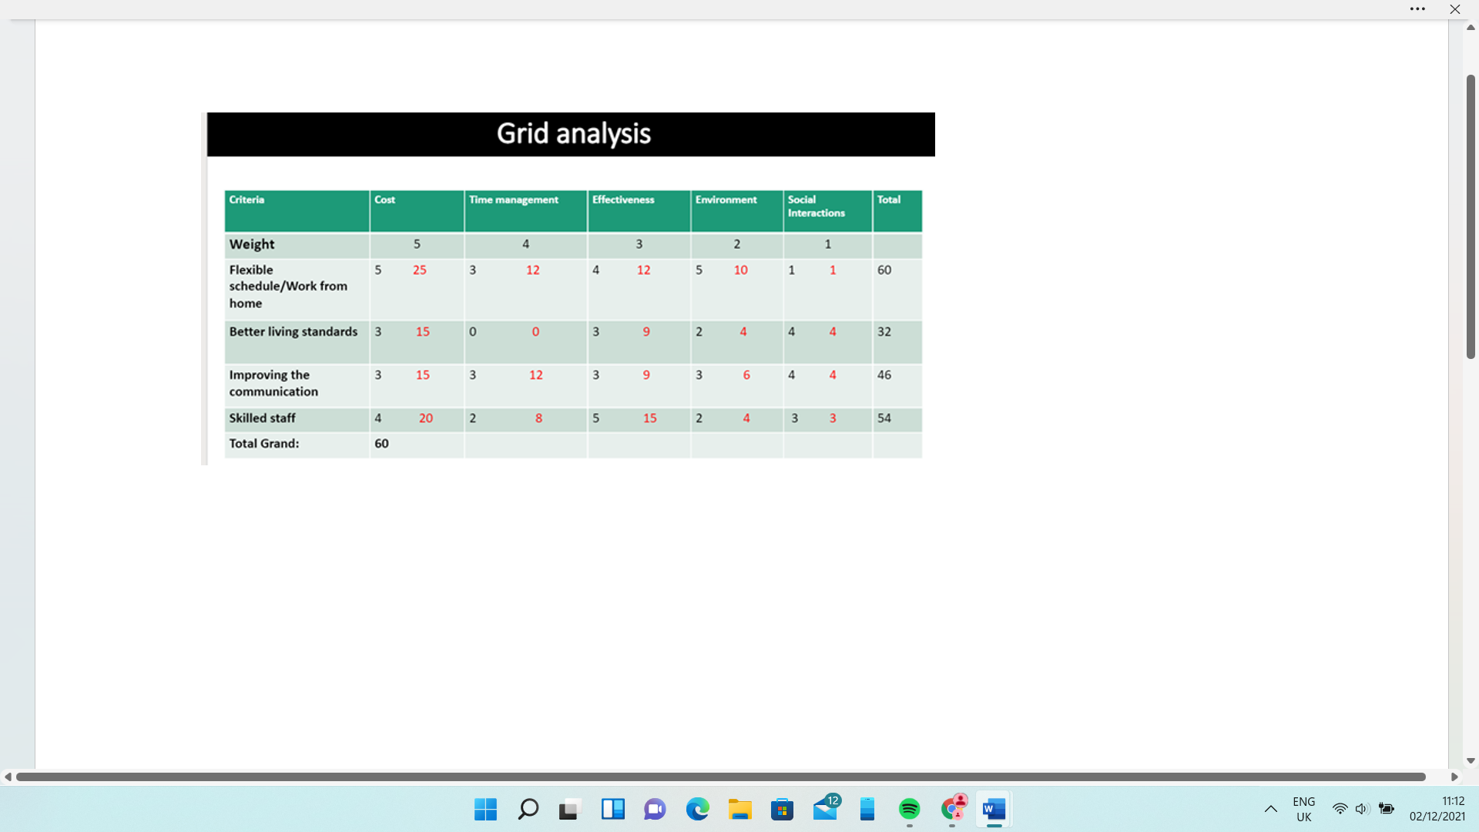

Plan to reduce stress

Based on the research, the study shows a few ideas to reduce stress and help individuals and companies to work in harmony with fewer worries. That means the implementation of the first solution, the higher scored WORK FROM HOME/FLEXIBLE HOURS should follow a few steps:
- The organization/ companies should be able to implement flexible hours for those who want to work part-time, also, they should be able to recruit enough staff to cover all the hours and to achieve the goal.
- For those working from home the companies should provide efficient tools to help them to carry out ethic job at home, the manager/director to be in touch with subordinates.
- Families should support the members and help to take care of children, where it is possible.
- The government must reduce/or help with the cost of childcare for those working from home because they need to work in a good environment at home with any disturbance from inside, like having kids around which can affect the daily task.

Conclusions

To conclude, stress has a substantial impact in every area, department, business, or family, affects every individual and every situation. PESTLE Analysis shows how the macro environment influences living and can cause pressure. Fishbone Diagram is a useful tool to identify the root of stress and find some solutions, and PMI table and Grid Analysis are efficient techniques to evaluate and to make the best decision to implement to reduce stress.
The process of implementation should be done by authorities, companies, and individuals as well, to prevent failure, also every new solution implemented should be monitored and evaluated for a better understanding and results.

References:
- Gordon, D., 2017. Measuring poverty in the UK. Poverty and Social Exclusion in the UK, 1, pp.17-40, Available at: https://books.google.co.uk/books?hl=en&lr=&id=WlI8DwAAQBAJ&oi=fnd&pg=PA17&dq=poverty+in+uk&ots=fV2CFWGxT3&sig=bhPz6rOiTORoo9H0P0Q3ngzIzHE&redir_esc=y#v=onepage&q=poverty%20in%20uk&f=false Accessed on: 02.12.2021
- Lindström, M. and Giordano, G.N., 2016. The 2008 financial crisis: Changes in social capital and its association with psychological wellbeing in the United Kingdom–A panel study. Social Science & Medicine, 153, pp.71-80, Available at: https://www.sciencedirect.com/science/article/pii/S0277953616300636, Accessed on: 21.11.2021
- Macrory, I., 2016. Measuring National Well-being: Life in the UK, 2016. Office for National Statistics, Newport. [Google Scholar].
- Pascoe, M.C., Hetrick, S.E. and Parker, A.G., 2020. The impact of stress on students in secondary school and higher education. International Journal of Adolescence and Youth, 25(1), pp.104-112. Available at: https://www.tandfonline.com/doi/full/10.1080/02673843.2019.1596823 Accessed on:25.11.2021
- Perera, R., 2017. The PESTLE analysis. Nerdynaut. Available: https://books.google.co.uk/books?hl=en&lr=&id=ZWpLDwAAQBAJ&oi=fnd&pg=PA2&dq=about+pestle+&ots=Dua3uP1BFE&sig=8Lz-DTPWMNZw3YypncaRs85JyYE&redir_esc=y#v=onepage&q&f=false Accessed on: 20.11.2021
- Pignata, S., Boyd, C.M., Winfield, A.H. and Provis, C., 2017. Interventions: Employees’ perceptions of what reduces stress. BioMed research international, 2017. Available at: https://www.hindawi.com/journals/bmri/2017/3919080/, Accessed on: 23.11.2021
- Stranks, J., 2005. Stress at work. Routledge, Available at: https://books.google.co.uk/books?hl=en&lr=&id=re-zAAAAQBAJ&oi=fnd&pg=PP1&dq=Jeremy+Stranks.+Stress+at+Work.+Routledge,+2005&ots=EjtbsM4B44&sig=FIlA68SYLcr7JDWplhE24q29mD8&redir_esc=y#v=onepage&q=Jeremy%20Stranks.%20Stress%20at%20Work.%20Routledge%2C%202005&f=false , Accessed on: 12.10.2021
- Taylor-Gooby, P., 2017. Re-Doubling the Crises of the Welfare State: The impact of Brexit on UK welfare politics. Journal of Social Policy, 46(4), pp.815-835, Available at: https://www.cambridge.org/core/journals/journal-of-social-policy/article/redoubling-the-crises-of-the-welfare-state-the-impact-of-brexit-on-uk-welfare-politics/8D0699DE22785BA46D805022C25E0838 Accessed on: 02.12.2021
- Van der Lippe, T. and Lippényi, Z., 2020. Beyond formal access: Organizational context, working from home, and work–family conflict of men and women in European workplaces. Social Indicators Research, 151(2), pp.383-402.
- Work-related stress, anxiety, or depression statistics in Great Britain, 2020, Available at: https://www.hse.gov.uk/statistics/causdis/stress.pdf Accessed on: 08.10.2021

