Managing Projects in the Organisation (BMSW5104_SWAN)

4th December 2020

Project Management

Encouraging more people of the BAME community to join South Wales Police Force

Introduction

The purpose of the report is to critically analyse, the previous project undertaken. The projects aim and objectives were to encourage more people of the BAME (BAME is an Acronym which stands for black, Asian, minority groups ethnic and is defined as all other ethnic groups, except white ethnic groups) community to join South Wales Police Force. The project was managed by a group of three students, Danielle Tooze, Samantha Davis, and Abdul Shahid. The project started on 23/10/20 and ended on 20/11/20, during this time the team created a weekly blog to analyse the progress of the project and to show the stakeholders how a project progresses with a step by step guide.
The definition of a project is to create a unique project or service, activities within the project cannot go on indefinitely and must have a defined purpose. Using project management tools such as quad charts to briefly describe the project, through writing a plan divided into four quadrants. The table is a high-level view of the project which is in the planning phase. By using a Pestle analysis and Gantt charts this will structure the project in stages which are segmented into smaller tasks with a specific time frame. This makes a task become a project, with a start and a clear result, by taking various steps the project will be successful.
The aim of the project was to identify any barriers and highlight issues, that may prevent people accessing information when applying for the police force. The project is unique as it encourages more people of BAME, to join the police force which, creates more diversity in the police force and build trust within the community. This is important to present equality in the South Wales community.

Main body

At the initiation phase (the start, the first stage in the project life cycle) research shows that only 2.6% of police officers working for South Wales police are of the BAME community, that made the group want to encourage more people from the BAME community to join the police force by removing barriers. The group chose this project as they are passionate about equality in the workplace and especially setting an example for the BAME community within the South Wales Police force.

“The Equality Act The Police and Crime Commissioner works to ensure that those who work or interact with us or South Wales Police, are treated fairly and with respect and that they are not discriminated against because of any of the protected characteristics under the Equality Act 2010.” (Police and Crime Commissioner, 2020)

In order to remove barriers, the group must understand why people wont apply to become a police officer, firstly the group conducted a fifteen-question online survey, with specific questions asking why they won’t join the police force and what barriers stand in their way. The group sent the surveys via email to participants in hope for some answers, the group received and analysed 75% of the returned surveys, to make the recruitment materials more accessible. Promoting awareness of various posts within South Wales Police is vital.
Secondary benefits are the police force promoting diversity and equality within the workforce, this helps the BAME community increase faith, in the police and South Wales police are more aware of the barriers that have been, preventing people of the BAME community from applying and can reduce and eliminate these barriers. The motivational factor in the project will gain trust in the community and make BAME officers feel more supported and better represented.
The stakeholders (external) who will be affected by the project are members of the BAME community, family members, students, and the government. The internal stakeholders who will be affected are BAME officers, South Wales police force and applicants.
“A stakeholder analysis allows you to map out and establish the appropriate level of communication with your stakeholders relative to their influence and interest in your project.” (Lucid Software Inc,2020)

How project managers communicate with stakeholders’ example -

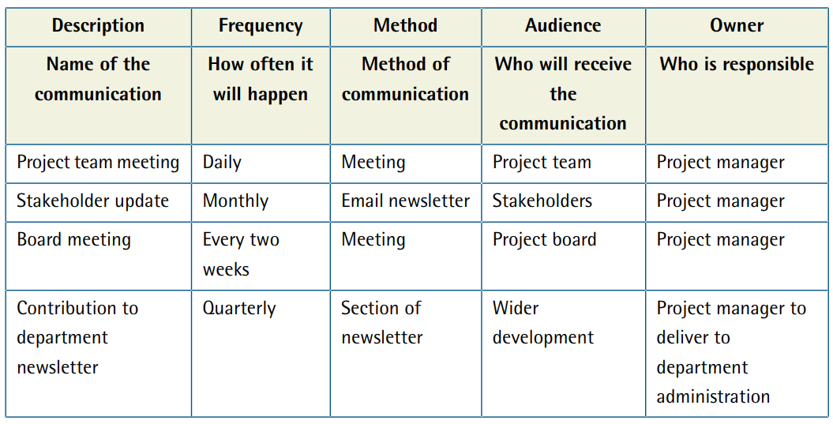 (Warren Lynch,2020)

The team keep stakeholders (external) family members, students and government by email, social media, and campaigns. The internal stakeholders police officers, the BAME community and applicants will be communicating through, weekly meetings and social media.
The stakeholder analysis will categorise priority tasks, look from a stakeholder’s point of view and create an understanding of what the project purpose is and how the team will overcome the barriers. For example one task that is high priority, the stakeholder is South Wales Police, stakeholders perspective is to try and encourage people from the BAME community to join the police force and lastly the action is to visit mosques to demonstrate and deliver how the police force work in order to encourage new BAME employees. The group found the stakeholder chart useful as they could analyse stakeholders’ perspectives and take better action moving forward.

Stakeholder chart for the BAME project -

Priority | Stakeholders | Stake holder’s perspective | Action
High | South wales police | Try and encourage people from the BAME community in joining the police. | Visiting mosques or churches to demonstrate and deliver how the police force work to encourage new BAME recruitment.
High | BAME people | They are the main people who SWP want in joining the police force. | Attending meetings or seminars held by south wales police. Actively enquiring on how to work in SWP.
Low | Government | Keep the community in safe and law abiding.  Encourage BAME to join the police force. | Encourage people from the BAME community to join SWP thus creating a diverse workforce.
Medium | Local community | The community can help encourage BAME people to join SWP. | Allow SWP in vising mosque and churches to deliver their projects. From local gathering, messages from SWP ca be spread out better and further. In turn they will be able to reach a greater audience.
(Created by the team,2020)

In the planning phase, the second stage in the project life cycle, the group measured the project success by feedback from online surveys was analysed and understood to enable South Wales police to make necessary changes. Recruitment figures have increased as information and support are more accessible, which means awareness and interest in various roles have increased.

The Quad chart for the BAME project -

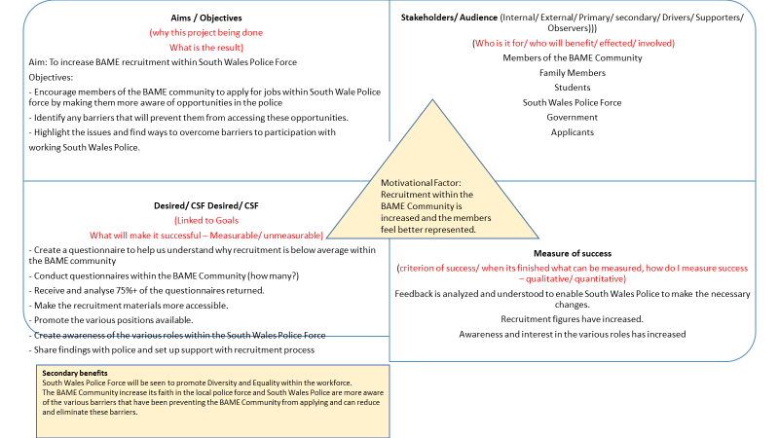(Created by Samantha Davis,2020)

The group found the Quad chart tool to be very useful, when using they can critically analyse all four segments in depth and add a fifth segment to include secondary benefits. The tool made the project more accessible when planning within the project. The group used the S.M.A.R.T tool understand the deliverables of the project plan. The S.M.A.R.T acronym stands for Specific, Measurable, Achievable, Realistic and Time-bound.

The group moved onto the third stage of the project life cycle, the implementation and execution stage. The group created a time frame chart also known as a Gantt chart, this tool gives each segment a timeline to be completed, no task must over-lap and the chart is always in the style of a graph. The team also created a work breakdown structure model, to create structure while undertaking the project.

The Gantt chart for the BAME project –

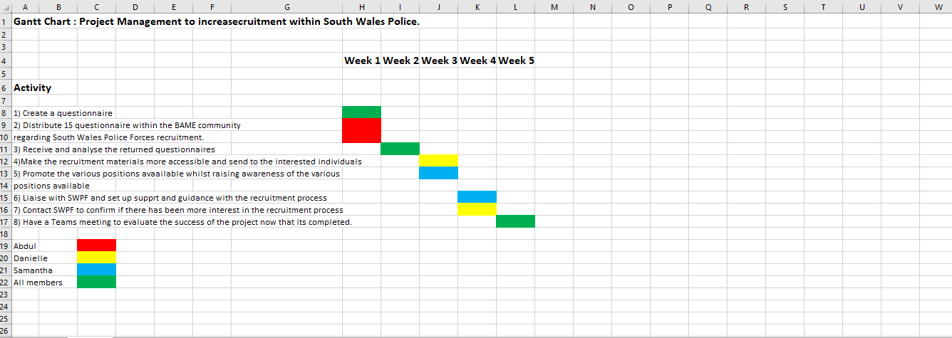
(Created by the group,2020)

As you can see above the Gantt chart is used as a timeline for each task, who is responsible for each task is colour coded, group tasks are in the colour green.
The group moved onto using a Work Breakdown Structure to organise the BAME project from start to finish. what is the purpose of a work breakdown structure? The purpose of using a WBS is an organisational tool that helps the team focus on the project scope, reduce complicated activities when under-taking each task. The general rules when using a WBS, you always start working from the top down, all work should be given a task, never have gaps and should never overlap. This WBS is also good for the project manager to oversee tasks being completed effectively.

“Management shows the hierarchy of the project work and deliverables of a project scope, completed work, remaining work and project team members working on same work package etc. So, all of these can be easily communicated to project stakeholders with the help of WBS Project Management. Since there will be several smaller parts under work packages, and these will be assigned to project team members, WBS Project Management will be helpful for the cooperation between project team members for completing project activities, respectively.” (Master of Project Acadamy,2020)

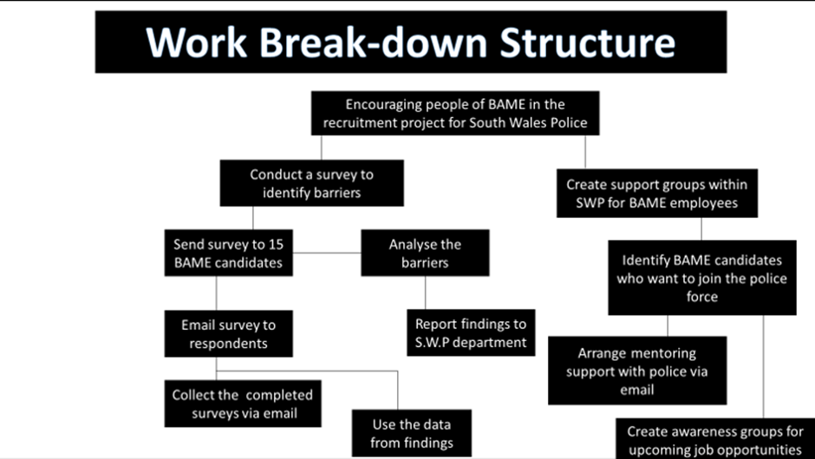
(Created by the group,2020)

The team used the WBS (Work Break-down Structure) to gain a clear view, of what needs to be done and which order tasks will be completed in. The WBS is a great tool for putting the pieces of the puzzle together and in order, the team found this easy to use.
The team moved onto the fourth phase of the project life cycle, the performance and monitoring stage, where they created used two more tools, a Project Network Diagram, and a Risk Analysis.
A project network diagram is a flow chart that creates dependencies between tasks and puts the tasks in order that they will be performed. Network Diagrams are used for projects such as the BAME project, where a group of individuals, undertake tasks in an orderly fashion, to overcome barriers and complete tasks within the project. By using a project network diagram this allows the team, to take every piece of the tasks required and organise them chronically.

SWOT Analysis V PESTLE Analysis –

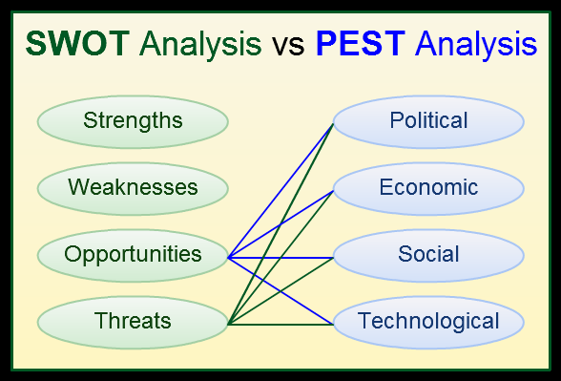 (Creatively,2020)

SWOT AND PESTLE Analysis is always used in project management to look at every aspect of the project.
Strengths - The BAME project its unique, never been done before and will encourage more BAME people to join the police force, weaknesses people of BAME already may distrust the police due to untruthful stories circling social media. Support groups for officer of BAME.
Opportunities – More positive campaigns directed at the BAME community and providing better support for BAME officers, proving that the police force treat every employee with equality.
Threats – People of BAME turning against the police instead of standing with them.
Political – Encouraging South Wales police force to get the government involved in positive campaigns.
Economic – Consumer confidence.
Social – Advertising more, a bigger social media presence and publicity factors.
Technological – Access to technology and research funding.
Legal – Following laws.
Environmental – Local environmental issues.

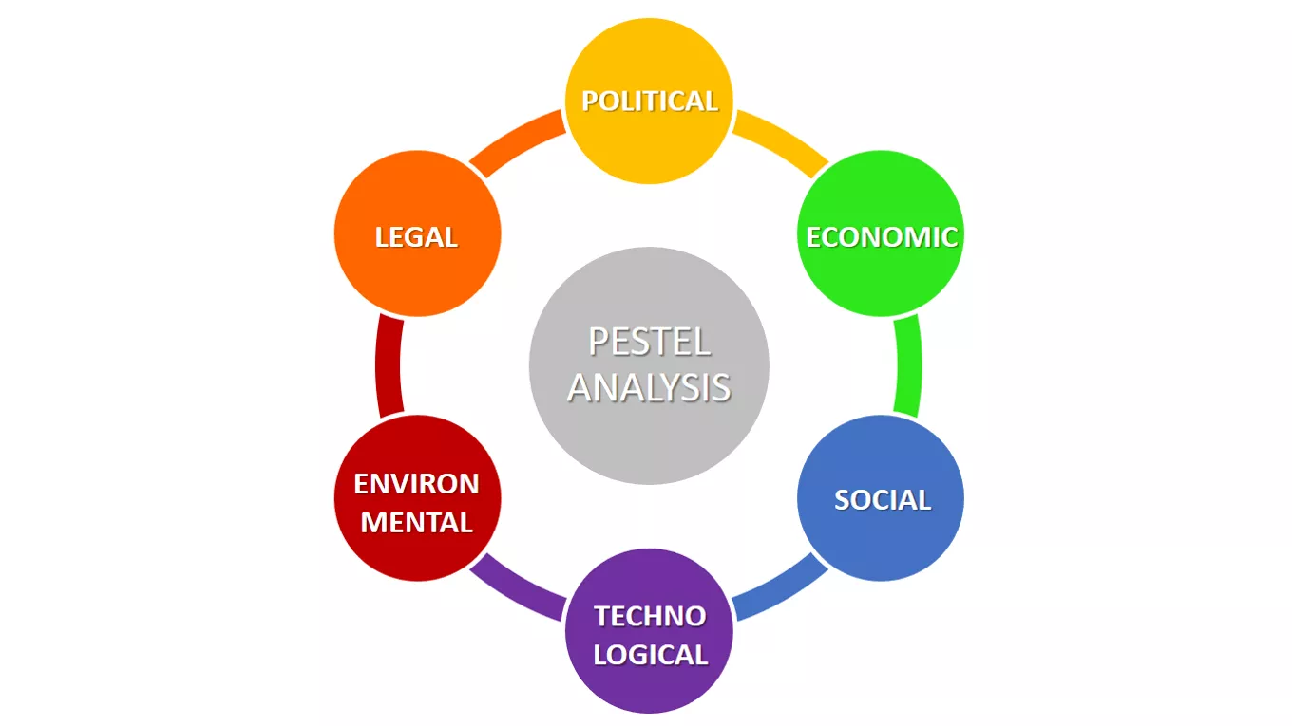
(Business to you,2020)

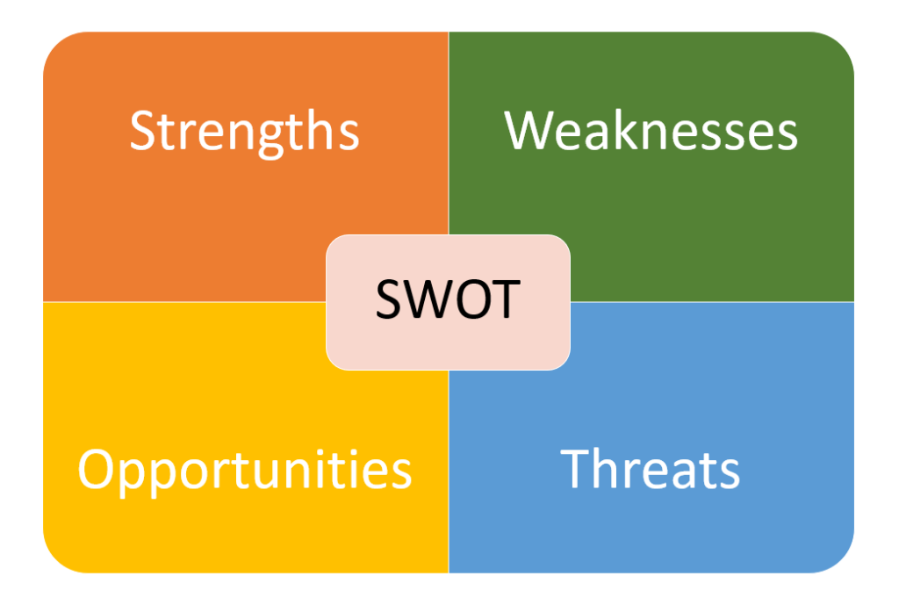
(Tallyfy,2020)

The teams project network diagram for the BAME project -

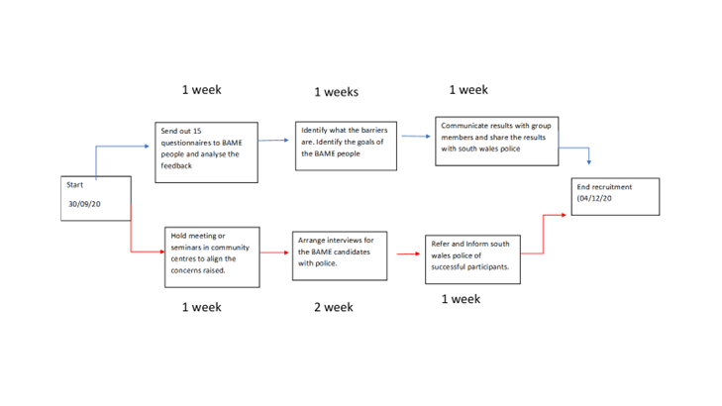(Created by the team,2020)

Network diagram uses three focus points –

Event - Also known as a milestone, this is a task that needs to be done, for example creating the design beginning, this is something that takes no time and uses no resources.
Activity – What work is required to move from one event to the next, this will use resources and timescale.
Span time – The actual time each task will take within the project, the duration of the task is important to be on schedule. The span time can vary on funds, resources, people, equipment, technology, environment, and time.

“A project network diagram is a visual representation of the workflow of a project. A network diagram is a chart that is populated with boxes noting tasks and responsibilities, and then arrows that map the schedule and the sequence that the work must be completed.” (Project Manager.com,2020)

The team created a Risk analysis to identify any potential risks and how to overcome them. A risk is why a project might not be completed; this is when a project does not do what it was supposed to do. The project could be late, may cost too much and use to much staff time.
A risk analysis is when you identify what could prolong a project, find out what internal and external risks there are and what barriers could make the BAME project fail. When creating a risk analysis, it enables the team to identify, what changes need to be made whin the project, for example changing a large project into two smaller successful projects. Change risky areas of concern and still achieve the end goal. As shown below risks are categorised into very low, low, medium, high, and very high, to show the team how each risk can affect the BAME project. The team felt the risk analysis was great to record potential risks and acting that needs to be taken, this helped the team going forward to be more aware of what could happen and how to eliminate potential risks.

The risk analysis for the BAME project –

IMPACT  (H/M/L) | LIKELIEHOOD  (H/M/L) | RISK | MITIGATING ACTION
H | H | People of BAME may not engage/return questionnaires | Try to be more understanding and transparent in why we are running this project
H | M | Reputation of SWPF. | Promote awareness of the positives of the police.
H | H | COVID | Due to the current pandemic and lockdown restrictions we need to keep in line with government guidance.
H | L | Poor technology, Wi-Fi | Changing suppliers, renewing devices and connection solutions.
H | L/M | Staff commitment, illness | As each member has different tasks communication and delegation will be of utmost importance.
(Created by the group,2020)

Risk Analysis chart –

Here is an example a risk analysis chart, what is the likelihood of a risk happening and the impact it has on a project.

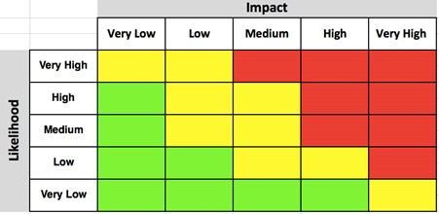
(FinancesOnline,2020)

The team go onto the final phase of the Project Lifecycle, the closing phase. As a group they have been monitoring the progress of the BAME project in great depth, using various tools to encourage people of BAME to join South Wales Police force. At the final phase, the group will identify what they intended to do, what went wrong and what went right. When things go wrong in a project its not to reflect blame, it is to learn from mistakes for future projects.

To evaluate a project, there are four key steps –

Input – This would be the team members, resources and activities that need to be completed.
Outputs – What services the team needs to provide to overcome barriers.
Outcomes – Immediate achievements the group has made.
Impact – Long-term changes, that encourage more officers from the BAME community.

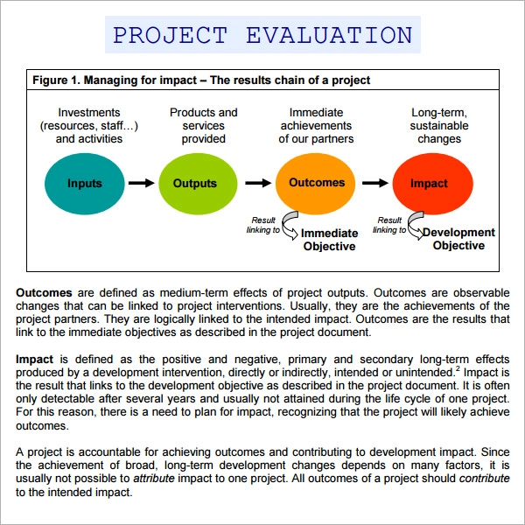(SampleTemplates,2020)

Evaluation in four steps –

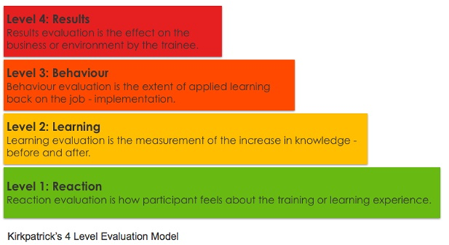 (ATD,2020)

Conclusion

The team’s conclusion overall. The chosen project was to encourage more people of the BAME community to join South Wales Police Force. The team of three individuals: Danielle Tooze, Samantha Davis, and Abdul Shahid, communicated via phone, Moodle, and Microsoft Teams, where they shared ideas and split the tasks. With regards to the ongoing pandemic Covid19, no face to face contact was made with South Wales police force, participants, and other team members, this made things more difficult and time consuming due to everyone being on different schedules.
In the initiation phase the team decided on which project they would undertake. Extensive research was gathered from South Wales police via Microsoft teams meeting, this was to extract relevant information for the project. The group followed the project life cycle route to make sure all tasks were covered at the correct phase.
As a project manager for this project, more attentiveness is needed, more authority is needed in future projects. Using the tools as mentioned above, has been very useful in creating organisation in the project, segmentation and being more aware of potential risk factors.

Personal Belbin Team Role Test, results show she is a team player –

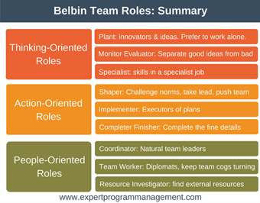(Expert Program Manager,2020)

Belbin’s Team Roles –

According to Belbin’s team roles quiz (shown above), results show she is a team player, to become a successful project manager, skills and training must be gained soon. She has strengths already held are time management skills, organisational skills, self-motivation and others and good communication skills – both written and verbal. To be a competent manager, she must work on adopting the following skills, conflict management, team building and consistency. Potential opportunities for her, are more management training to build confidence and gain more knowledge for future projects. The threats could be not learning from past mistakes, and rein acting them in future projects.

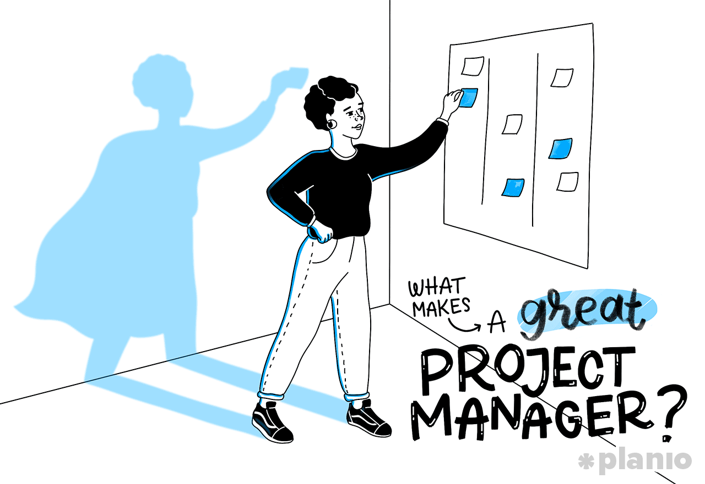(Planio,2020)

The project life cycle diagram –

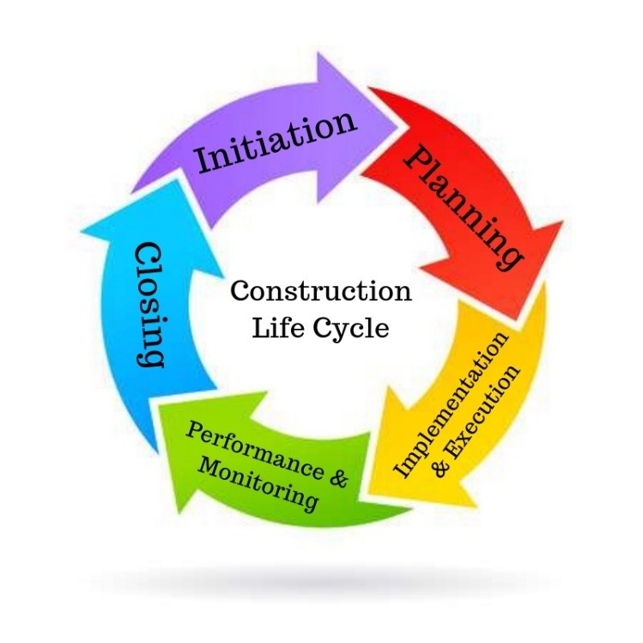(Synuma,2019)

The Project Scope –

The project scope is linked to the project life cycle, the triangle represents four quarters that a project must always take into consideration. The team found this to be verry helpful when evaluating the time, the project will take, the scope of the project, how much the project will cost and the quality of the project.

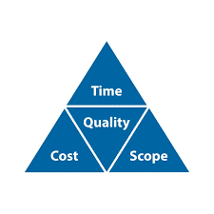 (Skillpoint,2020)

Reference list

Lucid Software Inc,(2020) Stakeholder Analysis: Securing the Buy-in You Need.
https://www.lucidchart.com/blog/how-to-do-a-stakeholder-analysis (accessed on 28/10/20)

Expert Program Manager, (2018) Belbin Team Roles.
https://expertprogrammanagement.com/2017/06/belbin-team-roles/ (accessed on 21/10/20)

Skill Point, (2020) Project Management: What is the ‘Triple constraint’ Model?
https://www.skillpoint.uk.com/triple-constraint-model/ (accessed on 22/10/20)

Master of Project Academy, (2020) benefits of WBS.
https://blog.masterofproject.com/wbs-project-management/ (Accessed on 04/11/20)

Synuma,(2019) 5 important phases of the construction life cycle.
https://synuma.com/blog/construction-life-cycle (Accessed on 04/11/20)

ProjectManager.com, (2020) 3 Free Management Tools for Making Network Diagrams.
3 Free Tools for Making Network Diagrams - ProjectManager.com (Accessed on 11/11/20)

Finances Online, (2020) Project Risk Assessment: Guide with Templates & Examples.
Project Risk Assessment: Guide with Templates & Examples - Financesonline.com (Accessed on 12/11/20)

Sample Templates, (2020) Project evaluation form.
FREE 9+ Sample Project Evaluation Templates in PDF | Google Docs | Pages | MS Word (sampletemplates.com) (Accessed on the 28/11/20)

ATD, (2020) Measuring training success in Healthcare.
Measuring Training Success in Healthcare (td.org) (Accessed on 28/11/20)

The police and crime commissioner, (2020) Equality and Inclusion.
Equality & Inclusion (south-wales.police.uk) (accessed on 01/12/20)

Warren Lynch, (2020) project Management.
Project Management — Communication Plan Template and Example | by Warren Lynch | Medium (accessed on 01/12/20)

Planio, (2020) what makes a project manager? The most 10 crucial skills for 2019 (and how to develop them.

What makes a great project manager? The 10 most crucial project management sk... | Planio (accessed on 02/12/20)

Creatively, (2020) SWOT Analysis and PESTLE Analysis – when to use them
SWOT Analysis and PEST Analysis - When to Use Them (creately.com) (accessed on 01/12/20)

Business to you, (2020) Pestle analysis.
PESTEL-analysis-updated.png (1360×765) (wp.com) (accessed on 02/12/20)
Tallyfy, (2020) SWOT Analysis
SWOT-Analysis-1024x689.png (1024×689) (tallyfy.com) (access on 02/12/20)

Created by the group -
Gantt chart.
Work break-down structure.
Stakeholder analysis chart.
Quad chart.
Risk analysis.

