 |  | Health assessment Report  Halema Begum / student ID: 1816637 / BSC health and social care




TABLE OF CONTENTS
Contents
1
Halema Begum / student ID: 1816637 / BSC health and social care 1
1
TABLE OF CONTENTS 3
INTRODUCTION 5
Assessment report 5
recommendations 8
conclusion 10
Reference 11
Appendix 13



INTRODUCTION | 
Many people around the globe suffer with different types of illnesses. Some can be minor moderate or even terminal. What impacts the illness is how early on it was caught and how best to manage and hopefully minimize any symptoms. To check what the symptoms are depending on the issue presented to the health professional and the severity many checks can hopefully rule out any long-term underlying issues but essentially what treatment is available

Case study
A patient presented themselves at the doctor’s surgery complaining of constipation, bloating, and gaining weigh with the additions of abdominal cramps and spasms. A health questionnaire was filled out(appendix) and consent was given. A conversation had revealed a lot of stress in their life. During patient HA visit it was also stated that when they go to the toilet, they feel that the bowels are not fully empty. They had been suffering with this for a year and needed it investigating as nothing seemed to be working.
Factors to also consider from the healthcare questionnaire are
- Patient is 37 years of age
- Patient smokes 1-9 cigarettes a day
- Known heart conditions in the family
- Has a good diet
- Exercises 3 times a week
- Does not consume alcohol


assessment report
Constructed on the answers provided by patient HA the following health concerns can be identified
Abnormal physiology conditions:
- Being 5 ft 7 and weighing 14 stones indicated that HA is clinically obese as the body mass index shows a result of 30,7.
- Have known heart conditions in the family.
- The patient’s ethnicity is Bangladeshi and plays a vital role in health conditions that they may be more prone to.
- Being obese and physically active highlights underlying concerns.
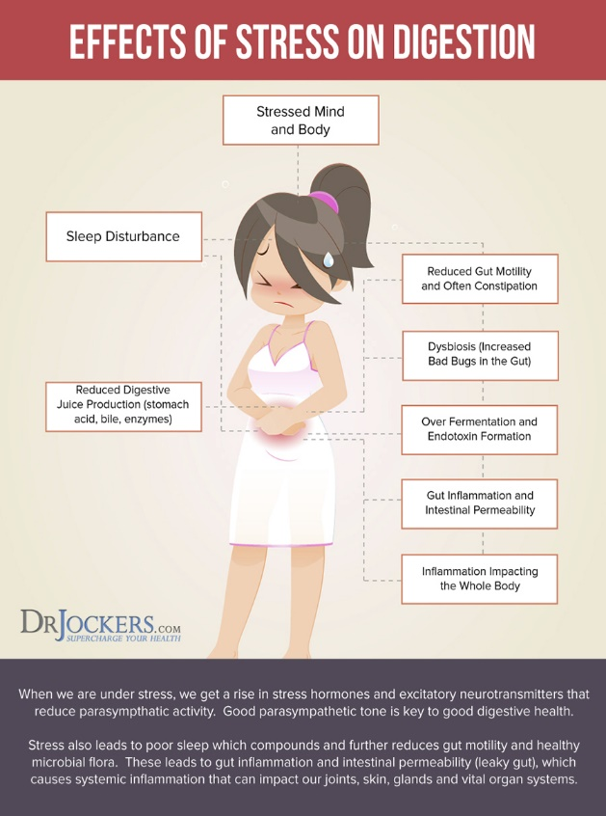
After listening to patient HA health complaint, the GP had asked questions on exercise and diet as well as what is stressing them out. The general practitioner (GP) thought that the patient had symptoms of irritable bowel syndrome (IBS) and was advise if diet and lifestyle changes were made this should ease symptoms but as the patient returned with same complaints several months later the doctor had decided to get patient HA referred for an endoscopy and get blood test done to eliminate any underlying health concerns. Ibs has triggers much like people and although the digestive track may seem uncomplicated even stress can cause IBS to fluctuate.

The graph on the side (16 Ways to Achieve Healthy Poop, 2022) shows the factors that can contribute to IBS
Although there are no known causes the factors stated (picture shown)
Do have major influences on IBS.

Normal physiology
The patient was physically active and had a varied healthy diet. The picture below will show what a normal intestine looks like and what a person with ibs intestine looks like.
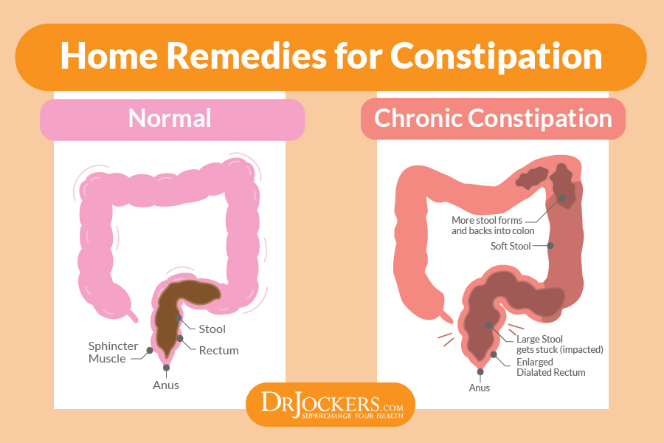
(16 Ways to Achieve Healthy Poop, 2022)
A normal intestinal track does not store old stools like one who suffers with ibs. Food is not digested correctly and in turn that waste is then actually turned into fat as the body does not recognize it as waste or energy. Ibs is categorized into 3 types ibs c which stands constipation. Ibs d which is diarrhea and lastly there is ibs m which is a combination of both constipation and diarrhea. Fluctuating from one extreme to another can be very hard especially when life is busy as it it and to spend half the day in the toilet is unheard of. Looking at an x ray of a person’s abdomen area who suffers with ibs can be inadequate as it will show that everything seems as it should, having said that there is more specific test available to target the insides of the digestive track. An endoscopy can be carried out it is a small camera is inserted through the bodies opening which is mainly the mouth and is inserted directly into organs which allows you to see defects that other imaging equipment would not allow. A colonoscopy is the same it is a thin tube with a camera on the tip and is inserted through the rectum and allows you to see into the intestinal walls. Usually, these tests are not done to diagnose IBS as it is a financial burden to the NHS and ibs patients are usually reporting the same complaints in the abdominal area. (Ladabaum et al., 2012)

Factors that cause concerns
- Patient HA is physically active and is eating a varied healthy diet but is not losing weight and is classed as clinically obese  - Blood test will help rule out if patient has an underactive thyroid which may explain the weight gain | - Although diet may be healthy it may be contributing as an aggressor in the body and working against the body.  - Most of the concerns are around the abdomen which may indicate the issue may also be in the abdomen area such as the large intestine.

recommendations

Irritable bowel syndrome is very common amongst the human race where a percentage of up to 10% of humans suffer with IBS. (Spiegel, 2009) genetics can play a part in a person getting IBS as well as nationality or geography of what part of a world a person may derive from (Black and Ford, 2020),
Diet has a major role to play in ibs patients (El-Salhy, 2012) as this is one of the triggers for ibs. A lot of people either steer away from food as it is physically draining as the digestive track cannot process the food correctly or eat food with the fear of a flare up. A diet plan that is low in sugar that may cause distress to the intestines also known as FODMAP may help as it will also help eliminate or narrow down foods that may cause irritability and this will be apparent when it is reintroduced into the diet (Staudacher and Whelan, 2017). Fruit and vegetables in any diet are beneficial but with someone that has IBS it may cause more harm as it will act as an aggressor so the FODMAP diet with help narrow down what is unsuitable for you, and this may be a short-term solution or if it is seen as advantageous then it maybe beneficial to be a whole lifestyle change. Diet also has a major impact on weight and if food is not getting digested properly it maybe harmful in this case causing obesity.
Irritable bowel syndrome is known as a gut-brain condition so if someone is overly stressed it will impact the gut and cause a flare up so practicing mindfulness is very important as a healthy mind is essentially the key to a healthy gut, this could be achieved by exercise. Exercise increases the body’s endorphins which is the body natural pain killer and mood enhancer (Amir et al,. 1980). Ethnicity can also play a major risk contributing factor for certain disease. For a short-term solution if the patient suffers with constipation, then it would be advised to try some laxative that will help along the stool in the digestive system, senna is a good natural product that has benefits for people suffering from constipation. But using any medication for too long has a detrimental impact on the bodily function as the body is not permitted to function on its own accord or rectify any alignments (Davidson et al.,2013). Regular intake of pre and probiotics can also be beneficial as it provides a barrier against free radicals (Probiotics, 2022), research has shown that probiotics acts as an ally for sufferers of IBS, Crohn’s, and colitis. Researchers such as Ford et al., 2014 has looked in depth how probiotics help the digestive functions and have stated that bowel movement has been reported to increase after the consumption of probiotics. A crucial element to any living being is also to be hydrated to drink enough water to nourish and hydrate the body is paramount. Waler in this case can help flush out toxins or stools that would’ve been compromised if sufficient water intake is not occurring. Water can also eliminate stomach distress that cannot be found in alternative beverages as some may contain sugar and others caffeine. (Couzin-Frankel, 2021). Everyone talks about spicing up their lives but regarding ibs this can act as a trigger as it can unsettle or aggravate the stomach which is a very vicious cycle to distance yourself from if your diet predominantly consists of spicy food (Esmaillzadeh, 2013). But as a starting point it is recommended to cut out gluten then maybe lactose as ibs symptoms can also be very similar to an intolerance to lactose or gluten and can be easily misdiagnosed (Carter and Attel, 2013). By cutting these out it help to differentiate between an intolerance or if in fact it is ibs.

conclusion
A person on paper may seem healthy as they are conforming to what society deems as safe or healthy in this case but ultimately if there are underlying issues than adequate research must be performed to get to the root cause of any underlying issue. The health questionnaire is a good base to start with, but I believe it does need to be a little more in depth to get a clearer general idea of an individual’s history but having said that when someone is in distress or discomfort this may cause further anxiety. Irritable bowel syndrome is a condition that leads to inadequate functions in the digestive system which leads to pain in the abdominal region. this has a detrimental impact on the quality of one’s life as they are in discomfort. If symptoms continue repeatedly this is known as a chronic condition and has no overnight fixers. If positive lifestyle changes are not made, then the patient will not get any ease of pain or relief. Reflecting on all the facts stated it is advised that someone suffering with ibs should be conscious of healthy eating or eating foods that do not cause flare ups. Exercise should be incorporated into the lifestyle if not already as this will contribute to positive changes and improve mental health. Food should not be an obstacle or a challenge but with ibs this is a regular occurrence but with simple changes this may slowly be rectified.

Reference
Amir, S., Brown, Z. and Amit, Z., 1980. The role of endorphins in stress: Evidence and speculations. Neuroscience &amp; Biobehavioral Reviews, 4(1), pp.77-86.

Black, C. and Ford, A., 2020. Global burden of irritable bowel syndrome: trends, predictions and risk factors. Nature Reviews Gastroenterology &amp; Hepatology, 17(8), pp.473-486.

Carter, S. and Attel, S., 2013. The diagnosis and management of patients with lactose-intolerance. The Nurse Practitioner, 38(7), pp.23-28.

Couzin-Frankel, J., 2021. What causes IBS pain? Maybe immune flare-ups. Science, 371(6527), pp.333-334.

Davidson, E., Vlachojannis, J., Cameron, M. and Chrubasik, S., 2013. Best Available Evidence in Cochrane Reviews on Herbal Medicine?. Evidence-Based Complementary and Alternative Medicine, 2013, pp.1-7.

DrJockers.com. 2022. 16 Ways to Achieve Healthy Poop. [online] Available at: <https://drjockers.com/16-ways-achieve-healthy-poop/> [Accessed 19 April 2022].

Ford, A., Quigley, E., Lacy, B., Lembo, A., Saito, Y., Schiller, L., Soffer, E., Spiegel, B. and Moayyedi, P., 2014. Efficacy of Prebiotics, Probiotics, and Synbiotics in Irritable Bowel Syndrome and Chronic Idiopathic Constipation: Systematic Review and Meta-analysis. American Journal of Gastroenterology, 109(10), pp.1547-1561.
Esmaillzadeh, A., 2013. Consumption of spicy foods and the prevalence of irritable bowel syndrome. World Journal of Gastroenterology, 19(38), p.6465.

Ladabaum, U., Boyd, E., Zhao, W., Mannalithara, A., Sharabidze, A., Singh, G., Chung, E. and Levin, T., 2012. Diagnosis, Comorbidities, and Management of Irritable Bowel Syndrome in Patients in a Large Health Maintenance Organization. Clinical Gastroenterology and Hepatology, 10(1), pp.37-45.

nhs.uk. 2022. Probiotics. [online] Available at: <https://www.nhs.uk/conditions/probiotics/>

Spiegel, B., 2009. The burden of IBS: Looking at metrics. Current Gastroenterology Reports, 11(4), pp.265-269.

Staudacher, H. and Whelan, K., 2017. The low FODMAP diet: recent advances in understanding its mechanisms and efficacy in IBS. Gut, 66(8), pp.1517-1527.

Appendix


