Jacqueline Rose Thomas 2014372.

Distinctiveness and regeneration. 18/30/2020

Llanelli is an old historical market town in South Wales,in the middle part of the nineteenth century many industries evolved and established themselves regarding the manufacturing of tinplate and steel which was at the namely Old Castle Works,having an expanded large production workforce.South West Wales was the leading producer of tinplate in the world.In 1914 at the beginning of WW2 over 3000 women were employed in this industry as the men were called up to defend Britain against Germany at the outbreak of an horrific war,women continued to play a vital role in the manufacturing of tinplate and steel until it,s sad decline in the 1980,Llanelli region was a major contributor fuelled in part by the introduction in 1859 of the sealed tinplate can for preserving food,this the name TINOPOLIS is associated with Llanelli town,at the same time the manufacturing of bricks became another significant industry in the area due to the abundance of Silica clays. Around 1878 Felinfoel Brewery established it,s factory near the town creating even more much needed employment,this was set up by one of the owners of the Tinplate works ,namely David John,by the middle of the nineteenth century Dafen Tin plate works had commenced production also.Llanelli relied heavily for it,s prosperity upon the employment provided by the tin mills, supplying all the armed forces.I,m certain the contribution of all the men and women working in these industries as well as the miners that dug for precious coal from the bowels of the earth to supply the steelworks furnaces are the reason we won both wars of the twentieth century and are the reason we are prospering today ,we owe them a debt of gratitude.Wales is known World wide for it,s excellent quality of steel,used in the buildings of famous Bridges, Roads and the Skyscrapers of all modern countries the skillful precision of the manufacturing is now based at Trostre works, Llanelli and PortTalbot at present.Sadly the dramatic decline of the Old Castle Works came to an end in the 1980,s,the old historic buildings cleared, demolished and left abandoned and derelict until a vision and masterplan to transform the old industrial eyesore into a new development came into fruition for a Millennium Coastal Park with the full support of the people of Llanelli. Leaving behind but never forgetting a once thriving industry an those hard working people that toiled day and night to feed so many hungry bellies of their large families. A timeline archived in History of Wales. There is a Monument ,a magnificent steel Obelisk standing tall on a hill on that historic site depicting the moment of time in Llanelli,s past and future generations will forever proudly embrace.
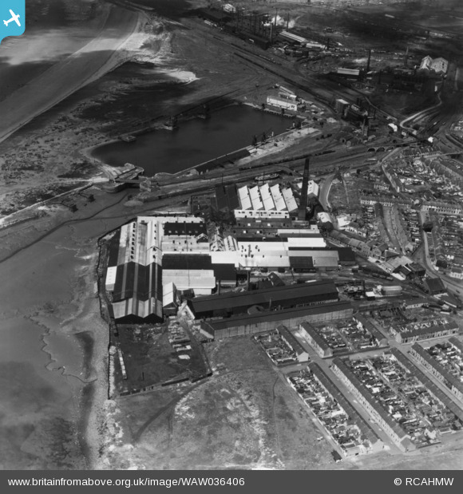
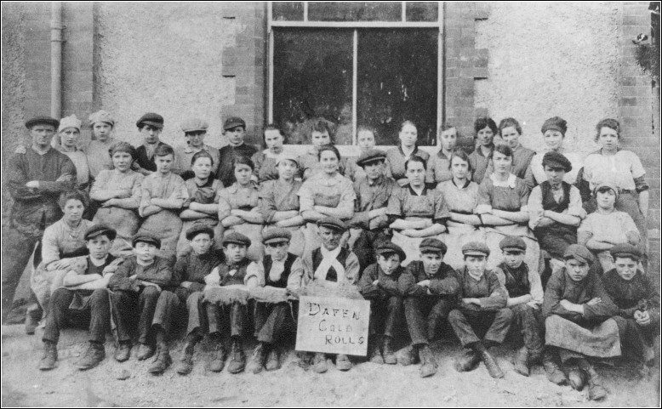
In this once thriving industrial town,the 1980,s seen an end to a way of life for so many manual steel and tinplate workers, a large part of the "Old Castle Works"ended up as a real ugly and ghostly eyesore,until a few years after the closure, major changes were underway with the full support of the public, the once delelict strip of land would be reclaimed, transforming an unique part of the Llanelli coastline. It was the 1995,the second Millennium was nearing, an ambitious vision ahead for vast plans to be drawn up for approval and the vast funding needed to fund it ,which came about from various sources e.g. the National Lottery funding, Carmarthen County Council,Welsh Assembly now named the Sennedd and the European Union.The aim of the new project "the Millennium Coastal Park"was to regenerate an area of dereliction along the coastline,by doing this it would encourage people to move to this beautiful area,a haven for tourists,thus bringing work and new welcoming ideas with them, providing new educational and information facilities accessible to inland towns by the nearby M4 corridor. The costings of this project was near to thirty million pounds at this time. This project today is still developing and expanding with the obvious financial benefits with growing employment and visitors.A smart cultural housing development with stunning views over the beauty spots of Gower has now been erected, a golf course, restaurants, hotels, outdoor activities as well as a creative and integral part of a healthier productive way of life for the benefiting communities across the area ,miles of walks and cycle paths along the beautiful waterside, accessible to other nearby beauty spots, including the Wetlands a wildlife sanctuary and the famous Pembrey Country Park and lovely golden beaches on the doorstep. A really inviting part of South West Wales for holidays where people will revisit year after year. It has been a grate success and will continue to grow in the future. Many people tend to enjoy days out etc. But as of now 2020 it’s been a massive change and affect in all businesses due to covid 19. People’s business have had to close due to restrictions which causes financial problems meaning they’d have to shut. It has made them fragile. In addition it’s impact on publics health coronavirus 19 have caused a minor economic shock. But as people fight this as a community and with the help of people supporting businesses things will gradually build up and fall back into place. It very well may take time to get back up and running but with continued support things will eventually get better financially also. it has affected a lot of people as a lot of them rely on there business to keep a living so without their businesses they have really been making any sort of money nor profit due to the COVID-19 . But other than the affect of COVID-19 the whole regeneration has been a success. And in future it will expand to bigger and better be open with peoples plans and futures. I hope to see it become a grate success in the next generation as it has for many many years. As of myself I have been a part of this beautiful area and it’s been wonderful to see the change throughout the years.



