Title: Strategic Analysis of iPhone in the United Kingdom Market
Programme: Master of Business Administration
Module Code: LCMB7003
Assignment Title: Assessment component - Individual report
Lecturer: Amare Desta (London), Ejike Udeogu (Birmingham)
Student Name: Hiraben devshibhai modhwadiya
Student ID: 2520086
Word Count: 5491

Table of Contents
Introduction 3
Section 1: Strategic Analysis & Choices 4
1.1 Organisational Context and Overview 4
1.1.2 Company Profile & History: 4
1.1.3 Strategic Intent 5
2. External and Internal Analysis 7
2.1 Macro-Environmental External Analysis (PESTEL Framework): 7
2.2 Resource-Based Internal Analysis (VRIO Framework): 14
2.3 SWOT Analysis: 17
3. Comprehensive and Holistic View 21
3.1 Corporate Social Responsibility (CSR) Audit: 21
3.2 The Balanced Scorecard: 22
4. Strategic Choices and Implementation 25
4.1 Business-Level Strategy Mapping: 25
4.2 Framework Validation: 25
4.3 Competitive Advantage & Execution: 29
4.4 Implementation Risk Management: 32
Section 2: Reflective Account 35
Conclusion 38
References 39

Introduction
This report strategically defines Apple’s current strtategic position with reference to its one of the premium products, iPhone, precisely in the UK market, and evaluates its internal and external environment and based on that recommends certain strategic steps that if implemented will help the company to gain competitive advantage. The report finally concludes by reflecting on the process and the hard toil it takes to make this report worth it.

Section 1: Strategic Analysis & Choices

1.1 Organisational Context and Overview

1.1.2 Company Profile & History:
The company Apple was established in California, USA, in 1976 by Steve Jobs, Steve Wozniak and Ronald Wayne, with the mission to make personal computing easier and more accessible. Apple is still showing outstanding financial performance as they reached a new high with revenue of $111.2 billion in the second quarter of fiscal 2026, up 17% year-on-year, and iPhone revenue hit a new March-quarter all-time high, fuelled by unprecedented demand specially for the latest iPhone 17 series (Apple, 2026a).
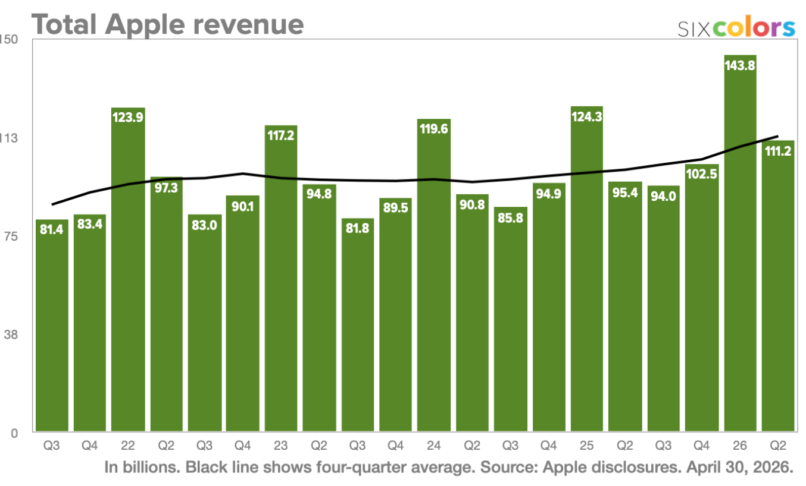
Figure 1: Apple’s Quarterly Revenue from 2022-2026
(Source: Sixcolors, 2026)
This report concentrates on the Apple iPhones in the United Kingdom, which is one of Apple's most developed premium electronic items.

1.1.3 Strategic Intent
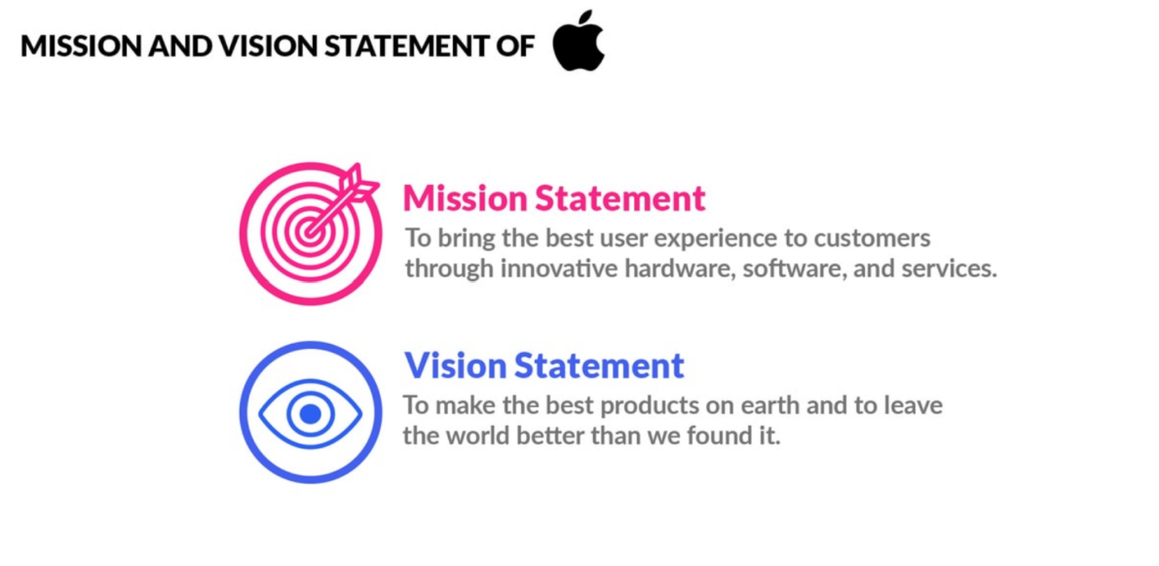
Figure 2: Mission and Vision of Apple
(Source: Pereira, 2025)

Mission Statement
Apple’s mission has always been “To deliver best customer experience through hardware, software and services” (Pereira, 2025).
Vision Statement
Apple's vision is to make the best products and retain the top spot in the world and leave the world in a better state than it was.
Core Business Model
Apple’s business philosophy revolves around innovation, product superiority, privacy, and a seamless user experience between devices and services. Most revenue comes from the sale of devices, specifically the iPhone and on-going sales of digital services. In addition to iPhone sales, Apple also noted that its Services business generated a record US$30.0 billion in Q4 2025, a 14% increase from the previous quarter, (Nasdaq, 2025).
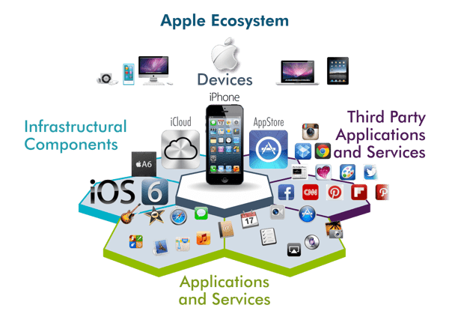
Figure 3: Apple’s Ecosystem Strategy
(Source: CDO Times, 2024)
Industry
Apple operates worldwide in a fiercely competitve industry across a number of segments starting from electronic items such as SmartPhones (iPhones), iPads to wearable devices and digital services against some of the top companies including Samsung, Google etc. Highly saturated, extensive competition and constant innovation are the key features of this industry where Apple holds the highest brand value (Song, 2024).
Key Competitors
Samsung Electronics and Google Pixel are Apple's main rivals with their high-end AI-powered smartphones with amazing features and equally competitive prices.
Market Position
Apple retains its high standing in the United Kingdom premium smartphone market largely thanks to its brand loyalty, ecosystem synergy, innovation, and impressive product features, which provide its iPhones with a unique competitive edge.

2. External and Internal Analysis

2.1 Macro-Environmental External Analysis (PESTEL Framework):
Political: The UK's political stability, combined with its transparency in regulations, creates a favourable climate for Apple's sustained investment and distribution of the iPhones. Additionally, the UK also adopts an open trade policy, as 0% Most Favoured Nation (MFN) prices, import duty is applied to smartphones, which allows Apple to import the devices into the UK without having to pay extra import taxes or import VAT (HS Rates, 2026).
Politically, the UK's many strong international trade ties remain to enable the import of technologies. UK trade in total was valued at £1.93 trillion in the 12 months to April 2026, a 4.2% rise on the previous year, and UK imports totalled £988.8 billion, an increase of 5.4%, showing a good trade climate for consumer electronics products like the iPhone (Trading Economics, 2026a).
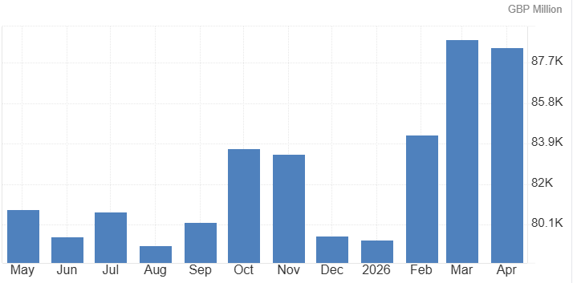
Figure 4: United Kingdom Imports
(Source: Trading Economics, 2026b)
Economic: The UK is currently the 5th largest economy, worth 4.2$ trillion based on Nominal GDP and the tenth largest in terms of PPP, which makes it a great market for luxury brands like Apple (Acharya, 2025). Apple's pricing policy and strong brand allow it to hold fast to its niche as a premium brand. Consumer spending has also increased to 419235 GBP Million in the first quarter of 2026 from 416831 GBP Million in the fourth quarter of 2025, enabling consumers to spend money on high-end consumer electronic devices, which is why Apple has more than 49% of the market share in the UK. Consumer Price Index (CPI) data from the Office for National Statistics (ONS) suggests moderate inflation in the UK, at 2.8% in the last 12 months, which has hardly had an impact on buying decisions and maintained a relatively healthy market for high-end smartphones at least for now (Office for National Statistics, 2026).
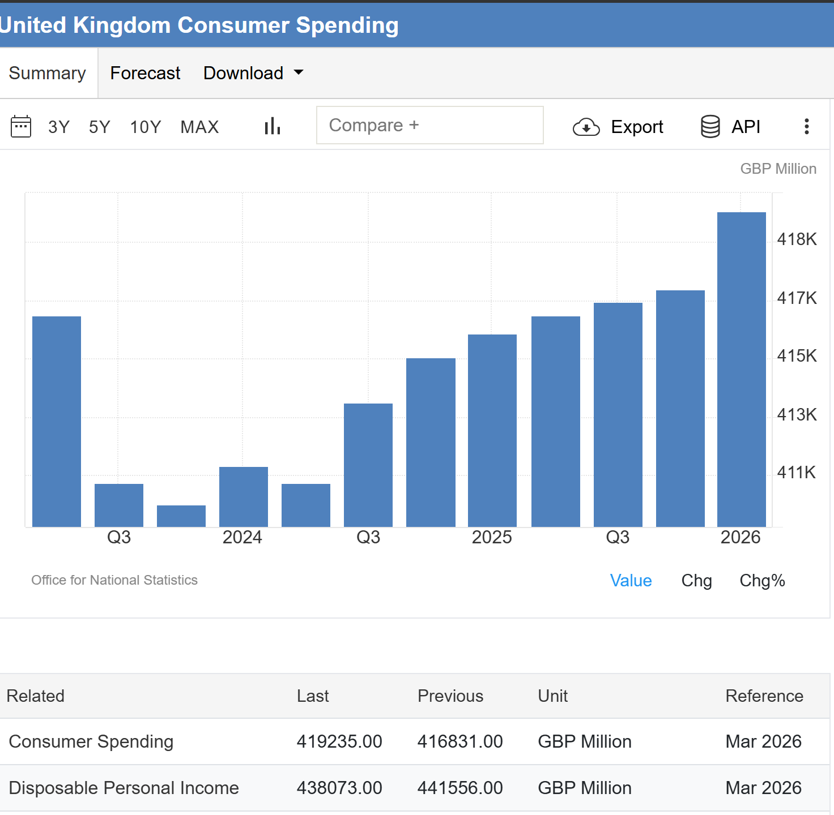
Figure 5: Consumer spending data of the UK
(Source: Trading Economics, 2026)
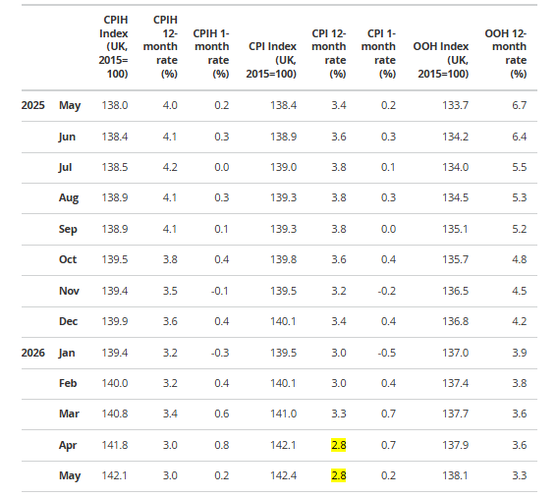
Figure 6: Consumer price inflation rates
(Source: Office for National Statistics, 2026)
Social: In the United Kingdom, social trends are growing towards premium smartphones capable of delivering sophisticated technology, security, sustainability and seamless digital connectivity. The Apple iPhone’s integration of digital ecosystems, artificial intelligence, and high-quality cameras resonates with the tech-savvy tastes of consumers, particularly within the younger segments of the professional community and Generation Z, where these features are highly prized. The iPhone has always dominated the smartphone market, and its role in everyday life and in accessing the internet has been underscored by Ofcom's Online Nation 2026 Report, which reveals that 94% of adults in the UK use a smartphone for internet access (Globig, 2026).
Technological: The reason for the competition in the UK market for smartphones is rapid technological innovation. To bolster the competition of the iPhones, Apple is continuously spending on research and development (R&D) on areas such as artificial intelligence, semiconductor performance, camera technology and ecosystem integration. Apple's Q2 2026 Financial Results report highlights the attention that the company placed on technological advancement and long-term innovation, showing growth of double digits in all geographic segments (Apple, 2026c).
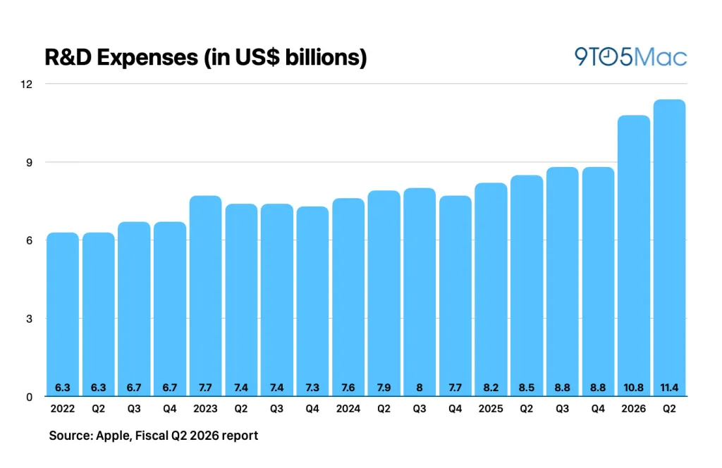
Figure 7: Apple’s R&D spending hits $11.4 billion
(Source: 9to5Mac, 2026)
Environmental: Apple's commitment to lower carbon emissions, boost energy efficiency and repurpose more materials in the iPhones could be spurred by a rising tide of new climate regulations and consumer expectations around green products. The strategies improve the brand image of Apple and allow it to adhere to the environmental policies in the UK. In accordance with Apple's 2026 Environmental Progress Report, the company's global GHG emissions have decreased by 60% from its 2015 baseline (Apple, 2026a). Additionally, there was use of 30% recycled material and 100% recycled cobalt batteries in products across all product lines including iPhones (Apple, 2026).
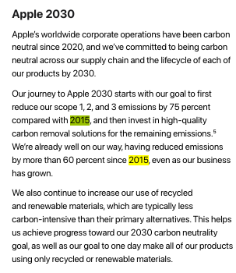
Figure 8: Apple's 2026 Environmental Progress Report
(Source: Apple, 2026b)
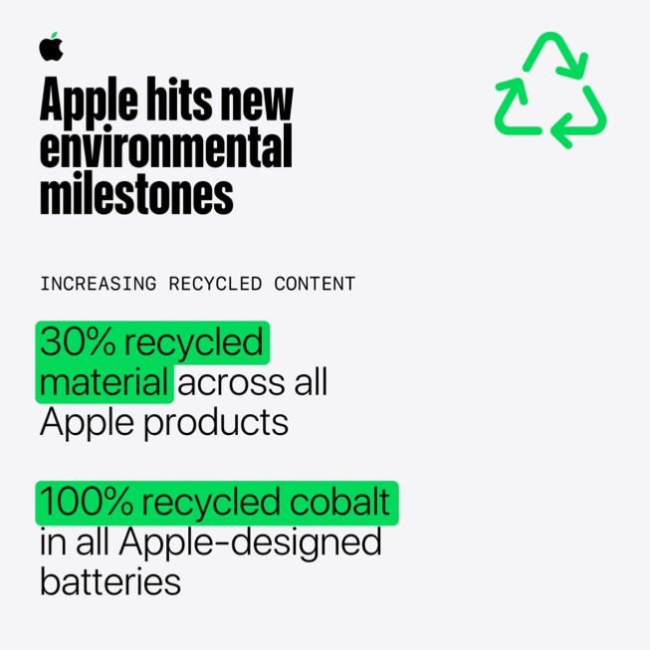
Figure 9: Apple is sharing its environmental milestones
(Source: Apple, 2026a)
Legal: Apple will have to follow the Employment Law, Consumer Protection Law, Product Safety Standards, Data Privacy Regulations and Competition policies in the UK. The adoption of the iPhone is especially significant for the General Data Protection Regulation (UK GDPR) and the Product Security and Telecommunications Infrastructure (PSTI) Act, as these laws bolster data protection and security measures for connected devices in the UK. Apple's payroll increase began in April 2026, with the National Living Wage increasing by £12.21 an hour, thus helping to ensure fair employment practices (GOV.UK, 2026).

2.2 Resource-Based Internal Analysis (VRIO Framework):
Strategic Resource/Capability | Valuable (V) | Rare (R) | Inimitable (I) | Organised (O) | Competitive Implication
Apple Brand Reputation | Yes | Yes | Yes | Yes | Sustained Competitive Advantage
iOS Ecosystem | Yes | Yes | Yes | Yes | Sustained Competitive Advantage
Apple Silicon (Custom Chips) | Yes | Yes | Yes | Yes | Sustained Competitive Advantage
Research & Development Capability | Yes | No | No | Yes | Competitive Parity
Global Supply Chain | Yes | No | No | Yes | Temporary Competitive Advantage
Apple Retail Stores & Customer Experience | Yes | Yes | No | Yes | Temporary Competitive Advantage
Services Ecosystem (App Store, iCloud, Apple Music) | Yes | Yes | Yes | Yes | Sustained Competitive Advantage
Premium Pricing Strategy | Yes | No | No | Yes | Competitive Parity

Table 1: VRIO
(Source: Author)
Value: Apple and its iPhones can be considered a valuable product as it utilises the market opportunity and the resources of Apple to overcome the various threats of competition in the UK. The company has an integrated ecosystem, proprietary technologies, a stellar brand value worth $607.6 Billion and a roadmap of consistent innovation to increase stickiness, justify amplified pricing and distinguish Apple from rivals. All these qualities also enable the enterprise to be more responsive to advancing technology and consumer tastes. Apple's Q1, 2026 financial results stated that Apple has over 2.5 billion active devices globally, highlighting its brand value (Apple, 2026b).
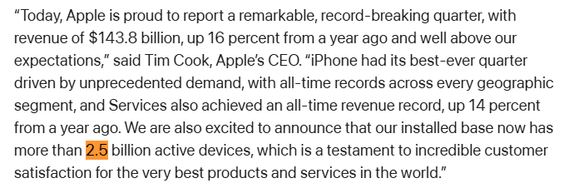
Figure 10: Apple’s First Quarter Report
(Source: Apple, 2026)
Rarity: Apple’s resources are unique, as hardly any other organisation has the mix of proprietary hardware, iOS operating system, and custom-made SoC, which creates a seamless ecosystem like Apple has. These features differentiate iPhones, from other smartphones and provide a seamless user experience that is hard to emulate. Apple's ability to innovate represents one of the key reasons why customers are willing to pay a premium price to buy their products in the UK market.
Inimitability: The inimitability of Apple's strategic resources stems from its unique strategy of developing an ecosystem, its proprietary knowledge, worldwide brand image, intellectual property and years of innovation capacities. However, building similar hardware, software and service is a major capital investment, which also takes a long time for customers to trust, as well as specialised know-how. Apple designs its own silicon architecture and iOS 27 kernel, which is inimitable for rivals, as well as Apple holds an exclusive partnership with Corning that provides Ceramic Shield 2 display prevents other competitors like samsung to buy (Apple Inc., 2026a). An iPhone with these features has maintained its competitive edge in the UK's high-end smartphone scene. In 2025, Apple reported US$416.2 billion in revenue, placing it 4th on the Fortune 500 List for 2026, which falls in the domain where rivals have to pay massive amounts of money to a large degree (Fortune, 2026).
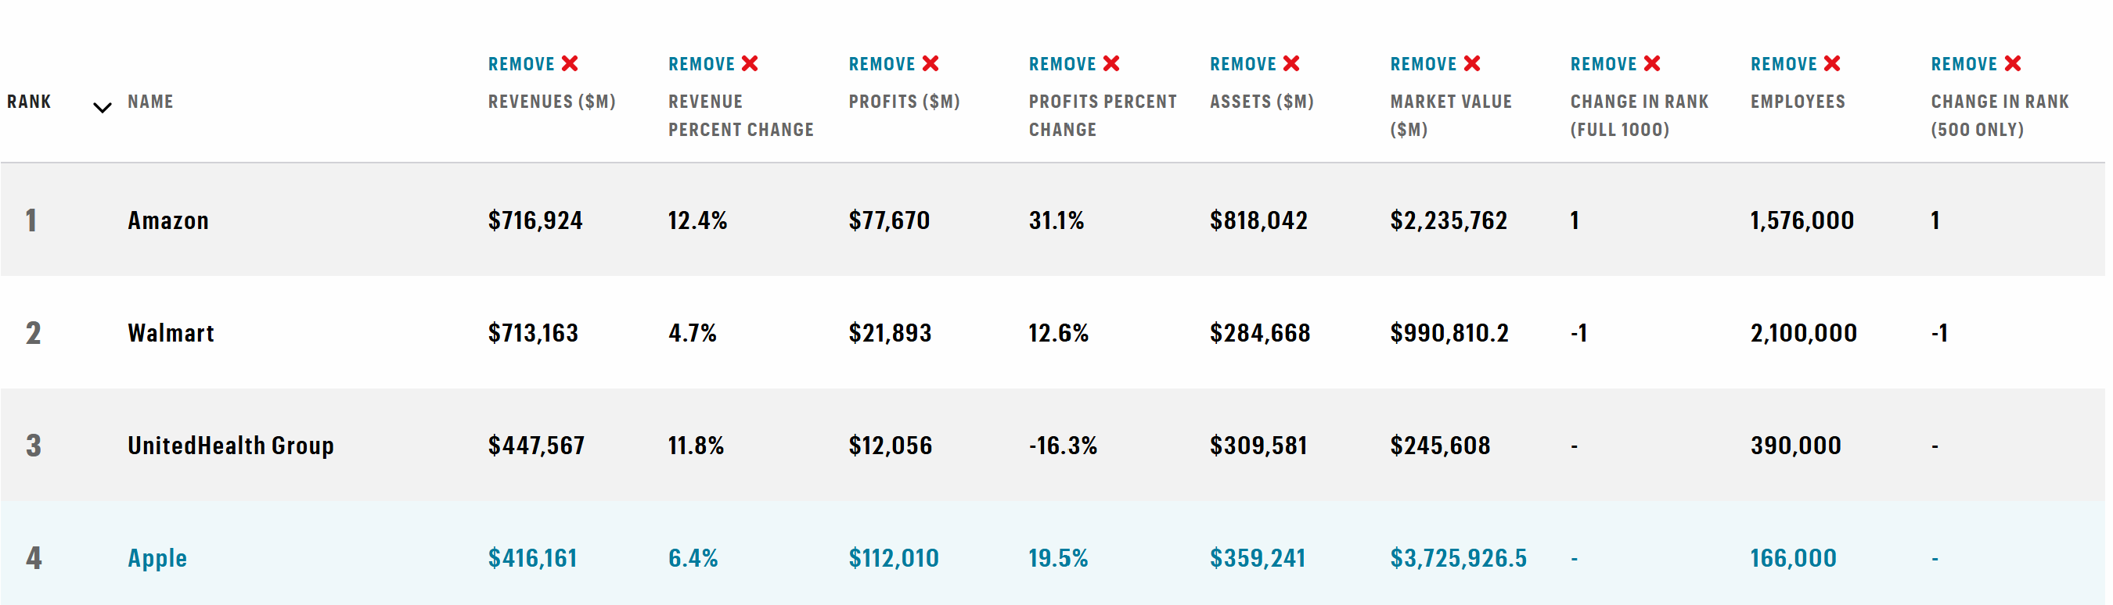

Organisation: As a centrally managed company with a worldwide integrated supply chain, its proprietary retail outlets and uniting hardware, software, and services, Apple is well positioned to maximise the value of its strategic resources (Chen, 2023). This organisational capacity helps streamline product creation, boost innovation, and ensure a seamless user experience, further enhancing the competitiveness of the iPhones in the UK market. Under Apple's excellent governance and operation, valuable, rare and hard-to-copy resources will be fully utilised. Fortune's World's Most Admired Companies 2026 determined that Apple's organisational capabilities and management systems are gaining recognition, as the company comes first globally, for the 19th straight year. (9to5Mac, 2026a).
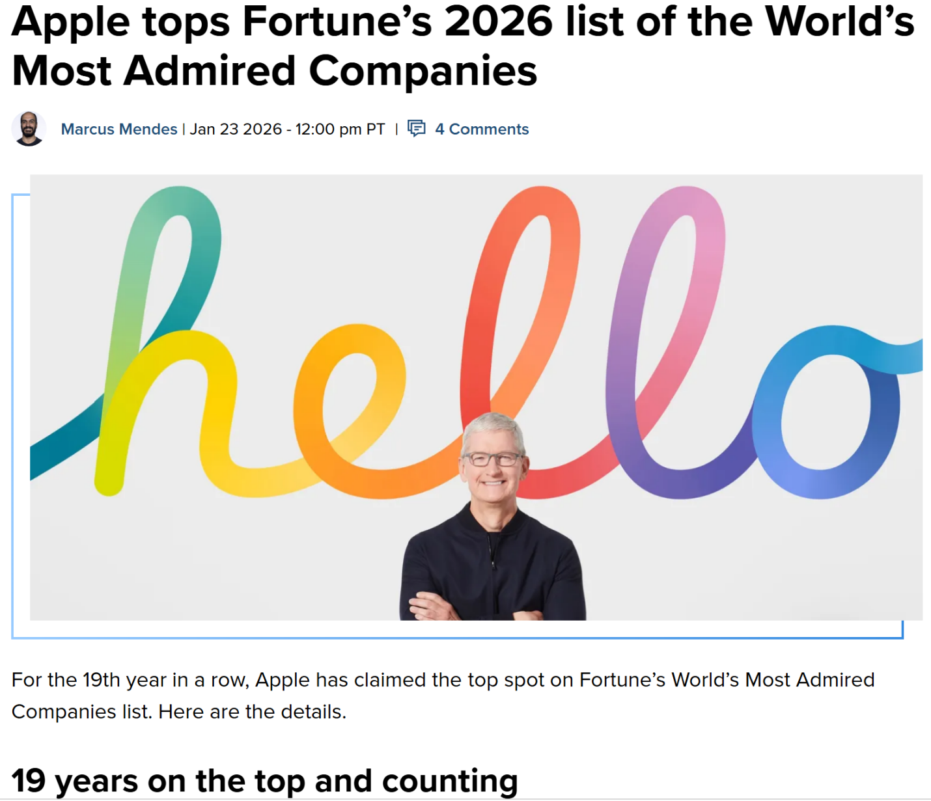
Figure 11: Apple tops the List
(Source: 9to5Mac, 2026b)

2.3 SWOT Analysis:
Strength:

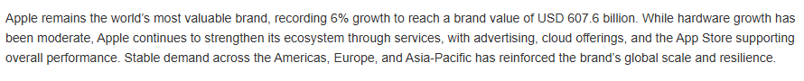
Figure 12: Apple Sustained Leadership and Accelerated Growth
(Source: AA, 2026)
Apple's strong “hallmark” is a key element in justifying their high prices, customer loyalty and ongoing competitive edge. With a brand value of US$607.6 billion, Apple maintained its position as the world's most valuable brand, according to the Global 500 (2026) list by Brand Finance (AA, 2026). This positive brand influence will help to build consumer trust, strengthen market leadership and ensure the iPhones dominate the high end of the UK smartphone market just like it did even in the second quarter with 51% of the total revenue (Jason, 2026). Apart from the brand value, Apple also has strong consumer support across the globe and also demonstrate strong R&D team, constant innovation and a huge cash reserve worth $6.5 trillion that allow the firm to expand its business in any part of the world and capture the market.
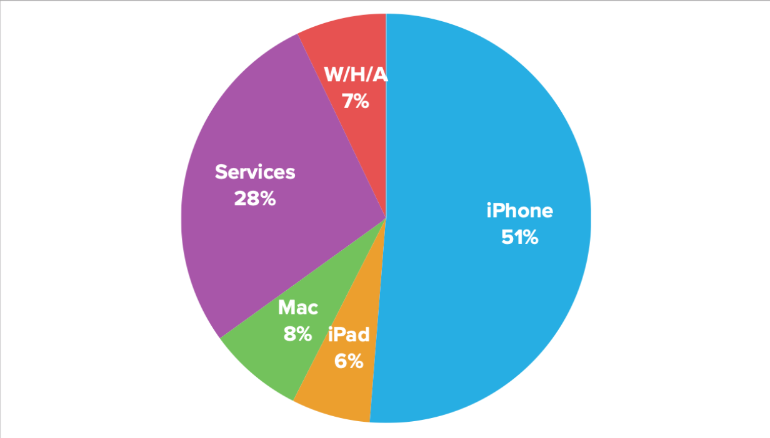
Figure 13: Apple’s revenue division product wise
(Source: Jason, 2026)
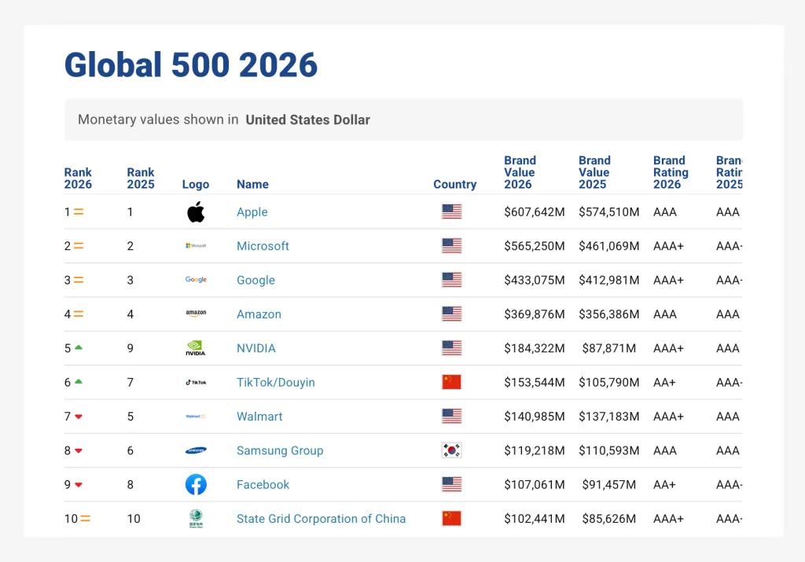
Figure 14: Apple World’s Most Valuable Brand
(Source: 9to5Mac, 2026)

Weakness:
Apple relies on multiple tiered suppliers from different countries in the world which raises risk for labour standards and responsible mineral sourcing (Apple, 2025). Moreover, in some markets, the products are not easily repairable and replacement parts are not readily available, which can shorten the lifespan of the product. Additionally, there is a significant investment associated with extended software support, which can lead to higher operating costs and conflict with profitability goals while working towards a circular economy. Another key challenge for Apple is the level of difficulty and the expenses of its sustainability efforts.
Opportunities:
To ensure that Apple occupies a stronger position, they should increase take-back and certified refurbishment programmes within the framework of circular economy legislation. More transparency of the origins to good or ethical sourcing can lead to more consumer trust and to premium pricing. Advanced recycling technologies can lower physical costs and emissions, and device-as-a-service (Daas) agreements with enterprises, learning institutions, and network carriers can help generate new income streams, boost support, and pave the way for greater recovery of devices. The GSMA expects 5G connections to make up 88% of all mobile connections by 2030, and adoption will be fast and furious, continuing throughout 2026, giving good market opportunities for the premium 5G smartphones like the iPhone 17 and 17 pro max (GSMA, 2026).
Threat:
Despite Apple's market dominance, competition in the high-end smartphone sector is fierce in the UK. Apple has 51.3% of the UK mobile device market, followed by Samsung with 29.5% and Google with 4.7% as of June 2026 (Statcounter Global Stats, 2026). However, competitors continue introducing AI-powered premium smartphones at competitive prices, while increasing regulatory requirements and rapid technological change pressure Apple to sustain continuous innovation and market leadership. Moreover, International Data Corporation (2026) projects that the global smartphone market will experience a decline of 13.9% y-o-y in 2026, which represents a maturing market with some downtrend and increased competition for premium smartphone manufacturers.
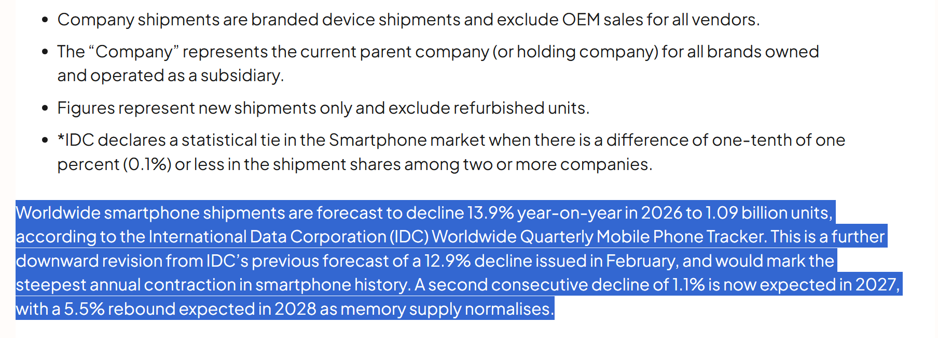
Figure 15: Downward projection of smartphone industry
(Source: IDC, 2026)

3. Comprehensive and Holistic View

3.1 Corporate Social Responsibility (CSR) Audit:
Corporate Social Responsibility (CSR) is a core part of Apple's business strategy, with information on ethical sourcing, the environment, employee welfare, and community engagement woven throughout its worldwide activities. In terms of the supply chain for the iPhones, Apple is making a point of emphasising responsible practices, in compliance with their Supplier Code of Conduct, which ensures adherence to labour rights, health and safety standards, and ethical business practices (Apple Inc., 2025a). Apple's 2026 Environmental Progress Report highlights that in 2025, suppliers with 18.9GW of renewable electricity procurement engaged in the Supplier Clean Energy Program, which had a substantial impact on reducing emissions throughout Apple's supply chain (OneStopESG, 2026). Moreover, Apple's efforts also resulted in the avoidance of around 41 million metric tonnes of greenhouse gas emissions in 2025, resulting in ongoing progress toward its ultimate ambition of becoming carbon-neutral in all operations by 2030 (ESG Dive, 2025).
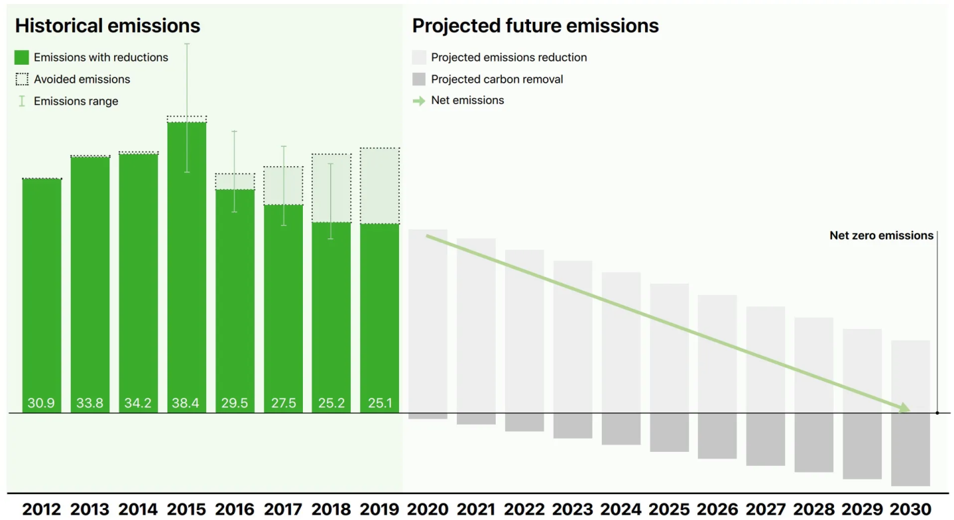
Figure 16: Net-Zero iPhones: Apple Pledges to Go Carbon-Neutral by 2030
(Source: Climate Impact Capital, 2026)
Analysis of alignment: Apple's CSR effort has a high level of coherence with its commercial business aim. Ethical sourcing, carbon reduction and responsible supply chain management act as a driver for the company in the longer term and are important for profitability. Moreover, Apple's sustainability efforts contribute to the company's environmental compliance with UK regulations, alleviating operational risks and enhancing the resilience of its supply chains (Apple, 2026a).

3.2 The Balanced Scorecard:
Financial Perspective:

Objective
By seeing the iPhones successfully perform in the UK high-end smartphone market, Apple aims to boost overall revenue and maximise profit in the long-term investment, while improving its shareholder value. (Apple, 2026b).

Key Performance Indicators (KPIs)
Apple's revenue growth, operating margin, earnings per share (EPS), return on invested capital (ROIC), and free cash flow are key metrics of financial performance. Management can use these indicators to see if the business is successful, efficient, and creating value for its shareholders.

Targets
By focusing on portfolio diversification, shifting to a services-led business, improving operating efficiency and maximising long-term investor returns, Apple hopes to achieve premium pricing, expand the ecosystem, boost revenue (Apple, 2026c).

Strategic Initiatives
To accomplish these goals, Apple has been, and will continue to be, investing in research and development, integration with artificial intelligence, supply chain optimisation and expansion in retail presence. As per Apple's Q1 Fiscal 2026 Results, the company reported an operating cash flow of around US$54 billion and returned US$32 billion to its shareholders via dividends and repurchasing its shares, signifying its strong financial performance and dedication to shareholder value (Quartz, 2026).
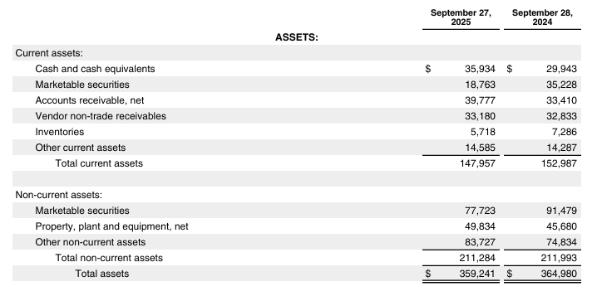
Figure 17: Apple Inc. CONSOLIDATED BALANCE SHEETS
(Source: Apple Inc., 2025b)
Customer Perspective:

Objective
The goal for Apple through the iPhones is to positively impact customer satisfaction, brand loyalty and market share in the UK premium smartphone market (Apple, 2026d).

Key Performance Indicators (KPIs)
Apple measures customer performance by way of customer satisfaction scores, Net Promoter Score (NPS), customer retention rate, market share, and paid service subscriptions and growth of active devices. These KPIs provide the company with an outlook of customer engagement, loyalty, and the brand's performance over time.

Targets
Apple's strategy is to keep customers longer, boost ecosystem penetration rates, grow market share in premium smartphones in the UK, and enhance the lifetime value of customers by seamlessly integrating its products and services (Apple, 2026a).

Strategic Initiatives
To achieve these objectives, Apple needs to personalise AI services and, more importantly, build a secure AI environment to ensure consumer privacy, a growth in Apple Care service, increase retail assistance, and tighter integration between the iPhone, Apple Watch, Mac and iCloud ecosystem.
Internal Business Processes:

Objective
Apple's goal is to achieve greater operational efficiency, ensure high-quality products, and boost innovation to enhance the competitiveness of the iPhones in the UK premium smartphone market (Apple, 2026b).

Key Performance Indicators (KPIs)
The major performance indicators for Apple are research and development (R&D) productivity, product quality, supply chain efficiency, manufacturing quality, and product defect rate. These are indicators to keep track of Operational Excellence and Continuous Innovation.

Targets
Apple has promoted technologies to achieve innovative products over a short cycle, high quality without compromise, and high manufacturing efficiency, while optimising the supply chain process (Apple, 2026c).

Strategic Initiatives
Apple's commitment to these goals is reflected in its investments in AI product design, high-quality manufacturing and supply chain optimisation. The Sustainable Innovation (2026) reported that over 320 suppliers are enrolled in Apple's Supplier Clean Energy Program in 2025, optimising their processes and manufacturing and supporting sustainable supply chains globally at Apple.
Learning and Growth:

Objective
Apples aim is to boost the innovation culture through upskill workforce, promoting lifelong learning and speeding up the uptake of technology (Apple, 2026b).

Key Performance Indicators (KPIs)
Apple's indicators of learning and growth include employee training, innovation, digital capability, workforce engagement, and leadership development. These are KPIs that measure the capability of the organisation to continually innovate and enhance the performance of its workforce.

Targets
The company wants to drive more highly skilled staff members, boost digital competence, and create a culture of ongoing innovation for the long-term (Apple, 2026).

Strategic Initiatives
Apple should invest in continuous learning programmes, leadership development, AI introduction and digital capability developments. Apple has announced that it will create a “$50 million Supplier Employee Development Fund” to increase access to learning opportunities and skills development (Apple, 2022).Apple also launched professional training and certifications to sharp the skills of the employess for further organisational development.

4. Strategic Choices and Implementation

4.1 Business-Level Strategy Mapping:
Cost Leadership Strategy: Given that it is being adopted at a business level by Apple Inc. in the United Kingdom, Apple's approach isn't to be the cheapest option for a phone, but to distinguish itself with iOS software, privacy, and Apple's ecosystem. All these deserve a premium price tag, and hence cutting down the cost is not the right path for Apple.
Differentiation: Apple continues to be different through constant innovation and regular upgrades of the iPhone. As highlighted by Apple in its Q2 Fiscal 2026 Results, instances of all Apple product categories and regions have reached record levels of installed base with active gadgets, proving that Apple has successfully differentiated its product, which hopefully leads to an increase in customer loyalty and maintains its lead over its rivals in the premium market for smart gadgets in the UK (Apple, 2026c).

4.2 Framework Validation:
Porter's Five Forces
Threat of New Entrants-Low
This threat is low because new entrants would need huge investment, technological prowess, well-known brands, and R&D resources to challenge Apple. Reaching the market and earning customers' trust are other hurdles for new companies. As per the data from the World Intellectual Property Organisation, the company Apple has been allocated 132542 patents across the globe, which shows that a strong intellectual property portfolio reduces the threat of newcomers (GreyB, 2026).
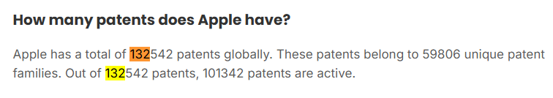
Figure 18: Apple have 132542 Patents
(Source: GreyB, 2026)
Bargaining Power of Suppliers-Low
Apple's worldwide purchase volumes, long-term contracts with suppliers and diversification of the supply chain minimise the role of suppliers, thereby contributing to the resilience of operations. In 2025, Apple's suppliers participated in Apple's Supplier Clean Energy Program to enhance cooperation between suppliers and the sustainability supply chain and efficiency (ESG News, 2025).
Bargaining Power of Buyers-Moderate
Buyer power is of a moderate degree, as in the UK, there are other premium smartphones available on the market, including Samsung and Google. However, Apple has a strong brand, it operates as an “ecosystem”, with more than 50% market share, so there are extremely few reasons to switch, and the sheer emotional attachment to Apple products means that buyers have little ability to negotiate a specific price. According to Apple's estimates from Q1 Fiscal 2026 Results, Apple has now overtaken 2.5 billion active devices, which suggests people’s trust in the brand.
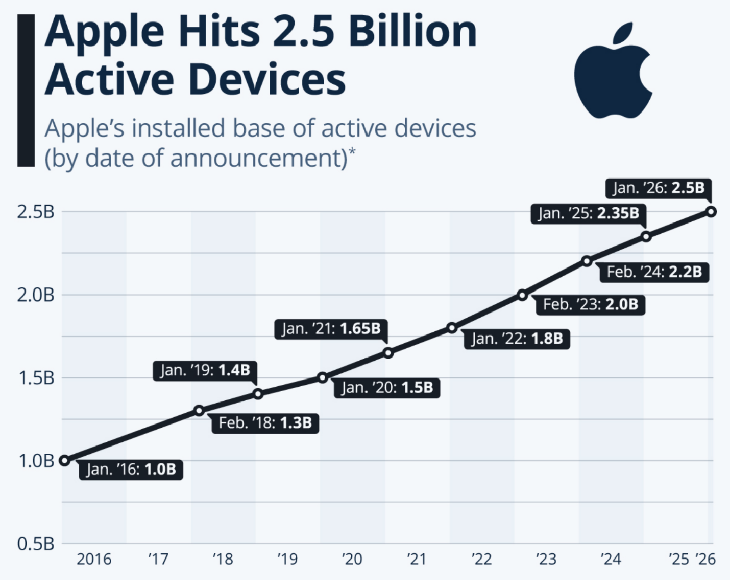
Figure 19: Number of users worldwide
(source: Richter,2026)
Threat of Substitute Products-Low
There is, however low threat of substitution as Apple's integrated ecosystem, software optimisation, privacy and user experience create a premium value that is unmatched for Android phones to level up. Latest iPhones like iPhone 17 or 17 pro max use Apple silicon chips and A19 pro processors that prolong battery performances and enhance gaming experiences are some of the key highlights of iPhones that are so dynamic that even if the competitors release substitutes to these features, are very less likely to match or beat iPhone’s craze.
Industry Rivalry- High
The competition in the UK smartphone market is extremely fierce, with Apple having to battle many constant challenges, including from Samsung, Google, and other Android smartphone makers, who are continuously launching smartphones with AI features. As stated, June 2026 data is quite accurate as in the UK market, Apple still dominates with a mobile vendors market share of (51.28%) followed by Samsung (29.54%) and Google (4.72%). While being the market leader, Apple has to continuously innovate its products, integrate its ecosystems, and differentiate its products to stimulate its market premium in a competitive market against the aggressive competitors (StatCounter, 2026).
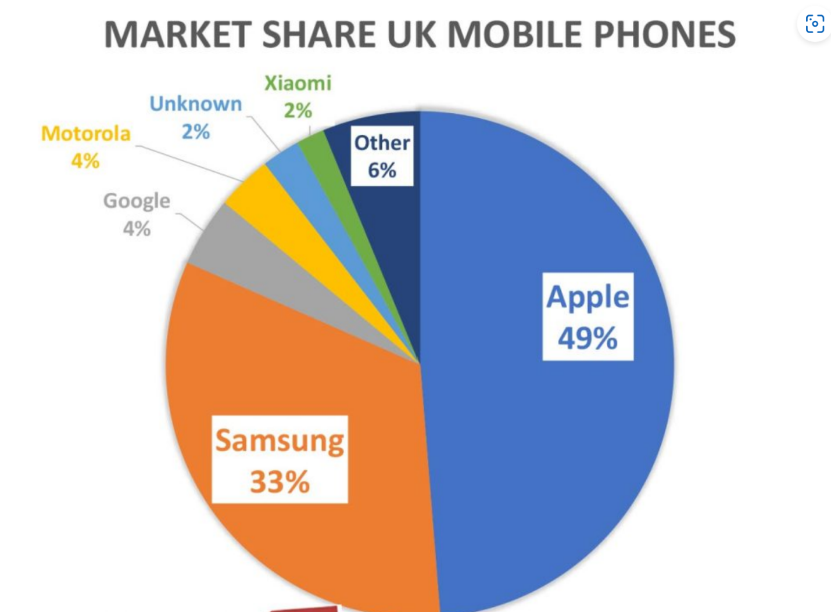
Figure 20: Apple vs Others’ market share
(Source: StatCounter, 2026)
Feasibility Check via SAFe Framework

Suitability
Innovation-led differentiation is appropriate given Apple's continuous effort to develop new technology and the rising UK demand for high-end smartphones featuring superior AI, privacy, and ecosystem functionality. It also helps in enabling the sustained competitive advantage desired by Apple by engaging in constant innovations.

Acceptability
This strategy is acceptable to all key stakeholders since the actions involved will improve customer satisfaction, generate higher value for the shareholders in the form of premium prices and secure long-term profitability.
Feasibility
The viability of the strategy is high because Apple has a lot of financial resources, technical expertise, a global supply chain and good R&D capacity to enable continuous innovation. In its Q2 Fiscal 2026 earnings report, Apple reported that it has generated US$29.58 billion, 3% increase from Q1 (Apple, 2026b). It is giving the company substantial financial resources to invest in the new product development, AI technology and strategic growth.
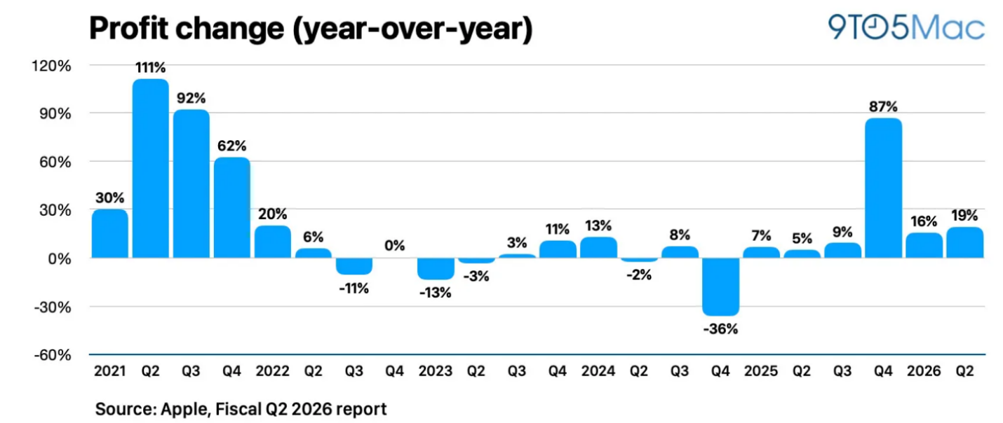
Figure 21: Profit of Apple in 2nd Quarter
(Source: Mendes, 2026)

4.3 Competitive Advantage & Execution:
Porter's Generic Strategy
Porter's Generic Strategy of Differentiation is the most appropriate explanation for Apple's competitive advantage in the United Kingdom. According to the works of Ali, and Anwar, (2021b), Apple's strategy is to offer a device that is differentiated and competitive on features rather than falling into the comparison of low prices (Cost Leadership). According to Porter's framework, a successful differentiation will allow companies to adopt a premium pricing strategy and attain sustainable competitive advantage (Institute for Manufacturing, 2026). Therefore, including the Advanced AI features in the iPhones and integrating with other Apple devices like the Apple Watch, Mac, AirPods, and iCloud, Apple can differentiate iPhone product features to gift the customer an enhanced user experience and also generate employee satisfaction with reduced workloads, just like in the case of Microsoft happened (Rizku, Mohammad and wisnu, 2025).
Example: Microsoft embeded AI Copilot in its Microsoft 365 softwares (words, excel, powerpoints etc), Windows, back in 2023 and it enhanced the user experience, employee satisfaction and organisational growth to a great leve (Rajiv, 2026b; Microsoft 2026e).
Triple Bottom Line
With careful attention to economic performance, social responsibility and environmental sustainability, Apple's Product Development Strategy resembles the Triple Bottom Line (TBL) Framework. Continuous innovations led differentiations of iPhone devices will lead to stronger pricing, customer loyalty, and profitability from the Profit perspective (CMA Knowledge 2025). On the People side, Apple by reshaping Its iPhones with more advanced technology, an enhanced security system and stronger durability can gain more consumer base in the UK market. The company has been incorporating recycled materials, renewable energy, and carbon reduction efforts in its products from the Planet's point of view unlike others and thereby differentiating itself from other competitors that are yet to be sustainable. Thus, Apple's differentiation is not just about being competitive but also about ensuring sustainable business growth by creating value for its shareholders, for society and for the environment. Apple's profitability in the fiscal year 2026, measured by its gross margin, has been consistently strong, reaching a maximum of about 69% in quarter 2 proves that differentiation will further boost their sales even more (Statista, 2026) .
The obvious example in the real world is Patagonia, known for being a leader around sustainability that is doing both, growing at large scale and at the same time differentiating itself by contributing to the planet by using 98% recycled material and 100% renewable energy in its US facilities (Cascade, 2026).

4.4 Implementation Risk Management:
Challenges
1. Rising R&D Cost
Justification
The strategy Apple has set forth in its Product Development suggests an ongoing commitment to AI, software solutions, battery competencies, and innovations within the ecosystem to keep the iPhones competitive in the UK premium smartphone market. Rising expenditures on research and development add costs in operations and put strain on profitability (Quartz, 2026).
Mitigation
Senior management should focus on high-value innovation projects, implement agile product development practices, optimise cross-functional interactions and track R&D performance against Balanced Scorecard key performance indicators to optimise ROI on innovation investments. Although, as per the reports of CNBC (2026), the company has spent 10.3% of their revenue in R&D, it may not be enough if Apple wants to dominate the smartphone market as several other competitors like Samsung is also planning to invest huge amount worth 73.3US$ billion in R&D in 2026.
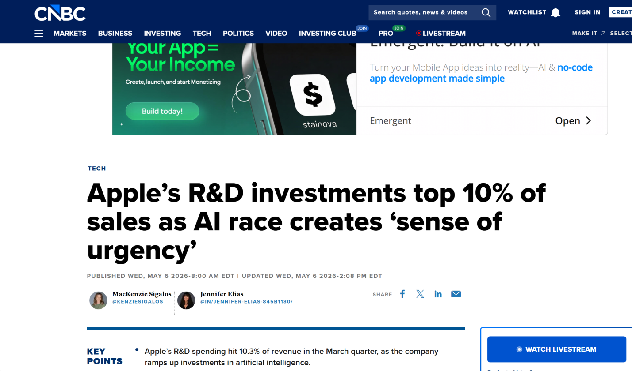
Figure 22: Apple’s investment in R&D
(Source: Sigalos, and Elias, (2026), 2026)
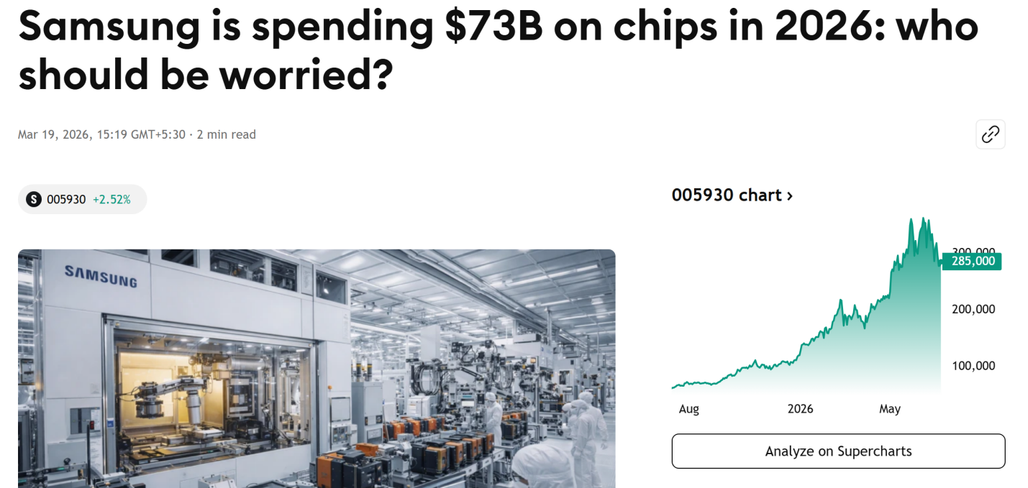
Figure 23: Samsung plans big on R&D
(Source: Tradingview, 2026)
2. Supply chain vulnerability
Justification
Apple has an intricate global supply chain for some top-shelf components that power the iPhones. Production could be delayed, and production costs could rise, and product quality and product launch dates may be impacted in the UK market by various factors such as supply shortages, geopolitical disturbances, labour issues or a shortage of components as Apple’s supply chain spans across many countries (ISM, 2026).
Mitigation
To enhance supply chain continuity, Apple needs to diversify its supplier base, foster strategic supplier relationships, build inventory buffers for key components, leverage AI for supply chain forecasting, and regularly assess supplier risks.
3. Regulatory Pressure
Justification
Regulatory pressure is increasing day by day, not just in the UK, but internationally from sustainability to digital markets, consumer protection to privacy and right to repair, competition law to IP law. It can add to the complexity of the operation, implementation costs, and product redesign requirements that ultimately lead to innovation stagnation as regulations change time to time (Adomako, and Tran, 2026).
Mitigation
To safeguard differences and long-term competitive advantage, Apple should set up proactive regulatory monitoring teams, enhance legal and compliance units, embed sustainability and compliance in product design, and keep in touch with regulators to ensure adherence in a timely fashion.

Section 2: Reflective Account
Description
In this strategic management report, I was asked to critically analyse organisation’s current strategic position and propose necessary recommendation as a strategic management consultant. First, I had to choose an organisation and a product which meets the criteria for the assignment and use information available in the public domain. With well-known research firms and official presentations from Apple that were used to develop this data, I found the data to be reliable. I have applied several strategic management models such as the PESTEL model, VRIO model, SWOT model, Porter's Five Forces model, SAFe Framework, Corporate Social Responsibility (CSR) and the Balanced Scorecard model. As I went through the research, I found and considered qualitative evidence and quantitative evidence for my analysis and strategic recommendations to enhance the credibility of the report
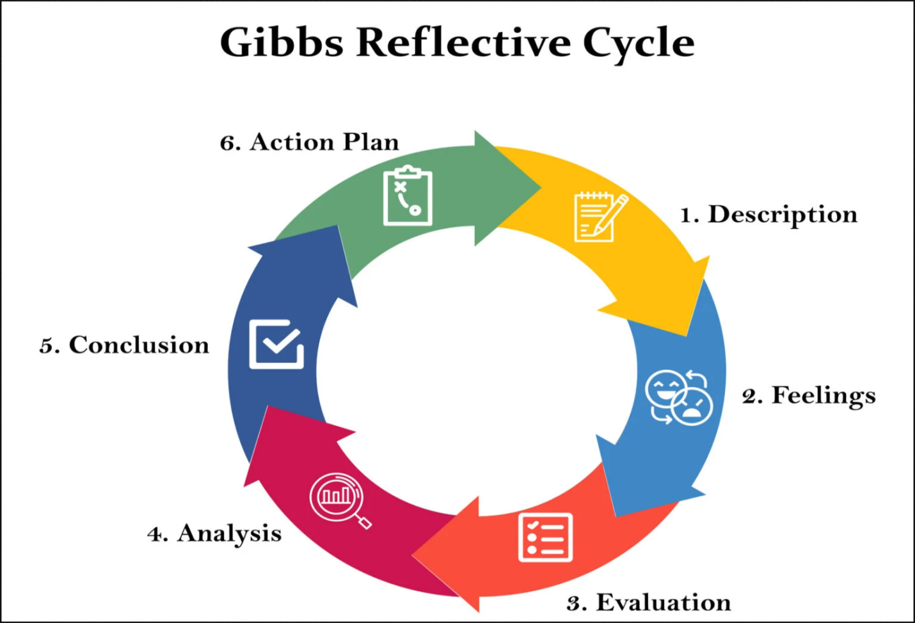
Figure 24: Gibbs Reflective Cycle
(Source: Simply Psychology, 2026)
Feelings
I was unsure about which was the most suitable organisation to choose and which geographic area and product to focus the analysis. My confidence grew as I went along because I was able to see what sorts of information were reliable and how each strategic framework factored into the analysis. There were times, however, when I felt challenged in reading information from financial statements and making sure that the statistical evidence applied throughout the various sections was relevant, accurate and that they were not repetitive. The report became an ongoing building process of strategic analysis, confidence, and an appreciation of evidence-based decision-making. One of the most rewarding accomplishments above all was the ability to take several strategic models and bring them together into a single report.
Evaluation
Various issues of the project went well. Apple has a good amount of detail information that is widely accessible in the public domain that helped in the access of reliable financial, sustainability and strategic information. Securing the official reports helped to ensure the credibility of my analysis and allowed me to support my recommendations with factual data. Also, the use of known strategic frameworks gave a logical structure to the report. Moreover, the use of similar strategic frameworks (SWOT, VRIO, Porter's five forces) had to be carefully interpreted and translated in order to prevent duplication of ideas.
Analysis
Overall, I am conscious of the need to assess the relevance and quality of evidence, not just collect it, when it comes to strategic analysis. By planning and taking notes in a systematic manner, I was able to organise complex information in effective ways and to ensure information consistency throughout the report. I have used more than one strategic framework, and this has enhanced my ability to consider business environments from multiple angles rather than using just one analytical framework. In addition, I was able to build up my critical thinking skills due to the comparisons I made between internal organisational factors and external environmental factors before suggesting suitable actions. The experience showed the importance of connecting the theoretical aspects of academic workshops with evidence from the business world to shew, and specifically, to provide workable strategic recommendations.
Conclusion
I feel I should have been more efficient with my work and should have spent more time working on industry reports ever since I got this assignment and done a bit more research into how Apple are doing compared to their larger rivals. An earlier development of a complete referencing system would have saved more time in the final editing and would have helped to keep citations consistent (Praveena et al., 2025). However overall am happy with the effort put in by me in developing this report which meets all the requirements needed.
Action Plan
In future I will establish a project timeline with research milestones completed, analysis, writing, and proofreading. I will create a well structured, mainly academic papers, company papers, statistical evidence database to enhance the organisation and avoid repetitions. I also plan on making more frequent use of the interpretation of an annual report and key performance indicators for financial analysis on a more regular basis. Lastly, I will carry out further evaluations of alternative strategic options in a critical manner and choose recommendations. Consequently, these improvements will result in better quality, higher efficiency and higher levels of academic excellence for my future strategic management work, as well as higher levels of skills to make decisions and analyse problems professionally.

Conclusion
In conclusion, Apple's Product Development approach for its iPhones indicates that it will continue to hold a competitive edge in the UK market by leveraging innovation, integration of its ecosystem, and sustainability efforts.

References
AA (2026) Apple keeps crown as world’s most valuable brand in 2026. Available at: https://www.aa.com.tr/en/economy/apple-keeps-crown-as-world-s-most-valuable-brand-in-2026/3805349
Acharya, M. (2025). World GDP Ranking 2025 List. [online] Cleartax. Available at: https://cleartax.in/s/world-gdp-ranking-list [Accessed 10 July 2026].
Adomako, S. and Tran, M.D. (2026). Innovating against the odds? The impact of regulatory challenges on technology commercialization and product innovation performance. Technology in Society, [online] 85, p.103214. doi:10.1016/j.techsoc.2026.103214. Available at: (PDF) Innovating Against the Odds? The Impact of Regulatory Challenges on Technology Commercialization and Product Innovation Performance
Ali, B.J. and Anwar, G. (2021b). Porter’s Generic Competitive Strategies and its influence on the Competitive Advantage. International Journal of Advanced Engineering, Management and Science, [online] 7(6). Available at: https://ijaems.com/detail/porter-s-generic-competitive-strategies-and-its-influence-on-the-competitive-advantage/ [Accessed 10 July 2026b].
Apple (2022) ‘Apple launches $50 million Supplier Employee Development Fund’, Apple Newsroom, 30 March. Available at: https://www.apple.com/in/newsroom/2022/03/apple-launches-50-million-supplier-employee-development-fund/
Apple (2025). Learn more at apple.com/supply-chain People and Environment in Our Supply Chain We set high standards Our requirements and due diligence practices are aligned with international standards, including the United Nations Guiding Principles on Business and Human Rights, the International Labour Organization’s International Labour Standards, and the Organisation for Economic Co-operation and Development (“OECD”) Due Diligence Guidance for Responsible Supply Chains of Minerals from Conflict-Affected and High-Risk Areas. ⦁ Identifying risks. [online] Available at: https://s203.q4cdn.com/367071867/files/doc_downloads/2025/04/Apple-How-we-source-materials-responsibly.pdf [Accessed 15 July 2026].
Apple (2026) ‘Apple accelerates progress with highest-ever recycled material in its products’, Apple Newsroom, April. Available at: https://www.apple.com/newsroom/2026/04/apple-accelerates-progress-with-highest-ever-recycled-material-in-its-products/
Apple (2026a) ‘Apple reports first quarter results’, Apple Newsroom, January. Available at: https://www.apple.com/newsroom/2026/01/apple-reports-first-quarter-results/
Apple (2026b) ‘Apple reports second quarter results’, Apple Newsroom, 2 April. Available at: https://www.apple.com/au/newsroom/2026/04/apple-reports-second-quarter-results/
Apple (2026c) Apple Environmental Progress Report 2026. Available at: https://www.apple.com/environment/pdf/Apple_Environmental_Progress_Report_2026
Apple (2026d) Environment - Apple (IN). Available at: https://www.apple.com/in/environment/
Apple (AAPL) - Cash on Hand. (2025a). [online] Companiesmarketcap.com. Available at: https://companiesmarketcap.com/inr/apple/cash-on-hand/
Apple Inc. (2025a) Annual Report on Form 10-K for the fiscal year ended September 27, 2025. Available at: https://s2.q4cdn.com/470004039/files/doc_financials/2025/ar/_10-K-2025-As-Filed.
Apple Inc. (2025b) Apple Supply Chain 2025 Progress Report. Available at: https://s203.q4cdn.com/367071867/files/doc_downloads/2025/04/Apple-Supply-Chain-2025-Progress-Report
Apple Inc. (2026a) Investor Relations. Available at: https://investor.apple.com/investor-relations/default.aspx
Apple Inc. (2026b) iPhone 17 - Technical Specifications. Available at: https://www.apple.com/uk/iPhone-17/specs/
AppleInsider (2026) ‘Amid record revenue, Apple's Q1 2026 R&D spend reveals its AI ambitions’, AppleInsider, 30 January. Available at: https://appleinsider.com/articles/26/01/30/amid-record-revenue-apples-q1-2026-rd-spend-reveals-its-ai-ambitions
Cascade (2026) Patagonia Strategy Study. Available at: https://www.cascade.app/studies/patagonia-strategy-study
CDO Times (2024) Case Study: Apple's Ecosystem Strategy — Building Loyalty and Revenue Through Integration and Innovation. Available at: https://cdotimes.com/2024/11/21/case-study-apples-ecosystem-strategy-building-loyalty-and-revenue-through-integration-and-innovation/
Chen, K. (2023) ‘Analysis On the Development of Apple Inc. Based on SWOT-Model’, Highlights in Business Economics and Management, 20, pp. 351–355. doi: 10.54097/hbem.v20i.12647
Climate Impact Capital (2026) Net-zero iPhones: Apple pledges to go carbon neutral by 2030. Available at: https://climateimpactcapital.com/newsfeed/net-zero-iPhones-apple-pledges-to-go-carbon-neutral-by-2030/
CMA Knowledge (2025) Apple's iPhone 17 Strategy: Cost Management and Market Expansion. Available at: https://www.cmaknowledge.in/2025/09/apples-iPhone-17-strategy-cost-management-and-market-expansion.html
ESG Dive (2025) ‘Apple surpasses 60 percent reduction in global emissions, moves closer to 2030 climate goal’, ESG Dive. Available at: https://www.esgdive.com/news/apple-surpasses-60-percent-reduction-in-global-emissions-moves-closer-to-2030-climate-goal/745908/
ESG News (2025) ‘Apple expands renewable energy portfolio across Europe’, ESG News. Available at: https://esgnews.com/apple-expands-renewable-energy-portfolio-across-europe/
Fortune (2026). Fortune 500. [online] Fortune. Available at: https://fortune.com/ranking/fortune500/2026/ [Accessed 14 July 2026].
Globig (2026) Mobile and internet usage in the UK. Available at: https://globig.co/mobile-and-internet-usage-in-the-uk/
GOV.UK (2026) National Minimum Wage and National Living Wage rates. Available at: https://www.gov.uk/national-minimum-wage-rates
GreyB (2026) Apple Patents: A Deep Dive into Apple’s Patent Portfolio. Available at: https://insights.greyb.com/apple-patents/
GSMA (2026) The Mobile Economy Europe. Available at: https://www.gsma.com/solutions-and-impact/connectivity-for-good/mobile-economy/europe/
HS Rates (2026) 8517.13 Smartphones. Available at: https://hsrates.com/en/codes/8517-13-smartphones/
IDC (2026) Smartphone Market Share. Available at: https://www.idc.com/promo/smartphone-market-share/
Institute for Manufacturing (2026) Porter's Generic Competitive Strategies. University of Cambridge. Available at: https://www.ifm.eng.cam.ac.uk/research/dstools/porters-generic-competitive-strategies/
ISM - Institute for Supply Management. (2026). Navigating the Apple Supply Chain Complexities. Available at: https://www.ism.ws/supply-chain/apple-supply-chain/
Jason, S. (2026). Apple announces record fiscal second quarter. [online] Six Colors. Available at: https://sixcolors.com/post/2026/04/apple-announces-record-fiscal-second-quarter/
Mendes, M. (2026). Apple reports Q2 2026 earnings: $111.2 Billion in revenue, up 17% [Charts]. [online] 9To5Mac. Available at: https://9to5mac.com/2026/04/30/apple-reports-q2-2026-earnings-111-2-billion-in-revenue-up-17/
Microsoft uses Copilot Studio to reshape customer experience and drive higher engagement (2026e). | Microsoft Customer Stories. [online] Microsoft.com. Available at: https://www.microsoft.com/en/customers/story/26166-microsoft-microsoft-copilot-studio [Accessed 15 July 2026e].
Nasdaq (2025) ‘Nasdaq-100 preliminary Q4 2025 earning update’, Nasdaq Articles. Available at: https://www.nasdaq.com/articles/global-indexes/nasdaq-100-preliminary-q4-2025-earning-update
Office for National Statistics (2026) Consumer price inflation, UK: May 2026. Available at: https://www.ons.gov.uk/economy/inflationandpriceindices/bulletins/consumerpriceinflation/may2026
OneStopESG (2026) ‘Apple avoids 26 million tons of emissions as supplier clean energy capacity surpasses 20 GW in 2025’, OneStopESG News. Available at: https://onestopesg.com/esg-news/apple-avoids-26-million-tons-of-emissions-as-supplier-clean-energy-capacity-surpasses-20-gw-in-2025
Pereira, D. (2025). Apple Mission and Vision Statement. [online] The Business Model Analyst. Available at: https://businessmodelanalyst.com/apple-mission-and-vision-statement/
Praveena,, K.S., F, J., M Patil, C. and K, B. (2025). Using Gibb’s Reflective Model Approach for Enhancing Project-BasedLearning Among Students Through Reflective Assessment. Journal of Engineering Education Transformations, [online] 38(2). Available at: https://journaleet.in/index.php/jeet/article/view/2071/2016.
Quartr (2026) Apple Inc. (AAPL) Q1 2026. Available at: https://quartr.com/events/apple-inc-aapl-q1-2026_3s71WCZV
Rajiv Dattani (2026b). From Pilot to Productivity: Embedding Microsoft Copilot Across Enterprise Workflows - TrnDigital. [online] TrnDigital. Available at: https://www.trndigital.com/blog/from-pilot-to-productivity-embedding-microsoft-copilot-across-enterprise-workflows/ [Accessed 15 July 2026b].
Richter, F. (2026). Apple Hits 2.5 Billion Active Devices. [online] Statista Daily Data. Available at: https://www.statista.com/chart/35762/apple-installed-base-of-active-devices/?srsltid=afmboorweefekdcqlgykdzl2uzzs93gsi5wgwutrlsybaypap66dgwei
Rizky Tri Aji Setiawan, Mohammad Dimas Ardiansyah and Wisnu Hafid Firdaus Oktobrian (2025). Analysis of Microsoft Copilot Acceptance as Artificial Intelligence-Generated Content (AIGC) Using the TAM/TPB Model. Journal of Artificial Intelligence and Engineering Applications (JAIEA), 4(3), pp.2241–2248. doi:10.59934/jaiea.v4i3.1142.
Samsung is spending $73B on chips in 2026: Who should be worried? [online] TradingView. Available at: https://www.tradingview.com/news/invezz:718a66f8d094b:0-samsung-is-spending-73b-on-chips-in-2026-who-should-be-worried/
Sigalos, M. and Elias, J. (2026). Apple’s R&D investments top 10% of sales as AI race creates “sense of urgency.” [online] CNBC. Available at: https://www.cnbc.com/2026/05/06/apples-rd-spending-climbs-to-10percent-of-revenue-on-ai-investments.html
Simply Psychology (2026) Gibbs’ Reflective Cycle. Available at: https://www.simplypsychology.org/gibbs-reflective-cycle.html
Song, J. (2024). A Company Analysis of Apple Inc. Based on its Internal and External Environment. [online] ResearchGate. Available at: https://www.researchgate.net/publication/383713124_A_Company_Analysis_of_Apple_Inc_Based_on_its_Internal_and_External_Environment
Sophic Capital (2025) ‘May 4, 2025: Key Earnings & Tariff Hopes Raise Market’, Sophic Capital. Available at: https://sophiccapital.com/may-4-2025-key-earnings-tariff-hopes-raise-market/
Statcounter Global Stats (2026) Mobile Vendor Market Share United Kingdom. Available at: https://gs.statcounter.com/vendor-market-share/mobile/united-kingdom
Statista (2026) Apple's gross margin since 2005. Available at: https://www.statista.com/statistics/263436/apples-gross-margin-since-2005/
The Sustainable Innovation (2026) Apple. Available at: https://thesustainableinnovation.com/apple/
Trading Economics (2026a) United Kingdom Imports. Available at: https://tradingeconomics.com/united-kingdom/imports
Trading Economics (2026b). United Kingdom Consumer Spending. [online] Tradingeconomics.com. Available at: https://tradingeconomics.com/united-kingdom/consumer-spending
Yahoo Finance (2026) ‘Apple Q1 FY2026 earnings record’, Yahoo Finance, January. Available at: https://finance.yahoo.com/markets/stocks/articles/apple-q1-fy2026-earnings-record-210144735.html
9to5Mac (2026a) ‘Apple world most valuable brand per Brand Finance Global 500 list’, 9to5Mac, 21 January. Available at: https://9to5mac.com/2026/01/21/apple-world-most-valuable-brand-per-brand-finance-global-500-list/
9to5Mac (2026b) ‘Apple tops Fortune World’s Most Admired Companies list 2026’, 9to5Mac, 23 January. Available at: https://9to5mac.com/2026/01/23/apple-tops-fortune-world-most-admired-companies-list-2026/

