4.3 | Site investigation (trial pits/boreholes) to establish: geology, substrata and site hydrology. Consult existing records or, if none available or appropriate, arrange for site investigation to be undertaken (possibly in conjunction with ground gas testing).  There is limited up-to-date data available for this specific area. As seen in the layout, the majority of trial pit information dates 1880. Within the region of this site, we have trial pit dating 1993, as below. As the trial pit details, the initial 2 metres references descriptions which elude to contaminant fill ie ash, slag and cuprous – whilst explicitly labelling material as fill. This continues with the rest of strata, with 2.0-2.8 metre depths giving descriptions of loose cobble, fine gravels and silty gravelly clay.  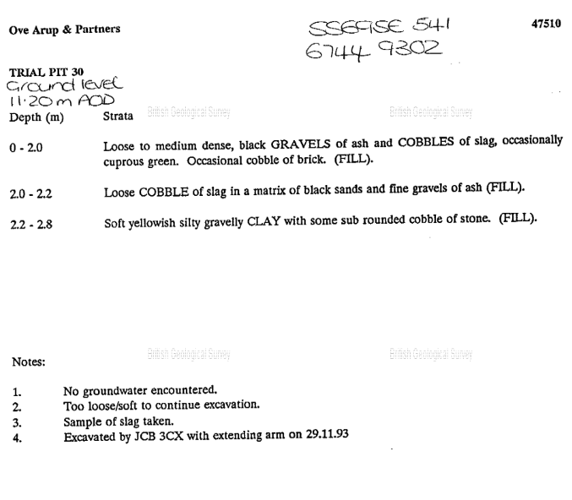  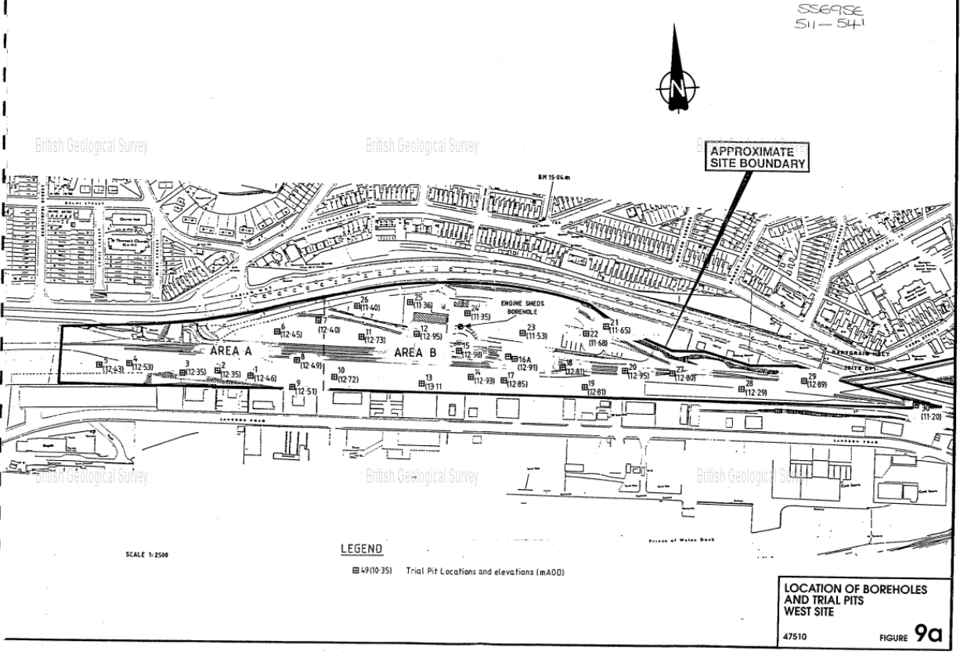
We have a number of more recent trial holes completed nearer to site but the access to this information restricts public access.
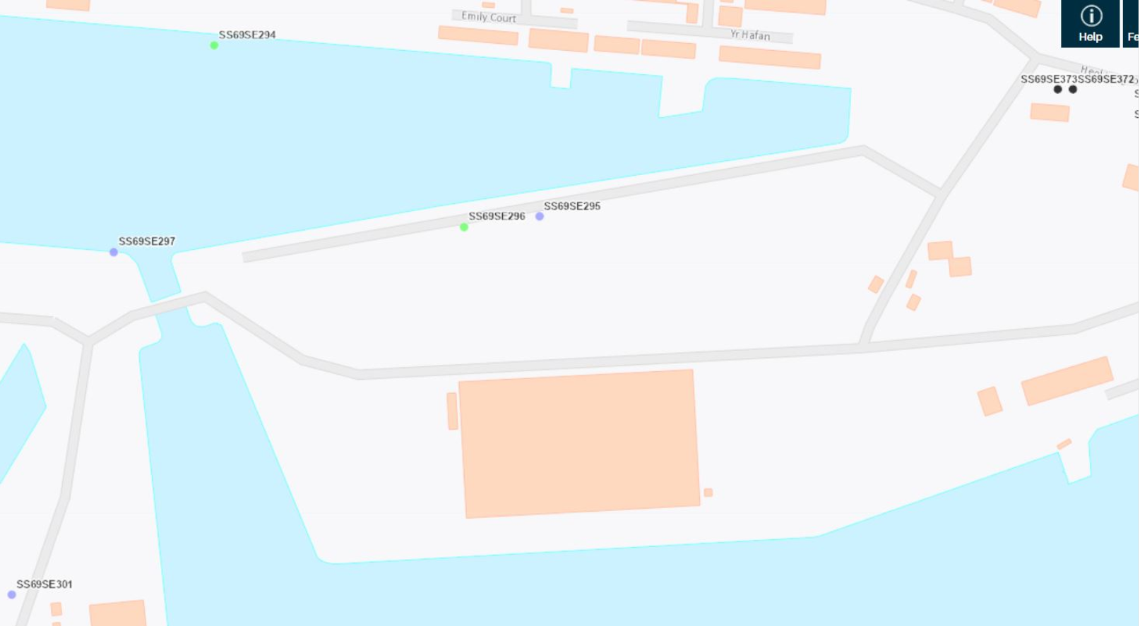

The below map indicates artificial deposits to the made ground of the docklands. From general reading, the historic use of heavy industry of this area leads to a strong assumption of land contamination.
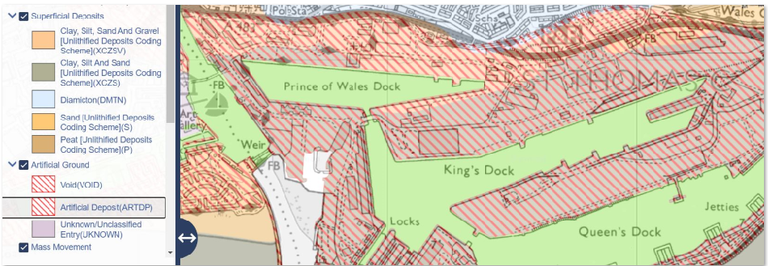
The below map indicates flood risk in local area. Although our site location does not fall directly inside these flood risk zones, the location is wedged between both sea and river flood risk area. This should be taken into account in terms of attenuation and adequate outfall.



