Tamara Khoury
Student No. 1602243
20 July 2019

MBA Dissertation

SBMA7123D

The Influence of Talent Management in Enhancing Organisational Performance
In the Non-Profit Sector

Supervisor: Julie Thomas

University of Wales Trinity Saint David

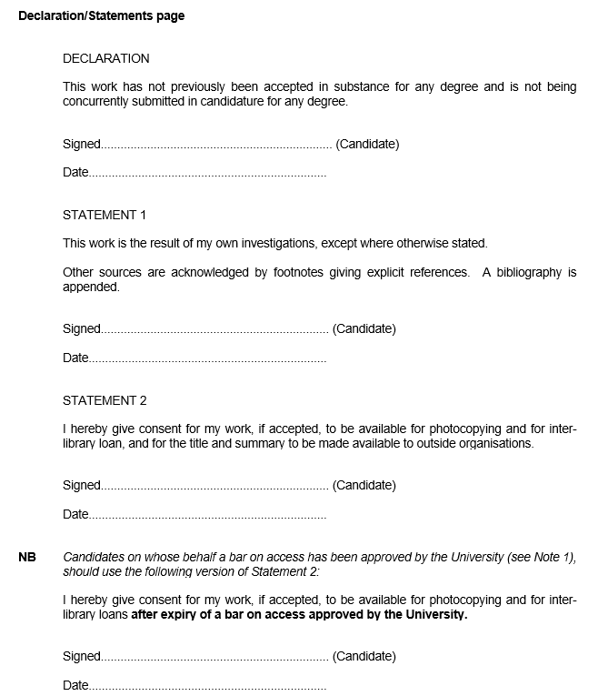

Acknowledgements:
I would like to take the opportunity to thank all the people that contributed to the progress of this dissertation.
Foremost, I would like to express my sincere appreciation to my Supervisor Julie Thomas who has throughout my research sparked me to investigate further into the subject and deliver my best, as well as the Director of the MBA programme, Alex Bell who gave me the opportunity to do this great project on the topic of Talent Management.
Secondly, I would also like to thank my family, colleagues and friends who encouraged and supported me a lot in finalising this project within the limited timeframe.
Finally, an enormous thank you to the case organisations for providing me with the essential contribution of valuable knowledge on the subject and giving me the time to gain insight on their Talent Management Strategies. This contribution enabled me to embark on this journey to deepen my knowledge within Talent Management and contribute to the field of Talent Management research.

Contents
i) Declaration 2
ii) Acknowledgements 3
iii) Abstract 7
1.0 Introduction 10
1.1 Topic of the Research 10
1.2 Introduction 10
1.3 The Status of TM in the Non-profit Sector in Jordan 11
1.4 TM and Organisational Performance in the Non- profit Sector 13
1.5 Justification 14
1.6 Research Aim & Objectives 15
1.7 Research Questions 15
1.8 Significance of the Research 16
2.0 Literature Review 17
2.1 Introduction 17
2.2 Talent Definition 17
2.3 Talent Management Definition 19
2.4 TM & Workforce Planning 20
2.5 TM Strategies 23
2.5.1 Talent Attraction 23
2.5.2 Talent Indenitification and Performance Management. 24
2.5.3 Talent Development 26
2.5.4 Talent Retention 29
2.6 Talent Management Challenges 32
2.7 Talent Benefits and Importance 34
2.8 2.8 Talent Management & Organisational Performance 36

3.0 Research Methodology 38
3.1 Introduction 38
3.2 The Research Onion 38
3.2.1 Research Philosophy: 39
3.2.2 Research Approaches 40
3.2.3 Research Strategy 40
3.2.4 Research Choice 41
3.2.5 Time Horizon 42
3.2.6 Research Techniques and Procurers 43
3.2.6 (A) Data Collection 43
3.2.6 (A.1) Primary Data 43
3.2.6 (A.2) Secondary Data 45
3.2.6 (A.3) Sample 45
3.2.6 (B) Methods of Data Analysis 47
3.3 Limitations of the Study 48
3.4 Ethical Considerations: 49
4.0 Analysis of Results 51
4.1 Introduction 51
4.2 Research Aim & Objectives 52
4.3 Research Questions 53
4.4 Overview of The Case-Studies Organisations 53
4.5 Talent & TM Definitions 57
4.6 Level of implementation of TM strategies and who is responsible? 58
4.7 Workforce Planning 60
4.8 TM Practices 61
4.8.1 Talent Attraction 61
4.8.2 Talent Identification and Performance Management: 62
4.8.3 Talent Development 64
4.8.4 Talent Retention 66
4.9 Challenges and Benefits of Implementing TM Strategies 68
4.10 TM and Organisational Performance 70
5.0 Conclusion 73
5.1 Recommendations 78
5.2 Limitations and Suggestions for Future Research 79
6.0 References 81
7.0 Appendices 91
7.1 Concent Form 91
7.2 Interview Questions 92
7.3 Transcript 1 93
7.4 Transcript 2 98
7.5 Transcript 3 102
7.6 Transcript 4 106
7.7 Transcript 5 109
7.8 Transcript 6 113
7.9 Transcript 7 117
7.10 Table 1 120
7.11 Table 2 121
7.12 Table 3 121
7.13 Table 4 122
7.14 Table 5 123
7.15 Table 6 124
7.16 Table 7 126
Inspiring Quotations 127

Abstract:
Since it is important for organisations to aim for high performance to succeed in today‘s growing worldwide rivalry and global changing environments, they are more aware of the importance of having loyal, skilled and knowledgeable workers, which are the key to competitive advantage (Sheehan, 2012a). Therefore, organisations are developing strategies to attract, retain, develop and manage talent internationally, where Talent management (TM) has proven to be an imperative strategic issue (Armstrong 2016). This also the case in the non-profit sector as organisations are under increased pressure from institutions, donors and governments to improve the effectiveness, transparency, efficiency and accountability of its processes to achieve its mission successfully and this is due to the increase in rivalry (Kaplan, 2001). Non-profits can achieve success through its people, where TM can prove to be essential to the organisational effectiveness (Noe et al 2016). Therefore, this research study aims to evaluate the importance of TM strategies in the non-profit sector to enhance organisational performance. It analyses the effectiveness of talent management strategies in the non-profit sector and identifies key elements of successful talent management strategies in order to make recommendations to improve the TM strategies and enhance performance. For those reasons, the study aims to answer the below research questions:
1. What are the effects of having TM strategies in the non-profit sector and why TM strategies are important for the success of organisations?
2. What are the challenges and opportunities of the current TM strategies in the non-profit sector and what are the TM strategies the organisation’s need to develop or adapt to add value and enhance organisational performance?
This study adopted qualitative methods, where data was collected using semi-structured interviews to provide rich descriptive information. The sample for this study involves seven non-profits ranging from local small charities to large international non-profit organisations and UN agencies operating in Jordan. The results were compared and discussed by using content analysis, where general patterns were formed, which helped the researcher to create conclusions and present deep insight into the existing practices in the selected organisation.
The study found that TM strategies have a positive effect not only on the organisation’s performance and workforce productivity, but also on the organisation as a whole. This can be seen in terms of changing staff min-sets by creating a culture where everyone can understand the purpose of TM framework and the positive effect such strategies can have on individual growth, development, performance, productivity and sustainability. Therefore, the recommendations prioritised and focused on creating an environment where employees, management and all stakeholders agree on that effective management of staff is a crucial part of ensuring a competitive system. In other terms, a system with a culture of recognising good performance, investing in staff development, keeping them motivated, and cared for, would result in better value for money, higher performance, and more informed decision-making.
The findings of this study can also make a valuable contribution to the research through developing and intensifying the literature on TM frameworks, and offer opportunities for other researchers to embark on further studies, which could be beneficial for diverse organisations needing to create or develop TM Strategies.

Chapter 1: Introduction
1.1Topic of Research
The Influence of Talent Management (TM) in Enhancing Organisational Performance (OP), in the Non-profit Sector.
Multiple Case Studies in the Non-profit Sector in Jordan.

1.2 Introduction:
Globalisation and growing worldwide rivalries have made organisations more aware of the importance of having loyal, skilled and knowledgeable workers, which are the key to competitive advantage (Sheehan, 2012a). In this case, organisations need to develop strategies to attract, retain, develop and manage talent internationally, where Talent management (TM) has proven to be an imperative strategic issue (Armstrong 2016).
According to Armstrong & Taylor (2014), Talent is what individuals need to have in order to perform well in their roles. They make a positive change to the organisational performance (OP) through their direct contributions and have the potential to make a significant input in the future (Tansley et al. 2007, p8). Therefore, TM goals are to find, obtain, retain, engage and develop those talented individuals (CIPD 2018).

1.3 The Status of TM in the Non-profit Sector in Jordan:
The lack of natural resources in Jordan has made the country more dependent on its highly educated human capital, where rivalry and efficiency of its industries, the prosperity and welfare of its communities all hinge on the availability of highly skilled and well-educated people (Irtaimeh et al. ,2016). However, growing global competition makes it more challenging than ever to attract, develop, and retain talented employees required for any sector. Therefore, it is essential that organisations adapt to their environmental changes and develop the main needed competencies (Beheshtifar et. al. 2012; Waheed et. al. 2012). This also the case in the non-profit sector as organisations are pressured to become more efficient and effective, since they are not only competing with other non-profits but also with the private sector as well (Word & Sowa 2017).
The non- profit sector in Jordan is vast, ranging from small local charities to international non- profits/non- governmental (INGOs) and humanitarian organisations, sometimes they are called “civil society organisations (CSOs). The demand for such organisations continues to grow in Jordan especially after the Arab spring as the country was severely impacted by the conflicts in neighbouring countries (Iraq, Syria and recently Yemen) with an estimated 89 refugees per 1,000 inhabitants (UNHCR 2015). There are almost 5,700 CSOs currently operating in Jordan (2015) with around 1.5 million members in total, equivalent to 43 per cent of the working-age population, which totals more than 3.5 million people (IRCKHF Report 2018). This large segment of people working in the non- profit sector, makes it even more essential to have effective strategies to manage them and to enhance their performance in order to achieve the purpose of the organisation itself and the sector as a whole, which in turn will have an impact on the welfare and the prosperity of communities (Irtaimeh et al. ,2016).
Besides, Non-profits in Jordan are faced with new sets of challenges in their operations; mainly that of their own sustainability due to greater competition amongst non-profits for funds, compounded by requirements for government approval of foreign aid facing long delays or rejection. Accordingly, non-profits have experienced reduced budgets and uncertainty of resources especially the local non-profits after the entry of international organisations into Jordan mainly during the Syria crisis. At this time, international non-profits absorbed funds that earlier went to local non-profits, as the international organisations do not need the government permission to receive foreign aid (IRCKHF Report 2018).
Funding limitations led to elevated rates of turnover amongst non-profit workers, as firms are at times forced to terminate the contracts of staff after the accomplishment of a project. Moreover, many small charities or non-profits depend on volunteers or hire staff who are less competent in order to respond to the demands of donors who require the implementation and the completion of project within a restricted timeframe (IRCKHF Report 2018). Therefore, small non-profits are not able to hire experts or the required talent, as they do not have the necessary funds to support their salaries, whereas larger international organisations are able to keep employees for a longer term as they have more financial flexibility; accordingly, they are likely to attract and retain higher-qualified employees. Moreover, procedures and policies in most of the local non-profits in Jordan are weak concerning the inclusion of women, minorities, and people with disabilities (IRCKHF Report 2018).
Therefore, there is an urgent need for a change in the processes non-profits operate under (Palotta 2012) in order to hire the right people from diverse backgrounds and not to lose them to other sectors by including TM strategies into the culture and budgets of non-profits.

1.4 TM and Organisational Performance in the Non- profit Sector:
Non-profits are under increased pressure from institutions, donors and governments to improve the effectiveness, transparency, efficiency and accountability of its processes in order to achieve its mission successfully and this is due to the increase in rivalry (Kaplan, 2001). Therefore, non-profits can achieve success through its people, where TM can prove to be essential to the organisational effectiveness (Noe et al 2016).
However, organisational effectiveness can have several meanings, for example: in the private sector, effectiveness means ‘profit’ for the company, return on investment for the shareholders; value products or services for customers; respectable wage, job security, development and promotion for employees (Huczynski & Buchanan, 2013). On the other hand, non-profits depend on its mission and purpose to attract resources and to influence policymakers’ decisions (Gou et al, 2011). Therefore, the evaluation of the organisational performance in the non -profit sector relies on the enhancement of accountability and transparency to achieve not only organisational effectiveness but also efficiency, sustainability, reputation and influence (OECD, 2016). Therefore, having effective TM strategies can form the base of a high-performance culture, where organisational structure, people and procedures work together to achieve organisational goals (Noe et al, 2016).
1.5 Justification
TM has been the centre of the literature on HR specialisations, including succession planning, human resources development and organisational development, where the majority of scholars highlighted the importance of talent as an obvious source of competitive advantage and critical for organisational success (Beechler & Woodward 2009; Iles, Chuai & Preece 2010; Sheehan, 2012a). Yet, only a small number of studies analysed the influence of TM on the organisation’s performance (Bethke-Langenegger 2012, Kehinde 2012), where it seems to be lacking empirical evidence of the connection between TM and organisational performance (OP) (Bethke-Langenegger 2012; GallardoGallardo, Dries & Gonzalez-Cruz 2013; Boudreau & Ramstad 2005). Scholars argued that evaluating and documenting, the effect of TM can be challenging due to the several methods that measure organisational performance (Bethke-Langenegger 2012) such as financial gains, operational success, customer satisfaction, employee satisfaction and retention (Tangen, 2005). On the other hand, most of the researches conducted on TM is related to the private or for-profit sector and only a few have touched on the topic of TM in the non-profit/ humanitarian sector. Therefore, there is a gap in the literature when it comes to emphasising on the importance of TM strategies in the non- profit sector. Both Non-profit and for-profit organisations have acknowledged the fact that although evaluating TM can be challenging but it is essential to ensure that the investment in talent is meeting the organisational objectives at any point in time (CIPD 2018). Therefore, the research will focus on the below:

1.6 Research Aim & Objectives:

Aim: To evaluate the importance of having TM strategies in the non-profit sector to enhance organisational performance.
Objectives:
- To assess the need to have TM strategies in the non-profit sector.
- To analyse the effectiveness of talent management strategies in the non-profit sector.
- To identify key elements of successful talent management strategies.
- To evaluate current practices in non-profit organisations (case study) in order to make recommendations to improve the TM strategies and enhance performance.

1.7 Research Questions:
1. What are the effects of having TM strategies in the non-profit sector and why TM strategies are important for the success of organisations?
2. What are the challenges and opportunities of the current TM strategies in the non-profit sector and what are the TM strategies the organisation’s need to develop or adapt to add value and enhance organisational performance?

In order to answer the above research questions, the study will focus on the main TM concepts and theories that could have an impact on the effectiveness of non-profits’ performance. Starting from the concepts of Talent and TM. This study will also move to other theories that affect the implementation process of TM strategies and the direction of the organisation, such as workforce planning, culture, diversity and the alignment to corporate strategy. Moreover, the research will investigate the importance of TM practices and how they can affect the efficiency of non-profits by attracting the right talent, identifying performance gaps, developing required competencies and retaining the most valuable employees. In addition, the main challenges facing organisations when implementing those strategies will be highlighted, with a focus on the changes required that could help leaders make informed decisions, thereby maximising the effectiveness of said strategies and their importance for the future of organisations.

The following Chapter will comprise the literature review, and will critically evaluate all relevant theories and concepts considered applicable to this research on Talent Management.

1.8 Significance of the Research:
The outcomes of this research will not only be of importance to the non-profit sector in Jordan but also internationally, as it will showcase TM strategies for attracting, identifying, developing and retaining employees, which is vital in achieving the objectives of any organisation. It will also help to introduce the concept of TM to smaller non-profits /charitable organisation for them to start to implement such strategies in the future for the benefit of the organisation. The study will be of benefit to the founders of non-profits where they will use this study as a tool to implement and design aid programs, taking into consideration the concepts and dynamics of TM. This research will also help policymakers to introduce policies and procedures to support non-profits in their mission to manage and sustain a reliable workforce; in addition to protecting the rights of employees. Moreover, the findings of this research project will add value to present literature in the areas of Talent Management and organisational performance especially in the non-profit sector and other sectors as well. In addition to highlighting the gaps for an additional research study to be conducted in these areas in the future.

Chapter 2: Literature Review
  - Introduction:
This chapter covers the main concepts and theories that support the subject of this thesis. First, the concepts of talent and TM are clarified linking them to the strategic direction of the organisation, where the importance of workforce planning, culture, diversity and the alignment to corporate strategy are highlighted. Furthermore, the research is looking into the main TM practices that can make a difference to the organisational performance such as attracting, identifying, developing and retaining talent, referring to the non-profit sector and how those practices are affecting the efficiency of non-profit organisations. In addition, the chapter highlights the importance of implementing TM strategies and presents the main challenges facing organisations when implementing those strategies. Finally, the research attempts to explain the effect of TM strategies on organisational performance and describes the difficulties when assessing the effectiveness of TM strategies and their importance for the future of organisations.
2.2 Talent Definition:
Talent in the world of work can mean whatever a researcher, HR practitioner or leader wants it to mean, since every one of them has his or her personal view of what the concept does and does not include (Ulrich, 2011). Various definitions of talent can be found in the theoretical HRM literature (see Appendices- Table 1). According to Armstrong & Taylor (2014), talent is what individuals need to have in order to perform well in their roles. Talented people make a positive change to the organisational performance (OP) through their direct contributions and they have the potential to make a significant input in the future (Tansley et al. 2007, p8). Therefore, there is a direct link between talent and performance, which the research would like to focus on. However, talent can be defined by using different approaches; while the first approach takes account of all the people in the organisation (Silzer and Dowell 2010, p14), the other approach assesses talent based on giftedness, strength, competencies, high potential, and high performance (Meyers et al 2013). Nonetheless, defining talent using the standard performance/ potential theory might be recognised as the straightforward definition of talent. Though both performance and potential are important, Ulrich (2011) acknowledged that an added contributor was that of a person’s commitment. As a result, Ulrich and Smallwood (2012, p6) developed a talent equation, where employees need to have the skills, wills, and purposes to be considered as talented individuals. This view is relevant to the non-profit sector, where talented people need to have not just the skills and experiences, but also the drive and purpose necessary to achieve the organisation’s mission. Ulrich’s talent equation suggests that real talent is a mixture of three vital components (Figure 1):
Figure 1
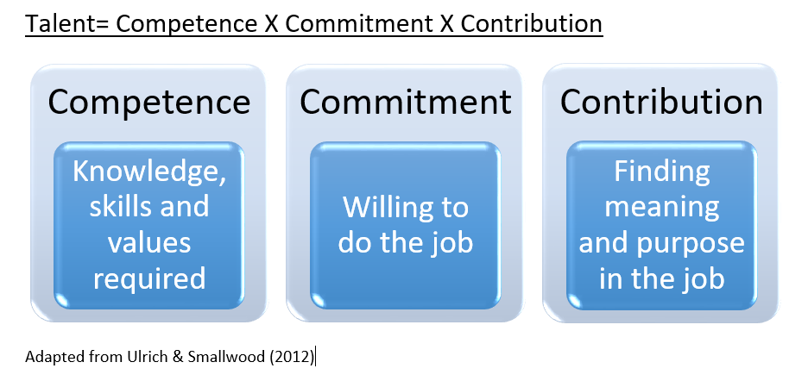
While the above examples provide some basis of a definitional framework, further complexity is added by the fact that the unique experiences and capabilities of each organisation can affect how talent is defined (Turner 2012). As such, some researchers and HR practitioners take a strategic approach when defining talent, proposing that the definition need to be determined by the organisation’s corporate strategy, the competitive situation and the type of sector (Ingham et al., 2008). Moreover, Collings and Mellahi (2009) claim that the organisation’s strategy should be the starting point when defining talent. Therefore, it is important that organisations begin from its strategy to first identify ‘talent positions’ – positions that create direct strategic impact, high performance and positive potential”, (Huselid, Beatty, & Becker, 2005, p. 4) – and only then identify the equivalent talent to fill those positions.
In this case, organisations need to develop effective strategies to identify, attract, retain, develop and manage talent, where Talent management (TM) has proven to be an imperative strategic issue (Armstrong 2016).
2.3 Talent Management Definition:
As the definition of talent is affected by the strategic direction of the organisation and TM is impacted by the organisation’s view of talent, there must be a connection between TM and strategy (Aarnio & Kimber 2016). Silzer and Dowell (2010) highlight the importance of allowing for the right type of talent the organisation needs, to develop long-term success. Therefore, TM can be defined as an organisation’s strategic efforts to attract, identify, develop, deploy retain and engage employees in organisations (Stahl et al. 2012).
TM processes need to be connected to the corporate strategy and applied in daily procedures all over the organisation. Armstrong (2011) explains that TM must have a strategic feature to it, as it needs to be aligned to the strategic direction of the firm. Additionally, to reach the “best fit “status, organisations need to recognise their present position to achieve success in their TM strategies (Corbridge & Omotayo 2013, p.98). According to Haturn (2010), TM can be defined as. ‘A strategic activity aligned with the organisation’s corporate strategy that intends to attract, develop and retain talented workers at all levels of the firm’ (2010, p. 13).Therefore, the positive effects on the organisational objectives are only realised when TM is aligned with corporate strategy (Bethke-Langenegger et al. 2011).
2.4 TM & Workforce Planning:
Forming a TM strategy begins with workforce planning, a procedure of evaluating the existing workforce and competencies to identify future workforce needs (CIPD 2018), where this process needs to be connected to the organisation’s strategic planning and corporate strategies.
The purpose of talent planning is to allow organisations to achieve the ideal phase of talent positioning, which is all about having the right talent at the right place at the right time with the required capabilities (Guthridge et al., 2008). This will allow organisations to reach their present strategic goals and to be ready for upcoming opportunities or challenges. However, to be prepared for the future, organisations need to have a workforce with a combination of talents from diverse cultures, nations, ages, genders and values, which can help organisations to react to any challenge or opportunity quickly and innovatively, particularly in this global age, where diversity needs to be attained by organisations as one of the important strategic organisational goals (Garvin 2001).
Moreover, in this technological era, organisations need to widen TM prospects to understand that work is not only achieved by relying on a workforce but also through technology. Therefore, the emphasis of TM is less workforce planning than on worktasks achievements. As a result, Ulrich (2019), proposed a new model, where the rationality of worktask planning can be accomplished with seven steps, as shown in (Figure 2). According to Ulrich (2019), this new method does not remove people but depends on people for strategic, innovative, and exclusive tasks, where routine and standard tasks will be shifted to technology, which can increase staff wellbeing, stakeholders confidence and customer satisfaction.
Figure 2: Worktask Planning- New Model
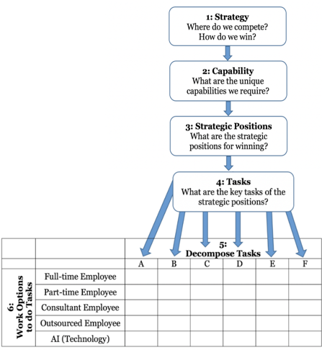
Ulrich (2019)
Another important branch of TM planning focuses mostly on the concept of talent pools, where a set of procedures intended to ensure a sufficient flow of talented workers into the organisation (Lewis & Heckman, 2006, p. 140). Lewis and Heckman (2006) assumed that this approach includes the structural level of the organisation, the requirement of a position in addition to other indicators such as budget, contracts and supply and demand. Therefore, organisations need to focus on maintaining a pool of talented individuals through a talent pipeline (Figure 3), where procedures of talent planning, resourcing and talent development can help the organisation to keep a flow of talent required to create a talent pool (Armstrong & Taylor 2014, p 266).
Figure 3: Talent Management Pipeline:
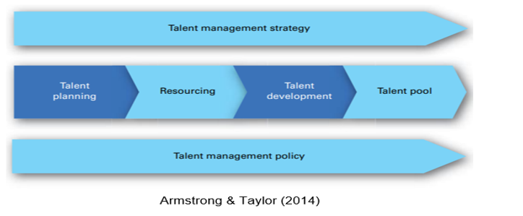
Therefore, in the humanitarian sector, having a talent pipeline with a flexible workforce who are prepared to respond to emergencies is a requirement. However, building an effective talent pool can only be achieved by focusing on TM strategies that can add value to the organisational performance by attracting, identifying, developing and retaining talented employees to keep the follow of talent required to achieve the organisational objectives.

2.5 TM Strategies:
2.5.1 Talent Attraction:
TM processes need to make sure that the right individuals will join the firm and effectively get new, talented employees into the organisation (Bethke-Langenegger, Mahler & Staffelbach, 2011, p529). However, attracting the right talent for the organisation is not an easy task especially in this competitive era. Therefore, firms need to ensure the right people are attracted by focusing on how the future potential candidates will view the organisation and whether they will have the same values. The image of the organisation and how it presents its values and beliefs to future employees can be influenced by two features-the Employer Brand and Employee Value Proposition (EVP). As a result, those two elements are becoming with time significant subjects for firms, as they play directly into the business reputation, culture, TM and employee engagement strategies (Martin et al., 2011, p 3618).
Therefore, organisations need to initially build an environment where a sense of pride is embedded in the culture of the organisation. According to Kontoghiorghes (2016), organisational culture has a great impact on talent attraction especially if it is a high-performance culture. As a result, organisations need to concentrate on creating a culture where they can attract talent instead of trying to invest in pricey TM processes and activities to increase talent attraction (Kontoghiorghes 2016).
In the humanitarian sector, introducing the right talent attraction strategy into the culture and budgets of non-profits is an essential step, as they are not only competing with other non-profits but also with the private sector as well (Word & Sowa 2017). Thus, non-profits need to concentrate on the culture, growth and development to attract potential talent. However, Chertavian (2013) argues that most non-profits do not have a problem with talent attraction as the mission and the purpose of the organisation can serve as strong enough tools to attract the right talent. However, she does underscore that non-profits find it difficult to develop and keep talent. The mission-related features in talent attraction can evidently be realised in the non-profit/humanitarian sector. In a humanitarian sector survey by Parry et al. (2010), almost all participants responded to the questionnaire by underlining ‘Making a difference’ as the most significant reason to join the humanitarian sector, demonstrating how effective a convincing mission can be to the attraction and retention of talent. Hence, non-profit organisations need to take this into consideration the significance of ‘mission’ in talent attraction.
Therefore, non-profits need to have an attractive culture, great leaders, and sustained strategies to not only attract talent but to retain and develop them in order to respond to future demand in the global marketplace.
2.5.2 Talent Identification & Performance Management:
The other important phase in TM is to identify talented people within the organisation. There are several methods of doing this but normally it is based on past performance and future potential, where a talent pipeline can be created to help organisations fill vital roles when needed ( CIPD 2018).
However, to create a talent pipeline, organisations need to focus not only on identifying talent but also on identifying the gaps related to talent and plan to close them. The first one is the performance gap, which is about the difference between present performance and anticipated results (Irtaimeh et al. 2016). In this case, performance needs to be increased to reach the desired points. The other gap is related to developmental and it is about the difference between the employee’s current capabilities and those needed to effectively achieve the required roles at desired points (Irtaimeh et al. 2016). Therefore, organisations are required to use the appropriate tools and approaches to close the gaps. Performance management is one of those tools that can assess the gaps and evaluate employees contrary to future requirements. According to a McKinsey report (2018), performance management is all about aligning employees’ goals to the organisation’s objectives. As a result, if organisations want to reach a higher potential, then it needs to realise the potentials of its workers (Poorhosseinzadeh and Subramaniam 2013).
In the non-profit sector, it is important to focus on the right talent that can make a difference to the organisation’s performance. Therefore, organisations need to find the appropriate tools and best practices to translate their views on talent based on the strategic direction and to link them to their performance (Parry et al. 2010). Using tools such as the “9 box grid” to identify talent within an organisation based on current performance and future potential is essential to assess talent. The 9 box grid below (Figure 4) has two dimensions to represent performance and potential. Normally, the horizontal dimension has three stages of performance and the vertical dimension has three stages of potential. This can help leaders of the organisation to make a decision based on where each staff member is located and therefore, assess the organisations’ talent to support future resource planning, training & development needs, and increase the focus on motivating and engaging talent within the organisation (Yarnall & Lucy 2015). Assessing talent can proactively secure the required human capitals in a process called succession planning which can help the organisation to achieve stability and sustainability. Succession planning is all about identification and development of successors for future leadership roles (Hor et al., 2010), which can also decrease turnover costs.
Figure 4
The 9 Box Grid:
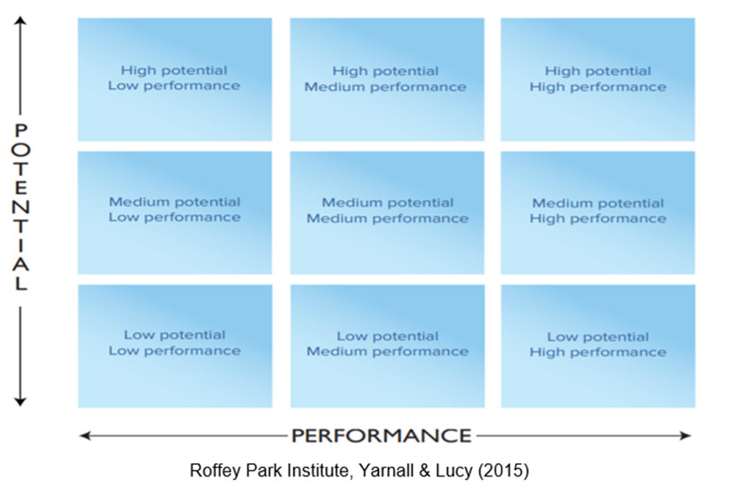

2.5.3 Talent Development:
Employee development is one of the main approaches for meeting present and future talent requirements in organisations (Björkman et al., 2013). Moreover, TM with development focus is claimed to have an influence on the present and future market value of the firm, as organisations increase the intelligent capital due to investing in the human capital (Bethke-Langenegger et al., 2011), which also can positively impact the strategic outcomes due to attracting new talented individuals to join the firm who are interested in development opportunities (Bethke-Langenegger et al., 2011).
Therefore, if an organisation wants the current and present employees to have the essential skills to function at a higher level, then it needs to create development opportunities and training programmes, as they are crucial to both the organisation’s performance and the development of personnel (Cecil and Rothwell, 2007). However, it is essential to highlight the differences between development and training. Training is a temporary effort planned to provide employees with the skills and knowledge they require to function in their current roles. Whereas, development is a continuing effort planned to build capabilities and experiences for the future. Therefore, they are both important for the current and future performance of the firm (Irtaimeh et al 2016). Talent training and development approaches can take so many forms such as formal training programmes, development experience (mentoring & coaching), work-based learning, and informal developmental actions (Garavan et al. 2012)- Figure 5.
Figure 5: Talent training & Development Approaches:
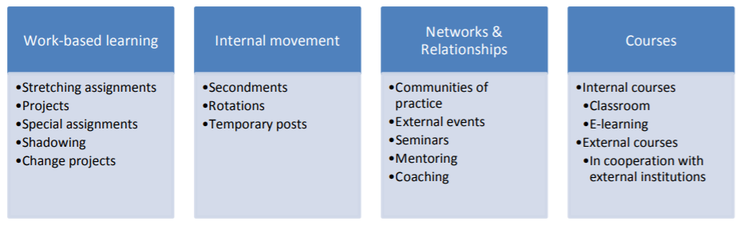
Garavan, Carbery and Rock (2012)
These approaches can also be divided using the 70-20-10-method. In this method, 70 % of the learning is work-based, 20 % based on coaching, mentoring & networking, whereas the 10 % based on formal training courses (Huselid et al 2009, p. 97). In Figure 5, general development tools are listed. Internal movement is also considered as part of the development schemes such as secondment opportunities and job rotation.
In the non-profit sector, internal development programmes such as coaching, mentoring and secondment schemes can be amongst the most popular and preferred methods due to the low cost and their effectiveness on talent development (Jayawickrama 2011).
However, Chertavian (2013) argues that most non-profits find it difficult to develop and keep talent, as it can be a challenge for them to offer development opportunities due to budget restrictions. Therefore, in-house development opportunities and on the job training, can be the solution for non-profits regardless of the economic situation and budget limitations (Kramer 2011).
However, talent development practices cannot be implemented without the involvement and the support of the leaders of the organisation. According to a survey by Bridgespan Group (2011), offering growth and development opportunities was ranked one of the main four reasons for management weakness in the non-profit sector.
Leaders should be accountable for the development, evaluation and the recognition of talent since they work directly with personnel on performance matters, progress needs and potential successors. Therefore, organisations need to invest in coaching leaders of the organisation to achieve the desired outcomes (Hancock et al 2018, P4). Hence, HR can deliver the tools and systems but leaders need to correctly use those systems to attract, develop and retain talent (Trudel 2011).
There is a huge gap when trying to connect learning and development investments to the organisational goals (CIPD 2015). Therefore, it is difficult for organisations and especially non-profits to measure ROI, however, they need to use different measures to establish the connection such as evaluating the return on expectation (ROE), employee satisfaction or employee retention (CIPD 2015).
This can be achieved by establishing clear objectives and following up by assessing the results. According to Chami-Malaeb (2013), who examined the link between talent development and retention, he found out that talent development is an essential element of TM and have a positive impact on employee satisfaction and retention.
2.5.4 Talent Retention:
Once the talented personnel are attracted, identified and developed, then organisations should focus on retaining those talented people. As explained before, investment in development opportunities can help to decrease workers turnover and positively influence retention efforts (Chami-Malaeb 2013).
Contrary to the above view, Mapelu and Jumah (2013) argue that lack of development and training opportunities are not predictors of talent turnover, they also encourage organisations to employ a selection of TM strategies and tactics to retain employees.
Taking both views into account, firms can have the right talent with all the required experiences, skills and capabilities while the performance of employees is still poor due to lack of motivation. Therefore, it is essential to try to attract, develop and retain highly skilled and experienced employees and keeping them motivated by nurturing a culture of employee engagement ( CIPD 2015), where employees believe in the purpose of the mission, which can also enhance workers retention (Brown et al. 2016, Deloitte). Whelan and Carcary (2011) argue that there are a number of influences on talent retention approaches, where hygiene factors can have a direct effect on retention, other factors such as recognition and rewards can have an indirect impact on career success and could reduce talent turnover (Whelan and Carcary, 2011).
Tymon et al. (2010) recognised the connection between intrinsic rewards and retention, explaining that reward could encourage retention as it increases employee satisfaction with the firm and one’s own career achievement.
In addition, Tymon et al. (2010) presented some of the main factors that could also influence employee retention such as a sense of achievement; the amount of enjoyment at work; development opportunities; feeling confident about career future; and work security (cited in Cascio 2006). Therefore, organisations need to recognise the significance of having a clear retention strategy, where employees can feel cared for by simply paying attention to their different needs, boosting teamwork, or providing flexible working arrangements (Thomas & Hatcher 2018).

The model below (Figure 6) can clarify the critical factors that can contribute to workers retention, where employees are provided with inclusive support, clear career pathways, development opportunities and flexible working environments.

Figure 6
Model of Critical Retention Factors:
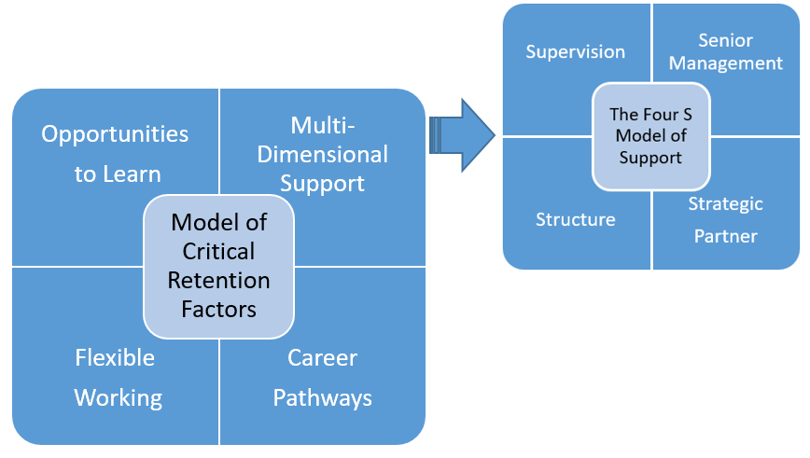
Thomas & Hatcher (2019)
Retention in the non-profit sector is no different from the private sector, where intrinsic rewards can have a substantial impact on talent attraction and retention. However, it could be more challenging for non-profits to compete with other sectors for talent as organisations assume they need to pay more to retain talented employees (Elkus 2018). However, non-profits can retain talent by looking into non-financial reward methods more closely to boost employee satisfaction and retention. Offering attractive benefits and taking care of the well-being of employees by offering flexible working hours can also be valuable retention tools (Elkus 2018).
For those reasons, introducing work-life balance procedures which give employees the opportunity for flexible working such as part-time opportunities, job sharing, working remotely, flexible work schedule and flexitime (Armstrong 2017) will give employees more control over their lives and will help in building a happier and more productive environment for everyone (Schofield 2013), which can reduce absence and turnover of staff who no longer suffer the stress of having to combine work and life demands.
However, well-being is also greatly impacted by how employees are managed. According to a study by Gallup (Deloitte Insight 2019), which revealed that around 50% of employees leave their organisations because of their manager, as bad managers are a primary reason of stress for employees (Eggers et al. 2019). Therefore, wellness activities must also focus on the improvement of management practices since management support is essential for promoting a caring culture where employees feel that they are valued and cared for which can increase not only talent retention but also employee productivity (Thomas 2019).

2.6 The Challenges and Benefits of Implementing TM Strategies:
Organisations should understand the benefits and costs of implementing TM strategies in order to make the best decisions for the organisation to achieve its goals. Actually, TM plays a vital role in the strategic management of the organisation since it manages its greatest assets - its people (Llamas 2018). Therefore, a focused strategic approach to TM that complements the organisational objectives is needed to effectively manage employees and invest in their development in order to retain them. Although, non-profits recognise the importance of improving their employee performance as they originate their power from committed and loyal staff/ volunteers, yet, development and retention of talented employees continue to be a great risk for non-profits (Chertavian 2013). According to (Eggers et al.2019), one of the main challenges to TM in the non-profit/governmental sector is failing to invest in their employees. This is due to the uncertainty of the flow of resources, which makes it difficult for non-profits to make longer-term plans since humanitarian aid can have restrictions/ time limits and funds can be allocated for special projects or specific programmes (Schmidt, 2016).
However, organisations may face other challenges related to the failure of investing in their talent, not only due to budget restriction and uncertainty of resources but mainly due to lack of time spent by management to invest in TM, which can be a barrier for high performance (Ashton and Morton, 2005). Therefore, to have effective TM strategies, everyone in the organisation should be accountable for implementing such strategies and to make sure it is properly communicated within all levels of the organisation from top management, HR, line managers to the employees themselves (Ready and Conger, 2003).
In addition, creating and communicating TM strategies can be a challenging task for organisations as there are several choices on how to link different combinations of TM plans and procedures (Sparrow et al. 2014). According to Garrow and Hirsh (2008), TM is all about the “best fit” between TM approaches with the organisation’s strategic objectives, culture and capabilities as well as the human resources practices and policies.
Therefore, to achieve the “best fit” approach in the non-profit sector, organisations should aim to apply fairness and reliability in all TM practices and policies, as well as diversity and inclusion efforts. According to CIPD (2018), failing to link TM strategies with diversity approaches can result in missing out on opportunities to gain access and to develop talent from the broadest possible pool. However, Beechler & Woodward (2009) argue that making diversity work is a challenging task for organisations in any sector as they need to understand that an inclusive approach is not only about recognising and including talent from different backgrounds but also about providing an actual added value for organisational growth. Therefore, this will support the demand for continuous improvement in every phase of TM, starting from recruiting to developing and retaining talent.
Non-profits can add value through diversity by encouraging and motivating specific groups within the organisation to further improve their talents. For example, organisations can actively involve female talented employees in career progress, which will help to include more women into leadership or central roles within the organisation (Eede 2018).
In a fast-changing global economy, diversity and inclusion can have a big impact on the organisation’s worth. Therefore, organisations that commit to creating an open and diverse work culture without losing their uniqueness (Grant 2013, p.105), will get the opportunity to truly make a difference in terms of adding value through their diverse talent with their distinctive experiences, capabilities and skills (Power 2017).
This is also the case in non-profits sector, where organisations that make a move in the direction of robust diversity approach are taking the correct path, as diverse workforces can have an advantage over other organisations in the same sector according to Non-profit TM Priorities survey (2017). Therefore, it is important to understand the need for having a diverse talent and employee groups for the benefits of all organisations in any sector (Beechler & Woodward, 2009).
TM is more than a trendy word but it is a progressive method, which can increase the firm's performance, flexibility and gives its management the tools to plan for change and development (Sinclair 2014). Moreover, TM is important for the sustainability of the organisation especially with the changes in the economic environment, where staff are expected to handle more complex roles, therefore, TM can be an effective tool to keep a talent pipeline available with the right talent to do the job (Vaiman et al. 2012). TM also helps in the assessment of the human capital data, which in turn can enhance the professional investment decisions since TM strategies aid the process of identifying high potentials, which makes it easier to invest in employees’ professional development (Juneja 2018).
According to CIPD (2018), TM strategies contribute to growth of the organisation and help the firm to achieve its strategic goals such as having a high-performance workplace, where a culture of employee engagement is created to give employees the chance to influence the strategic process, where they become more responsible and highly motivated (CIPD 2018). Having a strong TM culture can also positively impact how the organisation attracts and retain talent since employees have more confidence in the future of the firm (Brown et al. 2016, Deloitte).
This is also the case in the humanitarian sector, where non-profit organisations are pressured to become more efficient and effective, introducing TM into the culture and budgets of non-profits is an essential step to improve the way non-profits attracts, develop and retain employees, which will positively contribute to the overall performance of the firm (Chertavian 2013),
As a result, TM is the implementation of different strategies aimed to increase workforce productivity by improving the practices for attracting, retaining, and developing individuals to obtain the needed skills, competencies and capabilities to meet the present and future organisational objectives (Masa’deh et al 2018).
2.8 TM & Organisational Performance:
Several research studies confirmed the positive impact of TM on competitive advantage, organisational success, and outcomes of organisational performance (Schiemann, 2014). According to Turner and Kalman (2014), having the right talent is essential for the effectiveness of the organisational strategy and continuous success.
However, the effectiveness of TM strategy depends on the right implementation approach of such strategies, which in return can be considered as one of the most important measures that lead to outstanding organisational performance (Foster et al.,2007). Yet, evaluating the effectiveness of TM can be challenging but essential to make sure that the investment in talent is meeting organisational objectives at any point of time (CIPD 2018). Therefore, Return on Investment (ROI) can be one tool to assess outcomes in comparison to the cost of TM. In addition, evaluating employee turnover and retention data can be other valuable tools for measuring the efficiency of TM strategies especially for organisations in the non-profit sector.
Eventually, the success of the organisation can be one of the most effective evaluations of TM strategy (CIPD 2018).
Performance measurement has become critical for non-profit organisations as the demand for transparency and accountability has increased among donors, foundations and governments, and as they encounter increasing competition from a proliferation of a number of agencies (Kaplan, 2001).
Claeyé (2014), in turn, suggests that it is the choice of the activities of the non-profit that makes their management different from management in other sectors. With the choice, he refers to: “meeting human needs as opposed to maximizing shareholder profit or providing public service … requires a different approach.” (Claeyé, 2014, p. 22).
The Organisations for Economic Cooperation and Development (OECD) recommends the following criteria in evaluating the performance of aid programmes: relevance, effectiveness, efficiency, impact and sustainability. This evaluation framework seeks to enhance accountability and transparency by providing evidence about the effectiveness and impact of development aid programmes, while contributing to institutional learning and global knowledge (OECD, 2016).

Summary:
The above literature review focused on the main concepts and theories, which will be explored further in primary research. Starting from the concepts of Talent and TM and how the unique experiences and capabilities of each organisation can affect how talent is defined (Turner 2012), in addition to highlighting the importance of workforce planning and the concept of talent pools for the future of organisations especially in the non-profit sector, where building a flexible workforce of people who are prepared to respond to an emergency is a must for the existence of the organisation.
Therefore, the main priorities are to focus on TM strategies that add value to the organisation's performance such as attracting the right individuals and endeavouring to retain them by investing in individual development while paying attention to their different needs, which will be explored further in the primary research.
Furthermore, the literature review highlighted the challenges and benefits of implementing TM frameworks in the non-profit sector and how they will affect the decision-making process. This also needs to be taken forward to understand TM strategies in the non-profit sector and their importance for the future of organisations, since they can contribute to the growth of the organisation and help the firm achieve its strategic goals. However, as emphasised, the effectiveness of TM strategy depends on the right implementation approach of such strategies, which in return can be considered as one of the most important measures leading to outstanding organisational performance (Foster et al.,2007 ). Therefore, to foster effective TM strategies, everyone in the organisation should be accountable for implementing such strategies and ensure they properly communicated within and across all levels of the organisation from higher management, HR, line managers to the employees themselves (Ready and Conger, 2003).

The following chapter will explain the methodological approach and the materials used to collect the required data and to develop the research to achieve the aims and objectives of the study.

Chapter 3- Research Methodology
3.1 Introduction:
This chapter of the dissertation explains the overall methodologies and the materials that are used to collect the needed information and to develop the research to achieve the purpose of this study and to answer the research questions. The choice of methods were based on the research ‘onion’ (Saunders et al, 2016, p. 122) which includes six layers: research philosophies (Interpretivism), research approaches (Inductive), strategies (Case studies), methodological choices (Qualitative), time horizons (Cross-sectional) and research techniques and procedures (data collection, sampling methods and data analysis). This chapter also explains the ethical considerations and highlights the main limitations of the study.
3.2 The Research Onion:
Figure 7:
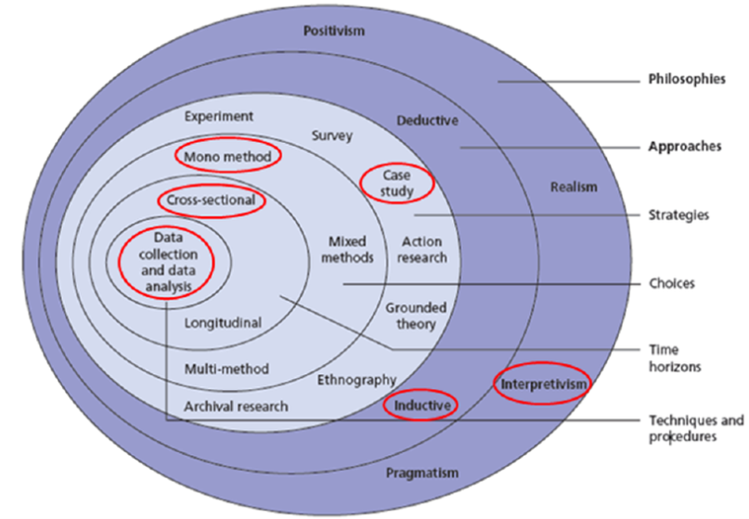Saunders et al (2016)
3.2.1 Research Philosophy:
The research philosophy is all about the development of knowledge by creating a system of assumptions and beliefs (Saunders et al. 2016, p124); therefore, it offers the justification for the research methodology. There are five main research philosophies: positivism, pragmatism, interpretivism, post-modernism and critical realism. For the purpose of this study, the researcher assumes that to answer the research question and meet the research aim and objectives, adopting the interpretivist philosophy will be the most appropriate approach for the study and therefore, qualitative data will be collected through interviews. The interpretivist philosophy specifies that the researcher should know about the variances among human in relation to their roles as the social actors (Saunders et al., 2012, p.116). Therefore, this will help to generally understand the human experience in definite situations or settings.
Adopting the interpretivist philosophy will help the researcher not to generalise the base of understanding for the entire population but instead to gain a deeper understanding of a complex subject such as TM in its unique settings (Creswell, 2007). Similarly, this approach will allow the researcher to understand “the different ways of seeing and experiencing the world through different contexts and cultures” and try to avoid the bias in studying the events and people with their own interpretations (Hammersley 2013). In addition to the positive impact, the qualitative technique can have on the research approach in terms of flexibility and interactively engaging with participants to discover their inner experiences and opinions about the subject (Maxwell 2012). The interaction between the researcher and the contributors is needed to produce the required data, which is a sign of the level of association and engagement in the field. Therefore, the researcher's own insights and explanations turn out to be part of the study. As a result, a personal and interpretive direction runs all through the research (Creswell, 2014). However, subjectivity is openly recognised in this type of research and can be managed by embracing an instinctive stand within the study (YIN, 2014).
3.2.2 Research Approaches:
According to Saunders et al, (2016), there are two kinds of approaches when developing a research study, the deductive and the inductive approach. The deductive approach is regarded as the move from general to specific, where the general idea and the primary information is first formed and the precise data is then gained from the research process and tested against it (Bryman & Bell, 2011). However, the inductive approach is regarded as the development from the precise to the general (Bryman & Bell, 2011), where the collection of data will be the starting point and patterns are looked for in the data (Beiske, 2007). Therefore, for the purpose of this research, the inductive approach was chosen as there is no general theory that primarily informs the data collection, instead the research focus can be established after the collection of data (Flick, 2011). This approach will complement the research interpretivist philosophy and the qualitative choice of data collection method, where the lack of a framework informing the research process may be an advantage by decreasing the possibility for researcher bias in the data collection phase (Bryman & Bell, 2011).
3.2.3 Research Strategy:
The researcher would rely on multiple case studies research of several Local and international non-profit organisations in Jordan, as there are recognised differences of the approaches to TM in different organisations (Meyers et al., 2013). The research involves the investigation of multiple organisations in order to have a wider view of the research subject and to build a more holistic picture of the phenomenon (Bryman & Bell, 2015, p.71). Using the Multiple case studies approach will allow the collected data to be compared in relation to different cases instead of depending on one single case study, which allow the researcher not only to collect, analyse and compare the data but also to find reliable patterns, common features and unique characteristics and divergent themes through the replication process and across the case studies (Yin 2014). Therefore, each organisation will be analysed separately and also compared to other organisations, where similarities and differences are recognised (Vannoni 2015). In addition, since TM strategies and procedures can be claimed to be complex, flexible, and even variable by nature, thus, case studies are the most appropriate tool to investigate them (Groves, 2007).Therefore, the researcher will assume that produced evidences will be more convincing and reliable (Baxter & Jack, 2008). As a result, a broader examination of the research questions and theory development will be achieved (Eisenhardt & Graebner, 2007).
3.2.4 Research Choice:
The research choices indicated in the research Onion contains three methods, which are the mono method, the mixed methods, and the multi-method (Saunders et al., 2012, pp. 164-166). In these research choices methods, we can differentiate between two research designs: quantitative research design and qualitative research design. Mono-method is a technique when you use a single research design process (either quantitative study or qualitative study). On the other hand, both techniques the qualitative and quantitative can be combined when using mixed-methods, whereas the multi-method refer to the use of either multi-method qualitative studies or multi-method quantitative studies (Saunders, et al, 2012, pp. 151-152).
The quantitative research design is typically linked to the positivism philosophy and the deductive approach, whereas the qualitative design is usually connected to the interpretive philosophy and the inductive approach.
Since the study involved using one focused research approach and was conducted on a complex subject, where the more thorough and rigorous examination was needed, therefore, the qualitative mono-method was favourable (Bryman and Bell 2015, p.25).
3.2.5 Time Horizon:
The Time Horizon is the time outline within which the research study is planned for completion (Saunders et al., 2007). There are two forms of time horizons according to the research onion: the cross-sectional and the longitudinal. The cross-sectional time horizon is used when the examination of subject was done at a precise time, whereas the longitudinal time horizon for data collection is concerned with the examination of a phenomenon repetitively over an extended period of time and the significant aspect of the study is investigating the change and development of a phenomenon over time (Goddard & Melville, 2004). Therefore, the cross-sectional time horizon was the most appropriate for this study, since the data was collected at a specific timeframe (Flick, 2011). This approach is usually used when there are time restrictions, and therefore a snapshot of the research phenomena is created (Collis and Hussey 2009).

3.2.6 Research Techniques and Procurers:
- Data Collection

A.1 Primary Data:
The primary data will be collected by conducting in-depth semi-structured interviews with key actors in the different selected organisations. Open-ended exploratory research questions will be used due to the exploratory and qualitative nature of the research. Therefore, the researcher adopted the exploratory case study design methods to help in developing an in-depth analysis of the subject with a view to understand and present the problem from the viewpoint of the contributors (Yin 2013). Bryman and Bell (2015, p.213) argued that this type of interviews allows additional data to be gained since the participants’ responses are not too restricted as they can reply to the questions more flexibly and openly. In total, 7 interviews were conducted in 7 non-profit organisations (Local and international) in Jordan (one interview in each organisation). The interviews were conducted either face to face or online (via Skype) as few participants from the international non-profits were based in different countries (HQ), since the researcher wanted to interview key actors and people who are responsible and representative of the organisation’s TM and could provide improved and in-depth responses to the interview questions. The participants were informed about the approach and purpose of the dissertation before conducting the interviews. In addition to explaining beforehand, the anonymity and the confidentiality of the research study.
The semi-structured questionnaire was informed by the material in the literature review. Moreover, a pilot study was conducted using the help of participants at the organisation where the researcher is working, however, they were not part of the final sample group. This was done to find out if the questions elicit good enough data for the study and thus the interview questions were refined and adjusted later before conducting the rest of the interviews. The interview questions were designed to help the researcher find out the participants’ views about the overall trends in relation to the subject, in order to achieve the aim and objectives of the research by assessing the current TM practices and analyse their effectiveness as well as identifying the main challenges facing non-profits when implementing TM strategies and policies. In addition, to reporting on selected contributors feedback on their expectations and experiences with regard to TM practices. The researcher will also list out suggestions for overall improvement for organisational effective performance by providing TM processes that can be useful to the workforces and the organisations. According to Kvale (2009), a semi-structured interview offers evidence from the contributors’ own individual insights, this will provide us with more valid and consistent information related to our objectives, and therefore, it will reinforce the result and conclusion (Saunders et al 2012).
The questionnaire contained 14 questions in total (see Appendices 7.2). The first three questions were designed to understand the background of the participant and the organisation’s main competencies and culture. The other 11 questions were divided under four main titles to give a better understanding of what the questions were linked to in the subject area, where each section represented an area that the researcher wanted to explore further. In addition, the researcher made sure to probe the participants’ answers and ask them for specific examples, particularly regarding the effectiveness of their strategies. The questions were carefully created from the theoretical background and literature review produced before conducting the interviews.
The main four areas of the interview questions are: Talent and TM definitions, TM practices and the effectiveness of the implementation process, the challenges and benefits of implementing such strategies and the final part concentrated on the evaluation methods of the TM strategies in addition to the participants own views on the influences TM has on the organisational performance.

A.2 Secondary Data
Some materials related to the subject were sent by the case organisations (Strategies, Annual reports, vision and mission of the firm), which provided a more thorough perspective of the TM strategies in the organisations and helped the researcher to analyse the activities in more detail. Secondary data was additionally acquired from the websites of the case organisations in to support the participants’ interviews.
Additional secondary data was also obtained from publications, textbooks, reports, books, websites, journals, manuals, case studies or any other related services.

A.3 Sample:
Using multiple case studies strategy for this research allowed the researcher to include various samples to fulfil the purpose and the needs of the repetition strategy. According to Yin (2014), there are no rules about the number of cases needed to achieve the results; yet, Yin (2014) recommended using between six and ten cases, if the outcomes turn out as anticipated, then, they are adequate to offer convincing support for the primary set of proposals. Therefore, the sample size is determined by the number of cases needed to reach the target for the study and no added value or important new outcomes are gained from any additional research activity.
The sample for this study involves seven Non-profits ranging from local small charities to large international non-profit organisations and UN agencies operating in Jordan. This sample was selected to allow variation, which is essential for the purpose of this study as the outcomes should not be reliant on a specific type of non-profit but rather an all-inclusive approach with variable patterns was of interest. Overall, 21 non-profits operating in Jordan were approached and contacted via email to invite them to participate in the research, in which 10 of them were interested to participate, however, 7 were selected to complete the process due to the availability of the key people and their willingness to share the information needed for this study. The people approached were either the directors of the non-profit or in key positions within HR/Talent Management. The non-profits taking part in the research were diverse in terms of size, culture, background, and competencies, etc. This was a conscious decision, as the purpose was to evaluate the importance of having TM strategies in the non-profit sector to enhance organisational performance by assessing the current TM practices and approaches in the non-profit sector.

Table 2 below demonstrates the list of the non-profits participating in the research and some of their features/ background information to provide an insight into the selected sample.

Table 2: Sample Information
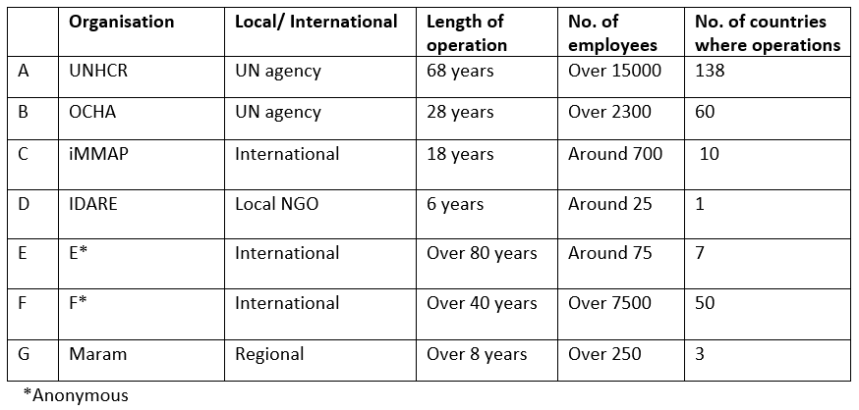

- Methods of Data Analysis
To enable the researcher to analyse the data thoroughly and in more detail, the interviews were recorded after getting permission from the participants. Then, the content of the collected data was analysed and categorised manually.
In case study research, there are few approaches to data analysis, though, the researcher used only one method in this research study to analyse the outcomes based on an inductive approach, where the objective was to find specific themes or patterns (seeming similarities or differences) extracted from the collected data concerning the case organisations (Eriksson & Kovalainen, 2008).
Therefore, content analysis was conducted as it was the most suitable approach for presenting the outcomes of the interviews for the purpose of this study (Zikmund et al., 2010 ). The answers, views and explanations obtained from the participants were examined thoroughly to find evolving patterns and words. Using the content analysis approach will involve a coding technique where data will not be only classified but also linked to the research subject and back to other data. Therefore, frames of coding were created so that the transcripts can be broken down into more manageable classifications (words, phrases or short sentences).
As mentioned earlier in the data collection section of the research, the interview questions were divided under four main topics to give a better understanding of what the questions were linked to in the subject area, where each section represented an area that the researcher wanted to explore further. The literature review created the basis for forming the interview questions, which allowed the researcher to describe the observed data in the coding system. Moreover, this allowed the researcher to compare the collected data to the finding in the Literature review and to place the outcomes under each topic of the coding system.
This design of the coding framework allowed the classification of the types of answers linked to each question (Bryman and Bell 2015, p.258). The specific interview questions can be found in the (Appendices 7.2).
Finally, the coding system was analysed as a whole and general patterns were formed, which helped the researcher to create conclusions and present deep insight into the existing practices in the selected organisations. In addition, to covering the strong points and weak links of the TM strategies as well as evaluating and assessing the current organisational performance based on the contributors’ overall awareness, prospects and satisfaction or dissatisfaction as offered by the TM practices of the organisations. Therefore, Quotes from the interviews were used to broadly reveal the primary and important patterns.
3.3 Limitations of the Study:
The researcher faced few difficulties in relation to the retrieving of information from the contributors, having a proper sample size, the quality of data collected and the approval to use the organisations as case studies. There are also some limitations related to the use of a case study approach and how well the case studies can be connected to a larger context since the case study strategy usually includes deep analyses of a small sample of issues rather than accumulating information from a large sample of participants. Therefore, this will result in a lack of generalizability of the findings.
The research was limited in its sample size, being focused on the non-profit sector and limited to 7 interviews in 7 non-profits from local and international organisations in Jordan. Therefore, the research would benefit from covering larger regions. Although case studies do create difficulties to the researcher in terms of sample size, generalizability, access to data, research findings, and possible causes of bias, these problems can all be tackled by considering presenting adequate evidence, from the observed information, reinforced by literature and theory within the study area. In addition, implementing multiple case studies research was extremely time consuming (Baxter & Jack, 2008). Starting from selecting the case-study organisations, getting the approvals, approaching the right people for interviews, contacting the participants and checking their availability, conducting the interviews to analysing the data. There are also limitations related to the subject area, since TM concepts and theories are ambiguous especially in the context of non-profits. As a result, the researcher experienced difficulties in approaching non-profit organisation in Jordan and introducing the concept of TM to them, as the subject is still not very familiar and confusing to some in the non-profit sector and especially to small local non-profits. Therefore, the results of the analysis have been influenced by the perspective of the researcher indicating and relating to specific terms or concept. However, the researcher selected carefully different visions and theories when introducing those concepts to the participants which enabled them to discuss these various views and relate to them.

3.4 Ethical Considerations:
The research involved coordination and collaboration between different individuals with varied standards; therefore, it is ethical to conduct the study with a high degree of honesty, accountability, fairness and mutual respect. The researcher adhered to the University’s ‘Research Ethics and Integrity Code of Practice and the selected organisations’ Ethical guidelines which are related to the data sharing policies, copyright, anonymity, protection and confidentiality rules (Bell & Bryman, 2007, Saunders et al, 2012).
This was achieved by explaining to the participants that their participation in the study is voluntary as they can withdraw at any time without any consequences, in addition to giving them the assurance that the shared information will be treated confidentially, this was stressed by the researcher by asking the participants to read and sign a consent form before the interview. (Consent form - Appendices).

Reliability and Validity:
The researcher ensured to incorporate tactics to improve the reliability and validity of the study such as engaging the participants in the data collection process by giving them the opportunity to comment on the interview draft as diverse views can help to form a more inclusive and valid results (Kuper et al, 2008).
This was also achieved by producing clear and transparent explanations of the research progression methods from the original plan, throughout the application of the process and reporting of the findings (Smith and Noble 2014). In addition to presenting adequate evidences and results, from the observed information, in an unbiased, fair and objective manner; demonstrating transparency and open communication at all times, reinforced by literature and theory within the study area.

Summary:
This chapter covers information on the methodological approach used in this research, starting from the research Philosophy to the research Techniques of the data collection, sampling methods and data analysis. The chapter explains why those particular methods are used to collect and analyse information to meet the research goals. It also presents the ethical considerations and the main limitation of the study, in addition to highlighting the reliability and validity of the chosen methods.
The next chapter will present analysis and discussions of the results, together with the implications and concerns raised. The chapter will also compare and contrast findings with earlier research results, recognised and discussed previously in the Literature Review.
Chapter 4- Analysis of Results
4.1 Introduction:
This chapter aims to present a clear summary of the results and the findings of the study. Data collected has been analytically evaluated and aligned to the overall objectives, research questions and literature, in an attempt to assess the importance of TM strategies in the non-profit sector to enhance the organisational performance. Therefore, content analysis was conducted as it was the most suitable approach for presenting the outcomes of the interviews for the purpose of this study (Zikmund et al., 2010 ). Using the content analysis approach involved a coding technique where data was not only classified but also linked to the research subject and back to other data. This design of the coding framework allowed the classification of the types of answers linked to each question (Bryman and Bell 2015, p.258).
The coding system was analysed as a whole and general patterns were formed, which helped the researcher to create conclusions and present deep insight into the existing practices in the selected organisations. In addition, to covering the strong points and weak links of the TM strategies as well as evaluating & assessing the current organisational performance based on the contributors’ overall awareness, prospects and satisfaction or dissatisfaction as offered by the TM practices of the organisations. Quotes from the interviews were used to broadly reveal the primary and important patterns.
This chapter consists of five sections. The first section offers an overview of each of the 7 organisations (case- studies), presenting information about the organisation’s size, competencies, mandate and culture. Sections two to four contain a cross-case analysis that involves recognising common patterns and distinguishing apparent similarities or differences across the seven cases.
The main four sections are: Talent & TM definitions, TM practices and the effectiveness of the implementation process, the challenges and benefits of implementing such strategies and the final part concentrated on the evaluation methods of the TM strategies and the views on the influences that TM has on the organisational performance.
Therefore, the purpose of this chapter is to offer and present a structured breakdown of the findings to achieve the aim and objectives of this study and to answer the research questions, which are:
4.2 Research Aim & Objectives:
Aim: To evaluate the importance of having TM strategies in the non-profit sector to enhance organisational performance.
Objectives:
- To assess the need to have TM strategies in the non-profit sector.
- To analyse the effectiveness of talent management strategies in the non-profit sector.
- To identify key elements of successful talent management strategies.
- To evaluate current practices in non-profit organisations (case studies) in order to make recommendations to improve the TM strategies and enhance performance.

4.3 Research Questions:
1. What are the effects of having TM strategies in the non-profit sector and why TM strategies are important for the success of organisations?
2. What are the challenges and opportunities of the current TM strategies in the non-profit sector and what are the TM strategies the organisation’s need to develop or adapt to add value and enhance organisational performance?

4.4 Overview of the Case Studies Organisations:
There are seven Non-profit organisations (case studies) took part in this research. The organisations all based or have offices in Jordan and diverse in terms of size, culture, background, and competencies, etc in order to assess the current TM practices and approaches in the non-profit sector and evaluate the implementation processes.

The Table (2) below lists the case study organisations and an overview of some features of them. For a more detailed understanding of their competencies and culture, please see (Appendices ). However, two out of the seven organisations prefer not to include their names or any information to identify them. Therefore, the background information for them is limited to guarantee anonymity and confidentiality.

Table 2: Case- Studies

Analysis:
See Table 3 in Appendices (7.12) with demographic information of the respondents.
4.5 Talent & Talent Management Definitions:
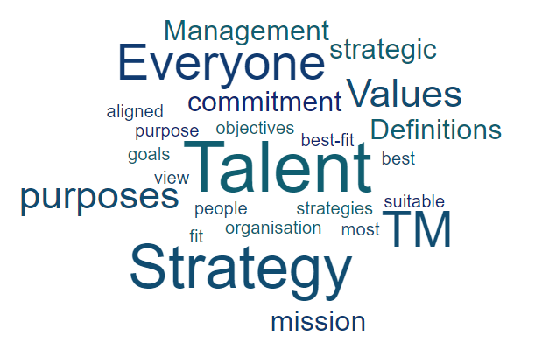

The findings show that six out of seven organisations view talent as everyone in the organisation (see Appendices- Table 4), however, with an emphasis on having people who fit within the organisation and show commitment to its values and purposes. Therefore, talent for them is what the organisation needs in order to achieve its mission, which also matches Ulrich views on talent, where employees need to have not only the skills and experiences but also the drive and purpose to be considered as talented individuals (Ulrich and Smallwood 2012).
R2 reflected the views of talent as all people, where she explained, “OCHA is its people, that represented 70% of its financial plan, therefore we seek an organisation that fosters talent, where all staff – through their different career paths – can fulfil their potential and that of OCHA itself”
R4 also clarified,” We look at our people as the right holders and resourceful and we believe everybody is competent, so people who join us need to fit into our culture and believe in our values and competencies”.
Only one organisation (iMMAP), considered high potential employees as talent, where they need to value and develop. R3 explained, “We are a technical organisation, we provide technical services for humanitarian organisations, therefore, people are the driving force, we look for people who make a difference and add value to our services so we look for high potential and efficient employees and value them”.
Therefore, TM practices reflect the organisation’s view on Talent, which mainly revolves around having the best-fit employees for the organisation in terms of purpose, value, mission and strategy. Corbridge & Omotayo (2013), share the same views where they define “best fit “status, as the recognition of the present position and purpose to achieve success in the TM strategies. Therefore, most organisations reflected on the link between TM strategies and the purpose, value and strategy of the organisation. According to R5, “TM is about recruitment, retention and development the most suitable people for the organisation and all aligned with the commitment and strategic objectives, ensuring employees express joy, a strong sense of engagement and co-ownership with the organisational goals, acting as proud advocates - developing themselves and the ecosystem, as a result, they have the right candidate for the right position at the right time”. Therefore, TM is more of an activity that is linked to the strategic purpose and goals of the organisation (Haturn 2010).

4.6 Level of Implementation of TM Strategies and Who Is Responsible?
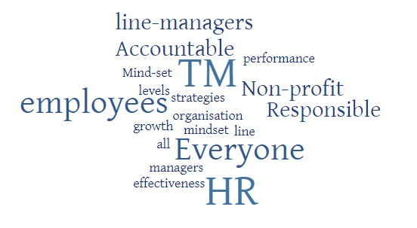
The finding suggests that TM strategies have been implemented one way or another in the non-profit sector (Case- studies) with larger organisations taking the lead (see Appendices- Table 5), as they do understand the importance of implementing such strategies for the organisational success in terms of performance, growth and effectiveness. Smaller and local organisations are starting to implement TM strategies for the same reasons. However, organisations cannot reap the benefits of TM without creating a talent mind-set where all TM actors from top management to HR executive are involved in the implementation process (CIPD 2013).
R1 explained, “HR facilitates TM strategies, so we are responsible in a way as we have to develop the necessary policies for it but I think managers play a big role in ensuring that, it is done properly because they are the ones who are implementing TM strategies”. The findings also show that almost all organisations involve everyone in the implementation process where HR create the policies and facilitate the process and leaders are responsible to use the tools to implement such strategies, which match the view of Trudel (2011).
R2 emphasised,” we all are accountable for implementation processes with HR overseeing the procedures and the managers creating the proper environment and to give the appropriate support to enable this”
R3 also stressed that “Employees, managers and Human Resources (HR) should all collaborate to build a continuous professional development culture. It’s an employee’s responsibility to seek new learning opportunities, the manager’s responsibility to coach their teams and identify employee development need, and the HR’s responsibility to facilitate any staff development activities and processes but management should implement and support those practices”.
Therefore, to have effective TM strategies, everyone in the organisation should be accountable for implementing such strategies and to make sure it is properly communicated within all levels of the organisation from CEOs, HR, line managers to the employees themselves (Ready and Conger, 2003).
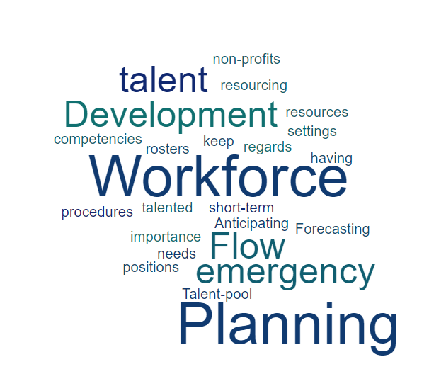
4.7 Workforce Planning:

The results show that all organisations have plans to keep the flow of talent either by forecasting the required workforce or by anticipating the development needs, resources, competencies and positions (see Appendices –Table 5).
R5 explained, “We have a need analysis planning, where we check the inventory of the existing competencies and then we identify the required competencies for the future. Therefore, we do assess the needs within the organisation, department or unit, where we check what skills and competencies are missing in the working team today, what skills and competencies are required for the future position… Without a proper needs analysis it is impossible to, know if we can use existing resources to fulfil our needs or if we need to recruit new employees”.
However, most of those plans are short term as six of the non-profit organisation in this sample work in emergency settings, therefore, having emergency rosters or talent pool is a must especially for large international non-profits to keep a flow of talented people when needed, which also supports the views of (Armstrong & Taylor 2014) with regards to the importance of having the procedures of talent planning, resourcing and talent development to keep a flow of talent required.
In two of the organisations, which were both UN agencies, this was highlighted:
R1,”We have a talent pool...as we are looking to have a group of people who are, on a short notice, able to take up a post without going through the whole recruitment cycle”.
R2, “We must deploy the right people to the right place at the right time. This requires building a flexible workforce of people who are prepared to respond to emergency contexts to meet the requirements of any humanitarian response”.
4.8 TM Practices:
The findings suggest that all organisations are implementing TM practices, although not fully implemented but they all understand the importance of having procedures to attract the right people, identify high potentials, develop competencies in the changing environments and retain good employees by fostering a culture where people are valued, developed and cared for. However, some of those practices are harder to apply especially in small organisations (see Appendices – Table 6).

4.8.1 Talent Attraction:
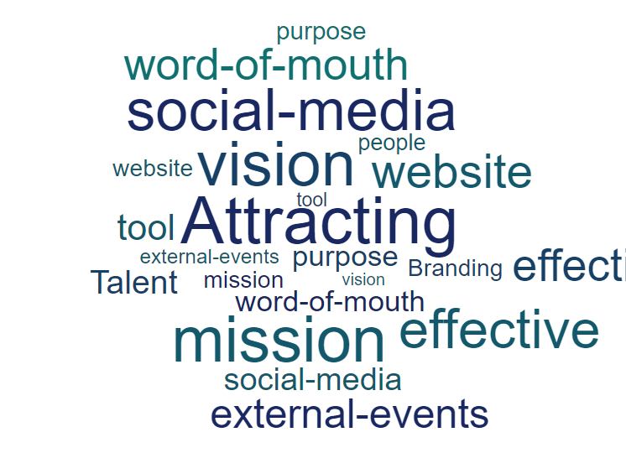
It was found that all of the non-profits in this sample do not have a problem with attracting people to come and work for their organisation as the mission, vision and purpose can be strong tools to attract applicants.
R6 confirms that “We have attractive culture, goals, mission and vision, we attract talent by our core values and principles as we promote diversity by offering equal opportunity and non-discrimination policies”. This was explained also earlier in chapter 2, where the image of the organisation and how it presents its values and beliefs are important to the future employees as they play directly into the business reputation, culture, TM and employee engagement strategies.” (Martin et al., 2011, p. 3618).
R1 clarifies, “The thing is we have a very good brand, so we capitalize on the brand. So it's not that we lack applicants, every time we advertise for a post, we get a high number of applicants but the issue is getting the right kind of applicants, for the right kind of profile that is the challenge, especially when we have a crisis or emergency”.
Therefore, the challenge for many non-profits is to find the right people with the right values, skills and competencies. This is also the view of Chertavian (2013), where she explained that most non-profits are able to attract talent by their purpose but find it difficult to develop and keep talent.
In terms of tools used by non-profits to attract talent, five respondents in this sample organisations agreed on that talented people attracts other talents; therefore, they counted “word-of-mouth” as the most significant tool for attraction, in addition to using the social media, external events and having an effective website.
R1 explains, “We attract talent through our external website, word of mouth by the staff themselves, as staff are our number one ambassadors”.
R4 also clarifies “We attract people to come and work with us from the youth and communities we are working with so they start as volunteers as we call them right holders and then they become employees”.
R7 highlighted,” We attract people by the mission and the quality of work delivered. Therefore, we hire people from the communities we serve as they understand exactly our purpose”

4.8.2 Talent Identification and Performance Management:
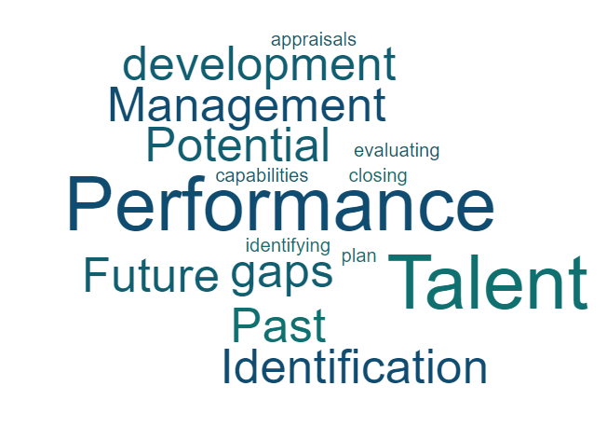
The results show that six out of seven organisations use some sort of performance mechanism to evaluate employees and identify high performers or people who have potential. According to R2, “A feasibility assessment will be undertaken on the options and implications of the use of talent pools. The process for the pools will identify high-performing and high potential staff, particularly with regard to promoting national staff and achieving gender parity across the organisation… transparent criteria will be identified for the selection process (including desirable performance and behaviour), and to ensure clarity on the expectations of staff who are included and not included in the pools”. The results comply with research conducted in chapter 2 where it was highlighted that the several methods of identifying talent are all based on past performance and future potential, where a talent pipeline can be created to help organisations fill vital roles when needed ( CIPD 2018).
However, it was also stressed that organisations need to focus not only on identifying and evaluating talent but also on identifying the gaps related to talent and plan to close them. One of those gaps is related to developmental and it is about the difference between the employee’s current capabilities and those needed to effectively achieve the required roles at desired skills (Irtaimeh et al. 2016). Therefore, methods such as performance appraisals can highlight those gaps and work on closing them by working on a development plan.
R5 explained, “We have something called Performance development dialogue (one to one) with management and we do not call it performance review as we concentrate on how we can develop our employees not to rate their performance only”
R6 also clarified that “Performance appraisal is not only a document but also a living constructive document, where people at the end will have a sense of achievement and sense of development”.

4.8.3 Talent Development:
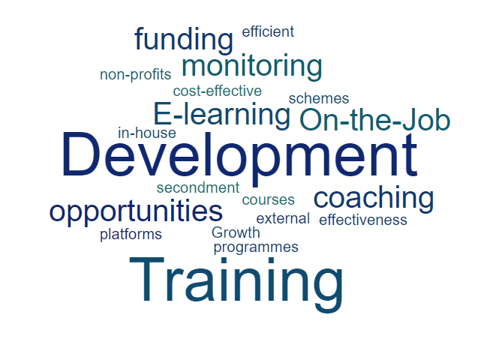
The non-profits in this sample all provide development opportunities for their staff but with different levels, depending on the size of the organisation and how much funding it allocates for such programmes. They all realise the importance of training and development opportunities for organisational effectiveness. According to R2, “We have the staff development and training fund allocated for that purpose to make sure there is a fair distribution of learning opportunities to all staff to make the organisation fit for purpose”.
R3 highlighted that “In the modern competitive environment, employees need to replenish their knowledge and acquire new skills to do their jobs better. This will benefit both them and the organisation. We want the employees to feel confident about improving efficiency and productivity, as well as finding new ways towards personal development and success”.
R7 explained, “We try our best to empower employees and develop them, we support our employees and give them the chance to grow. For example” whenever we see a weakness, we do our best to fill that gap. Employees are encouraged to attend trainings to strengthen their role. For example: we do offer to cover 50 % and sometimes 100% of the cost of courses such as Language courses”.
The result complies with (Cecil and Rothwell, 2007) views, where they suggest that if the organisation wants its current and present employees to have the essential skills to function at a higher level, then it needs to create development opportunities and training programmes as they are crucial to both the organisation’s performance and the development of personnel.
It also has an effect on the other TM strategies by attracting new talent and retaining the most valuable employees.
R5 clarified, “Our strategic, professional approach to talent development helps us to attract and retain highly motivated staff with the skills and competencies necessary to deliver our objectives. We aim to build sustainable processes of individual and collective development as a means of increasing our capacity and effectiveness. We are committed to providing staff with development opportunities to ensure that individuals and groups are able to contribute fully to the achievement of the organisation’s strategic and operational objectives”.
These views also support Bethke-Langenegger et al., (2011), where it was suggested that focusing on development could positively influence the strategic outcomes due to attracting new talented individuals to join the firm who are interested in development opportunities.
At the same time, the findings contradict with the result of a survey by Bridgespan Group conducted in 2011 (mentioned in Chapter2 ) where it was found that offering growth and development opportunities was ranked one of the main four reasons for management weakness in the non-profit sector. Therefore, we can see the shift in mind-sets, where the sector have realised that they need to focus more on growth and development as it can have a positive impact on the organisation in terms of organisational effectiveness, competitiveness and other TM strategies such as attracting the right talent and retaining the most valuable employees.
According to the findings, five out of the seven organisations (mainly the larger ones) offer in-house training programmes such as e-learning platforms and external training courses. The two UN agencies in the sample taking the lead by offering a wide range of e-learning programmes and growth opportunities that all of other organisation could take forward and learn from their experiences. However, all organisations stated that on the job training, coaching & monitoring and sometimes offering secondment schemes are the most efficient and cost-effective ways to develop their employees especially when the funding is scarce. This also supports Kramer (2011) view, who suggested that in-house development opportunities and on the job training, can be the solution for non-profits regardless of the economic situation and budget limitations.
4.8.4 Talent Retention:
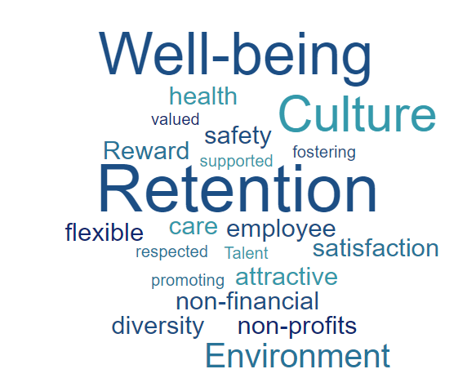

The main theme in the findings for this section is related to the culture of the organisation and how fostering an environment where people are valued, respected and supported by promoting the health, well-being, diversity and safety of staff can have a positive effect on employee retention.
The results also support (Elkus 2018), who suggests that non-profits should look into non-financial reward methods more closely to boost employee satisfaction and retention by offering attractive benefits and taking care of the well-being of employees by offering flexible working hours.
R1 explained, “We don't have a problem with retention as the number of people who are leaving the Organisation is very low and this is because we have a good culture”
R2 stressed, “We aim to create a working environment in which our staff feel supported, respected and empowered…our strategy outlines key actions that are required to support our commitment to promote the health, well-being and safety of our staff”.
The other common theme is related to the great impact managers and leaders have on employee retention in terms of providing employees with the needed support and development opportunities.
R2 stressed that, “We recognise that good management practice is essential for fostering the healthy, secure and motivated workforce needed to deliver our mandate. Especially the support to personnel assigned to insecure, isolated and difficult environments”.
R4 clarified, “We aim to have inspiring leaders who can put things into context to enable self-leadership and responsibility among co-workers. We know that people thrive when they are part of a well-functioning team. We work actively to promote diversity and counteract discrimination and see differences in perspective and background. We also aim to have leaders who are supportive of staff development and growth. We understand that without this, employees will feel disengaged, unsatisfied and not supported to do their job properly and productively which can lead to employees leaving the organisation and looking for better opportunities outside”.
These views comply with a study by Gallup (Deloitte Insight 2019), which revealed that around 50% of employees leave their organisations because of their manager, as bad managers are a primary reason of stress for employees (Eggers et al. 2019). Therefore, as mentioned in Chapter 2 that wellness activities must also focus on the improvement of management practices since management support is essential for promoting a caring culture where employees feel that they are valued and cared for which can increase not only talent retention but also employee productivity (Thomas 2019).

4.9 Challenges and Benefits of Implementing TM Strategies:
In terms of challenges, the main theme in the findings is related to the retention of talented employees. Although, organisations in the sample do not have retention problems on the short-term, but they do have a problem with making long-term commitments to employees due to the uncertainty of the flow of resources, which could lead to high rates of turnover, as firms are at times forced to terminate the contract of staff after the accomplishment of a project (see Appendices – Table 7), This complies with the views of Schmidt (2016) in chapter 2, where it was explained that non-profits experience difficulties to make longer-term TM plans since humanitarian aid can have restrictions/ time limits and funds can be allocated for special projects or specific programmes (Schmidt, 2016).
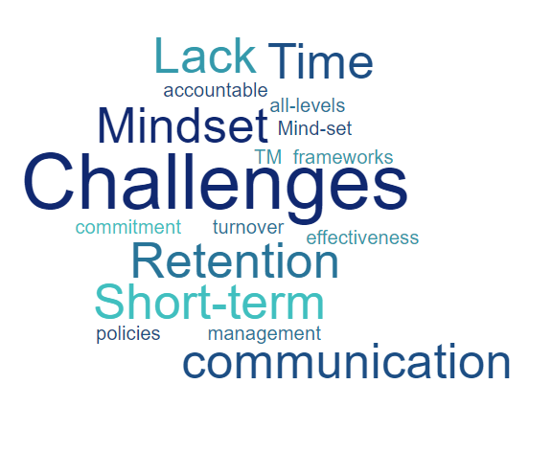
R1, explained, “The challenge is that we work in emergency settings, therefore, we have people hired for a certain need on short term contracts and once the crisis is over, those people will leave even if we found people who are of high potential we cannot keep them because of budget restrictions”.
R6 clarified that, “People are always looking for better opportunities. Therefore, the implementation of such strategies and the investment of the staff will be risky, as we do not want to be just like a school for some people so they only join to develop their skills and then go to look for other opportunities, so you will train people and then they will take their suitcase of knowledge and go to the next level outside”.
The other common theme is related to difficulties in creating a mind-set where people will understand the need of TM frameworks to contribute to the effectiveness of the policies and this could be mainly due to lack of time spent by management to invest in TM activities and communicate the benefits of such strategies to all employees. The findings support (Ready and Conger, 2003) views, where they suggest that everyone in the organisation should be accountable for implementing such strategies and to make sure it is properly communicated within all levels of the organisation from CEOs, HR, line managers to the employees themselves.
R2 stressed, “We face difficulties in creating a mind-set where people will understand the need for TM strategies so everyone will work towards that to contribute to the effectiveness of the policies”.
R5 explained, “For a small organisation like ours, we find it challenging to introduce such concepts and to make people understand why we are doing this and how it will affect them”.
In terms of benefits to the organisation, the results comply with the research findings in (chapter 2) where it was highlighted that such strategies can have an effect on workforce productivity by improving the practices for attracting, retaining, and developing individuals to obtain the needed skills, competencies and capabilities to meet the present and future organisational objectives (Masa’deh et al 2018).
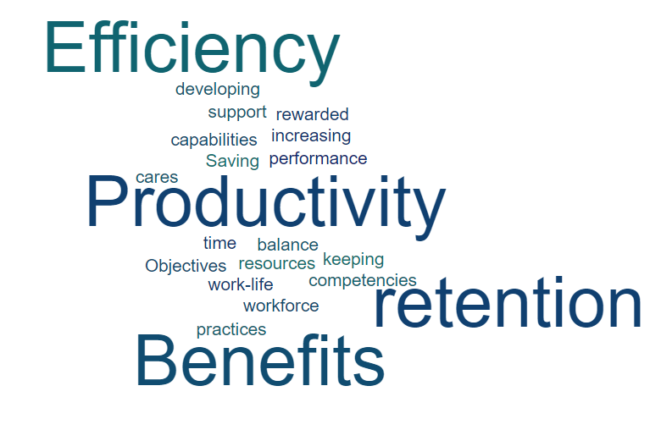
R1 explained, “We are a learning Organisation, there are huge benefits of having a talent management strategy, and also Organisation as big as ours and at the forefront of refugee and we are a solutions provider, therefore we need to be able to have good people working for us, people who are well-trained and well-developed”.
R4 clarified, “So, implementing such strategies will provide sustainability and strengthen our role as non- profit, working for the benefit of our youth”.
R6 highlighted, “Having TM strategies can benefit the organisation by shaping the employees with the history, culture and values of the organisation. In addition, if the organisation is aiming to be innovative in its field of expertise, then developing your own talent could help you being creative, because if your people know your values, history and the core of the organisation, then they are able to address challenges and come up with creative ideas to take the organisation to the next level”.
Also, the other benefit will be retention, keeping and developing your own people can have an effect on the organisation as gaping positions is always costly not only in terms of money but also in terms of saving time and increasing the efficiency. Also, people inside the organisation will feel rewarded for their performance and feels that the organisation cares about what they do and support them in their work-life balance.
R5 explained, “Having good TM strategies, where employees feel that they are valued and developed can help to retain them, which in return can save us time and costs of keeping to fill positions”
R7 suggested, “When we develop our employees, believe in them and care for them, we gain their loyalty and trust and therefore, it will be harder for them to leave the organisation”.

4.10 TM and Organisational Performance:
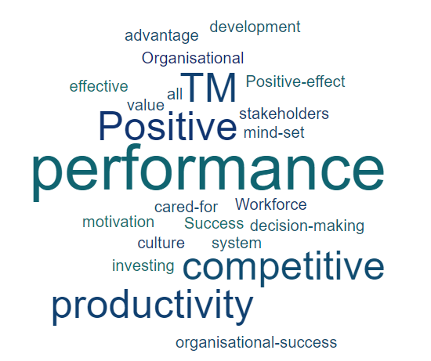
All seven organisations agree on that TM strategies have a positive effect on the organisation’s performance in terms of creating a mind-set where employees, management and stakeholders agree on that effective management of staff is a crucial part of ensuring a competitive system, one with a culture of recognising good performance, investing in staff development and keeping them motivated and cared for. This means better value for money, higher performance, and more informed decision-making, which complies with the views of Schiemann (2014) and several research studies, where it was confirmed that TM has a positive impact on competitive advantage, organisational success, and outcomes of organisational performance. According to Turner and Kalman (2014), having the right talent is essential for the effectiveness of the organisational strategy and the continuous success.
R2 stressed that, “With effective TM strategies, the performance of the people has become much better and understood by everyone and employees are built to what they expected of them, therefore, the organisational performance is getting better so we are achieving our purpose and mission and getting positive feedback from donors and other stakeholders (communities and governments)”.
R1 explained, “Effective management of staff is a crucial part of ensuring a competitive UN system, one with a culture of recognizing good performance, and sanctioning poor conduct or performance. Better management of staff skills and knowledge means better value for money, higher performance, and more informed decision-making”.
R5 also stressed, “I do believe that TM activities have a positive effect on the performance of the organisation as when we have staff that is loyal, accountable, cared for and developed, they become engaged and motivated which will affect their performance, which in turn will affect their ability to achieve our strategic and operational objectives, and ultimately our mission”.
R6 clarified, “If we believe that the current TM process has an impact on the capacity of the organisation to retain staff, to attract new staff and to remain as efficient and effective when implementing projects, so yes definitely, TM process has an impact on the organisational performance…because the people know the values and they are more committed and loyal”.
In terms of evaluating the effectiveness of TM strategies, the common themes were retention, staff satisfaction and the success of the implemented projects. In addition, four organisations highlighted that the successful implementation of capacity building plans to the organisational needs and goals can be another tool.
R6 suggested, “One measurement will be staff seniority, which means staff will stay longer in our organisation, so it is about retention. Also, the efficiency of your staff development, and how much your capacity building plans will match the organisational needs, this will be another measurement”.
R4 explained, “We evaluate the effectiveness of our strategies around people management by measuring the effects of the programmes we initiate on people and if our people are engaged with our mission they will provide excellent performance, which can have a positive effect on the success of our organisation”.
Those views conform with the research in Chapter 2 where OECD (2016) backed an evaluation framework that seeks to enhance accountability and transparency by providing evidence about the effectiveness and impact of development aid programmes (OECD, 2016). The responses also comply with CIPD (2018), where it was concluded that eventually, the success of the organisation could be one of the most effective evaluations of TM strategies.

Chapter 5: Conclusion and Recommendations:
Conclusion:
The research aimed to evaluate the importance of implementing TM strategies in the non-profit sector to enhance organisational performance. The conclusions drawn from the literature review and case studies provide several clear ways forward.
The literature on this topic suggests that since it is important for organisations to aim for high performance to succeed in today‘s growing worldwide rivalry and global changing environments, they are more aware of the importance of having loyal, skilled and knowledgeable workers, as key components for a competitive advantage (Sheehan, 2012a). Therefore, organisation are developing strategies to attract, retain, develop and manage talent internationally, where Talent management (TM) has proven to be an imperative strategic issue (Armstrong 2016).
The conclusions of this study suggest that organisations in the non-profit sector with different sizes, mandates and cultures are recognising the significance of developing TM strategies and how implementing such strategies can have a positive effect not only on workforce productivity but also on the organisation as a whole in terms of performance, growth and effectiveness. This will also help the organisation to meet the present and future organisational objectives.
The literature also suggests that defining talent in each organisation should be the starting point when creating TM strategies. However, the unique experiences and capabilities of each organisation can affect how talent is defined (Turner 2012), and the different approaches to this (everyone or high potential). Non-profits are no different from other organisations as it is important for them as well to focus on the right talent that can improve an organisation’s performance. A divergence of the literature was found in that the literature suggests that defining talent using the standard performance/ potential theory might be recognised as the straightforward definition of talent. However, the findings found that 6 out of 7 non-profits in this research, view talent as everyone in the organisation not only high performance/ potential, though, with an emphasis on having people who fit within the organisation and share the same values and purposes.
In the literature, it was highlighted that forming a TM strategy begins with workforce planning, where the organisation needs to evaluate the existing workforce competencies to identify future workforce needs (Cheese 2010). However, to be prepared for the future, organisations need to have a workforce with a combination of talents from diverse cultures which will help organisations to react to any challenge or opportunity quickly and innovatively, particularly in this global age, where diversity needs to be attained by organisations as one of the important strategic organisational goals (Garvin2001).
Yet, the research study suggests that most of those plans are short-term as six of the non-profit organisations in this sample work in emergency settings, therefore, having emergency rosters or talent pool is a must especially for large international non-profits to keep a flow of talented people when needed.
It was also emphasised in the literature that TM strategies need to focus on attracting the right individuals into the organisation and trying to retain them by investing in their development and paying attention to their different needs. While this is also the case in the non-profit sector where non-profits are able to attract talent easier by their purpose, they conversely find it difficult to develop and retain talent due to budget restrictions. As such, internal development programmes such as coaching, mentoring and secondment schemes can be amongst the most popular and preferred methods due to the low cost and effectiveness on talent development and retention.
Another divergence from the literature was found in the fact that in studies reviewed, all non-profits in the sample realised the importance of training programmes and development opportunities for organisational effectiveness. Therefore, all of them are offering training and development programmes either internally or externally. Talent development is clearly considered one of main strength in all organisations taking part in this research study, which contradicts with the findings in the literature review where it was noted that offering growth and development opportunities was ranked one of the main four reasons for management weakness in the non-profit sector. We can thus see the shift in mind-sets, where non-profits have realised that they need to focus more on growth and development since it can have a positive impact on the organisation in terms of increasing competitiveness and the effectiveness of its TM strategies such as attracting the right talent and retaining the most valuable employees. At the same time, it was found in the research study that on the job training, coaching & monitoring and sometimes offering secondment schemes are the most efficient and cost-effective ways to develop employees especially when the funding is scarce.
Furthermore, the literature states that fostering an environment where people are valued, respected and supported by promoting the health, well-being, diversity and safety of staff can have a positive impact on employee retention. This also tallies with the results in the research study. Therefore, organisations in the non-profit sector are starting to look into non-financial reward methods more closely to boost employee satisfaction and retention by offering attractive benefits and taking care of the well-being of employees by offering flexible working hours, encouraging diversity, equal opportunities and development.
It was also explained in the literature that organisations need to understand the benefits and costs of TM decisions to be prepared for future challenges. One of the main challenges highlighted in the literature is talent retention in the non-profit sector and this is due to lack of development opportunities as it is difficult to make longer-term TM development plans since humanitarian aid can have restrictions/ time limits and funds can be allocated for special projects or specific programmes (Schmidt, 2016).
However, the research study found that talent retention is one of the main challenges in the non-profit sector, not due to lack of development opportunities but due to employees being attractive to other organisations as a result of them being developed and cared for. Therefore, this means losing employees to other organisations but gaining new employees due to the non-profit being attractive in terms of creating development opportunities and capacity building.

The literature concluded that TM strategies are important for the future of organisations since they contribute to the growth of the organisation and help the firm to achieve its strategic goals as having the right talent is essential for the effectiveness of the organisational strategy and continuous success. The research study recognised and confirmed that TM strategies have a positive effect on the organisation’s performance in terms of creating a mind-set where employees, management and all stakeholders agree on that effective management of staff is a crucial part of ensuring a competitive system, one with a culture of recognising good performance, investing in staff development and keeping them motivated and cared for which means better value for money, higher performance, and more informed decision-making. This can form a TM model strategy for any organisation especially in the Non-profit sector since it is important for the effectiveness of the organisational performance.
However, the effectiveness of TM strategy depends on the right implementation approach of such strategies, which in return can be considered as one of the most important measures that lead to outstanding organisational performance (Foster et al.,2007). Therefore, the research study concluded that to have effective TM strategies, everyone should be accountable for implementation processes with HR overseeing the procedures and the managers creating the proper environment and giving the appropriate support to enable the correct implementation to achieve the objectives of the organisation, which in return could increase productivity and enhance the organisational performance. Therefore, the evaluation of the organisational performance in the non -profit sector relies on the enhancement of accountability and transparency to achieve not only organisational effectiveness but also efficiency, sustainability, reputation and influence (OECD, 2016). Having effective TM strategies can form the base of a high-performance culture, where organisational structure, people and procedures work together to achieve organisational goals (Noe et al, 2016).

5.1 Recommendations:
In addition to the findings and conclusions of research study, the last question in the interview helped mould the recommendations, concerning the vision of each organisation in the sample study on the importance of talent for the future of their non-profits (Appendices):

- The main priority in the non-profit sector is to understand that TM is about not only creating policies and procedures to attract, develop and retain talent but also about fostering an environment where people are valued, respected and supported by promoting the health, well-being, diversity and safety of staff. Thus, organisations in the non-profit sector should look into non-financial reward methods more closely in to boost employee satisfaction and retention by offering attractive benefits and taking care of the well-being of employees by offering flexible working hours, encouraging diversity, equal opportunities and work-life balance (Elkus 2018). .

- Non-profit organisations need to work on changing the mind-sets of people by creating a culture where everyone can understand the purpose of TM framework and the positive effects such strategies can have on the individual growth, development, performance, productivity and sustainability. As a result, people are encouraged to pursue talent, contributing to building a talent culture where everyone feels responsible for the organisational success, which in turn will help organisations to meet the present and future organisational objectives firm (Brown et al. 2016, Deloitte).

- Organisations in the non-profit sector should take into consideration their unique experiences and capabilities when designing and implementing TM frameworks to make sure TM strategies are fit for purpose (Turner 2012). As a result, they will not lose their identity in the process of copying other frameworks. Therefore, designing TM strategies should be aligned with the organisational strategy, purpose, mission and vision to achieve effectiveness (Ingham et al., 2008).

- Non-profits need to understand that offering training and development opportunities for staff are not only significant for the organisation in terms of effectiveness and competitiveness but also in terms of creating a culture of growth, creativity and innovativeness, which in turn will attract potential talent and retain the most valuable employees (Chami-Malaeb 2013).

- The new generation of talent has different needs and expectations. Non-profits should therefore cater to those needs and manage expectations. Non-profits need to understand that Talent in the future is going to be very dynamic, as a result, organisations should make sure that TM policies are up-to-date, flexible, efficient and functional when the needs for talent are changing (Sinclair 2014).

5.2 Limitations and Suggestions for Future Research:
The research study had few limitations that were highlighted in the methodology chapter in more detail, giving suggestions and highlighting the gaps for additional research studies to be conducted in these areas in the future.
The research was limited in its sample size, being focused on the non-profit sector and limited to seven interviews in seven non-profits from local and international organisations in Jordan. Therefore, the research would benefit from covering larger regions. However, the outcomes of this research will not only be of importance to the non-profit sector in Jordan but also internationally as it will showcase TM strategies for attracting, identifying, developing and retaining employees, which is vital in achieving the objectives of any organisation. Furthermore, TM concepts and theories are ambiguous especially in the context of non-profits. As a result, the researcher experienced difficulties in approaching non-profit organisation in Jordan and introducing the concept of TM to them, as the subject is still not very familiar and confusing to some in the sector, especially small local non-profits. Therefore, the perspective of the researcher indicating and relating to specific terms or concept has influenced the results of the analysis. Despite this, the researcher selected carefully different visions and theories when introducing those concepts to the participants, which enabled them to discuss these various views and relate to them. This research study focused on the HR viewpoint, which can be regarded as something that can be further challenged by conducting research based on other perspectives. For example, the viewpoints of employees or even the talents themselves could be of interest and bring new insight into the research field of Talent Management.

6. References:
Aarnio, A. & Kimber, E. (2016). Talent Management & Strategy: Identifying Patterns through a Multiple Case Study. [Online]. Available at: https://pdfs.semanticscholar.org/7659/80ba4c9d446791771e18b141fc2dd995b7d3.pdf [Accessed: 18 Jan 2019].

Armstrong, M. &Taylor S. (2014), Armstrong’s Handbook of Human Resource Management Practice, 13th edition. (Online.) Available at: https://otgo.tehran.ir/Portals/0/pdf/Armstrong%27s%20Handbook%20of%20Human%20Resource%20Management%20Practice_1.pdf (Last accessed: 25th of Feb 2019).

Armstrong, M. (2011). Armstrong's Handbook of Strategic Human Resource Management, 5th Edition. Philadelphia, Pa.: Kogan Page. [e-book]. Available at: http://library.books24x7.com.e.bibl.liu.se/assetviewer.aspx?bookid=43644&chunkid=9893072 39&noteMenuToggle=0&leftMenuState=1 [Last accessed: 11 Jan 2019].

Armstrong, M. (2016) Armstrong's Handbook of Strategic Human Resource Management. London: Kogan Page.

Armstrong, M. (2017) Armstrong’s Handbook of Human Resource Management Practice 14th ed. Kogan Page.

Ashton, C. and Morton, L. (2005). Managing Talent for Competitive Advantage: Taking a Systemic Approach to Talent Management." Strategic HR Review 4(5): 28-31.

Baxter, P. & Jack, S. (2008). Qualitative Case Study Methodology: Study Design and Implementation for Novice Researchers. The Qualitative Report, 13(4), pp.544-559

Beechler, S., & Woodward, I. C. 2009. The global “war for talent.” Journal of International Management, 15(3): 273–285.

Beheshtifar Malikeh, Nasab Hojat Yossefi, and Moghadam Mahmood Nekoie. (2012). Effective Talent Management: A Vital Strategy to Organisational Success . International Journal of Academic Research in Business and Social Sciences, 2(12), 227-234. ISSN: 2222-6990.

Beiske, B. (2007). Research Methods: Uses and limitations of questionnaires, interviews and case studies, Munich: GRIN Verlag.

Bell, E. & Bryman, A. (2007). “The ethics of management research: an exploratory content analysis”, British Journal of Management. 18(1) 63-77.

Bethke-Langenegger, P. (2012). The differentiated workforce: Effects of categorization in talent management on workforce level. Unpublished working paper, No.18. Switzerland: Department of Business Administration, University of Zurich.

Bethke-Langenegger, P., Mahler, P., & Staffelbach, B. (2011). Effectiveness of talent management strategies. European Journal of International Management Vol. 5, No. 5, 524-539.

Björkman, I., Ehrnrooth, M., Mäkelä, K., Smale, A., & Sumelius, J. 2013. Talent or Not? Employee Reactions fo Talent Identification. Human Resource Management, 52(2): 195–214.

Blass, E. (2009). Talent management: cases and commentary. Houndsmills: Palgrave MacMillan.

Brown D., Bersin J., Gosling W. and Sloan N.,(2016). Engagement. Deloitte Insight. (Online). Available at: https://www2.deloitte.com/insights/us/en/focus/human-capital-trends/2016/employee-engagement-and-retention.html (Accessed on the 9th Jan 2019).

Bryman, A., & Bell, E. (2011). Business Research Methods (3rd ed.) Oxford: Oxford University Press.

Bryman, A., & Bell, E. (2015). Business research methods. Oxford university press.

Cappelli, P. (2008). Talent management for the twenty-1st century. Harvard Business Review, March, 74-81.

Cappelli, P. (2008). Talent on demand: Managing talent in an age of uncertainty. Boston: Harvard Business Press.

Cappelli, P. (2008). The Talent Management Problem. In P. Cappelli, Talent on demand - Managing Talent in an Age of Uncertainty (pp. 1-10). Boston: Harvard Business Press.

Cappelli, P. (2009). What's old is new again: Managerial “talent”in an historical context. Research in Personnel and Human Resources Management,28, 179–218.

Cascio, W. F. 2006. The Economic Impact of Employee Behaviors on Organisational Performance. California Management Review, 48(4): 41–60.

Cecil, R. and Rothwell, W. (2007). Next Generation Management Development: The Complete Guide and Resource. San Francisco: Pfeiffer and Co.

Chami-Malaeb, R., & Garavan, T. (2013). Talent and leadership development practices as drivers of intention to stay in Lebanese organisations : the mediating role of affective commitment. International Journal of Human Resource Management, 24(21): 4046–4062

Cheese, P., Thomas, R.J. and Craig E. (2008). The Talent Powered Organisation: Strategies for Globalization, Talent Management and High Performance.Kogan Page.

Cheese, P., Thomas, R.J. and Craig E. (2008). The Talent Powered Organisation: Strategies for Globalization, Talent Management and High Performance.Kogan Page.

Chertavian G., (2013), Nonprofits Need to Compete for Top Talent. (Online). Available at: https://hbr.org/2013/03/nonprofits-need-to-compete-for (Accessed on the 9th Dec 2018).

Chuai, X., Preece, D., & Iles, P. (2008). Is talent management just “old wine in new bottles”?: The case of multinational companies in Beijing. Management Research News,31(12), 901–911.

CIPD (2015) Employee engagement: an introduction factsheet CIPD. (Online) Available at: https://www.cipd.co.uk/knowledge/fundamentals/relations/engagement/factsheet (Accessed: 10th April 2017).

CIPD (2015). Learning and Development. ANNUAL SURVEY REPORT. Available at: https://www.cipd.co.uk/Images/learning-development_2015_tcm18-11298.pdf (Accessed on the 9th Jan 2019).

CIPD (2018), HRM and talent management – driving performance. (Online) Available at: https://www.cipd.co.uk/knowledge/fundamentals/hrmandtalentmanagement/engagement/factsheet (Accessed: 29th Jan 2019).

CIPD (2018), Talent management. (Online) Available at: https://www.cipd.co.uk/knowledge/fundamentals/relations/talentmanagement/factsheet (Accessed: 29th Jan 2019).

CIPD, Factsheet (2013) Talent Management: an overview. Available at: http://www.cipd.co.uk/hr-resources/factsheets/talent-management-overview.aspx (Accessed: 24 March 2017).

Claeyé, F. (2014). Managing Nongovernmental Organisations: Culture, Power and Resistance. New York: Routledge.

Collings, D. G., & Mellahi, K. 2009. Strategic talent management: A review and research agenda. Human Resource Management Review, 19(4): 304–313.

Corbridge, M. & Omotayo, M. (2013). Talent Management Practices: Recruiting and Retaining Employees. In Hall, D., Pilbeam, S. & Corbridge, M., (Eds.), Contemporary Themes in Strategic People Management: A Case-Based Approach (pp.97-100). New York: Palgrave Macmillan. [ebook]. Available at: https://books.google.se/books?hl=en&lr=&id=bSkdBQAAQBAJ&oi=fnd&pg=PA97&dq=talent+m anagement+practices&ots=oktS0rA_Qx&sig=DZa_- 9eiY9ZVaogX74AP9N55Hu4&redir_esc=y#v=onepage&q=talent%20management%20practices &f=false [Accessed: 18 March 2019].

Creswell, J.,W. (2007). Research design. Qualitative and mixed methods approaches. London: Sage.

Creswell, John W. (2013). Qualitative inquiry and research design: Choosing among five approaches. Thousand Oaks, CA: Sage.

Creswell, John W. (2014). Research design: Qualitative, quantitative and mixed methods approaches (4th ed.). Thousand Oaks, CA: Sage.

Creswell, John W.; Hanson, William E.; Plano Clark, Vicki L. & Morales, Alejandro (2007). Qualitative research designs: Selection and implementation. The Counseling Psychologist, 35(2), 236-264. doi: 10.1177/0011000006287390

Duriau, Reger, & Pfarrer, (2007).A Content Analysis of the Content Analysis Literature in Organisation Studies: Research Themes, Data Sources, and Methodological Refinements. Organisation Research Methods, 10: 5–34.

Eede, C., (2018). DIVERSITY IN TALENT MANAGEMENT: ‘BEING DIFFERENT’ REALLY MAKES A DIFFERENCE’ [e-book]. Available at: https://www.libertyglobal.com/blog/diversity-in-talent-management-being-different-really-makes-a-difference/ [Accessed: 4 April 2019].

Eggers, W., O'Leary, J. and Datar A. ( 2019). The future of work in government. Navigating a shifting talent landscape. Deloitte Insight. ( Online). Available at: https://www2.deloitte.com/insights/us/en/industry/public-sector/future-of-work-in-government.html?id=us:2em:3na:4di4970:5awa:6di:031319&ctr=cta&sfid=0031O00002zz1SAQAY (Accessed on the 15 March 2019).

Eisenhardt, K.M., and M.E. Graebner. 2007. Theory building from cases: opportunities and challenges.Academy of Management Journal 50: 25–32.

Elkus, B. (2018). NONPROFIT TALENT TRENDS FOR 2018. JPS Nonprofit.( Online) Available at: https://jpsnonprofit.com/nonprofit-talent-trends-for-2018/(Accessed on the 7th Feb 2019).

Ensour A., ( 2015) DUCATION FOR PROSPERITY: DELIVERING RESULTS A National Strategy for Human Resource Development 2016 – 2025. (Online) Available at: http://www.mohe.gov.jo/en/Documents/National-HRD-Strategy.pdf (Accessed on the 10th March 2019).

Eriksson, P., & Kovalainen, A. 2008. Qualitative Methods in Business Research. London: SAGE Publications Ltd.

Executive Summary. (Online). Available at: https://www.roffeypark.com/wp-content/uploads2/Nine-Box-Grid-Exec-Summary-1.pdf (Accessed on the 9th Jan 2019).

Flick, U. (2011). Introducing research methodology: A beginner’s guide to doing a research project. London: Sage.

Foster, C., Harris, L., Stewart, J., Sempik, A., Tansley, C., Turner, P., and Williams, H. (2007 ) ―Talent-management Research insight‖, CIPD, London.

Gallardo-Gallardo et al. / Human Resource Management Review 23 (2013) 290–300

Garavan, T. N., Carbery, R., & Rock, A. 2012. Mapping talent development: definition, scope and architecture. European Journal of Training and Development, 36(1): 5–24.

Garrow, V. & Hirsh, W. (2008). Talent Management: Issues of Focus and Fit. Public Personnel Management, 37(4), pp.389-402.

Garvin DA (2001). The strategic asset of workplace diversity. Harvard Business Review 37
Goddard, W. & Melville, S. (2004). Research Methodology: An Introduction, (2nd ed.) Oxford: Blackwell Publishing.

Gou, C., Brown, W. A., & Ashcraft, R. F. (2011). Strategic Human Resources Management in Nonprofit Organisations. Review of Public Personnel Administration, 248-269.

Grant, R. M. (2013). Contemporary Strategy Analysis. 8th Edition. Chichester, West Sussex: Wiley.

Gritter, E (2011), Time Management Tips for Dissertation Writing. (Online.) Available at: http://thesawh.org/wpcontent/uploads/2012/06/Gritter_Revised_Time_Management_Tips_SAWH_Toolkit_Submission.pdf(Accessed: 11th of December 2018).

Groves, K. 2011. Integrating leadership development and succession planning best practices. IEEE Engineering Management Review, 39(3): 239–260

Guthridge, M., Komm, A. B., & Lawson, E. (2008). Making talent a strategic priority. McKinsey Quarterly, 1(November 2007): 3–6.

Hammersley, M. (2013). What is Qualitative Research? London and New York: Bloomsburry.

Hancock B., Hioe E., and Schaninger B., (2018). The fairness factor in performance management. McKinsey Quarterly. (Online). Available at: https://www.mckinsey.com/~/media/McKinsey/Business%20Functions/Organisation/Our%20Insights/The%20fairness%20factor%20in%20performance%20management/The-fairness-factor-in-performance-management.ashx(Accessed on the 9th Jan 2019).

Haturn, A. (2010). Next Generation Talent Management: Talent Management to Survive Turmoil. London: Palgrave Macmillan.

Hor, F.C., Huang, Liang-Chih, Shih, Hsu-Shih, Lee, Yen-Hua, and Lee, Stanley. (2012). Establishing Talent Management for Company s Succession Planning through Analytic Network Process: Application to an MNC Semiconductor Company in Taiwan . Computers and Mathematics with Applications, 60, 528 540.

Huczynski, A. A., & Buchanan, D. A. (2013). Organisational Behaviour - 8th ed. Edinburgh: Pearson Education Limited.

Huselid, M. A., Beatty, R. W., & Becker, B. E. (2005). “ A Players ” or “ A Positions ”? The Strategic Logic of Workforce Management “ A Players ” or “ A Positions ”? Harvard Business Review, December.

Huselid, M. A., Beatty, R. W., & Becker, B. E. 2005. “ A Players ” or “ A Positions ”? The Strategic Logic of Workforce Management “ A Players ” or “ A Positions ”? Harvard Business Review, December.

IDare for Sustainable Development (2019). Available at: https://www.i-dare.org(Accessed on the 25th March 2019).

Iles, P., Chuai, X., & Preece, D. (2010). Talent management and HRM in multinational companies in Beijing: Definitions, differences and drivers. Journal of World Business,45(2), 179–189.

immap Website (2019). Available at: https://immap.org/who-we-are/(Accessed on the 2nd April 2019).

Information and Research Center - King Hussein Foundation-IRCKHF (2018). 2017 Civil Society Organisation Sustainability Index for Jordan Report. ( Online) Available at: http://haqqi.info/en/haqqi/research/2017-civil-society-Organisation-sustainability-index-jordan (Accessed on the 12th March 2019).

Ingham, J., Annunzio-green, N. D., Maxwell, G., Watson, S., Hughes, J. C., et al. (2008). Strategic HR Review.

Irtaimeh H., Al-Azzam Z., and Khaddam A., (2016), EXPLORING THE IMPACT OF TALENT MANAGEMENT STRATEGIES AND SERVICE QUALITY ON BENEFICIARIES SATISFACTION IN JORDAN HEALTHCARE SECTOR: PROVIDER POINT OF VIEW. (Online). Available at: https://www.researchgate.net/publication/311563693_EXPLORING_THE_IMPACT_OF_TALENT_MANAGEMENT_STRATEGIES_AND_SERVICE_QUALITY_ON_BENEFICIARIES_SATISFACTION_IN_JORDAN_HEALTHCARE_SECTOR_PROVIDER_POINT_OF_VIEW (Accessed on the 9th Feb 2019).

Jayawickrama, S. 2011. Developing managers and leaders: Experiences and lessons from international NGOs. A Hauser Center- Harvard Humanitarian Initiative (HHI) Report. http://dash.harvard.edu/ handle/1/7784444.

Juneja, C., (2018). Benefits of Talent Management . Management Study Guide. (Online). Available at: https://www.managementstudyguide.com/benefits-of-talent-management.htm(Accessed on the April 2nd 2019).

Kaplan, R. S. (2001). Strategic Performance Measurement in Nonprofit Organisations. JosseyBase.

KEHINDE, J., PhD, ACA (2012), Talent Management: Effect on Organisational Performance. (Online.) Available at: http://macrothink.org/journal/index.php/jmr/article/viewFile/937/1286. (Accessed: 27th of November 2018).

Kontoghiorghes, C. 2016. Linking high performance Organisational culture and talent management: satisfaction/motivation and Organisational commitment as mediators. The International Journal of Human Resource Management, 27(16): 1833–1853.

Kramer, K., (2011). On-the-Job Development Opportunities for Nonprofit Staff. The Bridgespan Group. (Online). Available at: https://www.bridgespan.org/bridgespan/images/articles/on-the-job-development-opportunities/OnTheJobDevelopmentOpportunities.pdf?ext=.pdf (Accessed on the 9th Feb 2019).

Kuper A, Lingard L, Levinson W (2008). Critically appraising qualitative research. BMJ ;337:a1035. doi:10.1136/bmj.a1035FREE Full TextGoogle Scholar

Kvale, S. (2009) “Doing Interviews”. Sage Publications Ltd.

Lewis, R. E., & Heckman, R. J. 2006. Talent management: A critical review. Human Resource Management Review, 16(2): 139–154.

Llamas, C., (2018). The importance of talent management and why companies should invest in it. (Online). Available at: https://www.humanresourcesonline.net/the-importance-of-talent-management-and-why-companies-should-invest-in-it/ (Accessed on the April 2nd 2019).

Lockwood, Nancy. R. (2007). Leveraging employee engagement for competitive advantage: HR’s strategic Role. SHRM, Research Quarterly.

Mapelu, I., & Juma, L. (2013). Effects of training and development on employee turnover in selected medium sized hotels in Kisumu city, Kenya. Journal of Tourism, Hospitality and Sports, 1, 43-48. Re. (Online). Available at: http://iiste.org/Journals/index.php/JTHS (Accessed on the 9th July 2019)

Maram for Relief and Development (2019). (Online). Available at: http://maramfoundation.org/about-us-2/ (Accessed on the 9th Jan 2019).

Masa’deh R., Yassin H., Shatnawi Y., and Obeidat B.(2018). Bader Reviewing the Literature of the Effect of Talent Management on Organisational Effectiveness. (Online). Available at: http://www.centreofexcellence.net/J/JSS/Vol7/No2/JSSarticle6,7_2_pp139-156.pdf(Accessed on the 9th Dec 2018).

Maxwell, J. A. (2012). Qualitative research design: An interactive approach. London: Sage.

Meyers, M. C., van Woerkom, M., & Dries, N. (2013). Talent —Innate or acquired? Theoretical considerations and their implications for talent management. HumanResource Management Review,23(4), 305–321.

Noe, R. A., Hollenbeck, J. R., Gerhart, B., & Wright, P. M. (2016). Fundamentals of Human Resource Management - 6th ed. New York: Mc Graw Hill Education.

Nonprofit HR (2017). Five Key Takeaways from the 2017 Nonprofit Talent Management Priorities Survey. (Online) Available at:https://www.nonprofithr.com/five-key-takeaways-2017-nonprofit-talent-management-priorities-survey/( Accessed on the 2nd April 2019).

OECD. (2016). Evaluation Systems in Development Co-operations: 2016 Review. Paris: OECD publishing.

Ollis, J. & Hussey, R. (2009). Business Research: A Practical Guide for Undergraduate and Postgraduate Students, (3rd Ed.), New York: Palgrave Macmillan.

Palotta, D. (2010). Uncharitable. Lebanon, NH:Tuffs University Press.

Palotta, D. (2010).Charity case. San Francisco:Jossey- Bass.

Parry, E., Emmens, B., Williamson, C., & Dickmann, M. 2010. Engaging Tomorrow’s Global Humanitarian Leaders Today. London and Granfield.

Poorhosseinzadeh, Mahan and Subramaniam, Indra Devi. (2013). Talent Management Literature Review . Australian Journal of Basic and Applied Sciences, 7(6), 330 338.

Power, E., (2017). Why Diversity Matters in Your Workplace -- and How to Achieve It. (online). Available at: https://www.inc.com/rhett-power/why-diversity-matters-in-your-workplace-how-to-achieve-it.html. ( Accessed on the April 2nd 2019).

Ready, D. A., & Conger, J. A. 2007. Make Your Company a Talent Factory. HBR, (June).

Ready, D. A., & Conger, J. A., (2007). How to Fill the Talent Gap. Online Wall Street Journal.Retrieved October 27, 2015, from http://online.wsj.com/article/SB118841695428712511.html. (Accessed on the 9th Dec 2018).

Ready, D.A. and Conger, J.A. (2003). Why Leadership-Development Efforts Fail. MIT Sloan Management Review 44(3): 83-88.

Saunders, M., Lewis, P. and Thornhill, A. (2012). Research Methods for Business Students (6th edition). Harlow: Pearson.

Saunders, M., Lewis, P. and Thornhill, A. (2016). Research Methods for Business Students (7th edition). Harlow: Pearson.

Schaufeli W.B., Bakker A.B. (2004), Job demands, job resources and relationshipwith burnout and engagement: a muli-sample study, “Journal of Organisational Behaviour”, Vol. 25, p. 293-315

Schiemann, W. A. 2014. From talent management to talent optimization. Journal of World Business, 49(2): 281–288.

Schiemann, W. A.. From talent management to talent optimization, Journal of World Business, 2014, 49: 281–288.

Schmidt, J. (2016). Nature of NGO Volunteers' and Employee' Motivation. Implications and Recommendations for Managerial Staff.

Schofield, K. (2013) Cultural Fit in the Workplace: How Personality Affects Hiring and Teamwork. (Online) Available at: https://www.eremedia.com/ere/cultural-fit-in-the-workplace-how-personality-affects-hiring-and-teamwork/ (Accessed on the 7th April 2017).

Sheehan, M. (2012), Developing Managerial Talent: Exploring the link between management Talent and perceived Performance in Multinational Corporations (MNCs)’, European Journal of Training and Development, Vol.36,pp.66-85.

Silzer, R. & Dowell, B. E. (2010). Strategy-Driven Talent Management. San Francisco: Jossey-Bass. [e-book]. Available at: http://library.books24x7.com.e.bibl.liu.se/toc.aspx?site=XDC3X&bookid=33657 [Last accessed: 16 March 2019].

Sinclair C. (2014), Talent Management-Keeping the Right People on the Bus, (online). Available at: https://www.nonprofitkinect.org/article/4930-talent-management%E2%80%94keeping-the-right-people-on-the-bus (Last accessed: 25th of February 2019).

Smith J, Noble H. Bias in research. Evid Based Nurs 2014;17:2–3. doi:10.1136/eb-2014-101946PubMedGoogle Scholar

Snell, S.A. and Dean Jr., J.W. (1992) ‘Integrated manufacturing and human resource management: a human capital perspective’, Academy of Management Journal, Vol. 35, No. 3, pp.467–504.

Soane, E. (2013) ‘Leadership and employee engagement’, in Truss, C., Delbridge, R., Alfes, K., Shantz, A.

Sparrow, P. R., Scullion, H. & Tarique, I. (2014). Strategic Talent Management: Contemporary Issues in International Context. Cambridge: Cambridge University Press. [e-book]. Available at: http://library.books24x7.com.e.bibl.liu.se/toc.aspx?site=XDC3X&bookid=69075 [Last accessed: 4 April 2019].

Stahl, G. K., Björkman, I., Farndale, E., Morris, S. S., Paauwe, J., Stiles, P., Trevor, J. & Wright, P. M. (2012). Six Principles of Effective Global Talent Management. Sloan Management Review, 53(2), pp.25-42.

Stake, R. (1995). The art of case study research. Thousand Oaks, CA: Sage.

Stewart L. (2012), Leaders and Employee Involvement- IA CEO. (Online). Available at: https://www.youtube.com/watch?v=UQWzz9VdiU4(Last Accessed: 11th March 2019)

Tangen, S. (2005). Demystifying productivity and performance. International Journal of Productivity and Performance Management, 54(1), 34-46.

Tansley, C., Turner, P., Carley, F., Harris, L., Sempik, A., Stewart, J., et al. (2007). Talent: Strategy, management, measurement. London: Chartered Institute of Personnel and Development (CIPD).

Taylor, S. (2014) Resourcing and Talent Management. London: Kogan Page

The Office of the United Nations High Commissioner for Refugees (UNHCR), ( 2019). Available at: https://www.unhcr.org/(Accessed on 20th March 2019)

The United Nations Office for the Coordination of Humanitarian (OCHA), (2019). Available at: https://www.unocha.org/about-us/who-we-are(Accessed on 28th March 2019)

Thomas, J. & Hatcher (2018). THE KEY TO RETAINING TALENT. The leader’s role in creating a supporting and caring culture.(Online). Available at:https://www.roffeypark.com/wp-content/uploads2/The-Key-to-Retaining-Talent.pdf(Accessed on the 28th Feb 2019).

Thomas, J. (2019). Retaining talent with leadership that cares. HR Magazine. (Online). Available at: https://www.hrmagazine.co.uk/article-details/retaining-talent-with-leadership-that-cares (Accessed on the 28th Feb 2019).

Trudel, N. (2011). Who is Responsible for Talent Management? (Online). Available at: http://www.employee-performance.com/blog/who-is-responsible-for-talent-management/ (Last accessed on the 2nd of Jan 2019).

Turner, P. & Kalman, D. (2014). Make Your People Before You Make Your Products: Using Talent Management to Achieve Competitive Advantage in Global Organisations. Chichester: Wiley. [ebook]. Available at: https://books.google.se/books?id=8sDlBQAAQBAJ&pg=PR4&lpg=PR4&dq=turner+and+kalman +2014&source=bl&ots=s9oK- 69 h5Li1&sig=UO_3JZxSbDi_IK5_WP7HLdZRtTw&hl=en&sa=X&ved=0ahUKEwjAzdSHvOPMAhVhIJ oKHfs3C28Q6AEIJjAC#v=onepage&q=turner%20and%20kalman%202014&f=false [Last accessed: 17 Jan 2019].

Turner,P. A (2012) Stamford Global Talent for Tomorrow Summit, 23-25 April, Vienna.

Tymon, W. G., Stumpf, S. A., & Doh, J. P. 2010. Exploring talent management in India: The neglected role of intrinsic rewards. Journal of World Business, 45(2): 109–121.

Ulrich D. (2019). From Workforce to Worktask Planning. [Online]. Available at: https://www.linkedin.com/pulse/from-workforce-worktask-planning-dave-ulrich/ [Accessed: 18 Jan 2019].

Ulrich, D. (2011). Integrated talent management. In K. Oakes, & P. Galagan (Eds.), The executive guide to integrated talent management (pp. 189–211). Alexandria,Virginia: ASTD Press.

Ulrich, D., & Smallwood, N. (2012). What is talent? Leader to Leader,63,55–61.

Vaiman, V., Scullion, H., & Collings, D. G. 2012. Talent management decision making. Management Decision, 50(5): 2004–2013.

Vannoni, M; (2015) What Are Case Studies Good for? Vol 49, Issue 4, pp. 331 – 357

Waheed Sajjad, Zaim Abdülhalim, and Zaim Halil. (2012). Talent Management in Four Stages . The USV Annals of Economics and Public Administration, 12 1(15), 130-137.

Whelan, E. and Carcary, M. (2011). Integrating talent and knowledge management: Where are the benefits? . Journal of Knowledge Management, 15(4), 675-687.

Word J. and Sowa J. (2017). The Nonprofit Human Resource Management Handbook: From Theory to Practice. ( e-books). Available at: https://books.google.jo/books?id=rgkqDwAAQBAJ&pg=PT134&lpg=PT134&dq=talent+nonprofit+sector&source=bl&ots=9Tmyt2_rxH&sig=ACfU3U0wc8-yK52Ob1Qg8OV8K17Q1OgQoA&hl=en&sa=X&ved=2ahUKEwjJhIH_iOHhAhUtXhUIHfkjDIk4ChDoATAIegQICBAB#v=onepage&q=talent%20nonprofit%20sector&f=false (Accessed on the 12th Jan 2019).

Word, J. K. (2017). The Nonprofit Human Management Resource Handbook: From Theory to Practice. In Jessica E. Sowa, & Jessica K.A. Word (Eds.), New York, NY: Routledge.

Yarnall J. and Lucy D. (2015), IS THE NINE BOX GRID ALL ABOUT BEING IN THE TOP RIGHT?

Yin, R. K. (2013). Case Study Research: Design and Methods. 5th Edition. London: Sage Publications.

Yin, Robert K. (2014). Case study research: Design and methods. Los Angeles, CA: Sage.

Zikmund, W. G., Babin, B. J., Carr, J. C. and Griffin, M. ( 2010 ) Business Research Methods, th Ed. Canada: South

Consent Form

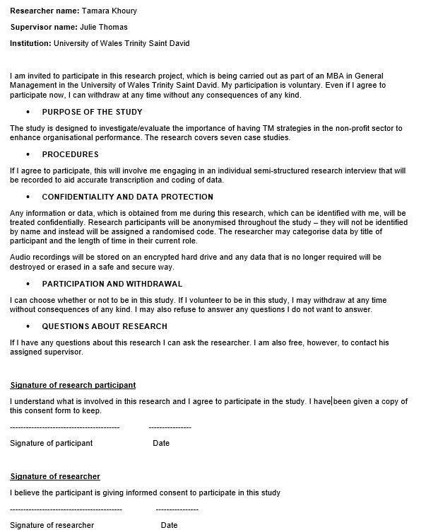

Overview of the Case-Study Organisations:

Organisation A: The Office of the United Nations High Commissioner for Refugees (UNHCR) is a UN agency with the mandate to serve people of concern, protect them and assist in their repatriation, integration or resettlement (UNHCR 2019). Almost 90 per cent of the UNHCR workforce is based in the field; therefore, one of the main competencies is the willingness to serve in hardship locations and being able to bring innovativeness by providing solutions to the people so they can build a better future. The organisation is driven by rotation and mobility with a diverse workforce from different backgrounds, therefore, the culture of wellbeing and duty of care is something very highly looked after.
Organisation B: The United Nations Office for the Coordination of Humanitarian ( OCHA) is a UN entity with a mission to mobilise and coordinate an effective humanitarian response to save lives and protect people in crisis and emergencies, and to advocate for the rights of people in need; promote sustainable solutions and information management to assess the needs ( OCHA 2019). Therefore, OCHA aims to build workforce capacities to achieve its mandate. OCHA is building a culture of accountability as well as promoting the health, well-being and safety of its people since OCHA trusts that people are OCHA’s foundation and therefore, OCHA requires a flexible, diverse, gender-balanced and mobile workforce.
Organisation C: iMMAP is a global non-profit organisation with a mission to employ the influence of information to enable evidence-based decisions so people lives can be improved as a result (iMMAP 2019). iMMAP supports other non-profits, UN agencies and humanitarian organisations to solve strategical and operational challenges by transforming data into information and providing knowledge for decision-makers for effective humanitarian response, emergency readiness and improvement aid activities such as Health, Education, Logistics, Gender-Based Violence, Protection, Nutrition, Food Security, Water, Sanitation & Hygiene and Camp Management. The organisation fosters innovation, promotes diversity and equal opportunity for all staff members and potential employees, and opposes all types of harassment or discrimination on the basis of nationality, religion, ethnic, colour, age, gender, sexual orientation, disability or race. Therefore, the culture is built on respect and dignity.

Organisation D: I-Dare is a local non- governmental organisation (NGO) based in Jordan. I-Dare mission is to promote Positive Youth Development by preventing violent, extremism and hate speech as well as working with youth and communities to strengthen their resilience (I-Dare 2019). The vision of the organisation is to create a culture where people can provide innovative solutions for sustainable development by believing in youth as the catalyst for positive change. I-Dare is value-based organisation where justice, creativity, youth agency, collaboration and lifelong learning are the basis of its culture.
Organisation E*: is an international non-profit with a mission to empower vulnerable people particularly women and young individuals so that they can get the strength to escape poverty. The organisation believes in giving people the same opportunity, regardless of race, religion or gender. Therefore, the organisation endeavour to have a staff structure with different backgrounds an experiences with a Mind-set culture based on humanity and obligation to the cause on an individual-, team- and organisational level.

Organisation F*: is a global humanitarian Organisation that takes influential action against the causes and effects of hunger by making sure that everyone can access clean water, food, training and healthcare. The organisation’s focuses on providing safe water, food security & livelihood, Nutrition & Health and responding to emergencies. The organisation has values where promoting gender, age and diversity are the main principals. Therefore, the culture is based on diversity with consideration for the work like the balance that applies in each country.

Organisation G: Maram Foundation for Relief and Development is a Non-profit regional organisation dedicated to delivering humanitarian assistance to refugees. The organisation aims not only to the relief of human suffering but also to a wider drive, which promotes for equal rights and opportunities for all people (Maram 2019).
The organisation foster a culture of development, collaboration and commitment with a mission to achieve social justice where people are encouraged to take part as equals can to achieve their full potentials and live in dignity and security.
7.2 Interview Questions:
About the interviewees:
- What is your position and how long have you been working in the organisation?
About the organisation:
- What are the main competencies / mandate of your organisation?
- How do you describe your organisation’s culture?
- How many people are working in the organisation? Is your organisation local or international, if International, in how many countries do you have offices? **************************************************************************
1. Talent Management Definition:
- What does the term “Talent Management” refer to in your organisation? Do you define
Talent as everyone or just high potentials? Is TM definition linked to the organisational strategy?
2. Talent Management Practices/ Processes:
- Is the process of TM fully implemented in your organisation? If yes, when? Who is responsible?

- Do you have workforce planning? To what extent is it aligned to your corporate strategy?
- Talent Attraction: How does your organisation attempt to attract talented people? Are key employees found and recruited internally or externally?
- Talent Identification: Do you use any system of evaluation for employees that helps identify top applicants for leadership positions? If yes, please explain the process?
- Talent Development: How do you develop your employees? Do you offer training and learning programs within your organisation?
- Talent Retention: What processes do you have to retain employees? Do you recognise and reward high performance/ potential employees?(Culture and wellbeing of staff)

3. Talent Management Opportunities/ Challenges
- What are the benefits and the challenges of implementing Talent Management strategies in your organisation?

4. Talent Management & Organisational Performance
- Do you think your TM process has any effect on your organisation’s performance?
- How do you evaluate the effectiveness of TM strategies?
- What is your vision on the importance of talent for the future of the organisation?

7.3 Transcript 1-UNHCR- UN Agency-
Interview Questions:
About the interviewees:
- What is your position and how long have you been working in the organisation?
I am the Chief, Talent Outreach and Acquisition, Affiliate Partnerships and Recruitment Section, DHR and I have been working with the UN for over 10 years.
About the organisation:
- What are the main competencies / mandate of your organisation?
The main competencies of our Organisation are the willingness to serve in hardship locations because we are a field based organisation, so almost 80% of our offices based in areas where there are refugees or people of concern ( IDPs) and other people in need so that's where our offices are.
So one of the main competencies that we are willing to be able to work in this kind of locations. In addition, we bring a lot of innovativeness in terms of how we provide solutions to the people we are trying to serve and so then, they can build a better future. We have a passion for humanitarian work as the real need to serve the people of concern.

- How do you describe your organisation’s culture?
Very interesting question, I think you know the culture of this Organisation is a very family oriented in a sense that you know, we care for all the staff. Therefore, when somebody joins this Organisation, we try our best to retain them but at the same time because the culture of the Organisation is driven by rotation and Mobility. So sometimes, people move a lot in that sense and that is why we know Duty of care is something very highly looked after.
As well as, the culture of the Organisation is a lot driven by consensus. We work with many partners, implementing Partners and other players in the market to ensure that we provide the best to the people on Concern. There is a high degree of commitment within the Organisation to serve the people of concern. So it is very evident in the culture of the Organisation, you talk to staff and they all say, we are here “to serve and we put people first and we want to make a difference in their lives -people's life”. It is also a multi-cultural organisation as we have people from different background and diverse cultures.

- How many people are working in the organisation? Is your organisation local or international, if International, in how many countries do you have offices?
The Office of the United Nations High Commissioner for Refugees is a United Nations programme, started 68 years ago and we have over 15000 employees, we work in 138 countries (International).
******************************************************************************************
1. Talent Management Definition:
- What does the term “Talent Management” refer to in your organisation? Do you define
Talent as everyone or just high potentials? Is TM definition linked to the organisational strategy?
I think you know for us, Talent management is an end-to-end framework. We are talking about, Talent acquisition, which means we acquire people from the outside and how do we identify internal talent because we have people working for us within us then how do we develop them? How do we support them? And how do we keep them engaged? How do we retain them and provide them with the necessary assignment? And then finally, we also look at the succession planning and how we can help people move up and finally, we also think about people, those who do not fit within the Organisation. How do we have an exit strategy for them so that, they can move on and work in another organisation? So our strategy includes everyone, we have our own limitations, within the scope of work, what we can do is look at everyone. For example: a driver who joins in and then maybe, we will be able to develop him or her and then he becomes a maybe a clerk or an assistant and then he becomes a senior assistant and then becomes a national officer of an international there are people who started in this Organisation as a G5 ( assistant) and now they are Directors (D2). Of course this process is connected to our organisational strategy, mission and vision.

- Is the process of TM fully implemented in your organisation? If yes, who is responsible?
Yes, and no because we are almost 15,000 people in our Organisation and it is implemented in one way or another. There are different units who are doing it and if you asked me today to send you a paper or policy to explain what is talent management in our Organisation, it will be very difficult for me to send, because it is kept in different areas for reasons. There is a section who does the assignment like my area I'm responsible for acquisition of talent, therefore, anything from the outside in our Affiliated Workforce or an external talent or internal general , how do I attract them and bring them to the Organisation? Then there is another unit another section which develops them and manages their performance and there is another unit which looks up the succession planning. So it is implemented but difficult for me to say if there is a total end to end.
When it was implemented? Of course it has been there for many years already. I mean in one way or another every Organisation, even a small Organisation of 10 people, it's there in a way or other, they have to find people to come and work and then they keep them motivated by giving them development and then they give them salary and bonuses and their managers will send them for training so it's there. So I cannot say, it started in 2025 or whatever but I think in the last 10 years or so it is slowly becoming more concrete that you can actually visualize in how the process is.
HR facilitates it, so we are responsible in a way as we have to develop the necessary policies for it but I think managers play a big role in ensuring that, it is done properly because they are the ones who are implementing TM strategies not HR.

- Do you have workforce planning? To what extent is it aligned to your corporate strategy?
In a way we did, for example: five years ago before we introduce our entry-level humanitarian program and we did around of workforce planning, where we talked to managers and then again a year and a half ago, we did another analysis, where we discussed with every unit and with all the functional units to identify short-term needs long-term needs and also the different new skill sets which we need to hire, so do we grow them on the we buy them and then also looking at how do we retain them and things like that? So we do that but it's not a systematic process because, we are, sort of a fast pace Organisation, things change any time and all of a sudden you have a new crisis and then you need to ramp up, sort of new areas and then we close this operation and open up another operation and then you ramp up again and so on.

We have a talent pool as well and it is developed as an outcome of this workforce planning activities, it is similar when we talked to the different functional gurus and they are the one who told us we need a pool of people in registration, so that is why we set up the registration pool to make sure that we have a pipeline of people coming in. Then some functional units will say that we don't need it anymore and we don’t need resettlement anymore because this resettlement is going down, then we don't built the pipeline in that area. So we do it based on our needs. We are looking to have a group of people who are, on a short notice, able to take up a post without going through the whole recruitment cycle.
2. Talent Management Practices/ Processes:
- Talent Attraction: How does your organisation attempt to attract talented people? Are key employees found and recruited internally or externally?
We attract people in many ways, we do an internal talent attraction, where we develop some policies within our Organisation which helps to develop and attract internal talent but we also attract people from outside, where we do a lot of outreach activities. We are also heavily involved in social media like LinkedIn and Twitter. We attend many career fairs to put the word out there.
The thing is we have a very good brand, so we capitalize on the brand. So it's not that we lack applicants, every time we advertise for a post, we get a high number of applicants but the issue is getting the right kind of applicants, for the right kind of profile that is the challenge, especially when we have a crisis and emergencies. For example: the Latin American crisis now, we need people with Spanish language and that is where we find it difficult in attracting people who speak Spanish and English of course and to be able to work in this location.
We attract talent through our external website, word of mouth by the staff themselves, as staff are our number one ambassadors.

- Talent Identification: Do you use any system of evaluation for employees that helps identify top applicants for leadership positions? If yes, please explain the process?
Of course we have what is called a screening process, where we screen the individuals to see if they have relevant qualifications and the educational background and then for quite a number of functional profiles, we have what we call functional clearance, which is given by the functional units. For example Finance, they will review the profile and see the applicants have the functional abilities to function from a technical perspective and then we put them into the pool and then they go through the normal interview process or a written assessment. We also had used in previously what we call psychometric testing, where we use to have three types of tests to test the cognitive abilities, the numerical abilities and the verbal abilities. For leadership positions and we don't have a particular system but they also go through the same process but for leadership positions, the interview is a must and then the review body and things like that.
We have two types of internal applicants where we evaluate, the professional and the general services staff: so for the professionals who are applying for their own post because we know we have to rotate, if they apply for the same level of position, then we do not interview them but we look at their performance record. However, if they apply for a level higher like a promotion then that's where we have to interview them so internals also gets interviewed and of course performance appraisal comes into play.
For general service staff who are also internal but because they are not professional they go through a different process. They will have to be fully vetted, where we will look at their suitability and functional clearance. We also have to do a reference check of the academic qualification and professional level before they are eligible to apply for positions within the Organisation.

- Talent Development: How do you develop your employees? Do you offer training and learning programs within your organisation?
I believe we have one of the biggest training platforms in the UN, which is called the Global Learning and Development Center, which provides online courses, so we do many e-learning courses and then classroom courses for different levels. We have also many certification programs, so people who want to change career can go into a certification programme such as HR certification, IT or Supply chain certification program. We have also functional training and management training, so we have quite a number of them all available and as an on the e-learning platform and then we have classroom for management to go through leadership training, so we have an extensive offerings of training program for everyone. In addition, we have compulsory or mandatory trainings that every staff member have to do such as the code of conduct and security trainings and things like that, so I would say honestly speaking, in terms of development and compared to some other Organisations, the library of courses we offer is quite extensive.

- Talent Retention: What processes do you have to retain employees? Do you recognise and reward high performance/ potential employees?(Culture and wellbeing of staff)
Honestly speaking, we don't have a problem with retention as the number of people who are leaving the Organisation is very low and this is because we have a good culture. I mean, is it good and bad.. right? As we do not want the good and the high performance people to leave, however, we have some staff who should leave but they do not leave because of the UN system, o that is the problem. We do recognize people but we don't have a system of reward and recognition implemented yet, however, we are starting to put together a Rewards program as such. However, anyone who has like 20 years of service or 30 years of service, they get recognition like a flag or something like that from The High Commissioner and things like that, and then during the performance appraisal cycle, you know 10% of the people can get what we call outstanding rating, which can help them to advance in their career. For example. I have a team of like 40 people reporting to me, so I do recognize the high potential and then in the performance appraisal, I will give them outstanding rating so I am are recognizing them, I will also make sure that these individuals are getting the necessary training and coaching and everything like that.

3. Talent Management Opportunities/ Challenges
- What are the benefits and the challenges of implementing Talent Management strategies in your organisation?
The benefits are like what I mentioned earlier as we are a learning Organisation, there are huge benefits of having a talent management strategy, and also Organisation as big as ours and at the forefront of refugee and we are a solutions provider and things like that, therefore we need to be able to have good people working for us people who are well-trained and well-developed. So there is a huge benefit for the Organisation, right? Because you know, we are serving the people of concern, if we do not have good people, we cannot serve these people. In addition, having TM strategies is good for retention, so people happy with the Organisation so they stay and work even when we have challenges and emergencies. It also reduces the cost of recruiting new staff and putting again a recruitment programme as if I have many people leaving then I am going to increase my recruitment costs. So by having good TM Strategies I reduce my costs of recruitment because I do not have to keep filling the positions.

The challenges are the same.. Right? So the challenge is how do we keep improving our talent management because you know people move, and new people are coming in, the young people coming in and they want different things, we have the new generation “Millenniums” and the Generation X and Y and they all have different needs. Right? We need to be able to cater for these different needs of people. Therefore, we need to ensure that they are kept motivated and this is a big challenge. Then the other big challenge is that talent management comes with a perception that everybody should be promoted and in an Organisation like ours we cannot keep promoting people because we are not a private sector, we have in a grading system or ranking posts and you need to compete and apply. The other challenge is that we work in emergency settings, therefore, we have people hired for a certain need on short-term contracts and once the crisis is over, those people will leave even if we found people who are of high potential we cannot keep them because of budget restrictions.

4. Talent Management & Organisational Performance
- Do you think your TM process has any effect on your organisation’s performance?
Yes as I mentioned before that we need to have good people working for us people who are well-trained and well-developed and implementing such strategies can enhance our capability of our organisation so we can serve the people of concern and therefore achieve our mission and goals. In addition, having TM strategies it is good for retention, so people happy with the Organisation so they stay and work harder and even in hardship locations so the performance of employees will increase and therefore the performance of the organisation will increase as well.
Effective management of staff is a crucial part of ensuring a competitive UN system, one with a culture of recognizing good performance, and sanctioning poor conduct or performance. Better management of staff skills and knowledge means better value for money, higher performance, and more informed decision-making.

- How do you evaluate the effectiveness of TM strategies?
The system we use for evaluating TM strategies are not central. We don't have a measurement centrally but what I can say that, we have done staff surveys which shows that people are still concerned about their development. They say that they want to get promoted but at the same time, we just did a survey of people in terms of what they like about this Organisation and people seem to be very passionate about this Organisation, so this is one Instrument of how we evaluate the effectiveness of TM.
The other measurement will be retention rate as it is low, so people like to stay within this Organisation because of the way we have looked after them and develop them. However, at the same time our survey which we did a few years ago shows that people are still unhappy with the lack of promotion and lack of growth in the Organisation, so those are the measurement we use for evaluating such strategies.

- What is your vision on the importance of talent for the future of the organisation?
If you ask me personally, this is my personal opinion and another vision for the talent management in the Organisation, so the first thing is we need to change the mind-set of people to make them understand that the new generation has different needs.. gone are the days where people will stay in the organisation –from Womb to Tomb ( I mean you join the Organisation when you are a baby like 18- 19 years old and then you retire from the Organisation). ..we need to cater for those needs and manage expectations as talent in the future is going to be very dynamic, people will come and go…people who will stay for a few years and then they want to move on to another position
So that we need to understand that the talent in the future is going to be very dynamic, people will come and people are going to go and people who will stay for a few years and then they want to move on to another position and I think that's what we need to do. We need to start trying to incorporate that in people when coming into the Organisation and stay that, this is a job, this is not your life long career and so therefore, we need to manage expectations of everyone that things change and then you have to keep yourself developed.
The second thing is my vision will be that people need to take ownership of their own development, to see how they can grow and how to manage their expectation and that is where it will help the Organisation manage its own talent management what we call strategies.
I think the hardest part about TM in our sector is not the attraction, it is not the development but is the retention because when you hire people, people have aspirations to grow and within a UN structure it is difficult to achieve. For example: we have seen people who join as a P2 and stay as they are automatically you will get a higher level P3 or P5 as you need to compete in the UN structure .. right? there people who join as P3 but then stay as they are for 15 years, so we need to find a way around that in terms of ensuring that , if someone is as a P3 for 10 years and is not doing something about it, then we need to have a good exit strategy for the individual to go. That is why I like Organisations such as IEA, where anyone can only work for them for seven years, after that they have to go, and so they have a very good exit strategy, so there are giving the people the expectation that after seven years, you need to start looking for a new job and develop yourself.

7.4 Transcript 2 – UN OCHA
Interview Questions:

About the interviewees:
- What is your position and how long have you been working in the organisation?
Head of Admin and HR in the Regional office-OCHA and I have been working with OCHA since April 2008.
About the organisation:
- What are the main competencies / mandate of your organisation?
Our mandate to mobilise and coordinate an effective humanitarian response to save lives and protect people in crisis and emergencies, and to advocate for the rights of people in need, promoting sustainable solutions and information management to assess the needs. Therefore, OCHA aims to build workforce capacities to achieve its mandate.

- How do you describe your organisation’s culture?
We create a working environment in which our staff feel supported, respected and empowered. We build a culture of accountability as well as promoting the health, well-being and safety of our people since we trust that people are OCHA’s foundation and therefore, OCHA requires a flexible, diverse, gender-balanced and mobile workforce.

- How many people are working in the organisation? Is your organisation local or international, if International, in how many countries do you have offices?
The United Nations Office for the Coordination of Humanitarian Affairs (OCHA) is a United Nations (UN) body formed in December 1991, OCHA has 2,300 staff spread across the world in over 60 countries (International).

**************************************************************************
1. Talent Management Definition:
- What does the term “Talent Management” refer to in your organisation? Do you define
Talent as everyone or just high potentials? Is TM definition linked to the organisational strategy?
OCHA is its people that represented 70% of its financial plan; therefore, we seek an organisation that fosters talent, where all staff through their different career paths can fulfil their potential and that of OCHA itself. We use the Term people’s Strategy instead of TM Strategy, as we believe all people in the organisation need to have it. However, we select the people who have that potential in the first place, therefore, we assume that everyone in the organisation is an added value and with potential to grow.
Our people strategy is a fit-for purpose and integrated. The strategy requires adaptability to changes in the demand for its services or the availability of financial resources. It includes processes to promote effective use of secondments and roster mechanisms as a rapid staff-deployment tool. It also establishes a career management model with appropriate training, learning and development tools.

2. Talent Management Practices/ Processes:
- Is the process of TM fully implemented in your organisation? If yes, when? Who is responsible?
Almost 90% implemented. The People Strategy and Management Committee (PSMC) will oversee its implementation, and designated focal points to be responsible for oversight and to review and update processes with a consultation with key stakeholders.

However, we all are accountable for implementation processes with HR overseeing the procedures and the managers creating the proper environment and to give the appropriate support to enable this.

- Do you have workforce planning? To what extent is it aligned to your corporate strategy?
Yes, More than 70% of our budget goes to our people therefore, the investment goes to our people, we plan the activities in different units/offices and by reviewing the current capacities at different levels and based on that additional staffing requirement are planned.
The plan reflects the need to fulfil the corporate vision of the type of people-centred Organisation that OCHA now is, and to establish a forward-looking and comprehensive approach to workforce planning. This vision will inform the type, skills and capacity of staff that OCHA needs, provide a basis for their career expectations and relationship with the Organisation, and determine how OCHA manages, supports and deploys them
We also have a pool of people to be ready for deployment within 24hours (Emergency Roster). We must deploy the right people to the right place at the right time. This requires building a flexible workforce of people who are prepared to respond to emergency contexts to meet the requirements of any humanitarian response.
.
- Talent Attraction: How does your organisation attempt to attract talented people? Are key employees found and recruited internally or externally?
We attract diverse gender and geographic talent from a variety of sources as well as establishing viable rosters of available candidates in functions such as Administration, Humanitarian Affairs, Information Management, Public Information and Programme Management.
We attract potential talent by promoting a healthy and respectful work environment
We use our website at a global level to attract people, with different languages. We also use social media.
Our priority to hire internal staff if they have the capability. However, we open positions for outsider if we do not have the competencies from inside the organisation.

- Talent Identification: Do you use any system of evaluation for employees that helps identify top applicants for leadership positions? If yes, please explain the process?
We have a system to evaluate employees but we have changed it from “Performance Appraisals” (10 years ago) to “Performance Management and Development”. What that means is that we are giving the people the chance to develop themselves as we believe employees who are not performing well can be due to many reasons outside of their control such as: not giving people the right assignment or that they do not have capacity or due to not providing the right working environment or sometimes the supervisor making them not performing well. Therefore, we need to assess the gaps and work on filling them with the right approach, this continuous dialogue can bring people to a level that the organisation wants and investing in their development.
Historically, OCHA has had a low compliance rate in this evaluation system as people did not understand the purpose of such systems. Therefore, we are working on an action plan to support a clearer recognition of performance, especially collaborative team efforts and the work of national staff. One priority is for senior staff to model desirable behaviour, including field deployments and internal collaboration.
We also guide managers to approach performance management as a proper evaluation tool to provide constructive feedback; to acknowledge and reward good performance, and address underperformance issues through remedial action and targeted training; to recognize high-performing staff for talent pools; to provide opportunities for all staff to enhance their performance through a range of means, including mentoring, coaching, learning and development; and to proactively address issues related to staff not meeting performance expectations and ensure procedures to remedy performance. Feasibility assessment will be also undertaken on the options and implications of the use of talent pools. The process for the pools will identify high-performing and high potential staff, particularly with regard to promoting national staff and achieving gender parity across the organisation… transparent criteria will be identified for the selection process (including desirable performance and behaviour), and to ensure clarity on the expectations of staff who are included and not included in the pools.
We believe that a high-performing organisation depends on each and every one of us. We are each accountable for our own performance – and to do the very best we possibly can and our managers must strive to create the environment and to give the appropriate support to enable this.

- Talent Development: How do you develop your employees? Do you offer training and learning programs within your organisation?
We have the staff development and training fund allocated for that purpose to make sure there is a fair distribution of learning opportunities to all staff to make the organisation fit for purpose.
We created training opportunities, in connection with UN University to make sure staff are getting all the training and qualification they need ( tailored training), for example we created a training for the supervisors ( leadership development training) with different levels where they ask staff member to identify areas where they need training, which can contribute to their own development in the organisation. Supervisors are accountable to identify the areas where their staff member are fit to work in and if they need development. We monitor the process to make sure a fair allocation of the resources. We also provide internal online training within the organisation for everyone at a different level.
Learning has already taken place in relation to a variety of content areas, including core values (mandatory training), personal and team effectiveness in foundational areas, as well as OCHA-specific technical/thematic training in support of functional specialization.
We also provide a mandatory induction for all staff to ensure ‘one OCHA’ and common professional standards in humanitarian coordination; and to establish talent pools to increase diversity and for the targeted development of high-potential staff for management roles. We identify, establish and expand partnerships to collaborate in formal training, staff exchanges and other experiential learning. We have fully implemented the OCHA Common Monitoring and Evaluation framework for learning and we developed a framework to scale up peer coaching, knowledge management, and experiential and collaborative methods.
We believe that investing in and developing our staff is essential to leverage and support talent and ensure high- performance to deliver on our mandate.
We align our learning content to the 2018-2021 Strategic Plan and five core functions.

- Talent Retention: What processes do you have to retain employees? Do you recognise and reward high performance/ potential employees?(Culture and wellbeing of staff)
Yes, we do have a rewarding system, we ask everyone to nominate a team or a person so we give recognition to teams and individuals.
We aim to create a working environment in which our staff feel supported, respected and empowered, our strategy outlines key actions that are required to support our commitment to promote the health, well-being and safety of our staff.
We recognise that good management practice is essential for fostering the healthy, secure and motivated workforce needed to deliver our mandate. Especially the support to personnel assigned to insecure, isolated and difficult environments.
OCHA staff and managers work together to build a culture of trust, transparency and accountability within our Organisation; and implements processes and practical solutions that promote the health, security and well-being of our people serving in all duty stations.

3. Talent Management Opportunities/ Challenges
- What are the benefits and the challenges of implementing Talent Management strategies in your organisation?
Benefits:
Effective management of staff by attracting the right people and giving them the opportunity to grow and keeping them happy to increase productivity.
Retaining good staff working for long years which can benefit the organisation and making the organisation efficient and effective by saving resources and contributing to the performance ( performing the mandates) to achieve the objectives of the organisation and the mission. We also being effective to the donors , government and the people we serve.

Building a workforce that is agile and flexible to operate with diverse partners in cross-disciplinary and multi-sectoral environments, together with leaders that have the sensitivity and courage to lead Rights up Front, and have the skills to convene multi-stakeholder partnerships.
Achieving a delicate balance between staff conditions remaining competitive and attractive, and the need to simplify processes and reduce transaction costs. In addition to improving and strengthening the conditions of service for staff while also driving cost effectiveness, simplification and transparency.

Challenges:
We face difficulties in creating a mind-set where people will understand the need for TM strategies so everyone will work towards that to contribute to the effectiveness of the policies.
Also, we face challenges to justify the importance of investing in the staff development due to budget limitations or restrictions. Therefore, contributions need to be flexible to enable the allocation of funds where and when they are needed. Some donor policies allow, or favour, the allocation of unearmarked funding to humanitarian Organisations in return for corporate-performance commitments, and an expectation that funds will be internally allocated where they are most needed.

4. Talent Management & Organisational Performance
- Do you think your TM process has any effect on your organisation’s performance? Yes
With effective TM strategies, the performance of the people has become much better and understood by everyone and employees are built to what they expected of them, therefore, the organisational performance is getting better so we are achieving our purpose and mission and getting positive feedback from donors and other stakeholders (communities and governments).

- How do you evaluate the effectiveness of TM strategies?
Our retention rate is low, this one way of evaluating the effectiveness that is means that we are doing something right.
They are also different ways, we collect feedback from all stakeholders, to see if OCHA is fulfilling the purpose or not. We also conduct a periodic staff survey and review to identify gaps and challenges and to inform priorities.

- What is your vision on the importance of talent for the future of the organisation?
TM is important for the future as we are building capacities so OCHA’s staff are attractive to others in the market, even when we lose one employee and we gain another one by being attractive to other people who value our role and want to grow and develop. So we are losing staff not because we are not handling staff well but because they became attractive to other employers because they are well developed.
It is not only the capacity building but the exposure they are getting and the experience they are getting allowing them to grow. I see OCHA that produces talent and developing by making them work in diverse not only to serve in one area but in many areas and making them marketable.
The Global UN System Workforce and Transformative Leadership, calls for the UN system “to develop a high-performing, diverse workforce that exhibits a “One UN” mind-set and is increasingly cross-disciplinary, mobile, comfortable working across UN pillars and skilled in leveraging multi-stakeholder partnerships.

7.5 Transcript 3 – iMMAP
Interview Questions:

About the interviewees:
- What is your position and how long have you been working in the organisation?
Human Resources Officer and I been working with the organisation for almost 4 years.
About the organisation:
- What are the main competencies/ mandate of your organisation?
iMMAP is a global non-profit organisation with a mission to employ the influence of information to enable evidence-based decisions so people lives can be improved as a result.
We also provide technical support ( Information Management) to other non-profits, UN agencies and humanitarian organisations to solve strategical and operational challenges by transforming data into information and providing knowledge for decision-makers for effective humanitarian response, emergency readiness and improvement aid activities such as Health, Education, Logistics, Gender-Based Violence, Protection, Nutrition, Food Security, Water, Sanitation & Hygiene and Camp Management.
We also offer Capacity building training programmes in information management to other non-profit organisations.

- How do you describe your organisation’s culture?
The organisation fosters innovation, promotes diversity and equal opportunity for all staff members and potential employees, and opposes all types of harassment or discrimination on the basis of nationality, religion, ethnic, colour, age, gender, sexual orientation, disability or race. Therefore, culture is built on respect and dignity.
We have a diverse workforce and provide them with an enabling environment for them to reach their full potential.

- How many people working in the organisation? Is your organisation local or international, if International, in how many countries, you have offices?
We have approx. 700 people working in our organisation in 10 countries. iMMAP started 18 years ago.
**************************************************************************
1. Talent Management Definition:
- What does the term “Talent Management” refer to in your organisation? Do you define
Talent as everyone or just high potentials? Is TM definition linked to the organisational strategy?
We are a technical organisation, we provide technical services for a humanitarian organisation, therefore, people are the driving force, we look for people who make a difference and add value to our services so we look for high potential and efficient employees and value them.

Our team is composed of some of the most qualified national and international information management specialists and other multi-sectoral experts.

Investing in efficient employees is the main TM strategy as we consider efficient employees as valuable assets. In addition to making sure that we attract and retain staff in the right numbers with the appropriate skills and capability and they are treated equally and fairly.
Decisions on recruitment and selection, training, promotion and career progression are based solely on objective and job-related criteria. Therefore, we connect our TM plans to our mission and purpose of the organisation as more than 80% of its fund allocated to the people.

2. Talent Management Practices/ Processes:
- Is the process of TM fully implemented in your organisation? If yes, when? Who is responsible?
The process not fully implemented. However, the development part of TM strategies is the most implemented part and working on attraction and retention policies to be updated.
HR is responsible for providing advice to managers on good practices and each department head will be responsible to ensure the implementation of and adherence to the policies and guidelines.
Employees, managers and Human Resources should all collaborate to build a continuous professional development culture. It’s an employee’s responsibility to seek new learning opportunities, the manager’s responsibility to coach their teams and identify employee development need, and the HR’s responsibility to facilitate any staff development activities and processes but management should implement and support those practice.
Managers are responsible for the design of the job description and the identification of the personal qualities required filling that job. The Human Resource Department is responsible for providing advice to managers on good practice in recruitment and selection methods, and for monitoring the implementation of this procedure. Special workshops and guidance will also be provided to managers.

- Do you have workforce planning? To what extent is it aligned to your corporate strategy?
We have a more of development planning approach for all the training and capacity building activities to find out the requirements from other partners for a certain project to provide them with the needed support. We also calculating learning and development KPIs whenever possible and decide on improvement plans.

- Talent Attraction: How does your organisation attempt to attract talented people? Are key employees found and recruited internally or externally?
We promote our brand to other organisations by attracting people who would like to improve their technical skills experience. We promote iMMAP as an employer of choice by continuously improving the consistency and effectiveness of recruitment and selection processes and setting out a framework to promote objective, fair and transparent recruitment practices. In addition to ensuring that attracting and retaining staff in the right numbers with the appropriate skills and capability and that the recruitment and selection procedure promotes a positive image of the organisation.
However, our priority is to fill new vacancies internally by offering secondment or internal transfer.
Our own people attract other employees through word of mouth.

- Talent Identification: Do you use any system of evaluation for employees that helps identify top applicants for leadership positions? If yes, please explain the process?
We have performance appraisal where the strength and weaknesses for each employee will be identified by aligning employee’s objective to the organisational objectives and work on development plan.
The performance appraisal policy supports the performance appraisal scheme. The scheme is a formal process centred on an annual meeting of each employee and their line manager to discuss his/her work. The purpose of the meeting is to review the previous period’s achievements and to set objectives for the following period. These should align individual employees’ goals and objectives with Organisational goals and objectives. This will help us
to improve the effectiveness of the Organisation by contributing to achieving a well-motivated and competent workforce. The appraisal discussion is a two-way communication exercise to ensure that both the needs of the individual, and of the Organisation are being met, and will be met in the next period. We use the appraisal process also to identify the individual’s development needs and support the objectives of the Training and Development Policy.

- Talent Development: How do you develop your employees? Do you offer training and learning programs within your organisation?
In the modern competitive environment, employees need to replenish their knowledge and acquire new skills to do their jobs better. This will benefit both them and the Organisation. We want the employees to feel confident about improving efficiency and productivity, as well as finding new ways towards personal development and success. As mentioned before employees, managers and HR should all collaborate to build a culture of development, where employees are responsible to seek new learning opportunities, managers responsible to coach their teams and identify employee development need, and HR to facilitate the processes.
We offer formal training sessions (individual or corporate). Also, we offer intensive development plan for 6 weeks for the people who needs it. In addition to encouraging employee coaching and mentoring, on-the-job training, Job shadowing and Job rotation.

All employees that have worked for the Organisation more than four months are eligible to participate in external training programs individually or in teams. A budget will be set for each employee at the beginning of the year, which will be renewed annually. Employees can choose to attend as many training programs as they want, provided they do not exceed the budget. If they do, they will have to pay any extra fees themselves. We might occasionally engage experts to train our employees. The Organisation will cover the entire cost in this case. Examples of this kind of training and development are equal employment opportunity training, Diversity training and Leadership training for managers.

- Talent Retention: What processes you have to retain employees? Do you recognise and reward high performance/ potential employees?(Culture and wellbeing of staff)

We promote innovation, diversity and equal opportunity for all staff members and potential employees, and opposes all types of harassment or discrimination on the basis of nationality, religion, ethnic, colour, age, gender, sexual orientation, disability or race. Therefore, culture is built on respect and dignity. We also provide staff with an enabling environment for them to reach their full potential, therefore, staff feel valued and respected, which can be a good retention tool.
We also working to develop a reward and recognition strategy for retention as we lack in these areas. Our benefits, facilities and services will be reviewed from time to time in order to ensure that there is no unlawful direct or indirect discrimination because of one or more of the protected characteristics.
For example, the Organisation is committed to equal pay and equality of terms in employment, so male and female employees should receive equal pay where they are carrying work of equal value. In order to achieve this, the Organisation will endeavour to maintain a pay system that is transparent, free from bias and based on objective criteria.

3. Talent Management Opportunities/ Challenges
- What are the benefits and the challenges of implementing Talent Management strategies in your organisation?
Without our employees we cannot deliver our mission, therefore, having good TM can help us to attract the right talent for the organisation as well as keeping them motivated, happy, loyal and engaged. Also, improving the capabilities of our staff especially technically to improve their role. In addition to making them feel valued and respected, which can improve retention rates.

The first challenge will be the funds as we have a project based funds restricted to special projects. However, we still face difficulties in finding the right talent with the right technical abilities and specialised job profiles to fill the gaps as we need them to provide help to other agencies not only inside the organisation, so we feel the responsibility to cater for both needs. The other challenge is related to losing the employees after developing them to other competitors due to high expectation.

4. Talent Management & Organisational Performance
- Do you think your TM process has any effect on your organisation’s performance?
Yes, totally 100% as when we look after our staff and develop them, their performance will increase and they will do their job to the highest standards to reach their full potential and achieve the organisational mission and objectives, therefore, this will have a positive effect on the performance of employees and the organisation.

- How do you evaluate the effectiveness of TM strategies?
We evaluate our performance by the feedback we get from our partners and donors. Also, having satisfied employees and keeping them motivated by improving the staff technical abilities and invest in their development so our people will gain the expertise and the skills needed in the areas they work in can have an effect on their retention, which could be another tool to evaluate effectiveness.

- What is your vision on the importance of talent for the future of the organisation?
We are well known for our expertise in information management; therefore, people will keep joining us to get the experience and to develop themselves. This is what we are good at and our strength, so we need to work on that not only to attract people, as they will come anyway but to keep them engaged and motivated to stay. Our vision is to become the employer of choice, where we can offer our employees with their different backgrounds and needs the base to be innovative and creative to achieve their full potential and the organisational mission and mandate. We have to improve our benefits and packages we offer to employees so they become happy.
We are very advanced with technology and innovation is one of our main strengths.
We also need to connect leaders to knowledge, drawing on leadership innovations and providing the tools to better tackle different challenges.

7.6 Transcript 4-IDARE: Non-profit Entity
Interview Questions:
About the interviewees:
- What is your position and how long have you been working in the organisation?
Co-founder and Programme Director, started the organisation in October 2013.
About the organisation:
- What are the main competencies / mandate of your organisation?
I-Dare mission is to promote Positive Youth Development by preventing violent, extremism and hate speech as well as working with youth and communities to strengthen their resilience. We care about youth employability; therefore, we hire people who are the right holders of the project so they benefit from the project.
I–Dare believes in youth as the driving force towards development in its comprehensive sustainable concept where social, economic and political dimensions are equally respected. I-Dare exists to be the platform for the voice and efforts of young active citizens in transforming their societies to achieve remarkable success in all their endeavours.

- How do you describe your organisation’s culture?
In our organisation, we have 5 values that represent us and they are the foundation for our organisation’s culture, therefore, we are a value- based organisation and those 5 values are: justice, creativity, youth agency, collaboration and lifelong learning.
The vision of the organisation is to create a culture where people can provide innovative solutions for sustainable development by believing in youth as the catalyst for positive change.

- How many people are working in the organisation? Is your organisation local or international, if International, in how many countries do you have offices?
I-Dare for Sustainable Development is a local non- governmental organisation (NGO) based in Jordan established in Oct. 2013. We have around 25 people working for us (employees and right holders).
******************************************************************************************
1. Talent Management Definition:
- What does the term “Talent Management” refer to in your organisation? Do you define
Talent as everyone or just high potentials? Is TM definition linked to the organisational strategy?
We look at our people as the right holders and resourceful and we believe everybody is competent, so people who join us need to fit into our culture and believe in our values and competencies. They need to have self-awareness of the values so it becomes a culture. For example, lifelong learning is one of our values, if people do not share this value, they are not going to fit with the organisation and they cannot add value and deliver our mission. TM is about providing an enabling environment so people could fulfil or reach their goals, therefore, people need to have the self-awareness about which competencies they need to develop. It is all about effective management of people so they can reach their goals and achieve the organisation’s mission vision and purpose and it is connected to the main competencies of the organisation.

- Is the process of TM fully implemented in your organisation? If yes, when? Who is responsible?
Started to implement an approach with links to TM strategies but in the absence of an HR Unit everyone is responsible.
Therefore, we have an approach which is implemented but it's not positioned under talent management. So we are trying to implement such strategies related to our theory of change, therefore, for our organisation it is all about understanding our people and making sure we have the right people at the right place.

- Do you have workforce planning? To what extent is it aligned to your corporate strategy? Could you please answer this part and check the below to see if it is appropriate.
Our plans depend on the projects we are working on, so based on our needs, we plan to hire people or ask volunteers to participate in our projects. We also have development plans to build the capacity gaps so we can achieve the purpose of the project we are implementing.
2. Talent Management Practices/ Processes:
- Talent Attraction: How does your organisation attempt to attract talented people? Are key employees found and recruited internally or externally?
Attracting the people from communities and youth our organisation is working with by planning and running special programmes and meetings to make the organisation visible and to promote the mission.
We have a model like one of the programs that we are running we call “Khetab” or “Speech”. This is where we see and meet people over like four to six months continuously. And yes, we hire from those people sometimes and other times we open a call for public, so it depends on what position we are hiring for but the priority is always to hire from the youth we work with on the projects.

- Talent Identification: Do you use any system of evaluation for employees that helps identify top applicants for leadership positions? If yes, please explain the process?
As I said before, we have a value based organisation. So we look at values that the person have and this is the foundation for how we identify people. Like if people have values shared with our approach, then those are people that could be part of the team and we hire them. So we do not look for people with degrees but it depends on each position. We also believe that people could learn. For example: we have people with us who are completely illiterate or they didn't know English or any other languages or high skills but because we believe in this thing related to competency then anyone could acquire, develop and grow and therefore this is how we look at this. If I can summarize it to you about identification and criteria, it is the competency model and the values.
We started to use new indicators for accountability to assess staff with an expert to help us. We identify the high potential employees to be the coordinators for any new projects to lead the team. We also have team building activities that can help us to assess who can be the leader of the project based on certain competencies and qualities.

- Talent Development: How do you develop your employees? Do you offer training and learning programs within your organisation?
Strengthening the capabilities of our employees in order to be able to provide the same to others. The main ways we use is to provide coaching and monitoring as well as on the job training and job shadowing.
So we have other areas that we need to develop in order to provide competency acquiring and development in that sense. Also, we provide special kind of training to strengthen people in a specific area if needed.

- Talent Retention: What processes do you have to retain employees? Do you recognise and reward high performance/ potential employees?(Culture and wellbeing of staff)
We do not have an appraisal system that you might normally find in companies and corporate organisations, where, people will be given the financial increase accordingly. However, we are working on a system that is tailored to the organisation, which will look at accountability and reward. The mission and the work environment give people the chance to interact and help other youth, which will reflect positively on the employees.
Our aim is not to keep employees in our organisation for a long time as our mission is to develop youth so they can help other youth, so basically it is a cycle.

3. Talent Management Opportunities/ Challenges
- What are the benefits and the challenges of implementing Talent Management strategies in your organisation?
As we do not have TM strategies as such, however, at the moment, we are undergoing restructuring and repositioning of the organogram of the organization. So we are looking at something which related to this subject for the effective management and accountability of our staff. However, what is preventing us from implementing such strategies at the moment is lack of funds and the understanding of such concept and how it will affect our organisation.
For a small organisation like ours, we find it challenging to introduce such concepts and to make people understand why we are doing this and how it will affect them. To enable us to change the mind-sets of people, it will take many resources and time to implement it.
I believe that effective talent management can provide sustainability and strengthen our role as non- profit working for the benefit of our youth.

4. Talent Management & Organisational Performance
- Do you think your TM process has any effect on your organisation’s performance?
We do have systems for evaluation where we diagnose the performance of the organisation ,but it is not in the area of talent management, however, I do think that our people can have an impact on the Organisational performance and without their input, our organisation will fail as we work for the people and youth. So the role our youth play is vital in terms of changing lives of other youth which is exactly why the organisation exit.

- How do you evaluate the effectiveness of TM strategies?
We evaluate the effectiveness of our strategies around people management by measuring the effects of the programmes we initiate on people and if our people are engaged with our mission, they will provide excellent performance, which can have a positive effect on the success of our organisation.
For example: organising successful events where members of the community will meet with the youth to showcase our part in how we deal with youth to strengthen communities can be a good example of how we measure the effectiveness of our people role.
We have retreats, capacity building gatherings and informal meeting to increase our role as a caring organisation that values the wellbeing of their employees.

- What is your vision on the importance of talent for the future of the organisation?
We need to create job opportunities for our youth where we can help the communities and see it on the ground, so we deliver our mission effectively and efficiently. So youth employability is one of the main objectives. We also need to provide chances to learn something new so we can open opportunities for people and give them new ideas to create chances for themselves and then they can help other youth to do the same ( becomes a cycle).
I believe that maybe there is a new area that we need to consider which is talent management strategy and would like to thank you really for the opportunity to let me know about this area. And definitely there is something we need to feel it to this area that we need to think of and develop for the effectiveness of the performance of our people and therefore the organisational effectiveness.

We need also to understand that each organisation has its own identity, views and beliefs, therefore, we need to stay true to what we know and not to follow or copy other models, and frameworks that might not be effective for us but to create something that suits us to achieve sustainability.

7.7 Transcript 5- Organisation E
Interview Questions:
About the interviewees:
- What is your position and how long have you been working in the organisation?
Country Director and I have been working in the organisation for over 3 years
About the organisation:
- What are the main competencies/ mandate of your organisation?
Our organisation is an international non-profit. Our main competencies are to empower vulnerable people especially women and young people so that they can escape poverty. We would like to see communities where everyone gets the same opportunity, regardless of gender, background or religion.

- How do you describe your organisation’s culture?
We are a multicultural organisation with different backgrounds and experiences. Our Mind- set culture based on humanity and obligation to the cause on an individual-, team- and organisational level. We believe that nobody can do everything but everyone can do something. We are also working on a transformation change policy, where we encourage a Growth Mind-set culture is fundamental.

How many people are working in the organisation? Is your organisation local or international, if International, in how many countries do you have offices?
We are around 75 employees working in 7 country locations (International).
**************************************************************************
1. Talent Management Definition:
- What does the term “Talent Management” refer to in your organisation? Do you define
Talent as everyone or just high potentials? Is TM definition linked to the organisational strategy?
We look at everyone in the organisation as talent; however, they have to have the commitment and will to do fit in our organisation.
Therefore, our TM is about recruitment, retention and development the most suitable people for the organisation and all aligned with the commitment and strategic objectives, ensuring employees express joy, a strong sense of engagement and co-ownership with the organisational goals, acting as proud advocates - developing themselves and the ecosystem. As a result, we have the right candidate for the right position at the right time.

2. Talent Management Practices/ Processes:
- Is the process of TM fully implemented in your organisation? If yes, explain and Who is responsible?
The organisation is going through new transition time to develop new strategic process, so are going from direct service implementation to a more societal change perspective, therefore our people are the main priority as they can help us to smooth up the implementation process. Therefore, our TM is part of this new strategic transformation. Our main objective for this period is to ensure that all recruitment, development and exit can proceed in such a way that is developed as an Organisation and in line with the competence needed for strategic goals. We also need to develop these strategies on an individual basis to achieve goal fulfilment, ability to achieve results; commitment, competence and aspiration should affect the strategic moves of talent management.
Therefore, everyone should be involved in this change, however, even if we have the right processes and strategies in place, we need the right management to implement it with HR overseeing the change and making sure it is within our policies and framework. So the implementation process depends on the country level, so the management in each country needs to encourage people to transform themselves so they can understand the benefits of TM changed processes. It also depends on the funds we have to implement fully those strategies as for example this year we had to cut down some of capacity building activities due to lack of funding.

Do you have workforce planning? To what extent is it aligned to your corporate strategy? Yes, we have a need analysis planning, where we check the inventory of the existing competencies and then we identify the required competencies for the future. Therefore, we do assess the needs within the organisation or department or unit, where we check what skills and competencies are missing in the working team today, what skills and competencies are required for the future position Without a proper needs analysis it is impossible to, know if we can use existing resources to fulfil our needs or if we need to recruit new employees

- Talent Attraction: How do your organisation attempt to attract talented people? Are key employees found and recruited internally or externally?
We are an attractive employer for target group as we have a culture of wellbeing, growth and development.
For example : we give our employee the opportunity to go abroad to learn how development cooperation goes into practice.
We try to attract and keep highly motivated, competent and satisfied employees. We make sure that all recruitments and selection of employees is fair, open and transparent as good practice in recruitment and selection is important to keep the interests of the right holders, partners as well as members, employees and the management. We aim to attract the right kind of employees, with the knowledge, skills and abilities that are needed for the position and the organisation. So they need to fit in the culture and share our goals and vision.
Our priority is to hire internally and give the employee the opportunity to grow, therefore, when there is a need for additional staff the possibility of internal recruitment should first and foremost be considered.
We use social media and we also have a very good Website but we mainly hire employees through our own staff so through word of mouth.

Talent Identification: Do you use any system of evaluation for employees that helps identify top applicants for leadership positions? If yes, please explain the process?
We have something called Performance development dialogue (one to one) with management and we do not call it performance review as we only concentrate on how we can develop our employees not to rate their performance only. We also ask the employees to evaluate management so the evaluation both ways. In this dialogue, we identify key capacity building needs to develop individuals through development plans and to find ways to how we can meet those needs. It ensures that the employee has the opportunity to influence his growth for effective changes on, his/her own work situation. In the end, we wish to establish common agreement on what are the objectives, both general ones and those, which apply to a specific place of work.

- Talent Development: How do you develop your employees? Do you offer training and learning programs within your organisation?
Our strategic, professional approach to talent development helps us to attract and retain highly motivated staff with the skills and competencies necessary to deliver our objectives. We aim to build sustainable processes of individual and collective development as a means of increasing our capacity and effectiveness. We are committed to providing staff with development opportunities to ensure that individuals and groups are able to contribute fully to the achievement of the organisation’s strategic and operational objectives.
Our capacity development is one of the cornerstones of the organisation’s theory of change. It is considered a precondition for achieving sustainable and effective results. It applies to our partner as well as other organisations. Learning is at the heart of the organisation and is central to all of its functions and processes and is used to transform and develop the organisation. The organisation is committed to providing staff with development opportunities to ensure that individuals and groups are able to contribute fully to the achievement of the strategic and operational objectives.
We show commitment to the development of our staff through encouraging an environment conducive to development and learning. Regional and country directors are expected to enable and support all employees to take advantage of internal and external capacity building opportunities relevant to their identified development needs as without their support even if we have all the right policies in the world, it will not be effective without implementing them properly.

- Talent Retention: What processes you have to retain employees? Do you recognise and reward high performance/ potential employees?(Culture and wellbeing of staff)
We encourage our employees to take music classes or to go to the gym where we cover all the costs as we believe this is part of our culture where we promote health and well being. We also foster the right conditions for growth and development that enable collegial support between each other and creates opportunities for learning and reflection. Therefore our employees express joy, a strong sense of engagement and co-ownership with our work, proud and loyal to the organisation. That culture build trust and sustainable relationships with co-workers and colleagues so they become loyal to the organisation. We also encourage self-leadership and responsibility among co-workers.
Also, We work actively to promote diversity and counteract discrimination and see differences in perspective and background as a strength and good for both teams and the outcome of our work.
We also encourage leaders to switch between different roles such as manager, leader and coach depending on what is needed in the one, specific situation and we give them the tools for work with a coaching approach, with a focus on highlighting strengths and unleashing potential. Key tools for this are the ‘Appreciative Inquiry’ approach and feedback.

3. Talent Management Opportunities/ Challenges
- What are the benefits and the challenges of implementing Talent Management strategies in your organisation?
We believe that our employees are fundamental for our ability to achieve our strategic and operational objectives, and ultimately our mission of fighting and exposing poverty and social exclusion. If TM policies properly used and respected, we can have the right candidate for the right position at the right time. Also when we have effective TM and we invest in our employees, develop them and care for their wellbeing, staff will become more accountable and loyal and they own the process and engaged, therefore, they will benefit themselves and the organisation and work to achieve success. They also have loyalty to the organisation and therefore stay and develop themselves to grow.
However, we can have all the processes and right policies for effective TM but do not have the right leaders who can implement them properly due to lack of time, resources or opportunities, therefore, the challenges are lack of management understanding and believe to invest in staff development or they do not spend much time to listen to employees and know their needs. Also, lack of resources and funds, as we had to cut down on capacity building activities due to budget limitations.
The other challenge, for a small organisation like ours, we lack promotion due to lack of job opportunities, even if we develop our staff, we do not have positions for them to grow.

4. Talent Management & Organisational Performance
- Do you think your TM process has any effect on your organisation’s performance?
Yes, I do believe that TM activities have a positive effect on the performance of the organisation as when we have staff that is loyal, accountable, cared for and developed; they become engaged and motivated which will affect their performance, which in turn will affect their ability to achieve our strategic and operational objectives, and ultimately our mission. This will have a great impact on our organisation performance and quality of work, reputation and therefore will gain the trust of our donors, right holders and employees as well. It becomes a cycle where everyone will benefit even the community as a whole. This is also reflected in our theory of change, where we aim to have transformative change.

How do you evaluate the effectiveness of TM strategies?
We can evaluate the effectiveness of our strategies through dialogues, team meetings and leadership team meetings – leveraging the processes in place and focusing on cultural development. So we have a feedback mechanism and internal accountability framework.
All capacity-building activities are evaluated. Staff members or teams providing internal capacity building activities are responsible for evaluating the effectiveness of what they provide.

We are committed to the continuous improvement of our TM and encourage feedback from staff. Where appropriate, best practice shall be shared as part of our commitment to continuously improve and develop the organisation.
Those responsible for managing staff should, together with the staff member, evaluate the extent to which development undertaken has achieved the intended objectives, and where necessary agree on appropriate next steps with the staff member during the annual development dialogue.

- What is your vision on the importance of talent for the future of the organisation?
The organisation is working on one organisational vision but I believe talent in the future will benefit from rotation and sharing experiences not only between one organisation but also between different organisations. Also to further strengthen the work of Talent Management, clearer offers will be developed, e.g. including but not being limited to: Stretch assignments and projects, Job Enrichment, Mentoring or Coaching, Job Shadowing, Job Rotation, Lateral move and Promotions.
Also, we need to educate managers in the new model and develop a systematic time-schedule of the process and for effective implementation. Encouraging leaders to switch between different roles such as manager, leader and coach depending on what is needed in the one, specific situation making sure they have the tools for work with a coaching approach, with a focus on highlighting strengths and unleashing potential. As we believe that people thrive when they are part of a well-functioning team and effective leader who work actively to promote diversity and counteract discrimination and see differences in perspective and background as a strength and good for both teams and the outcome of our work, so basically a good leader who can help us to deliver our vision and mission.

7.8 Transcript 6- Organisation F*
Interview Questions:
About the interviewees:
- What is your position and how long have you been working in the organisation?
Head of the HR Department and I started working with the organisation 3.5 years ago.
About the organisation:
- What are the main competencies / mandate of your organisation?
We are a global humanitarian Organisation that takes decisive action against the causes and effects of hunger. We save the lives of malnourished children. We ensure everyone can access clean water, food, training and healthcare.

We do focus on four areas: Nutrition, health, safe water, sanitation, and hygiene. In addition, we do focus on food security & livelihoods and emergency response.

- How do you describe your organisation’s culture?
In our organisation, we have principles and values we do promote diversity and equality principles. We also take into consideration the laws in each country where we have our mission, then we have to set the specific standards in term of working hours, health insurance for employees, we also have consideration for the work life balance that we apply in each country.

- How many people are working in the organisation? Is your organisation local or international, if International, in how many countries do you have offices?
We have over 7500 staff working for us in more than 50 countries; in Jordan we have 130 employees. We have almost 40 years of expertise responding to emergencies caused by conflict, natural disasters and food crises.
**************************************************************************
1. Talent Management Definition:
- What does the term “Talent Management” refer to in your organisation? Do you define
Talent as everyone or just high potentials? Is TM definition linked to the organisational strategy?
We do not have specific Talent Management strategy as such but we do have staff development policy which intimately linked to it and it is not specifically intended to be for high potentials, as it is applying to all as we try to give the staff the opportunity to develop their capacity according to their performance evaluation.
We also aim to link these activities to our organisation’s strategy as we try to develop the talent that could be useful for our organisation’s objectives.

- Is the process of TM fully implemented in your organisation? If yes, when? Who is responsible?
TM processes are not fully implemented but we are developing a new package and reward system for the staff to enhance retention. However, the processes we have now which is related to TM is falling under the HR department but in close collaboration with the management and the technical manager of each department.

- Do you have workforce planning? To what extent is it aligned to your corporate strategy?
Yes, we do have a plan where we forecast the number of staff we need to recruit in general according to the project that we will have to develop in the year to come and then we know approximately the type of positions that we need and the type of expertise and skills required to fill those positions. In addition, we do distinguish if these people will have to come internally or externally for any new position. Therefore, our plan needs to include the estimate or an approximate number of people we have to recruit and their profiles.

2. Talent Management Practices/ Processes:
- Talent Attraction: How does your organisation attempt to attract talented people? Are key employees found and recruited internally or externally?
In terms of recruitment, there are two ways either as you said internally, where we develop ways of retaining the staff that we have through developing an attractive package that enables the staff to feel like they have been recognized for their performance. Also, we provide a work environment that is inclusive for everyone to feel that they are part of the Organisation mandate and that they have a meaning in the work that they do. In addition, as I mentioned previously, we develop a yearly training plan which aims at giving people the opportunity to develop their skills. So we do this first because the structure needs it and we need to enhance the capacity of the Organisation as well as it is something that could be also interesting for the staff in their personal development. So, of course we put the priority on the first one where the structure needs someone to enhance their skills to achieve the Organisation’s objectives or strategy but we do have room for personal development as well.
For our attraction strategy externally, we have attractive culture, goals, mission and vision, we attract talent by our core values and principles as we promote diversity by offering equal opportunity and non-discrimination policies.
We also have a recruitment policy where we try to be as efficient, attractive and professional as possible. So this goes from the advertising part where we make sure that we promote our values, promote gender equality, promote non discrimination at any stage. We also try to remain professional, at all stages of recruitment to ensure that people would be considering our organisation as the employer of choice.
We also developing this year a package to attract people and to give them the willingness to come to the Organisation not only for its package but because we believe that, the motivation of the people and retention does not lay on the attractiveness of that package but it has an impact. So we reviewed the package to be able to sit at the same level as the main Organisation in Jordan. So that's another thing to adjust.
We also ensured our participation in several external events where we market the brand of the Organisation to make sure it is visible and that people would choose the Organisation to come and work for us.

Talent Identification: Do you use any system of evaluation for employees that helps identify top applicants for leadership positions? If yes, please explain the process?
Yes we do have a performance evaluation system where every employee should be evaluated on a yearly basis or upon the departure of their manager or upon their departure and this appraisal is done based on the description of the employees’ responsibilities and the tasks that they have to do throughout their mission period with the organisation.
So in this appraisal document we list the objectives that the staff have to achieve and evaluate their performance based on their achievements of the listed objectives, therefore, they will be evaluated based on their performance either satisfactory, unsatisfactory, to be improved or exceeded the expectations. Then, based on this the manager and the employee will have to come up with a plan to develop some of the capacities or the areas which have been identified as to be improved, so performance appraisals is not only a document but also a living constructive document, where people at the end will have a sense of achievement and sense of development.

- Talent Development: How do you develop your employees? Do you offer training and learning programs within your organisation?
Staff development or capacity building plan, where we combine the requests from the employee and manager, which have been gathered through the performance evaluation also through observations. So, at the end of each year each manager provides the request that they have for each member of their team, then the HR department gathers these requests and rank them or rate them according to priorities. After that, they will see which requests do or do not match with the Organisation strategy or overall plan, and then we filter afterwards according to several criteria, which are the number of training requests for each employee, the cost and the duration of the contract of the employee. We do offer capacity-building opportunities based on the requests we receive and then we review with the technical managers to see whether it would be more relevant to address the request, which has been approved internally, or we should address them through external service provider.
Internally, we have an e-learning platform, which has many different topics such as the project cycle management and other technical modules in each of the sectors that we discussed in the beginning. We have also some internal experts from HQ or based in Jordan that will be able to develop training materials and facilitate the training to our staff. If none of these is made possible to all relevant requests for training course, which have been raised then we decide to go external training provider in Jordan or sometime we could even get someone from outside.

- Talent Retention: What processes do you have to retain employees? Do you recognise and reward high performance/ potential employees?(Culture and wellbeing of staff)
We try to put some importance regarding the work environment first to retain all the employees that we have whether they perform or not, at least to create a conducive environment because we believe it is very important.
We also put emphasis on welfare as we have different types of welfare events and annual retreats or monthly gathering for staff for each base. We also encourage managers to have regular team meetings to create a team spirit.
On the other hand, we have a few incentives, not only about motivation as it is also about what the Organisation is able to give. Today, we have a seniority policy, which means that employees who are loyal to the Organisation, they are rewarded for that, so the longer you stay with the Organisation, the higher the percentage of the increment and they will get them automatically, regardless of their performance. We also have performance review which is linked to the performance evaluation and based on the performance evaluation, we have the individual progression plan so each employee has access to four different levels for their position (beginner, qualified, …… and expert) which means every time you do your performance evaluation if your evaluation meets the criteria that we have then the staff is eligible to go to the next step which is step in terms of numbers higher than the previous one.

3. Talent Management Opportunities/ Challenges
- What are the benefits and the challenges of implementing Talent Management strategies in your organisation?
Having TM strategies can benefit the organisation by shaping the employees with the history, culture and values of the organisation.
In addition, if the organisation is aiming to be innovative in its field of expertise, then developing your own talent could help you being creative, because if your people know your values, history and the core of the organisation, then they are able to address challenges and come up with creative ideas to take the organisation to the next level.
Also, the other benefit will be retention, keeping and developing your own people can have an effect on the organisation as and gaping positions is always costly not only in terms of money but also in terms of saving time and increasing the efficiency. Also, people inside the organisation will feel rewarded for their performance and feels that the organisation cares about what they do and support them in their work-life balance.
In terms of challenges, the turnover in Jordan is quite high. People are always looking for better opportunities. Therefore, the implementation of such strategies and the investment of the staff will be risky, as we do not want to be just like a school for some people so they only join to develop their skills and then go to look for other opportunities, so you will train people and then they will take their suitcase of knowledge and go to the next level outside.
Also, the other challenge that may prevent us from implementing effective TM strategies will be the contract duration, as we cannot provide staff with long employment and future plans due to limitation of funds, which also preventing us from offering efficient development activities as they cannot spend too much time in training and capacity building activities because of the contract duration and fund limitations as the bulk of the funds we have, goes to implementing our projects and therefore we have limited funds to spend on staff development as sometimes the budgets we have left for staff development is close to zero.

4. Talent Management & Organisational Performance
- Do you think your TM process has any effect on your organisation’s performance?
Going back to the questions before, if we believe that the current TM process has an impact on the capacity of the organisation to retain staff, to attract new staff and to remain as efficient and effective when implementing projects, so yes differently, TM process has an impact on the organisational performance, because the people know the values and they are more committed and loyal.
Also, even when we have short time to develop staff and then they leave, they will come back again as they know you are offering something that they cannot find outside and you are becoming the employer of choice and then you keep the people that you developed and the project that you are implementing becomes more efficient because the people know the values and they are more committed and loyal.

- How do you evaluate the effectiveness of TM strategies?
One measurement will be staff seniority, which means staff will stay longer in our organisation, so it is about retention.
Also, the efficiency of your staff development, and how much your capacity building plans will match the organisational needs, this will be another measurement.
For example, during a workshop we ask people why they join the organisation and the responses were quite positive and we sensed that employees are proud of being part of the organisation but this does not mean that they are happy with their development plans as this could be linked to other things such as the quality of projects we have.

- What is your vision on the importance of talent for the future of the organisation?
I think talent management is not only at the specific time where the Organisation gives you a week off to go and develop your skills. It’s how the Organisation decides to welcome the employees to induct them and take the time to make sure that the employees feel they are part of the bigger picture and they all given the chance to feel part of this family. I believe that we need to invest more in our staff from the beginning, to make sure they have training in the core areas such as the Organisation's values and principles, so they understand exactly what the organisation is all about. Also, there are many cost effective ways that our organisation can benefit from in the future, such as Job rotation, sharing experiences and secondment schemes, which can give the opportunity for our talent to develop themselves and grow as well as benefiting the organisation.
For example: in a region like the Middle East , the Organisation has several offices (Lebanon, Iraq, Jordan and Yemen) so there could be more exchanges between the Nations to develop the talent of our people by benefiting for example from the talent in one county, where we have people who are very talented in emergency response and emergency preparedness, and when there is a need ( crisis for example), they could come to the other country to develop and implement programmes in those areas. Therefore, we have to develop this to become a system that the organisation as a whole can benefit from.
Also, if the Organisation had specific willingness to have budgets maybe that HQ would have some budget set aside to be available for all the missions where this could be spent depending on the needs because I believe that not all missions are equals to that the development of our staff as some budgets are specifically allocated for emergency response and we are not always allowed to use them for other needs as it depends on the proposal when we try to secure funds or because of the agreement we signed with donors , so it was not made possible for us to use that fund to develop our staff capacity. So at least we can have some money for that and we do have such things because they are technical workshops technical trainings which is conducted every year in the specific sectors that we mentioned previously where funds are set aside enabled us to conduct such development programmes.

7.9 Transcript 7- Maram Foundation for Relief and Development
Interview Questions:

About the interviewees:
- What is your position and how long have you been working in the organisation?
CEO and Co-founder. I have started the organisation 8 years ago.
About the organisation:
- What are the main competencies / mandate of your organisation?
Maram Foundation for Relief and Development (MFRD). We are a non-profit regional organisation dedicated to delivering humanitarian assistance to refugees. The organisation aims not only to the relief of human suffering but also to a wider drive, which promotes equal rights and opportunities for all people. When we started the organisations we were one of the few organisations on the scene to help with projects in the Syria crisis, therefore, in order to cover all the demands of beneficiaries, we had to work is so many areas so we are a Multi-sector organisation and we work directly with beneficiaries.

- How do you describe your organisation’s culture?
We are a Multi-culture organisation and we look after our staff and encourage development and ethical values. The organisation foster a culture of development, collaboration and commitment with a mission to achieve social justice where people are encouraged to take part as equals can to achieve their full potentials.

- How many people are working in the organisation? Is your organisation local or international, if International, in how many countries do you have offices?
There are 250 people working in the organisation. We are Regional organisations, so we have offices in Jordan, Syria and Turkey. **************************************************************************
1. Talent Management Definition:
- What does the term “Talent Management” refer to in your organisation? Do you define
Talent as everyone or just high potentials? Is TM definition linked to the organisational strategy?
For us we look at everyone in the organisation from the smallest employee to the most important one. We try our best to support, empower and develop everyone. So whenever we feel we have a weakness we try to fill the gap, however, we require our people to have the right skill and commitment. Therefore, TM is about empowering employees giving them the chance to develop themselves; by supporting them and offering them equal opportunities where they can add value and quality to their work. TM is connected to the purpose and vision of the organisation and therefore we encourage the values in our mission.

2. Talent Management Practices/ Processes:
- Is the process of TM fully implemented in your organisation? If yes, Who is responsible?
The process is implemented but also updated and ongoing all the time with an emphasis on the development part of TM. We have just updated our strategy and signed a new code of conduct about ethics and prevents of harassment and other policies where we can enhance and add value for the benefit of all, the organisation and the employees.
Everyone is responsible but with leaders creating the right environment to reach full potential. We also talk to the team and listen to our employees to update our strategies as well as having consultants from outside to get their views.

- Do you have workforce planning? To what extent is it aligned to your corporate strategy?
We have a plan to develop everyone and if we have new projects and we need to hire new capacities, therefore, our workforce planning is linked to the strategy and programmes implemented. Also, development planning is essential to build capacities.

- Talent Attraction: How does your organisation attempt to attract talented people? Are key employees found and recruited internally or externally?
As a small NGO, we face competition from bigger NGOs where they offer better packages, therefore, to compete with them we focus on our quality and purpose to attract the right people. For us we focus on our mission as it makes a lot of difference when you work directly with the beneficiaries. When you connect with people directly and see the changes you are doing in their lives, you recognise the value of joining the organisation. This will attract many people who connect with the mission and feel that they can add value. We also concentrate on building something unique so we put quality over quantity. So to wrap up, we attract people by the mission and the quality of work delivered. Therefore, we hire people from the communities we serve, as they understand exactly our purpose. Also, when attending meetings that with partners we promote the mission of the organisation and attract the media attention by the high quality of work.
We also study in each market, and ask what people need in each market so what people are looking for in each market. They look for a good salary and the work environment and we try to offer what the market wants. Also it is about the leadership vision, we aim to attract people who are committed to our mission and try to invest them as much as we can to develop people and engage them in our programme so they involved in decision making. We also do a few things to show that we care about our people. For example: we pay rent for the first month when they move to a new house.

- Talent Identification: Do you use any system of evaluation for employees that helps identify top applicants for leadership positions? If yes, please explain the process?
We have a system to evaluate our employees to understand their needs so we can improve their skills but also employees evaluate their management and the system. Therefore, the management will evaluate employees to recognise high potentials and the employees will evaluate management to improve communication and increase effectiveness.

- Talent Development: How do you develop your employees? Do you offer training and learning programs within your organisation?
We try our best to empower employees and develop them; we support our employees and give them the chance to grow. For example” whenever we see a weakness, we do our best to fill that gap. Employees are encouraged to attend training to strengthen their role. For example: we do offer to cover 50 % and sometimes 100% of the cost of courses such as Language courses
We have also had internal learning programmes, where everyone in the organisation can participate. For example: we ask employees to prepare a three minutes presentation and then we ask other employees to evaluate them, this is will give them the chance to work on their skills and to build their capacity.
In addition, we conduct training programmes for the safety of our employees, so an awareness session.

- Talent Retention: What processes do you have to retain employees? Do you recognise and reward high performance/ potential employees?(Culture and wellbeing of staff)
We encourage a happy environment, where people feel that they belong. We also care about our employees and give them incentives (increments). We also encourage their development. When we see committed people, we believe in them, invest in them and train them from scratch, in return, they become loyal and dedicated to our mission

3. Talent Management Opportunities/ Challenges
- What are the benefits and the challenges of implementing Talent Management strategies in your organisation?

When we develop our employees, believe in them and care for them, we gain their loyalty and trust and therefore, it will be harder for them to leave the organisation.
In addition, when we implement such strategies effectively, we create a culture of commitment and loyalty where everyone in the organisation work to deliver the mission and achieve success. In addition to building the capacity of employees to deliver their roles effectively and efficiently.

The challenges are related to funding as we have funds that are restricted to certain projects, therefore, people hired on short-term basis, which could affect morale.
The system needs to be updated regularly to cater for the different needs and this also needs funds to empower and develop people and to improve our services.

4. Talent Management & Organisational Performance
- Do you think your TM process has any effect on your organisation’s performance?
It is related to what I mentioned before, about gaining staff loyalty and commitment, they will work harder to deliver our mission and achieve success and this will affect the organisation in a positive way. Also, when the leaders of the organisation work on improving TM policies, they affect the morale of people and they feel cared for so they will work better with each other and have good communication skills which also will impact their performance and the performance of the organisation in a good way.

- How do you evaluate the effectiveness of TM strategies?
We bring consultants from outside the organisation to review our strategies to advise us. We believe this is effective as they can see things that we cannot see. Also, they will help us to see the gaps and to improve and develop our strategies. We have a yearly assessment of our services and we check what are the challenges and how we can face them. Also, high turnover (people leaving too soon) can be an indicator that the organisation needs to adjust its strategies and policies, so we listen to our people by conducting team building activities and retreats to check if they have any concerns.

- What is your vision on the importance of talent for the future of the organisation?
We hire smart people not to tell them what to do but to tell us what to do, therefore, we have to listen to our people and get their views in order to develop the organisation so it becomes competitive and attractive. Also, flexibility is so important when designing TM strategies or framework, we have to be prepared for the changes and limitations we will face and to changes in people needs, otherwise the organisation becomes too rigid and loses its value. Talented people are so important to build the organisation and to increase its potential. So even when we develop them and leave the organisation, we believe that we are doing something good for society and sometimes they come back again stronger and more experienced and benefit the organisation.

Appendices:
7.10 Table1- Talent Definitions:
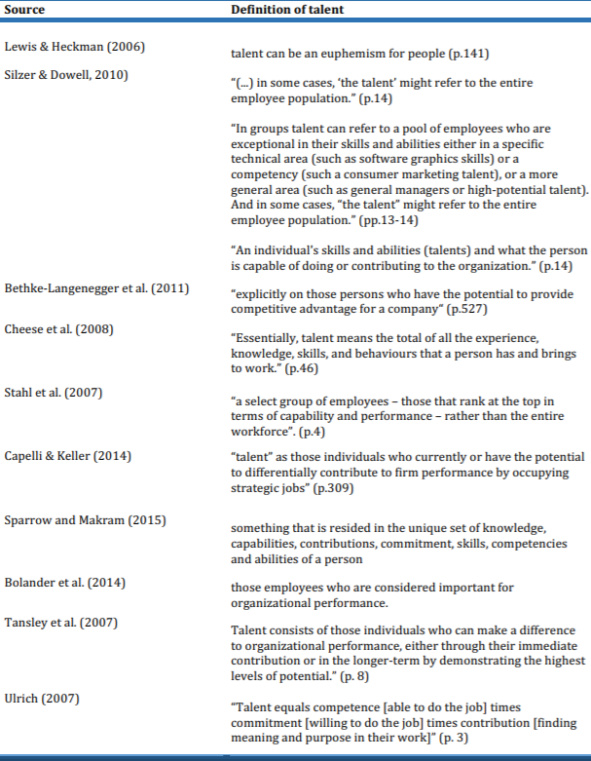

 | Organisation | Local/ International | Length of operation | No. of employees | No. of countries where operations
A | UNHCR | UN agency | 68 years | Over 15000 | 138
B | OCHA | UN agency | 28 years | Over 2300 | 60
C | iMMAP | International | 18 years | Around 700 | 10
D | IDARE | Local NGO | 6 years | Around 25 | 1
E | E* | International | Over 80 years | Around 75 | 7
F | F* | International | Over 40 years | Over 7500 | 50
G | Maram | Regional | Over 8 years | Over 250 | 3
7.11 Table 2: Overview – Case Studies
*Anonymous

 | Organisation | Responders | Title | Length in the organisation
A | UNHCR | R1 | Chief, Talent Outreach and Acquisition, Affiliate Partnerships and Recruitment Section | Over 10 years
B | OCHA | R2 | Head of Admin and Human Resources | Over 10 years
C | iMMAP | R3 | Human Resources Officer | 4 years
D | IDARE | R4 | Programme Director and Co- Founder | 6 years
E | E* | R5 | Country Director | 4 years
F | F* | R6 | Head of the Human Resources | 3.5 years
G | Maram | R7 | Director and Co- Founder | Over 8 years
7.12 Table 3: Responders
*Anonymous

7.13 Table 4: Talent & Talent Management Definition
 | Organisation | Talent | TM Strategy | Level of connection to Strategy
A | UNHCR | Everyone as long as they fit within the organisation and its mission. | End-to-end framework: Talent acquisition, identification, growth & development, engagement, succession planning and retention. In addition, to providing talent with the necessary assignment that matches their skills and provides an exit strategy for those that do not fit within the Organisation. | Connected to the organisational strategy, mission and vision.
B | OCHA | Everyone who fits with the organisation’s culture and have the same values and competencies. | Fit-for purpose and integrated People Strategy. The strategy requires adaptability to changes in the demand for its services or the availability of financial resources. It includes processes to promote effective use of secondments and roster mechanisms as a rapid staff-deployment tool. It also establishes a career management model with appropriate training, learning and development tools. | Connected to Strategy as people represent 70% of the financial plan.
C | iMMAP | High potentials | Investing in efficient employees is the main TM strategy. In addition to making sure that, staff are attracted and retained in the right numbers with the appropriate skills and capability and they are treated equally and fairly. Decisions on recruitment and selection, training, promotion and career progression are based solely on objective and job-related criteria. | Connected to the mission and purpose of the organisation as more than 80% of its fund allocated to the people.
D | IDARE | Everyone with the same competencies and values. | TM is about providing an enabling environment so people could fulfil or reach their goals, therefore, people need to have the self-awareness about which competencies they need to develop. It is all about effective management of people so they can reach their goals and achieve the organisation’s mission vision and purpose. | Connected to the competencies and values of the organisation.
E | E* | Everyone who fits in the organisation. | TM is about recruitment, retention and development the most suitable people for the organisation and all aligned with its commitment and strategic objectives. Ensuring employees express joy, a strong sense of engagement and co-ownership with the organisational goals, acting as proud advocates - developing themselves and the ecosystem as a result they have the right candidate for the right position at the right time. | TM is aligned with the organisation’s commitment and strategic objectives.
F | F* | Everyone | Mainly about staff development so staff can have the opportunity to develop their capacity according to their performance evaluation. In addition to promoting the right environment to attract and retain talent.  TM activities are linked to the organisation’s strategy so the development plan could be useful for the organisation’s objectives. | The connection to strategy is mainly based on development plans.
G | Maram | Everyone | TM is about empowering employees giving them the chance to develop themselves; by supporting them and offering them equal opportunities where they can add value and quality to their work. | Connected to the purpose and vision of the organisation.

7.14 Table5: Level of TM implementation & Talent Planning
 | Organisation | Level of TM implementation | Who is responsible for the implementation of TM Strategies? | Workforce Planning
A | UNHCR | Not fully implemented. TM processes are divided into sections and each section is implemented by different units. | HR facilitates the process and responsible to develop the necessary TM policies but managers play a big role in ensuring the implementation processes are done properly. | Short term planning based on need as it is a fast-paced organisation due to emergencies, sudden crisis and limitation in funding.  Talent pool is created to have a supply of people when needed.
B | OCHA | Almost 90% implemented with special HR committee created to oversee TM implementation, and designate focal points to review and update processes with consultation with key stakeholders. | All are accountable for implementation processes with HR overseeing the procedures and the managers creating the proper environment and to give the appropriate support to enable the correct implementation. | Activity Planning for different units and offices by reviewing the current capacities at different levels and based on that additional staffing requirement are planned.  Talent pool of people (Emergency Roster) to be ready for deployment within 24hours.
C | iMMAP | Not fully implemented  The development part of TM strategies is the most implemented part and working on attraction and retention policies to be updated. | Each department head will be responsible to ensure the implementation of and adherence to the policies and guidelines.  HR is responsible for providing advice to managers on good practices. | TM planning is more of development planning for all the training and capacity building activities to find out the requirements from other partners for a certain project to provide them with the needed support.
D | IDARE | Started to implement an approach with links to TM strategies in the absence of an HR Unit. | Everyone is responsible for implementation process. | Planning activities depends on the projects and based on need.
E | E* | Not fully implemented but going through transformation process to connect it to strategies. | All involved with the right management to implement it and HR overseeing the change and making sure it is within the policies and framework. | Planning a need analysis to check the inventory of the existing competences and to identify the required competences for the future.
F | F* | Not fully implemented working on developing a reward and retention policies to enhance its effectiveness. | HR department is responsible for implementation but in close collaboration with the management and the technical manager of each department. | Planning is about forecasting the number of staff needed according to projects by knowing approximately the type of positions needed and the type of expertise and skills required to fill those positions.
G | Maram | Implemented and also Updated and ongoing all the time with and emphasis on the development part of TM. | Everyone is responsible but with leaders creating the right environment to reach full potential. | Workforce Planning is linked to the strategy and programmes implemented. Also, development planning is essential to built capacities.

7.15 Table 6: Talent Management Practices/ Processes
 | Organisation | Attraction Strategy | Identification and Performance Management Strategy | Development Strategy | Retention  Strategy
A | UNHCR | Strong Brand- Attract potential talent by presenting a strong organisation’s image, culture, purpose and mission.  Effective Website, Social Media, word of mouth and attending career fairs. | Identify the right candidate by screening (competency and technical evaluation) internal and external candidates.  Performance appraisal system to identify & recognise high performance employees. | Global Learning and Development Center  (internal E-learning programmes).  Certification & technical programmes.  Functional training and management and leadership training. | Low turnover due to family oriented culture, encouraging diversity, equal opportunities, development and well-being.  Recognising loyal employees and working on a reward strategy.
B | OCHA | Promotes a healthy and respectful work environment to attract potential talent.  Website in different languages to attract diverse talent. | Performance Management and development evaluation tool.  Using transparent feasibility assessment to identify employees with desirable performance and behaviour to include in the talent pool. | Mentoring and coaching.  Learning and development  (internal e-learning programmes)and staff exchanges. Tailored training and leadership & development training. | Foster an environment where people are valued, respected and supported by promoting the health, well-being, diversity and safety of staff. Building a culture of trust, transparency and accountability.  Recognizing high performers.
C | iMMAP | Promote our brand to other organisation by attracting people who would like to improve their technical skills experience.  Word of mouth and from other employees. | Performance appraisal where strength and weaknesses for each employee will be identified by aligning employee’s objective to the organisational objectives and work on development plan. | Intensive development plan (6 weeks).  Formal training sessions (individual or corporate)  Employee Coaching and Mentoring, on-the-job training, job shadowing and rotation. | Provides an enabling environment for employees to reach their full potential by  equal opportunities  development. Not very developed retention policy and working to improve our reward and recognition strategy.
D | IDARE | Attracting the people from communities and youth the non-profit is working with by planning and running special programmes and meetings to make the organisation visible and to promote the mission. | No system for evaluation as such but using indicators for accountability to assess staff. identify the high potential employees to be the coordinators and to lead the team using building activities that can help to assess who can be the leader of the project based on certain competencies and qualities. | Strengthening the employees in order to be able to provide the same to others. Coaching and Monitoring and on the job training. | Working on a system that is tailored to the organisation which will look at accountability and reward. The mission and the work environment give people the chance to interact and help other youth, which will reflect positively on the employees.
E | E* | Attractive culture, goals, vision. Also, attract talent by the core values and principles such as equal opportunity and non-discrimination. In addition to capacity building opportunities.  Website, social media and word of mouth. | Identify key competences and roles required to achieve commitment to fulfil the need.  Performance development dialog both ways so evaluation will be from the employee to management and back for effective feedback. | Capacity development, Stretch assignments and projects, Job Enrichment, Mentoring or Coaching, Job Shadowing, Job Rotation, Lateral move and Promotions. | Provide the right conditions to grow and develop. Promote joy, a strong sense of engagement by creating the right environment and promoting the wellbeing of the staff.  Effective leadership that encourages growth.  No reward strategy yet.
F | F* | Promote the values of the firm such as gender equality and non-discrimination at any stage to be considered as employer of choice.  Website and participating in external events to be visible and to market the brand. | Identify the competencies and the areas to be improved for each employee using the Performance appraisal system to work on development plan with supervisor. | Capacity building plan- internal e-learning platform and internal experts from HQ.  External training courses if needed. | Create a conducive environment  Considering the welfare of the staff and promoting age ,diversity principles and work-life balance.  Recognise loyal employees and reward them (increments).
G | Maram | Attract people by the mission and the quality of work delivered.  Word of mouth and from the communities we serve. Attend meetings that promote the mission of the organisation and attract the media attention. | Identify and evaluate employees to understand their needs to improve our systems. Therefore, the management will evaluate employees to recognise high potentials and the employees will evaluate management to improve communication and increase effectiveness. | Offer capacity building programmes and encourage employees to attend training to strengthen their role.  Offer to cover 50 % and some times 100% of training courses (Language courses).  Offer internal training to empower staff. | Create an environment where everyone feels valued and cared for Encourage a culture of growth and development. In addition to other benefits and increments.

7.16 Table 7: Challenges and Benefits of Implementing TM Strategies
 | Organisation | Challenges | Benefits
A | UNHCR | Cater for different needs for diverse staff.  Budget restrictions. | Building capabilities of staff .  Retaining good employees.  Reduces the costs of recruiting new staff.
B | OCHA | Difficulties in creating mind-set where people will understand the need for TM to contribute to the effectiveness of the policies.  Justifying importance of investing in the staff due to budget limitation. | Effective management of staff by attracting the right people and giving them the opportunity to grow and keeping them happy to increase productivity.  Building a workforce that is agile and flexible to operate with diverse partners in cross-disciplinary and multi-sectoral environments.
C | iMMAP | Difficulties in finding the right talent as a technical organisation providing help to other agencies and losing those employees after developing them to other competitors due to high expectation. | Retaining good employees.  Attracting the right Talent.  Develop high potential people (technical abilities).
D | IDARE | Lack of funds and the understanding of such concept and how it will affect our organisation. | Provide sustainability and strengthen our role as non- profit working for the benefit of our youth” from the youth.
E | E* | Lack of funding for development needs.  Lack of Management support  Not able to keep people in the organisations due to lack of promotion. | Help in the development of a strong Growth Mind-set culture. In addition to increasing loyalty and accountability which will retain good employees which will reduce costs of hiring new staff.
F | F* | High turnover as people is always looking for better opportunities.  Risking losing staff after investment in them as they will be attractive to other employers (competitors). | Shaping the employees with the history, culture and core values of the non-profit.  Increase innovative environment by developing employees and creating the right environment to address challenges and come up with creative ideas and solutions to take the organisation to the next level.
G | Maram | Fund limitation to certain projects, therefore people hired on short-term basis which could affect morale. The system needs to be updated regularly to cater for the different needs. | Creating a culture of commitment and loyalty where everyone in the organisation work to deliver the mission and achieve success. In addition to building the capacity of employees to deliver their roles effectively and efficiently.

Inspiring Quotations:
The vision of each organisation on the importance of talent for the future of their non-profit:

R1: “We need to change the mind-set of people to make them understand that the new generation has different needs…Gone are the days where people will stay in the organisation –from Womb to Tomb, we need to cater for those needs and manage expectations as talent in the future is going to be very dynamic, people will come and go…people who will stay for a few years and then they want to move on to another position”.

R2: “In the future, I see OCHA that produces talent and developing them by making them work in diverse areas not only to serve in one area but in many areas and making them marketable and attractive so they can serve their communities”.

R3: “Our vision is to become the employer of choice, where we can offer our employees with their different backgrounds and needs the base to be innovative and creative to achieve their full potential and the organisational mission and mandate”

R4: “We need also to understand that each organisation has its own identity, views and beliefs, therefore, we need to stay true to what we know and not to follow or copy other models, and frameworks that might not be effective for us but to create something that suits us to achieve sustainability”.

R5: “Encouraging leaders to switch between different roles such as manager, leader and coach depending on what is needed in the one, specific situation making sure they have the tools for work with a coaching approach, with a focus on highlighting strengths and unleashing potential. As we believe that people thrive when they are part of a well-functioning team and effective leader who work actively to promote diversity and counteract discrimination and see differences in perspective and background as a strength and good for both teams and the outcome of our work, so basically a good leader who can help us to deliver our vision and mission”.

R6: “There are many cost-effective ways that our organisation can benefit from in the future, such as Job rotation, sharing experiences and secondment schemes, which can give the opportunity for our talent to develop themselves and grow as well as benefit the organisation”.

R7: “We hire smart people not to tell them what to do but to tell us what to do, therefore, we have to listen to our people and get their views in order to develop the organisation so it becomes competitive and attractive”.

