Managing Projects in the Organisation

Table of Contents
Introduction 2
Task 1 4
Introduction 4
Project Closure for Tesco Extra Project 5
Financial Resources and Information for the Project 7
Conclusion 9
Task 2 10
Project Outline: Tesco Extra 10
Stakeholder Analysis 10
Scope 12
Work Breakdown Structure (WBS) for Tesco Extra Project 13
GANTT Chart 15
Project Closure for Tesco Extra Project 16
Costs/Resources Draft 17
Risk in Tesco Extra Project 19
Project Management Tools and Techniques for Tesco Extra Project 20
Conclusion 23
References 24

Introduction
This project details an in-depth effort designed to both elevate customer experience and foster sustainability at Tesco Extra, one of the premier retail chains. This project presents strategies to create personalized shopping experiences through data analytics and AI, introduce self-checkout systems, and strengthen loyalty programs. Furthermore, this report explores sustainability practices such as eco-friendly packaging innovations, energy-efficient technologies, and responsible sourcing practices. Furthermore, project management tools and techniques were applied to successfully plan, execute, monitor, and oversee each phase of a project's execution and monitoring phases. Tesco Extra prioritizes customer-centricity as a priority while prioritizing environmental responsibility as key aspects in maintaining its competitive advantage while contributing towards creating a more sustainable future.

Task 1

Introduction
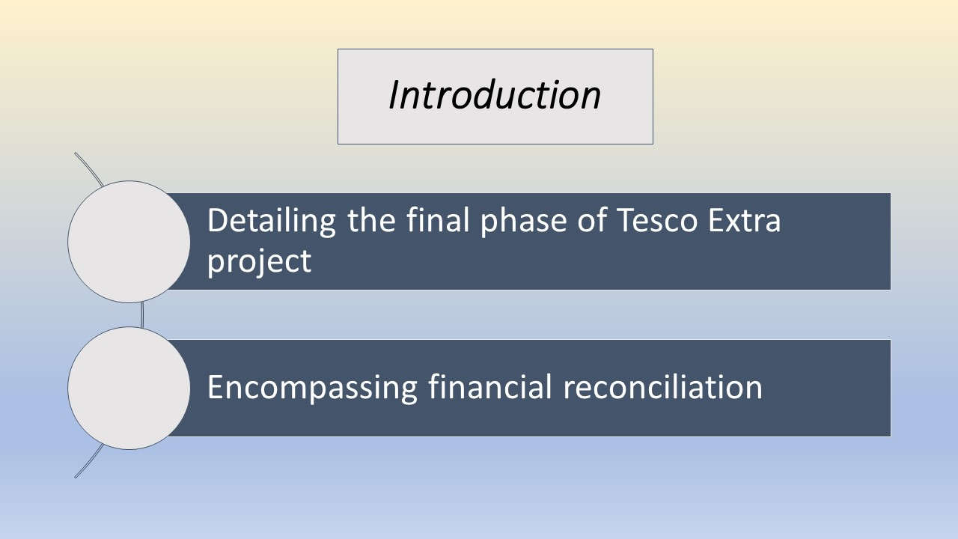
This report details the final phase of Tesco Extra project--its closure. Encompassing financial reconciliation, resource administration and stakeholder communications ensuring its successful culmination while adhering to project management principles for further improvements down the line.

Project Closure for Tesco Extra Project
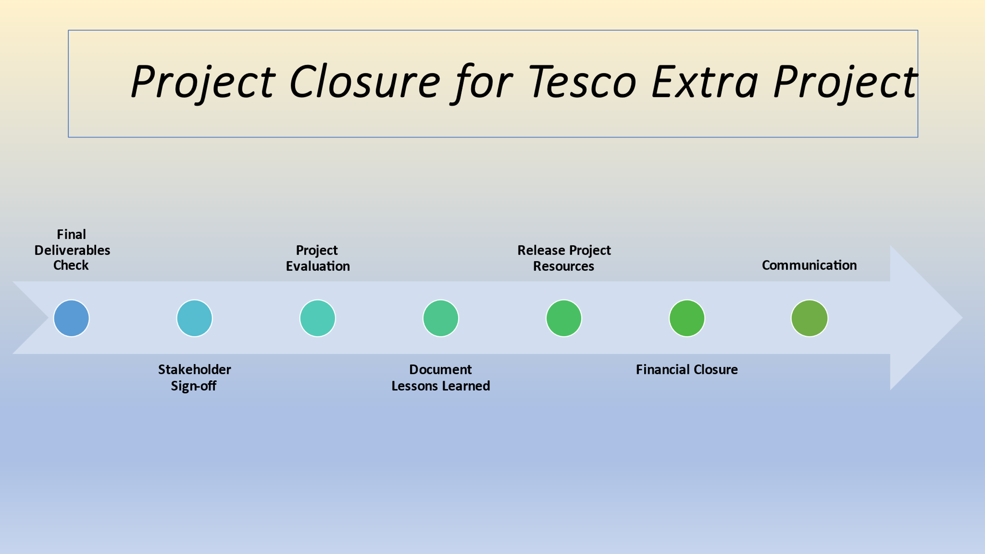
The final phase of the Tesco Extra project is its closure. It is an essential part of the project management life cycle, as it ensures that all objectives have been met and stakeholders are informed about the project's outcome. Here's a detailed breakdown:
Project Closure Activities:
11.1 Final Deliverables Check:
- Confirm that all deliverables of the project have been completed (Gido and Clements, 2014).
- Meet requirements outlined by project initiation documents.
11.2 Stakeholder Sign-off:
- Secure approval from all key stakeholders at the conclusion of a project to ensure satisfaction with its results and no unresolved issues remain (Pollack, 2007).
11.3 Project Evaluation:
- Conduct a post-project review to identify successes and areas for improvement within the project.
- Compare performance against initial project goals, timelines, and budget.
11.4 Document Lessons Learned:
- Collect feedback from project team, stakeholders, and other relevant parties regarding what went well and areas for improvement, document these lessons for future reference in similar projects (Phillips, Bothell and Snead, 2012).
11.5 Release Project Resources:
- Ensure all project resources - human, material and otherwise - are appropriately tracked, recorded, released, or returned as soon as they come available for release or return (Levitt, 2011).
11.6 Financial Closure:
- Assure all bills and financial obligations have been satisfied.
- Analyse project budget versus actual spending to record any variations between them.
11.7 Archive Project Documentation:
- Maintain all project documentation in one central place. This may include contracts, plans, reports, communication logs or any other relevant files.
11.8 Communication:
- Inform all stakeholders and the wider organization of the project's conclusion through formal communications or by organizing a project closure event (Nicholas and Steyn, 2008).
11.9 Celebrate:
- Host a team celebration or event to recognize all those involved with a project's completion and their hard work and achievements, providing morale-boosting motivation and increased commitment for future projects.
Project Closure ensures a formal and successful conclusion of a project by meeting all stakeholder expectations, and gathering lessons learned for future endeavors (Zhang and Enemark, 2016). Completion of this phase should provide closure for both team members as well as set the foundation for new endeavors.

Financial Resources and Information for the Project
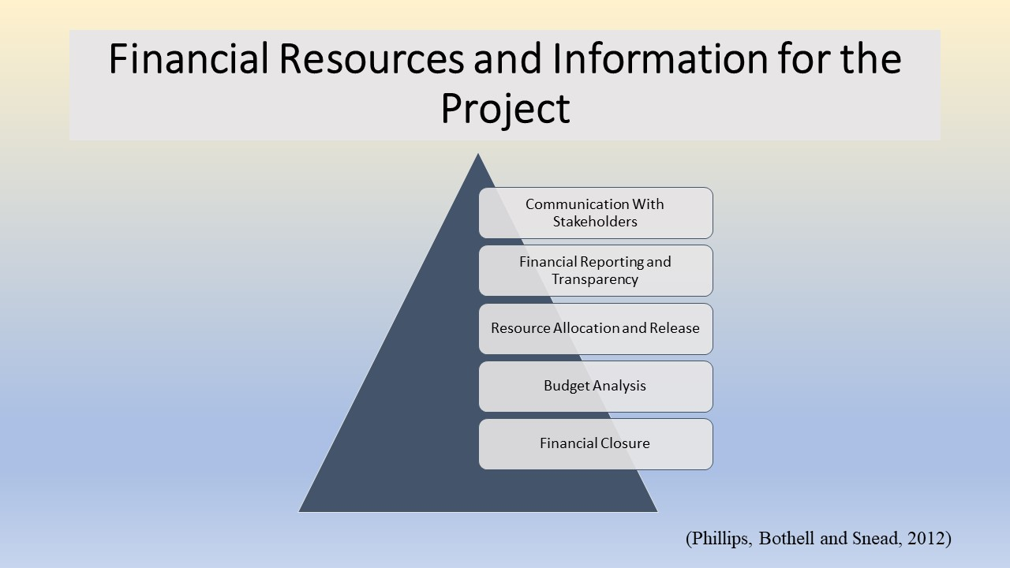
Tesco Extra's final phase involves meticulous attention being paid to managing financial resources and information effectively in order to guarantee its successful conclusion. This phase encompasses various activities focused on financial accountability and resource optimization.
Financial Closure:
At this phase of a project's financial lifecycle, all expenses, bills, and financial commitments should be closely reviewed to ensure accurate reporting and confirm all contractual agreements have been fulfilled with service providers such as suppliers or vendors (Phillips, Bothell and Snead, 2012).
Budget Analysis:
A key aspect of financial management during project closure involves conducting an in-depth examination of a project's budget in relation to actual expenditures (Gillum and Rob, 2011). Doing this allows project teams to gain valuable insights into cost variations as well as possible areas for over or underspending compared with initial allocation. Furthermore, such analyses provide invaluable lessons for future budgeting efforts on similar endeavors.
Resource Allocation and Release:
A key aspect of financial resource management involves overseeing their allocation and release (Hubar and Kuzmin, 2022). This involves tracking how funds are distributed among project components, making sure resources are utilized efficiently in meeting project goals, as well as identifying any surplus monetary or physical resources; surpluses could either be reallocated elsewhere within a project, returned back to stakeholders, repurposed, discarded altogether or released according to project requirements.
Financial Reporting and Transparency:
Project teams need to generate comprehensive financial reports during project closure that highlight expenses, budget usage and any variances from plans or goals (Levitt, 2011). The documents allow stakeholders to assess both financial health of a project as well as its adherence with said goals.
Communication With Stakeholders:
An essential aspect of financial management, communication between project team and stakeholders regarding any aspects pertaining to project closure that require financial oversight such as any concerns that might arise and making sure everyone involved understands and appreciates what this entails for both sides (Walker, 2015). The project team should inform its constituents about these outcomes while keeping all involved informed as part of financial reporting obligations.
By carefully overseeing financial resources and information, the Tesco Extra project team demonstrated their dedication to sound financial stewardship. Their approach promoted transparency, accountability, and informed decision-making - leading to its overall success and providing a foundation for future endeavors.

Conclusion
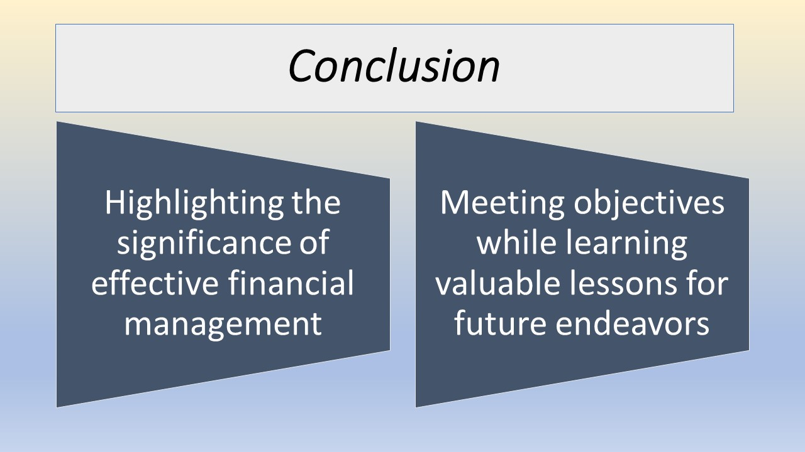
Tesco Extra's meticulous project closure phase execution highlights the significance of effective financial management, efficient resource allocation and open stakeholder communication. By adhering to established project management practices, its team ensured meeting objectives while learning valuable lessons for future endeavors and setting them on course towards further success in future endeavors.

Task 2

Project Outline: Tesco Extra
This project details a strategy to enhance customer experience and environmental practices at Tesco Extra, one of the nation's premier retail chains (Tsviliy, Gurova and Kuklina, 2021). Through customer-oriented initiatives and green operations practices, the retailer hopes to maintain competitive edge within its market while making positive impactful impactful steps towards sustainability practices.
Improvements to the customer experience:
- Implement personalised purchasing experiences using AI-driven insights and data analytics.
- Add self-checkout options to improve convenience and cut down on wait times.
- Expand the loyalty program to include personalised promos and prizes.
Sustainable Business Practices:
- Lower the use of plastic by introducing innovative packaging and encouraging eco-friendly substitutes.
- Use sources of clean energy and technologies that are energy-efficient to lessen carbon footprint.
- Work with regional groups on environmental initiatives and encourage ethical purchasing methods.
Tesco Extra will undergo a transformation into a customer-focused and ecologically conscious retailer as a result of this program, encouraging customer loyalty and promoting a future that is more environmentally friendly.

Stakeholder Analysis
Stakeholder analysis is an essential process that allows organizations like Tesco Extra to identify and understand those individuals, groups, or entities with an influence in its operations or success who hold a significant interest (Walker, 2015). By conducting an exhaustive stakeholder assessment process, Tesco Extra can develop strategies to engage its key stakeholder groups effectively while meeting their needs and meeting any concerns expressed. Below is an example stakeholder analysis conducted for Tesco Extra:
1. Customers: Tesco Extra's customers are of paramount importance to its success, as their purchasing decisions drive revenue for the business. To retain customer loyalty and satisfaction, Tesco Extra must focus on creating an enjoyable shopping experience, offering diverse products, addressing feedback promptly and responding accordingly to guarantee maximum efficiency for customer interactions (Walker, 2015).
2. Employees: Tesco Extra's employees constitute an important stakeholder group, as employee satisfaction and motivation play an essential part of both productivity and customer service delivery. Tesco Extra must ensure fair wages, benefits, career development opportunities, a safe work environment to retain and attract talented personnel.
3. Suppliers and Partners: Tesco Extra relies heavily on its suppliers and business partners for goods and services, so having strong relationships with these parties is crucial in maintaining product availability, upholding quality standards, as well as driving mutual growth and innovation (Pollack, 2007).
4. Shareholders and Investors: Tesco Extra's shareholders and investors hold an inordinately financial stake in its success and profitability, so its management must communicate openly and provide regular updates about financial performance to keep their support (Phillips, Bothell, and Snead, 2012).
5. Local Communities: Tesco Extra stores play an essential part in their surrounding communities and must engage actively to understand their specific needs while contributing positively through initiatives like job creation, charitable giving, and environmental preservation (Phillips, Bothell, and Snead, 2012).
6. Government and Regulatory Bodies: Complying with local laws and regulations is of utmost importance for Tesco Extra's operations, so maintaining positive relations with government bodies as well as taking proactive measures against any legal or regulatory concerns may arise is necessary for their operations (Phillips, Bothell, and Snead, 2012).
7. Non-Governmental Organizations (NGOs): Advocacy groups may monitor Tesco Extra's practices related to sustainability, environmental impact, and social responsibility. Engaging with such NGOs and responding to their concerns will enhance Tesco Extra's reputation and commitment to ethical business practices.
8. Competitors: Competitors both big and small play an instrumental role in shaping the retail landscape, so Tesco Extra must closely observe and adapt its offering based on competitor activity and strategies.
9. Public perception and media coverage have an immense influence over Tesco Extra's brand image and should be managed carefully to promote an optimal public relations image and provide clear engagement between Tesco Extra and media representatives.
10. Academia and Research Institutions: Engaging academia and research institutions can yield invaluable insights, innovations, and collaborations which benefit Tesco Extra and retail.
Tesco Extra understands the interests, expectations and influence of each stakeholder group and can use that insight to tailor strategies specifically tailored for them while fulfilling its social and environmental responsibility obligations. Proper stakeholder management is vital in creating long-term sustainability of its business activities.

Scope
This project involves the implementation of strategies and initiatives aimed at increasing customer experience while improving sustainability at Tesco Extra. This encompasses various aspects of its operations both inside stores and behind-the-scenes; key areas covered are as follows.
1. The client experience
- Data analysis and AI: Analysing customer data to provide individualised product suggestions and experiences while shopping (Zhang and Enemark, 2016).
- Self-Checkout System: Adding self-checkout choices will speed up shopping and cut down on delays.
- Loyalty Program: Improving the current loyalty program to offer customers personalised rewards and incentives (Verevka, 2016).
2. Sustainability Techniques:
- Package Innovations: Identifying eco-friendly substitutes and minimizing the use of plastic in containers.
- Energy Efficacy: To reduce emissions of carbon, use technologies that are energy-efficient and investigate alternate energy supplies.
- Promoting ethical business practices and working with vendors to ensure items are sourced sustainably.
3. Participating in Local Communities
- Working with regional groups to endorse environmental initiatives and promote civic engagement.
Maintaining a focused and feasible scope to successfully execute Tesco Extra's strategies requires maintaining an appropriate project scope that complements their resources, capabilities, long-term objectives and tangible and measurable results (Zhang and Enemark, 2016). Regular review of and adjustments to project scope could become necessary depending on market dynamics, technological advancements or changes to customer preferences.

Work Breakdown Structure (WBS) for Tesco Extra Project
Establishing a Work Breakdown Structure (WBS) for the Tesco Extra project means breaking it into manageable tasks and deliverables, with each subproject having specific deliverables and deliverables.
Project Initiation
1.1 Define Project Objectives and Scope
1.2 Conduct Initial Stakeholder Analysis
1.3 Establish Project Team and Roles
Market Analysis and Expansion Strategy
2.1 Analysing Existing Store Locations and Performance,
2.2 Suggest Potential Store Sites,
2.3 Conduct Demographic Market Research for Target Areas
Customer Experience Enhancement
3.1 Conduct customer surveys and feedback collection
3.2 Analyze customer responses and identify points of pain for customer experience enhancement.
3.3 Draft plans to improve store layout and signage.
3.4 Implement changes to product availability and organization 3.5 Train staff on customer service and engagement.
Digital Transformation and E-commerce Integration
4.1 Evaluate current digital infrastructure and capabilities.
4.2 Create a Digital Transformation Roadmap.
4.3 Enhance website features and user experience.
Maintain a fully optimized supply chain.
5.1 Supply chain processes to identify any bottlenecks.
5.2 Optimize inventory management and stock replenishment Improve logistics and distribution efficiency.
5.3 Implement demand forecasting systems as well as inventory tracking systems.
5.4 Establish partnerships with efficient suppliers.
Community Engagement and CSR Initiatives
6.1 Determine community needs and preferences.
6.2 Create programs and events geared to engaging community stakeholders.
6.3 Support charitable causes and local initiatives.
Data Analytics and Personalization
7.1 Collect and analyze customer data and purchasing trends, and implement data-driven marketing and personalized promotions with data collection methods and analytics (in the form of CRM systems etc.
7.2 Utilize data-driven promotions tailored specifically using customer data driven insights as source.
7.3 Create a customer loyalty program using data insights.
7.4 Leverage analytics to optimize product placement and pricing.

GANTT Chart
The GANTT chart of the project has been illustrated in the following:
Particulars | Week 1 | Week 2 | Week 3 | Week 4 | Week 5 | Week 6 | Week 7 | Week 8
Project Initiation
Market Analysis and Expansion Strategy
Customer Experience Enhancement
Digital Transformation and E-commerce Integration
Maintain a fully optimized supply chain
Community Engagement and CSR Initiatives
Data Analytics and Personalization

Project Closure for Tesco Extra Project
The final phase of the Tesco Extra project is its closure. It is an essential part of the project management life cycle, as it ensures that all objectives have been met and stakeholders are informed about the project's outcome. Here's a detailed breakdown:
Project Closure Activities:
11.1 Final Deliverables Check:
- Confirm that all deliverables of the project have been completed.
- Meet requirements outlined by project initiation documents.
11.2 Stakeholder Sign-off:
- Secure approval from all key stakeholders at the conclusion of a project to ensure satisfaction with its results and no unresolved issues remain.
11.3 Project Evaluation:
- Conduct a post-project review to identify successes and areas for improvement within the project.
- Compare performance against initial project goals, timelines, and budget.
11.4 Document Lessons Learned:
- Collect feedback from project team, stakeholders and other relevant parties regarding what went well and areas for improvement, document these lessons for future reference in similar projects.
11.5 Release Project Resources:
- Ensure all project resources - human, material and otherwise - are appropriately tracked, recorded, released or returned as soon as they come available for release or return.
11.6 Financial Closure:
- Assure all bills and financial obligations have been satisfied.
- Analyse project budget versus actual spending to record any variations between them.
11.7 Archive Project Documentation:
- Maintain all project documentation in one central place. This may include contracts, plans, reports, communication logs or any other relevant files.
11.8 Communication:
- Inform all stakeholders and the wider organization of the project's conclusion through formal communications or by organizing a project closure event.
11.9 Celebrate:
- Host a team celebration or event to recognize all those involved with a project's completion and their hard work and achievements, providing morale-boosting motivation and increased commitment for future projects.
Project Closure ensures a formal and successful conclusion of a project by meeting all stakeholder expectations, and gathering lessons learned for future endeavors (Zhang and Enemark, 2016). Completion of this phase should provide closure for both team members as well as set the foundation for new endeavors.

Costs/Resources Draft
Customer Experience Enhancements:
- Data Analytics and Artificial Intelligence: Investment in tools, AI algorithms and skilled analysts to process and analyze customer data is estimated at £550000
- Loyalty Program Upgrade: Development of a new loyalty program platform and promotional materials at an estimated cost of £300,000.
Sustainable Operations:
- Packaging Innovations: Research and development costs for eco-friendly packaging alternatives is estimated to cost £200,000.
- Energy Efficiency: Upgrading lighting, HVAC systems and investing in renewable energy sources to increase energy efficiency will cost approximately £1500,00
- Sustainable Sourcing: Recurring expenses associated with sustainable suppliers and certification processes may add up to an estimated cost of £400,000.
Participating in Local Communities
- Community Tasks: Financial aid and assistance for regional environmental programmes. Cost projection: £100,000.
Personnel resources
- Hiring experts in community involvement, sustainability, and data analytics. Cost each year estimated at £400,000.
Education and Training:
- Staff training programs on cutting-edge technologies and environmentally friendly procedures. Cost projection: £150,000.
Marketing and communication:
- Advertising campaigns to let customers know about the improvements. £250 000 is the projected price.
Assessment and Monitoring:
- The enactment of tools to monitor the project's development. Cost projection: £100,000.
Total Estimated Project Cost: £1750,000
Resources Allocation:
Financial Resources: Finding funding through internal budget allocation or partnerships and investors (Walker, 2015).
Human Resources: Allocating teams dedicated to data analytics, sustainability, and community engagement aspects.
Technological Resources: Utilizing data analytics tools, self-checkout systems and energy efficient technologies as capital investments (Shtal and others, 2021).
Time Resources: Devising an implementation timeline with clearly marked milestones and deadlines to meet.
Conduct a cost-benefit analysis to make certain the benefits derived from customer experience improvements and sustainability efforts outweigh their respective investments. Regular evaluation will enable Tesco Extra to adjust as required and optimize resource allocation throughout its project lifecycle.

Risk in Tesco Extra Project
Tesco Extra, designed to improve customer experience and promote sustainability, may present various risks that must be identified and managed for successful project implementation. Following are some potential dangers involved with Tesco Extra:
Integral Issues: New technologies like data analytics or self-checkout systems could present integration difficulties when combined with existing systems and processes (Schwalbe, 2009).
Technical Glitches: Any technical failures or downtime with AI-powered recommendations or self-checkout kiosks could wreak havoc and leave customers dissatisfied and unhappy with operations (Pollack, 2007).
Customer Acceptance Risks: Assurance may also pose risks when accepting recommendations derived through artificial intelligence systems; customer dissatisfaction could occur as a result.
Resistance to Change: Customers might resist self-checkout systems or customized shopping experiences that require them to change, negatively affecting adoption rates (Tsviliy, Gurova and Kuklina, 2021).
Data Privacy Concerns: Collecting and analyzing customer data could spark privacy fears among customers leading to mistrust between businesses and shoppers alike.
Supply Chain Disruptions: Partnering with sustainable suppliers could present difficulties meeting demand or create disruptions in the supply chain and may prove challenging or costly in terms of finding viable eco-friendly packaging alternatives.
Cost Overruns: Unforeseen expenses or inadequate cost estimation could exceed the allocated budget, leading to cost overruns.
Return On Investment (ROI): Benefits derived from customer experience enhancement and sustainability initiatives may not meet their expected ROI within their projected timelines. Compliance Risks (RCLs): There may also be compliance-related risks as part of any project.
Environmental Regulations: Noncompliance with environmental regulations could incur fines or cause irreparable reputational harm, while mishandling customer data could incur legal ramifications that harm both Tesco and their reputation (Verevka, 2019).
Data Protection Laws: Mishandling customer information could bring legal implications that have far reaching ramifications that jeopardize Tesco's good name and undermine Tesco's presence within an industry.
Competitive Risks: Noncompliance could expose Tesco to competitive threats in their marketplaces.
Competitor Responses: Rival retailers might implement similar customer-oriented and sustainability initiatives that impact Tesco's competitive advantage.
Market Changes: Shifts in consumer preferences or trends might alter how effective implemented strategies are, while external factors could play a factor (Walker, 2015).
Economic Recession: Consumer spending could decrease and jeopardise project success during an economic recession.
Natural Disasters: Unforeseen natural disasters might disrupt operations and project execution resulting in delays or cancellation of plans to implement projects (Zhang and Enemark, 2016).
Tesco Extra should take steps to mitigate risks by conducting thorough risk analyses, creating contingency plans, and closely tracking project progress. Engaging stakeholders and communicating the benefits of the project effectively are also key components to effectively managing challenges and ensuring its successful outcome.

Project Management Tools and Techniques for Tesco Extra Project
Project management tools and techniques play a pivotal role in Tesco Extra's quest to enhance customer experience while increasing sustainability. Their effectiveness ensures its overall effectiveness as well as timely completion.
1. Work Breakdown Structure (WBS): Tesco Extra's project team utilizes WBSs to break complex projects down into manageable tasks and subtasks that they can complete efficiently with limited resources, leading to effective resource allocation and scheduling decisions (Zhang and Enemark, 2016). With such an organized roadmap in place, they are better able to organize and prioritize activities more effectively.
2. Gantt Chart: The Gantt chart can assist project teams by visually representing project schedule, task dependencies and timelines in an easy-to-use format. It allows team members to effectively track progress while quickly addressing any delays due to critical paths identified as critical paths - an essential time management tool which ensures tasks are accomplished according to plan (Madeira, Palrão and Mendes, 2020).
3. Risk Management: Through effective risk management techniques, Tesco Extra can effectively identify, assess, and mitigate project risks. After conducting detailed risk analyses, project teams can develop appropriate response plans designed to minimize uncertainties that impact project objectives negatively (Madeira, Palrão and Mendes, 2020).
4. Agile Methodology: Employing agile methodology enables Tesco Extra to quickly respond and adapt quickly to changes, meeting evolving customer requirements quickly and flexibly. Scrum's iterative development cycle and regular customer feedback loop ensure the project stays customer-driven while remaining sensitive to market dynamics.
5. Project Management Software: Utilizing project management software facilitates better communications, documentation, and collaboration within Tesco Extra's project teams by centralizing project-related information in one central place - increasing coordination while keeping stakeholders up to date in real-time (Shtal and others, 2021).
6. Stakeholder Engagement: Tesco Extra's project management tools and techniques enable effective stakeholder engagement by identifying key stakeholders and devising an engaging communication plan, to ensure all relevant parties remain involved and informed throughout its lifecycle (Verevka, 2019).
7. Quality Management: Tesco Extra utilizes quality management practices to maintain high standards in project deliverables. By setting up quality assurance and control processes, their project team ensures that any improvements to customer experience or sustainability practices meet established standards while exceeding customers' expectations.

Conclusion
Tesco Extra project represents an innovative initiative to transform customer experience and sustainability practices within retail industries. Tesco Extra aims to cultivate loyalty among its customers while decreasing its ecological impact through innovative technologies, data-driven personalization, and eco-conscious initiatives. Project management tools and techniques implemented at Tesco Extra are essential in providing efficient planning, risk mitigation and resource optimization. By responding swiftly to market changes while remaining adaptive to stakeholder engagement strategies, Tesco Extra will be better prepared to face its challenges head-on and meet its goals - setting itself as the premier retailer with sustainable practices for customers across its retail network. This transformational project promises great things.

References
Gido, J. and Clements, J., 2014. Successful project management. Cengage Learning.
Gillum, A. and Rob, M.A., 2011. IT project management: class project of a point of sale (POS) system implementation in a restaurant. Volume, 12, pp.67-73.
Hubar, T. and Kuzmin, O., 2022. Models of engineering in restaurant business (Doctoral dissertation).
Kwok, L. and Yu, B., 2013. Spreading social media messages on Facebook: An analysis of restaurant business-to-consumer communications. Cornell Hospitality Quarterly, 54(1), pp.84-94.
Lenfle, S., 2008. Exploration and project management. International Journal of Project Management, 26(5), pp.469-478.
Levitt, R.E., 2011. Towards project management 2.0. Engineering project organization journal, 1(3), pp.197-210.
Madeira, A., Palrão, T. and Mendes, A.S., 2020. The impact of pandemic crisis on the restaurant business. Sustainability, 13(1), p.40.
Mashika, H., Kudrina, O., Nurgaliyeva, A., Berkova, O., Metil, T. and Novichkov, V., 2021. Competitiveness of hotel, restaurant, and tourism business: Factors and tools.
Nicholas, J.M. and Steyn, H., 2008. Project management for business, engineering, and technology: principles and practice. Elsevier.
Phillips, J.J., Bothell, T.W. and Snead, G.L., 2012. The project management scorecard. Routledge.
Pollack, J., 2007. The changing paradigms of project management. International journal of project management, 25(3), pp.266-274.
Schwalbe, K., 2009. Introduction to project management. Boston: Course Technology Cengage Learning.
Shenhar, A.J. and Dvir, D., 2007. Reinventing project management: the diamond approach to successful growth and innovation. Harvard Business Review Press.
Shtal, T.V., Staverska, T.O., Svitlichna, V.Y., Kravtsova, S.V., Kraynyuk, L.N. and Pokolodna, M.M., 2021. Digitalization as a tool for ensuring innovative development of restaurant business. Studies of Applied Economics, 39(5).
Tsviliy, S., Gurova, D. and Kuklina, T., 2021. Marketing competitiveness of hotel and restaurant enterprise: theoretical approach and methods of definition. VUZF Review, 6(2), p.30.
Verevka, T.V., 2019. Development of industry 4.0 in the hotel and restaurant business. IBIMA business review, 324071.
Walker, A., 2015. Project management in construction. John Wiley & Sons.
Zhang, J. and Enemark, A.E., 2016. Factors influencing business performance in hotels and restaurants.



