Business Skills for the International Hotel Industry
BMIH4001

Student Name: Ionel Simion
Student ID: 2220997

Table of Contents
Introduction 3
Task 1: Mode of Assessment 3
Task 2 Citation and Referencing 4
Task 3: Reflective essay and action plan 6
Time Management 6
Action Plan 7
Task 4: Industry Event reflection 8
Task 5: Communication and Interpersonal Skills Interview 9
Task 6: Integrate images into your portfolio of evidence 11
Task 7: Legal Issues – Health and Safety Poster 12
Introduction: 12
Role of Health and Safety within the Hotel Industry: 12
Conclusion: 13
Conclusion 13
References 14
Appendix: 17
Appendix 1: Poster: 17

Introduction
This report will aim to provide the detailed analysis of the academic writing abilities and the process of reflective writing considering the dynamic hotel industry landscape. Moreover, this report will analyse my personal strengths and weaknesses and cater to the areas of improvement using a Personal Development Plan.

Task 1: Mode of Assessment
The academic essays, reflective writings, and academic reports consists of varied important elements that are crucial in completing the assignments provided by a university, demanding varied skills and approaches. The understanding of patterns and structures of writing styles are important to foster success within academics and enhancement of professional skills (Fang, 2021). The skills of reflective writing highlight a mode of using a first-person perspective with the encouragement towards personal exploration and the developmental process of an individual opinion and thought process. This allows an individual in fostering the learning and personal experiences to gain a profound connection to the overall subject (Soemantri et al. 2022). Considering this, my overall strengths lie within the capabilities for expressing my emotions and thoughts simultaneously, thus providing an introspective and vicious narrative. On the contrary, the stature of academic reports and essays comprehend to the demand of an objective-based approach that are structured and formal (Haines, 2021).
Considering this, my strength in writing includes the abilities in constructing coherent-based arguments which cater to the opinions on the basis of varied evidence. However, I have acknowledged profound weaknesses in maintaining a formal tone throughout the writing consistently and is the area I could benefit with through refinement of my academic skills. Moreover, the differences among reports and essays portrays biasness based on purpose, structures, and presentation (Uto and Okano, 2021). Writing a report requires a structure that is formal, which incorporates tables, graphs, bullet points, and a clear structure. The strengths I possess in writing an academic report lies on the emphasis of my organisational skills which caters to the presentation of varied data in the form of a reader-friendly and logical manner. On the contrary, writing an academic essay fosters an idea-based and argumentative structure (Yuan et al. 2023). The weakness I possess within this field of expertise is to maintain a consistent style of narration, which I look forward to enhancing and improve in the future. For gaining a profound excellence in my academics, I intend to leverage my strengths within the reflective writing through the incorporation of my personalised experiences within writing the reports and essays. The Academic Liaison Library could also assist in providing, using, finding, and utilising the source of information for enhancing the skills for future developmental opportunities. Moreover, through the enrolment within various workshops, I could gain significant opportunities for enhancing these skills for personal and professional development. The utilisation of credible resources could help in presenting a crucial role in catering to the success within the academics (Alzubi, 2023). These would help in assisting with enquiries that are specific for evaluating and referencing the information and data used within the writing.

Task 2 Citation and Referencing
Understanding the Referencing style:
The Harvard Referencing style is a citation that is used widely for citation within the writing of report and essays (Azizah et al. 2021). This serves as a strategic process for acknowledgement of the information source and ideas used within the academic writing. The important features of this reference in style includes the detailed referencing list at the end of the documented work and the in-text citations which ensures the credibility and transparency of the piece of writing. Within the stature of Harvard Referencing style, while citing a source within the academic text, the surname of the author with the year of publication are included while writing, for example, (Author’s Surname, 2020). Considering the reference list, the overall details of the publication source are provided in alphabetical order which includes the name of the authors, publication details, page numbers, and the title of the work (Bahadoran et al. 2020). This system of referencing helps in ensuring that the readers could verify and trace the information used by the author.
The Relevance of Harvard Referencing:
Crediting the Authors: Through the use of herbal referencing style the writers comprehend the work of the original authors as a contribution to their own work. Thus, it helps to foster an environment of academic integrity which is built on the respect of harmonising the intellectual property (Brown, 2021).
Avoiding Plagiarism: Plagiarism could be stated as an act of representation of someone else's work as their own and is considered as a crucial offence towards academic integrity. Hence the hardware referencing could help the scholars and the students to avoid plagiarism through presenting their ideas which are borrowed from other authors (Vilhuber, 2020).
Facilitating Verification: Through providing detailed and precise information about the sources used, this form of referencing helps in enabling the readers to verify and locate the information independently which enhances the transparency and readability of the academic work presented.
Promotion of Consistency: This form of referencing style helps in offering a standardised structure for references and citations which makes the document visually appealing and further helps the reader to navigate the information used easily (Bahadoran et al. 2020).
Supporting Future Research: A strategically constructed list of references helps in allowing the readers to explore the works that are sighted and contributes to a larger discourse of academics. It helps in building a principle of cumulative academic knowledge that enables a writer to showcase the information used within their literary works.
Weaknesses and Self-Reflection:
Considering the relevance, there are significant challenges that a student faces while catering at these references. The entry cases of specific rules of formatting and managing various sources could be a significant challenge while using this source of referencing (Cottrell, 2019). However, I acknowledge my overall strengths in fostering a profound understanding on the fundamental principles of this refining style. I am capable of recognising the importance of citations and maintaining a profound integrity within my academic works. This helps me position for success within my academics and ensure that my work is built upon the foundation of mutual respect and honesty for academic contributions. On the contrary my weakness lies in the oversight of catering to the details of the citation such as the variations of formatting for different source types. To address this weakness, my university offers various support mechanisms with the likes of workshops and seminars that are available for consultations and clarifying doubts regarding the citation of Harvard referencing style.

Task 3: Reflective essay and action plan

Time Management
Upon reflecting on the practices of profound time management abilities, I have recognised varied factors that have been impeding the capabilities for utilising the time effectively. One of the most significant barriers that has been getting on my way in fostering effective time management abilities is multitasking. I have observed that in an attempt to simultaneously complete multiple tasks, I often find myself compromising on the overall quality of my work and losing significant time frames. The misconception on the enhancement of productivity through multitasking is a hindrance to the effectiveness of utilisation of time for an individual. Another significant challenge that I face on managing time efficiently is my lack of time prioritisation. I often tend to allocate my time without a clear strategy or structure of tasks based upon their importance and urgency. This has resulted in catering to spending time excessively on activities that are less important and neglecting the tasks that are on a high priority list. Hence it is crucial for an individual to strategically cater to the tasks that are on high priority and ensure that they put an emphasis on allocating time in the activities that aligns with the deadlines and overall goals (Soatova, 2023).
Procrastination is another significant challenge that stands as an obstacle in fostering effective management of time. There have been instances in which I delay in starting a task through an assumption that there is an ample amount of time left to complete it later. This process of procrastination often leads to the situation of rush at the last minute, thus tends to compromise with the quality of the work and a situation of stress. Therefore, addressing this weakness would require a swift mindset for acknowledging that the initiation of tasks on a timely basis would reduce stress and enhance overall productivity. Moreover, the lack of a clear difference among leisure and work fosters a challenge in managing my time effectively on a regular basis (Thielsch et al. 2021). The implementation of strategies with the likes of integrating tasks into small manageable chunks and setting idealistic goals with the utilisation of tools such as a to do list could help in enhancing the capabilities to effectively manage time. Moreover, through the cultivation of a disciplined routine and resistance to the teacher of multitasking through a plan of essential steps would help in improving my overall skills in time management.

Action Plan
Objectives | Specific | Measurable | Attainable | Relevance | Time-Bound
Improve Task Prioritisation | Develop a daily to-do list, prioritising tasks based on urgency and importance. | Track completion of high-priority tasks daily. | Ensure the list is realistic and manageable. | Enhance overall productivity and goal alignment. | Within the next 2 weeks.
Minimise Multitasking | Commit to focusing on one task at a time without distractions. | Record instances of multitasking and reduce them. | Gradually shift from multitasking to single tasking. | Improve task quality and efficiency. | Implement within the 1 month.
Overcome Procrastination | Set clear deadlines for tasks and break them into smaller, manageable deadlines. | Track completion against set deadlines. | Establish realistic deadlines. | Enhance timely task completion and reduce stress. | With immediate discourse.
Establish Work-Leisure Balance | Designate specific time blocks for work and leisure activities. | Monitor adherence to designated time blocks. | Create a schedule that accommodates both work and leisure. | Improve focus during work hours and enhance work-life balance. | Within the next 1 week.
Table 1: SMART Objectives
(Source: Self-Developed)

Task 4: Industry Event reflection
My previous employment within the hotel industry as a food and beverage manager catered to an important role in my professional stature which evoked various impressions, inspirations, emotions, and apprehensions about this industry. This experience for me was a myriad of emotions considering the vicious nature of the hotel industry which evoked a sense of exhilaration. The management of the food and beverage department catered to a sense of organisational skills, adaptability towards the organisation and fostering multitasking abilities. The profound thrills of catering to seamless operations during the peak hours ensured customer satisfaction and fostered a sense of accomplishment for the role and my passion towards this industry. The multi faced environment also fostered the essence of pressure and stress within me which demanded a balance of management and customer expectations with the intricacies of teams which created a stake of high paced atmosphere. The responsibilities within the department instilled the requirement of profound decision-making abilities and at times catered to the essence of leading the overall discourse of the organisation (Autere and Sandnes, 2023). Hence, these challenges helped me in the process of my growth and pushed me in the development of profound problem-solving skills and resilience. This event also created a source of inspiration by focusing on the witness of farming collaborative efforts with my team and delivering an effective service to the client during peak seasons. The positive feedback from the guests and satisfied customers also instilled a sense of motivation to reinforce the impact of creating profound experience and service measures (Li et al. 2021).
On the contrary, the high demanding nature of the hospitality and tourism industry required an adaptation for continuous changes in skills and abilities which had instilled a sense of mixed feelings within individuals (Mullins, 2019). My professional development in catering to the success within the industry was outcasted as I found it difficult to maintain an equable work life balance. The irregular hours of work and the requirement to be on calls consistently made me question my sustainability for a lifestyle within the long-time frame. Hence it led to seeking advice and guidance from the experts within the industry. Considering this, I had to turn to my mentors who had faced similar instances within their experiences of professional work. The advice provided a perspective on the challenges which were inherent within this sector and suggested valuable strategies foster a profound balance in work and life. Moreover, I tended to seek advice from my career counsellors and catered to various opportunities of professional development for enhancing my skills in the future.

Task 5: Communication and Interpersonal Skills Interview
SWOT Analysis:
Strengths | Weaknesses
- I have undermined that I possess organisational skills that has catered to my management abilities effectively within the department of Food and Beverage. Moreover, the strength in organisational skills facilitates the intricacies of inventory management, scheduling, and event coordination (Zaman et al. 2023).  - Another strength that I possess is the skills to adaptability. This skill helps in the adaptation to profound decision-making protocols which contributes to the flexibility and resilience of operational measures. | - The hostile nature of the hotel industry possess varied challenges for harmonising intricate balance in personal and professional sphere (Walker, 2021). Hence balancing my work with the intricacies of personal life could be stated as my weakness which could lead to the potentials of burnouts and fatigues.  - Another area of improvement that I have identified is the lack of communicational skills. It could be undermined that effective skills in communicational abilities is important within the role of client-facing within the hotel industry (van and Pierson, 2024). Hence, I could state that I need to enhance my communicational skills to ensure that my clients that I serve are satisfied.
Opportunities | Threats
- The opportunities for professional developmental measures and training protocols could enhance and mitigate the weaknesses I possess, having a profound focus on the lack of communication abilities. Enrolling within the courses and workshops which are focused on enhancing the communicational skills could contribute to the improvement in coordination within team members and ensure clarity in addressing a client.  - The implementation of skills in relation to strategic time management abilities could help in mitigating the challenges faced in relation to work-life balance (Yener et al. 2021). Moreover, goal-settings techniques and task prioritisation could help in catering to opportunities in a sustained balance in personal and professional sphere. | - The hotel sector has been inherent to the intricate demands that fosters a sense of threat in maintaining a profound work-life balance (Migdal et al. 2015).  - Hence to mitigate this threat, I could set expectations that are realistic and seek support for industry experts.  - The hostel industry is highly competitive and requires a scope of continuous improvements and development of new skills (Vinodh et al. 2021). The lack in communication abilities could pose a significant challenge to the foster profound satisfaction of guests, thus harming the image and reputation of the organisation.  - Hence to mitigate this weakness, I tend to engage with my team members and a diverse group of audience to enhance my confidence to communicate appropriately.
Table 2: SMART Objectives
(Source: Self-Developed)
Personal Developmental Plan:
Objectives | Specific | Measurable | Attainable | Relevance | Time-Bound
Enhance Communication Skills | Enrol in a communication skills workshop to improve clarity and confidence. | Track progress through feedback and self-assessment. | Achievable through dedicated practice and learning. | Essential for effective client interactions and team coordination. | Within 3 months.
Improve Work-Life Balance | Establish a weekly schedule with designated work hours and personal time. | Monitor adherence to the schedule. | Attainable by prioritising tasks and setting realistic boundaries. | Crucial for personal well-being and sustained professional success. | Within 1 month.
Professional Development | Identify relevant professional development courses related to the F&B management. | Completion of selected courses and workshops. | Select courses aligned with career goals. | Enhance knowledge and skills for career advancement. | Within 6 months.
Time Management Efficiency | Implement time management tools, such as task prioritisation and goal setting. | Track completion of tasks within set deadlines. | Achievable through consistent application of tools. | Enhance overall productivity and reduce stress. | Within 2 weeks.
Table 3: SMART Objectives
(Source: Self-Developed)

Task 6: Integrate images into your portfolio of evidence
SMART Objectives:
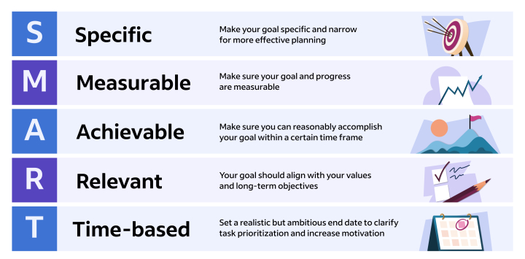
Figure 1: SMART Goals
(LinkedIn, 2021)

Task 7: Legal Issues – Health and Safety Poster
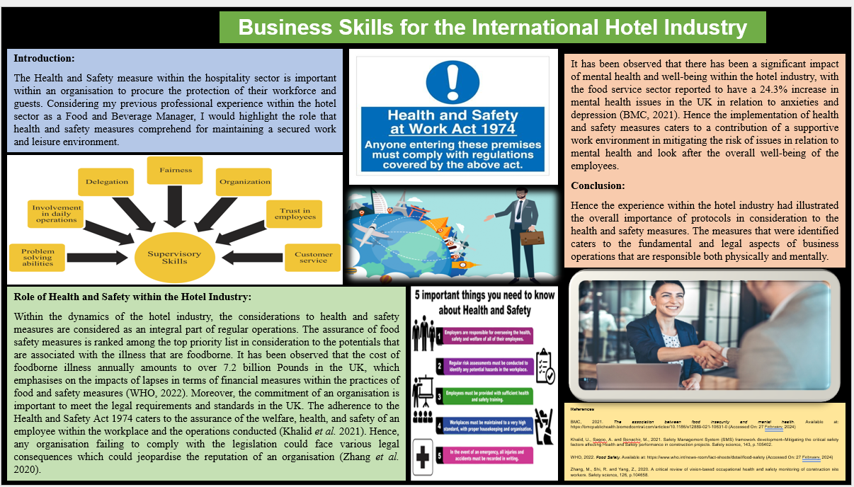

Introduction:
The Health and Safety measure within the hospitality sector is important within an organisation to procure the protection of their workforce and guests. Considering my previous professional experience within the hotel sector as a Food and Beverage Manager, I would highlight the role that health and safety measures comprehend for maintaining a secured work and leisure environment.

Role of Health and Safety within the Hotel Industry:
Within the dynamics of the hotel industry, the considerations to health and safety measures are considered as an integral part of regular operations. The assurance of food safety measures is ranked among the top priority list in consideration to the potentials that are associated with the illness that are foodborne. It has been observed that the cost of foodborne illness annually amounts to over 7.2 billion Pounds in the UK, which emphasises on the impacts of lapses in terms of financial measures within the practices of food and safety measures (WHO, 2022). Moreover, the commitment of an organisation is important to meet the legal requirements and standards in the UK. The adherence to the Health and Safety Act 1974 caters to the assurance of the welfare, health, and safety of an employee within the workplace and the operations conducted (Khalid et al. 2021). Hence, any organisation failing to comply with the legislation could face various legal consequences which could jeopardise the reputation of an organisation (Zhang et al. 2020).
It has been observed that there has been a significant impact of mental health and well-being within the hotel industry, with the food service sector reported to have a 24.3% increase in mental health issues in the UK in relation to anxieties and depression (BMC, 2021). Hence the implementation of health and safety measures caters to a contribution of a supportive work environment in mitigating the risk of issues in relation to mental health and look after the overall well-being of the employees.

Conclusion:
Hence the experience within the hotel industry had illustrated the overall importance of protocols in consideration to the health and safety measures. The measures that were identified caters to the fundamental and legal aspects of business operations that are responsible both physically and mentally.

Conclusion
In a nutshell, this report reflects on the intricacies of aspects in relation to reflective practices, academic writing techniques and the overall dynamics of the hotel sector. Moreover, through the acknowledgement of my strengths and weaknesses, I intend to strategically approach the development of personal and professional skills which are guided by the excellence of professionalism and academics.

References
Alzubi, A., (2023). The role of multimedia tools in Hashemite Kingdom of Jordan education classroom teaching in the digital era. European Journal of Interactive Multimedia and Education, 4(2), p.e02303.
Autere, O. and Sandnes, J., (2023). Beyond borders: the ability of FMCG companies leveraging their internal capabilities internationally.
Azizah, N.N., Maryanti, R. and Nandiyanto, A.B.D., (2021). How to search and manage references with a specific referencing style using google scholar: From step-by-step processing for users to the practical examples in the referencing education. Indonesian Journal of Multidiciplinary Research, 1(2), pp.267-294.
Bahadoran, Z., Mirmiran, P., Kashfi, K. and Ghasemi, A., (2020). The principles of biomedical scientific writing: citation. International Journal of Endocrinology and Metabolism, 18(2).
BMC, (2021). The association between food insecurity and mental health. [online] Available at: https://bmcpublichealth.biomedcentral.com/articles/10.1186/s12889-021-10631-0 (Accessed On: 27 February, 2024)
Brown, B.A., (2021). Science in the city: Culturally relevant STEM education. Harvard Education Press.
Cottrell, S. (2019). “Study skills handbook, 5th Edition. Palgrave Macmillan: Basingstoke
Fang, Z., (2021). “Demystifying academic writing: Genres, moves, skills, and strategies. Routledge.
Haines, C., (2021). Assessing students' written work: marking essays and reports. Routledge.
Khalid, U., Sagoo, A. and Benachir, M., (2021). Safety Management System (SMS) framework development–Mitigating the critical safety factors affecting Health and Safety performance in construction projects. Safety science, 143, p.105402.
Li, B., Zhong, Y., Zhang, T. and Hua, N., (2021). Transcending the COVID-19 crisis: Business resilience and innovation of the restaurant industry in China. Journal of Hospitality and Tourism Management, 49, pp.44-53.
LinkedIn, 2021. How To Write SMART Goals in 5 Steps. [online] Available at: https:// www.indeed.com%2Fcareer-advice%2Fcareer-development%2Fhow-to-write-smart-goals (Accessed On: 27 February, 2023)
Migdal, N. Taylor. and Francis (2015). Hotel law: Transactions, management and franchising. Abingdon: Routledge.
Mullins, L. J. (2019). Organisational behaviour in the workplace. Harlow: Pearson Education
Soatova, S., (2023). TIME MANAGEMENT IN ADMINISTRATION. Science and innovation, 2(A6), pp.335-339.
Soemantri, D., Mustika, R. and Greviana, N., (2022). Inter-Rater Reliability of Reflective-Writing Assessment in an Undergraduate Professionalism Course in Medical Education. Education in Medicine Journal, 14(1).
Thielsch, M.T., Röseler, S., Kirsch, J., Lamers, C. and Hertel, G., (2021). Managing pandemics—demands, resources, and effective behaviors within crisis management teams. Applied Psychology, 70(1), pp.150-187.
Uto, M. and Okano, M., (2021). Learning automated essay scoring models using item-response-theory-based scores to decrease effects of rater biases. IEEE Transactions on Learning Technologies, 14(6), pp.763-776.
van Zeeland, I. and Pierson, J., (2024). Changing the whole game: effects of the COVID-19 pandemic's accelerated digitalization on European bank staff's data protection capabilities. Financial Innovation, 10(1), p.29.
Vilhuber, L., (2020). Reproducibility and replicability in economics. Harvard Data Science Review, 2(4), pp.1-39.
Vinodh, S., Antony, J., Agrawal, R. and Douglas, J.A., (2021). Integration of continuous improvement strategies with Industry 4.0: a systematic review and agenda for further research. The TQM Journal, 33(2), pp.441-472.
Walker, J. (2021). Introduction to hospitality 8th Edition. Harlow: Pearson
WHO, 2022. Food Safety. [online] Available at: https://www.who.int/news-room/fact-sheets/detail/food-safety (Accessed On: 27 February, 2024)
Yener, S., Arslan, A. and Kilinç, S., (2021). The moderating roles of technological self-efficacy and time management in the technostress and employee performance relationship through burnout. Information Technology & People, 34(7), pp.1890-1919.
Yuan, R., Wang, Z. and Liu, S., (2023). When big ideas meet critical thinking in lesson study: Insights from a pre-service language teacher education course. Language Teaching Research, p.13621688231211664.
Zaman, S.I., Khan, S., Zaman, S.A.A. and Khan, S.A., (2023). A grey decision-making trial and evaluation laboratory model for digital warehouse management in supply chain networks. Decision Analytics Journal, p.100293.
Zhang, M., Shi, R. and Yang, Z., (2020). A critical review of vision-based occupational health and safety monitoring of construction site workers. Safety science, 126, p.104658.

Appendix:

Appendix 1: Poster:
[Developed for Task 7]

